My experience of requirement analysis

王子豪

2017302580257

In the course project, I just did some coding work and not involving in designing, so I don`t have much experience to record. But in another course named Web design, I experienced the whole process of software designing, and I am especially impressed by the process of requirement analysis and design, so I want to talk about that in this article.

At first, we noticed that the blood database in our country is not connected to each other, which means if you donate your blood in Wuhan, you cannot execute your power of the priority of using blood in other place. We think that is a problem need to be solved, and can be solved through software, so we were excited that we found a good idea.

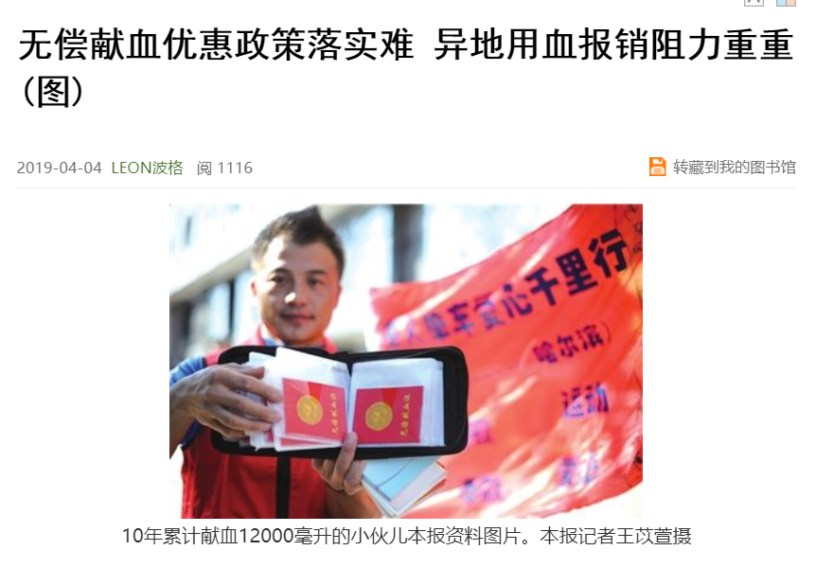

So our initial goal was to make a website that can record users` blood donation records, so that our user can use the record on our website to prove his blood donation history. Then we started to think what service our website should provide. Our initial design was: First the user need to sign up with his phone number, then he need to sign in. After signing in, he should input his user profile such as height, name, ID number and etc. Then he can make an appointment with the hospital to donate blood, and he can check his donate records.

At that time we did not realize what problems do we have, but later we found that there are servral issues we need to handle.

The first and the most critical problem is, how can our web be put into use. If it`s just a homework of Web design course, the initial design is ok because it covers the knowledge we learnt in class. But if you consider putting it into use, you can see that our web cannot be put into use. Our website just provide interface to the users, but no interface to the hospital, which means the website is not complete. It cannot actually work. Also, we just assume that the government and the law will allow us to do that. We should do some research before to make sure that our website is legal.

The second thing is security. In our design, our user need to sign in and input his profile, including his ID, but we cannot provide any safety guarantee, thus the user will not want to input his profile to a website. The security of the users` ID number is very important, which means no one will be released to input his own ID on a website.

The third thing is user friendly. We imagine that checking the record can help to resolve the remote donating problem, but actually we just provide a table which is not intuitional. It`s hard to look through that much words. Also, making an appointment is not useful enough, because the place you can donate your blood is not in the hospital, you always need to find that place. What the user need is a more detailed guide.

The last thing is, we didn`t check what function did the existing website provide, which means our website lacked of a lot of functions. It means that we just design the website through our imagination without knowing what is existing.

Then we start to solve the problems. To solve the first problem, we add medical workers interface. In that website, the medical workers can input information of the donation records and check the database.

For the second one, we change the input phase and sign up phase into offline, which means the data of the user should be input offline, in the place where you donate blood. The user can only be signed into our website with the help of medical workers.

As to the third problem, we add a data visualization map which can show the data from our database. For the medical workers, they can see the blood donation of the whole country, and for the normal users, they can see their own donation records in the map. Through the data map, the medical workers can do some data analysis to know which blood is in need, as to the normal users, they can see their own donation records more easily. Also, we use Baidu Map API to guide the user to find their way to the hospital. In this way the user can find their way to the donation point more easily.

And the last problem. We check the existing website and find that they have news part, and in the website we can see what type of blood is being short of. So we add the news in user part, and add the function of asking for blood that is being short of. The medical workers can give out the notice and when any user sign in, they can receive the notice.

After that, I cannot ensure that our website can really be put into use, but it should be much better than the first version.

In this project, I learned that when you make requirement analysis and design, an idea is not the most important thing, the following design is also needed. When you have the initial idea, you may think you find something that the market hasn`t have yet, but the very first thing you should do is to check the similar website, to see whether they have similar function, and check what function they have. Then, instead of think what function you want to design, you should think about what function is needed, and what function can be put into use. You should always think in the aspect of your users.

“Requirement analysis is also known as the software requirements analysis, system requirements analysis or demand analysis engineering, etc., is the developer after intensive research and analysis, accurate understanding of user and project of the function, performance, reliability and other specific requirements, the user the demand in the form of expression into the complete requirements definition, to determine what system must process.” So when you design your product, the very first thing you should think about is what your users need. Every function you design should base on the requirement of the users.

Also, I realize that the reason why our design seems unrealistic. It is because there is no actual user for us to ask for. According to an article about requirement analysis:

“Capture requirements phase:

Observation: By observing user`s action, get the demand.

Actual experience: Play the role of the user into the actual action, and sort out the demand.

Questionnaire: Make a questionnaire

Interview: Conduct face-to-face conversation and interview to get the demand through communication

Demand survey meeting: through the meeting, convene relevant personnel to communicate and determine the demand.

Analysis of competitive products: through the dynamic, update and independent discovery of demand of competitive products.

User feedback: Feedback through user comments, complaints, phone calls and other channels to obtain requirements.”

In my project, we just carry out “actual experience”, but we did not do any of other requirement analysis. In my introspection, I realize the importance of “analysis of competitive products”, but other analysis which requires the help of the communication to other customers are what we cannot do. In this way, our product will become biased. In the future, when get into the company, the requirement will be more complete, not like now, we cannot do that much in the university.

In the actual world, requirement analysis is much more than what we do in the course, what we can do is just part of the job.

Requirement analysis is a work that needs to be perceived in both rational and perceptual dimensions. On the one hand, we should master the tools and methods of rational analysis to ensure that there will be no big mistakes in the cooking process. On the other hand, in the specific implementation details, we need to use empathy and high perception to experience the emotional fluctuations of users. Of course, just as you can never read a person, there can be no perfect requirements analysis and no perfect solution. But all these efforts are aimed at bringing our output closer and closer to "perfection". In a word, requirements analysis is to understand your users, understand the user's situation, understand the user's problems, help users solve.

When in school, maybe we cannot do much, but we should our best to think what customers need.