Weekly Finance Dashboard Automation Playbook
Snowflake Stored Procedures, Task Scheduling, and Tableau Refresh Automation

System / Report | Weekly Finance Dashboard
Environment | Snowflake: MHTEAM.MHA; Warehouse: MHA_WH
Primary Tools | Snowflake Stored Procedures, Snowflake Task, Tableau
Purpose | Document the end-to-end process used to build and automate the dashboard refresh

Introduction
The Weekly Finance Dashboard automation was developed to automate the creation and delivery of weekly eligibility monitoring reports used by MassHealth Analytics. Prior to automation, report generation required manually executing multiple SQL scripts, validating output tables, refreshing reporting data, and coordinating Tableau updates. The goal of the automation was to standardize the process, reduce manual effort, improve repeatability, and provide a reliable Tableau dashboard for weekly reporting.
The automation was built as a sequence of Snowflake Stored Procedures controlled by a single Master Procedure. A Snowflake Task then schedules the Master Procedure to run automatically. The final Snowflake reporting tables are used as the data source for the Tableau dashboard, and a Tableau deployment / refresh request was submitted so the dashboard refresh and subscription process could be automated.
The dashboard supports weekly reporting for:
- Caseload
- Member Adds
- Member Terms
- Weekly Membership Changes
- Demographic Group
- Plan Type
- Benefit Category

Automation Build Logic
The automation was built in the same general pattern as a scheduled SAS Cron process: first the repeatable processing logic was organized, then it was converted into executable components, then those components were combined under a single driver process, then the driver process was scheduled, monitored, and connected to the reporting layer.
- Convert repeatable SQL logic into stored procedures.
- Use individual procedures for snapshot, caseload, adds, terms, and final refresh logic.
- Create a Master Procedure to run all child procedures in the correct order.
- Create a Snowflake Task to run the Master Procedure automatically.
- Validate the task and monitor execution history.
- Connect the final Snowflake tables to Tableau.
- Submit the Tableau deployment / refresh request so the dashboard refreshes automatically.

Why Stored Procedures Instead of Regular SQL Scripts?
The first design decision was to move from manually-run SQL scripts to Snowflake Stored Procedures. Regular SQL scripts are useful during development, but they require someone to open the worksheet, run code in the correct order, confirm results, and manually repeat the process each week. Stored Procedures allow the same logic to be saved as reusable database objects that can be called consistently by another procedure or by a scheduled task.
Using stored procedures provides several advantages:
- The logic is saved in Snowflake and does not depend on a user copying and running SQL manually.
- Each part of the process can be rerun consistently.
- The procedures can be called by a Master Procedure, which controls execution order.
- The Master Procedure can be called by a Snowflake Task for automated scheduling.
- The automation is easier to troubleshoot because each procedure has a defined purpose.

1. Creating the Snapshot Procedure
The first example of the automation pattern is the Snapshot Procedure. This procedure creates a weekly eligibility snapshot table that is used by the downstream caseload, adds, and terms procedures. The procedure dynamically identifies the most recent Saturday and creates a snapshot table using the naming pattern BG_SNAP_YYYYMMDD.
This procedure is an example of how the weekly SQL logic was converted into a reusable Snowflake procedure. Instead of manually changing dates and creating a snapshot table each week, the procedure calculates the snapshot date and creates the table automatically.
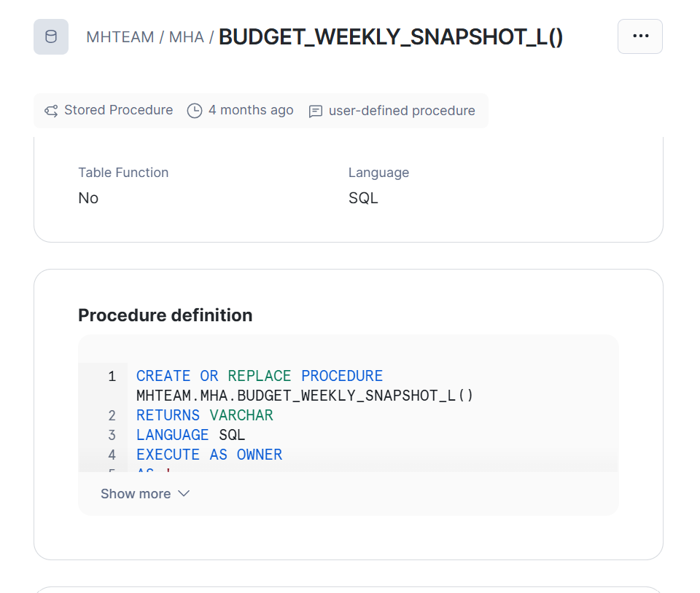
Screenshot 1. BUDGET_WEEKLY_SNAPSHOT_L procedure stored in Snowflake Horizon Catalog.
Example procedure code excerpt:
CREATE OR REPLACE PROCEDURE MHTEAM.MHA.BUDGET_WEEKLY_SNAPSHOT_L()
RETURNS VARCHAR
LANGUAGE SQL
EXECUTE AS OWNER
AS '
DECLARE
snap_date_raw DATE;
snap_date_str STRING;
sql_stmt STRING;
BEGIN
/* Most recent Saturday */
snap_date_raw :=
DATEADD(
DAY,
-MOD(DAYOFWEEKISO(CURRENT_DATE()) - 6 + 7, 7),
CURRENT_DATE()
);
snap_date_str := TO_CHAR(snap_date_raw, ''YYYYMMDD'');
/* Create weekly snapshot table */
sql_stmt := ''
CREATE OR REPLACE TABLE MHTEAM.MHA.BG_SNAP_'' || snap_date_str || '' AS
SELECT
se.id_medicaid,
LPAD(se.cde_budget_group, 2, ''''0'''') AS bg,
se.cde_aid_category,
se.cde_pgm_health,
bg.*
FROM MHDWPROD.NW.NW_STATE_ELIGIBILITY_HIST se
LEFT JOIN MHTEAM.MHA.BUDGET_XWALK_MEMBER_GROUPING bg
ON LPAD(se.cde_budget_group, 2, ''''0'''') = bg.cde_budget_group
WHERE TO_DATE('''''' || TO_CHAR(snap_date_raw, ''YYYY-MM-DD'') || '''''')
BETWEEN se.valid_from_dt_tm AND se.valid_thru_dt_tm
AND se.ind_active = ''''Y''''
'';
EXECUTE IMMEDIATE sql_stmt;
RETURN ''Snapshot created: MHTEAM.MHA.BG_SNAP_'' || snap_date_str;
END;
';
The complete procedure contains the full eligibility date filtering and output logic. The excerpt above shows the important automation pattern: declare variables, calculate the reporting date, build the dynamic table name, execute the SQL, and return a completion message.

2. Creating Supporting Procedures
After the snapshot process was created, additional procedures were developed for the remaining dashboard components. The purpose of splitting the logic into multiple procedures is similar to creating separate jobs in a SAS Cron process: each part has a clear function, can be tested independently, and can be corrected without rewriting the full process.
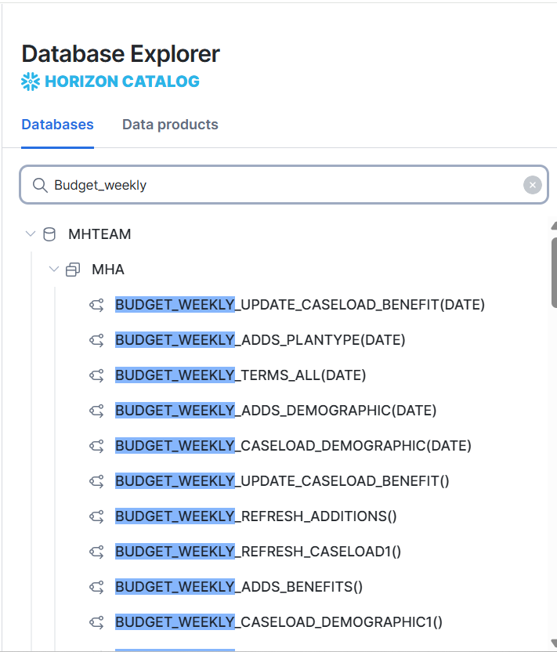
Screenshot 2. Snowflake Horizon Catalog search showing multiple Weekly Finance stored procedures.
Examples of procedures used in the Weekly Finance Dashboard automation include:
- BUDGET_WEEKLY_SNAPSHOT_L - creates the weekly eligibility snapshot.
- BUDGET_WEEKLY_CASELOAD_DEMOGRAPHIC_T1 - calculates caseload by demographic group.
- BUDGET_WEEKLY_CASELOAD_PLANTYPE_T1 - calculates caseload by plan type.
- BUDGET_WEEKLY_CASELOAD_BENEFIT_T1 - calculates caseload by benefit category.
- BUDGET_WEEKLY_ADDS_DEMOGRAPHIC_T1 - calculates member adds by demographic group.
- BUDGET_WEEKLY_ADDS_PLANTYPE_L - calculates member adds by plan type.
- BUDGET_WEEKLY_ADDS_BENEFITS_L - calculates member adds by benefit category.
- BUDGET_WEEKLY_TERMS_ALL_L - calculates member terms.
- BUDGET_WEEKLY_REFRESH_CHANGES2_T1 - refreshes change reporting tables.
- BUDGET_WEEKLY_REFRESH_CASELOAD_L - refreshes final caseload reporting tables.

3. Creating the Master Procedure
Once the individual procedures were created and tested, they were combined into a single Master Procedure. The Master Procedure is the main entry point for the automation. Instead of manually running each procedure one by one, the Master Procedure runs the full weekly dashboard refresh process in the correct order.
This is the same concept as compiling several SAS jobs into one shell script for Cron scheduling. The individual procedures do the work, and the Master Procedure controls the order of execution.
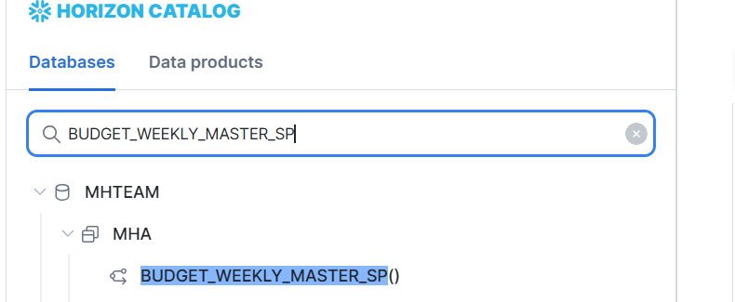
Screenshot 3. Master Procedure stored in Snowflake Horizon Catalog.
Example Master Procedure call:
CALL MHTEAM.MHA.BUDGET_WEEKLY_MASTER_SP();
Example Master Procedure structure:
CREATE OR REPLACE PROCEDURE MHTEAM.MHA.BUDGET_WEEKLY_MASTER_SP()
RETURNS VARCHAR
LANGUAGE SQL
EXECUTE AS OWNER
AS '
DECLARE
out_msg STRING DEFAULT '''';
one_msg STRING;
BEGIN
/* Main Pipeline */
CALL MHTEAM.MHA.BUDGET_WEEKLY_SNAPSHOT_L();
SELECT $1 INTO :one_msg FROM TABLE(RESULT_SCAN(LAST_QUERY_ID()));
out_msg := out_msg || one_msg || ''
'';
CALL MHTEAM.MHA.BUDGET_WEEKLY_CASELOAD_DEMOGRAPHIC_T1();
CALL MHTEAM.MHA.BUDGET_WEEKLY_CASELOAD_PLANTYPE_T1();
CALL MHTEAM.MHA.BUDGET_WEEKLY_CASELOAD_BENEFIT_T1();
CALL MHTEAM.MHA.BUDGET_WEEKLY_ADDS_DEMOGRAPHIC_T1();
CALL MHTEAM.MHA.BUDGET_WEEKLY_ADDS_PLANTYPE_L();
CALL MHTEAM.MHA.BUDGET_WEEKLY_ADDS_BENEFITS_L();
CALL MHTEAM.MHA.BUDGET_WEEKLY_TERMS_ALL_L();
CALL MHTEAM.MHA.BUDGET_WEEKLY_REFRESH_CHANGES2_T1();
CALL MHTEAM.MHA.BUDGET_WEEKLY_REFRESH_CASELOAD_L();
RETURN out_msg;
END;
';
General execution flow:
- Weekly Snapshot
- Caseload Calculations
- Adds Calculations
- Terms Calculations
- Final Reporting Tables
This design simplifies maintenance because future corrections or enhancements can be made to an individual child procedure while preserving a single master entry point for scheduled execution.

4. Creating the Snowflake Task
After the Master Procedure was completed, a Snowflake Task was created to schedule the automation. The Snowflake Task is the equivalent of the Cron schedule in the SAS example. It tells Snowflake when to run the process and what procedure to call.
The task uses Snowflake CRON syntax and calls the Master Procedure automatically. This removes the need for a user to manually run the procedure each week.
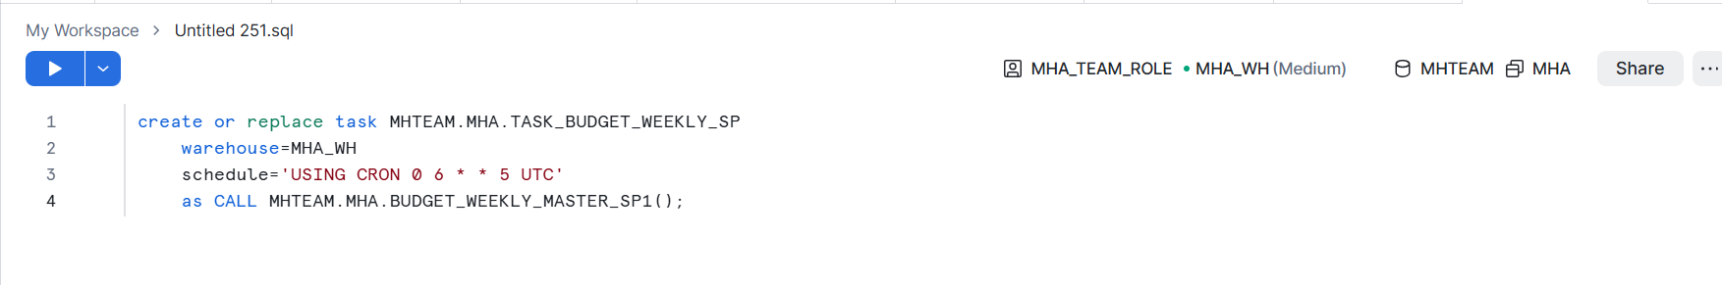
Screenshot 4. Snowflake worksheet used to create the weekly automation task.
Example Task Creation Code:
CREATE OR REPLACE TASK MHTEAM.MHA.TASK_BUDGET_WEEKLY_SP
WAREHOUSE = MHA_WH
SCHEDULE = 'USING CRON 0 6 * * 5 UTC'
AS
CALL MHTEAM.MHA.BUDGET_WEEKLY_MASTER_SP1();
The task definition includes the task name, warehouse, schedule, and the procedure call. The screenshot shows the active master procedure version used at the time the task was created. If the master procedure is renamed later, update the task definition and the manual rerun command so both point to the same active procedure. The schedule should be reviewed carefully because Snowflake CRON schedules are defined in UTC unless otherwise specified.

5. Verifying the Task Was Created
After the task is created, the SHOW TASKS command can be used to confirm that the task exists in the expected database and schema and is assigned to the correct warehouse.
SHOW TASKS LIKE 'BUDGET_WEEKLY_SP';
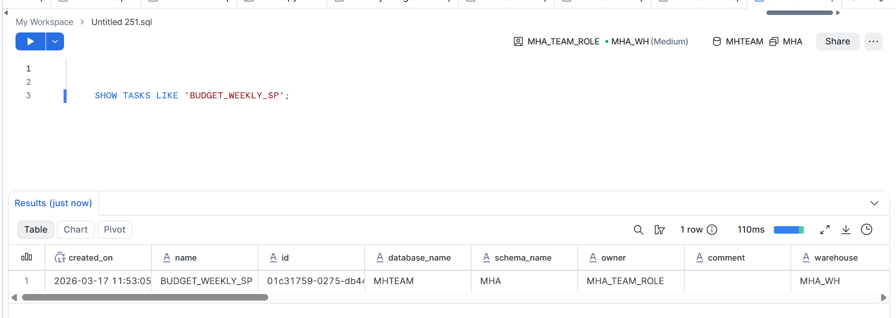
Screenshot 5. SHOW TASKS result confirming the task exists in MHTEAM.MHA and uses MHA_WH.
The result should return one row for BUDGET_WEEKLY_SP. Important fields to review include database_name, schema_name, owner, and warehouse.

6. Monitoring Task Execution
Task execution history can be reviewed in Snowflake using TASK_HISTORY. This is used to confirm successful runs, identify failed runs, review execution timing, and troubleshoot issues.
SELECT
NAME,
SCHEDULED_TIME,
COMPLETED_TIME,
STATE,
QUERY_ID,
ERROR_CODE,
ERROR_MESSAGE
FROM TABLE(
INFORMATION_SCHEMA.TASK_HISTORY(
TASK_NAME => 'BUDGET_WEEKLY_SP'
)
)
ORDER BY SCHEDULED_TIME DESC;
If the most recent run does not show a successful status, review the error message and identify the procedure where the process stopped. After correcting the issue, the Master Procedure can be rerun manually.

7. Manual Execution and Rerun Process
Manual execution is useful after a code change, data correction, task failure, or Tableau refresh issue. Rather than waiting for the next scheduled task, the full process can be rerun by calling the active Master Procedure directly. Use the same Master Procedure version that the Snowflake task is currently configured to call.
CALL MHTEAM.MHA.BUDGET_WEEKLY_MASTER_SP();
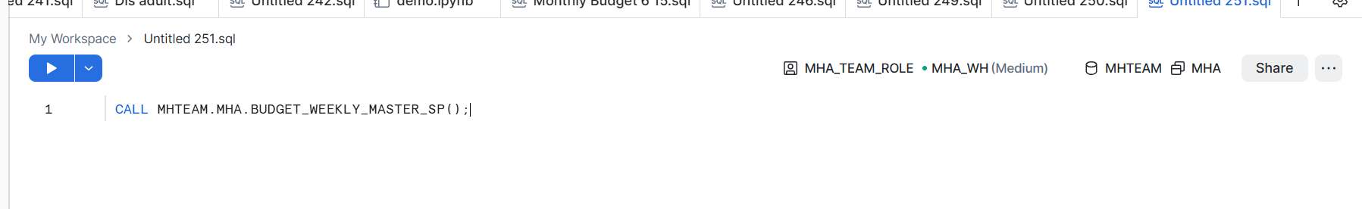
Screenshot 6. Manual execution of the Master Procedure from a Snowflake worksheet.
After a manual rerun, validate that the final reporting tables were refreshed and confirm that Tableau refreshes successfully.

8. Final Reporting Tables for Tableau
The final procedures generate the reporting tables used by Tableau. These tables contain the data displayed on the Weekly Finance Dashboard, including caseload, adds, terms, and related grouping dimensions.
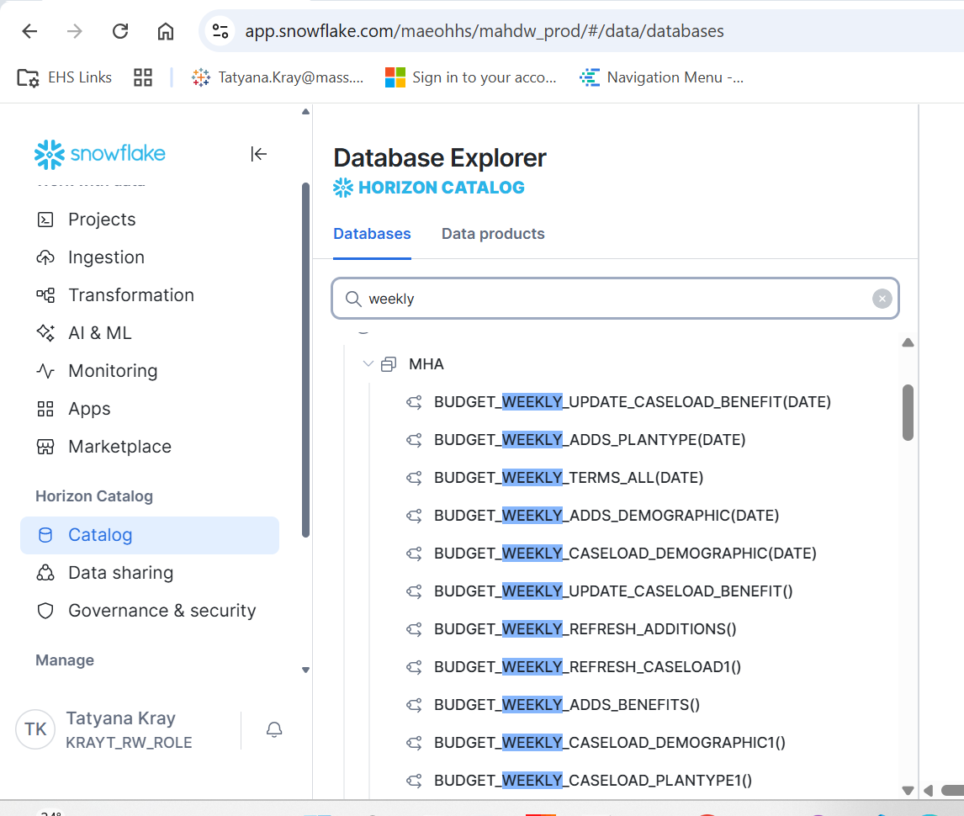
Screenshot 7. Snowflake Horizon Catalog showing Weekly Finance reporting objects used by the dashboard.
The reporting tables support dashboard metrics for:
- Weekly Caseload
- Member Adds
- Member Terms
- Demographic Groups
- Plan Types
- Benefit Categories
The final reporting tables are the bridge between the Snowflake automation and Tableau. Once the Snowflake task completes, these tables contain the updated data needed by the dashboard.

9. Connecting Tableau to Snowflake
After the Snowflake reporting tables were created, Tableau was connected directly to the final Snowflake tables. The Tableau workbook uses the Snowflake connection as its primary data source.
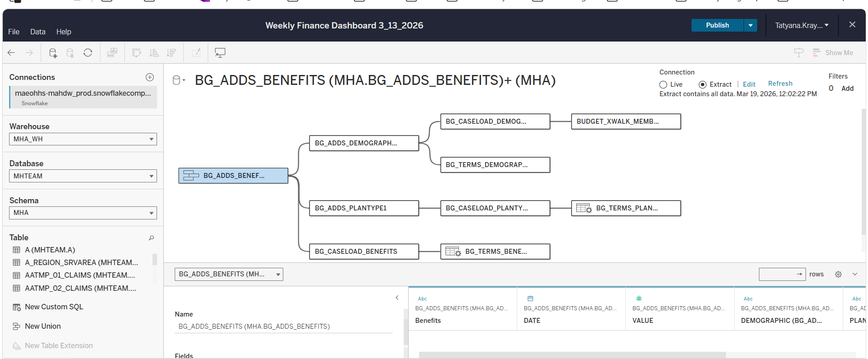
Screenshot 8. Tableau data source connection showing Snowflake reporting tables used in the workbook.
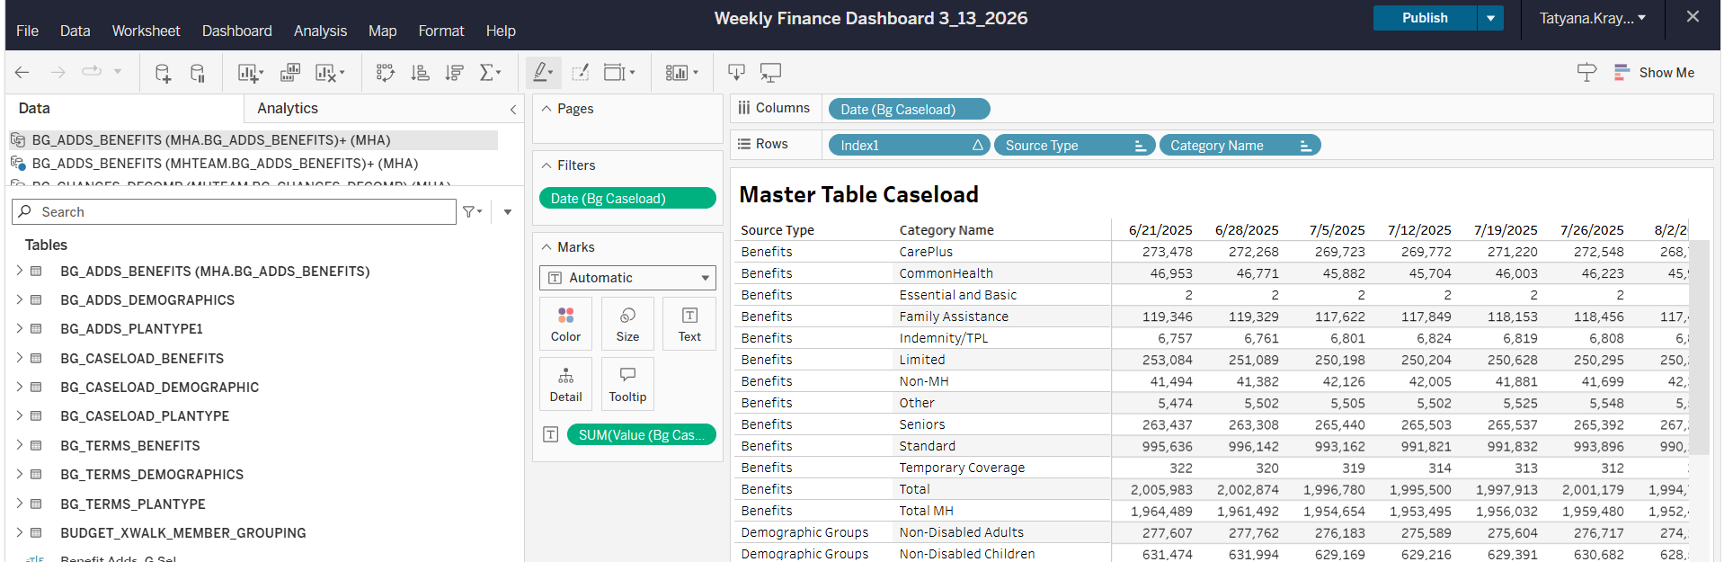
Screenshot 9. Weekly Finance Dashboard workbook view in Tableau.
The workbook was then published to Tableau Server so business users could access the dashboard and receive scheduled subscription updates.

10. Tableau Deployment and Refresh Request
To complete the automation, a Tableau Deployment Request was submitted to the Tableau Administration Team. This request is required to move or maintain the workbook in the production Tableau environment and configure refresh and access requirements.
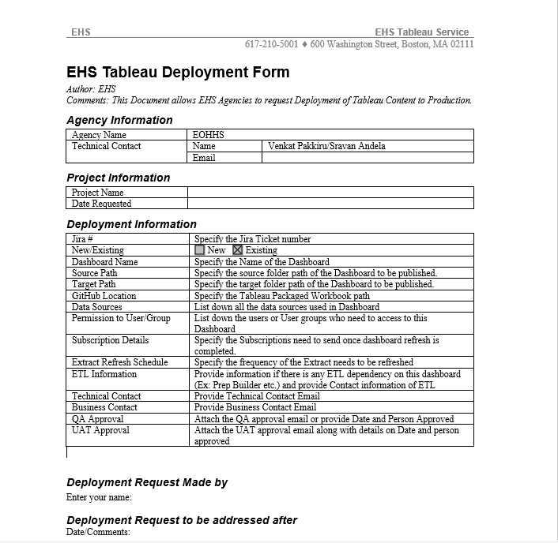
Screenshot 10. EHS Tableau Deployment Form used to request production deployment and refresh configuration.
The request generally includes:
- Workbook / dashboard name
- Project or folder location
- Data source information
- User access or permission requirements
- Refresh schedule requirements
- Subscription details
- Business justification
- Business and QA approval information
After approval, Tableau was configured to refresh the dashboard using the Snowflake reporting tables, allowing the dashboard and subscription process to update automatically after the Snowflake process completed.

11. Source Code Management
The automation code should be maintained in GitHub so that procedures, task definitions, documentation, and deployment history are version controlled. GitHub provides a recovery point if production code needs to be reviewed or restored.
Recommended repository contents include:
- Child procedure SQL files
- Master procedure SQL file
- Task creation SQL file
- Validation queries
- Tableau deployment documentation
- Change notes or enhancement history
[INSERT GITHUB SCREENSHOT IF AVAILABLE]

12. Final Automated Process
The completed end-to-end automation process operates as follows:
Stored Procedures
↓
Master Procedure
↓
Snowflake Task Scheduler
↓
Final Reporting Tables
↓
Tableau Data Source Refresh
↓
Weekly Finance Dashboard
↓
Dashboard Subscription Distribution
This automation eliminates the need to manually execute the weekly reporting SQL process and provides a repeatable, scheduled path from Snowflake data processing through Tableau dashboard delivery.

Appendix A. Common Validation Queries
-- Verify task exists
SHOW TASKS LIKE 'BUDGET_WEEKLY_SP';
-- Review task execution history
SELECT *
FROM TABLE(INFORMATION_SCHEMA.TASK_HISTORY())
ORDER BY SCHEDULED_TIME DESC;
-- Rerun the full automation manually
CALL MHTEAM.MHA.BUDGET_WEEKLY_MASTER_SP();
-- Review available snapshot tables
SHOW TABLES LIKE 'BG_SNAP%';

Appendix B. Maintenance Notes
The following items should be reviewed whenever the automation is modified:
- Confirm the task points to the current active Master Procedure.
- Confirm any new or renamed child procedures are included in the Master Procedure in the correct order.
- Confirm final reporting table names used by Tableau did not change unless the Tableau data source was updated.
- Confirm Tableau refresh timing occurs after Snowflake processing is complete.
- Keep GitHub code synchronized with production Snowflake objects.

