Sim_ABCRF

LEJEUNE Thomas

2025-04-29

library(tidyverse)

## ── Attaching core tidyverse packages ──────────────────────── tidyverse 2.0.0 ──  
## ✔ dplyr 1.1.4 ✔ readr 2.1.5  
## ✔ forcats 1.0.0 ✔ stringr 1.5.1  
## ✔ ggplot2 3.5.2 ✔ tibble 3.2.1  
## ✔ lubridate 1.9.4 ✔ tidyr 1.3.1  
## ✔ purrr 1.0.4   
## ── Conflicts ────────────────────────────────────────── tidyverse_conflicts() ──  
## ✖ dplyr::filter() masks stats::filter()  
## ✖ dplyr::lag() masks stats::lag()  
## ℹ Use the conflicted package (<http://conflicted.r-lib.org/>) to force all conflicts to become errors

library(abcrf)  
library(ggplot2)  
library(tinytex)

# Desktop detection  
home_path <- Sys.getenv("HOME")  
  
desktop_path <- if (dir.exists(file.path(home_path, "Desktop"))) {  
 file.path(home_path, "Desktop")  
} else if (dir.exists(file.path(home_path, "Bureau"))) {  
 file.path(home_path, "Bureau")  
} else {  
 stop  
}  
  
# Complete path  
file_path <- file.path(desktop_path, "simulations", "Ref_table", "summary_table.csv")  
  
# Reading file  
data <- read_csv(file_path)

## Rows: 13000 Columns: 99  
## ── Column specification ────────────────────────────────────────────────────────  
## Delimiter: ","  
## chr (19): simulation_id, Coan_f1_Pop1, Coan_f1_Pop2, HE_weighted_D_mean_0.05...  
## dbl (76): pop_size, num_loci, sample1_generation, sample2_generation, sample...  
## num (4): HE_weighted_D_mean_0.050_Pop1, HE_weighted_D_mean_0.020_Pop1, HE_w...  
##   
## ℹ Use `spec()` to retrieve the full column specification for this data.  
## ℹ Specify the column types or set `show_col_types = FALSE` to quiet this message.

# Function that will search every column and count the "NA", then remove the columns having too much missing values according to the threshold  
remove_high_na_cols <- function(data, threshold = 0.05) {  
 total_rows <- nrow(data)  
 na_summary <- data %>%  
 summarise(across(everything(), ~ sum(is.na(.)))) %>%  
 pivot_longer(cols = everything(), names_to = "Variable", values_to = "NA_count") %>%  
 mutate(  
 Total_rows = total_rows,  
 NA_percentage = round((NA_count / Total_rows) * 100, 2)  
 )  
 cols_to_remove <- na_summary %>%  
 filter(NA_percentage > threshold * 100) %>%  
 pull(Variable)  
 data_clean <- data %>% select(-any_of(cols_to_remove))  
 list(data_clean = data_clean, removed = cols_to_remove, na_summary = na_summary)  
}  
result <- remove_high_na_cols(data, threshold = 0.05)  
data_clean <- result$data   
result$na_summary # List of removed col

## # A tibble: 99 × 4  
## Variable NA_count Total_rows NA_percentage  
## <chr> <int> <int> <dbl>  
## 1 simulation_id 0 13000 0  
## 2 pop_size 0 13000 0  
## 3 num_loci 0 13000 0  
## 4 sample1_generation 0 13000 0  
## 5 sample2_generation 0 13000 0  
## 6 sample1_size_Ne 0 13000 0  
## 7 sample2_size_Ne 0 13000 0  
## 8 sample1_size_CMR 0 13000 0  
## 9 sample2_size_CMR 0 13000 0  
## 10 low_repeats 0 13000 0  
## # ℹ 89 more rows

top_n_display <- 20  
  
ggplot(result$na_summary %>%   
 filter(NA_percentage > 0) %>%   
 slice_max(NA_percentage, n = top_n_display),  
 aes(x = reorder(Variable, -NA_percentage), y = NA_percentage)) +  
 geom_col(fill = "steelblue") +  
 coord_flip() +  
 labs(  
 title = "Top 30 variables with most NA",  
 x = "Resuming stats",  
 y = "NA percentage (%)"  
 ) +  
 theme_minimal(base_size = 14)

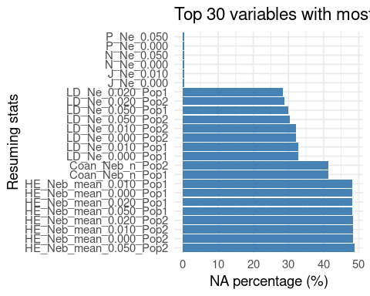

data_clean <- data_clean %>%  
 mutate(census_N = ifelse(census_N == 0, NA, census_N))  
  
data_clean <- data_clean %>%  
 drop_na()

# Search every column for NA then calculate the median of the existing values and add it to the missing values  
data_imputed <- data %>% mutate(across(everything(), ~ ifelse(is.na(.), median(., na.rm = TRUE), .)))

## Warning: There were 5 warnings in `mutate()`.  
## The first warning was:  
## ℹ In argument: `across(...)`.  
## Caused by warning in `mean.default()`:  
## ! l'argument n'est ni numérique, ni logique : renvoi de NA  
## ℹ Run `dplyr::last_dplyr_warnings()` to see the 4 remaining warnings.

# Hard version of the last method, choose the columns to delete to avoid suppressing too many lines while removing the NAs  
to_remove <- c(  
 "HE_Neb_mean_0.050_Pop2", "HE_Neb_mean_0.020_Pop2", "HE_Neb_mean_0.010_Pop2", "HE_Neb_mean_0.000_Pop2",  
 "HE_Neb_mean_0.050_Pop1", "HE_Neb_mean_0.020_Pop1", "HE_Neb_mean_0.010_Pop1", "HE_Neb_mean_0.000_Pop1",  
 "Coan_Neb_n_Pop1", "Coan_Neb_n_Pop2",  
 "LD_Ne_0.050_Pop1", "LD_Ne_0.020_Pop1", "LD_Ne_0.010_Pop1", "LD_Ne_0.000_Pop1",  
 "LD_Ne_0.050_Pop2", "LD_Ne_0.020_Pop2", "LD_Ne_0.010_Pop2", "LD_Ne_0.000_Pop2"  
)  
  
# Remove the lines that contain at least one "NA"  
data <- data %>% select(-any_of(to_remove)) %>% na.omit()

# List of parameters  
param_cols <- c("simulation_id", "pop_size", "num_loci", "sample1_size_Ne", "sample2_size_Ne",  
 "sample1_size_CMR", "sample2_size_CMR", "mutation_rate", "recap_Ne")  
params <- data_clean %>% select(all_of(param_cols))  
  
# List of resuming statistics  
stat_keywords <- c("id", "LD", "HE", "Coan", "het", "alleles", "P_", "N_", "J_")  
stat_cols <- names(data_clean)[sapply(names(data_clean), function(col) any(str_detect(col, stat_keywords)))]  
stats_table <- data_clean %>% select(all_of(stat_cols))

# Choose the parameter that will be predicted and create a new dataframe with it in the first column and the resuming stats  
target_param <- "pop_size"  
learning_data <- bind_cols(y = params[[target_param]], stats_table) %>% rename(!!target_param := y)  
  
# Regression ABCRF that will predict the values of a parameters from the data base formed by the simulations  
model_rf <- regAbcrf(as.formula(paste(target_param, "~ .")), data = learning_data, ntree = 500)

## Growing trees.. Progress: 42%. Estimated remaining time: 42 seconds.  
## Growing trees.. Progress: 84%. Estimated remaining time: 11 seconds.

summary(model_rf)

## Length Class Mode  
## call 4 -none- call  
## formula 3 formula call  
## model.rf 19 ranger list

# Determines the order of importance of every resuming stat in the dataframe concerning the prediction of the parameter  
importance_df <- model_rf$model.rf$variable.importance %>%  
 sort(decreasing = TRUE) %>%  
 enframe(name = "Statistic", value = "Importance")  
top_n <- 20  
importance_top <- importance_df %>%  
 slice_head(n = top_n) %>%  
 mutate(Statistic = fct_reorder(Statistic, Importance))  
  
# Plotting the barplot showing the order of importance  
ggplot(importance_top, aes(x = Statistic, y = Importance)) +  
 geom_col(fill = "steelblue") +  
 coord_flip() +  
 labs(  
 title = paste("Top", top_n, "variables importantes pour l'estimation de", target_param),  
 x = "Statistique",  
 y = "Importance (abcrf)"  
 ) +  
 theme_minimal(base_size = 14)

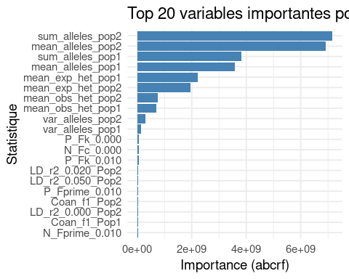

# Use the model to make the predictions according to the "observed data" from the Out-Of-Bag "OOB"  
predictions <- predict(model_rf, training = learning_data, obs = learning_data)$expectation  
  
# Plotting the curve demonstrating the differences of the predictions of the dataframe studied with the target data from the Out-Of-Bag  
plot(learning_data[[target_param]], predictions,  
 xlab = "Vraie pop_size", ylab = "Prédiction pop_size (OOB)",  
 main = "Comparaison vraie vs prédite",  
 pch = 20, col = "blue")  
abline(0, 1, col = "red")

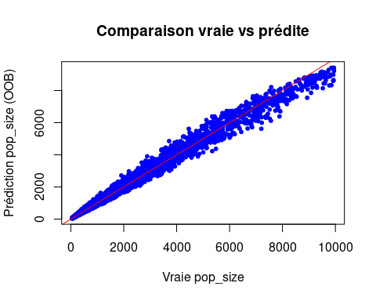

# ---- Courbe POD vs tolérance ----  
  
# Vecteur de tolérances (exprimées en %)  
tolerance_vec <- seq(0.01, 0.2, by = 0.01) # de 1% à 20%  
  
# Calcul de la POD pour chaque tolérance  
pod_df <- data.frame(  
 Tolerance = tolerance_vec,  
 POD = sapply(tolerance_vec, function(tol) {  
 mean(abs(predictions - learning_data$pop_size) / learning_data$pop_size < tol)  
 })  
)  
  
# Affichage du tableau si besoin  
print(pod_df)

## Tolerance POD  
## 1 0.01 0.0960322  
## 2 0.02 0.1864098  
## 3 0.03 0.2759249  
## 4 0.04 0.3610312  
## 5 0.05 0.4479586  
## 6 0.06 0.5239601  
## 7 0.07 0.5983324  
## 8 0.08 0.6587119  
## 9 0.09 0.7100824  
## 10 0.10 0.7559900  
## 11 0.11 0.7975848  
## 12 0.12 0.8295956  
## 13 0.13 0.8591144  
## 14 0.14 0.8819245  
## 15 0.15 0.9028177  
## 16 0.16 0.9200690  
## 17 0.17 0.9347326  
## 18 0.18 0.9458501  
## 19 0.19 0.9547633  
## 20 0.20 0.9623347

# ---- Visualisation avec ggplot2 ----  
library(ggplot2)  
  
ggplot(pod_df, aes(x = Tolerance * 100, y = POD * 100)) +  
 geom_line(color = "steelblue", size = 1.2) +  
 geom_point(color = "darkblue", size = 2) +  
 labs(  
 title = "Probabilty of Detection (POD)",  
 x = "Tolerance (%)",  
 y = "POD (%)"  
 ) +  
 theme_minimal(base_size = 14)

## Warning: Using `size` aesthetic for lines was deprecated in ggplot2 3.4.0.  
## ℹ Please use `linewidth` instead.  
## This warning is displayed once every 8 hours.  
## Call `lifecycle::last_lifecycle_warnings()` to see where this warning was  
## generated.

