DATED: 2017-AUG-02

BRITEHOUSE DOCUMENTATION

SCHOOL OF INFORMATION TECHNOLOGY | IT DEVELOPMENT

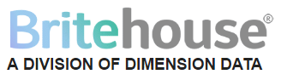

Table of Contents

[**1.** **INTRODUCTION** 2](#_Toc490051886)

[**2.** **VISION** 2](#_Toc490051887)

[**3.** **MISSION** 2](#_Toc490051888)

[**4.** **PROJECT TIMELINE** 2](#_Toc490051889)

[**5.** **SYSTEM ANALYSIS ASPECTS** 2](#_Toc490051890)

[***5.1*** ***PROBLEM DEFINITION*** 2](#_Toc490051891)

[***5.2*** ***THE CURRENT MANUAL SYSTEM*** 3](#_Toc490051892)

[**5.4.1** **OBJECTIVES OF THE PROPOSED SYSTEM** 3](#_Toc490051893)

[**5.4.2** **SCOPE OF THE SYSTEM** 3](#_Toc490051894)

[**5.4.3** **THE ADVANTAGES OF THE SYSTEM** 3](#_Toc490051895)

[***5.5*** ***SYSTEM FEASIBILITY STUDY*** 4](#_Toc490051896)

[**5.5.1** **ECONOMIC FEASIBILITY STUDY** 4](#_Toc490051897)

[**5.5.2** **TECHNICAL FEASIBILITY STUDY** 4](#_Toc490051898)

[**5.5.3** **SCHEDULE FEASIBILITY** 4](#_Toc490051899)

[***5.6*** ***FACT FINDING*** 4](#_Toc490051900)

[**6** **SYSTEM DESIGN ASPECTS** 4](#_Toc490051901)

[**7** **DATABASE INITIAL STUDY** 4](#_Toc490051902)

[**7.1** ***THE NATURE OF THE COMPANY AND ITS MISSION*** 4](#_Toc490051903)

[**8** **PROBLEMS AND CONSTRAINTS** 5](#_Toc490051904)

[***7.1*** ***DELIVERY PLANNER’S PERSPECTIVE*** 5](#_Toc490051905)

[***7.2*** ***DELIVERY PLANNER’S PERSPECTIVE*** 5](#_Toc490051906)

[**8** **DEFINE OBJECTIVES** 6](#_Toc490051907)

[**9** **DEFINE SCOPE AND BOUNDARIES** 6](#_Toc490051908)

[**10** **CONCEPTUAL ER DIAGRAMS** 7](#_Toc490051909)

[*Figure 10.1: Entity Relationship Model (Conceptual) diagram* 7](#_Toc490051910)

[**11** **DBMS SOFTWARE SELECTION** 8](#_Toc490051911)

[***11.1*** ***ADVANTAGES*** 8](#_Toc490051912)

[***11.2*** ***DISADVANTAGES*** 8](#_Toc490051913)

[***11.3*** ***SYSTEM REQUIREMENTS*** 8](#_Toc490051914)

[***11.4*** ***HARDWARE REQUIREMENTS*** 9](#_Toc490051915)

[**REFERENCES** 10](#_Toc490051916)

1. **INTRODUCTION**

Britehouse delivery management system was developed following system development and database designs stages for smooth running and management of Britehouse deliveries. Furthermore, following from the specification provided from the functional workshop that was held between the company’s IT manager, delivery manager, delivery planner, representatives from both the customers and the drivers, enabled system analyst to recognize and define problems in the current manual system. We also can conclude that there is a need for a computerized management system. The database system should at least support create, read, update, and delete operations. The system was developed using HTML scripting language for applications. This system will indeed help the delivery management and the esteemed staff members to manage and steer the company’s functionality and transactions to realize its maximum potential in addition to its competence in the delivery business field.

1. **VISION**

After successful implementation of web-based application together with its database, I foresee myself working on a similar project as the delivery management for the company.

1. **MISSION**

A web-based application should be provided to Britehouse Inc. with reliable and satisfactory database that generate accurate, relevant, consistent, and timely reports, of which they are critical in decision-making in a company.

1. **PROJECT TIMELINE**
2. **SYSTEM ANALYSIS ASPECTS**
   1. ***PROBLEM DEFINITION***

Britehouse specializes in delivering items. They deliver:

* Consignments
* Packages
* Envelopes containing products shipped to its customers
* Documentations and invoices,
* and payments, gifts and other items.

They have trucks, minivans, and smaller three wheeled delivery vehicles. They have different load capacities and not all the vehicles can carry all the types of packages we must deliver. They have different costs to operate, and different ranges from the depot they can cover.

Although the company have every resources for their deliveries, the company is not realizing its maximum potential due to delay of activities and undesirable situations caused by the current redundant manual system. Due to huge losses suffered by the delivery company from frequent errors in the current system, Britehouse delivery management need a computerized system, which would:

* Be friendlier to customers and Britehouse staff.
* Improve customer services.
* Increase delivery performance.
* Reduce the operational costs of deliveries.
  1. ***THE CURRENT MANUAL SYSTEM***

The current manual system is paper-based and uses direct human language communication by mouth to manage the deliveries. This delays information transmission in deliveries. Delivery request is done through phone calls and customers need to phone the delivery people in the days leading up to the delivery to confirm, and they’re not always available. Even when customers do confirm the delivery schedule, it often doesn’t happen the way they planned.

* 1. ***PROBLEMS IN THE MANUAL SYSTEM***
* Human and computational costs.
* Poorly generated records.
* Complaints from customers.
* Poor communication.
* Difficulty in data analysis.
  1. ***OVERVIEW OF PROPOSED SYSTEM***
     1. **OBJECTIVES OF THE PROPOSED SYSTEM**
* To enable online placing of deliveries via internet.
* To enable automated data entry methods.
* Ensure efficient and reliable communication within drivers, customers, and delivery planner and delivery manager.
* Avoid data entry errors.
* Enable easy authorization modification of data.
* Enable fast and easy retrieval of delivery records and data for fast reference activities.
  + 1. **SCOPE OF THE SYSTEM**

To help the system smoothly carry out its intended purpose to meet the Britehouse delivery management needs, at least the following tables will be needed:

* CUSTOMER table
* DELIVERY table
* ADDRESS table
* COMPANY table
* TRUCK table
* DRIVER table
  + 1. **THE ADVANTAGES OF THE SYSTEM**
* The system provides better data management facilities.
* Easy update of delivery records.
* Greatly reduce paper use at the company.
* Improves collaboration.
  1. ***SYSTEM FEASIBILITY STUDY***

A feasibility study was carried out to determine the benefits of the current manual system and the proposed computerized system. The system is indeed viable:

* + 1. **ECONOMIC FEASIBILITY STUDY**

The estimated costs of the system will indeed outweigh the estimated costs of development of the system. The estimated costs of the system are as shown below

* + 1. **TECHNICAL FEASIBILITY STUDY**

The system will be easy to maintain for the technical staff. The system structure is easy 0to 0imodify 0by the experts in order to meet the hotel needs and maintain its competence in the business world in the future.

* + 1. **SCHEDULE FEASIBILITY**

The system development process will meet the delivery deadline of seven months provided by the hotel management team. The following is a breakdown of the activities as anticipated to be carried out:

* 1. ***FACT FINDING***

The *Interview method* was the most exhaustible method of data collection. The team used their data superior collection skills to extract data out of the hotel management team, the hotel employees and the hotel’s guests at the moment of data collection. The interviewers created a conducive environment in which the interviewees could feel free to let out the best they could that helped the team come up with the most effective system to fulfil their needs. Among the data collected the following was highlighted to be of a great consideration: The guests’ feelings about the current management of the hotel, the employees’ comfortability with the proposal of introducing a new computerized system. Many computer illiterate employees had fears of replaced PR displaced by the computer literate employees but they were assured of their survival should they be ready to prove their competence in their activities. The management’s dire need for management of the hotel’s proceedings was pu8t into consideration by the system developers.

1. **SYSTEM DESIGN ASPECTS**
2. **DATABASE INITIAL STUDY**
   1. ***THE NATURE OF THE COMPANY AND ITS MISSION***

Britehouse Inc. is a company that specializes in delivering of items. Their deliveries include the following:-

* Consignments
* Packages
* Envelopes containing products shipped to its customers
* Documentations and invoices,
* and payments, gifts and other items.

The company also owns trucks, minivans and three wheeled vehicles that performs their day-to-day deliveries from 8:00 to 17:00 and 08:00 to 13:00 on Saturdays.

The Britehouse Inc., from the specification given, it seems to be expanding and dynamic in its requirements. Although, the company it is immature in terms of their system environment and database environment. This can be concluded from the fact that, some of the company’s day-to-day operations are not being attended to in an efficient and effective way. The communication between the customer, delivery manager, delivery planner and drivers is not efficient as they current experiencing problems with deliveries.

Although, the delivery planner plans the delivery schedules but their planning is not effective. Many factors that comes into play are left out. It can be concluded that the company is still based on traditional paper-based systems succeeding from specification given after the meeting was held between company’s representatives. Traditional paper-based system has so many disadvantages such as supply costs, poor environmental credentials, limited collaboration, editing problems etc.

1. **PROBLEMS AND CONSTRAINTS**
   1. ***DELIVERY PLANNER’S PERSPECTIVE***

* Some deliveries are not on Britehouse’s daily routes hence they often using external delivery company.
* The company have problems with tracking their fuel costs against deliveries.
* Fuelling costs cannot be easily correlated with daily delivery schedule.
* The company regularly receive traffic fines but hard to track which drivers and deliveries each fine related to.
* The company cannot always figure out why the trucks are at certain location at the time of the fine.
* Hard to track when and why certain trucks deviated from original route.
* Hard to make effective changes to the schedule because the company does not know where the trucks are at, at the certain time and they reach their clients.
  1. ***DELIVERY PLANNER’S PERSPECTIVE***
* They does not exactly know when the products will be packaged and ready for delivery.
* Customer’s complain about late deliveries as well as early deliveries.
* Sometimes there can be confusion about addresses where the delivery should be delivered.
* Sometimes the delivery addresses are incorrectly captured, not verified and found to be wrong.

1. **DEFINE OBJECTIVES**

* Ensure all database servers are backed up in a way that meets the business’s Recovery Point Objectives (RPO).
* Test backups to ensure we can meet the business’s Recovery Time Objectives (RTO).
* Provide timely reports on the company’s database data.
* Ensure processing of data takes place.
* Provide database that will capture data, do lookups, remove data and update information as necessary to the company.
* Document the company’s database environment.

1. **DEFINE SCOPE AND BOUNDARIES**

* The Britehouse delivery company need to be provided with a centralized delivery management database system. The database system will enable end-users to share information and also promote integration among themselves within the company practices. This system will help end-users to input, read, update and delete information as necessary. The system data will only be accessed by authorized personnel for improved security and privacy to company’s information.
* The database system will also accommodate the daily operations of the company such as creating profiles for the deliveries that are available, create new customer delivery requests as well as capturing driver details with their associated truck and all other necessary information needed to be captured.
* The database system will also address the following transactions:-
  + Provide a list of drivers for the company.
  + Customers whom have requested a delivery for their respective preferable times.
  + List of available trucks prior to selected date.
  + List of deliveries on a specific day.
  + Provide customer information etc.
* The database system will also be able to generate some reports for the company e.g. financial statement for financial managers, and graphically representation of the financial trend of the company.

1. **CONCEPTUAL ER DIAGRAMS**

**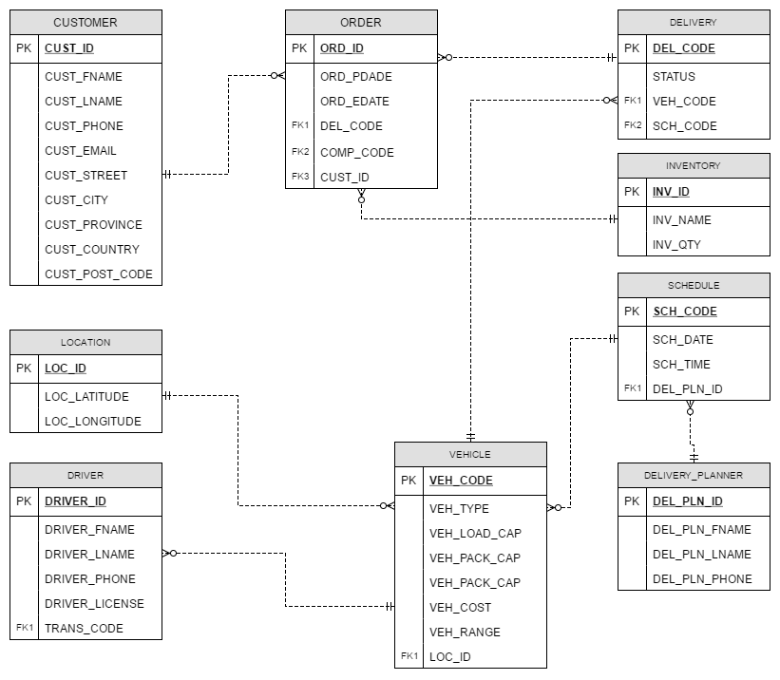**

## *Figure 10.1: Entity Relationship Model (Conceptual) diagram*

1. **LOGICAL ER DIAGRAMS**

## **C:\Users\TLHOGI MOLWANA\Downloads\Britehouse_ERD.png** *Figure 10.1: Entity Relationship Model (logical) diagram*

1. **DBMS SOFTWARE SELECTION**
   1. ***ADVANTAGES***

MySQL is selected as the DBMS for this project because, MySQL is the world’s most popular database with plenty advantages, disadvantages and many other features that contribute to its popularity. It comes with new versions that are updates of the original software and new features that are being implemented in the existing ones. MySQL is the best software for our system because of the following advantages that it contains:-

* It is very easy to install in a computer or laptop and it is also an easy database to work with.
* Support is readily available whenever necessary.
* It’s open source.
* It’s incredibly inexpensive–it is less expensive than most other database options on the market.
* It is standard for the industry and it is still extremely popular.
* It is compatible with every operating system (virtually).
* Reliable.
* Improved data integrity–use of triggers and stored procedures.
* Reduced network traffic (reliable and it increases performance).
* The stored procedure in MySQL-stored procedures enables better tuning for performance.
  1. ***DISADVANTAGES***

Although MySQL supports large data, data type supports numbers and characters. Given that it also provides the data to support object-oriented database storage and has the ability to manage multiple databases using a two-phase commit protocol it also contains some disadvantages. The following are its disadvantages as compared to its competitors (Ask.com):-

* Stability Issues (references, transitions, and Auditing) – MySQL tends to be somewhat less reliable than peers.
* It Suffers From Relatively Poor Performance Scaling.
* Functionality tends to be heavily dependent on Add-ons.
* Developers may find some limitations to be frustrating – MySQL database is not fully SQL compliant and limited in areas including data warehousing.
  1. ***SYSTEM REQUIREMENTS***

**Our System Software Requirements include:**

* Operating system (windows 7, 8 or 10).
* Microsoft.NET Framework 4.5.
* Microsoft visual C++ 2015 Redistributable package.
* 2015 with MySQL workbench 6.3.9.
* Database server.
* Access control.
  1. ***HARDWARE REQUIREMENTS***

**Hardware requirements of our system includes:**

* Size: 700MB.
* Size on disk: 755MB.
* Processor: Intel Core i3.
* RAM: 2GB @ 1.83GHz (4GB recommended).

# **REFERENCES**

1. http://www.locisolutions.com/blog/7-disadvantages-paper-based-document-management