<https://youtu.be/WCSJBzbldeQ>

GitHub Guideline

1. Click ”Code” button.
2. Download ZIP.
3. Download my database -> Download config file “Download google-services.json”

(<https://console.firebase.google.com/project/doctorappointmentapp1/settings/general/android:com.example.doctorappointmentapp1>)

1. Download latest SDK, Gradle(https://gradle.org/), JDK.
2. Click Android ->Gradle Sripts

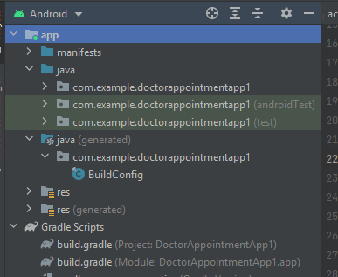

|  |  |
| --- | --- |
| Project-level build.gradle (<project>/build.gradle): | App-level build.gradle (<project>/<app-module>/build.gradle): |
| buildscript {  repositories {  mavenCentral()  google() // Google's Maven repository  }  dependencies {  classpath 'com.google.gms:google-services:4.3.13'  }  }// Top-level build file where you can add configuration options common to all sub-projects/modules.  plugins {  id 'com.android.application' version '7.1.0' apply false  id 'com.android.library' version '7.1.0' apply false  }  allprojects {  repositories {  jcenter()  maven {  url "https://maven.google.com" // Google's Maven repository  }  google()  }  }  //allprojects {  // google() // Google's Maven repository  //}  task clean(type: Delete) {  delete rootProject.buildDir  } | plugins {  id 'com.android.application'  id 'com.google.gms.google-services'  }  android {  compileSdk 32  defaultConfig {  applicationId "com.example.doctorappointmentapp1"  minSdk 21  targetSdk 32  versionCode 1  versionName "1.0"  testInstrumentationRunner "androidx.test.runner.AndroidJUnitRunner"  }  buildTypes {  release {  minifyEnabled false  proguardFiles getDefaultProguardFile('proguard-android-optimize.txt'), 'proguard-rules.pro'  }  }  compileOptions {  sourceCompatibility JavaVersion.VERSION_1_8  targetCompatibility JavaVersion.VERSION_1_8  }  }  dependencies {  implementation 'androidx.appcompat:appcompat:1.4.1'  implementation 'com.google.android.material:material:1.5.0'  implementation 'androidx.constraintlayout:constraintlayout:2.1.3'  implementation platform('com.google.firebase:firebase-bom:30.2.0')  implementation 'com.google.firebase:firebase-analytics:21.0.0'  implementation 'com.google.firebase:firebase-auth:21.0.6'  implementation 'com.google.firebase:firebase-database:20.0.5'  testImplementation 'junit:junit:4.13.2'  androidTestImplementation 'androidx.test.ext:junit:1.1.3'  androidTestImplementation 'androidx.test.espresso:espresso-core:3.4.0'  implementation 'com.firebaseui:firebase-ui-database:8.0.1'  implementation 'com.github.bumptech.glide:glide:4.13.2'  annotationProcessor 'com.github.bumptech.glide:compiler:4.13.2'  } |