**Reflective Journal – TensorFlow Playground**

A neural network is a machine learning model with a topology like the human brain. It is designed to identify patterns and make decisions. Major components include neurons, layers, and activation functions.

1. Neurons: These serve as the building blocks of a neural network, like a human brain. They all work with each other by receiving data, processing it, and then passing it off to others.
2. Layers: This comprises of three parts, input, hidden, and output layer. The input layer is the first layer, and the one that receives the input. The hidden layer is the middle layer responsible for processing data, while the output layer displays the prediction based on the inputs and processed data.
3. 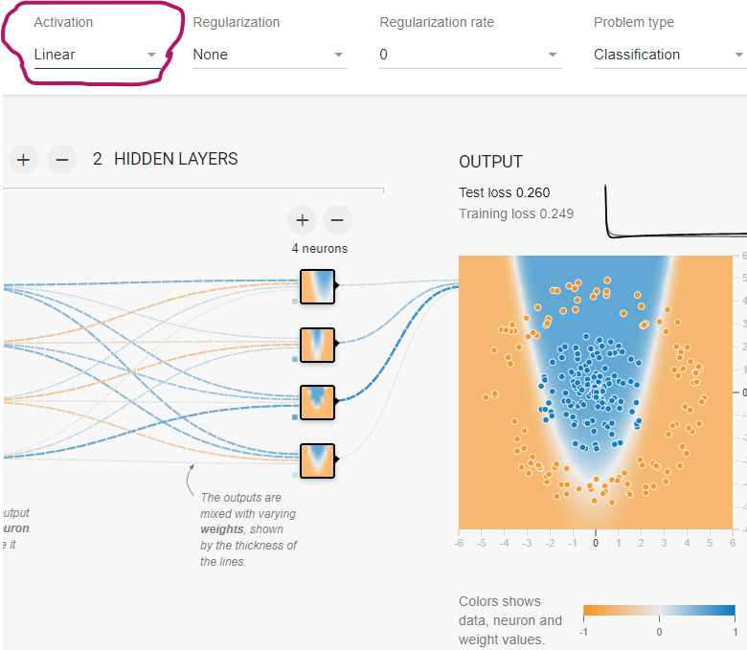Activation functions: These introduce non-linearity to the network, which allows it to learn complex patterns. Common activation functions include Sigmoid, ReLu, and Tanh.

We increased the number of neurons of neurons in the hidden layer and observed that the network performed better as it was able to learn more complex patterns, However, when I added too many neurons I noticed overfitting, where the network learned the training data too well but struggle with new data. So, it shows while more neurons and lyres can improve learning, there is balanced to avoid overfitting and slow training.

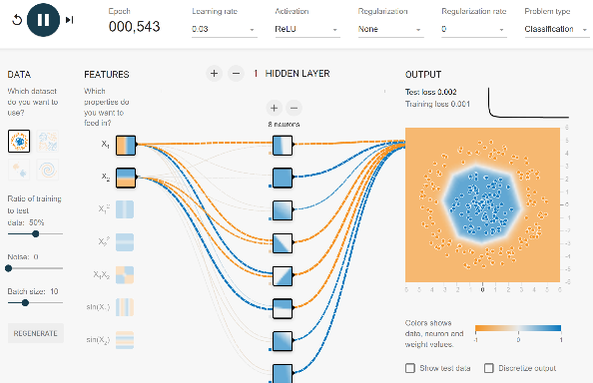 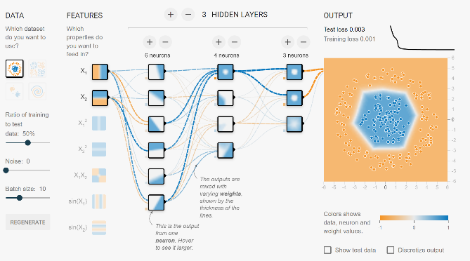

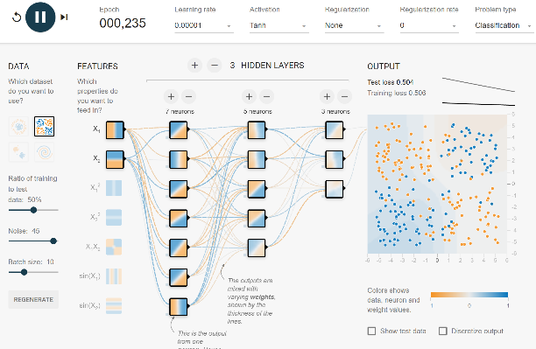

I adjusted the learning rate and observed how it impacted the network’s performance. When I set the learning rate to high the network learned quickly but often jumped to incorrect conclusions, missing the optimal solution. When I lower the learning rate the network, learned more slowly but more accurately over time. This shows that the learning rate is crucial in finding the balance between speed and accuracy in training a neural network.

Parameter changes are crucial for optimizing performance in real-world applications like in Healthcare and Business. In Business Optimization adjusting all these components like learning rates and neuron count indeed enhance models. This improves the decision-making process and resources to determine the wellbeing of the company. In Healthcare medical imaging which incorporates handling data noise and activation functions helps create a more accurate and efficient outcome. This can include an accurate disease detection model which can accelerate the time a patient is informed and provided with a treatment plan, decreasing the rate of mortality. Understanding the significance of these parameters creates a more efficient, reliable, and accurate neural networks narrowed to specific tasks. Design systems are created with more intel to overrule against overfitting, knowing how to handle noisy data, and overall enhance computational efficiency.

We explored the different datasets in the TensorFlow Playground and studied the relationships and behaviors regarding the neural network. The datasets (Spiral, Gaussian, Exclusive, Gaussian,) are all displayed in TensorFlow and used to display different behaviors and outputs from their understanding of the neural networks. We also played with the other activation functions (RELU, Tanh, Sigmoid) to understand how the neural networks worked together and documented the similarities between each. Each dataset is important because they all display different learning capabilities and levels of understanding of the neural network; therefore, knowing when to deploy each is pertinent. The Exclusive dataset highlights nonlinear activation functions. The Gaussian dataset is to show how neural networks handle overlapping class distributions. The XOR dataset is used to display images of circles. As we used the circle dataset, we added hidden layers of neurons that made the output faster and made it easier for the neural network to understand. The spiral dataset displays circular, “spiral,” patterns in the network, which it did.

In conclusion, the activation functions, layers, and neurons and layers serve as the cornerstone of the neural network, and we were able to try our hand in the TensorFlow playground to gain a general understanding of how they all relate.

**Works Cited**

Amelia, Matteson. “Understanding Neural Networks with TensorFlow Playground - DataScienceCentral.com.” *Data Science Central*, 7 Sept. 2017, www.datasciencecentral.com/understanding-neural-networks-with-tensorflow-playground/. Accessed 3 Oct. 2024.

Carter, Daniel Smilkov and Shan. “TensorFlow — Neural Network Playground.” *Playground.tensorflow.org*, playground.tensorflow.org/#activation=linear&batchSize=10&dataset=circle®Dataset=reg-plane&learningRate=0.03®ularizationRate=0&noise=0&networkShape=4.

Key, Jimmy. “Neural Networks in Process Control: Neural Network Architecture, Controls.” *Control Engineering*, 26 Feb. 2016, www.controleng.com/articles/neural-networks-in-process-control-neural-network-architecture-controls/.

Shivanandhan, Manish . “How to Use TensorFlow for Deep Learning – Basics for Beginners.” *FreeCodeCamp.org*, 14 Feb. 2023, [www.freecodecamp.org/news/tensorflow-basics/](http://www.freecodecamp.org/news/tensorflow-basics/).

Siddharth, S. "The Most Commonly Used Activation Functions in TensorFlow v2.11." Medium, 1 Oct. 2024, medium.com/@ssiddharth408/the-most-commonly-used-activation-functions-in-tensorflow-v2-11-2132107a440.