CMPG222 – Practical Assignment 3

Dear students
Please do the following assignments at the end of Chapter 3: 1, 7, 11, 13 and 14. The LOs (learning objectives) addressed by the assignments are indicated as part of the assignment. To complete the tasks, you must study Sections 3.1 to 3.6 in the textbook. Please note that the data files you must use to do the assignments are shown to the left of the work in the book. These files are available on eFundi under the Resources tool. Copy the relevant data to your sheet and use the data to answer the assignment. Submit the answers to these assignments as a single Microsoft Excel document on the eFundi assignment. Create a separate sheet for each of the five questions as follows:
Also, remember to show the sub-sections of each question clearly in each sheet, e.g.:
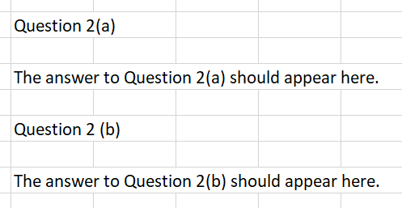
Kind regards
The CMPG222 lecturers

