Networx Radio — Pricing, Profits & User Projections
Internal finance briefing · Updated Aug 2026 pricing (Pro-Radio $4.99/ $1.99 intro · Bundle $12.99)
This document catalogs every paid product in Networx Radio, shows how money splits between the company, creators, and app stores, and projects company income at different monthly active user (MAU) levels. Projections use explicit conversion assumptions — they are planning scenarios, not forecasts of guaranteed revenue.

1. Pricing catalog

1.1 Subscriptions
Product | Price | Intro | Channel | Notes
Pro-Radio | $4.99 / mo | $1.99 first month | iOS · Android · Web | On-demand listening & playlists
Pro-Networx | $9.99 / mo | $4.99 first month | iOS · Android · Web | Creator tools, DMs, contact info
Pro Bundle | $12.99 / mo | — (flat) | iOS · Android · Web | Both Pros — save $1.99 vs $14.98 solo
Refinery submission | $4.99 one-time | — (was $9.99) | iOS · Android · Web | SKU nwx_refinery_submission · Stripe on web

Bundle SKU: nwx_pro_bundle_monthly. Completing a bundle purchase grants both Pro-Radio and Pro-Networx access. Solo SKUs remain available for users who only want one.

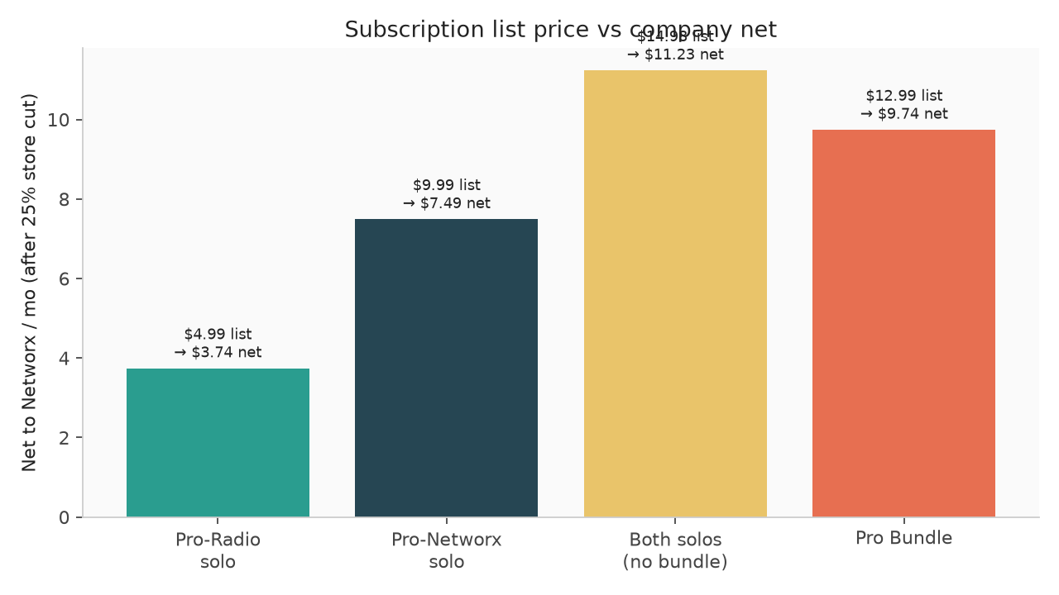
Figure: List price vs Networx net after blended 25% store cut. Bundle ($12.99) undercuts buying both solos ($14.98).

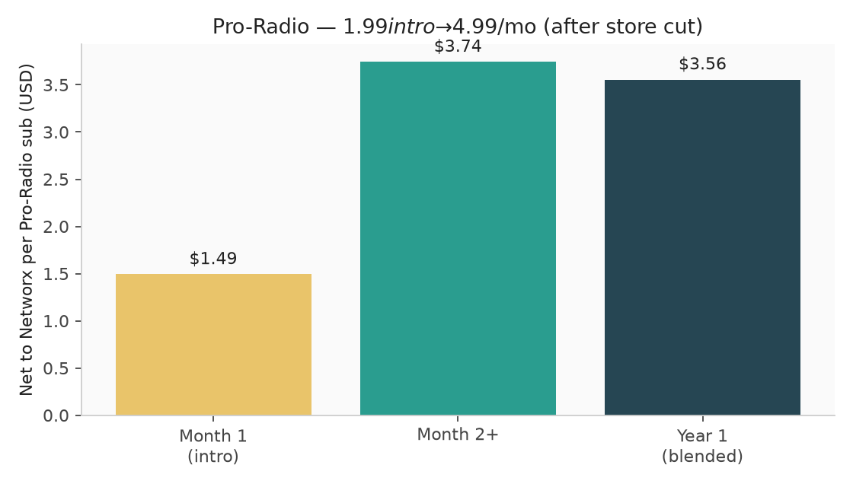
Figure: Pro-Radio intro $1.99 → regular $4.99/mo.

1.2 Song & beat sales (download ladder)
Artists set price at upload from fixed tiers. Default song $0.99 · default beat $9.99. Platform fee: 15% to Networx (SONG_SALE_PLATFORM_FEE_BPS = 1500); 85% to artist.
List price | Artist (85%) | Networx (15%) | IAP SKU
$0.99 | $0.84 | $0.15 | nwx_song_099
$1.99 | $1.69 | $0.30 | nwx_song_199
$2.99 | $2.54 | $0.45 | nwx_song_299
$4.99 | $4.24 | $0.75 | nwx_song_499
$9.99 | $8.49 | $1.50 | nwx_song_999
$19.99 | $16.99 | $3.00 | nwx_song_1999
$29.99 | $25.49 | $4.50 | nwx_song_2999
$49.99 | $42.49 | $7.50 | nwx_song_4999

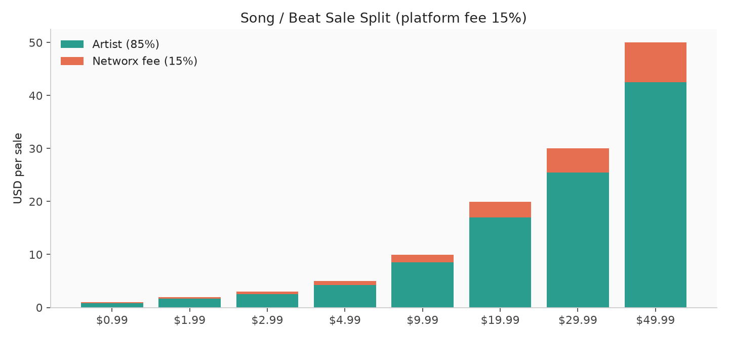

1.3 Discovery placements
Discovery plays are sold at $1.99 each via packs (preferred path). Legacy credit packs remain in catalog for restore/history but are no longer the primary sell.
Pack | Plays | Price | Per play | SKU
1 play | 1 | $1.99 | $1.99 | nwx_song_plays_1
5 plays | 5 | $9.99 | $2.00 | nwx_song_plays_5
10 plays | 10 | $19.99 | $2.00 | nwx_song_plays_10
25 plays | 25 | $49.99 | $2.00 | nwx_song_plays_25
50 plays | 50 | $99.99 | $2.00 | nwx_song_plays_50
100 plays | 100 | $199.99 | $2.00 | nwx_song_plays_100

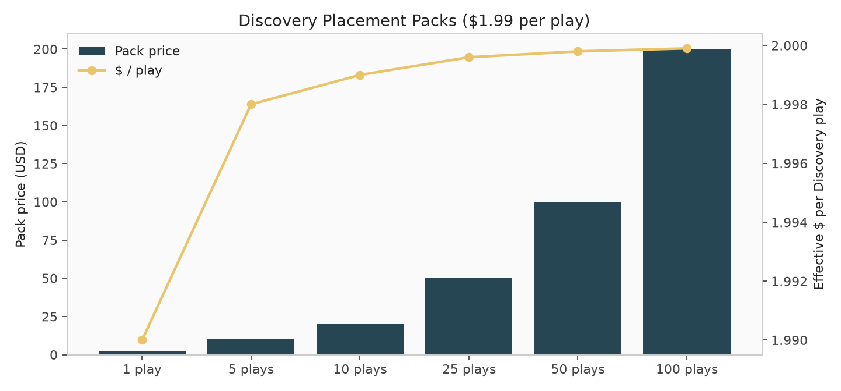

1.4 Livestream tips
Amount | SKU
$1.99 tip | nwx_tip_199
$4.99 tip | nwx_tip_499
$9.99 tip | nwx_tip_999
$24.99 tip | nwx_tip_2499
Tips are primarily creator income. Projection model below assumes Networx retains ~10% of post-store tip proceeds as a placeholder operating fee — adjust when tip payout rules are finalized.

1.5 Legacy credits (reference)
Pack | Credits | Price | SKU
10 credits | 10 | $9.99 | nwx_credits_10
25 credits | 25 | $19.99 | nwx_credits_25
50 credits | 50 | $34.99 | nwx_credits_50
100 credits | 100 | $59.99 | nwx_credits_100

2. How Networx makes money
Company (Networx) net revenue ≈:
- Pro Bundle ($12.99/mo): list price minus store cut — unlocks both Pros
- Pro-Radio solo ($4.99/mo, intro $1.99): after Apple/Google or Stripe fees
- Pro-Networx solo ($9.99/mo, intro $4.99): same
- Discovery placement packs: nearly 100% of post-store proceeds
- Song/beat sales: 15% platform fee on sale price (artist receives 85%)
- Refinery: one-time web purchase after Stripe fees
- Tips: mostly creator; small platform share assumed in projections
App Store note: Apple Small Business Program is 15%; standard is 30%. Subscriptions often drop to 15% after year one. This model uses a blended 25% mobile store cut.

3. Projection assumptions
Assumption | Value | Meaning
Pro Bundle conversion | 2% of MAU | Pay $12.99/mo for both Pros
Pro-Networx solo | 2% of MAU | Networx only at $9.99/mo
Pro-Radio solo | 1.5% of MAU | Radio only at $4.99/mo
Discovery spend | $0.15 / MAU / mo | Average across all users
Song/beat GMV | $0.25 / MAU / mo | Gross before fee split
Platform fee on sales | 15% | Networx share of GMV
Tip spend | $0.05 / MAU / mo | Gross tips
Platform share of tips | 10% of post-store | Placeholder
Refinery spend | $0.02 / MAU / mo | Web AI analysis
Mobile store cut | 25% blended | Between 15% and 30%
Sub prices used | Steady-state regular | Intros ignored in monthly run-rate

4. Monthly company revenue by MAU
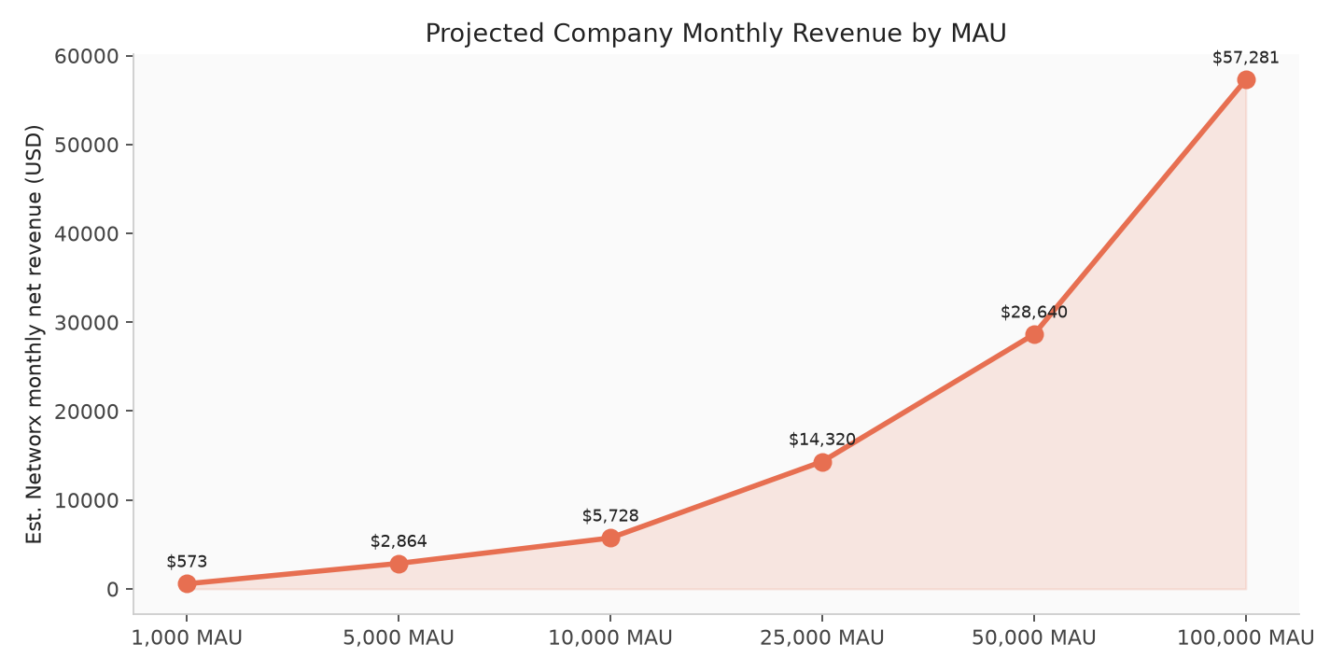

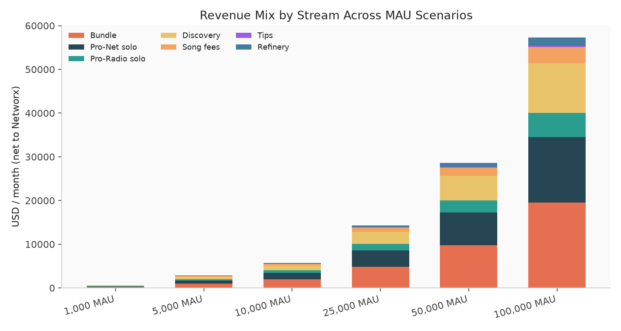
MAU | Bundle | Pro-N | Pro-R | Discovery | Sale fees | Tips | Refinery | Monthly | Annual
1,000 MAU | $195 | $150 | $56 | $112 | $38 | $4 | $18 | $573 | $6,874
5,000 MAU | $974 | $749 | $281 | $562 | $188 | $19 | $91 | $2,864 | $34,368
10,000 MAU | $1,948 | $1,498 | $561 | $1,125 | $375 | $38 | $182 | $5,728 | $68,737
25,000 MAU | $4,871 | $3,746 | $1,403 | $2,812 | $938 | $94 | $455 | $14,320 | $171,842
50,000 MAU | $9,742 | $7,492 | $2,807 | $5,625 | $1,875 | $188 | $911 | $28,640 | $343,683
100,000 MAU | $19,485 | $14,985 | $5,614 | $11,250 | $3,750 | $375 | $1,822 | $57,281 | $687,366

5. Snapshot — 10,000 MAU
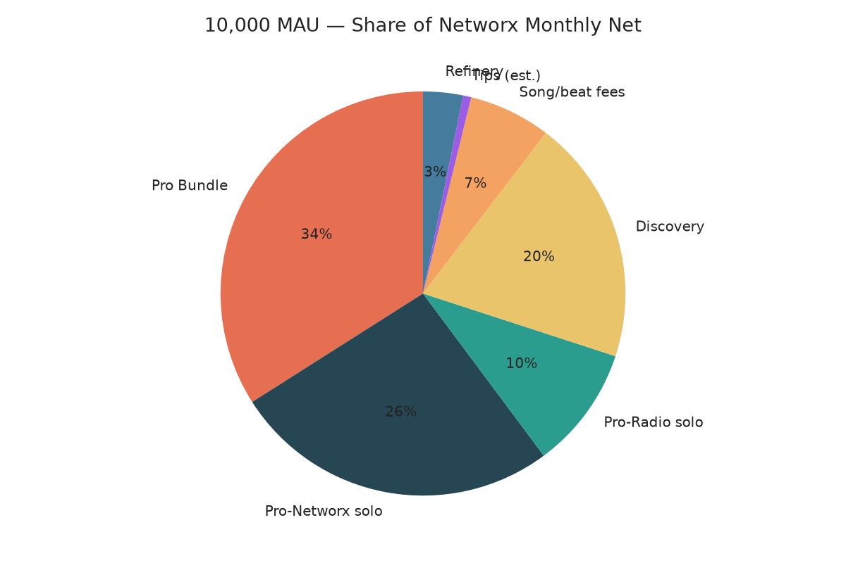
At 10,000 MAU under these assumptions, estimated Networx monthly net is $5,728 (~$68,737 / year). Largest drivers: Discovery placements and Pro Bundle / Pro-Networx.

6. Annual projection curve
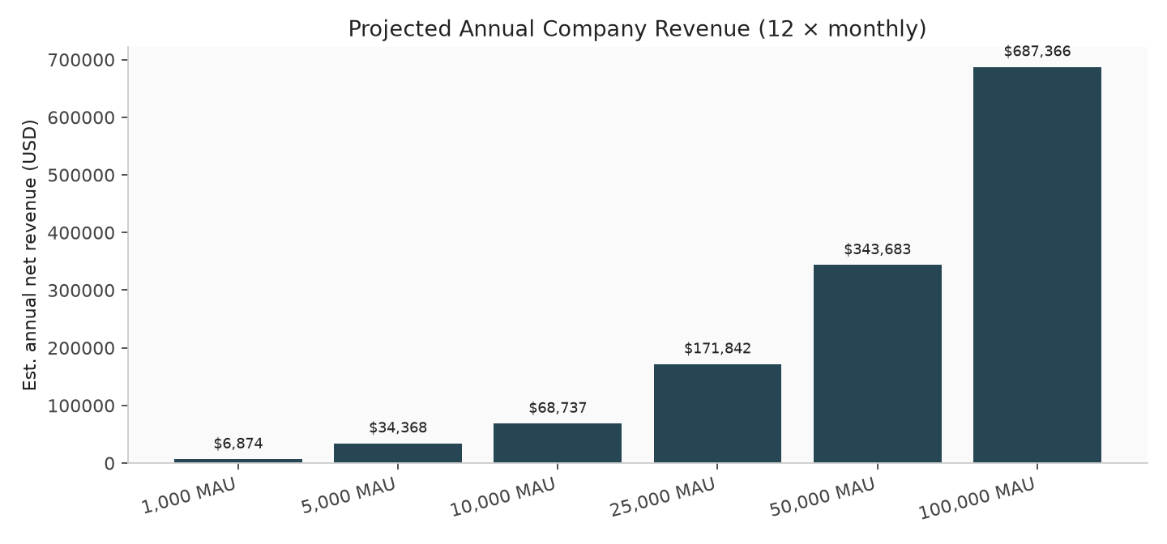

7. Sensitivity — what moves the needle
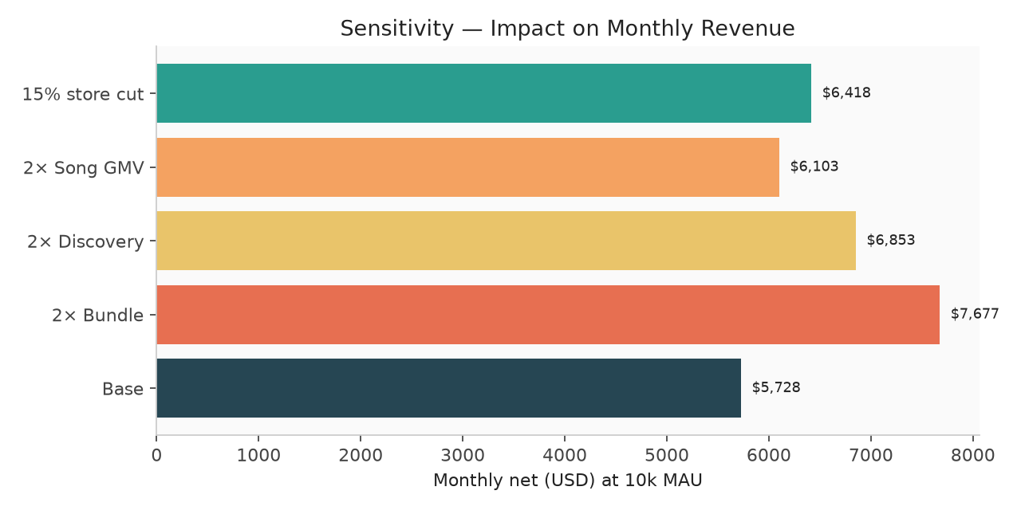

8. Important caveats
- Numbers are illustrative planning scenarios based on conversion rates you can change.
- Does not subtract hosting, CDN, payroll, marketing, refunds, chargebacks, or taxes.
- Pro-Radio intro ($1.99) and Pro-Networx intro ($4.99) lower early-cohort ARPU vs steady-state used here.
- Pro Bundle is flat $12.99/mo with no intro in the current catalog.
- Web Stripe vs mobile IAP mixes will change net take as channel mix shifts.
- Song sale fee is configurable via SONG_SALE_PLATFORM_FEE_BPS (default 1500 = 15%).
- Credit packs are legacy; Discovery packs are the active monetization path for plays.
- Store consoles must list nwx_pro_radio_monthly at $4.99/$1.99 intro and nwx_pro_bundle_monthly at $12.99.
Source: mobile/docs/APP_STORE_IAP.md, backend iap-product-catalog, song-price-tiers, pro-radio / pro-networx / pro-bundle pricing constants, stripe.service getSongSaleFeeBps().
Refinery submission ($4.99) is available in the mobile app via consumable SKU nwx_refinery_submission (App Store / Google Play). Web uses Stripe Checkout. During beta, submissions may be free.

