RETAILSPHERE (PTY) LTD
Data Platform Programme
Physical Database Design
Step 9 Deliverable — DDL Scripts and Physical Design Specifications

Document ID | PDD-001
Version | 1.0 - Draft
Date | 30 July 2026
Author | Thozamile Mbalo – Data Solutions Architect
Reviewed by | Nomvula Mahlangu – Chief Data Officer
Target Platform | Microsoft Fabric Warehouse
Status | Draft – In Progress

Purpose
This document defines the physical database design for the RetailSphere Gold layer data platform hosted on Microsoft Fabric Warehouse. It translates the conceptual dimensional model defined in DM-001 into deployable DDL scripts including CREATE TABLE statements, primary and foreign key constraints, and distribution strategies. PDD-001 serves as the primary technical reference for the engineering team during the Gold layer build phase (Step 15).

Scope
This document covers the physical design of all 9 dimension tables and 7 fact tables defined in DM-001 across 6 business domains, deployed within the gold schema in Microsoft Fabric Warehouse. It includes DDL scripts, constraint definitions, and distribution strategy for each table.
This document does not cover Bronze or Silver layer physical design – those are addressed in DID-001 (Step 10 – Data Integration Design). Pipeline orchestration and deployment automation are addressed in Step 16.

Target Platform
The RetailSphere Gold Layer is hosted on Microsoft Fabric Warehouse, Microsoft’s unified data lake storage layer accessible by all Fabric experiences.
Microsoft Fabric Warehouse was selected for the Gold layer for the following reasons:
- Azure-native alignment: RetailSphere is designed as an Azure-native platform. Fabric is Microsoft’s strategic direction for modern data platforms on Azure, with active investment and roadmap commitment.
- Unified storage via OneLake: All fabric experiences – Warehouse, Lakehouse, Notebooks, Power BI – read from the same OneLake storage. No data movement or distribution is required between the Gold layer and the Power BI reporting layer.
- T-SQL compatibility: Fabric Warehouse uses T-SQL syntax, directly compatible with the team’s existing SQL Server expertise. Temp tables and CTEs are supported.
- Automatic data optimization: Fabric Warehouse applies Delta Lake V-Order optimization automatically at write time. No manual index creation is required, reducing operational overhead.
- Power BI native integration: Power BI connects to Fabric Warehouse natively without a gateway, simplifying the reporting layer deployment in Step 17.
FABRIC WAREHOUSE CONSTRAINTS:
The following SQL Server features are not supported in Fabric Warehouse and have been considered in the DDL design:
- Recursive CTEs – not supported.
- Triggers – not supported.
- Stored procedures with complex DML – limited support.
- Foreign key enforcement – constraints are informational only, not enforced at engine level.

Naming Conventions
All Gold layer objects in Microsoft Fabric Warehouse follow a consistent naming convention to ensure readability, maintainability, and alignment with Kimball dimensional modelling standards.
Schema:
All Gold layer tables are created within the gold schema.
Example: gold.DimProduct, gold.FactSales
Table Names:
Tables use a prefix followed by PascalCase naming.
Dimension tables: Dim prefix
Example: DimDate, DimProduct, DimCustomer
Fact tables: Fact prefix
Example: FactSales, FactInventorySnapshot, FactReplenishment
Column Names
All column names use lowercase
snake_case.
Example: product_key, sales_date_key, unit_price
Primary Key Constraints:
pk_[tablename] in lowercase.
Example: pk_dimproduct, pk_factsales
Foreign Key Constraints:
fk_[facttable]_[dimension] in lowercase.
Example: fk_factsales_product, fk_factsales_customer
Note: Foreign key constraints in Microsoft Fabric Warehouse are informational only. They document relationships for lineage and documentation purposes but are not enforced at the engine level. Data integrity is enforced at the engine level. Data integrity is enforced through dbt tests in the Silver layer transformation pipeline.

Gold Layer DDL Scripts
This section contains the CREATE TABLE DDL scripts for all 16 Gold layer tables deployed in the gold schema in Microsoft Fabric Warehouse. Tables are sequenced – dimensions first, then fact tables. Each script includes primary key and foreign key constraint definitions.
  - Dimension Tables
The following DDL scripts define all 9 dimension tables in the RetailSphere Gold layer.

DimDate
-- ============================================
-- DimDate
-- Pre-populated date dimension
-- No SCD Type 2 required
-- ============================================

CREATE TABLE gold.DimDate (
date_key INT NOT NULL,
date DATE NOT NULL,
ansi_date CHAR(10) NOT NULL,
sql_date DATETIME NOT NULL,
day INT NOT NULL,
day_of_the_week INT NOT NULL,
day_name VARCHAR(9) NOT NULL,
day_of_the_year INT NOT NULL,
week_number INT NOT NULL,
month INT NOT NULL,
month_name VARCHAR(9) NOT NULL,
short_month_name CHAR(3) NOT NULL,
quarter CHAR(2) NOT NULL,
year INT NOT NULL,
fiscal_week INT NULL,
fiscal_period CHAR(4) NULL,
fiscal_quarter CHAR(3) NULL,
fiscal_year CHAR(6) NULL,
week_day TINYINT NOT NULL,
rsa_holiday TINYINT NOT NULL,
short_trading_day TINYINT NOT NULL,
month_end TINYINT NOT NULL,
period_end TINYINT NULL,

CONSTRAINT pk_dimdate
PRIMARY KEY (date_key)
);

    - DimProduct
DimProduct is a conformed dimension implementing SCD Type 2 for price and status changes. Cross-reference columns for SAP, Shopify, and POS are nullable as a product may not exists in all three source systems at initial load. ADR-001 governs the identity resolution strategy for this dimension
-- ============================================
-- DimProduct
-- Conformed dimension — SCD Type 2
-- Sources: SAP ECC, Shopify, Oracle MICROS POS
-- ADR-001: Master Product Identifier Strategy
-- ============================================

CREATE TABLE gold.DimProduct (
product_key INT NOT NULL,
product_code VARCHAR(20) NOT NULL,
name VARCHAR(30) NOT NULL,
description VARCHAR(100) NULL,
product_type VARCHAR(20) NULL,
product_category VARCHAR(30) NULL,
product_subcategory VARCHAR(30) NULL,
unit_price MONEY NOT NULL,
unit_cost MONEY NOT NULL,
status VARCHAR(15) NOT NULL,
sap_stock_code VARCHAR(20) NULL,
shopify_sku VARCHAR(50) NULL,
pos_barcode VARCHAR(20) NULL,
supplier_code VARCHAR(20) NULL,
effective_start_date DATE NOT NULL,
effective_end_date DATE NULL,
is_current BIT NOT NULL,
source_system_code INT NOT NULL,
create_timestamp DATETIME NOT NULL,
update_timestamp DATETIME NOT NULL,

CONSTRAINT pk_dimproduct
PRIMARY KEY (product_key)
);

    - DimCustomer
DimCustomer is the most complex dimension in the platform, implementing SCD Type 2 and sourcing identity data from six systems per ADR-002. The majority of the columns are nullable to accommodate the 66% of in-store transactions that are anonymous. POPIA compliance columns opted_out_status and is_anonymous are NOT NULL with safe default values – ensuring compliance is enforced at the physical layer regardless of data availability.
-- ============================================
-- DimCustomer
-- Conformed dimension — SCD Type 2
-- Sources: Salesforce CRM, Shopify,
-- Oracle MICROS POS, Marketing Cloud,
-- Meta, GA4
-- ADR-002: Unified Customer Identity Resolution
-- ADR-007: Contact Governance and Opt-out
-- ============================================

CREATE TABLE gold.DimCustomer (
customer_key INT NOT NULL,
customer_id VARCHAR(50) NOT NULL,
customer_loyalty_number INT NULL,
first_name VARCHAR(100) NULL,
last_name VARCHAR(100) NULL,
gender CHAR(1) NULL,
email_address VARCHAR(200) NULL,
date_of_birth DATE NULL,
id_number VARCHAR(20) NULL,
address1 VARCHAR(50) NULL,
address2 VARCHAR(50) NULL,
address3 VARCHAR(50) NULL,
address4 VARCHAR(50) NULL,
city VARCHAR(200) NULL,
province VARCHAR(150) NULL,
postal_code VARCHAR(50) NULL,
country VARCHAR(250) NULL,
phone_number VARCHAR(30) NULL,
occupation VARCHAR(100) NULL,
household_income VARCHAR(20) NULL,
date_registered DATETIME NULL,
status VARCHAR(10) NULL,
salesforce_loyalty_id VARCHAR(50) NULL,
shopify_customer_id VARCHAR(50) NULL,
pos_receipt VARCHAR(50) NULL,
mk_cloud_id VARCHAR(50) NULL,
meta_pixel_id VARCHAR(50) NULL,
ga4_client_id VARCHAR(50) NULL,
opted_out_status BIT NOT NULL,
popia_consent_date DATE NULL,
is_anonymous BIT NOT NULL,
customer_segment VARCHAR(50) NULL,
effective_start_date DATE NOT NULL,
effective_end_date DATE NULL,
is_current BIT NOT NULL,
source_system_code INT NOT NULL,
create_timestamp DATETIME NOT NULL,
update_timestamp DATETIME NOT NULL,

CONSTRAINT pk_dimcustomer
PRIMARY KEY (customer_key)
);

    - DimStore:
DimStore describes RetailSphere’s 87 stores nationally. SCD Type 2 is applied to track store manager changes for historical sales performance attribution. Address and configuration field names are nullable as POS field names are assumed pending source system configuration in Step 13.
-- ============================================
-- DimStore
-- Domain-specific dimension — SCD Type 2
-- Source: Oracle MICROS POS
-- SCD Type 2 trigger: Store manager change
-- ============================================

CREATE TABLE gold.DimStore (
store_key INT NOT NULL,
store_id VARCHAR(20) NOT NULL,
store_number INT NOT NULL,
store_name VARCHAR(100) NOT NULL,
store_type VARCHAR(50) NULL,
region VARCHAR(50) NULL,
store_address1 VARCHAR(50) NULL,
store_address2 VARCHAR(50) NULL,
store_address3 VARCHAR(50) NULL,
store_address4 VARCHAR(50) NULL,
city VARCHAR(100) NULL,
province VARCHAR(150) NULL,
postal_code VARCHAR(20) NULL,
phone_number VARCHAR(30) NULL,
store_manager VARCHAR(100) NULL,
store_size_sqm INT NULL,
trading_hours VARCHAR(100) NULL,
is_active BIT NOT NULL,
effective_start_date DATE NOT NULL,
effective_end_date DATE NULL,
is_current BIT NOT NULL,
source_system_code INT NOT NULL,
create_timestamp DATETIME NOT NULL,
update_timestamp DATETIME NOT NULL,

CONSTRAINT pk_dimstore
PRIMARY KEY (store_key)
);

    - DimEmployee
DimEmployee describes RetailSphere employees who process sales transactions, primarily cashiers and store managers. SCD Type 2 is applied with store transfer and promotion as change triggers, enabling historical sales performance attribution to the correct employee role and location at time of sale. Salary data is deliberately excluded from the Gold layer and remains in the OLTP HR source system.
-- ============================================
-- DimEmployee
-- Domain-specific dimension — SCD Type 2
-- Source: Oracle MICROS POS
-- SCD Type 2 triggers: store transfer, promotion
-- Salary excluded — remains in OLTP HR system
-- ============================================

CREATE TABLE gold.DimEmployee (
employee_key INT NOT NULL,
employee_id VARCHAR(20) NOT NULL,
first_name VARCHAR(100) NOT NULL,
last_name VARCHAR(100) NOT NULL,
gender CHAR(1) NULL,
email_address VARCHAR(200) NULL,
phone_number VARCHAR(30) NULL,
date_of_birth DATE NULL,
id_number VARCHAR(20) NULL,
address1 VARCHAR(50) NULL,
address2 VARCHAR(50) NULL,
address3 VARCHAR(50) NULL,
address4 VARCHAR(50) NULL,
city VARCHAR(200) NULL,
province VARCHAR(150) NULL,
postal_code VARCHAR(50) NULL,
country VARCHAR(250) NULL,
employment_type VARCHAR(50) NULL,
title VARCHAR(100) NULL,
manager_id VARCHAR(50) NULL,
store_id VARCHAR(20) NULL,
department_name VARCHAR(150) NULL,
effective_start_date DATE NOT NULL,
effective_end_date DATE NULL,
is_current BIT NOT NULL,
source_system_code INT NOT NULL,
create_timestamp DATETIME NOT NULL,
update_timestamp DATETIME NOT NULL,

CONSTRAINT pk_dimemployee
PRIMARY KEY (employee_key)
);

DimSupplier
DimSupplier describes RetailSphere’s 340 active suppliers and is used across the Inventory, Procurement, and Finance domains. SCD Type 1 is applied – supplier profile changes are overwritten as historical supplier contact details carry no analytical value. Contracted rates, lead times, and payment terms are held in FactSupplierContract rather than this dimension, as the supplier-to-product relationship is many-to-many.
-- ============================================
-- DimSupplier
-- Domain-specific dimension — SCD Type 1
-- Source: SAP ECC (LFA1 Vendor Master)
-- Used by: Inventory, Procurement, Finance
-- Contract terms held in FactSupplierContract
-- ============================================

CREATE TABLE gold.DimSupplier (
supplier_key INT NOT NULL,
supplier_code VARCHAR(20) NOT NULL,
supplier_name VARCHAR(100) NOT NULL,
email_address VARCHAR(200) NULL,
phone_number VARCHAR(30) NULL,
address1 VARCHAR(50) NULL,
address2 VARCHAR(50) NULL,
address3 VARCHAR(50) NULL,
address4 VARCHAR(50) NULL,
city VARCHAR(100) NULL,
province VARCHAR(150) NULL,
postal_code VARCHAR(20) NULL,
region VARCHAR(50) NULL,
country VARCHAR(250) NULL,
contact_person VARCHAR(100) NULL,
status VARCHAR(20) NOT NULL,
supplier_category VARCHAR(50) NULL,
source_system_code INT NOT NULL,
create_timestamp DATETIME NOT NULL,
update_timestamp DATETIME NOT NULL,

CONSTRAINT pk_dimsupplier
PRIMARY KEY (supplier_key)
);

DimCampaign
DimCampaign describes marketing campaigns across RetailSphere’s three marketing platforms. SCD Type 1 is applied as campaign history is not required – a campaign’s attributes are fixed once launched, and date change trigger a new campaign rather than a revision. The status column is system-calculated daily by the Silver layer based on comparison between end_date and current date, rather than being manually maintained in source systems.

-- ============================================
-- DimCampaign
-- Domain-specific dimension — SCD Type 1
-- Sources: Salesforce Marketing Cloud,
-- Meta Business Manager, GA4
-- status is system-calculated daily
-- ============================================

CREATE TABLE gold.DimCampaign (
campaign_key INT NOT NULL,
campaign_id VARCHAR(20) NOT NULL,
campaign_name VARCHAR(100) NOT NULL,
campaign_type VARCHAR(50) NULL,
budget MONEY NULL,
start_date DATE NOT NULL,
end_date DATE NULL,
status VARCHAR(20) NOT NULL,
source_system_code INT NOT NULL,
create_timestamp DATETIME NOT NULL,
update_timestamp DATETIME NOT NULL,

CONSTRAINT pk_dimcampaign
PRIMARY KEY (campaign_key)
);

    - DimChannel
DimChannel is a small reference dimension of approximately seven rows describing RetailSphere’s sales and marketing channels. It is not extracted from any source system – it is manually maintained and loaded once at platform setup, updated only when new channels are introduced. All columns are NOT NULL as the table is manually curated. The channel_type column must align with the attribution channel definitions established in ADR-006.

-- ============================================
-- DimChannel
-- Reference dimension — manually maintained
-- No source system extraction
-- Approximately 7 rows
-- ============================================

CREATE TABLE gold.DimChannel (
channel_key INT NOT NULL,
channel_code VARCHAR(20) NOT NULL,
channel_name VARCHAR(50) NOT NULL,
channel_type VARCHAR(50) NOT NULL,
create_timestamp DATETIME NOT NULL,
update_timestamp DATETIME NOT NULL,

CONSTRAINT pk_dimchannel
PRIMARY KEY (channel_key)
);

    - DimAccount
DimAccount describes RetailSphere’s Chart of Accounts, providing the account type and category hierarchy required for financial statement grouping and subtotaling. SCD Type 2 is applied to preserve historical account classifications – this is an audit requirement, ensuring financial statements can be reproduced exactly as originally reported and signed off even if account classifications are subsequently changed. The account_type and normal_balance columns are NOT NULL as financial statement aggregation logic depends on both.

-- ============================================
-- DimAccount
-- Domain-specific dimension — SCD Type 2
-- Source: SAP ECC Chart of Accounts
-- SCD Type 2 for audit reproducibility
-- ============================================

CREATE TABLE gold.DimAccount (
account_key INT NOT NULL,
account_code VARCHAR(20) NOT NULL,
account_name VARCHAR(100) NOT NULL,
account_type VARCHAR(20) NOT NULL,
account_category VARCHAR(50) NULL,
normal_balance VARCHAR(10) NOT NULL,
is_active BIT NOT NULL,
effective_start_date DATE NOT NULL,
effective_end_date DATE NULL,
is_current BIT NOT NULL,
source_system_code INT NOT NULL,
create_timestamp DATETIME NOT NULL,
update_timestamp DATETIME NOT NULL,

CONSTRAINT pk_dimaccount
PRIMARY KEY (account_key)
);

  - Fact Tables
This section defines the seven fact tables in the RetailSphere Gold Layer. Each fact table declares a surrogate primary key, foreign key constraints to its supporting dimensions, and where applicable a unique constraint on its degenerate dimension columns.
Foreign key and unique constraints in Microsoft Fabric Warehouse are informational only – they are stored as metadata for lineage, documentation, and uniqueness are enforced by dbt tests in the Silver layer transformation pipeline before data is committed to Gold. The constraints defined here document the intended data contract; dbt enforces it.
Foreign key referencing DimCustomer and DimStore permit a value of 0 rather than NULL, where no business entity applies – 0 references a designated ‘unknown’ member row in each dimension. This preserves the integrity of inner joins in the reporting layer, avoiding the silent row loss that NULL foreign keys would cause.

    - FactSales
FactSales is a transaction-grain fact table capturing one row per product line item per transaction. It is the highest-volume table in the platform and serves the Sales domain reporting requirements FR-SAL-001 through FR-SAL-005.
A surrogate primary key sales_key is used rather than a composite of dimension foreign keys, as the dimension combination is not unique – a customer may purchase the same product at the same store on the same day in separate transactions. The degenerate dimension columns order_id and line_number carry the business transaction identity and are declared as a unique constraint to prevent duplicate line loads.
customer_key is set to 0 for the 66% of in-store transactions that are anonymous. store_key is set to 0 for online Shopify orders where no physical store applies.

-- ============================================
-- FactSales
-- Transaction grain — one row per line item
-- Sources: Oracle MICROS POS, Shopify,
-- Salesforce CRM
-- ============================================

CREATE TABLE gold.FactSales (
sales_key BIGINT NOT NULL,
sales_date_key INT NOT NULL,
customer_key INT NOT NULL,
employee_key INT NOT NULL,
channel_key INT NOT NULL,
product_key INT NOT NULL,
store_key INT NOT NULL,
order_id VARCHAR(50) NOT NULL,
line_number INT NOT NULL,
quantity INT NOT NULL,
unit_price MONEY NOT NULL,
unit_cost MONEY NULL,
sales_value MONEY NOT NULL,
sales_cost MONEY NULL,
margin MONEY NULL,
discount_amount MONEY NOT NULL,
discount_pct DECIMAL(5,2) NOT NULL,
sales_timestamp DATETIME NOT NULL,
source_system_code INT NOT NULL,
create_timestamp DATETIME NOT NULL,
update_timestamp DATETIME NOT NULL,

CONSTRAINT pk_factsales
PRIMARY KEY (sales_key),

CONSTRAINT uq_factsales_order_line
UNIQUE (order_id, line_number),

CONSTRAINT fk_factsales_date
FOREIGN KEY (sales_date_key)
REFERENCES gold.DimDate (date_key),

CONSTRAINT fk_factsales_customer
FOREIGN KEY (customer_key)
REFERENCES gold.DimCustomer (customer_key),

CONSTRAINT fk_factsales_employee
FOREIGN KEY (employee_key)
REFERENCES gold.DimEmployee (employee_key),

CONSTRAINT fk_factsales_channel
FOREIGN KEY (channel_key)
REFERENCES gold.DimChannel (channel_key),

CONSTRAINT fk_factsales_product
FOREIGN KEY (product_key)
REFERENCES gold.DimProduct (product_key),

CONSTRAINT fk_factsales_store
FOREIGN KEY (store_key)
REFERENCES gold.DimStore (store_key)
);

    - FactInventorySnapshot

  - Fact

Gold Layer DDL Scripts

Inventory Domain
The inventory domain tracks the stock levels and replenishment across RetailSphere’s 87 stores. Two fact tables serve this domain – FactInventorySnapshot for daily stock level tracking and FactReplenishment for end-to-end replenishment pipeline monitoring. DimSupplier is introduced here as it primarily supports inventory and procurement domains.

FACTINVENTORYSNAPSHOT
FactInventorySnapshot is a periodic snapshot fact table capturing one row per product per store per day. It enables daily stock level monitoring, shrinkage calculation, and inventory value reporting as required by FR-INV-001 to FR-INV-005. Quantity measures are semi-additive and must be averaged – not summed across date ranges in reporting.
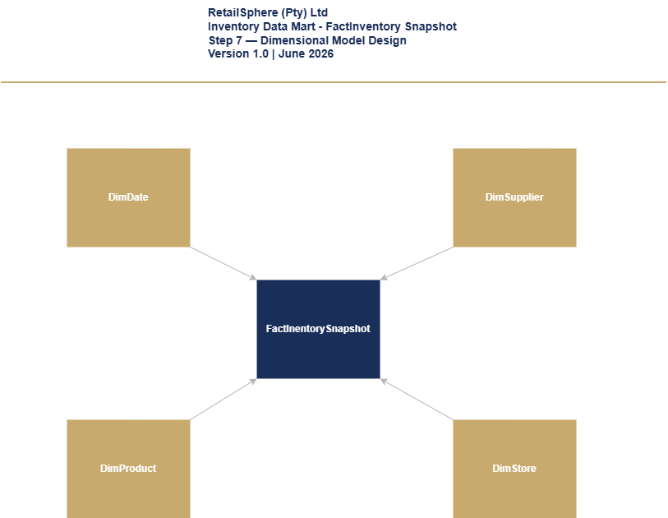

Figure 6.1 - FactInventorySnapshot Start Schema

Table 6.1 FactInventorySnapshot Fact Table
Column Name | Data Type | Description | Sample value
snapshot_date_key | int | FK to DimDate. Date the snapshot was taken. Format YYYYMMDD. | 20260601
product_key | int | FK to DimProduct. Product being tracked. | 200
store_key | int | FK to DimStore. Store holding this stock. | 10
supplier_key | int | FK to DimSupplier. Primary supplier of this product to this store. | 50
quantity_on_hand | int | Current stock quantity physically in the store at snapshot time. Semi-additive — average across dates. | 48
quantity_on_order | int | Stock ordered from supplier but not yet received at store. Semi-additive. | 100
quantity_reserved | int | Stock allocated to online orders not yet dispatched. Semi-additive. | 5
unit_cost | money | Cost price per unit at time of snapshot. Used for inventory value calculation. | 320
total_inventory_value | money | Total value of stock on hand. Calculated: quantity_on_hand x unit_cost. Derived in dbt Gold model. | 15,360
snapshot_timestamp | datetime | Exact date and time the snapshot was captured from SAP and POS systems. | 2026-06-01 23:00:00
source_system_code | int | Key of source system. 1 = SAP ECC. 2 = Oracle MICROS POS. | 1
create_timestamp | datetime | When the record was created in the data platform. | 2026-06-02 0:00:00
update_timestamp | datetime | When the record was last updated in the data platform. | 2026-06-02 0:00:00

FACTREPLENISHMENT
FactReplenishment is an accumulating snapshot fact table capturing one row per replenishment order per store per product. It tracks the full replenishment pipeline from reorder through DC pick, dispatch, and store receipt – enabling pipeline efficiency and supplier lead time analysis.
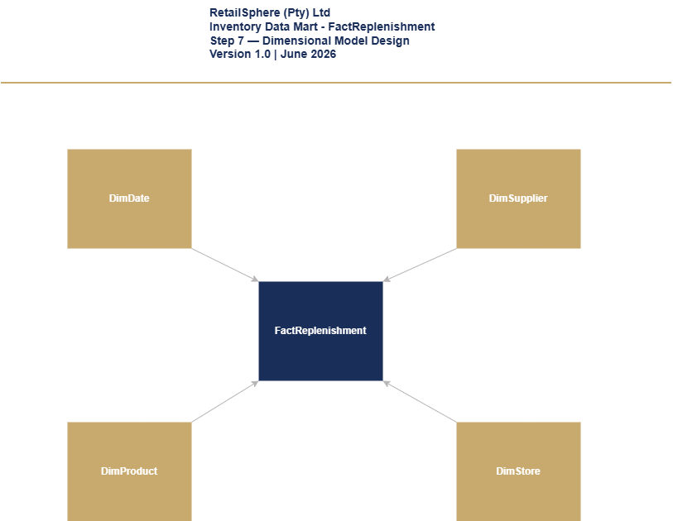

Figure 6.2 – FactReplenishment Start Schema

Table 6.2 FactReplenishment Fact Table
Column Name | Data Type | Description | Sample value
reorder_date_key | int | FK to DimDate. Date the snapshot was taken. Format YYYYMMDD. | 20260601
product_key | int | FK to DimProduct. Product being replenished. | 200
store_key | int | FK to DimStore. Store that needs stock replenishment. | 50
supplier_key | int | FK to DimSupplier. Supplier fulfilling the replenishment order. | 50
order_id | varchar(50) | Replenishment order identifier from SAP. Format RS-REP-[SEQUENCE]. | RS-REP-001001
dc_pick_date | date | Date the Distribution Centre picked the stock. NULL if not yet picked. | 2026-06-03
dispatch_date | date | Date stock left the DC and went in transit to store. NULL if not yet dispatched. | 2026-06-04
store_receipt_date | date | Date stock arrived at store and GRN was captured in SAP. NULL if not yet received. | 2026-06-07
days_to_pick | int | Days from reorder to DC pick. Calculated: dc_pick_date minus reorder_date. NULL until DC pick complete. | 2
days_to_dispatch | int | Days from reorder to dispatch. Calculated: dispatch_date minus reorder_date. NULL until dispatch complete. | 3
days_to_receipt | int | Days from reorder to store receipt. Calculated: store_receipt_date minus reorder_date. NULL until received. | 6
total_days_pipeline | int | Total days from reorder to store receipt. Calculated: store_receipt_date minus reorder_date. NULL until complete. | 6
quantity | int | Quantity of units ordered for replenishment. | 200
order_status | varchar(20) | Current pipeline stage. Pending, Picked, In Transit, Received, Cancelled. Derived from populated date columns. | Received
source_system_code | int | Key of source system. SAP ECC replenishment orders. | 1
create_timestamp | datetime | When the record was created in the data platform. | 2026-06-01 0:00:00
update_timestamp | datetime | When the record was last updated. Updates at each pipeline stage completion. | 2026-06-08 0:00:00

DIMSUPPLIER
DimSupplier describes RetailSphere’s 340 active suppliers. It is used across the Inventory, Procurement, and Finance domains. No SCD Type 2 is applied – supplier profile changes are overwritten using SCD Type 1.
Table 6.3 DimSupplier Dimension Table
Column Name | Data Type | Description | Sample Value
supplier_key | int | Surrogate key of the supplier dimension. Unique, not null, primary key. | 50
supplier_code | varchar(20) | Natural key. Format RS-SUP-[SEQUENCE]. Assigned by RetailSphere. Never changes. | RS-SUP-001
supplier_name | varchar(100) | Full registered trading name of the supplier. | Cape Cotton Manufacturers (Pty) Ltd
email_address | varchar(200) | Primary supplier contact email address. | orders@capecotton.co.za
phone_number | varchar(30) | Supplier contact number including area code. | (+27) 21 555 7890
address1 | varchar(50) | First line of supplier address. | Unit 5
address2 | varchar(50) | Second line of supplier address. | Montague Gardens Industrial Park
address3 | varchar(50) | Third line of supplier address. | Montague Drive
address4 | varchar(50) | Fourth line of supplier address. Optional
city | varchar(100) | City where the supplier is located | Cape Town
province | varchar(150) | Province where the supplier is located. | Western Cape
postal_code | varchar(20) | Postal code of the supplier. | 7441
region | varchar(50) | RetailSphere trading region of the supplier. | Cape Metro
country | varchar(250) | Country where the supplier is registered. | South Africa
contact_person | varchar(150) | Primary account manager or contact at the supplier. | Thandi Eksteen
status | varchar(20) | Current supplier relationship status. Active — trading normally. Suspended — temporarily on hold. Blacklisted — no longer used. | Active
supplier_category | varchar(50) | Category of goods supplied. Clothing, Homeware, Electronics, Logistics, Packaging. | Clothing
create_timestamp | datetime | When the record was created in the data platform. | 2020-01-01 0:00:00
update_timestamp | datetime | When the record was last updated in the data platform. | 2024-06-01 0:00:00

Procurement Domain
The Procurement domain tracks RetailSphere’s supplier purchasing process from purchase order through to invoice payment. Two fact tables serve this domain – FactProcurement for end-to-end PO lifecycle tracking and FactSupplierContract for contracted rates and terms extracted from 340 active supplier contracts via ADR-003.

FACTPROCUREMENT
FactProcurement is an accumulating snapshot fact table capturing one row per purchase order line item per supplier. It tracks the full procurement pipeline from PO raised through GRN receipt, invoice matching, and payment – enabling supplier on-time delivery, invoice accuracy, price variance, and days payable outstanding analysis as required by FR-PRO-001 to FR-PRO-005.
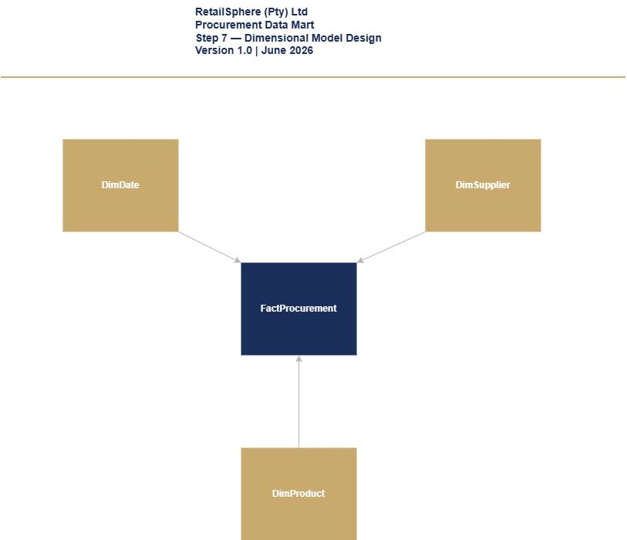

Figure 7.1 – FactProcurement Star Schema Diagram

Table 7.1 – FactProcurement Fact Table
Column Name | Data Type | Description | Sample value
po_date_key | int | FK to DimDate. Date the purchase order was raised. Format YYYYMMDD. | 20260601
product_key | int | FK to DimProduct. Product being procured. | 200
supplier_key | int | FK to DimSupplier. Supplier fulfilling the purchase order. | 50
purchase_order_id | varchar(50) | Purchase order identifier from SAP. Format RS-PO-[SEQUENCE]. | RS-PO-001001
grn_received_date | date | Date goods were received at DC or store. GRN captured in SAP. NULL if not yet received. | 2026-06-05
invoice_received_date | date | Date supplier invoice was received. NULL if not yet received. | 2026-06-06
invoice_matched_date | date | Date invoice was matched against PO and GRN (3-way match). NULL if not yet matched. | 2026-06-07
invoice_paid_date | date | Date invoice was paid to supplier. NULL if not yet paid. | 2026-06-14
delivery_date | date | Contracted delivery date from supplier contract. Used for on-time delivery calculation FR-PRO-001. | 2026-06-05
days_to_delivery | int | Days from PO date to GRN received. NULL until GRN complete. | 4
days_to_invoice | int | Days from GRN to invoice received. NULL until invoice received. | 1
days_to_match | int | Days from invoice received to 3-way match complete. NULL until matched. | 1
days_to_payment | int | Days from invoice matched to payment made. NULL until paid. | 7
quantity | int | Quantity of units ordered on this PO line item. | 500
unit_cost | money | Actual cost paid per unit. Sourced from SAP invoice. | 330
contracted_rate | money | Contracted price per unit from supplier contract PDF. ADR-003 dependency. | 320
price_variance | money | Variance between actual and contracted rate. Calculated: unit_cost minus contracted_rate. Derived in dbt Gold. | 10
price_variance_pct | decimal(5,2) | Price variance as percentage of contracted rate. Calculated: price_variance / contracted_rate x 100. | 3.13
total_order_value | money | Total value of this PO line item. Calculated: quantity x unit_cost. | 165,000
total_days_pipeline | int | Total days from PO raised to invoice paid. NULL until payment complete. | 13
po_status | varchar(20) | Current procurement stage. Ordered, Delivered, Invoiced, Matched, Paid, Disputed. Derived from populated date columns. | Paid
source_system_code | int | Key of source system. SAP ECC procurement records. | 1
create_timestamp | datetime | When the record was created in the data platform. | 2026-06-01 0:00:00
update_timestamp | datetime | When the record was last updated. Updates at each procurement stage completion. | 2026-06-15 0:00:00

FACTSUPPLIERCONTRACT
FactSupplierContract resolves the many-to-many relationship between suppliers and products. One row per supplier per product per contract captures contracted rates, lead times, and payment terms extracted from PDF contracts via ADR-003. This table is the source of contracted_rate used in FR-PRO-003 price variance calculation in FactProcurement.
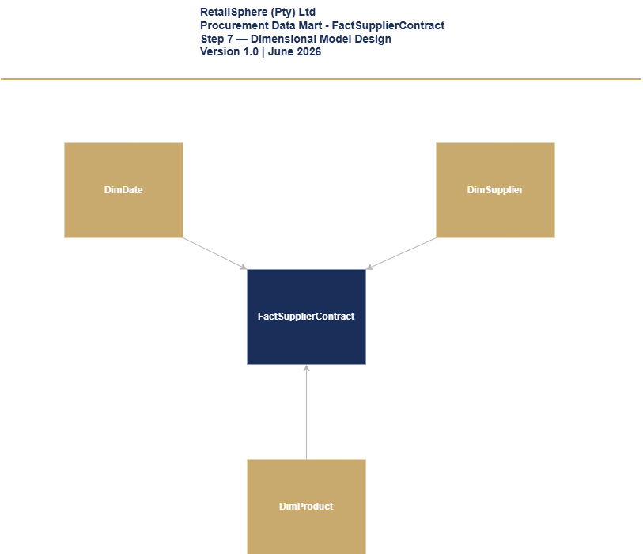

Figure 7.2 – FactSupplierContract Start Schema Diagram

Table 7.2 FactSupplierContract Fact Table
Column Name | Data Type | Description | Sample value
contract_start_date_key | int | FK to DimDate. Date this contract became effective. Format YYYYMMDD. Primary date dimension link. | 20260601
supplier_key | int | FK to DimSupplier. Supplier party to this contract. | 50
product_key | int | FK to DimProduct. Product covered by this contract. | 200
contract_id | varchar(50) | Unique contract identifier. Format RS-CON-[SEQUENCE]. Extracted from supplier contract PDF via ADR-003. | RS-CON-001001
contract_end_date | date | Date this contract expires. NULL if open-ended contract. | 2026-12-31
quantity | int | Minimum order quantity agreed in this contract. | 500
contracted_rate | money | Agreed price per unit for this product under this contract. Extracted from PDF via ADR-003. Used in FR-PRO-003 price variance calculation. | 320
lead_time | int | Agreed number of days from purchase order to delivery. Extracted from PDF via ADR-003. | 7
payment_terms | varchar(20) | Agreed payment terms. 30 days, 60 days, 90 days. Extracted from PDF via ADR-003. | 30 days
source_system_code | int | Key of source system. ADR-003 PDF extraction pipeline. | 9
create_timestamp | datetime | When the record was created in the data platform. | 2026-01-01 0:00:00
update_timestamp | datetime | When the record was last updated in the data platform. | 2026-01-01 0:00:00

CRM AND MARKETING
The CRM and Marketing domain tracks all customer communications and campaign activity across RetailSphere’s marketing channels. FactContactHistory serves both the CRM and Marketing domains, capturing every contact attempt per customer per campaign per channel. This table enforces POPIA compliance through the 4-contact monthly cap and opt-out suppression logic governed by ADR-007.

FACTCONTACTHISTORY
FactContactHistory is an accumulating snapshot fact table capturing one row per customer per campaign per channel per contact attempt. It tracks the full communication lifecycle from sent through to delivery, opened, clicked, bounced, and unsubscribed. Suppressed contact attempts are also recorded with a suppression reason – enabling Priya’s team to audit POPIA compliance and Rethabile’s team to measure campaign attribution as required by FR-CUS-001, FR-CUS-002, and ADR-006.
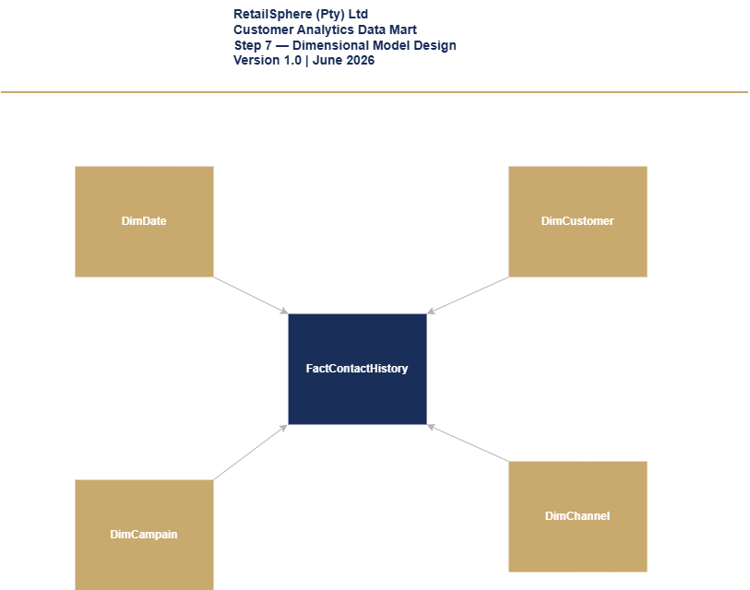
Figure 8.1 – FactContactHistory Star Schema

Table 8.1 FactContactHistory
Column Name | Data Type | Description | Sample value
contact_attempt_date_key | int | FK to DimDate. Date this contact attempt occurred or was attempted. Format YYYYMMDD. | 20260601
customer_key | int | FK to DimCustomer. Member who was contacted. | 100
campaign_key | int | FK to DimCampaign. Campaign that triggered this contact. | 200
channel_key | int | FK to DimChannel. Channel used for this contact. Email, SMS, Push, Social. | 3
response_status | varchar(20) | Furthest stage reached for this contact attempt as of last update. Sent, Delivered, Opened, Clicked, Bounced, Unsubscribed, Suppressed. | Opened
suppression_reason | varchar(30) | reason this contact was blocked before sending. NULL if not suppressed. Opt-out, Monthly cap reached. | NULL
was_suppressed | bit | 1 if this contact attempt was blocked before sending. 0 if it was sent. | 0
sent_date | date | Date the message was sent. NULL if suppressed or not yet sent. | 2026-06-01
delivered_date | date | Date the message was confirmed delivered. NULL if not yet known. | 2026-06-01
opened_date | date | Date the customer opened the message. NULL if not opened. | 2026-06-01
clicked_date | date | Date the customer clicked a link in the message. NULL if not clicked. | NULL
bounced_date | date | Date the message bounced (failed delivery). NULL if not bounced. | NULL
unsubscribed_date | date | Date the customer unsubscribed as a result of this message. NULL if not applicable. | NULL
source_system_code | int | Key of source system. 1 = Marketing Cloud. 2 = Meta. 3 = GA4. | 1
create_timestamp | datetime | When the record was created in the data platform. | 2026-06-01 0:00:00
update_timestamp | datetime | When the record was last updated. Updates daily as new status data lands from source extract. | 2026-06-02 0:00:00

DIMCAMPAIGN
DimCampaign describes all marketing campaigns across RetailSphere’s three marketing platforms – Salesforce Marketing Cloud, Meta Business Manager, Google Analytics 4. Campaign status is a system-calculated field updated daily by the Silver layer based on end_date comparison. SCD Type 1 is applied – campaign history is not required.
Table 8.2 DimCampaign Dimension Table
Column Name | Data Type | Description | Sample Value
campaign_key | int | Surrogate key of the campaign dimension. Unique, not null, primary key. | 200
campaign_id | varchar(20) | Natural key. Format RS-CAM-[SEQUENCE]. Assigned by RetailSphere. Never changes. | RS-CAM-001
campaign_name | varchar(100) | Full name of the marketing campaign. | Winter Warmers 2026
campaign_type | varchar(50) | Type of campaign channel. Email, SMS, Social Media, Display, Push Notification. | Email
budget | money | Total budget allocated to this campaign in ZAR. | R250,000.00
start_date | date | Date the campaign started sending. | 2026-06-01
end_date | date | Date the campaign ended. NULL if still active. | 2026-06-30
status | varchar(20) | Current campaign status. Planned, Active, Paused, Completed, Cancelled. | Active
source_system_code | int | Key of the source system where this campaign originated. Marketing Cloud, Meta, or GA4. | 1
create_timestamp | date | When the record was created in the data platform. | 2026-06-01 0:00:00
update_timestamp | date | When the record was last updated in the data platform. | 2026-06-01 0:00:00

DIMCHANNEL
DimChannel is a conformed dimension used on both the Sales and CRM and Marketing domains. Full column design is documented in Section 5.4.

FINANCE DOMAIN
The Finance domain tracks all General Ledger transactions for RetailSphere’s financial reporting and audit requirements. FactFinance captures individual GL journal line items enabling Johan’s team to produce month-end close packs, detect backdated postings within 1 hour per FR-FIN-005, and support external auditor requirements. DimAccount introduces the Chart of Accounts hierarchy as a domain-specific dimension.

FACTFINANCE
FactFinance is a transaction fact table capturing one row per GL journal line item posted in SAP. Two-role playing date dimensions are used – posted_date_key for the date the entry was posted and transaction_date_key for the actual business transaction date. Comparison of these two dates enables automated backdated posting detection and alerting as required by FR-FIN-005.
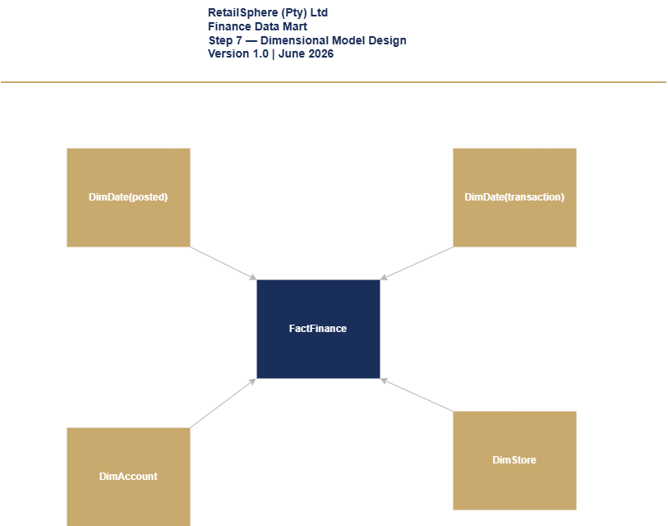
Figure 9.1 – FactFinance Star Schema

Table 9.1 FactFinance Fact Table
Column Name | Data Type | Description | Sample value
posted_date_key | int | FK to DimDate. Date this journal line was posted to the GL in SAP. | 20260601
transaction_date_key | int | FK to DimDate. Actual date the underlying business transaction occurred. Compared to posted_date_key to detect backdated postings. | 20260528
account_key | int | FK to DimAccount. The GL account this line debits or credits. | 300
store_key | int | FK to DimStore. Store this transaction relates to. 0 for head office/non-store transactions. | 10
journal_entry_id | varchar(50) | Groups the debit and credit lines belonging to one journal entry. Format RS-JE-[SEQUENCE]. | RS-JE-005001
line_number | int | Line number within the journal entry. Starts at 1. | 1
debit_amount | money | Amount if this line is a debit. 0 if this line is a credit. | 1100
credit_amount | money | Amount if this line is a credit. 0 if this line is a debit. | 0
is_backdated | bit | 1 if transaction_date falls within a period that was already closed when posted. Triggers FR-FIN-005 alert within 1 hour. | 0
fiscal_period_key | int | FK to DimDate fiscal_period column. The accounting period this transaction belongs to. | FP6
source_system_code | int | Key of source system. SAP ECC General Ledger. | 1
create_timestamp | datetime | When the record was created in the data platform. | 2026-06-01 0:00:00
update_timestamp | datetime | When the record was last updated in the data platform. | 2026-06-01 0:00:00

DIMACCOUNT
DimAccount describes RetailSphere’s Chart of Accounts – the complete list of GL accounts used in financial reporting. It provides a two-level hierarchy of account type and account category enabling financial statement grouping and subtotaling. SCD Type 2 is applied to preserve historical account classifications for audit reproducibility – ensuring that financial statements can be reproduced exactly as originally reported even if account classifications change in future.
Table 9.2 DimAccount Dimension Table
Column Name | Data Type | Description | Sample Value
account_key | int | Surrogate key of the account dimension. Unique, not null, primary key. | 300
account_code | varchar(20) | Natural key. SAP General Ledger account number. Never changes once assigned. | 4000100
account_name | varchar(100) | Specific name of the GL account as it appears on financial statements. | Clothing Sales Revenue
account_type | varchar(20) | Top-level financial statement classification. Asset, Liability, Equity, Revenue, Expense. | Revenue
account_category | varchar(50) | Grouping within account type. Used for financial statement subtotals. | Sales Revenue
normal_balance | varchar(10) | Whether an increase in this account is normally recorded as a Debit or Credit. | Credit
is_active | bit | 1 if account is currently in use. 0 if account has been retired/closed. | 1
effective_start_date | date | SCD Type 2 start date. Date from which this version of the account classification is valid. Defaults to 01-01-1900. | 2020-01-01
effective_end_date | date | SCD Type 2 end date. NULL means currently active. Defaults to 31-12-2999. | 2999-12-31
is_current | bit | 1 if this is the current active version of the account record. 0 if expired. | 1
source_system_code | int | Key of source system. SAP ECC Chart of Accounts. | 1
create_timestamp | datetime | When the record was created in the data platform. | 2020-01-01 0:00:00
update_timestamp | datetime | When the record was last updated in the data platform. | 2020-01-01 0:00:00

Data Mart Summary
This section summarizes the complete dimensional model for the RetailSphere Gold Layer data platform across all six business domains.
Domain | Fact Tables | Dimensions Used
Sales | FactSales | DimDate, DimCustomer, DimProduct, DimStore, DimEmployee, DimChannel
Inventory | FactInventory  FactReplenishment | DimDate, DimProduct, DimStore, DimSupplier
Procurement | FactProcurement  FactSupplierContract | DimDate, DimProduct, DimSupplier
CRM/Mktg | FactContactHistory | DimDate, DimCustomer, DimCampaign, DimChannel
Finance | FactFinance | DimDate, DimStore, DimAccount

Fact Tables: 7
Dimensions: 9
Total Tables: 16

Next Steps
The completion of DM-001 marks the end of Step 7 – Dimensional Model Design. The following steps are required to progress the RetailSphere data platform build:
Step 8 – Source to Target Mapping (STM-001): Map every source system column identified in SSI-001 to its corresponding Gold Layer dimension or fact table column defined in this document.
Step 9 – Physical Database Design (PDD-001): Translate the conceptual dimensional model defined in DM-001 into physical DDL scripts including CREATE TABLE statements, indexes, constraints, and partitioning strategies for Azure Synapse Analytics.
Step 10 – Data Integration Design (DID-001): Design the ADF pipeline architecture for Bronze, Silver, and Gold layer ingestion and transformation, including error handling, retry logic, and monitoring.
Outstanding items requiring resolution before build can begin:
- ADR-002: POPIA legal review and Priya Naidoo sign-off.
- ADR-003: Sipho Dlamini sign-off on PDF extraction approach.
- ADR-006: Rethabile Sithole sign-off on attribution model.
- ADR-007: Priya Naidoo sign-off on contact governance.

Document Change Log

Version | Date | Author | Description
1.0 | 25 June 2026 | Thozamile Mbalo | Initial draft. 9 dimension tables and 7 fact tables designed across 6 business domains. DimAccount and FactSupplierContract discovered during design process and added to scope. Star schema diagrams produced in draw.io.

— End of Document —

