RETAILSPHERE (PTY) LTD
Data Platform Programme
Dimensional Modelling Design
Step 7 Deliverable — Dimensional Model Design

Document ID | DM-001
Version | 1.1
Date | 23 August 2026
Author | Thozamile Mbalo – Data Solutions Architect
Reviewed by | Nomvula Mahlangu – Chief Data Officer
Total Tables | 7-fact tables and 9-dimension tables
Status | Complete

Purpose
This document defines the dimensional modelling design of all fact and dimension tables for the RetailSphere Gold layer data platform. These tables were derived from all functional requirements stated in FRD-001 covering all business domains within the organisation. The dimensional model follows the Kimball methodology — star schema design with conformed dimensions shared across multiple data marts to ensure consistency and enable cross-domain analysis.

Scope
This document covers the conceptual design of all fact and dimension tables, covering 9 dimension tables and 7 fact tables across 6 business domains. It includes star schema diagrams and full column detail — column names, data types, descriptions, and sample values for each table.
This document does not cover physical database design — DDL scripts, indexes, constraints, and partitioning strategies are addressed in PDD-001 (Step 9 — Physical Database Design).

Dimensional Modelling Approach
The dimensional modelling approach used is the Kimball start schema – one central fact table surrounded by one level of dimension tables.
Three fact table types were implemented across the seven fact tables:
- Transaction fact tables (FactSales, FactFinance).
- Periodic snapshot fact tables (FactInventorySnapshot)
- Accumulating snapshot fact tables (FactReplenishment, FactProcurement, FactContactHistory)
FactSupplierContract does not cleanly fit any of the three types above – see section 7.2 note.
Both conformed dimensions (shared across multiple data marts) and domain-specific dimensions were used. Conformed dimensions include DimDate, DimProduct, and DimCustomer.
Two Slowly Changing Dimension strategies were applied:
- SCD Type 2 (history preserved): DimProduct, DimCustomer, DimStore, DimEmployee, DimAccount.
- SCD Type 1 (overwrite, no history): DimCampaign.

Conformed Dimensions
Conformed dimensions are dimension tables that are shared across different data marts. RetailSphere's conformed dimensions include DimDate, DimProduct and DimCustomer.
  - DimDate
DimDate is a conformed dimension shared across all 7 fact tables in the RetailSphere data platform. It provides a comprehensive set of date attributes supporting calendar and fiscal period analysis. DimDate is pre-populated programmatically and does not require SCD Type 2 as dates do not change.

Table 4.1 DimDate Dimension Table
Column Name | Data Type | Description | Sample value
date_key (PK) | int | The surrogate key of data dimension. This is the primary key of the date dimension. It is unique and not null. | 2024
date | char(10) | Full date in mm/dd/yyyy format | 06/09/2024
ansi_date | char(10) | Full date in yyyy-mm-dd format. | 2024-06-09
sql_date | datetime | Full date in SQL Server datetime data type | 09/06/2024 0:00:00
day | int | The day of the month | 9
day_of_the_week | int | The day of the week; 1 for Monday, 7 for Sunday | 2
day_name | varchar(9) | The name of the day in a week | Tuesday
day_of_the_year | int | The number of elapsed days since January 1, aka Julian date | 48
week_number | int | The number of elapsed weeks since January 1, weeks start on Monday | 7
month | int | The number of the month | 2
month_name | varchar(9) | The full name of the month in English | February
short_month_name | char(3) | The short name of the month in English | Feb
quater | char(2) | Three-month period in calendar year, Qn format | Q1
year | int | The calendar year of the date | 2008
fiscal_week | int | The number of elapsed weeks since September 1. | 27
fiscal_period | char(4) | A period consists of four or five weeks depending on the fiscal calendar. Usually, the pattern used in this company is 454, 544, or 445. in FPn format. A fiscal year always consists of 12 periods. | FP9
fiscal_quarter | char (3) | A fiscal quarter is three fiscal periods, from September 1, FQn format | FQ2
fiscal_year | char (6) | Fiscal year begins on September 1, in FYnnnn format | FY2008
week_day | tinyint | 1 if it is Monday to Friday; 0 otherwise | 0
rsa_holiday | tinyint | 1 if SA public holiday 0 otherwise | 0
month_end | tinyint | 1 if it is the last day in the month; 0 otherwise | 0
period_end | tinyint | 1 if it is last day in a fiscal period; 0 otherwise | 0
short_tradingday | tinyint | 1 if on that day the offline stores' opening hours are shorter than normal opening hours; 0 otherwise. This is applicable only for offline stores | 0

  - DimProduct
DimProduct is a conformed dimension shared across FactSales, FactInventorySnapshot, FactProcurement, and FactSupplierContract. It defines the full product hierarchy – type, category, and subcategory and includes cross-reference codes for all three source systems (SAP, Shopify, and Oracle MICROS POS) as resolved by ADR-001. SCD Type 2 is applied to preserve historical product pricing for accurate historical margin reporting.

Table 4.2 DimProduct Dimension Table
Column Name | Data Type | Description | Sample Value
product_key | int | The surrogate key of the product dimension. It is unique it is not null, and is the primary key of product dimension | 100
product_code | varchar(20) | Natural key. follows this format RS-[CATEGORY]-[SEQUENCE] for example: RS-CLT-00001 (clothing item 1), RS-HMW-00001 (homeware item 1), and RS-ELC-00001 (electronics item 1) Assigned by RetailSphere. Owned by Sipho's team. Never changes. All three source systems map to it. | RS-CLT-00001
name | varchar(30) | Product name | Classic Cotton Tee
description | varchar(100) | Product description | Unisex cotton t-shirt available in 6 colours and 5 sizes.
product_type | varchar(20) | Level 1 of the product hierarchy, such as clothing, electronics, homeware | Clothing
product_category | varchar(30) | Level 2 of the product hierarchy. Groups products within a type. For clothing: Tops, Bottoms, Footwear, Accessories. For homeware:  Bedding, Kitchen, Bathroom. For electronics: Audio, Computing, Gaming. | Tops
product_subcategory | varchar(30) | Level 3 of the product hierarchy. Most granular product grouping. For Tops: T-shirts, Shirts, Hoodies, Jackets. For Bottoms: Jeans, Shorts, Trousers, Leggings. Used by Zanele for shrinkage reporting by subcategory — FR-INV-003. | T-shirts
unit_price | money | Price for one Item | 500.00
unit_cost | money | Allocated direct and indirect costs | 320.00
status | varchar(15) | Upcoming if we have signed contract with the supplier, Active if it is still being offered to the customer, and Expired if it is no longer being offered. | Active
sap_stock_code | varchar(20) | Product code as stored in SAP ECC material master. Part od ADR-001 cross-reference mapping. | MAT-001-BLK-L
shopify_sku | varchar(50) | Product SKU as stored in Shopify Plus product catalogue. Part of ADR-001 cross-reference mapping. | RS-TEE-BLK-L
pos_barcode | varchar(20) | EAN/UPC barcode scanned at Oracle MICROS POS checkout. Primary matching key for ADR-001 identity resolution. | 4501234567890
supplier_code | varchar(20) | Links product to supplier in DimSupplier. Used for procurement price variance calculation FR-PRO-003. | SUP-001
effective_start_date | date | Date from which this version of the product record is valid. Populated when record is created or updated. | 2024-01-01
effective_end_date | date | Date on which this version expired. NULL means currently active record. | NULL (current) or 2026-06-07
is_current | BIT | 1 if this is the current active version of the product record. 0 if expired. | 1
source_system_code | int | The key of the source system where this record was coming from. | 2
create_timestamp | datetime | When the record was created in DDS | 2024-01-01 0:00:00
update_timestamp | datetime | When the record was last updated. | 2024-01-01 00:00:00

  - DimCustomer
DimCustomer is a conformed dimension shared across FactSales, FactContactHistory, and FactFinance. It covers RetailSphere's 2.1 million loyalty members as well as anonymous in-store customers. Identity resolution across six source systems is governed by ADR-002, with a tiered matching hierarchy applied in the Silver layer. SCD Type 2 is applied to track customer segment changes over time. POPIA compliance fields including opt_out_status and popia_consent_date are embedded directly in this dimension.

Table 4.3 DimCustomer Dimension Table
Column Name | Data Type | Description | Sample Value
customer_key | int | The surrogate key of the customer dimension. It is unique it is not null, and is the primary key of customer dimension | 100
customer_id | varchar(50) | Natural key. follows this format RS-CUST-[SEQUENCE]. Assigned by RetailSphere. Owned by Priya's team. Never changes. All three source systems map to it. | RS-CUST-0000001
customer_loyalty_number | int | The loyalty member number for the 2.1 million loyal members. 0 for non-loyal members | 1245
first_name | varchar(100) | Customer's first name | John
last_name | varchar(100) | Customer's last name | Smith
gender | char(1) | M for Male; F for Female | M
email_address | varchar(200) | Customer's e-mail address. | john.smith@gmail.com
date_of_birth | date | Customer's date of birth | 18-04-1973
id_number | varchar(20) | Customer's ID Number | 73041895709081
address1 | varchar(50) | First line of address | 20
address2 | varchar(50) | Second line of address | Piet Retief St
address3 | varchar(50) | Third line of address | Wellington
address4 | varchar(50) | Fourth line of address
city | varchar(200) | Village, town, or city of the customer's residence. | Wellington
province | varchar(150) | The province of the customer's residence | Western Cape
postal_code | varchar(50) | Postal code | 7654
country | varchar(250) | Country | South Africa
phone_number | varchar(30) | Telephone number including area code | (+27) 74 701 8535
occupation | varchar(100) | Customer's job/profession TBC with Priya if we need these | DBA
household_income | varchar(20) | Rang of household income in ZAR - TBC with Priya if we need these | 50-60k
date_registered | datetime | The date when the customer first purchased or became a loyalty member | 01-05-2024
status | varchar(10) | Active is the customer is currently a loyalty member or made a purchase in the last 12 months | Active
effective_start_date | date | For SCD type 2, when the data in the row becomes effective; this defaults to 01-01-1900 | 01-01-1900
effective_end_date | date | For SCD type 2, when the data in the row is no longer valid; this defaults to 31-12-2999. | 31-12-2999
is_current | BIT | For SCD type 2, 1 if this is the current record; 0 otherwise | 1
salesforce_loyalty_id | varchar(50) | customer identification from Salesforce | TBC
shopify_customer_id | varchar(50) | customer identification from Shopify | TBC
pos_receipt | varchar(50) | customer identification from POS | TBC
mk_cloud_id | varchar(50) | customer identification from Marketing Cloud | TBC
meta_pixel_id | varchar(50) | customer identification from Meta | TBC
ga4_client_id | varchar(50) | customer identification from Google Analytics 4 | TBC
opted_out_status | BIT | 1 if customer has opted out of all marketing; 0 if still opted in | 0
popia_consent_date | date | Date customer gave consent for data processing. Required for POPIA compliance. | 2024-01-01
is_anonymous | BIT | 1 if the customer is an anonymous in-store transaction with no identity signal available. 0 if identity is known. | 0
customer_segment | varchar(50) | One of four segments from FR-SAL-003: Anonymous in-store, Online only, Loyalty only, Full cross-channel. SCD Type 2 tracks segment changes. | Full cross-channel
create_timestamp | datetime | When the record was created in DDS. | 01-05-2024
update_timestamp | datetime | When the record was updated. | 01-05-2024

SALES DOMAIN
The Sales domain covers all customer purchase transactions across RetailSphere’s three channels – In-store POS, online Shopify, and mobile. The primary fact table is FactSales, supported by DimStore, DimEmployee, and DimChannel as domain-specific dimensions. Conformed dimensions DimDate, DimProduct, and DimCustomer are shared with other data marts.
  - FactSales
FactSales is a transaction fact table capturing one row per product line item per transaction. It is the most granular sales record in the platform, enabling customer lifetime value, channel performance, margin analysis, and discount effectiveness reporting as required by FR-SAL-001 to FR-SAL-005.
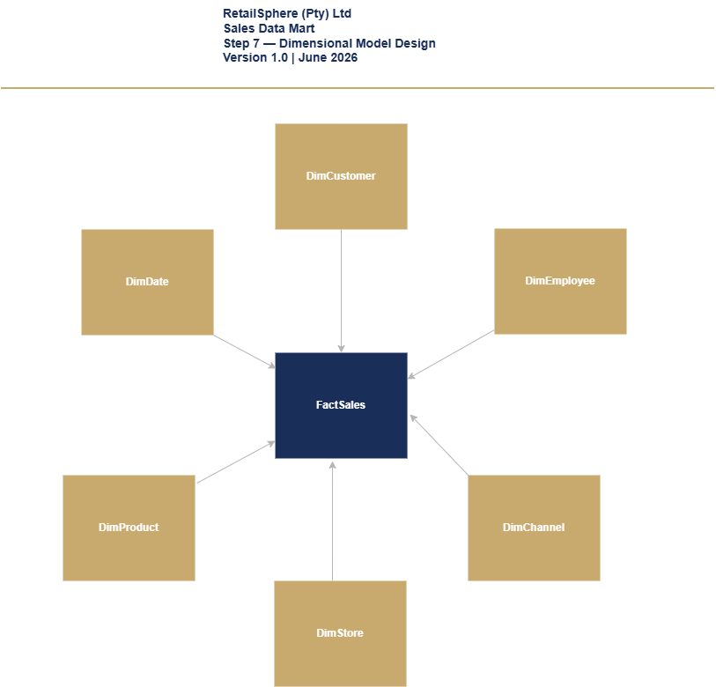
Figure 5.1 – FactSales Star Schema

Table 5.1 FactSales Fact Table
Column Name | Data Type | Description | Sample value
sales_date_key | int | FK to DimDate. Date the transaction occurred. Format YYYYMMDD. | 20260601
customer_key | int | FK to DimCustomer. 0 for anonymous in-store transactions. | 100
employee_key | int | FK to DimEmployee. Cashier who processed the transaction. 0 for online orders. | 101
channel_key | int | FK to DimChannel. Sales channel — In-store POS or Online Shopify. | 1
product_key | int | FK to DimProduct. Current version of product at time of sale. | 200
store_key | int | FK to DimStore. Store where transaction occurred. 0 for online orders. | 10
order_id | varchar(50) | Transaction or order identifier from source system. | POS-2026-001001
line_number | int | Line-item number within the transaction. Starts at 1. | 1
quantity | int | Number of units sold on this line item. | 2
unit_price | money | Selling price per unit at time of sale. Snapshot — not affected by future price changes. | 550
unit_cost | money | Cost price per unit at time of sale. Used for margin calculation. | 320
sales_value | money | Total line-item revenue. Calculated: quantity x unit_price. | 1100
sales_cost | money | Total line-item cost. Calculated: quantity x unit_cost. | 640
margin | money | Gross margin on this line item. Calculated: sales_value - sales_cost. Derived in dbt Gold model. | 460
discount_amount | money | Rand value of discount applied to this line item. 0 if no discount. | 110
discount_pct | decimal(5,2) | Percentage discount applied to this line item. 0.00 if no discount. | 20
sales_timestamp | datetime | Exact date and time the transaction was processed at the till or online checkout. | 2026-06-01 10:35:22
source_system_code | int | Key of the source system. 1 = Oracle MICROS POS. 2 = Shopify Plus. | 1
create_timestamp | datetime | When the record was created in the data platform. | 2026-06-01 0:00:00
update_timestamp | datetime | When the record was last updated in the data platform. | 2026-06-01 0:00:00

  - DimStore
DimStore describes RetailSphere’s 87 stores nationally. It supports store-level performance analysis across sales, inventory, and finance domains. SCD Type 2 is applied to track store manager changes for historical performance attribution.
Table 5.2 DimStore Dimension Table
Column Name | Data Type | Description | Sample Value
store_key | int | Surrogate key of the store dimension. Unique, not null, primary key | 10
store_id | varchar(20) | Natural key. follows this format RS-STR-[SEQUENCE]. Assigned by RetailSphere. Never changes | RS-STR-001
store_number | int | Internal store number used by operations team. | 87
store_name | varchar(100) | Full trading name of the store | Canal Walk
store_type | varchar(50) | Type of store format. Full format, express, or outlet. | Full Format
region | varchar(50) | RetailSphere trading region. May differ from provincial boundary. | Cape Metro
store_address1 | varchar(50) | First line of stored address. | Shop 214
store_address2 | varchar(50) | Second line of stored address. | Canal Walk Shopping Centre
store_address3 | varchar(50) | Third line of stored address. | Century City
store_address4 | varchar(50) | Fourth line of stored address. Optional.
city | varchar(100) | City where the store is located. | Cape Town
province | varchar(150) | Province where the store is located | Western Cape
postal_code | varchar(20) | Postal code of the store | 7441
phone_number | varchar(30) | Store contact number including area code. | (+27) 21 555 1234
store_manager | varchar(100) | Full name of the current store manager SCD Type 2 tracks manager changes for performance analysis. | Thabo Nkosi
store_size_sqm | int | Floor size of the store in square meters. Used for stock capacity planning. | 850
trading_hours | varchar(100) | Normal store operating hours. Links to DimDate short_trading_day column. | Mon-Sat 09h00-21h00, Sun 10h00-17h00
is_active | bit | 1 if store is currently trading. 0 if closed or under renovations | 1
effective_start_date | date | SCD Type 2 start date. Date from which this version of the store record is valid. Defaults to 01-01-1900 | 2020-03-01
effective_end_date | date | SCD Type 2 end date. NULL means currently active. Defaults to 31-12-2999 | 2999-12-31
is_current | bit | 1 if this is the current active version of the store record. 0 if expired | 1
source_system_code | int | Key of the source system where this record originated. | 1
create_timestamp | datetime | When the record was created in the data platform. | 2020-03-01 0:00:00
update_timestamp | datetime | When the record was last updated in the data platform. | 2020-03-01 0:00:00

DimEmployee
DimEmployee describes all RetailSphere’s employees who interact with the data platform – primarily in-store sales staff and cashiers. SCD Type 2 is applied to track store transfers and promotions. Salary data is excluded from this dimension and remains in the OLTP source system.
Table 5.3 DimEmployee Dimension Table
Column Name | Data Type | Description | Sample Value
employee_key | int | Surrogate key of the employee dimension. Unique, not null, primary key | 101
employee_id | varchar(20) | Natural key. follows this format RS-EMP-[SEQUENCE]. Assigned by RetailSphere. Never changes | RS-EMP-101
first_name | varchar(100) | Employee's first name | Siphokazi
last_name | varchar(100) | Employee's last name | Booi
gender | char(1) | M for Male; F for Female | F
email_address | varchar(200) | Employee's email address | siphokazi.booi@retailshpere.co.za
phone_number | varchar(30) | Employee's contact number including are code | (+27) 72 704 1952
date_of_birth | date | Employee's date of birth | 01-08-1997
id_number | varchar(20) | Employee's id number | 9708015709080
address1 | varchar(50) | First line of employee's address | 11
address2 | varchar(50) | Second line of employee's address | Thyme Str
address3 | varchar(50) | Third line of employee's address | Bardale Village
address4 | varchar(50) | Fourth line of employee's address | Kuilsriver
city | varchar(200) | Village, town, or city of the employee's residence. | Cape Town
province | varchar(150) | The province of the employee's residence | Western Cape
postal_code | varchar(50) | Postal code | 7884
country | varchar(250) | Country | South Africa
employment_type | varchar(50) | Current Employee's title (in-store: full-time, casual/part-time) | full-time
title | varchar(100) | Current Employee's role (Store Manager, Cashier, Sales Rep, Team Leader) | Cashier
manager_id | varchar(50) | RS-EMP-[SEQUENCE] - Manager's employee number | RS-EMP-005
store_id | varchar(20) | Store ID where the employee works. Links to the DimStore dimension. | RS-STR-001
department_name | varchar(150) | The department where the employee belongs | Sales
source_system_code | int | Key of the source system where this record originated. | 2
effective_start_date | date | SCD Type 2 start date. Date from which this version of the employee record is valid. Defaults to 01-01-1900 | 2020-03-01
effective_end_date | date | SCD Type 2 end date. NULL means currently active. Defaults to 31-12-2999 | 2999-12-31
is_current | bit | 1 if this is the current active version of the employee record. 0 if expired | 1
create_timestamp | datetime | When the record was created in the data platform. | 3/1/2020 0:00:00
update_timestamp | datetime | When the record was last updated in the data platform. | 3/1/2020 0:00:00

DimChannel
DimChannel is a small reference dimension describing RetailSphere’s sales and marketing channels. It is used in both the Sales and CRM and Marketing domains.
Table 5.4 DimChannel Dimension Table
Column Name | Data Type | Description | Sample Value
channel_key | int | Surrogate key of the channel dimension. Unique, not null, primary key. | 1
channel_code | varchar(20) | Natural key. Format RS-CHN-[SEQUENCE]. Assigned by RetailSphere. Never changes. | RS-CHN-001
channel_name | varchar(50) | Full name of the sales or marketing channel. | In-store POS
channel_type | varchar(50) | Category of channel. Sales: In-store, Online, Mobile. Marketing: Email, Social, Display, SMS. Attribution channels must align with ADR-006. | Sales
create_timestamp | datetime | When the record was created in the data platform. | 2026-01-01 0:00:00
update_timestamp | datetime | When the record was last updated in the data platform. | 2026-01-01 0:00:00

Inventory Domain
The inventory domain tracks the stock levels and replenishment across RetailSphere’s 87 stores. Two fact tables serve this domain – FactInventorySnapshot for daily stock level tracking and FactReplenishment for end-to-end replenishment pipeline monitoring. DimSupplier is introduced here as it primarily supports inventory and procurement domains.

FACTINVENTORYSNAPSHOT
FactInventorySnapshot is a periodic snapshot fact table capturing one row per product per store per day. It enables daily stock level monitoring, shrinkage calculation, and inventory value reporting as required by FR-INV-001 to FR-INV-005. Quantity measures are semi-additive and must be averaged – not summed across date ranges in reporting.
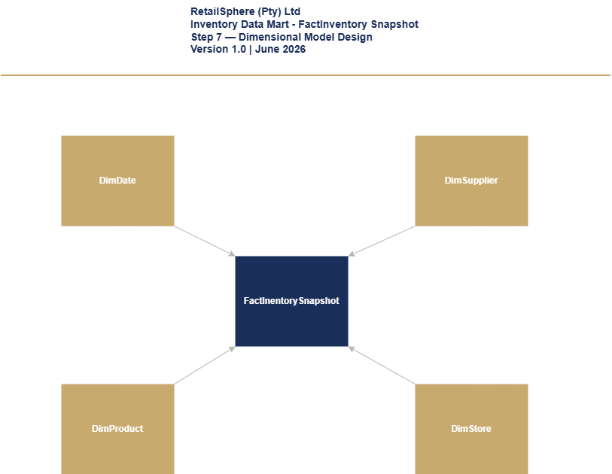

Figure 6.1 - FactInventorySnapshot Start Schema

Table 6.1 FactInventorySnapshot Fact Table
Column Name | Data Type | Description | Sample value
snapshot_date_key | int | FK to DimDate. Date the snapshot was taken. Format YYYYMMDD. | 20260601
product_key | int | FK to DimProduct. Product being tracked. | 200
store_key | int | FK to DimStore. Store holding this stock. | 10
supplier_key | int | FK to DimSupplier. Primary supplier of this product to this store. | 50
quantity_on_hand | int | Current stock quantity physically in the store at snapshot time. Semi-additive — average across dates. | 48
quantity_on_order | int | Stock ordered from supplier but not yet received at store. Semi-additive. | 100
quantity_reserved | int | Stock allocated to online orders not yet dispatched. Semi-additive. | 5
unit_cost | money | Cost price per unit at time of snapshot. Used for inventory value calculation. | 320
total_inventory_value | money | Total value of stock on hand. Calculated: quantity_on_hand x unit_cost. Derived in dbt Gold model. | 15,360
snapshot_timestamp | datetime | Exact date and time the snapshot was captured from SAP and POS systems. | 2026-06-01 23:00:00
source_system_code | int | Key of source system. 1 = SAP ECC. 2 = Oracle MICROS POS. | 1
create_timestamp | datetime | When the record was created in the data platform. | 2026-06-02 0:00:00
update_timestamp | datetime | When the record was last updated in the data platform. | 2026-06-02 0:00:00

FACTREPLENISHMENT
FactReplenishment is an accumulating snapshot fact table capturing one row per replenishment order per store per product. It tracks the full replenishment pipeline from reorder through DC pick, dispatch, and store receipt – enabling pipeline efficiency and supplier lead time analysis.
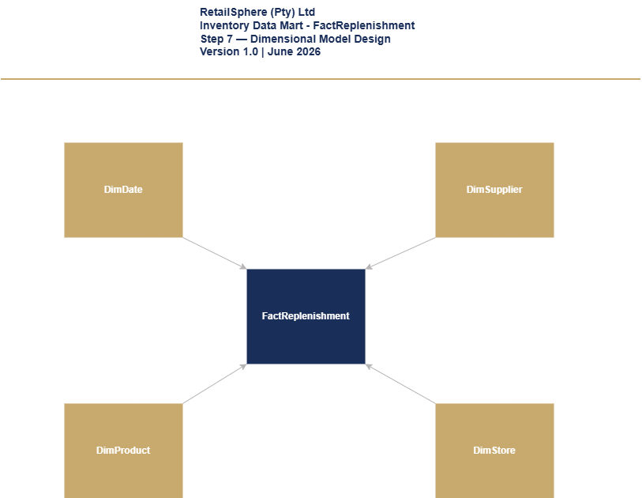

Figure 6.2 – FactReplenishment Start Schema

Table 6.2 FactReplenishment Fact Table
Column Name | Data Type | Description | Sample value
reorder_date_key | int | FK to DimDate. Date the snapshot was taken. Format YYYYMMDD. | 20260601
product_key | int | FK to DimProduct. Product being replenished. | 200
store_key | int | FK to DimStore. Store that needs stock replenishment. | 50
supplier_key | int | FK to DimSupplier. Supplier fulfilling the replenishment order. | 50
order_id | varchar(50) | Replenishment order identifier from SAP. Format RS-REP-[SEQUENCE]. | RS-REP-001001
dc_pick_date | date | Date the Distribution Centre picked the stock. NULL if not yet picked. | 2026-06-03
dispatch_date | date | Date stock left the DC and went in transit to store. NULL if not yet dispatched. | 2026-06-04
store_receipt_date | date | Date stock arrived at store and GRN was captured in SAP. NULL if not yet received. | 2026-06-07
days_to_pick | int | Days from reorder to DC pick. Calculated: dc_pick_date minus reorder_date. NULL until DC pick complete. | 2
days_to_dispatch | int | Days from reorder to dispatch. Calculated: dispatch_date minus reorder_date. NULL until dispatch complete. | 3
days_to_receipt | int | Days from reorder to store receipt. Calculated: store_receipt_date minus reorder_date. NULL until received. | 6
total_days_pipeline | int | Total days from reorder to store receipt. Calculated: store_receipt_date minus reorder_date. NULL until complete. | 6
quantity | int | Quantity of units ordered for replenishment. | 200
order_status | varchar(20) | Current pipeline stage. Pending, Picked, In Transit, Received, Cancelled. Derived from populated date columns. | Received
source_system_code | int | Key of source system. SAP ECC replenishment orders. | 1
create_timestamp | datetime | When the record was created in the data platform. | 2026-06-01 0:00:00
update_timestamp | datetime | When the record was last updated. Updates at each pipeline stage completion. | 2026-06-08 0:00:00

DIMSUPPLIER
DimSupplier describes RetailSphere’s 340 active suppliers. It is used across the Inventory, Procurement, and Finance domains. No SCD Type 2 is applied – supplier profile changes are overwritten using SCD Type 1.
Table 6.3 DimSupplier Dimension Table
Column Name | Data Type | Description | Sample Value
supplier_key | int | Surrogate key of the supplier dimension. Unique, not null, primary key. | 50
supplier_code | varchar(20) | Natural key. Format RS-SUP-[SEQUENCE]. Assigned by RetailSphere. Never changes. | RS-SUP-001
supplier_name | varchar(100) | Full registered trading name of the supplier. | Cape Cotton Manufacturers (Pty) Ltd
email_address | varchar(200) | Primary supplier contact email address. | orders@capecotton.co.za
phone_number | varchar(30) | Supplier contact number including area code. | (+27) 21 555 7890
address1 | varchar(50) | First line of supplier address. | Unit 5
address2 | varchar(50) | Second line of supplier address. | Montague Gardens Industrial Park
address3 | varchar(50) | Third line of supplier address. | Montague Drive
address4 | varchar(50) | Fourth line of supplier address. Optional
city | varchar(100) | City where the supplier is located | Cape Town
province | varchar(150) | Province where the supplier is located. | Western Cape
postal_code | varchar(20) | Postal code of the supplier. | 7441
region | varchar(50) | RetailSphere trading region of the supplier. | Cape Metro
country | varchar(250) | Country where the supplier is registered. | South Africa
contact_person | varchar(150) | Primary account manager or contact at the supplier. | Thandi Eksteen
status | varchar(20) | Current supplier relationship status. Active — trading normally. Suspended — temporarily on hold. Blacklisted — no longer used. | Active
supplier_category | varchar(50) | Category of goods supplied. Clothing, Homeware, Electronics, Logistics, Packaging. | Clothing
create_timestamp | datetime | When the record was created in the data platform. | 2020-01-01 0:00:00
update_timestamp | datetime | When the record was last updated in the data platform. | 2024-06-01 0:00:00

Procurement Domain
The Procurement domain tracks RetailSphere’s supplier purchasing process from purchase order through to invoice payment. Two fact tables serve this domain – FactProcurement for end-to-end PO lifecycle tracking and FactSupplierContract for contracted rates and terms extracted from 340 active supplier contracts via ADR-003.

FACTPROCUREMENT
FactProcurement is an accumulating snapshot fact table capturing one row per purchase order line item per supplier. It tracks the full procurement pipeline from PO raised through GRN receipt, invoice matching, and payment – enabling supplier on-time delivery, invoice accuracy, price variance, and days payable outstanding analysis as required by FR-PRO-001 to FR-PRO-005.
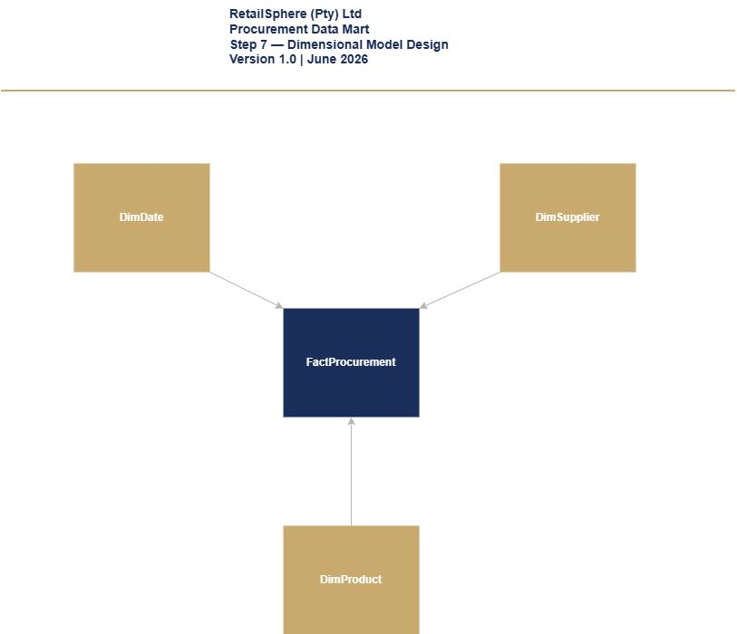

Figure 7.1 – FactProcurement Star Schema Diagram

Table 7.1 – FactProcurement Fact Table
Column Name | Data Type | Description | Sample value
po_date_key | int | FK to DimDate. Date the purchase order was raised. Format YYYYMMDD. | 20260601
product_key | int | FK to DimProduct. Product being procured. | 200
supplier_key | int | FK to DimSupplier. Supplier fulfilling the purchase order. | 50
purchase_order_id | varchar(50) | Purchase order identifier from SAP. Format RS-PO-[SEQUENCE]. | RS-PO-001001
grn_received_date | date | Date goods were received at DC or store. GRN captured in SAP. NULL if not yet received. | 2026-06-05
invoice_received_date | date | Date supplier invoice was received. NULL if not yet received. | 2026-06-06
invoice_matched_date | date | Date invoice was matched against PO and GRN (3-way match). NULL if not yet matched. | 2026-06-07
invoice_paid_date | date | Date invoice was paid to supplier. NULL if not yet paid. | 2026-06-14
delivery_date | date | Contracted delivery date from supplier contract. Used for on-time delivery calculation FR-PRO-001. | 2026-06-05
days_to_delivery | int | Days from PO date to GRN received. NULL until GRN complete. | 4
days_to_invoice | int | Days from GRN to invoice received. NULL until invoice received. | 1
days_to_match | int | Days from invoice received to 3-way match complete. NULL until matched. | 1
days_to_payment | int | Days from invoice matched to payment made. NULL until paid. | 7
quantity | int | Quantity of units ordered on this PO line item. | 500
unit_cost | money | Actual cost paid per unit. Sourced from SAP invoice. | 330
contracted_rate | money | Contracted price per unit from supplier contract PDF. ADR-003 dependency. | 320
price_variance | money | Variance between actual and contracted rate. Calculated: unit_cost minus contracted_rate. Derived in dbt Gold. | 10
price_variance_pct | decimal(5,2) | Price variance as percentage of contracted rate. Calculated: price_variance / contracted_rate x 100. | 3.13
total_order_value | money | Total value of this PO line item. Calculated: quantity x unit_cost. | 165,000
total_days_pipeline | int | Total days from PO raised to invoice paid. NULL until payment complete. | 13
po_status | varchar(20) | Current procurement stage. Ordered, Delivered, Invoiced, Matched, Paid, Disputed. Derived from populated date columns. | Paid
source_system_code | int | Key of source system. SAP ECC procurement records. | 1
create_timestamp | datetime | When the record was created in the data platform. | 2026-06-01 0:00:00
update_timestamp | datetime | When the record was last updated. Updates at each procurement stage completion. | 2026-06-15 0:00:00

FACTSUPPLIERCONTRACT
FactSupplierContract resolves the many-to-many relationship between suppliers and products. One row per supplier per product per contract captures contracted rates, lead times, and payment terms extracted from PDF contracts via ADR-003. This table is the source of contracted_rate used in FR-PRO-003 price variance calculation in FactProcurement.
Note on fact table type: FactSupplierContract does not fit any of the three fact table types defined in section 3. Rows are immutable at creation except for contract_end_date, which transitions from NULL to a populated date only on contract row (new contract_id) rather than an update to an existing row’s product_key, preserving historical rate integrity for FR-PRO-003 price variance calculations in FactProcurement. Treated in PDD-001 as an atypical transaction fact with a single permitted state transition.
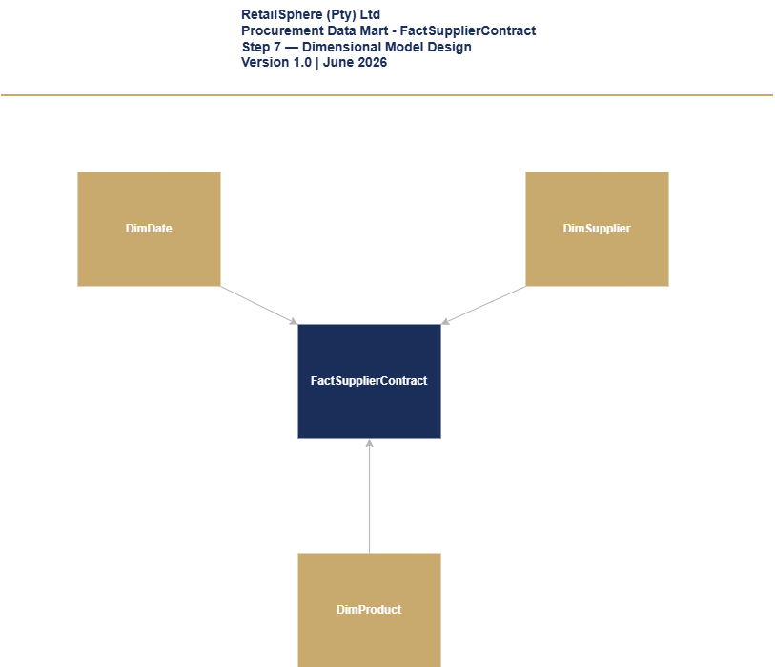

Figure 7.2 – FactSupplierContract Start Schema Diagram

Table 7.2 FactSupplierContract Fact Table
Column Name | Data Type | Description | Sample value
contract_start_date_key | int | FK to DimDate. Date this contract became effective. Format YYYYMMDD. Primary date dimension link. | 20260601
supplier_key | int | FK to DimSupplier. Supplier party to this contract. | 50
product_key | int | FK to DimProduct. Product covered by this contract. | 200
contract_id | varchar(50) | Unique contract identifier. Format RS-CON-[SEQUENCE]. Extracted from supplier contract PDF via ADR-003. | RS-CON-001001
contract_end_date | date | Date this contract expires. NULL if open-ended contract. | 2026-12-31
quantity | int | Minimum order quantity agreed in this contract. | 500
contracted_rate | money | Agreed price per unit for this product under this contract. Extracted from PDF via ADR-003. Used in FR-PRO-003 price variance calculation. | 320
lead_time | int | Agreed number of days from purchase order to delivery. Extracted from PDF via ADR-003. | 7
payment_terms | varchar(20) | Agreed payment terms. 30 days, 60 days, 90 days. Extracted from PDF via ADR-003. | 30 days
source_system_code | int | Key of source system. ADR-003 PDF extraction pipeline. | 9
create_timestamp | datetime | When the record was created in the data platform. | 2026-01-01 0:00:00
update_timestamp | datetime | When the record was last updated in the data platform. | 2026-01-01 0:00:00

CRM AND MARKETING
The CRM and Marketing domain tracks all customer communications and campaign activity across RetailSphere’s marketing channels. FactContactHistory serves both the CRM and Marketing domains, capturing every contact attempt per customer per campaign per channel. This table enforces POPIA compliance through the 4-contact monthly cap and opt-out suppression logic governed by ADR-007.

FACTCONTACTHISTORY
FactContactHistory is an accumulating snapshot fact table capturing one row per customer per campaign per channel per contact attempt. It tracks the full communication lifecycle from sent through to delivery, opened, clicked, bounced, and unsubscribed. Suppressed contact attempts are also recorded with a suppression reason – enabling Priya’s team to audit POPIA compliance and Rethabile’s team to measure campaign attribution as required by FR-CUS-001, FR-CUS-002, and ADR-006.
No attempt-sequencing column exists to distinguish multiple contact attempts to the same customer/campaign/channel on the same day. PDD-001 v1.0 proceeds on the assumption of at most one attempt per day per combination. This assumption requires validation against actual Marketing Cloud send behaviour before build; unresolved as of this revision.
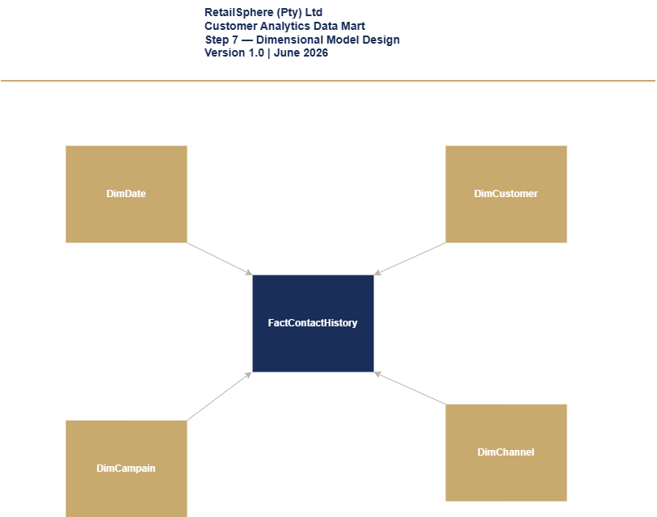
Figure 8.1 – FactContactHistory Star Schema

Table 8.1 FactContactHistory
Column Name | Data Type | Description | Sample value
contact_attempt_date_key | int | FK to DimDate. Date this contact attempt occurred or was attempted. Format YYYYMMDD. | 20260601
customer_key | int | FK to DimCustomer. Member who was contacted. | 100
campaign_key | int | FK to DimCampaign. Campaign that triggered this contact. | 200
channel_key | int | FK to DimChannel. Channel used for this contact. Email, SMS, Push, Social. | 3
response_status | varchar(20) | Furthest stage reached for this contact attempt as of last update. Sent, Delivered, Opened, Clicked, Bounced, Unsubscribed, Suppressed. | Opened
suppression_reason | varchar(30) | reason this contact was blocked before sending. NULL if not suppressed. Opt-out, Monthly cap reached. | NULL
was_suppressed | bit | 1 if this contact attempt was blocked before sending. 0 if it was sent. | 0
sent_date | date | Date the message was sent. NULL if suppressed or not yet sent. | 2026-06-01
delivered_date | date | Date the message was confirmed delivered. NULL if not yet known. | 2026-06-01
opened_date | date | Date the customer opened the message. NULL if not opened. | 2026-06-01
clicked_date | date | Date the customer clicked a link in the message. NULL if not clicked. | NULL
bounced_date | date | Date the message bounced (failed delivery). NULL if not bounced. | NULL
unsubscribed_date | date | Date the customer unsubscribed as a result of this message. NULL if not applicable. | NULL
source_system_code | int | Key of source system. 1 = Marketing Cloud. 2 = Meta. 3 = GA4. | 1
create_timestamp | datetime | When the record was created in the data platform. | 2026-06-01 0:00:00
update_timestamp | datetime | When the record was last updated. Updates daily as new status data lands from source extract. | 2026-06-02 0:00:00

DIMCAMPAIGN
DimCampaign describes all marketing campaigns across RetailSphere’s three marketing platforms – Salesforce Marketing Cloud, Meta Business Manager, Google Analytics 4. Campaign status is a system-calculated field updated daily by the Silver layer based on end_date comparison. SCD Type 1 is applied – campaign history is not required.
Table 8.2 DimCampaign Dimension Table
Column Name | Data Type | Description | Sample Value
campaign_key | int | Surrogate key of the campaign dimension. Unique, not null, primary key. | 200
campaign_id | varchar(20) | Natural key. Format RS-CAM-[SEQUENCE]. Assigned by RetailSphere. Never changes. | RS-CAM-001
campaign_name | varchar(100) | Full name of the marketing campaign. | Winter Warmers 2026
campaign_type | varchar(50) | Type of campaign channel. Email, SMS, Social Media, Display, Push Notification. | Email
budget | money | Total budget allocated to this campaign in ZAR. | R250,000.00
start_date | date | Date the campaign started sending. | 2026-06-01
end_date | date | Date the campaign ended. NULL if still active. | 2026-06-30
status | varchar(20) | Current campaign status. Planned, Active, Paused, Completed, Cancelled. | Active
source_system_code | int | Key of the source system where this campaign originated. Marketing Cloud, Meta, or GA4. | 1
create_timestamp | date | When the record was created in the data platform. | 2026-06-01 0:00:00
update_timestamp | date | When the record was last updated in the data platform. | 2026-06-01 0:00:00

DIMCHANNEL
DimChannel is a conformed dimension used on both the Sales and CRM and Marketing domains. Full column design is documented in Section 5.4.

FINANCE DOMAIN
The Finance domain tracks all General Ledger transactions for RetailSphere’s financial reporting and audit requirements. FactFinance captures individual GL journal line items enabling Johan’s team to produce month-end close packs, detect backdated postings within 1 hour per FR-FIN-005, and support external auditor requirements. DimAccount introduces the Chart of Accounts hierarchy as a domain-specific dimension.

FACTFINANCE
FactFinance is a transaction fact table capturing one row per GL journal line item posted in SAP. Two-role playing date dimensions are used – posted_date_key for the date the entry was posted and transaction_date_key for the actual business transaction date. Comparison of these two dates enables automated backdated posting detection and alerting as required by FR-FIN-005.
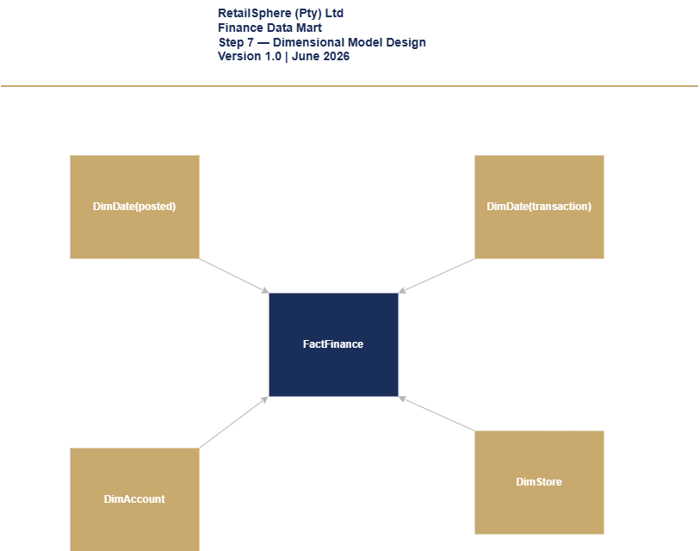
Figure 9.1 – FactFinance Star Schema

Table 9.1 FactFinance Fact Table
Column Name | Data Type | Description | Sample value
posted_date_key | int | FK to DimDate. Date this journal line was posted to the GL in SAP. | 20260601
transaction_date_key | int | FK to DimDate. Actual date the underlying business transaction occurred. Compared to posted_date_key to detect backdated postings. | 20260528
account_key | int | FK to DimAccount. The GL account this line debits or credits. | 300
store_key | int | FK to DimStore. Store this transaction relates to. 0 for head office/non-store transactions. | 10
journal_entry_id | varchar(50) | Groups the debit and credit lines belonging to one journal entry. Format RS-JE-[SEQUENCE]. | RS-JE-005001
line_number | int | Line number within the journal entry. Starts at 1. | 1
debit_amount | money | Amount if this line is a debit. 0 if this line is a credit. | 1100
credit_amount | money | Amount if this line is a credit. 0 if this line is a debit. | 0
is_backdated | bit | 1 if transaction_date falls within a period that was already closed when posted. Triggers FR-FIN-005 alert within 1 hour. | 0
source_system_code | int | Key of source system. SAP ECC General Ledger. | 1
create_timestamp | datetime | When the record was created in the data platform. | 2026-06-01 0:00:00
update_timestamp | datetime | When the record was last updated in the data platform. | 2026-06-01 0:00:00
fiscal_period_key (present in v1.0) has been removed. fiscal_period is an attribute of DimDate, not a key column – it is already accessible via the posted_date_key join and does not require separate foreign key relationship.

DIMACCOUNT
DimAccount describes RetailSphere’s Chart of Accounts – the complete list of GL accounts used in financial reporting. It provides a two-level hierarchy of account type and account category enabling financial statement grouping and subtotaling. SCD Type 2 is applied to preserve historical account classifications for audit reproducibility – ensuring that financial statements can be reproduced exactly as originally reported even if account classifications change in future.
Table 9.2 DimAccount Dimension Table
Column Name | Data Type | Description | Sample Value
account_key | int | Surrogate key of the account dimension. Unique, not null, primary key. | 300
account_code | varchar(20) | Natural key. SAP General Ledger account number. Never changes once assigned. | 4000100
account_name | varchar(100) | Specific name of the GL account as it appears on financial statements. | Clothing Sales Revenue
account_type | varchar(20) | Top-level financial statement classification. Asset, Liability, Equity, Revenue, Expense. | Revenue
account_category | varchar(50) | Grouping within account type. Used for financial statement subtotals. | Sales Revenue
normal_balance | varchar(10) | Whether an increase in this account is normally recorded as a Debit or Credit. | Credit
is_active | bit | 1 if account is currently in use. 0 if account has been retired/closed. | 1
effective_start_date | date | SCD Type 2 start date. Date from which this version of the account classification is valid. Defaults to 01-01-1900. | 2020-01-01
effective_end_date | date | SCD Type 2 end date. NULL means currently active. Defaults to 31-12-2999. | 2999-12-31
is_current | bit | 1 if this is the current active version of the account record. 0 if expired. | 1
source_system_code | int | Key of source system. SAP ECC Chart of Accounts. | 1
create_timestamp | datetime | When the record was created in the data platform. | 2020-01-01 0:00:00
update_timestamp | datetime | When the record was last updated in the data platform. | 2020-01-01 0:00:00

Data Mart Summary
This section summarizes the complete dimensional model for the RetailSphere Gold Layer data platform across all six business domains.
Domain | Fact Tables | Dimensions Used
Sales | FactSales | DimDate, DimCustomer, DimProduct, DimStore, DimEmployee, DimChannel
Inventory | FactInventory  FactReplenishment | DimDate, DimProduct, DimStore, DimSupplier
Procurement | FactProcurement  FactSupplierContract | DimDate, DimProduct, DimSupplier
CRM/Mktg | FactContactHistory | DimDate, DimCustomer, DimCampaign, DimChannel
Finance | FactFinance | DimDate, DimStore, DimAccount

Fact Tables: 7
Dimensions: 9
Total Tables: 16

Next Steps
The completion of DM-001 marks the end of Step 7 – Dimensional Model Design. The following steps are required to progress the RetailSphere data platform build:
Step 8 – Source to Target Mapping (STM-001): Map every source system column identified in SSI-001 to its corresponding Gold Layer dimension or fact table column defined in this document.
Step 9 – Physical Database Design (PDD-001): Translate the conceptual dimensional model defined in DM-001 into physical DDL scripts for Microsoft Fabric Warehouse, per ADR-004's medallion architecture decision. Note: Fabric Warehouse constraints are informational only (dbt-enforced); native table partitioning is not currently supported by the platform.
Step 10 – Data Integration Design (DID-001): Design the ADF pipeline architecture for Bronze, Silver, and Gold layer ingestion and transformation, including error handling, retry logic, and monitoring.
Outstanding items requiring resolution before build can begin:
- ADR-002: POPIA legal review and Priya Naidoo sign-off.
- ADR-003: Sipho Dlamini sign-off on PDF extraction approach.
- ADR-006: Rethabile Sithole sign-off on attribution model.
- ADR-007: Priya Naidoo sign-off on contact governance.

Document Change Log

Version | Date | Author | Description
1.0 | 25 June 2026 | Thozamile Mbalo | Initial draft. 9 dimension tables and 7 fact tables designed across 6 business domains. DimAccount and FactSupplierContract discovered during design process and added to scope. Star schema diagrams produced in draw.io.
1.1 | 23 August 2026 | Thozamile Mbalo | Corrected FactFinance classification (section 3): accumulating snapshot → transaction fact. Removed fiscal_period_key from FactFinance (section 9.1) — redundant with posted_date_key → DimDate join. Added fact-type exception note for FactSupplierContract (section 7.2): fits none of the three defined types; documented immutability and substitution-handling rule. Corrected stale "Azure Synapse Analytics" partitioning reference in Next Steps, reflecting ADR-004's Fabric Warehouse decision and the platform's current lack of native partitioning support. FactContactHistory attempt-sequencing gap (section 8.1) remains an open item pending validation against Marketing Cloud behaviour — not resolved in this revision.

— End of Document —

