Game of Thrones: An Interactive Visualisation

Tim Merckens, John Grigorian

1 LIACS, Leiden University, Niels Bohrweg 1, Leiden, The Netherlands

tim@merckens.nl, jgri6800@uni.sydney.edu.au

supervised by Assistant, Course Admin.

Tim Poot & Prof. Dr. Fons J. Verbeek.

Game of Thrones is an intricate television show based on a fictional universe where a multitude of characters over multiple storylines interact between eachother. The solution we implemented was designed to improve understanding of the Game of Thrones universe as the story progresses. We implemented an interactive map displaying the location of important characters relative to episodes. Our solution is effective in helping users achieve a better grasp on or remembering the complex story through the use of visual aid. The similar products that currently exist visualise the storyline but we have done so in a clearer way using character filters, adjusting size of moving characters to promote visibility, whilst also enhancing usability for the full spectrum of users using an auto-play feature and including names of characters and house sigils.

1 Introduction

Game of Thrones is an American fantasy drama television series based on the books by George R. R. Martin. The series plays out in the fictional continents of Essos and Westeros and focuses on 3 major story lines. The first story line concentrates on the battle for the Iron Throne in the Seven Kingdoms between noble families including their alliances and conflicts. The second story line focal point is on the exiled descendants of the previously ruling dynasty who plot to take back the throne. The final story line centres on the impending Winter a long with the threat of ancient, undead creatures that are situated north of the Wall and threaten the lives of people living in the Seven Kingdoms.

The story is filled with so many in-depth characters, sub-story lines and dynamically changing relations which makes it both a compelling but confusing show to watch. With so many details to remember fans of the show can easily forget the specifics of what has happened in previous episodes. Our approach to solve the problem was to make use of visual aids and visual stimulus to promote a better understanding of characters and story.

In this paper, we will discuss the background of Game of Thrones and define the problem associated. We will then provide our solution to said problem including results and evaluations to support our claim. Lastly, we will end with a conclusion, discussion and insights to future work.

2 Compelling but Confusing

In 2016, Game of Thrones became the most awarded series in Emmy Awards history, with a total of 38 wins and holds two world records from the Guinness Book of World Records: "Most pirated TV program and Largest TV drama simulcast”.

Due to the popularity of the show and with a growing cast including over 150 named characters there is a high-demand from people users who would be interested in our project. Additionally, the immense popularity means there are a lot of people who are interested in watching the show but not fully sold or ready to invest so much time. Our solution can either be the bridge for potential users to get a taste and start watching the show or just attain enough understanding of Game of Thrones to join in social situations and conversations. Despite this extra benefit, for the scope of our project we focussed on users who are currently watching the show and want to either improve their current understanding of the Game of Thrones universe or help to remember plot of previous seasons before embarking on new seasons.

Other approaches also included a map of the universe but included lines tracking movement of characters which overwhelmed users demoting visibility. Also, other approaches did not promote a clear understanding of characters, auto-play feature or filtering by house sigils affecting usability.

3 A picture is worth a thousand words

Why this approach? Extensive research shows that visual cues help us to better retrieve and remember information. Words are abstract and rather difficult for the brain to retain, whereas visuals are concrete and more easily remembered; especially considering the fact that that our brains are mainly an image processor not a word processor. In a similar way, when a human interacts with a task he or she is far more likely to remember and have a better understanding of details.

What resulting solution is? For these reasons, our solution is a data visualisation which also affords user interaction. Features like filtering by character, filtering by house and mouse-hover to display names of characters/houses were all considered to improve visibility.

The usability requirements were considered during implementation phase and realised through our usability specifications.

1. A user selects the specific, desired episode using the filter bar at the bottom of the screen - this is to allow users to easily navigate through different episodes or get the specific details of a certain episode.
2. A user selects the appropriate filter when filtering map by individual character(s) - allows users to improve their visibility for only the character(s) they are interested in seeing.
3. A user finds “auto-play” button the screen and enables it - allows users to sit back and watch the story unfold and character locations change promoting a dynamic visibility and usability for users of all technical levels.
4. A user selects the appropriate filter when filtering map by house - allows users to improve their visibility for only the houses they are interested in seeing.
5. A user looks up the details of a character - affords users the ability to obtain a better understanding of characters that are of interest to them a long with the story so far (depending on what episode they have filtered to).

4 Results and Evaluation

### Evaluations

The first evaluations were designed to be more of a demonstration where features and interface design was shown to the user. We focussed on if the overall design was clear, if the choice of features were useful and which would be most meaningful. Based on the first evaluations, the overall design was well received but wanted more information about the characters and houses. All the basic features were said to be useful, however, there were comments about the auto-play feature since it may accidentally show spoilers.

The second evaluation was more test-based where users were required to complete a series of tasks of which results were measures in regards to time to complete task and rate of errors. These results can be found under appendix A.

Based on this evaluation and the following tasks we have tested our usability specifications as shown in Table 1.

|  |  |  |  |  |  |
| --- | --- | --- | --- | --- | --- |
| Feature | Measuring | Description (or Task to be measured) | Target Level | Result  Before* | Result  After* |
| Select episode | Observe and record time | A user selects the specific, desired episode using the filter bar at the bottom of the screen | 5 s | 4 s | 5 s |
| Enable “auto-play” | Observe and record time | A user finds “auto-play” button the screen and enables it | 3 s | 4 s | 6 s |
| Filter by house | Rate of error | A user selects the appropriate filter when filtering map by house | Correct filter selected by at least 3rd try | 18 s – 4  errors | 15 s – 2 errors |
| Select character | Observe and record time | A user clicks on the correct character to show it’s detailed information | 10s | 12 s | 10 s – 5 errors ** |

Table 1. Usability Specification results

* First results are before hovering over a character/house showed their names, second results after it shows.

** unable to find character that appears in later episode

### Response to Feedback

We have mostly asked for feedback on new/existing features and to ways to make using our site feel as intuitively as possible. We’ve tried to implement as many of these as possible within our timeframe, but were unable to fit in everything we originally wanted to include. An example of this would be showing character relations on the map, which would be really cool to have, but we lacked the time to do so.

A couple of suggestions from user evaluations that we implemented are:

- Changing the text font to be better readable

- Hovering over a character shows their name

- Hovering over houses shows the house name

- Rewrote the user guide to be better understandable

Originally, we wanted to provide a solution for both our user groups, but we ended up focussing more on the people who have already watched the show. For the second user group, the people who have not yet watched the show, but might want to get into it, we wanted to implement the following:

- “Spoiler-Free” mode, replacing the text when you click on a character with a

background on that character, instead of their progress through season 1

- A list of sorts that would better allow you to select characters, since this group won’t recognise the characters from a portrait, having a way to select a character that involves a list of names instead of pictures could be useful.

Lastly there are a couple of bugs in our current product that we would’ve liked to be able to fix:

- Upon clicking the play button, an interval is started where characters move, then the program waits a couple of seconds to make sure moving multiple episodes doesn’t overlap, and then moves again. However, at the moment when you press play, it starts with the couple second wait before moving, which makes users think something went wrong.

- If you filter houses while auto-play is on, it will “skip” moving for one episode. The characters will be automatically set to the next episode (and then there’s a waiting time again).

5 Conclusion and Discussion

One of the conclusions derived from our results was the solution was useful and informative for users who have watched the show. Despite being a visualisation project, the detailed character information text was more useful to provide information on the story so far to supplement it being just a visualisation. Additionally, it can help users who haven’t watched the show but isn’t so user friendly for them as they don’t know which character portrait represents which character and which house sigil represents which house.

An insight gained through the project user evaluations was that users who interacted with the application and features had more enjoyment using the product and improved learnability. The choice of font and text size was a significant point to take into account that affects visibility. We found that the nicest looking font was not always the best option for readability. The character portrait size was an important factor in determining overall visibility and, as a result, understanding character locations. Similarly, we noticed a difference between shapes of character portraits, where the square portraits made the interface look more cluttered compared to circular portraits.

6 Future Work

There are many ways to improve our current product, a couple of which mentioned earlier; more support for people who have not watched the show and showing relations between characters.

Besides these we could eventually add the other seasons/characters and keep it up to date as new seasons are released.

A multitude of features could still be implemented, such as showing more animations when characters are first introduced into the series or when they die, providing background story on the cities and areas on the map, showing which family rules over which provinces at any point in time, allowing zooming into the map while character icons stay the same size (to make the screen less filled up with characters if there are many important characters at the same spot in later episodes) or making the slider move while auto-play is on to correctly indicate the current episode.

References

1. Haig Kouyoumdjian, (2012). Learning through Visuals. Visual Imagery in the Classroom. <https://www.psychologytoday.com/blog/get-psyched/201207/learning-through-visuals>. 2/1/2018

Appendix

### Appendix A

User A (before changes)

|  | Time (seconds) | Rate of Errors |
| --- | --- | --- |
| **Filter by House Stark** | 20 | 4 |
| Filter by House Stark, Baratheon and Lannister | 18 | 1 |
| Go to Episode 7 | 4 | 0 |
| Autoplay from Episode 4 | 4 | 0 |
| Look up details on character Jon Snow | 13 | 0 |
| Look up details on Robin Arryn | 12 | 0 |

User B (after changes)

|  | Time | Rate of Errors |
| --- | --- | --- |
| **Filter by House Stark** | 15 | 2 (clicked mouse too quickly to see the house names until told) |
| Filter by House Stark, Baratheon and Lannister | 8 | 0 |
| Go to Episode 7 | 5 | 0 |
| Autoplay from Episode 4 | 6 | 0 |
| Look up details on character Jon Snow | 10 | 5 |
| Look up details on Robin Arryn | n/a | unable to complete as she didn’t know Robin Arryn wasn’t on the map until a later episode |

### Appendix B: Interface Design

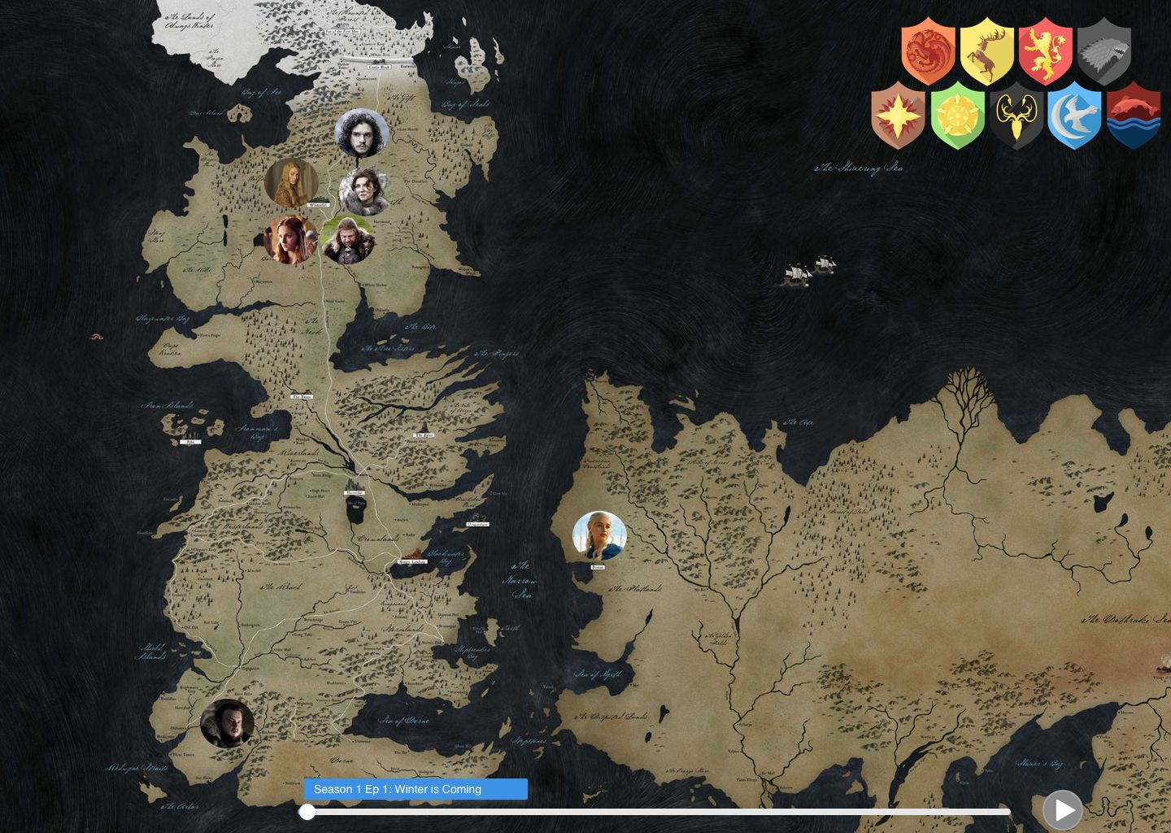

Prototype

Final design