Cryptography & Security
CT5046

1 February

Assignement, 2026/27.

Table of Contents
Introduction 3
1. Public Key Infrastructure (PKI) Design 3
1.1 Model Implementation 3
1.2 Certificate Creation Process and Validation 3
1.3 Certificate Validation 3
1.4 Cryptographic Mechanism 4
2. Key Generation 4
3. Hash Algorithm 6
4. Testing 6
4.1 Resource Testing 6
4.2 Certificate Authority Testing 8
4.3 Certificate revocation testing 9
4.4 PKI Testing 10
4.5 Algorithm Testing 12
Conclusion 13
Bibliography 13

Introduction
Cryptography is a crucial topic in cybersecurity, especially regarding how data should be protected, whether in transit, during processing, or when stored. It involves the science and practice of securing data by transforming it into an unreadable format to prevent unauthorized access. This report presents a comprehensive approach and design process for implementing a lightweight cryptographic system tailored for constrained environments. The design follows several structured steps: integrating Public Key Infrastructure (PKI), key management, implementing cryptographic mechanisms, developing the cryptographic system, testing each function, and evaluating effectiveness. Each section details the design decisions and implementation specifics, aligning with the assessment’s learning outcomes and showcasing both technical skills and statistical reasoning.

Public Key Infrastructure (PKI) Design
The PKI is a crucial system for establishing a cryptographic foundation. It manages digital certificates, software, certificate validation, user registration, and policies. PKI benefits include user authentication, data protection in transit, and non-repudiation enabled by digital signatures. PKI is composed of a few components, such as:

1.1 Model Implementation
The PKI can be built using various models, but for the cryptographic design, the hierarchical model will be utilized. This model is selected because it is common in real systems and widely adapted; it features a single root certificate authority that issues certificates to subordinate entities and end users.

1.2 Certificate Creation Process and Validation
The digital certificate will undergo a binding process using the client's information. A verified and validated user generates a public and private key; the public key is merged with the client's identification and sent to the Certificate Authority (CA). The root certificate authority (CA) verifies the user’s information and signs the certificate with its private key.
The user's certificate contains vital information, such as the public key, device identity, validation period, and the signature signed by the root certificate authority. This ensures the certificate belongs to a legitimate user.

1.3 Certificate Validation
Validating a certificate is necessary to ensure that the website or server a user wants to connect to is who they claim to be, this process prevents attackers from faking and impersonating legitimate service providers. Once a certificate is successfully validated, a secure TLS session is established for data transmission. It equally ensures that the certificate is signed by the trusted CA.

1.4 Cryptographic Mechanism
A lightweight cryptographic system involves creating a secure platform that can operate on constrained devices like IoT devices and smart cards. Choosing the correct cryptographic algorithm is essential, especially when developing a secure, lightweight system. Therefore, important key information must be noted, defined, and assessed, which is the next step in designing the system. Examples of this information include constraints, security aspects (confidentiality, integrity, authentication, non- repudiation, and availability), threat models, key management, safety implementation (testing), compliance, and standards. Evaluating this information resulted in the implementation of a hybrid algorithm in the system design. This information focused on PKI management (responsible for managing digital certificates), digital certificates (verification and proof of identity), and file encryption integration. It is important to select the right algorithm for encrypting large files, as improper choices can introduce security vulnerabilities. The hybrid algorithm implemented consists of a symmetric algorithm (AES: Advanced Encryption Standard) and an asymmetric algorithm (ECC: Elliptic Curve Cryptography). Both have their benefits and drawbacks, but when combined, they create a strong security system. ECC(P-256) offers advantages such as faster operations, smaller keys, lower power consumption, and less memory usage, especially for key exchange and authentication. AES(GCM) provides strong security for larger files, is very fast at encryption and decryption on modern or lightweight hardware and offers strong security with small key sizes. Merging these algorithms is the hash function, with one used in key generation and another to ensure data integrity, especially during data decryption.(Guido van Rossum, 1991; Jetbrains, 2013)


Fig 1. Imported Libraries.

Key Generation
With all these algorithms in the system, the second phase was accomplished: implementing cryptographic mechanisms. Each of these mechanisms includes a function; ECC's function is to derive a shared secret, a private key (which should not be shared by the user), and a public key for the sender and receiver. The sender’s private key and the receiver’s public key were used to create a shared secret key; this key was used to generate the symmetric key (AES), which is hashed with the SHA-256 hash algorithm. The AES(GCM) key is generated and then used to encrypt and decrypt data. During encryption and decryption, the shared secret must be similar; only then can decryption occur.
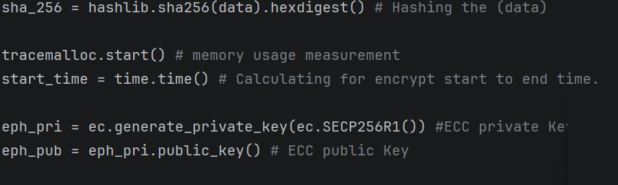
Fig 2. Public/private Key Generation.
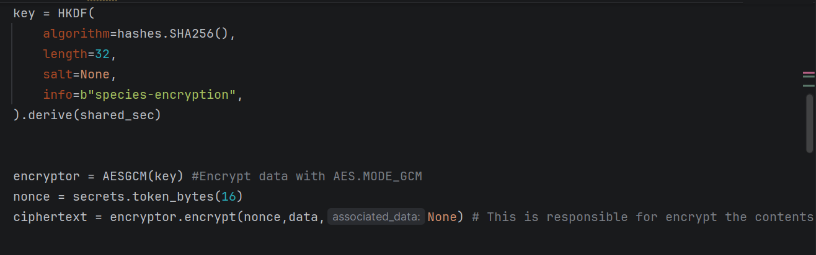
Fig 3. Data encryption with a key.
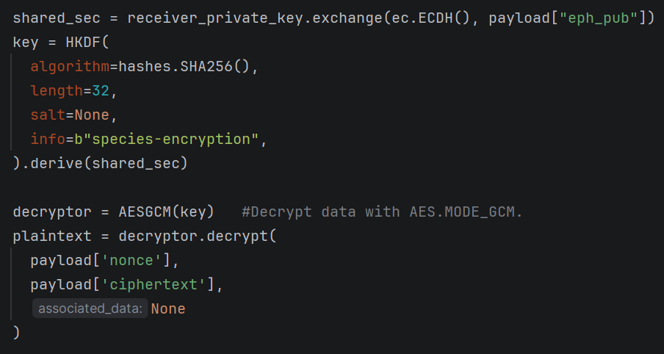
Fig 4. Data decryption, shared secret, and the key used.

Hash Algorithm
The hash algorithm provides integrity and should be used whenever security is a concern, especially to verify that information came from the right client or source. The SHA-256 algorithm was selected because it has a hash code length and its widely used in security, it was applied in the cryptographic system to hash the data before the encryption phase, and during the decryption phase, when the encrypted data is decrypted, it verifies the decrypted data; if there is a match, it prints the value, and if there is no match, it displays an error message to the interface. Applying this ensures that information from the sender is authenticated. When a single bit is altered in the ciphertext, it causes a failed hash verification, demonstrating integrity protection.
Fig 5. Hashed data before encryption
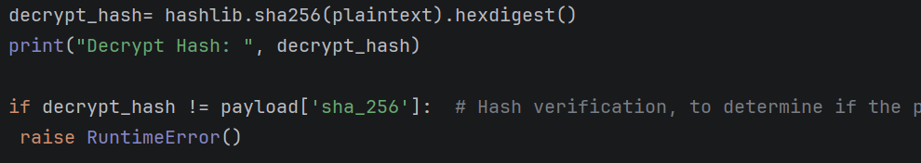
Fig. 6. Verification of decrypted data.

Testing
Testing is always required after building a system, especially a system that is required to secure information on transmission and fulfill the CIA triad. This is necessary to ensure that every function or task implemented in the system performs as intended with no flaws. The test phase underwent several sections, such as resource testing, PKI testing, and an attack-based algorithm.

4.1 Resource Testing
It calculates the resource performance used by the cryptographic system. The goal is to limit the use of these resources when employed in a constrained device or environment. These resources include CPU usage, key generation time, Memory usage, and encryption/decryption time. Testing verifies that your crypto system is practical on limited hardware.
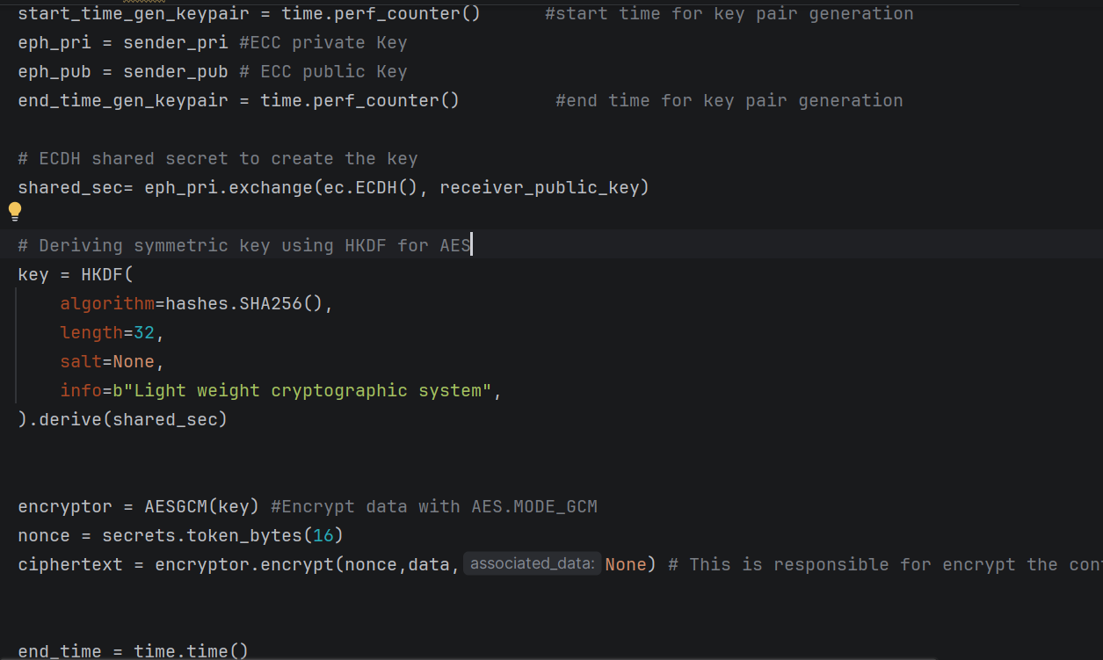
Fig 7. Calculating Total encryption time.
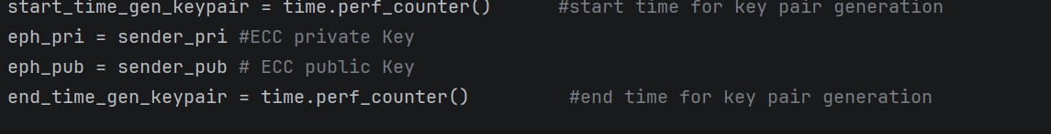
Fig 8. Calculating Key Generation Time.
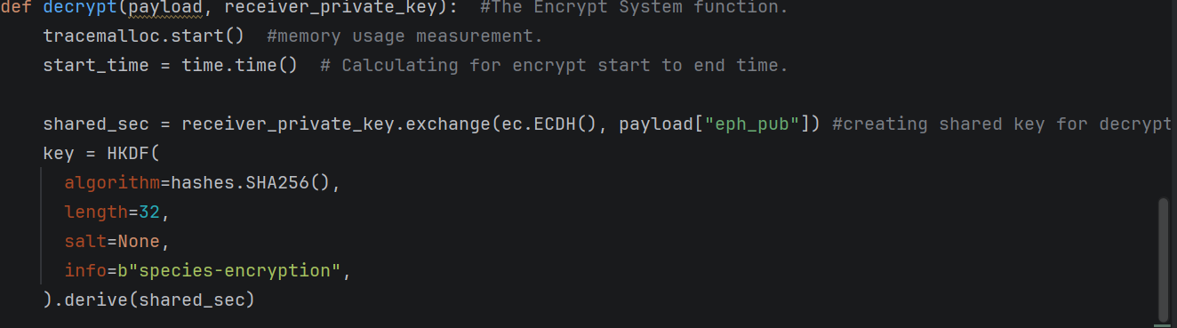
Fig 9.1 Calculating Total decryption time
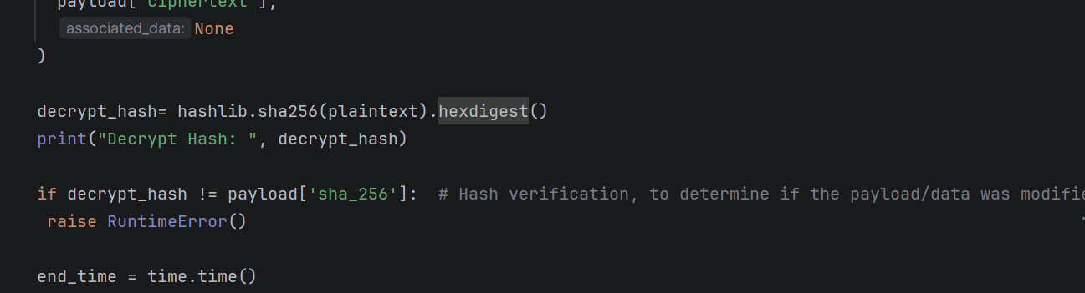
Fig 9.2 Calculating Total decryption time
Fig 10. Total encryption and key pair generation time
Fig 11. Total decryption time
The performance result presented above indicates that applying the ECC cryptographic algorithm in a lightweight cryptographic mechanism is a preferable option to limit high resource usage in a device.

4.2 Certificate Authority Testing
As mentioned, the public Key Infrastructure validates a certificate Authority, ensuring that each CA registered is authentic, avoiding key misuse. To ensure functionality, the PKI must be tested. Among the defined functions of the PKI was the Certificate Authority that issued X.509 certificates, binding ECC public keys to verified identities.
Many aspects of the PKI can be tested and evaluated, but the most important are the Certificate creation, Certificate signing, Trust validation, and Revocation performance.
A root certificate of authority was created to sign a user’s certificate, with the right imported libraries, new key pairs were created for the subject issuer with the ECC algorithm along with the CA certificate saved in a “PEM” format. The same steps were implemented to issue a certificate to the user, indicating a successful certificate creation for a user and signing by the certificate authority. (Matthew Kosinski, 2025)
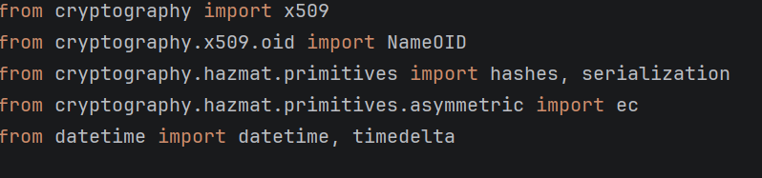
Fig 12. The libraries are imported.

Fig 13. The CA certificate
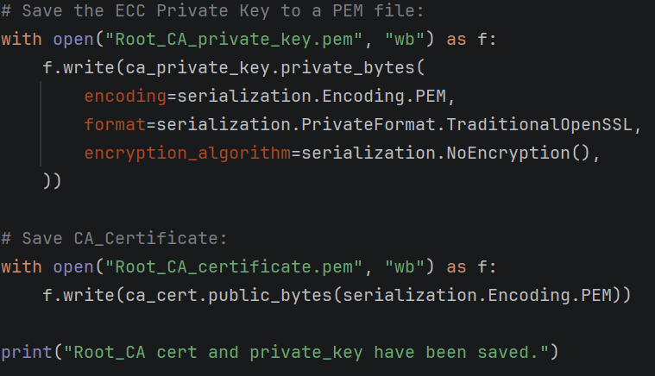
Fig 14. The CA certificate is saved in “ROOT_CA_certificate.pem”
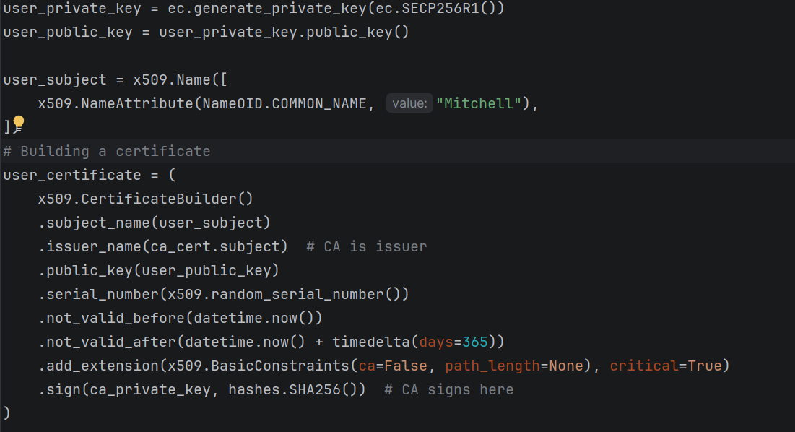
Fig 15. Building the certificate for the user signed with the CA certificate.
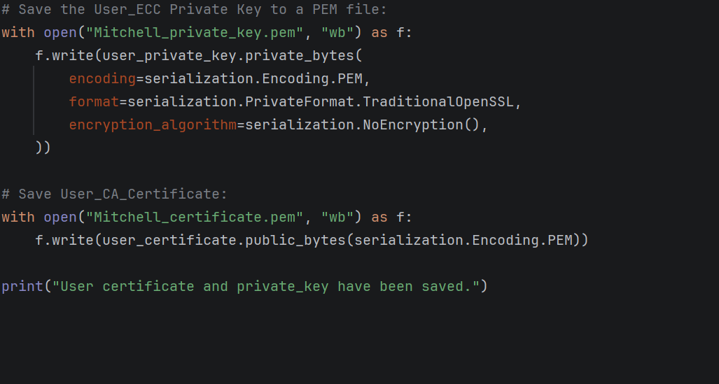
Fig 16. The stored user certificate.

4.3 Certificate revocation testing
A defined function was created in the PKI to revoke certificates if violated. Each certificate created was registered with a serial number for identification, and for every serial number and subject certificate added to the revoked list, that certificate will be considered invalid for data transmission across the internet. The revoke function was put to a test which resulted in one of the registered users being invalid, indicating that the function was successful.
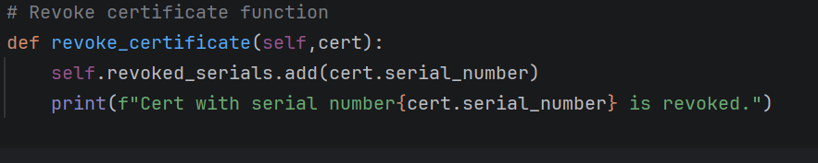
Fig 17. The revoke function was created in the PKI.

4.4 PKI Testing
With each function in place such as the user verification and validation, a test was conducted to determine if a message could be between two verified users. The two verified users were Paul the receiver and Mitchell the sender. A message was successfully sent across with the selected PKI model, hierarchical, indicating a successful function implementation in the PKI.(IBM, 2025)
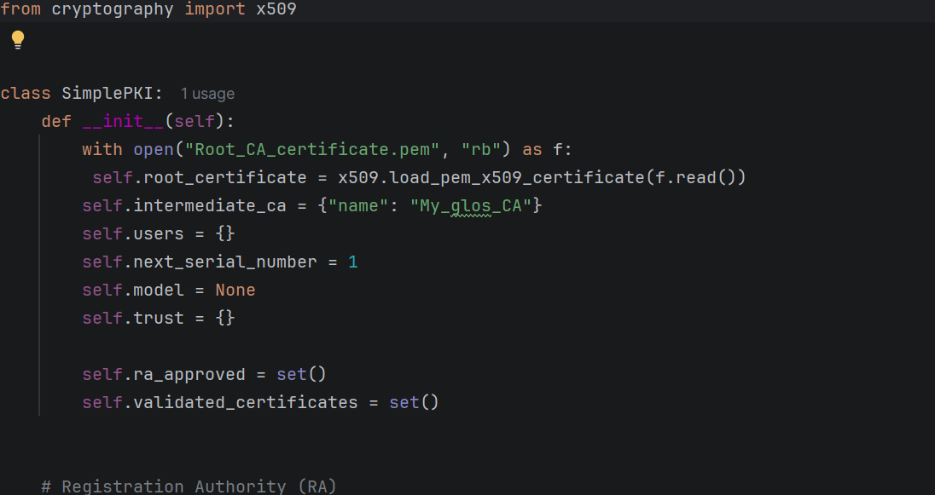
Fig 18. The self-function.
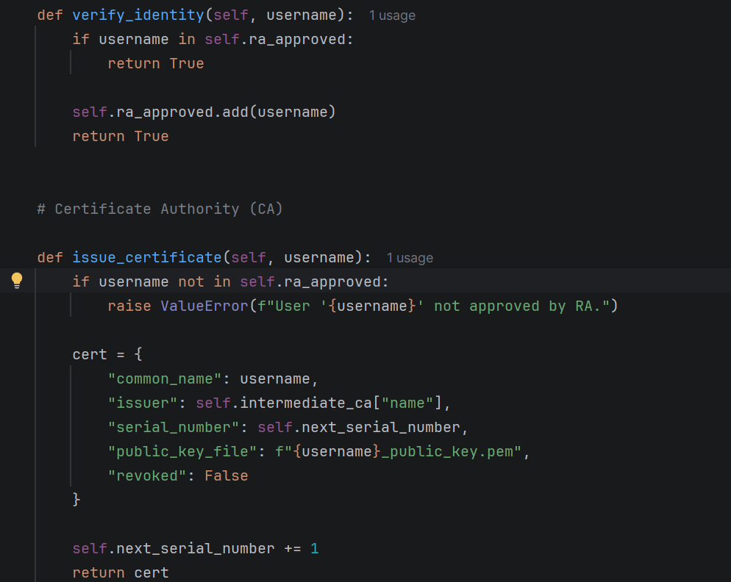
Fig 19. Identity verification function and issuing certificates by the CA function.
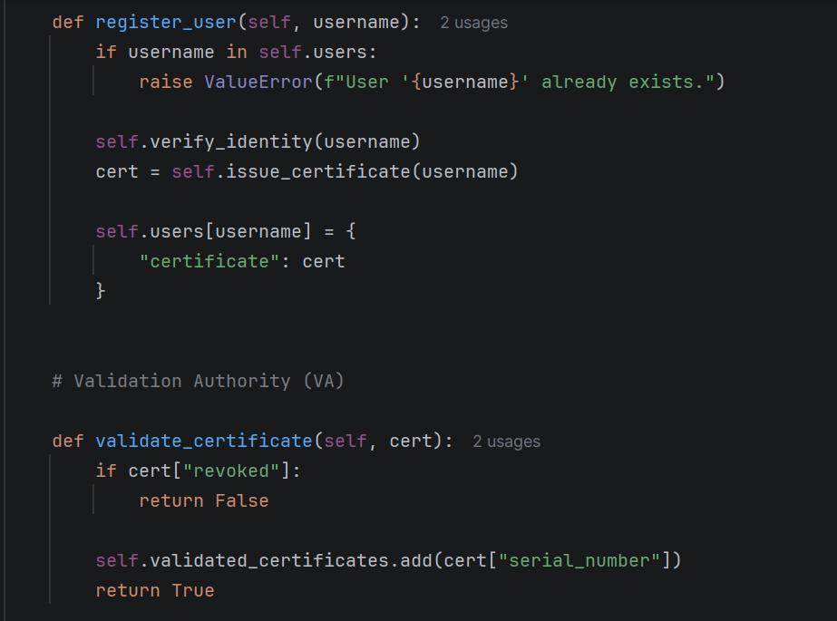
Fig 20. Certificate validation and new user registration
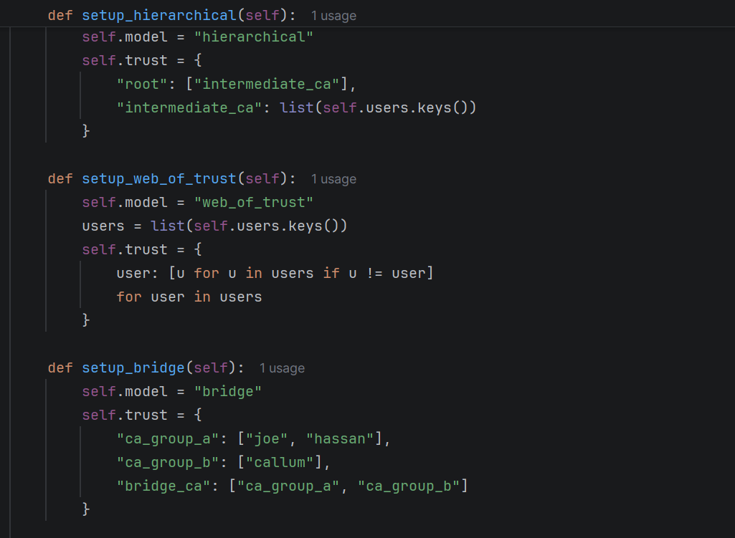
Fig 21. PKI models
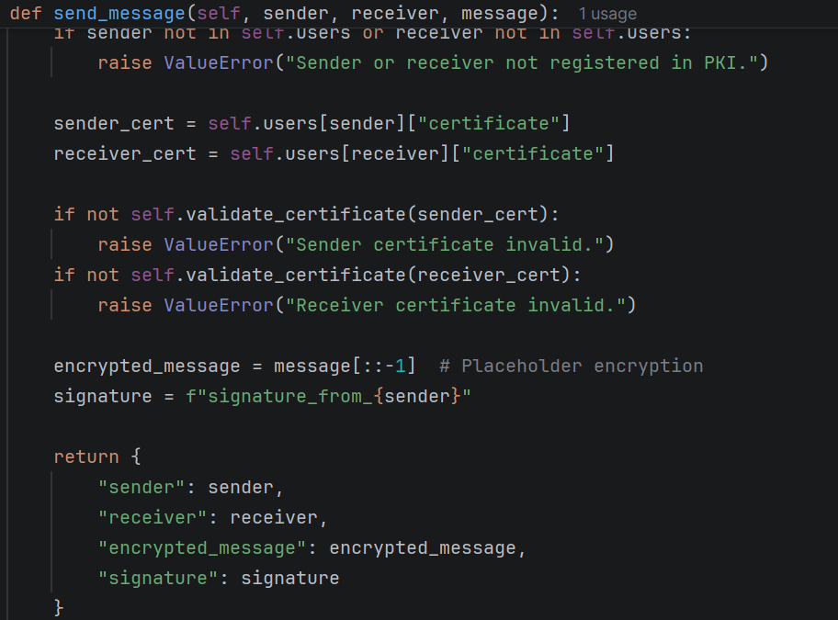
Fig 22. Secure messaging
The PKI was successfully tested, confirming CA trust validation and effective key management.
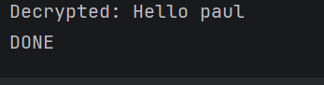

4.5 Algorithm Testing
With the hybrid algorithm (AES + ECC) in place, the next step was to test the cryptographic mechanism with the recipient certificate to ensure that the hybrid algorithm functions properly by encrypting and decrypting the text in the selected file. During the test, an issue came up where it failed to decrypt the text, after serval attempt and corrections, it was successful. It happened to be that the AES key derived from the shared secret was different from what was used to encrypt the text initially, so the shared secret must be similar to achieve a successful decryption. The hybrid algorithm was tested again with a different text, which held a positive result again. The hybrid algorithm provided a security CIA triad, and the encryption provided confidentiality, the hash algorithm provided integrity, and the PKI and certificate authority which handled the keys provided availability. (letsdefend, 2022)
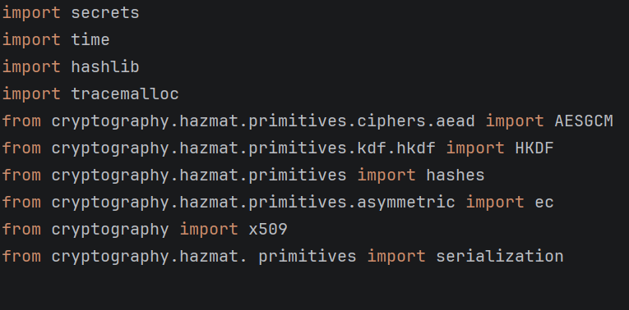
Fig 23. Importing Libraries.
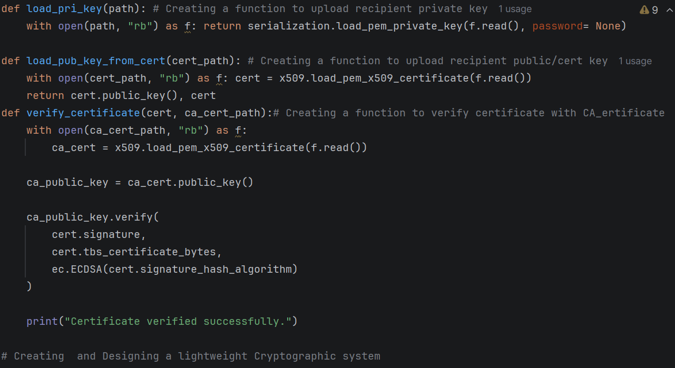
Fig 24. A created function to upload the recipient certificate for decryption.
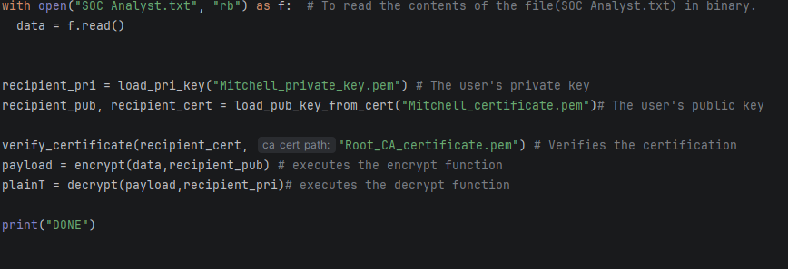
Fig 25. The uploaded user certification “Mitchell_private_key.pem”.
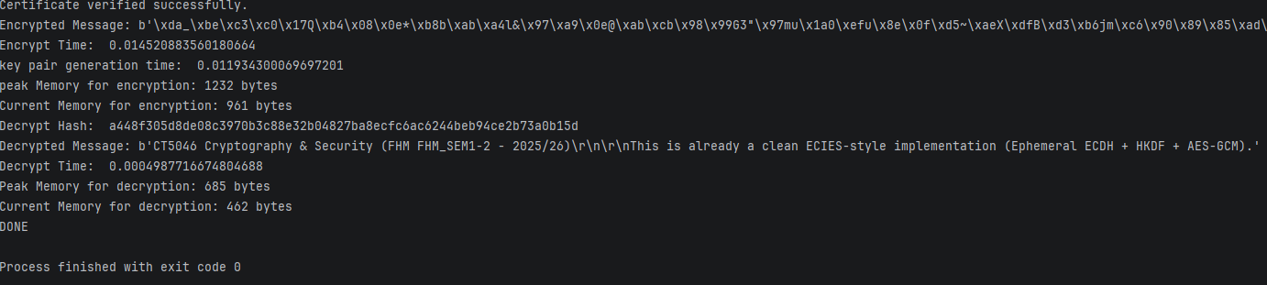
Fig 26. The successful result from testing the hybrid algorithm.

Compliance and standard
The light weight cryptographic system aligns with recognized security standards, such as: PKI follows the X.509 certificate framework, AES and SHA-256 comply with National Institute of Standards and Technology (NIST) guidelines, ECC is recommended by both National Institute of Standards and Technology and European Union Agency for Cybersecurity (ENISA), and the hybrid encryption model reflects the design principles used in Transport Layer Security (TLS).

Conclusion
This project designed and implemented a lightweight hybrid cryptographic system suitable for constrained environments. By integrating PKI for secure key management and authentication, using asymmetric cryptography for key exchange, AES for efficient data encryption, and SHA-256 for integrity, the system ensures confidentiality, integrity, and trust. Testing confirmed correct certificate validation, secure communication, and reliable hashing. Overall, the solution achieves a practical balance between security, efficiency, and compliance for lightweight devices such as IoT systems.

Bibliography
Guido van Rossum (1991) Python, Python software foundation. Available at: https://www.python.org/ (Accessed: February 23, 2026).
IBM, I.S. josh schneider (2025) public-key-infrastructure, IBM Think. Available at: https://www.ibm.com/de-de/think/topics/public-key-infrastructure (Accessed: February 23, 2026).
Jetbrains (2013) Pycharm, Jetbrains. Available at: https://www.jetbrains.com/pycharm/download/?section=windows (Accessed: February 23, 2026).
letsdefend (2022) Introduction-to-cryptography, letsdefend.io. Available at: https://app.letsdefend.io/training/lessons/introduction-to-cryptography (Accessed: February 23, 2026).
Matthew Kosinski (2025) Data Breach, IBM Think. Available at: https://www.ibm.com/de-de/think/topics/data-breach (Accessed: February 23, 2026).

