# Node.js Docker Deployment Assignment

## Overview

This project demonstrates deploying a Node.js application using GitHub,
Linux, Docker, and Docker Hub.

## Technologies

- Node.js
- GitHub
- Linux
- Docker
- Docker Hub

#SCREENSHOT 1

# Docker Build

##command used
sudo docker build -t timyjosh/nodejs-app:1.0

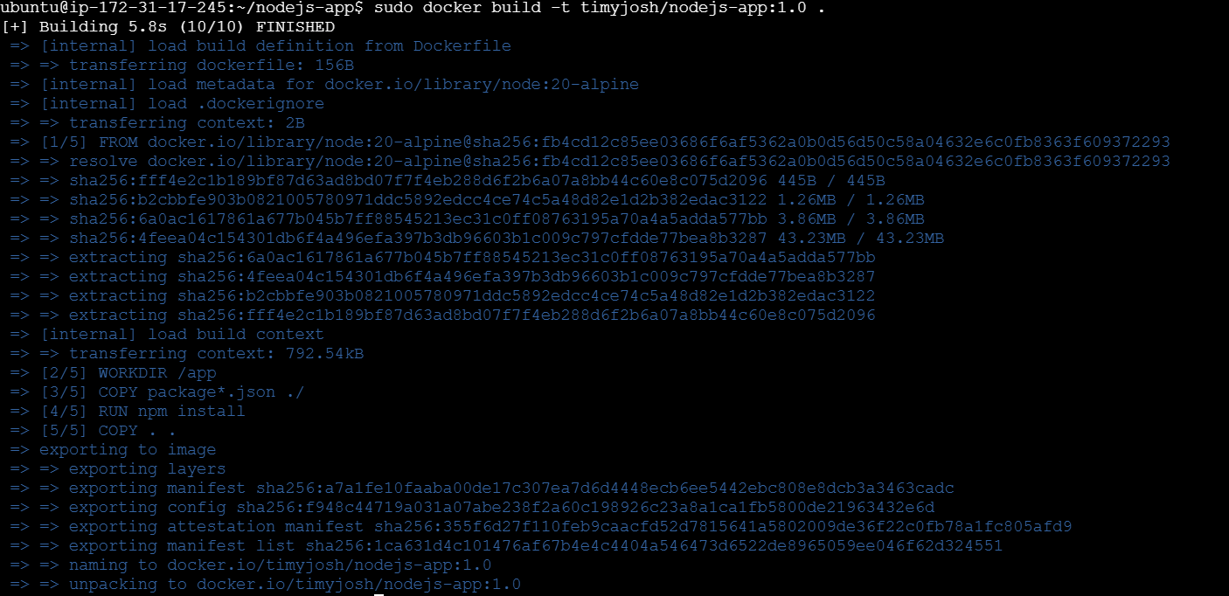

##SCREENSHOT 2

dockerhub image
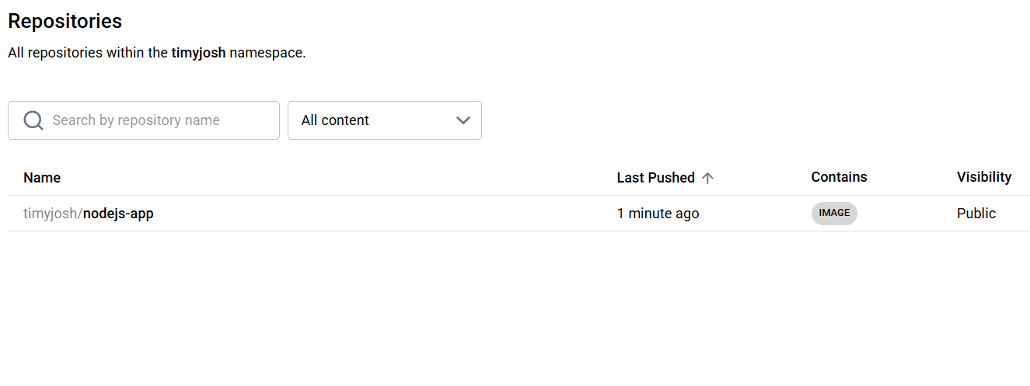
#SCREENSHOT 3

##running docker container

Command used
sudo docker ps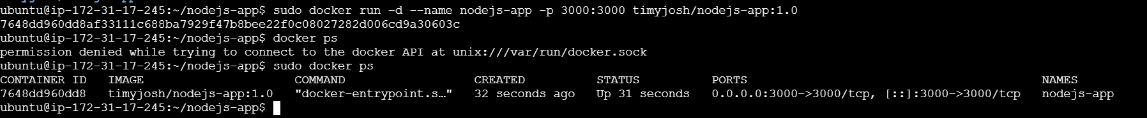

##SCREENSHOT 4

Live application

