SOURCE CODE:

using System;

using System.Collections.Generic;

using System.ComponentModel;

using System.Data;

using System.Drawing;

using System.Linq;

using System.Text;

using System.Threading.Tasks;

using System.Windows.Forms;

namespace MidtermPart2

{

public partial class Form1 : Form

{

DataTable table;

//^^Created a data table here

public Form1()

{

InitializeComponent();

}

private void label1_Click(object sender, EventArgs e)

{

}

private void button3_Click(object sender, EventArgs e)

{

int index = dataGridView1.CurrentCell.RowIndex;

if(index>-1)

{

txtTitle.Text = table.Rows[index].ItemArray[0].ToString();

txtMessage.Text = table.Rows[index].ItemArray[1].ToString();

//Indexes the text in the textboxes if you click on save button

}

}

private void Form1_Load(object sender, EventArgs e)

{

table = new DataTable();

table.Columns.Add("Title", typeof(String));

table.Columns.Add("Messages", typeof(String));

//Creates the column titles and decides what kind of data it can recieve.

dataGridView1.DataSource = table;

dataGridView1.Columns["Messages"].Visible = false;

dataGridView1.Columns["Title"].Width = 140;

//Shortens the data table width and doesn't show the messages table

}

private void bttNew_Click(object sender, EventArgs e)

{

txtTitle.Clear();

txtMessage.Clear();

//If you click on the new button, it will clear the two textboxes.

}

private void bttSave_Click(object sender, EventArgs e)

{

table.Rows.Add(txtTitle.Text, txtMessage.Text);

//Adds the stuff to the datatable

txtTitle.Clear();

txtMessage.Clear();

//Clears after it saves the stuff to the datatable

}

private void bttDelete_Click(object sender, EventArgs e)

{

int index = dataGridView1.CurrentCell.RowIndex;

table.Rows[index].Delete();

//Delets the index text on the data table rows.

}

private void dataGridView1_CellContentClick(object sender, DataGridViewCellEventArgs e)

{

}

}

}

~~PAGE BREAK~~

~~PAGE BREAK~~

~~PAGE BREAK~~

~~PAGE BREAK~~

~~PAGE BREAK~~

~~PAGE BREAK~~

~~PAGE BREAK~~

~~PAGE BREAK~~

GUI DESIGN SCREENSHOT:

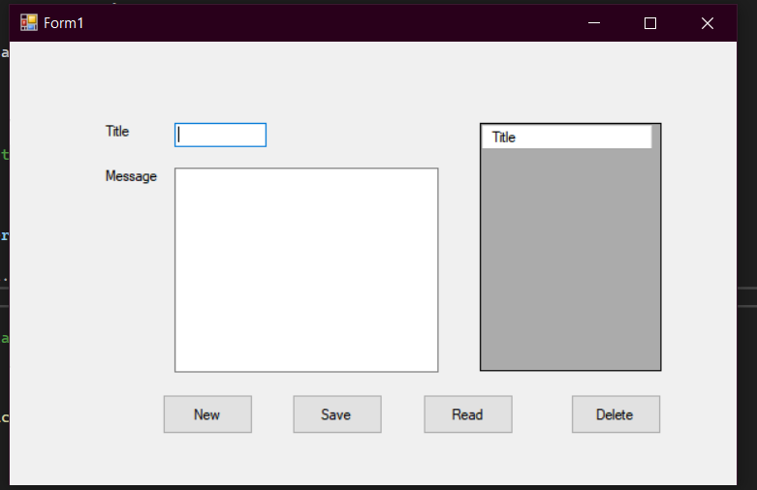

WORKING APPLICATION TEST RUN VIA VIDEO SHOW:

[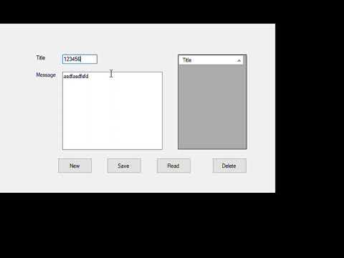](https://www.youtube.com/embed/fU3D8IO_nvI?feature=oembed)

ALTERNATIVE LINK: <https://www.youtube.com/watch?v=fU3D8IO_nvI>