report1

谭铭瑞

2023-04-20

#导入数据文件xt4_13  
library(haven)  
xt4_13 <- read_sav("C:/Users/Administrator/Desktop/xt4.13.sav")  
View(xt4_13)  
fit1 = lm(y~x,data = xt4_13)  
summary(fit1)

##   
## Call:  
## lm(formula = y ~ x, data = xt4_13)  
##   
## Residuals:  
## Min 1Q Median 3Q Max   
## -0.151659 -0.068633 -0.003432 0.046715 0.184384   
##   
## Coefficients:  
## Estimate Std. Error t value Pr(>|t|)   
## (Intercept) -1.434832 0.241956 -5.93 1.3e-05 ***  
## x 0.176163 0.001632 107.93 < 2e-16 ***  
## ---  
## Signif. codes: 0 '***' 0.001 '**' 0.01 '*' 0.05 '.' 0.1 ' ' 1  
##   
## Residual standard error: 0.09744 on 18 degrees of freedom  
## Multiple R-squared: 0.9985, Adjusted R-squared: 0.9984   
## F-statistic: 1.165e+04 on 1 and 18 DF, p-value: < 2.2e-16

#查看方差图看看是否呈自相关  
plot(xt4_13$x,fit1$residuals,main = "residuals plot")  
library(lmtest)

## 载入需要的程辑包：zoo

##   
## 载入程辑包：'zoo'

## The following objects are masked from 'package:base':  
##   
## as.Date, as.Date.numeric

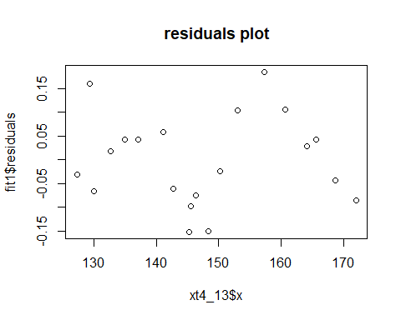

#计算dw  
dwtest(fit1,alternative = "two.side")

##   
## Durbin-Watson test  
##   
## data: fit1  
## DW = 0.66325, p-value = 0.0001257  
## alternative hypothesis: true autocorrelation is not 0

#转存dw和计算ρ  
dw = 0.66325  
rhohat = 1-dw/2  
x = xt4_13$x  
y = xt4_13$y  
  
#迭代法消除自相关  
#计算y`=y.(t)-ρy.(t-1)  
newx = x[2:20]-rhohat*x[1:19]  
newy = y[2:20]-rhohat*y[1:19]  
#用普通最小二成估计  
fit2 = lm(newy~newx)  
#计算dw查看p是否大于0.05，p>0.05则dw显著，可以认为已经消除自相关  
dwtest(fit2,alternative = "two.side")

##   
## Durbin-Watson test  
##   
## data: fit2  
## DW = 1.3597, p-value = 0.0862  
## alternative hypothesis: true autocorrelation is not 0

summary(fit2)

##   
## Call:  
## lm(formula = newy ~ newx)  
##   
## Residuals:  
## Min 1Q Median 3Q Max   
## -0.107113 -0.051913 -0.000163 0.036810 0.130277   
##   
## Coefficients:  
## Estimate Std. Error t value Pr(>|t|)   
## (Intercept) -0.300278 0.177646 -1.69 0.109   
## newx 0.172686 0.003475 49.69 <2e-16 ***  
## ---  
## Signif. codes: 0 '***' 0.001 '**' 0.01 '*' 0.05 '.' 0.1 ' ' 1  
##   
## Residual standard error: 0.07296 on 17 degrees of freedom  
## Multiple R-squared: 0.9932, Adjusted R-squared: 0.9928   
## F-statistic: 2469 on 1 and 17 DF, p-value: < 2.2e-16

#差分法消除自相关  
#计算增量数据  
deltax = diff(x)  
deltay = diff(y)  
#用最小二乘估计  
fit3 = lm(deltay~deltax)  
#计算dw  
dwtest(fit3,alternative = "two.side")

##   
## Durbin-Watson test  
##   
## data: fit3  
## DW = 1.4798, p-value = 0.2728  
## alternative hypothesis: true autocorrelation is not 0

summary(fit3)

##   
## Call:  
## lm(formula = deltay ~ deltax)  
##   
## Residuals:  
## Min 1Q Median 3Q Max   
## -0.126529 -0.058215 -0.000915 0.050771 0.140315   
##   
## Coefficients:  
## Estimate Std. Error t value Pr(>|t|)   
## (Intercept) 0.032892 0.025847 1.273 0.22   
## deltax 0.160963 0.008243 19.528 4.42e-13 ***  
## ---  
## Signif. codes: 0 '***' 0.001 '**' 0.01 '*' 0.05 '.' 0.1 ' ' 1  
##   
## Residual standard error: 0.07449 on 17 degrees of freedom  
## Multiple R-squared: 0.9573, Adjusted R-squared: 0.9548   
## F-statistic: 381.3 on 1 and 17 DF, p-value: 4.42e-13

#比较两个回归方程的r(Multiple R-squared)，越接近1则回归方程越合适

F越大越合适

report2

谭铭瑞

2023-04-20

#导入数据文件xt4_14  
library(haven)  
xt4_14 <- read_sav("C:/Users/Administrator/Desktop/xt4.14.sav")  
View(xt4_14)  
fit1 = lm(y~x1+x2,data = xt4_14)  
summary(fit1)

##   
## Call:  
## lm(formula = y ~ x1 + x2, data = xt4_14)  
##   
## Residuals:  
## Min 1Q Median 3Q Max   
## -747.71 -229.80 -2.15 267.23 547.68   
##   
## Coefficients:  
## Estimate Std. Error t value Pr(>|t|)   
## (Intercept) -574.0624 349.2707 -1.644 0.1067   
## x1 191.0985 73.3092 2.607 0.0121 *  
## x2 2.0451 0.9107 2.246 0.0293 *  
## ---  
## Signif. codes: 0 '***' 0.001 '**' 0.01 '*' 0.05 '.' 0.1 ' ' 1  
##   
## Residual standard error: 329.7 on 49 degrees of freedom  
## Multiple R-squared: 0.2928, Adjusted R-squared: 0.264   
## F-statistic: 10.15 on 2 and 49 DF, p-value: 0.0002057

plot(fitted(fit1),fit1$residuals,main = "residuals plot")  
library(lmtest)

## 载入需要的程辑包：zoo

##   
## 载入程辑包：'zoo'

## The following objects are masked from 'package:base':  
##   
## as.Date, as.Date.numeric

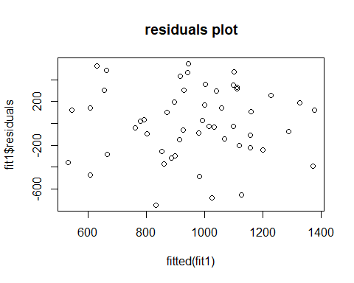

dwtest(fit1,alternative = "two.side")

##   
## Durbin-Watson test  
##   
## data: fit1  
## DW = 0.74526, p-value = 3.517e-07  
## alternative hypothesis: true autocorrelation is not 0

dw = 0.74526  
rhohat = 1-dw/2  
x1 = xt4_14$x1  
x2 = xt4_14$x2  
y = xt4_14$y  
  
  
newx1 = x1[2:52]-rhohat*x1[1:51]  
newx2= x2[2:52]-rhohat*x2[1:51]  
newy = y[2:52]-rhohat*y[1:51]  
fit2 = lm(newy~newx1+newx2)  
dwtest(fit2,alternative = "two.side")

##   
## Durbin-Watson test  
##   
## data: fit2  
## DW = 1.7162, p-value = 0.3612  
## alternative hypothesis: true autocorrelation is not 0

deltax1 = diff(x1)  
deltax2 = diff(x2)  
deltay = diff(y)  
fit3 = lm(deltay~deltax1+deltax2)  
dwtest(fit3,alternative = "two.side")

##   
## Durbin-Watson test  
##   
## data: fit3  
## DW = 2.0417, p-value = 0.7901  
## alternative hypothesis: true autocorrelation is not 0

summary(fit2)

##   
## Call:  
## lm(formula = newy ~ newx1 + newx2)  
##   
## Residuals:  
## Min 1Q Median 3Q Max   
## -496.06 -228.25 40.02 180.34 574.87   
##   
## Coefficients:  
## Estimate Std. Error t value Pr(>|t|)   
## (Intercept) -178.8440 90.3694 -1.979 0.0536 .   
## newx1 211.1096 47.7502 4.421 5.6e-05 ***  
## newx2 1.4365 0.6287 2.285 0.0268 *   
## ---  
## Signif. codes: 0 '***' 0.001 '**' 0.01 '*' 0.05 '.' 0.1 ' ' 1  
##   
## Residual standard error: 257.9 on 48 degrees of freedom  
## Multiple R-squared: 0.4731, Adjusted R-squared: 0.4511   
## F-statistic: 21.55 on 2 and 48 DF, p-value: 2.099e-07

summary(fit3)

##   
## Call:  
## lm(formula = deltay ~ deltax1 + deltax2)  
##   
## Residuals:  
## Min 1Q Median 3Q Max   
## -546.4 -208.8 -23.7 192.3 616.6   
##   
## Coefficients:  
## Estimate Std. Error t value Pr(>|t|)   
## (Intercept) 7.6981 39.7542 0.194 0.8473   
## deltax1 209.8911 44.1432 4.755 1.85e-05 ***  
## deltax2 1.3990 0.5828 2.400 0.0203 *   
## ---  
## Signif. codes: 0 '***' 0.001 '**' 0.01 '*' 0.05 '.' 0.1 ' ' 1  
##   
## Residual standard error: 283.8 on 48 degrees of freedom  
## Multiple R-squared: 0.5106, Adjusted R-squared: 0.4902   
## F-statistic: 25.04 on 2 and 48 DF, p-value: 3.557e-08