**Attachments**

**General Description**

The function of the attachment subsystem is to hold components of other subsystems in appropriate positions and orientations on the robot without hindering component operation. These attachments will also allow for easy customization of the robot for future teams through easy addition, removal, and adjustment capabilities. This will be accomplished through the design of each attachment and the integration of drop-in t-slot nuts.

**Equipment, Parts, Software Used**

The software used to design these components was Autodesk Inventor.

|  |  |
| --- | --- |
| Part Name (Quick Specs) | Link to the part purchased |
| T slot nut | https://www.amazon.com/KOOTANS-Fastener-Sliding-Aluminum-Extrusion/dp/B07PMM7C44/ref=sr_1_3?crid=3AKF8MW05TU94&keywords=extrusion%2Bnuts&qid=1700589657&sprefix=extrusion%2Bnuts%2Caps%2C123&sr=8-3&th=1 |
| Screws for T-nuts | https://www.amazon.com/Screws-M4x16mm-Button-Socket-Stainless/dp/B0CBKCZ727/ref=sr_1_7_sspa?crid=TX7Q7OIPLN4Q&keywords=m4%2Bscrew&qid=1700595068&sprefix=M4%2B%2Caps%2C93&sr=8-7-spons&sp_csd=d2lkZ2V0TmFtZT1zcF9tdGY&th=1 |

**Schematic**

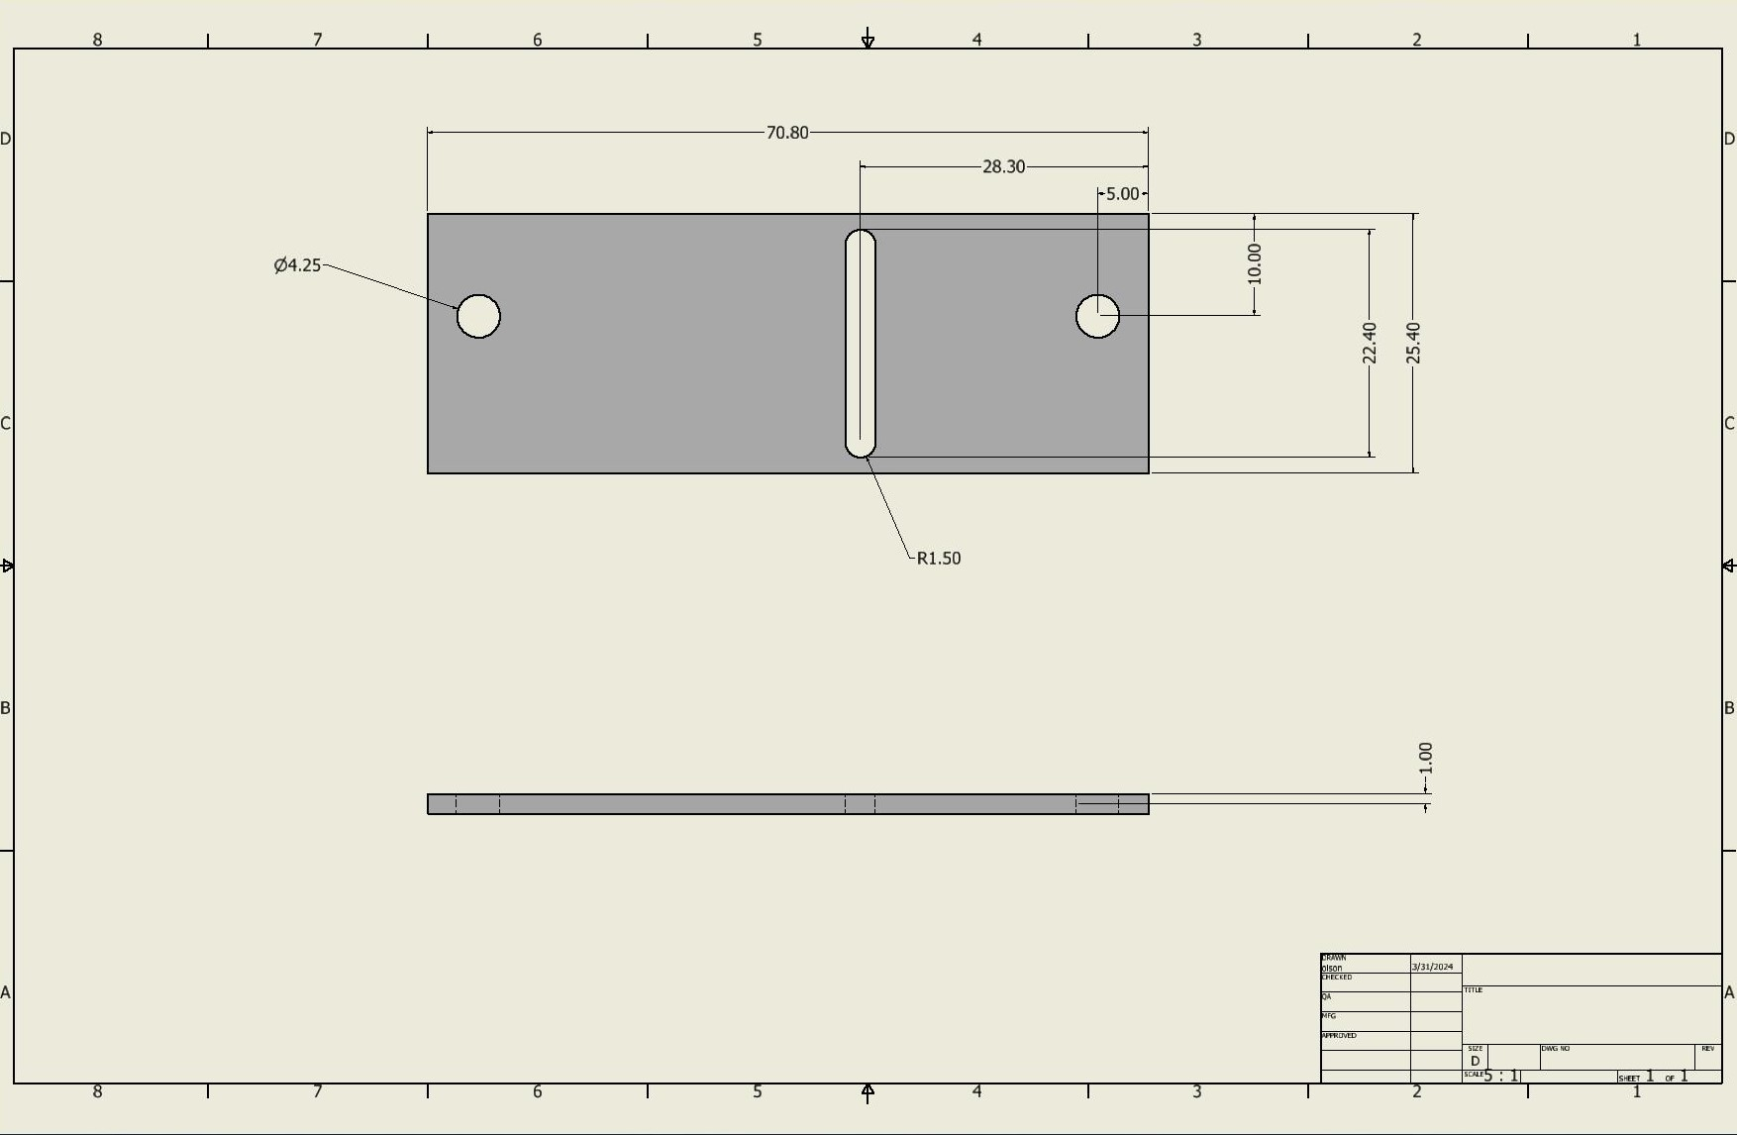

*Figure 1. Ultrasonic Sensor Attachment for Side of Robot*

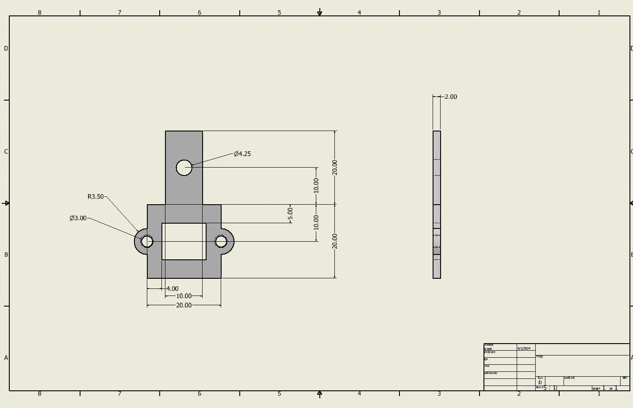

*Figure 2. Time of Flight Sensor Attachment*

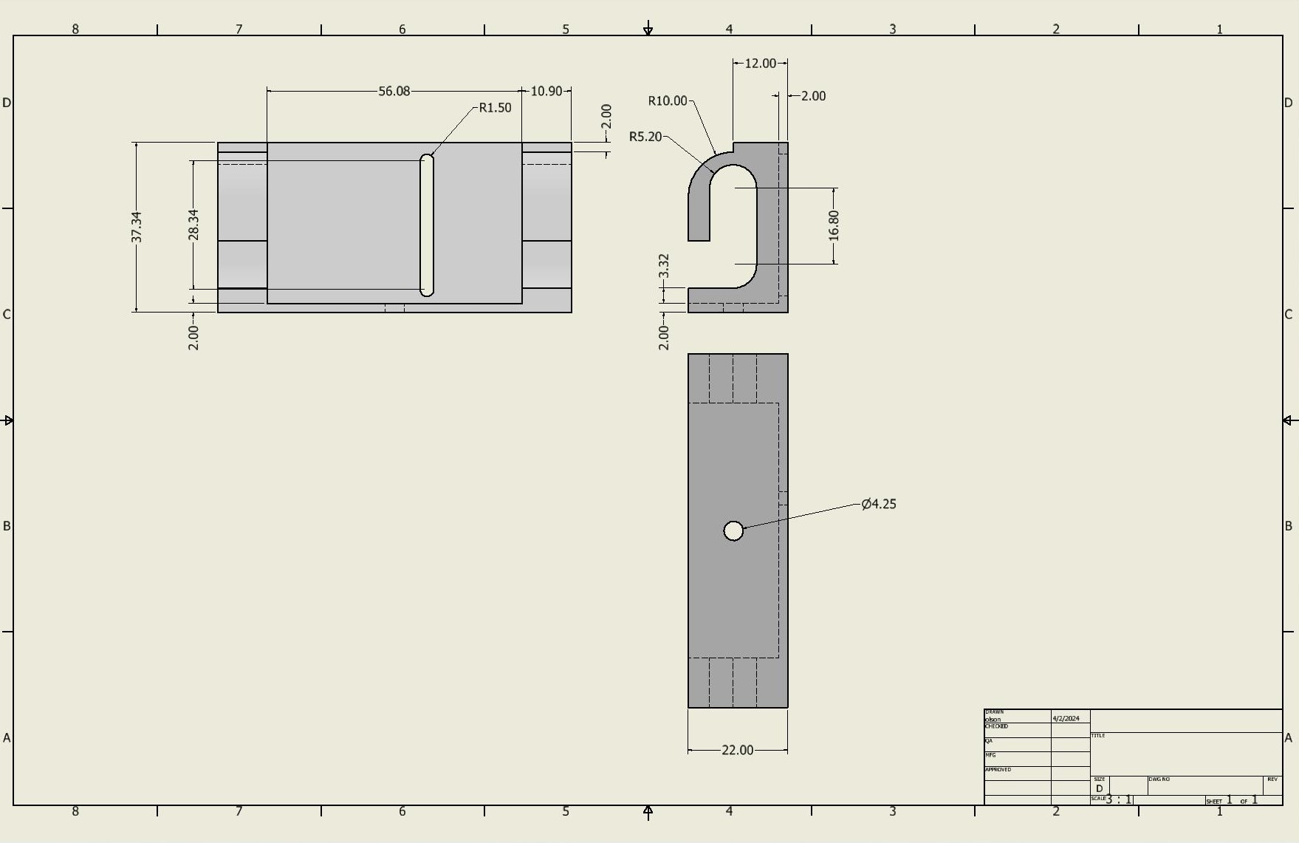

*Figure 3. Line Following Sensor Adjustment Attachment with Ultrasonic Integration*

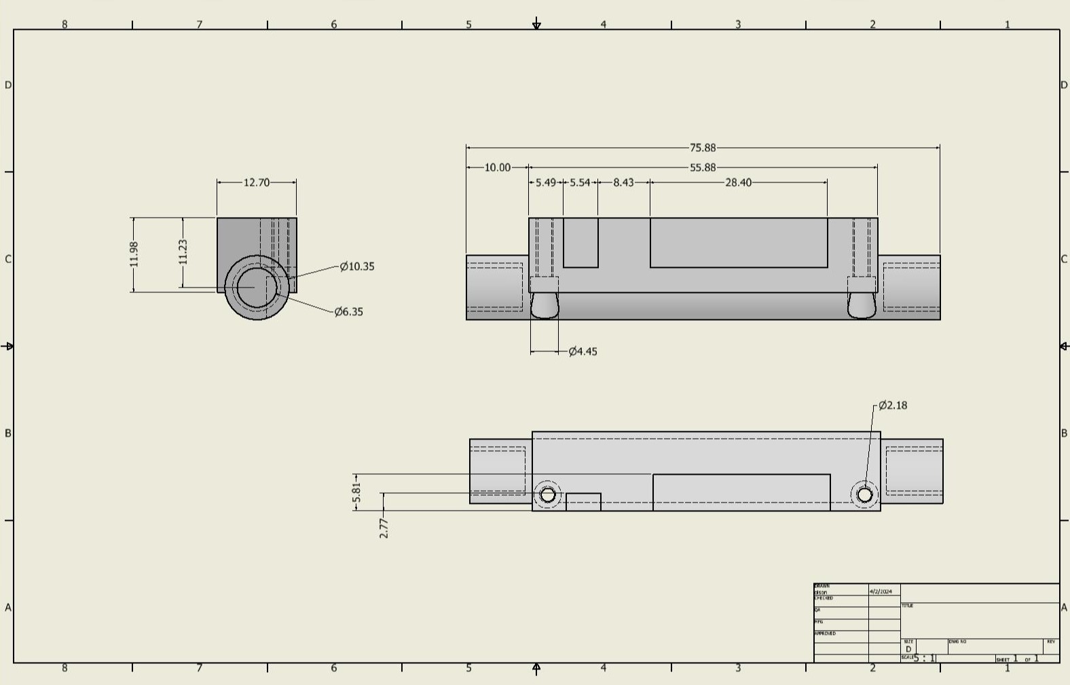

*Figure 4. Line Following Sensor Bracket Attachment*

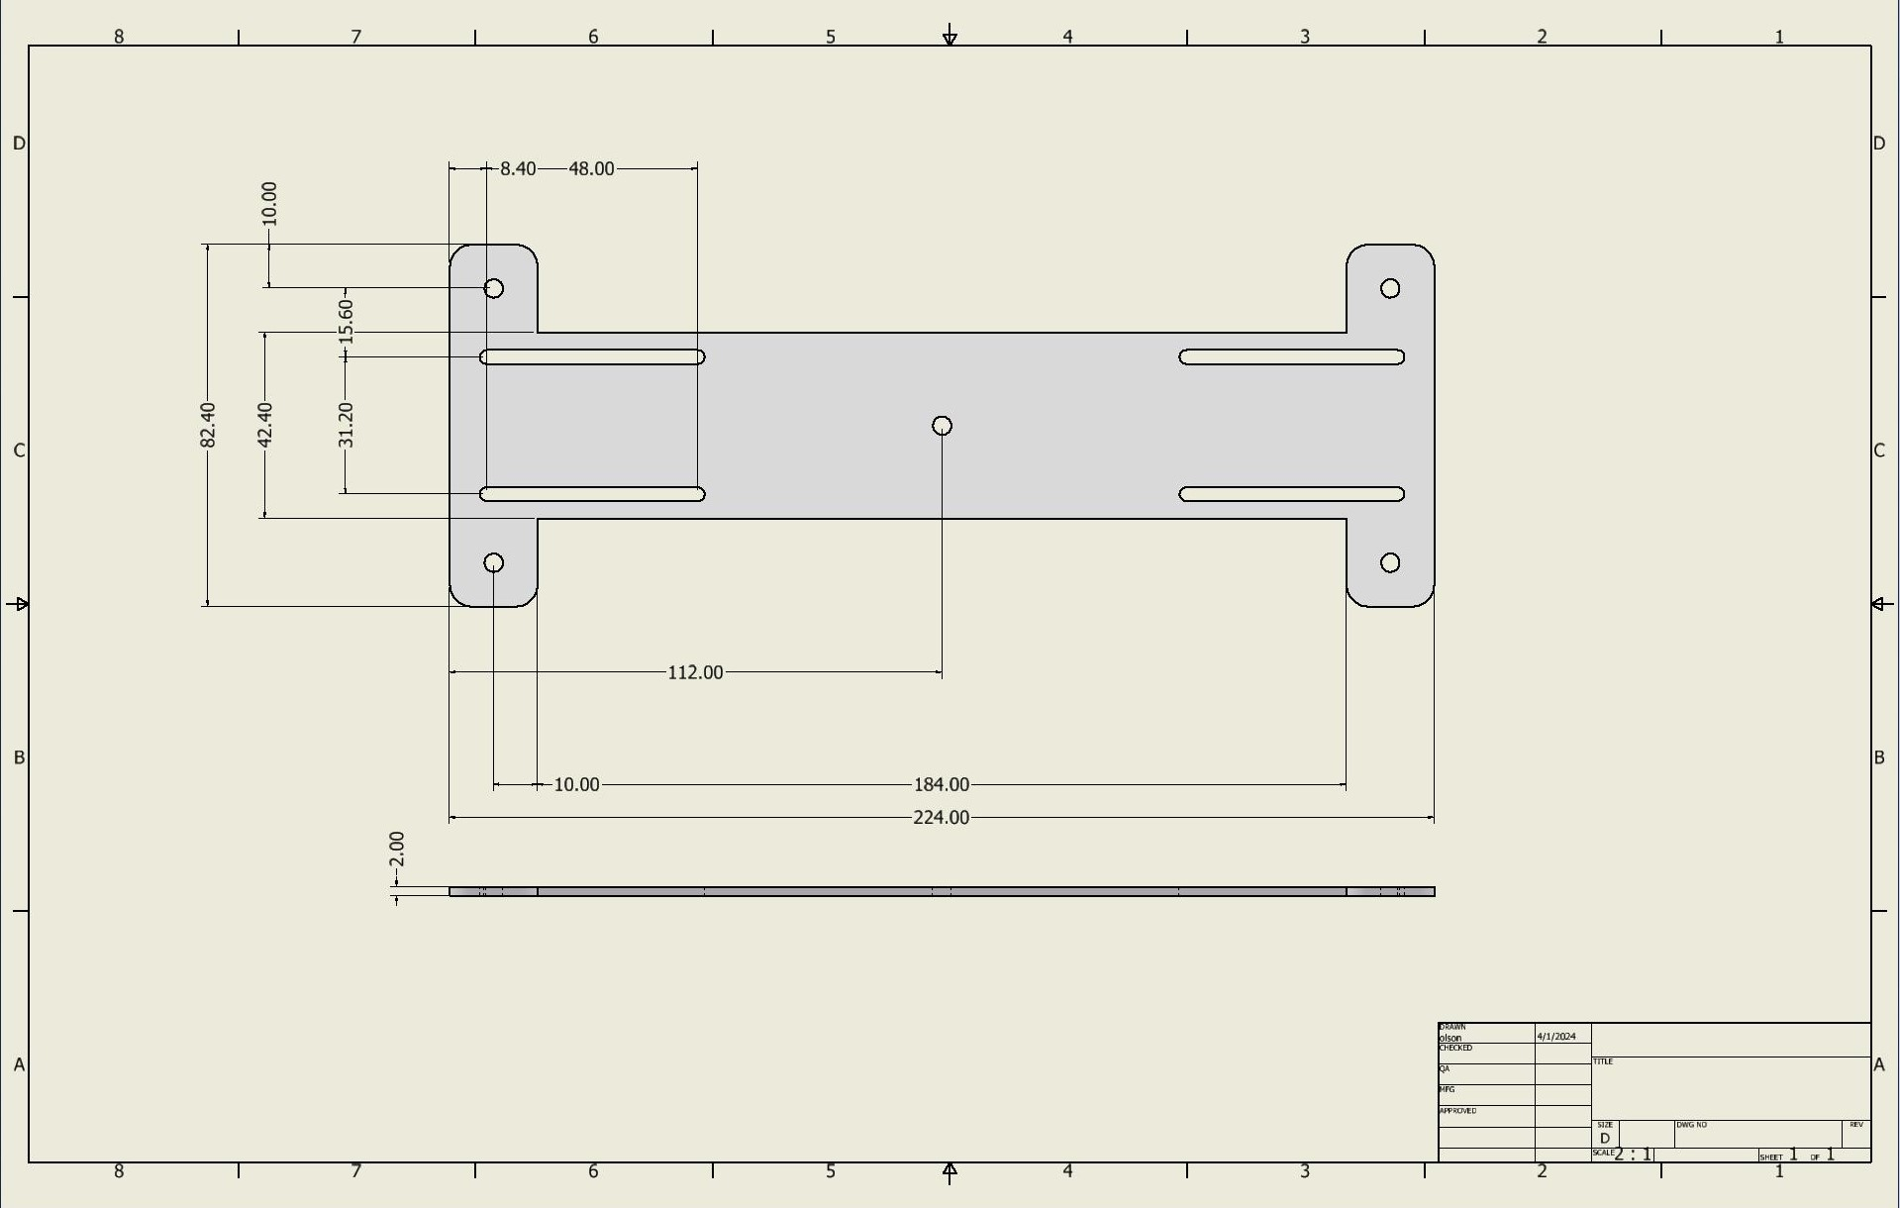

*Figure 5. Motor Attachments*

**Logic, General Notes, Reasonings**

This subsystem was created to give versatility to future SECON teams. With multiple sensors sets, there was a need for easy removal, addition, and movement of sensors. Therefore, a 3D printed component was made for each sensor with this in mind. To solve these problems, holes to attach sliding t-slot nut were integrated into each design seen above. The t-slot nuts can be added by dropping them in and tightening down the screw. This means that the frame does not need to disassemble to add or remove any component to it. Additionally, by slightly unscrewing a component can then be slid along the extruded aluminum for easy movability. For future teams, changes to designs for specific uses can be made using 3D software. Another option is to create new attachment designs if large changes are needed. It will be important to add the holes to still use the t-slot nuts to any future designs.

The designs for the ultrasonic sensor were designed to account for a few things. The front design was integrated into the line following attachment due to space and both items needing to be in the middle of the robot. The side design was designed to reduce space consumption because time of flight sensors also needed to be placed in that area. Both had to go in between the motors, so being aware of space was important. The time-of-flight sensors are simple. They needed to take up a small amount of space and allow the cord on the back of the device to be accessible. The line following attachment was slightly more complicated. Originally, the sensor had a specification of needing to be 0.125 to 0.375 inches from the ground. However, it was discovered that for our application we could raise it and it still works. We also needed to be able to traverse an incline so raising the sensor was needed to be able to clear an incline. For a specific application a new design of this attachment is recommended.

The motor attachment went through multiple iterations. Originally each motor had its own attachment, and they were made of plastic. Both attributes were changed. The design was changed so that motors across from each other were on one attachment to that when moved the motors would stay in line with the one across from it. This prevents alignment issues. Also, the design had to be cut out of metal because the PLA was too flexible. The flexibility caused instability and did not hold the motors rigid enough. This resulted in the sagging of the motors. After both ideas were integrated, the attachment has worked great since.