**Chassis**

**General Description**

The function of this subsystem is to be the structure of the robot. This will let components be connected through a strong frame. The goals of this subsystem are to offer customizable dimensions, allow for easy adaptability, and be able to withstand a 20-pound load. All of this will be accomplished by using extruded aluminum to construct the frame.

**Equipment, Parts, Software Used**

|  |  |
| --- | --- |
| Part Name (Quick Specs) | Link to the part purchased |
| T Slot Extruded Aluminum | https://www.amazon.com/Aluminum-Extrusion-European-Standard-Anodized/dp/B08CN92SP1/ref=asc_df_B08PQPJYHX/?tag=hyprod-20&linkCode=df0&hvadid=476087064164&hvpos=&hvnetw=g&hvrand=14031235594181596355&hvpone=&hvptwo=&hvqmt=&hvdev=c&hvdvcmdl=&hvlocint=&hvlocphy=9013365&hvtargid=pla-1157023532048&th=1 |
| Connectors for Extruded Aluminum | https://www.amazon.com/L-Shape-Interior-Connector-Aluminum-Extrusion/dp/B08D6T9CGN/ref=pd_bxgy_sccl_1/139-9689770-5042269?pd_rd_w=LBF8j&content-id=amzn1.sym.43d28dfc-aa4f-4ef6-b591-5ab7095e137f&pf_rd_p=43d28dfc-aa4f-4ef6-b591-5ab7095e137f&pf_rd_r=SWJHE8MBWCDTXK7NJSQ6&pd_rd_wg=9JGgU&pd_rd_r=4831d6bc-d14e-4b38-ba79-b635511d6877&pd_rd_i=B08D6T9CGN&th=1 |
| Drop in T-nuts | https://www.amazon.com/KOOTANS-Fastener-Sliding-Aluminum-Extrusion/dp/B07PMM7C44/ref=sr_1_9?crid=2ZUI5D5IZL1PU&dib=eyJ2IjoiMSJ9.Hk2bm5mMqUaRd_8_UECGogBRO_2RuCVE5Qqe2ml6Q0su1SPxhIllrtoO8GOmUirvnGVB3aAU-EHWGAEsmKeLD3aYAS3JYoGE8Nx_T1ah0er9NIKsNzPDW1sDH_Fg-hs_ID0mcQXrP86VZ64V2IvoK4lxcxVGJYyhkPWwkmfrP0SX9srZn6n2PAuKQyXs0UVfCATpoh4kET6nSs7GcXOcUiLL93ASEQFR7RgZHXEDGJdc66vwd5-FqPfYJi7xmMlfOkeXUua5WQoGCLSOHm3KWRW-J3sJTG0MyeRLwdZ5bms.6Ulsfou4V9A4vQcGNSTqkyzDCcgQBrmiEAZXOINJxEY&dib_tag=se&keywords=drop%2Bin%2Bnut&qid=1711337924&s=hi&sprefix=drop%2Bin%2Bnut%2Ctools%2C133&sr=1-9&th=1 |

**Schematic**

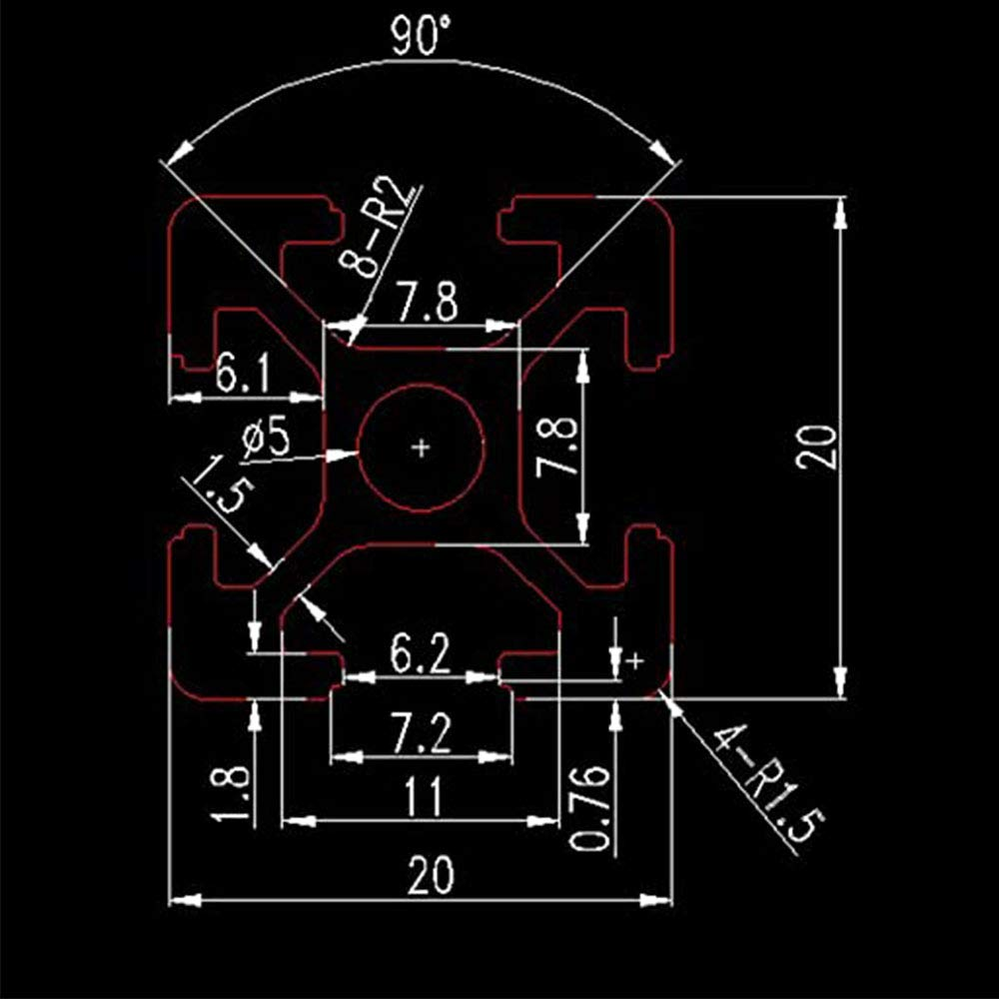

*Figure 1. Extruded Aluminum Specs*

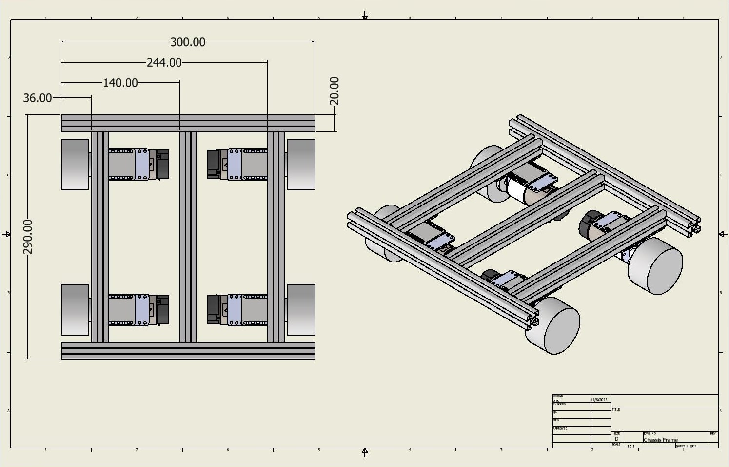

*Figure 2. Frame Layout*

**Logic, General Notes, Reasonings**

T-slotted extruded aluminum was generally selected for its strength, weight, and versatility. With a high yield strength, the aluminum can easily withstand the 20-pound expected load and any future additions. The aluminum is also lightweight; therefore, it does not add considerably to the overall weight of the robot. In competitions where a weight limit is enforced, the frame will take up a minimal amount. Finally, the versatility of the material was the main reason it was selected. Two of the main functions of the robot are to have customizable dimensions and be easily adaptable. The aluminum comes in multiple lengths and if those are not exactly the sizes needed, then they can be cut to length. Additionally, the t-slots with drop-in nuts allow for any attachment to easily be added, moved, or removed. With all these attributes, the t-slot extruded aluminum was a great selection for the chassis of the robot.

The specific size and lengths of extruded aluminum were selected for this project for a few reasons. The smaller 20 mm by 20 mm extrusion was selected to minimize the space consumed by the chassis. For future use, an additional layer will need to be added to the robot or a different layout selected. Therefore, it was important to select an extrusion that was as small as possible that would still perform. The two lengths selected, 250 mm and 300 mm, were chosen because combined in the layout selected allowed the robot to take up as much of the 12 in by 12 in maximum competition area while also allowing some clearance on both sides of the robot.

Future teams can either adopt the layout selected or redesign it for competition needs. Redesigning would be easy due to the easy adaptability of the extruded aluminum, the slotted sheets included in this manual, and the designing of attachments for components like sensors.