**Game Performance**

1. 反应时间 becoming smaller and smaller?

Mauchly's Test, P= 0.000004 <0.05 violates, then we use Greenhouse-Geisser

F(2.959118, 79.896192) = 0.866086, P= 0.461033>0.05, ηp2 = 0.031080

No trending at all!

H:

Mauchly's Test, P= 0.001036 <0.05 violates, then we use Greenhouse-Geisser

F(2.428629, 21.857661) = 1.437709, P= 0.259823>0.05, ηp2 = 0.137742

D:

Mauchly's Test, P= 0.000110 <0.05 violates, then we use Greenhouse-Geisser

F(1.677632, 15.098689) = 1.261806, P= 0.304687>0.05, ηp2 = 0.515031

M:

Mauchly's Test, P= 0.566555 >0.05 no violates, then we use Sphericity Assumed

F(6.000000, 54.000000) = 0.602378, P= 0.727166>0.05, ηp2 = 0.062732

All No trending

1. 正确率 becoming bigger and bigger

Mauchly's Test, P= 4.429E-12 <0.05 violates, then we use Greenhouse-Geisser

There was a significant effect of DayTime on Success rate at the p<.05 level for the three conditions [F(2.217682, 59.877409) = 27.500078 , p = 1.0511E-9<0.05, ηp2 = 0.504588].

成绩都是越来越好

H:

Mauchly's Test, P= 0.045603 <0.05 violates, then we use Greenhouse-Geisser

F(1.977863, 17.800765)= 12.401458 p= 0.000437 ηp2= 0.579468

H组成绩是越来越好的

D:

Mauchly's Test, P= 0.043960 <0.05 violates, then we use Greenhouse-Geisser

F(2.436380, 21.927416)= 9.240414 p= 0.000709 ηp2= 0.506590

D组也是越来越好

M:

Mauchly's Test, P= 4.6932E-13 <0.05 violates, then we use Greenhouse-Geisser

F(1.100707, 9.906363)= 7.521379 p= 0.019157 ηp2= 0.455251

M组也是越来越好, 但是H组的增长趋势是最明显的

1. 每组每个人每次平均反应时间的折线图

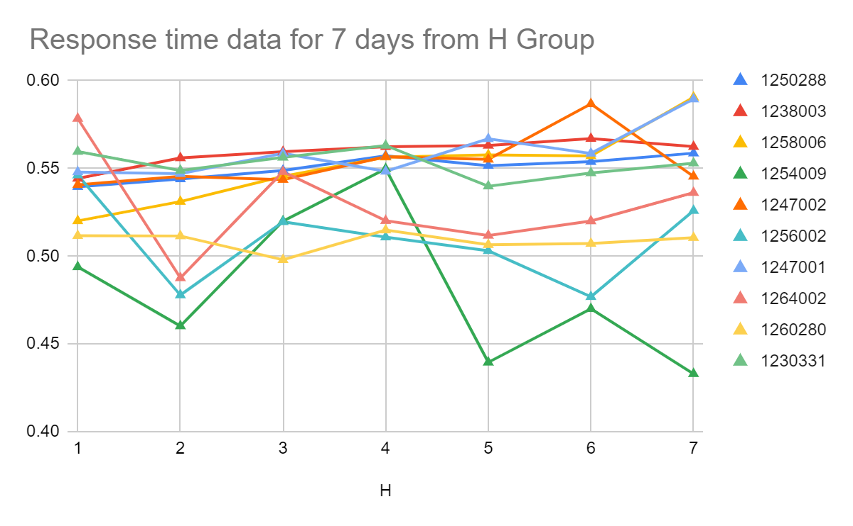

H group Game Performance response time

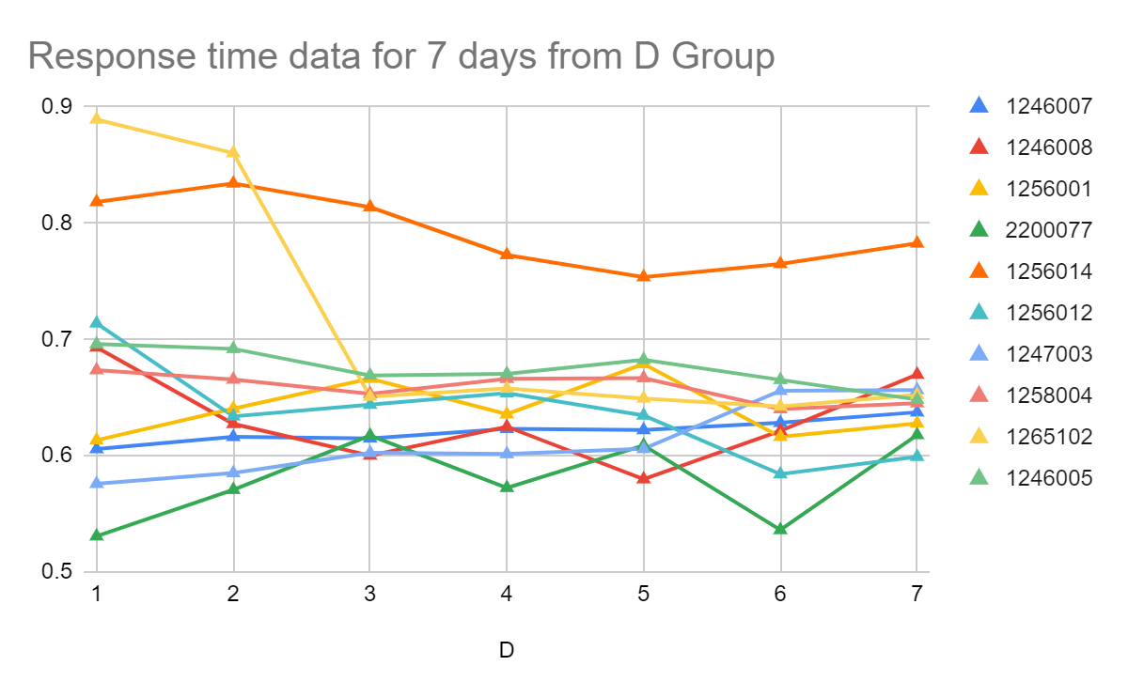

D group Game Performance response time

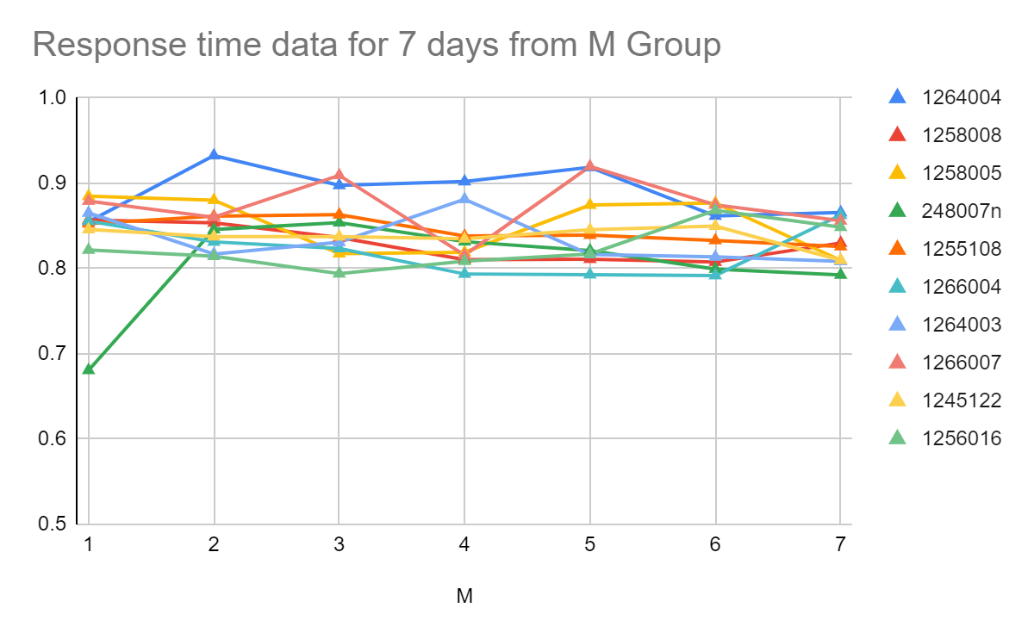

M group Game Performance response time

1. 每组每个人每次平均正确率的折线图

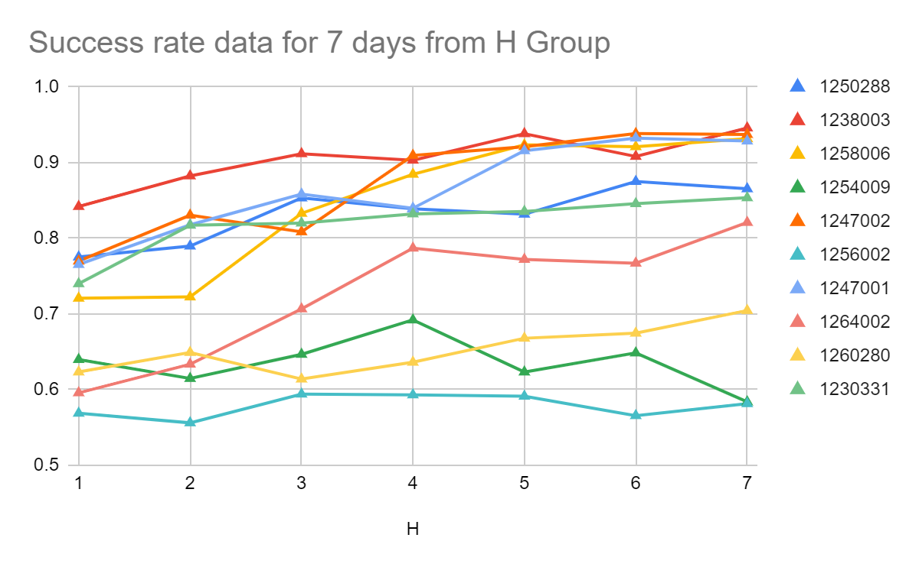

H group Game Performance success rate

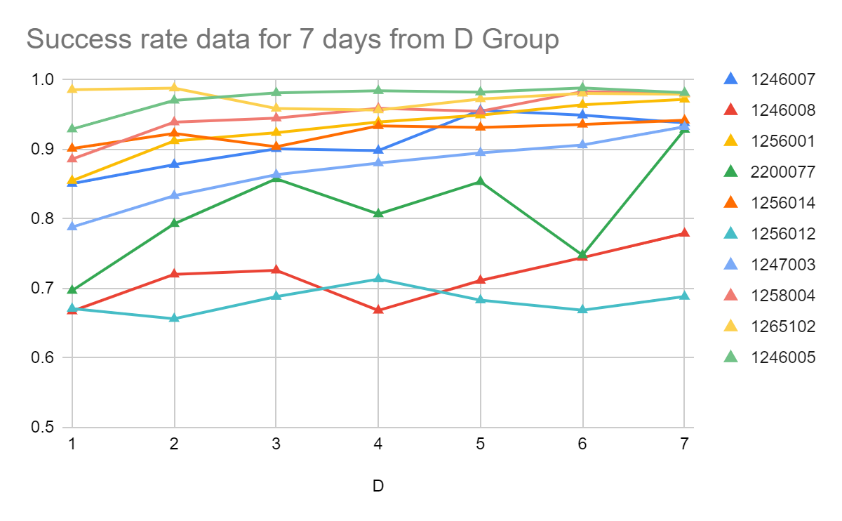

D group Game Performance success rate

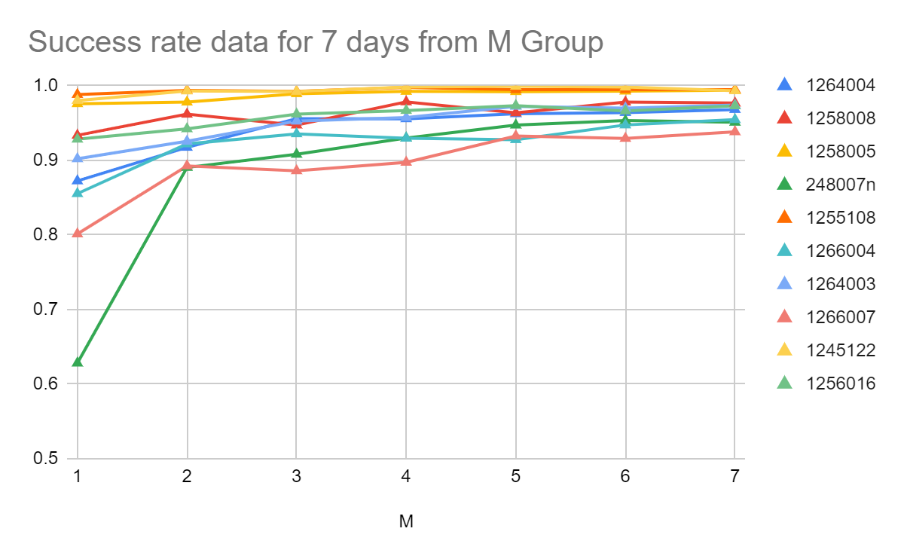

M group Game Performance success rate

1. 个人整体实验平均反应时间组间对照

F(2,27)= 142.171285

P=4.6205E-15<0.05 ηp2= 0.913279

H vs M = 2.6371E-15

H vs D= 0.000001

M vs D= 3.2115E-10

It reflects that the response time for each group is essentially different from each other, HIIT is the most challenging.

|  |  |  |  |  |
| --- | --- | --- | --- | --- |
| SUMMARY | |  |  |  |
| Groups | Count | Sum | Average | Variance |
| H | 10 | 5.353494 | 0.535349 | 0.000744 |
| D | 10 | 6.560141 | 0.656014 | 0.003605 |
| M | 10 | 8.41058 | 0.841058 | 0.000654 |

1. 正确率组间对照

F(2,27)= 9.058058

P=0.000977<0.05 ηp2=0.401544

H vs M = 0.000699

H vs D= 0.066260

M vs D= 0.243052

H显著低于M

H和D差别不显著

M和D差别也不显著

|  |  |  |  |  |
| --- | --- | --- | --- | --- |
| SUMMARY |  |  |  |  |
| Groups | Count | Sum | Average | Variance |
| H | 10 | 7.738304 | 0.77383 | 0.01342 |
| D | 10 | 8.745965 | 0.874596 | 0.010955 |
| M | 10 | 9.49802 | 0.949802 | 0.001445 |

1. MICT 观察是否正确率稳定

Yes, gradually converging to 90%-100%

1. DDA正确率是否在一个区间

0.85-1.0

1. HRT & RRT between subjects

F (1, 18) = 2.443351

P= 0.135434>0.05

ηp2=0.119518

HIIT和Rest阶段的反应时间区别不显著

1. HSR & RSR between subjects

F (1, 18) = 0.172055

P= 0.683194>0.05

ηp2= 0.009468

HIIT和Rest阶段的正确率区别不显著

1. HRT或者RRT becoming better and better

HRT:

Mauchly's Test, P= 0.850927 >0.05 not violates, then we use Sphericity Assumed

F(6.000000, 54.000000)= 1.311413 p= 0.267995>0.05 ηp2= 0.127181

HIIT阶段的反应时间上并没有显著性的变快

RRT:

Mauchly's Test, P= 0.138052 >0.05 not violates, then we use Sphericity Assumed

F(6.000000, 54.000000)= 3.683806 p= 0.003861<0.05 ηp2= 0.290434

REST阶段的反应时间上有显著性的变快. 但效应量不太足.

1. HSR or RSR 逐渐变得更好

HSR:

Mauchly's Test, P= 0.217931 >0.05 not violates, then we use Sphericity Assumed

F(6.000000, 54.000000)= 11.490101 p= 3.0423E-8<0.05 ηp2= 0.560764

HIIT阶段的正确率有显著性地变好

RSR:

Mauchly's Test, P= 0.115883>0.05 not violates, then we use Sphericity Assumed

F(6.000000, 54.000000)= 2.535830 p= 0.030949<0.05 ηp2= 0.219822

REST阶段的正确率有显著性的变快. 但效应量不太足 比HIIT阶段差.

**Pre-Post stop signal task**

1. We have excluded success rates below 80%
2. 反应时间前后测是否有差异

整体前后

Within Time:

F(1,27)= 4.406048 P= 0.045298<0.05 ηp2= 0.140293

前后显著

但effect size稍微有点低

H:

F(1.000000, 9.000000)= 5.807843 p= 0.039252<0.05 ηp2= 0.392214

H组训练之后反应时间显著更快了, 但是效应量稍微有点小

D:

F(1.000000, 9.000000)= 0.548551 p= 0.477787>0.05 ηp2= 0.057449

D组训练之后几乎没有提高

M:

F(1.000000, 9.000000)= 0.886987 p= 0.370886>0.05 ηp2= 0.089713

M组训练之后也基本没提高

Between Groups:

F(2.000000, 27.000000)= 0.369994 p= 0.694187>0.05 ηp2= 0.026676

组与组之间无显著性反应时间的差别, 说明人之间的反应时间其实是差不多的, 不太受难度影响

1. 正确率前后测是否有差异

整体:

Within:

Time:

F(1,27)= 2.170420

P= 0.152251>0.05 ηp2= 0.074405

前后不显著

H:

F(1.000000, 9.000000)= 0.000136 p= 0.990936>0.05 ηp2= 0.000015

H组前后正确率并不显著  
D:

F(1.000000, 9.000000)= 4.804317 p= 0.056079>0.05 ηp2= 0.348030

D组也不显著  
M:  
F(1.000000, 9.000000)= 0.673393 p= 0.433068>0.05 ηp2= 0.069613

M组也不显著

其实就是前后基本没有训练效果.

Between Groups:

F(2,27)= 1.241623

P= 0.304891>0.05 ηp2= 0.084226

不同组之间的区别也不大

1. 反应时间差值组间对照

F(2,27)= 0.251093

P= 0.779747>0.05 ηp2= 0.01825985196 区别不显著

反应时间差组别并不明显

1. 正确率差值组间对照

F(2,27)= 0.980347

P= 0.388141>0.05 ηp2= 0.06770192584

正确率组别依旧不明显

**Scales**

PENS & IMI

1. Descriptive
2. Each scale between group

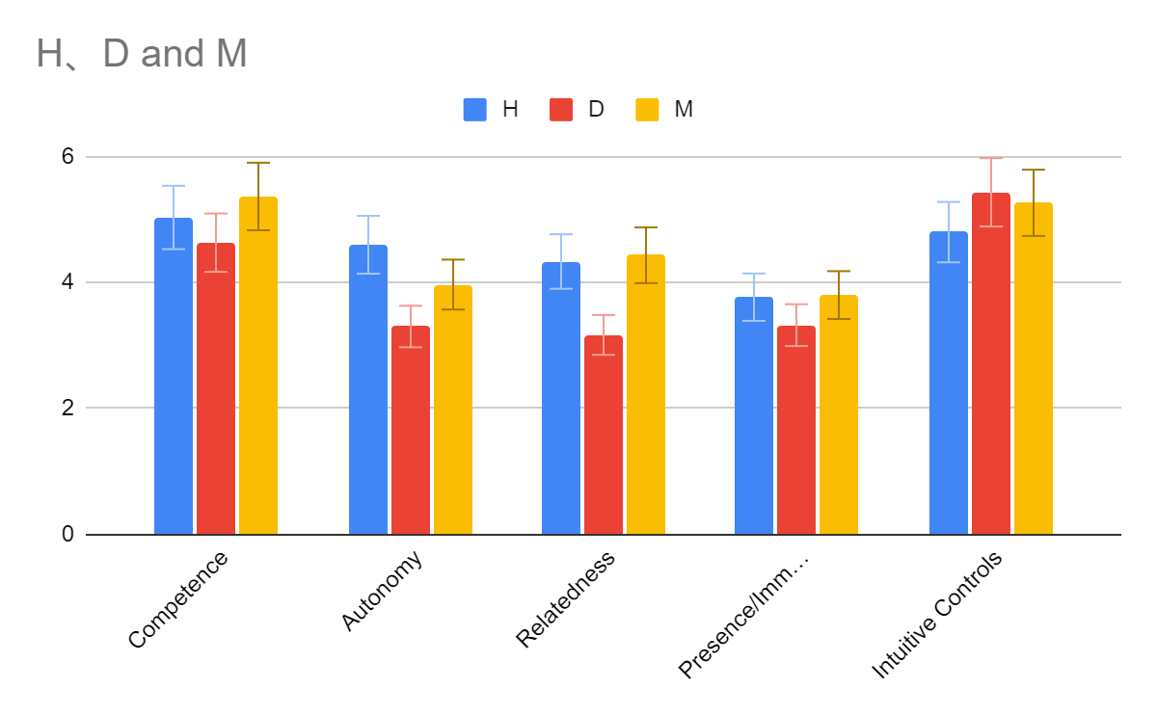

PENS

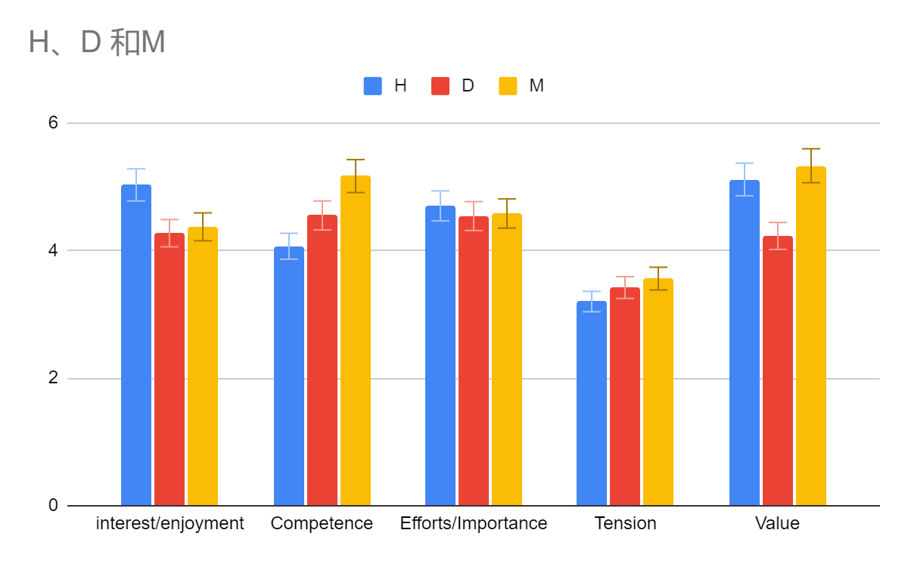

IMI

1. IMI between subjects

|  |  |  |  |  |  |  |
| --- | --- | --- | --- | --- | --- | --- |
| **ANOVA** | | | | | | |
|  | | Sum of Squares | df | Mean Square | F | Sig. |
| Interest/enjoyment | Between Groups | 3.384 | 2 | 1.692 | .963 | .395 |
| Within Groups | 47.447 | 27 | 1.757 |  |  |
| Total | 50.831 | 29 |  |  |  |
| Competence | Between Groups | 6.080 | 2 | 3.040 | 2.004 | .154 |
| Within Groups | 40.958 | 27 | 1.517 |  |  |
| Total | 47.038 | 29 |  |  |  |
| Efforts/Importance | Between Groups | .139 | 2 | .069 | .091 | .913 |
| Within Groups | 20.460 | 27 | .758 |  |  |
| Total | 20.599 | 29 |  |  |  |
| Tension | Between Groups | .659 | 2 | .329 | .281 | .758 |
| Within Groups | 31.700 | 27 | 1.174 |  |  |
| Total | 32.359 | 29 |  |  |  |
| Value | Between Groups | 6.801 | 2 | 3.401 | 1.939 | .163 |
| Within Groups | 47.349 | 27 | 1.754 |  |  |
| Total | 54.150 | 29 |  |  |  |

All of them are not significant.

1. PENS between subjects

|  |  |  |  |  |  |  |
| --- | --- | --- | --- | --- | --- | --- |
| **ANOVA** | | | | | | |
|  | | Sum of Squares | df | Mean Square | F | Sig. |
| Competence | Between Groups | 2.696 | 2 | 1.348 | 1.700 | .202 |
| Within Groups | 21.411 | 27 | .793 |  |  |
| Total | 24.107 | 29 |  |  |  |
| Autonomy | Between Groups | 8.452 | 2 | 4.226 | 2.735 | .083 |
| Within Groups | 41.711 | 27 | 1.545 |  |  |
| Total | 50.163 | 29 |  |  |  |
| Relatedness | Between Groups | 9.919 | 2 | 4.959 | 5.181 | .012 |
| Within Groups | 25.844 | 27 | .957 |  |  |
| Total | 35.763 | 29 |  |  |  |
| Presence/Immersion | Between Groups | 1.423 | 2 | .712 | .586 | .563 |
| Within Groups | 32.758 | 27 | 1.213 |  |  |
| Total | 34.181 | 29 |  |  |  |
| Intuitive Controls | Between Groups | 2.156 | 2 | 1.078 | .735 | .489 |
| Within Groups | 39.567 | 27 | 1.465 |  |  |
| Total | 41.722 | 29 |  |  |  |

Only Relatedness has significant between-group differences

|  |  |  |  |
| --- | --- | --- | --- |
| Bonferroni | 0 | 1 | .038 |
| 2 | 1.000 |
| 1 | 0 | .038 |
| 2 | .022 |
| 2 | 0 | 1.000 |
| 1 | .022 |

H & D: p=0.038374 Significant

H & M: p=1.000 Not significant

D & M: p=0.022262 Significant