Screenshots

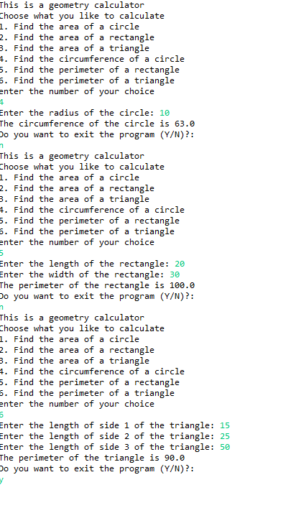

I have learned a lot from this lab. This lab helped me understand more about methods. The problem I had before was that the answers would always be 0. And to fix the problem I had to set the value to equal to whatever method is being used from one of the 6 choices of the menu.

But overall this lab was fairly easy.