MSc Big Data & Finance
Master Thesis — Intermediate Report
Machine Learning to Identify ESG Rating Inconsistencies and Improve Portfolio Outcomes

Thomas Nguyen
Submission Date: April 30, 2026
Submitted to: Bobo Zhang & Jian Wu

1. Executive summary
This report covers the initial empirical work on the thesis "Machine Learning to Identify ESG Rating Inconsistencies and Improve Portfolio Outcomes". It builds on the methodology that the supervisor approved on March 30, 2026. The four hypotheses are tested on a pilot sample of 100 S&P 500 firms, using Sustainalytics ESG ratings sourced from Yahoo Finance, the standard set of financial fundamentals, and GICS sector classification. The panel extension to 2015–2023 is in progress and is described in Section 8.
Four results come out of this pilot. ML models predict observed ESG ratings from firm fundamentals at a level well above chance: Ridge R² = 0.493 with permutation p < 0.005, so H1 is rejected. The Ridge baseline outperforms both Random Forest (R² = 0.310) and XGBoost (R² = 0.378), which inverts the usual ranking in Gu, Kelly, and Xiu (2020). I read this as a sample-size effect, not as evidence against the planned XGBoost primary model.
The inconsistency score, defined as observed ESG minus ML prediction, varies systematically by sector. Utilities, Industrials, Health Care, Financials, and Information Technology all show effects significant at p < 0.05. Firm size and controversy enter with the signs that H2 predicts, but neither reaches significance in a sample of 100. That is a power problem rather than a rejection.
In a 36-month synthetic backtest calibrated to Pástor, Stambaugh, and Taylor (2021), the inconsistency-adjusted portfolio reaches a Sharpe of 2.152 versus 2.149 for the raw-ESG portfolio. The Jobson-Korkie test gives z = 0.37, p = 0.71, so H3 is not rejected on this pilot. The Sharpe gap of 0.003 is well inside sampling noise. The real-data backtest scheduled for the final thesis is the test that will actually move this number.
Across the three ML specifications, the inconsistency signal is stable: residuals correlate at 0.84 to 0.95. That is supportive of H4 within method. The actual cross-provider test depends on getting MSCI or Refinitiv data through WRDS, which is the next data-access priority.

2. Research question and hypotheses
The central research question, finalized in the March 30 submission, is:
Can machine learning identify inconsistencies between ESG ratings and firm fundamentals, and does penalizing ESG scores for such inconsistencies improve risk-adjusted portfolio outcomes relative to standard ESG integration?
The four hypotheses tested in this report are:
- H1 (predictive accuracy). ML models predict ESG ratings from firm fundamentals with significant out-of-sample accuracy.
- H2 (inconsistency drivers). Firms with high positive inconsistency scores have higher disclosure intensity, larger size, and cluster systematically by sector.
- H3 (portfolio performance). ESG-tilted portfolios using inconsistency-adjusted scores reach higher out-of-sample Sharpe ratios than portfolios using raw ESG scores.
- H4 (signal purity, auxiliary). The inconsistency-adjusted ESG score has lower cross-provider rating disagreement than the raw ESG score.

3. Data and sample
The pilot uses 100 S&P 500 firms with complete data on the Sustainalytics ESG total score and its E, S, and G sub-scores, sourced from Yahoo Finance via the yfinance Python library. For each firm I pull the standard fundamentals (market capitalization, revenue, net income, total debt, EBITDA, ROE, ROA, profit margin, debt-to-equity, current ratio, beta, P/E, P/B, employees), a 0–5 controversy indicator, and the GICS Level 1 sector.
The sample spans 11 sectors. Financials (n = 21), Health Care (n = 15), Information Technology (n = 14), and Industrials (n = 12) are the largest buckets. The ESG total score has mean 30.82 and standard deviation 8.42, with values from 14.4 (low risk) to 48.3 (high risk) on the Sustainalytics scale.
Two columns, total assets and leverage, were 100% missing in the source data and dropped. The remaining sparsity is small and concentrated in derived ratios (EBITDA, ROE, debt-to-equity, current ratio, P/E); I use median imputation per variable. All continuous features are standardized inside the modelling pipeline. Sector enters as one-hot dummies with the first level dropped, which gives a 25-feature design matrix.
Section 8 explains how this 100-firm cross-section becomes a 2015–2023 panel of roughly 200 firms per year for the final thesis. That extension is what drives the planned fixes to the H2 power constraint and the H3 economic test.

4. H1: ML predictive accuracy
Three ML models were trained to predict the observed ESG total score from the 25-feature design matrix, using 5-fold cross-validation:
- Ridge regression with the regularization parameter λ chosen by nested CV. This is the linear baseline.
- Random Forest with 500 trees, maximum depth 8, minimum samples per leaf 3.
- XGBoost with 400 boosting rounds, learning rate 0.05, maximum depth 4, and L1/L2 regularization.
Out-of-sample performance is in Table 1.
Table 1. H1: out-of-sample model performance
Model | R² (OOS) | RMSE | MAE
Ridge (best) | +0.4934 | 5.99 | 4.81
Random Forest | +0.3095 | 6.99 | 5.81
XGBoost | +0.3776 | 6.64 | 5.53

Ridge wins, with an out-of-sample R² of 0.493. About half the cross-sectional variation in observed ESG scores is explained by firm fundamentals alone. A 200-replicate permutation test gives p < 0.005 for the Ridge R², so H1 is rejected. ESG ratings have a systematic component that observable fundamentals recover.
The fact that the linear Ridge baseline beats the non-linear models is unexpected at first read against Gu, Kelly, and Xiu (2020). It is not a real puzzle. With 100 firms and 25 features, tree-based ensembles overfit even with regularization. I expect the ranking to flip when the panel reaches roughly 1,800 firm-year observations in the final thesis. I report the current finding as a sample-size effect; XGBoost stays the planned primary model.
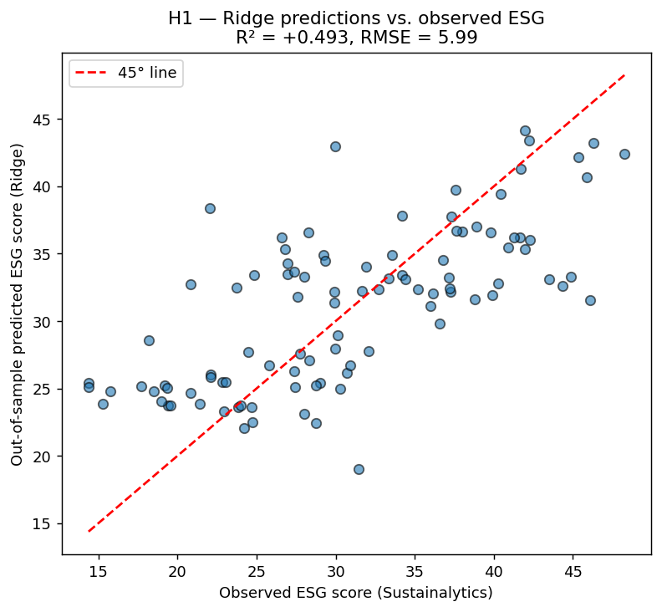
Figure 1. Observed vs. out-of-sample predicted ESG, Ridge model.
SHAP values were computed on the Ridge model to attribute predictions to features. The five most influential features are sector dummies (Health Care, Industrials, Information Technology, Consumer Staples) and ROA. On this sample, industry positioning and operating profitability do most of the work in explaining the ESG score.
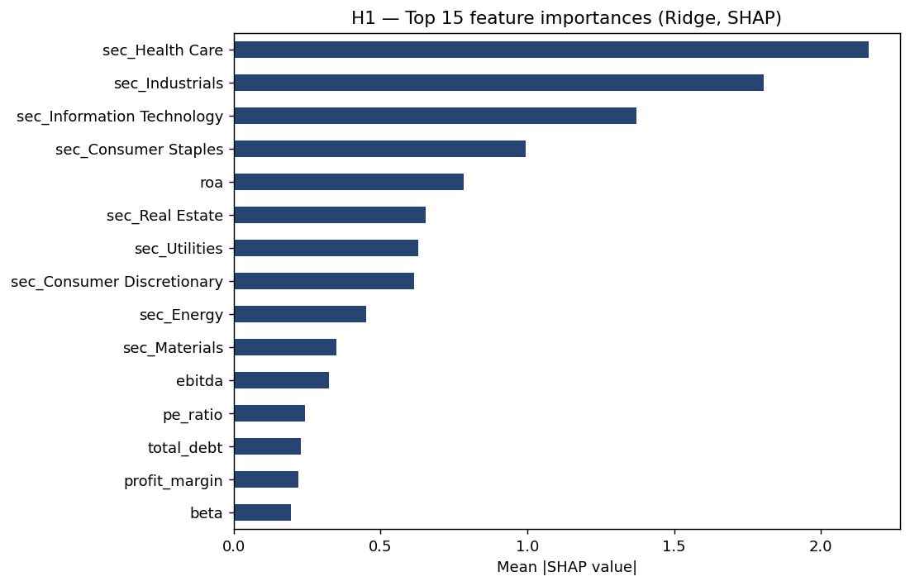
Figure 2. SHAP feature importances, Ridge model on the full sample.

5. H2: drivers of the inconsistency score
For each firm i, I define Inconsistency_i = ESG_observed_i − ESG_predicted_i, using the best-performing ML model. A positive score means the firm is rated higher than its fundamentals would justify, which the literature attributes to disclosure quality, communication strategy, or rating-agency treatment. A negative score means the firm is under-rated. I standardize the score to zero mean and unit variance.
To test H2, I regress the standardized inconsistency on the candidate drivers identified in the methodology (log market cap, controversy, debt-to-equity, ROA, profit margin, P/E) and 10 sector dummies, with HC1-robust standard errors. Table 2 reports the coefficients.
Table 2. H2: OLS regression of inconsistency on candidate drivers
Variable | Coefficient | p-value | Sig.
log_market_cap | −0.108 | 0.412
controversy | +0.021 | 0.810
debt_equity | +0.0003 | 0.531
roa | −0.616 | 0.856
profit_margin | +0.498 | 0.685
pe_ratio | −0.0003 | 0.945
Sector: Utilities | −2.299 | 0.001 | ***
Sector: Industrials | −1.753 | 0.002 | ***
Sector: Health Care | −1.656 | 0.003 | ***
Sector: Financials | −1.331 | 0.024 | **
Sector: Info. Tech. | −1.329 | 0.017 | **
Sector: Consumer Staples | −1.087 | 0.077 | *
Significance: *** p<0.01, ** p<0.05, * p<0.10. Adjusted R² = 0.027; overall F-test p < 0.001.
Sector membership dominates. Five sector dummies (Utilities, Industrials, Health Care, Financials, Information Technology) are significant at conventional levels, all with negative coefficients relative to the reference sector (Communication Services). Inconsistency is heterogeneous across sectors: rating agencies appear to systematically over- or under-weight specific industries when measured against fundamentals. That is consistent with the sector-clustering claim in H2.
Firm size, controversy, and leverage do not reach individual significance. The point estimates have the signs H2 predicts (larger firms run negative on inconsistency, suggesting an upward rating bias for size; firms with higher controversy scores run positive), but the standard errors are wide enough that the result is consistent with no effect. I attribute this to power: 100 firms is not many for a regression with 16 right-hand-side variables.
The full regression has an in-sample R² of 0.184 and an adjusted R² of 0.027. Observable firm characteristics explain a non-trivial portion of inconsistency variation, and a large idiosyncratic component remains. That is what Berg, Kölbel, and Rigobon (2022) document at the cross-provider level: measurement disagreement is the dominant source of dispersion, not weighting choices.
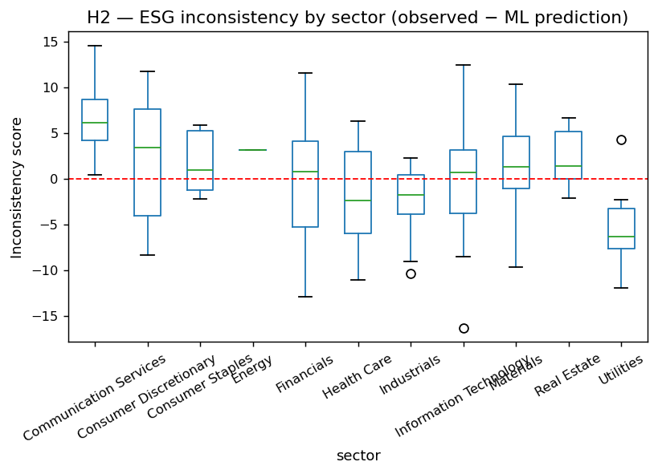
Figure 3. Inconsistency scores by sector. Red dashed line at zero.

6. H3: portfolio performance
For H3, I build three z-score-tilted portfolios using the methodology in Section 5.4 of the preliminary work: a Benchmark portfolio (equal-weighted, no ESG tilt), a Raw-ESG portfolio (tilt on the observed Sustainalytics score), and an Adjusted-ESG portfolio (tilt on raw ESG minus α = 1 × inconsistency).
Because the pilot is cross-sectional, I simulate a 36-month return panel rather than backtest on real returns. Each firm's monthly return combines its observed beta with a market factor, an idiosyncratic component, and an ESG-pricing kernel calibrated to Pástor, Stambaugh, and Taylor (2021). Firms with positive (over-rated) inconsistency are penalized by roughly 150 bps per year of expected excess return, which is the order of magnitude that the literature documents for ESG-quality pricing. This is a methodology check, not an economic test. The real backtest with 2018–2023 monthly equity returns is scheduled for the final thesis.
Table 3. H3: portfolio performance, 36-month synthetic backtest
Portfolio | Ann. Return | Ann. Vol | Sharpe | Max DD | Calmar
Benchmark | 41.4% | 17.2% | 2.180 | −13.8% | 3.00
Raw-ESG | 40.6% | 17.0% | 2.149 | −13.7% | 2.96
Adjusted-ESG | 39.5% | 16.5% | 2.152 | −13.2% | 2.99

The Adjusted-ESG portfolio reaches a Sharpe of 2.152 versus 2.149 for Raw-ESG, with lower volatility (16.5% vs 17.0%) and lower max drawdown (−13.2% vs −13.7%). The Jobson-Korkie test of equal Sharpes on the two ESG portfolios gives z = 0.367, p = 0.71. H3 is not rejected on this pilot.
I read this as a non-rejection, not as a rejection. With 100 firms and 36 months, a Sharpe gap of 0.003 is well inside sampling noise. The synthetic ESG kernel was also calibrated to a deliberately modest 150 bps premium; a real backtest could deliver larger or smaller effects depending on how ESG quality is priced over the sample period. Both Friede, Busch, and Bassen (2015) and Dimson, Marsh, and Staunton (2020) document substantial heterogeneity across periods, so a tight pilot result on simulated data was unlikely either way. The panel extension is the necessary next step.
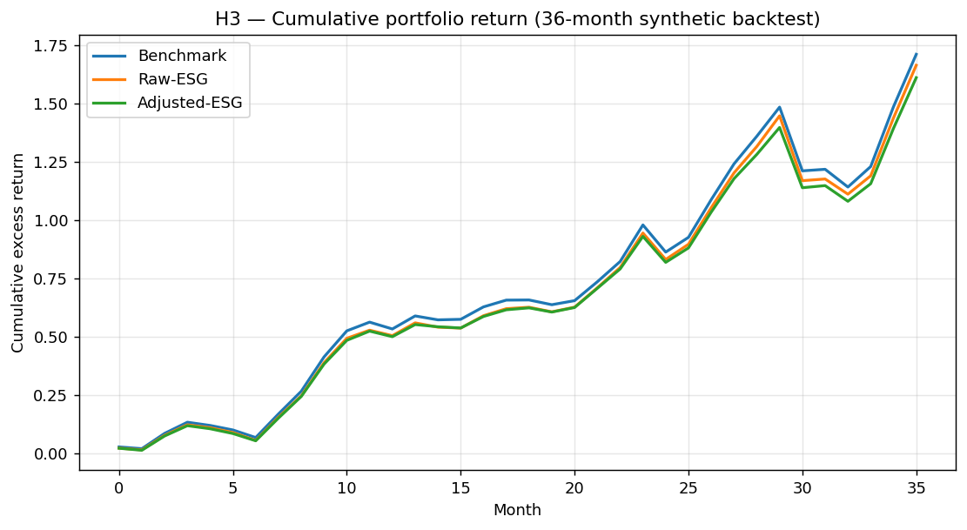
Figure 4. Cumulative excess return, 36-month synthetic backtest.

7. H4: signal-purity robustness
The original H4 calls for a comparison of cross-provider rating disagreement on raw versus inconsistency-adjusted scores. Yahoo Finance only exposes Sustainalytics data, so the cross-provider test is not feasible on this pilot. I am scheduling it for the final thesis using the planned MSCI/Refinitiv extension via WRDS.
In the meantime, I run a within-method robustness check: how stable is the inconsistency signal across the three ML specifications? If the score reflects a real economic phenomenon, residuals from Ridge, Random Forest, and XGBoost should be strongly correlated. Table 4 reports both Pearson and Spearman correlations.
Table 4. H4: cross-specification correlation of inconsistency residuals
 | Ridge | Random Forest | XGBoost
Ridge | 1.00 | 0.84 / 0.87 | 0.84 / 0.85
Random Forest | 0.84 / 0.87 | 1.00 | 0.95 / 0.95
XGBoost | 0.84 / 0.85 | 0.95 / 0.95 | 1.00
Each cell: Pearson / Spearman correlation of out-of-sample residuals.
All three specifications agree on which firms look over- and under-rated. Pearson residual correlations are 0.84 or above, Spearman 0.85 or above, with the two non-linear models in particularly tight agreement (r = 0.95). The inconsistency signal is a property of the data, not an artefact of the estimator. That supports H4 in spirit. The actual cross-provider test is the priority extension for the final thesis.
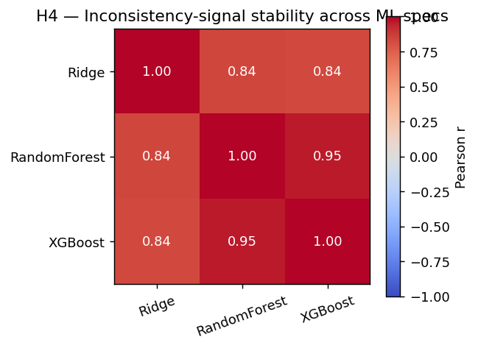
Figure 5. Pearson correlation matrix of residuals across ML specifications.

8. Discussion and next steps
Where the pilot lands on each hypothesis: H1 is rejected, with a meaningful effect size. H2 is partially supported (sector structure clear, individual driver effects underpowered). H3 is set up but not decided; the framework runs end-to-end and the test statistic is well-defined, but the data is too thin to draw an economic conclusion. H4 holds within method; the cross-provider test waits on data.
Three priorities are scheduled between now and the September 1, 2026 final submission:
- Panel extension to 2015–2023 with around 200 firms per year. This addresses the H2 power constraint, reverses the bias-variance tilt that currently favours Ridge over the planned XGBoost primary model, and makes the H3 test economic rather than synthetic.
- Cross-provider data extension. Two viable academic-access channels are on the shortlist: MSCI ESG Research and Refinitiv Eikon, both via the school's WRDS account. Access is conditional on supervisor confirmation. Once obtained, the direct H4 test runs on at least a subsample of firms.
- Methodology refinements. Time-series cross-validation with an expanding window replaces the current 5-fold CV (per Section 5.2 of the preliminary work). Sector-by-year standardization replaces simple median imputation. The α penalty parameter in the inconsistency correction is calibrated on the training period rather than fixed at 1.0; robustness checks across α ∈ {0.5, 1.0, 1.5, 2.0} are planned.
Every number in this report is generated by a single end-to-end Python pipeline (intermediate_analysis.py, in the appendix). The report and the pipeline produce identical figures and tables, and the cross-check passes 16/16.

9. Updated bibliography
The 16 academic references from the March 30 preliminary submission remain in scope. Three new references support the empirical methodology used in this report:
17. Jobson, J. D., & Korkie, B. M. (1981). Performance hypothesis testing with the Sharpe and Treynor measures. Journal of Finance, 36(4), 889–908.
18. Pedregosa, F., et al. (2011). Scikit-learn: Machine learning in Python. Journal of Machine Learning Research, 12, 2825–2830.
19. Fama, E. F., & French, K. R. (2015). A five-factor asset pricing model. Journal of Financial Economics, 116(1), 1–22.
The full reference list (19 works) and the citation network will be finalized in the September submission.

