WIMAX Network Operation Centre (NOC)

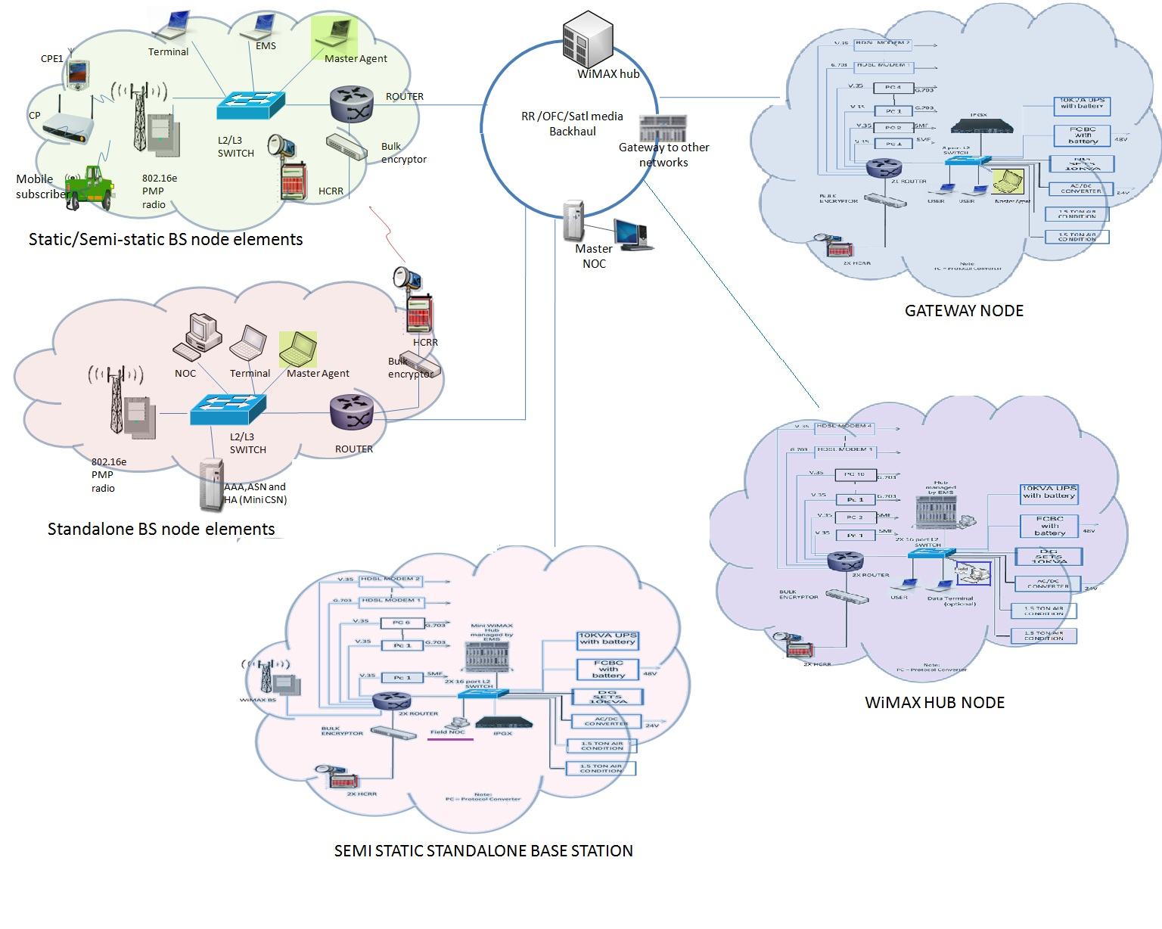

WiMAX NOC Configuration.
NOC Terminal with Standby.
- 8 Port (or more) L-2 Switch.
- IP Encryptor
- Router with Two LAN, and Six WAN links with Transit Switching capacity.
- Protocol Converters like V.35 <-> G.703, Optical <-> V.35
- Point-to-Point High Capacity 2/8/34 Mbps Radio relays to facilitate WAN connectivity between Routers.
- Generator, UPS with Battery Bank, Temperature Control and Earthing equipment.
- Interconnection, 19” rack, cabling and wiring, as required.

NOC Architecture
The NOC Architecture for WiMAX Based Tactical Broadband Wireless System Test Bed is based on Telecom Management Network (TMN) Model of the ITU (T).

The Network Management System (NMS) and Element Management System (EMS) are main parts of NOC which follow the TMN architecture as per ITU m.3010 standard.

The EMS provides all FCAPS functionality and web based management capabilities including:-
- Fault Management.
- Configuration management.
- Accounting management.
- Performance monitoring.
- Security management.

The EMS has open interfaces such as ITU Q3 or TMF-CORBA-SNMP and is capable of integration with other standards based NMS systems in Army. The interfaces towards/from Network elements may be SNMP ver2 or better.

The NMS and EMS uses Application Independent, Open APIs and Standard Interfaces.

Device Management. The NOC provides the following functionalities:-
- Automatic and manual device discovery of all Network Elements (NEs) such as WiMAX BS and WiMAX CPEs by EMS and Device Management System respectively.
- Web based graphical view with context sensitive on-line help and information about distributed Network Elements.

Configuration Management. Menu-driven and hierarchy based operations on the Network elements through all necessary commands or operations to configure network components are provided. Tasks are characterized by either single command or scripts that combine a sequence of commands to one compound task.

End User Configuration and Provisioning Management. It is possible to create, configure and manage users with differentiated QoS requirements based on per user bandwidth allocation. It also supports possible QoS based service classed for applications such as voice and multimedia.

Software Management. The EMS has Software Management System for remote installation, Upgrade and Correction of the NEs, including downloading of Patch Application for Software correction in the network and backup on a periodic basis.

Alarm and Event Handling. All alarms from all network elements being managed are received and logged. The alarms are made visible in various ways e.g. displayed in Alarms List on the screens and printouts automatically generated on specific devices for further treatment. The WiMAX Base Station is able to indicate failure of any of its receive or transmit antennas / antenna elements and failure / degradation of Base Station Antenna Link through alarms and / or parameters such as VSWR etc. either through EMS or the NOC.

Performance Management. Performance management parameters of WiMAX Base Station are load, number of active user connections, sessions with detailed parameters, session terminations, access point restarts, positioning events, access denied, online site usage monitoring etc.

Report Generation. The EMS generates the following reports:-
- Inventory Reports, including current version and status.
- Performance Reports, by different time cuts (hour, day week, month, etc)
- Configuration Reports.
- Performance Characteristics over a specified period of time.

System Administration. This includes all user related system and account management tasks such as:-
- Addition/change/configuration/removal of accounts Username/Password, etc) into the database.
- Addition/change/configuration/removal of NEs.
- Addition/change/configuration/verification/removal of BSs.

User Creation and Access Right Management

- Network Manager creates user with User-ID and Passwords. It controls and limits authorization rights and privileges of NEs under it. Network Manager is an account with full control rights and privileges.
- Access control procedures allow classification of BS group with common access rights characteristics with possibilities to restrict and extend the common access rights for users.
- Restriction of access to network elements and/or to logs
- All messages between EMS and the NEs can be logged.
- The system blocks the access from a local or remote terminal after receipt of consecutive five wrong Logins/Passwords and unauthorized commands.

WiMAX NMS is a two tier hierarchal distributed architecture:

- NMS at Master NOC node is the ultimate manager of network, having controlling capability and highest authority in changing the configuration at NOC terminal including Facility Control.

- NOC Application will be lowest level agent at semi static standalone base station node to collect status of local node, display and forward filtered information to NMS at Master NOC Node.

NMS Software Architecture

a) NMS Software Architecture Layered View
- The underlying TMN architecture as per ITU m.3010 applications is based on Standard 5 -layer architecture that supports distributed deployment.
- Database is scalable, license free, unambiguous and customizable to scalable requirements.
- NMS application will allow in band as well as out of band management. Network Management System (NMS) and Element Management System (EMS) are part of NOC which follows the TMN architecture.

- Network Element Layer: SNMP agent available at each node supports features of Network Element Layer.

- Element Management Layer: The vendor EMS of various devices (WiMax HUB, Switch/Router, HCRR, Radio Relay, UPS and DG SET) provides all FCAPS functionality and web based management capabilities including:-
- Fault Management
  - Configuration management
  - Accounting management
  - Performance monitoring
  - Security management

- Network Management Layer:
NMS application at Mater NOC will display complete picture of WiMAX network by collecting status and filtered information of vendor EMS through SNMP interface via applications of Field NOC and Managed Nodes of various nodes.

b) Device Management: The NMS provides the following functionalities:-
1. Automatic device discovery: NMS can discover all devices in WiMAX network based on IP Range, Seed Based and Event based.

2. Manual device discovery: Manual device addition and deletion feature can be used for device management features at NMS.

Fault Management: Fault management involves fault detection and logging of faults at system and subsystem level. NMS can receive, decode, display and logging of events for protocols of SNMP Trap (v1, v2, v3)

Report Generation: NMS can generate various reports of nodes like Network Management Report, Performance Reports, Configuration Report and User login activity report.

Performance Management: NMS can calculate network bandwidth usage for each active ports, OS resource utilization parameters monitoring.

- Service Management Layer:
End User Configuration and Provisioning Management:
NMS can support differentiated QoS requirement by using priority matrix on per user bandwidth allocation. EMS of devices would support to find out which application is taking how much bandwidth usage in network.

- Business Management Layer
User Creation and Access Right Management
AAA server solution in WiMAX network would be used for access control procedures for each EMS.
AAA server will authenticate access to network elements and/or to logs.
Login detail messages between EMS and the NEs are logged into AAA server database. AAA server EMS can be viewed at NMS of Master NOC

Rule can be set on AAA server to block the access from a local or remote terminal after receipt of consecutive five wrong logins/Passwords and unauthorized commands.

c) Major Sub-Systems with Software
  - Network Management WorkStation:
It resides on Master NOC for centralized control of WiMAX network including various sub-networks.

  - Managed Node:
It resides on Static Base Station Node, Semi- Static Base Station Node and Gateway Node to collect status, monitoring of local sub-network and report to Master NOC NMS.

  - NOC Applications:
It resides at field NOC with local network display for Semi Static Standalone Base Station and Wimax Hub Node to collect status, monitoring of local sub-network and report to Master NOC NMS.

c) Software Deployment View:

S. No. | Network Name | SW Application Name | Hw Node Name
1. | STATIC BASE STATION NODE | Managed Node Application | Managed Node
2. | SEMI STATIC BASE STATION NODE | Managed Node Application | Managed Node
3. | SEMI STATIC STANDALONE BASE STATION NODE | Managed Node Application | Field NOC
4. | WiMAX HUB NODE | Managed Node Application | Managed Node
5. | GATEWAY NODE | Managed Node Application | Managed Node
6. | MASTER NOC NODE | Network Management System | Network Management WorkStation

d) NMS Architecture Concept:
- Low Bandwidth usage for monitoring and control of WiMAX network
- Distributed processing for achieving near real time performance over non-real time infrastructure
- Network Map generation and Display
- Periodic or on demand statistics of network parameters
- Software Modules in the system have well defined roles.
- For every requirement in the system various scenarios will be developed.
- For each scenario, a scenario description shall be defined identifying the task to be performed by each module.
- The interaction between various applicable modules shall be modeled using CASE tools identifying the interfaces.
- Concurrent Processing for handling Network Traps, Polling, Continuous health monitoring of various managed devices and critical software applications.

e) Rack layout of Master NOC Node:
