## 查看都安装了哪些东西

rpm –qa |grep –I mysql

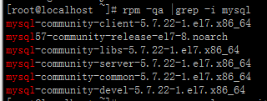

## 开始卸载

yum remove mysql-community mysql-community-server mysql-community-libs mysql-community-common

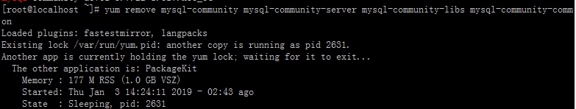

1. 若遇到上述情况
2. 停止Mysql服务：systemctl stop mysqld.service
3. 强制关闭yum进程：rm –f /var/run/yum.pid

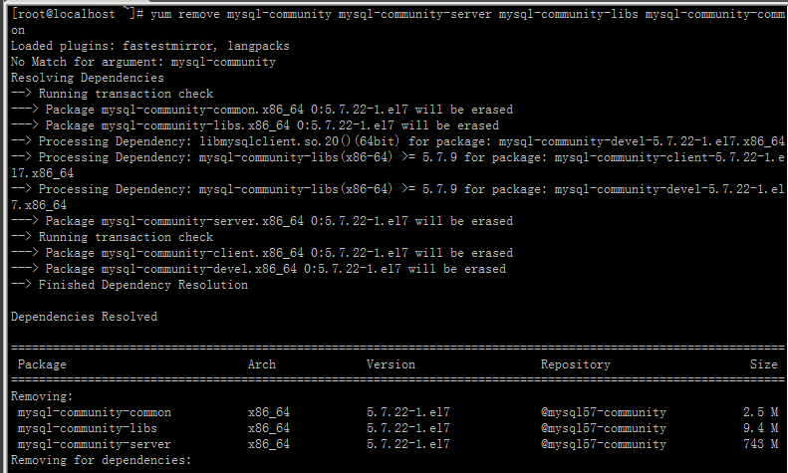

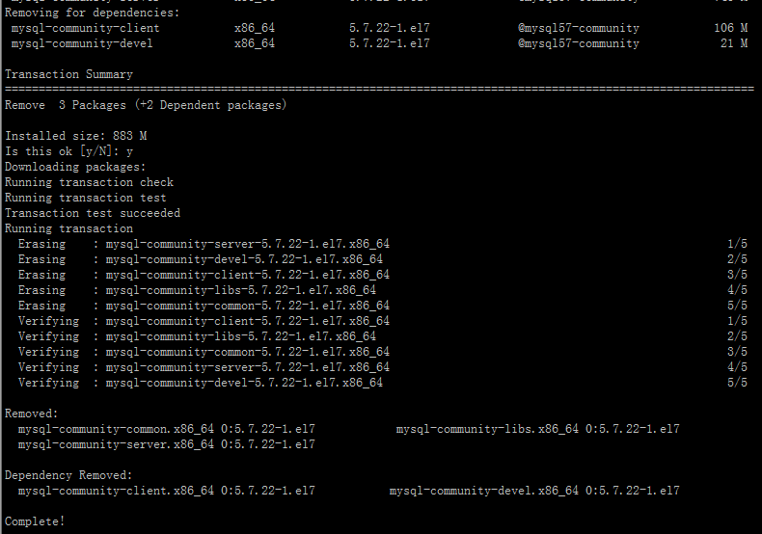

## 检查残余

rpm –qa |grap –I mysql



## 卸载残余

yum remove mysql57-community-release

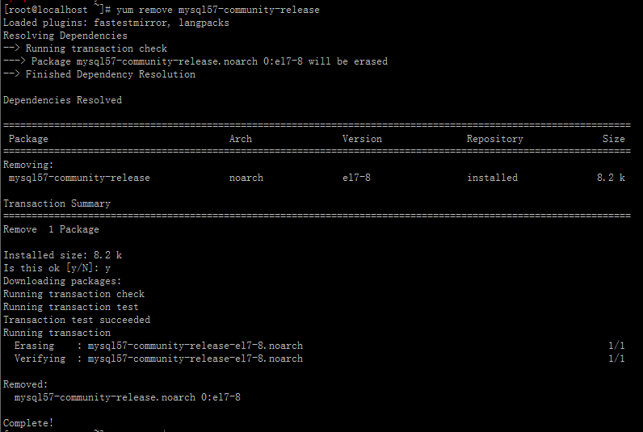

## 删除相关残余文件

