Họ và tên: Trần Thiện Đạt

MSSV: 20047071

**MODULE 4: ASSIGNING THE RESOURCE FOR A PROJECT**

Mục lục

**Exercise 1. Entering work resource** 2

**Capture:** 2

**Capture: Task Clean Machine** 3

**PROJECT INFORMATION BEFORE:** 3

**Exercise 2. Entering work resource** 4

**Capture:** 4

**Capture:** 5

**Exercise 3. Entering work resource** 7

**Capture: Create project** 7

**Capture: Add the resource for this project bellow: Type Work/Materia** 8

**Capture: Assign the resource for each task** 8

Task Plannig 8

Task Requirement documents 9

Task Sign off 9

Task Development 10

Task Testing 10

Task Implementation 11

Task Review 11

**Exercise 4. Entering work resource** 11

**Capture Resource:** 14

**Capture Assign the resource for each task in the project** 14

**PROJECT INFORMATION BEFORE:** 15

**PROJECT INFORMATION AFTER:** 15

**Exercise 5. Entering work resource** 16

**Capture: Working time** 18

**Capture Project:** 22

**Capture resource:** 22

**Capture Assign the resource for each task in the project:** 22

Task The Venue - Confirm Dates 23

Task The Photographer 23

Task The Cars 24

Task The DJ 25

Task The Flowers 26

Task The Venue - Pay Balance 26

**PROJECT INFORMATION BEFORE:** 27

**PROJECT INFORMATION AFTER:** 27

# **Exercise 1. Entering work resource**

Open the Exercise 1 (Module 3)

Tab View -> Resource Sheet

Add the resource for this project bellow: Type Work (person)

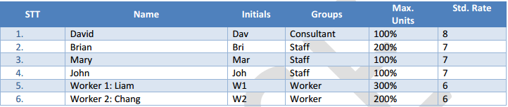

## **Capture:**

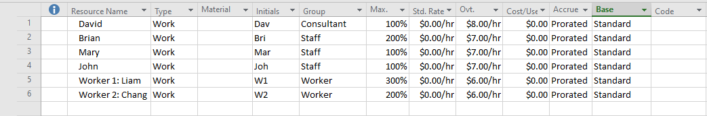

Assign the resource for each task

Tab Task => Gantt Chart => Select the task that you want to assign the resource

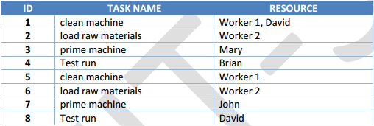

## **Capture: Task Clean Machine**

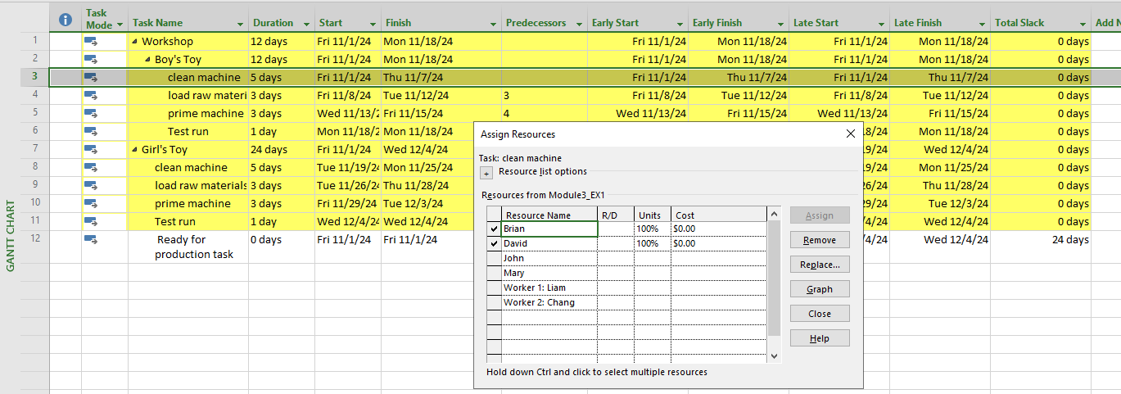

## **PROJECT INFORMATION BEFORE:**

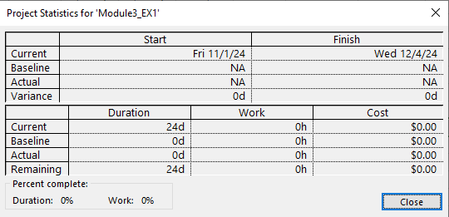  
**PROJECT INFORMATION AFTER:**

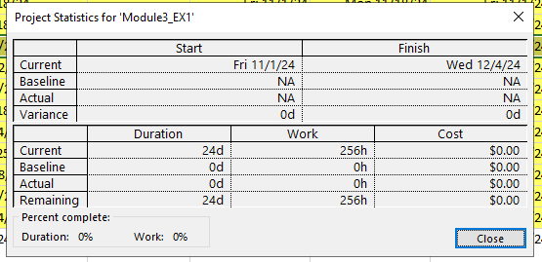

# **Exercise 2. Entering work resource**

Open the Exercise 2 (Module 3)

Tab View =>Resource Sheet

Add the resource for this project bellow: Type Material

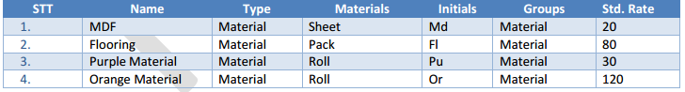

## **Capture:**

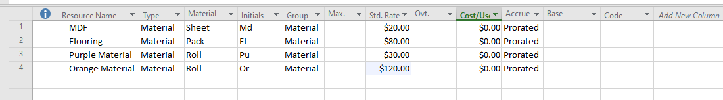

The information of resource that will assign for the task

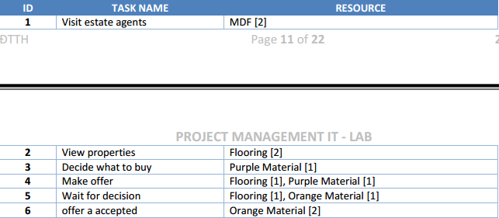

## **Capture:**

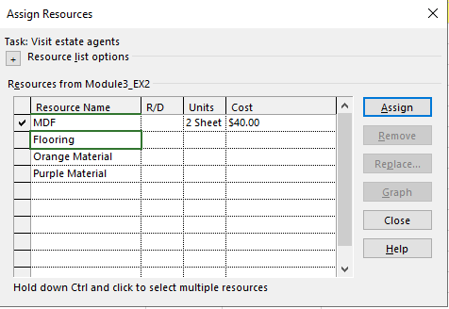

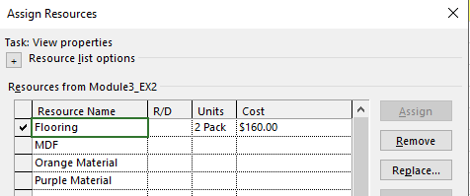

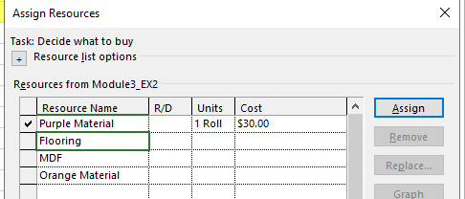

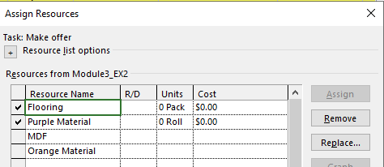

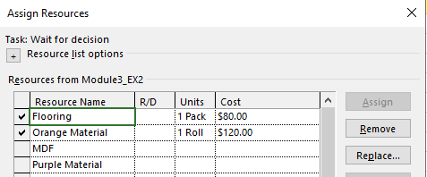

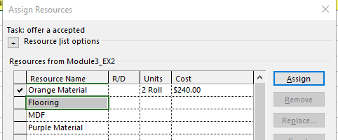

# **Exercise 3. Entering work resource**

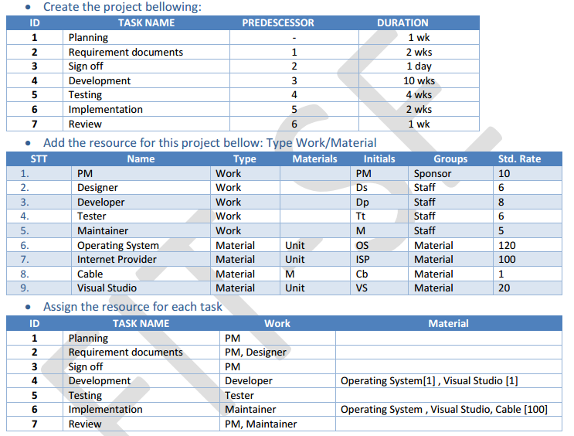

## **Capture: Create project**

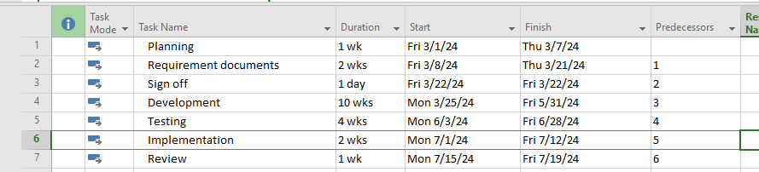

## **Capture: Add the resource for this project bellow: Type Work/Materia**

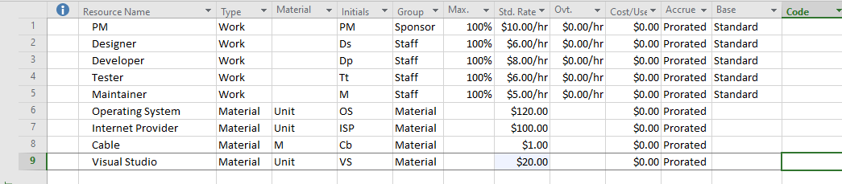

## **Capture: Assign the resource for each task**

### Task Plannig

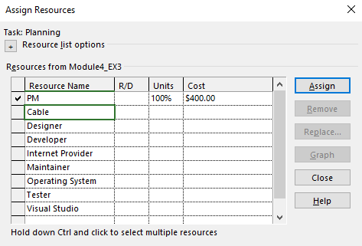

### Task Requirement documents

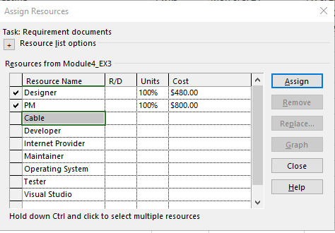

### Task Sign off

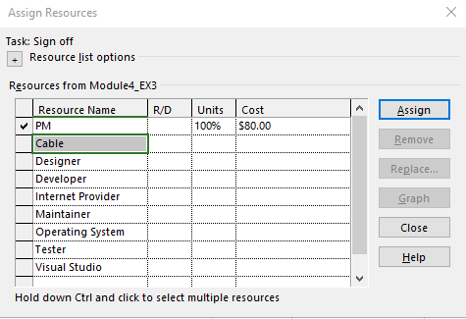

### Task Development

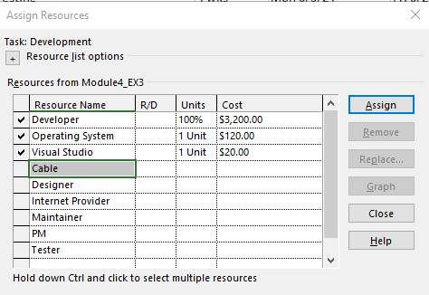

### Task Testing

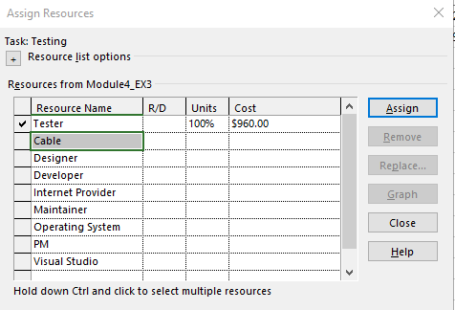

### Task Implementation

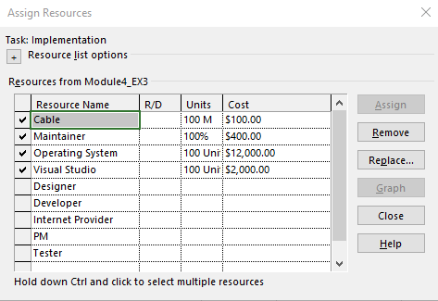

### Task Review

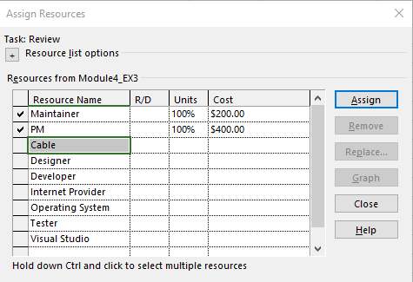

# **Exercise 4. Entering work resource**

Open the Exercise 3 (Module 3)

Tab View →Resource Sheet → Resource Views

Establish the resource that type is work (default) for the project below:

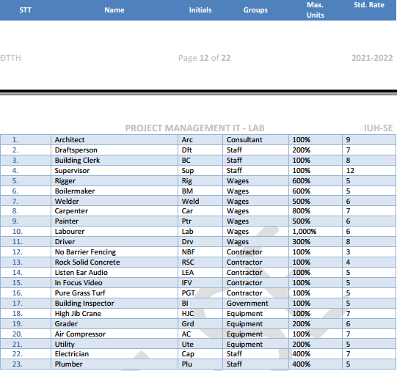

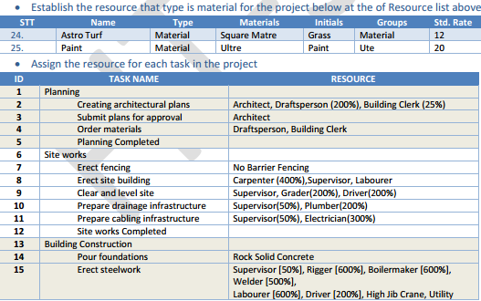

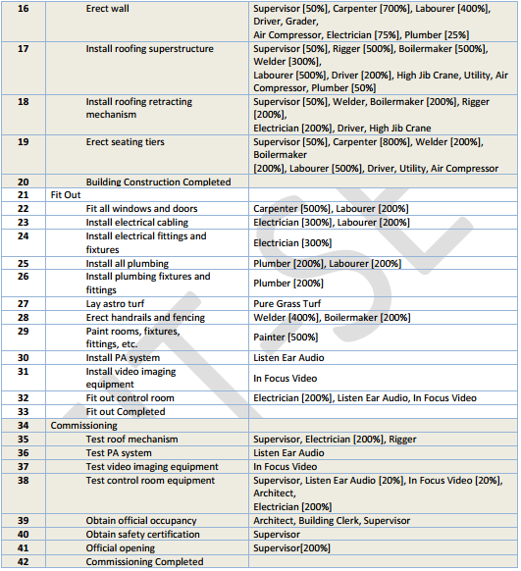

## **Capture Resource:**

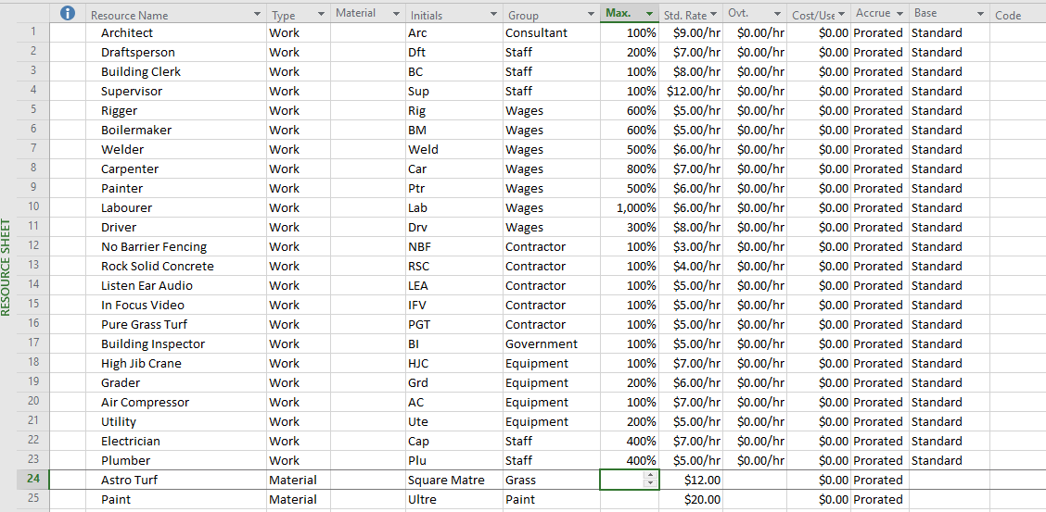

## **Capture Assign the resource for each task in the project**

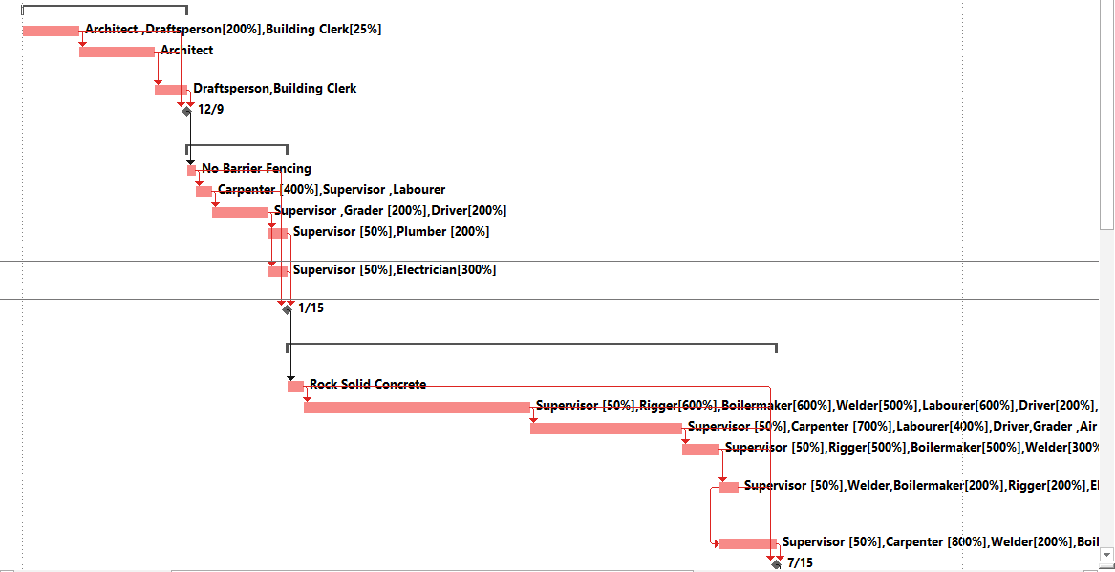

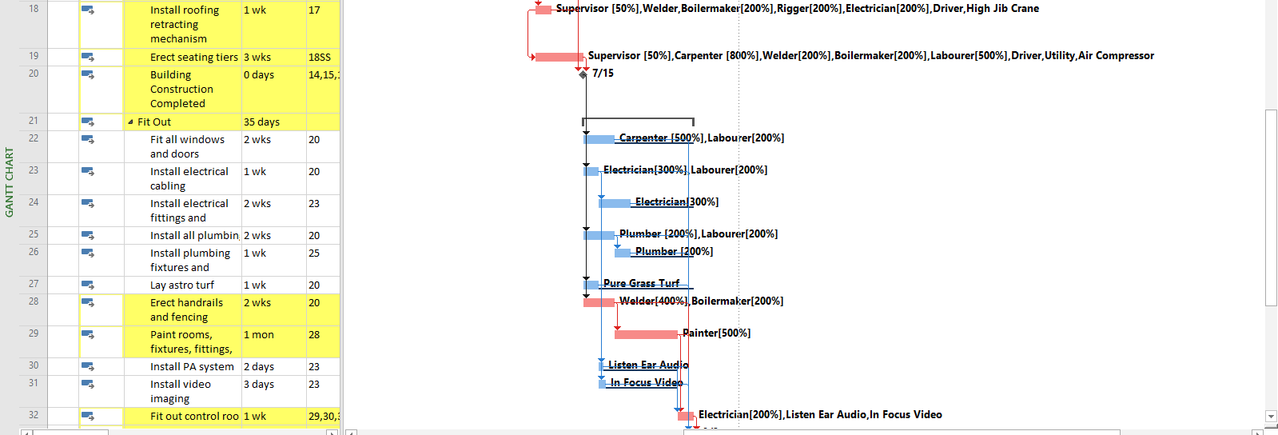

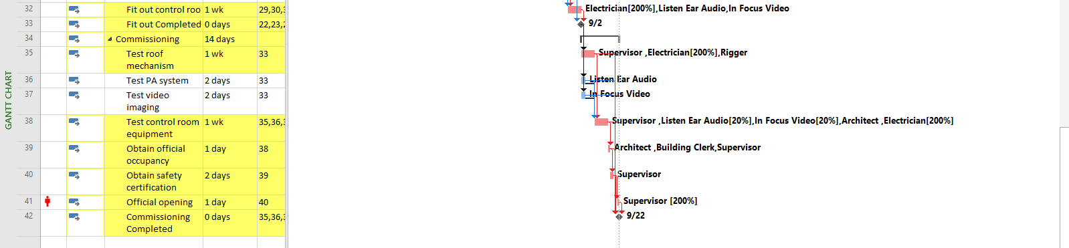

## **PROJECT INFORMATION BEFORE:**

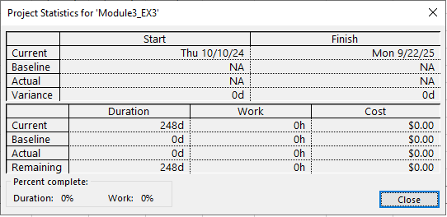

## **PROJECT INFORMATION AFTER:**

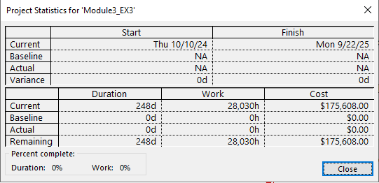

# **Exercise 5. Entering work resource**

Creating the following tasks (Project Start Date 6/12/2024)

Establish working time: MSSV_Time

1. Working time: Mon – Fri: 8AM – 11AM, Sat: 11AM-9PM
2. Nonworking time: Sun
3. Exception: Nonworking time: 24/12/2024, 1/1/2022

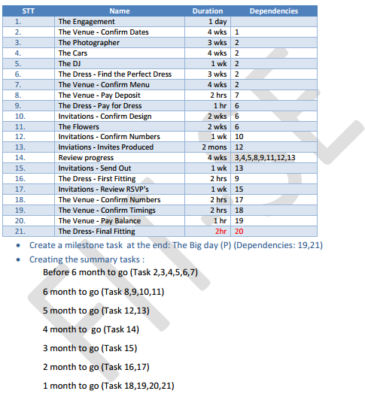 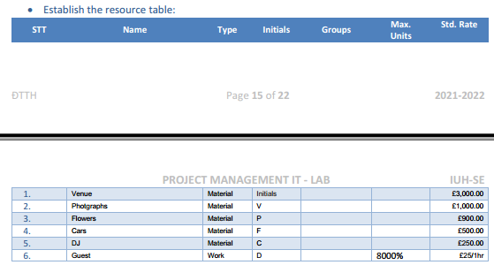

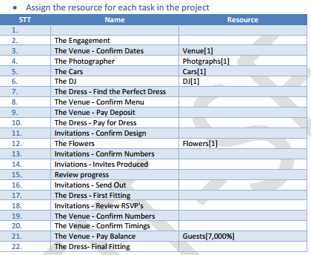

## **Capture: Working time**

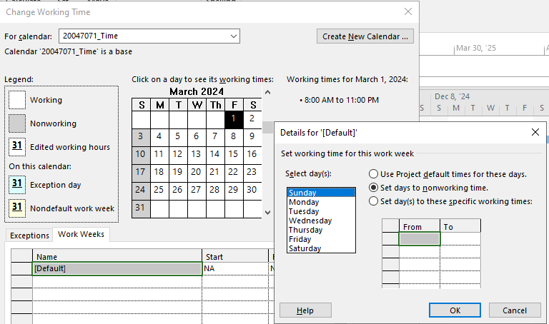

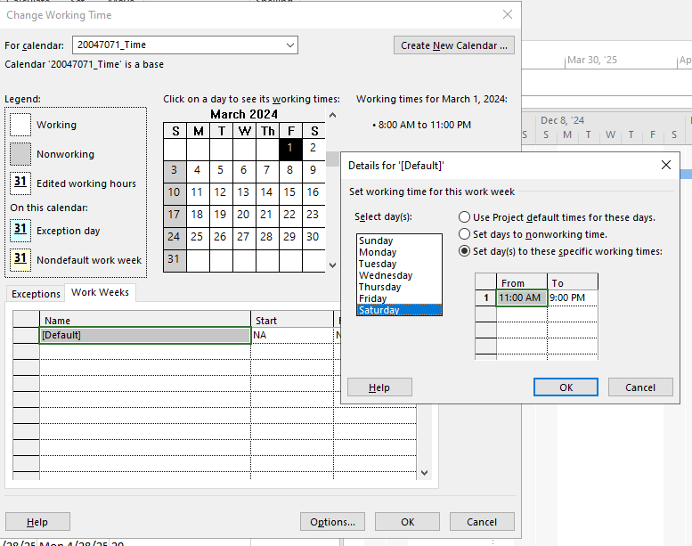

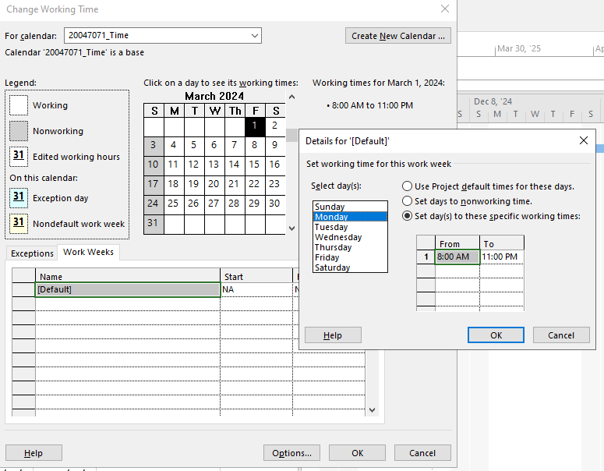

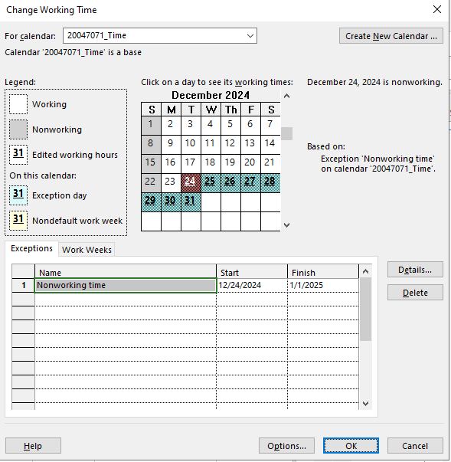

## **Capture Project:**

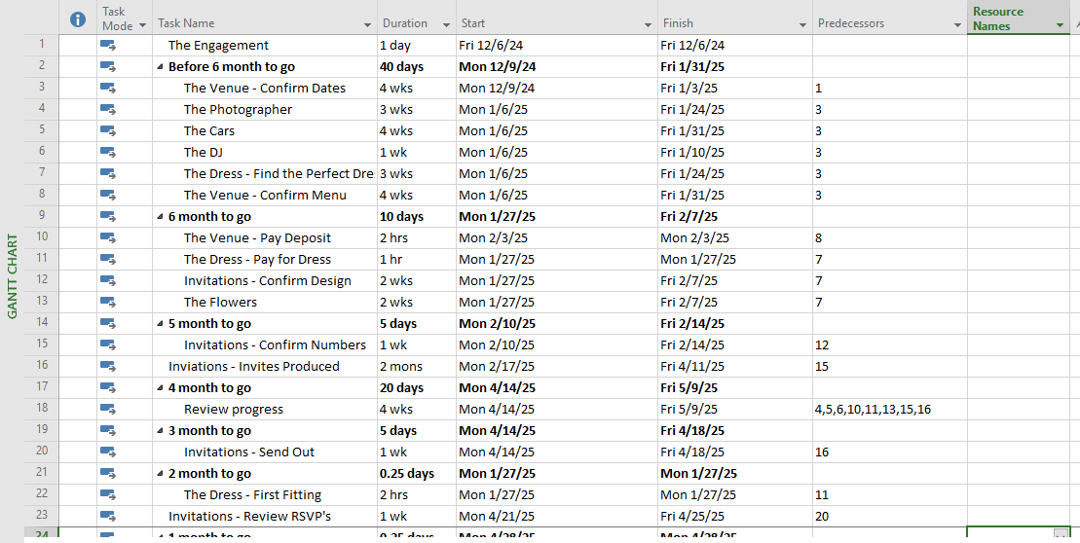

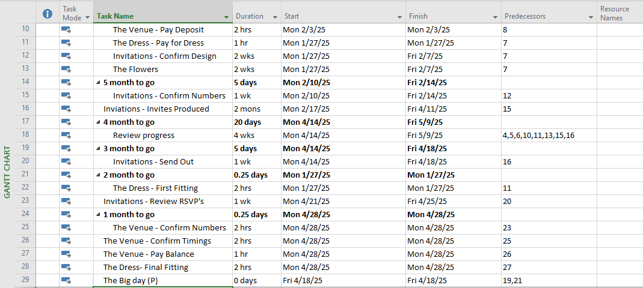

## **Capture resource:**

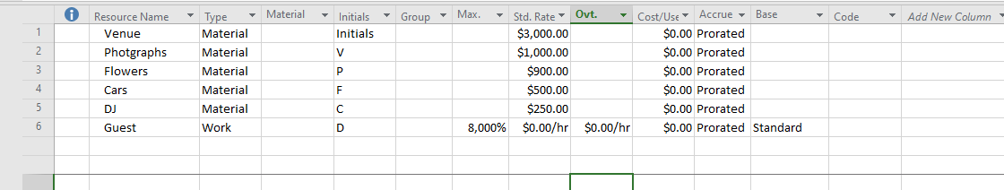

## **Capture Assign the resource for each task in the project:**

### Task The Venue - Confirm Dates

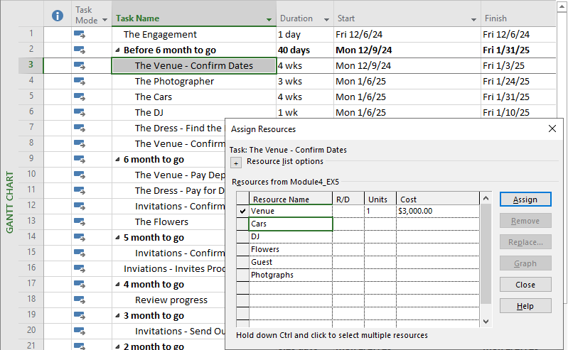

### Task The Photographer

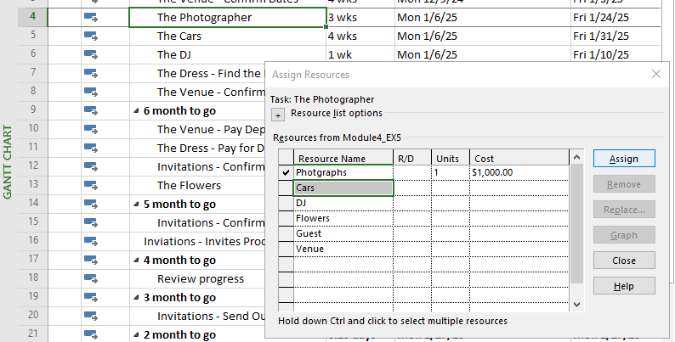

### Task The Cars

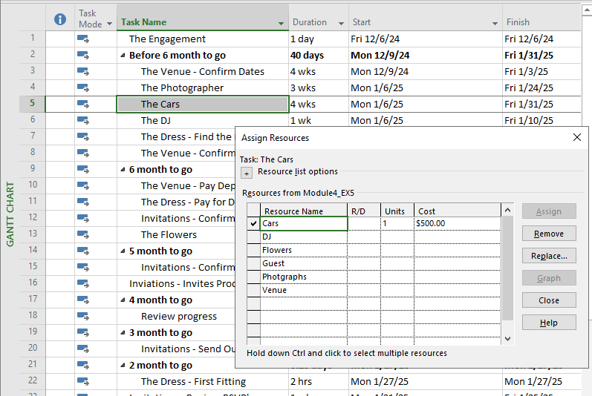

### Task The DJ

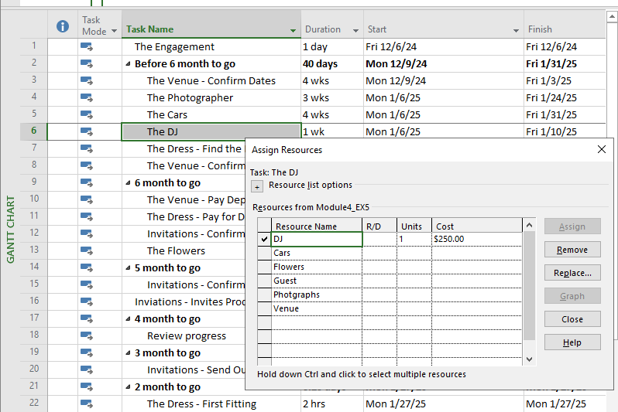

### Task The Flowers

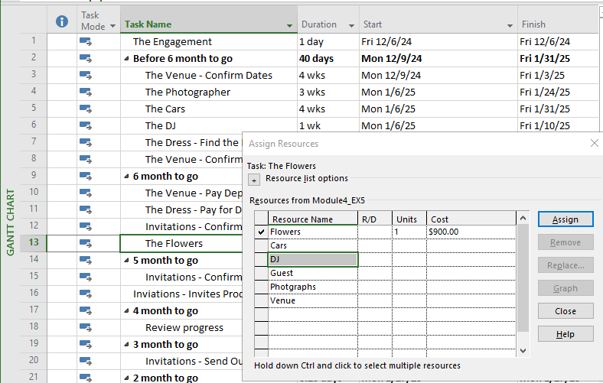

### Task The Venue - Pay Balance

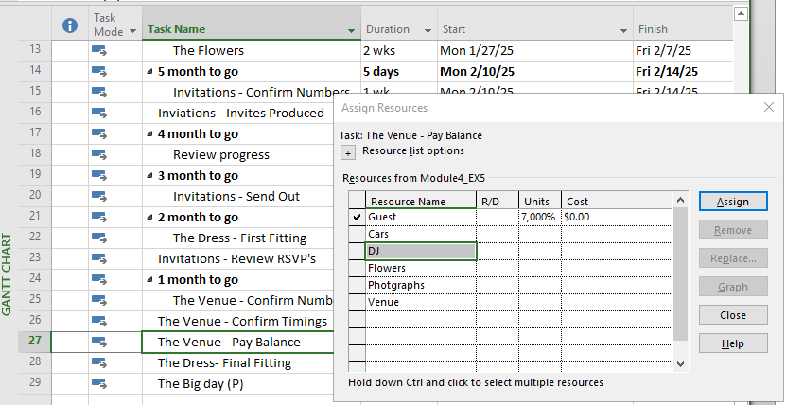

## **PROJECT INFORMATION BEFORE:**

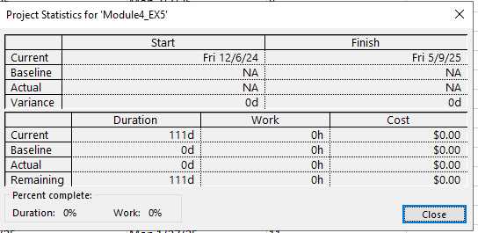

## **PROJECT INFORMATION AFTER:**

