Grid CSS --> Tailwind (ok) --> grid --> ok commit (45')

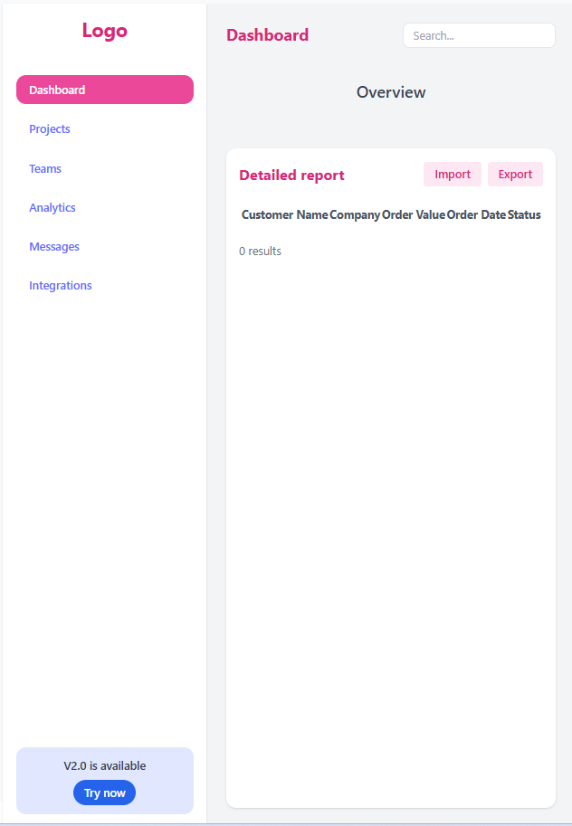

Get api Overview (3 api --> 1 api, json server --> 3 api local) --> commit (45') 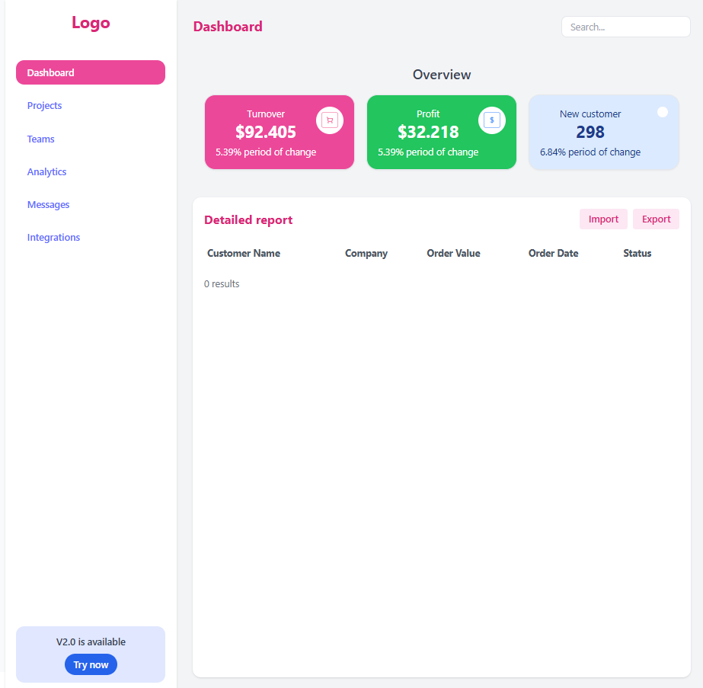

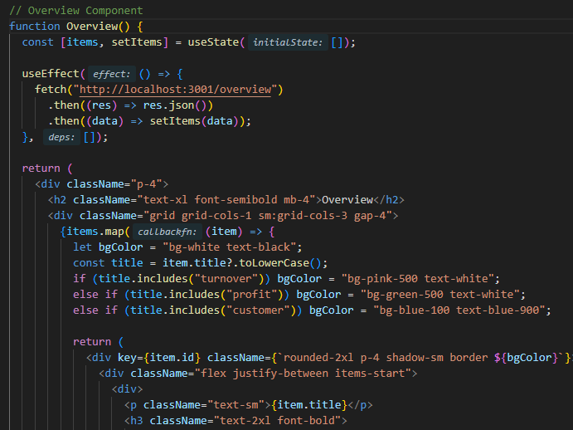

DataTable --> commit (20-30') 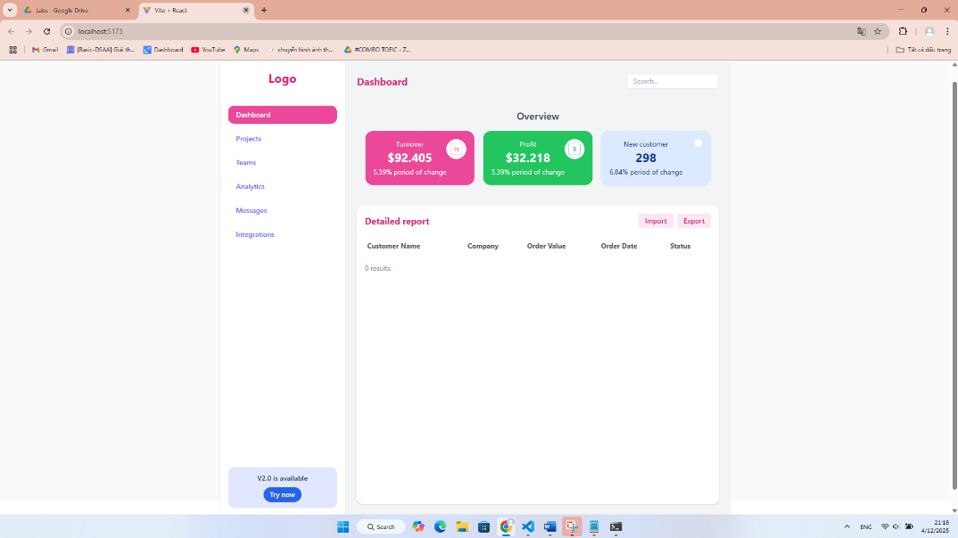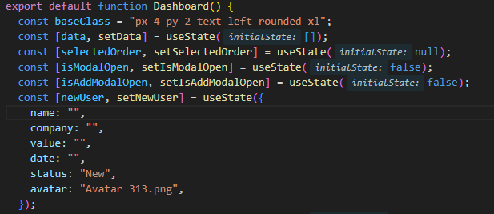

DataTable + get API --> commit (30')

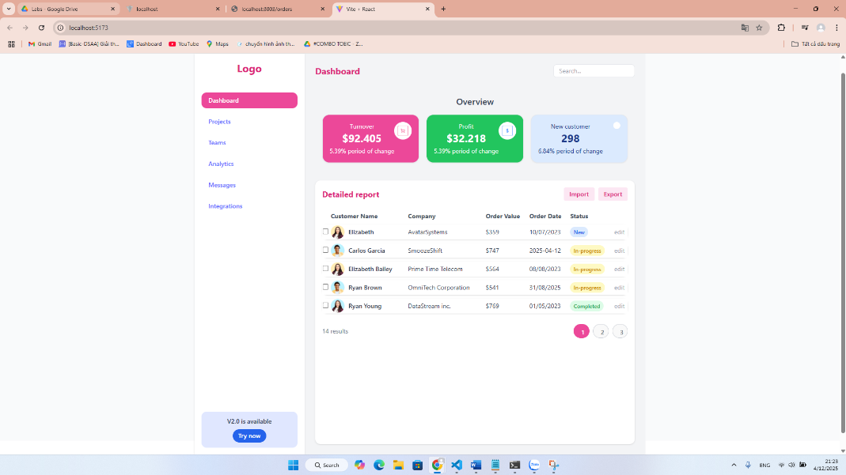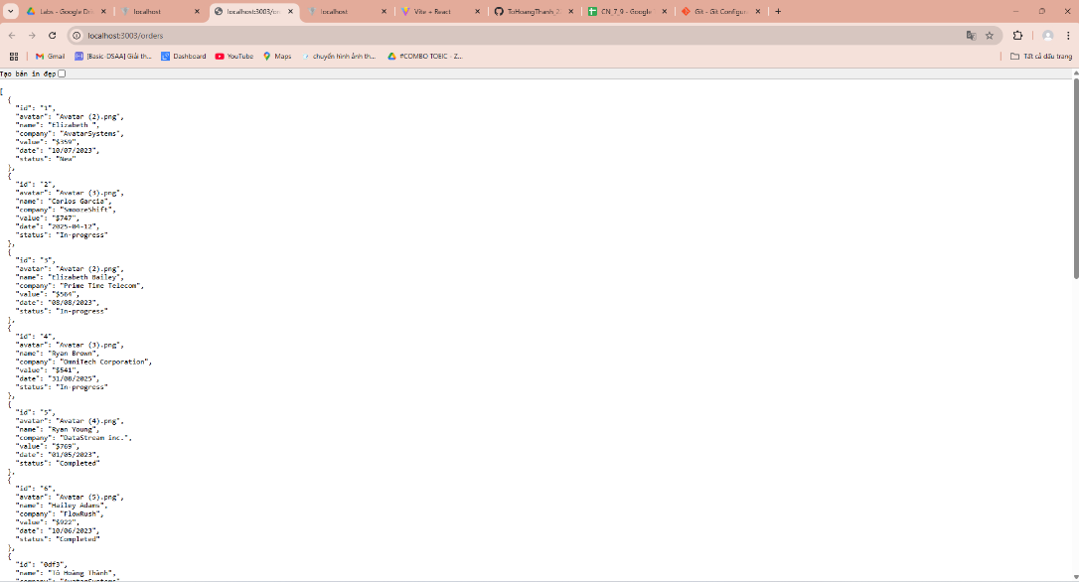

Click Edit --> Modal + Data (get api) --> commit (30') 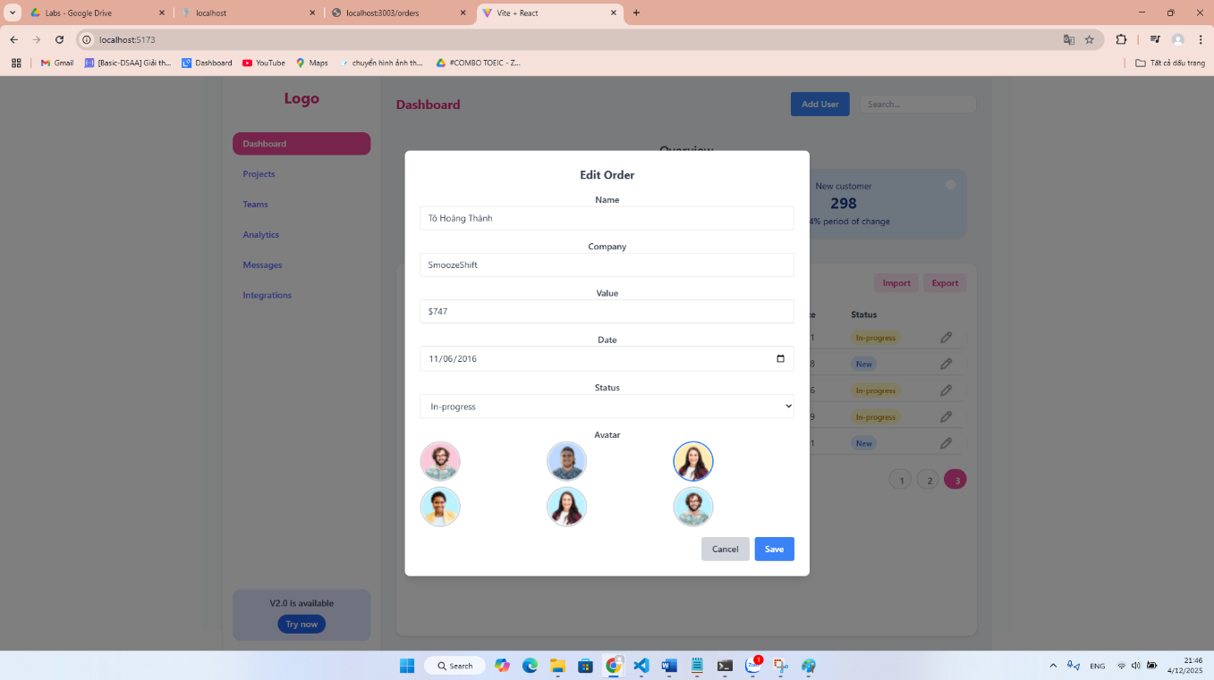

.

Click Save --> put API --> commit (30')

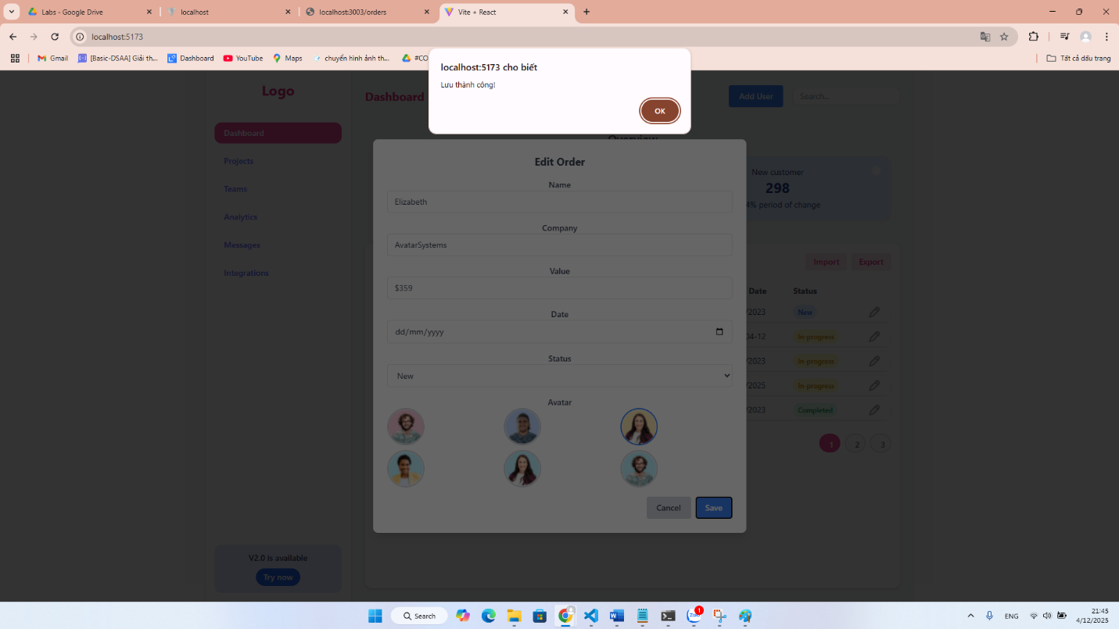

Add User --> Modal + Post API --> commit (30-45') 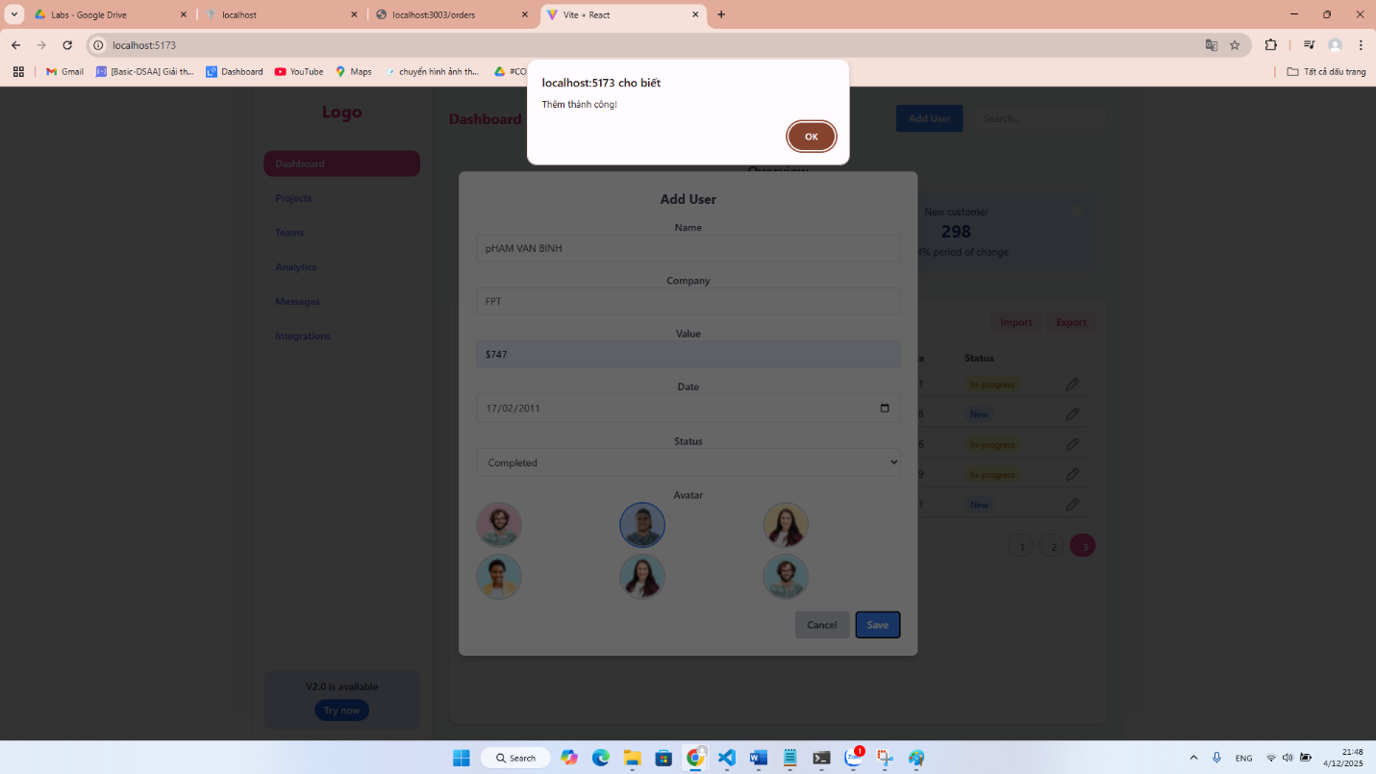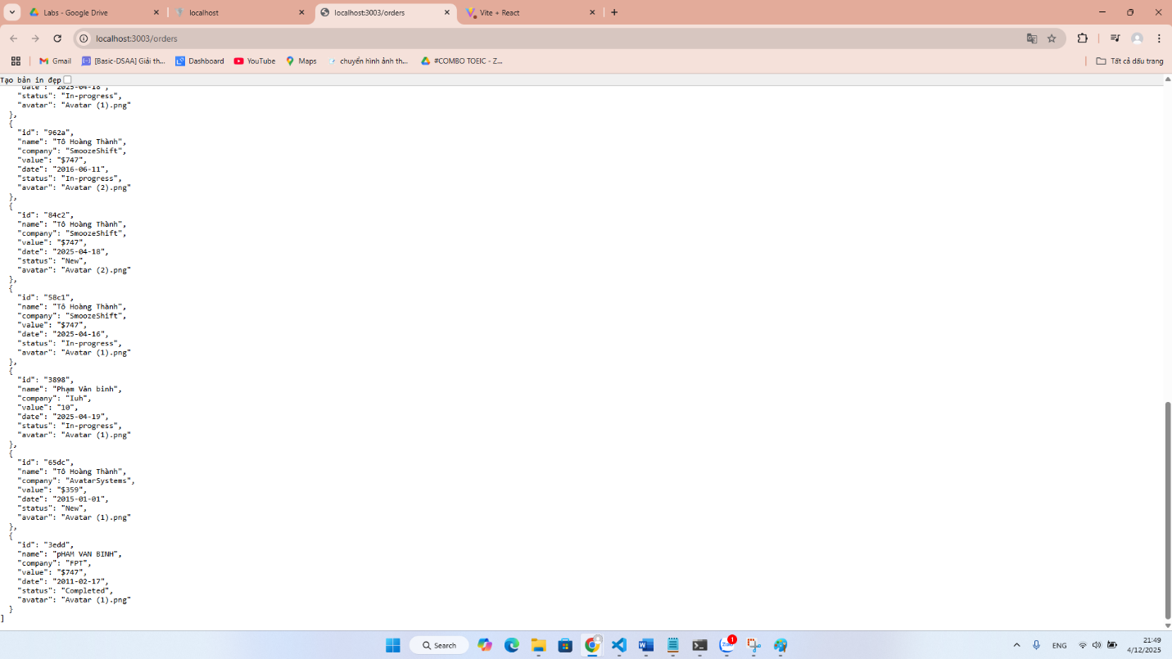

isActive --> React Router Dom (NavLink --> Css --> active) --> commit (20-30') 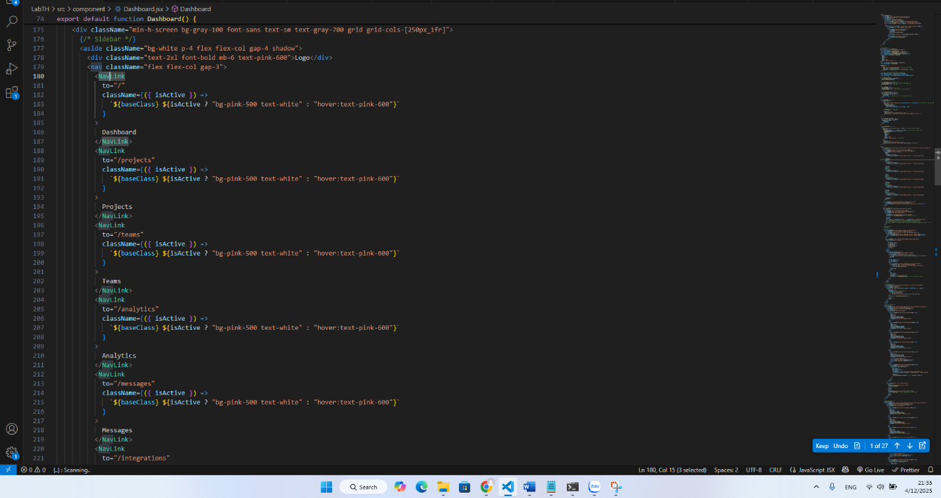

React Router Dom --> Link --> Page --> component (30') 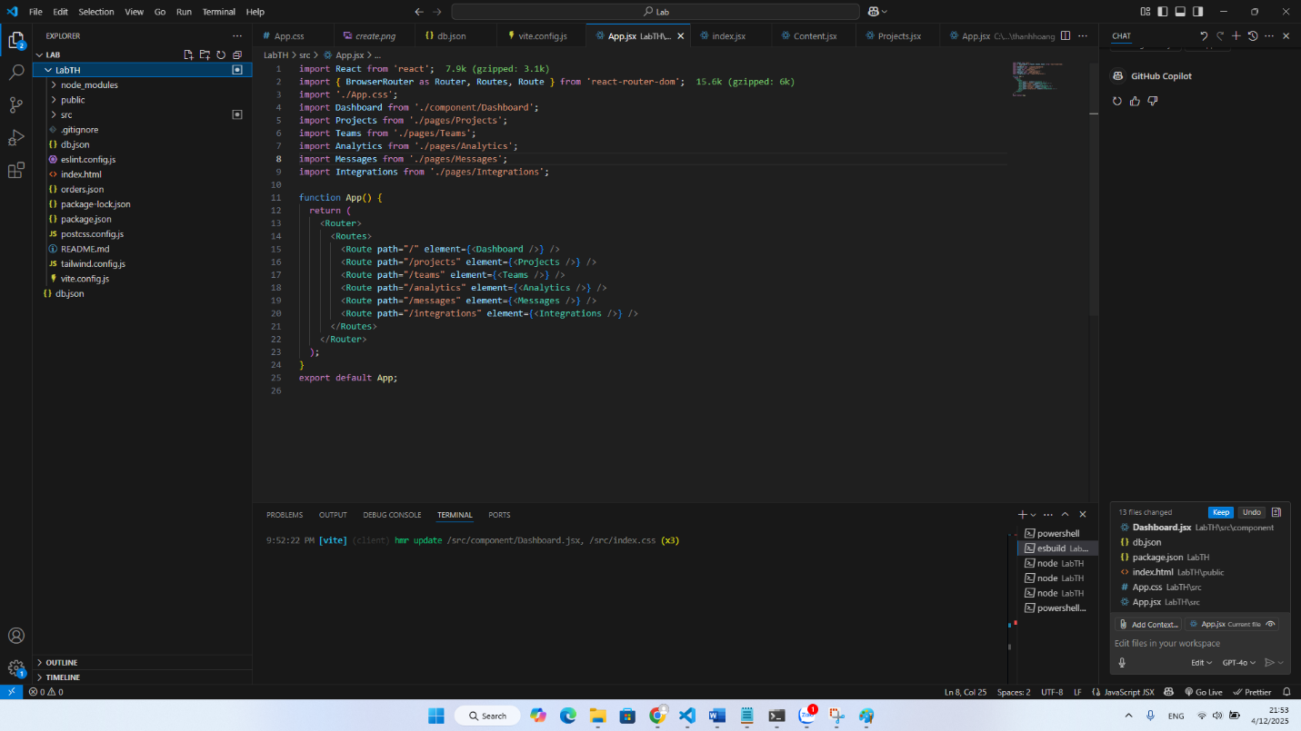

SPA --> Single Page Application --> commit (30-45') 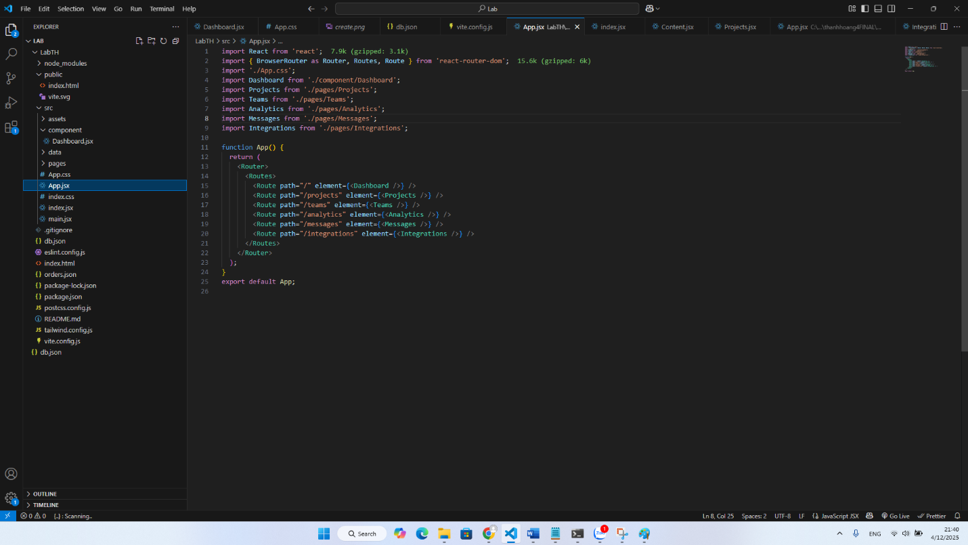

CSS all admin app --> commit (30-45')

