SAMAÚMA
Eco-Cultural Island Destination
Detailed Business Plan & Resort Development Concept
Fictional island in Amapá, Brazil • €30 million development budget
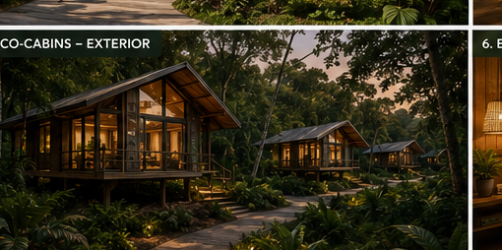
Concept image — Samaúma eco-cabins
Brand promise
“The island is not our product. The island is our partner.”

1. Executive Summary
Samaúma is a small-scale, high-value eco-cultural destination proposed for a fictional island in Amapá, Brazil. The island combines beautiful beaches, tropical forest, a freshwater lake, a small mountain, traditional villages and a protected area containing rare wildlife. It has approximately 50,000 residents, no airport and very limited roads.
The business model deliberately avoids mass tourism. Samaúma will use low-impact eco-cabins instead of a large hotel, prioritise Brazilian and regional suppliers, employ and train local residents, protect sensitive cultural and ecological areas, and dedicate resources to biodiversity research.
A compact Convention & Knowledge Centre creates a second economic engine: during the high season it supports tourism, corporate events and workshops; during the low season it becomes a platform for environmental awareness, scientific research, Brazilian government programmes and international forums.

2. The Samaúma Model

Four pillars
- ECO — low-impact infrastructure, renewable energy, responsible water management and protected biodiversity.
- CULTURE — local communities are hosts, partners and beneficiaries; traditional villages and sacred areas are respected.
- KNOWLEDGE — scientific research, environmental education and a year-round Convention & Knowledge Centre.
- VALUE — tourism revenue should circulate through local households, businesses, producers and Brazilian suppliers.
Core positioning
Luxury in the experience, not luxury through scale. Samaúma sells exclusivity, authenticity and access to nature — not mass accommodation.

3. Destination Experience & Masterplan
The resort should be distributed rather than concentrated into one large complex. Development is kept away from the most sensitive wildlife areas, while the existing villages remain living communities rather than themed tourist attractions.
- Eco-cabin zone positioned close enough to the lake/forest landscape for immersion, but outside protected habitats.
- Small international airport and arrival/meet-and-greet area designed for controlled passenger flows.
- Docks for low-impact water transport and island connectivity.
- Shared e-bike stations and electric shuttles connecting key zones.
- Community & Cultural Centre with a high-quality, rain-protected outdoor circulation area.
- Organic farm supplying part of the resort's food needs and providing an educational visitor experience.
- Protected beach areas with basic, low-impact visitor infrastructure.
- Research and conservation facilities associated with the protected area, with controlled access.

4. Accommodation Strategy
Samaúma will not build a conventional luxury hotel. The accommodation concept is a collection of small eco-cabins, allowing the resort to offer a premium experience while keeping the physical footprint relatively low.

Eco-cabin exterior concept
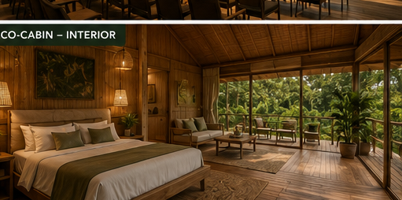
Eco-cabin interior concept

Luxury features
- Premium beds and bedding, private bathrooms and high-quality natural materials.
- Large openings and private verandas oriented to forest or lake views.
- Selected premium units with outdoor bathing experiences.
- Brazilian-made furniture and locally/regional sourced materials wherever possible.
- Solar power and water-efficiency features.
- Low-impact lighting and discreet technology to preserve the sense of escape.
- Welcome amenities based on Brazilian and regional products.

5. Signature Tourist Packages
Packages are designed to distribute visitors across nature, culture, education and relaxation rather than concentrating everyone around the beach.
Package | Length | Core experience
Amazon Roots | 5 days | Traditional village visit, local cooking experience, crafts, forest walk and community-led cultural activities.
Wild Island | 6 days | Wildlife trails, freshwater lake experience, mountain excursion and conservation briefing.
Blue & Green | 5 days | Protected beach experience, kayaking, forest activity and sustainable Brazilian cuisine.
Samaúma Immersion | 7 days | Full cultural and nature programme combining community, food, forest, lake and conservation experiences.
Corporate Impact | 2–4 days | Conference or workshop programme combined with conservation, community and sustainable-development activities.

6. Arrival, Mobility & International Airline Partnership
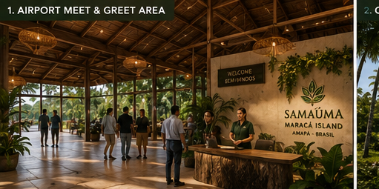
Airport meet-and-greet concept
Because the island currently has no airport, the development includes a small international airport. The objective is not to create a mass-market aviation hub, but to establish controlled, reliable access.
- Pursue a long-term partnership with an international airline.
- Use scheduled capacity and destination marketing to reach selected international markets.
- Scale flight frequency only when environmental, water, transport and community capacity allow it.
- Create a warm Brazilian welcome through a dedicated meet-and-greet arrival service.
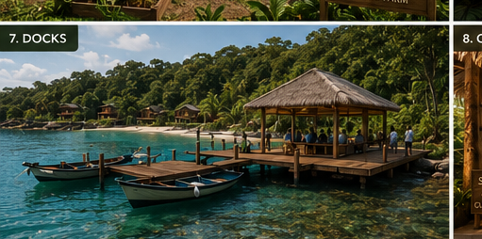
Docks and low-impact water transport concept
On-island mobility combines electric shuttles, shared e-bikes and pedestrian routes. This reduces the need for extensive new roads and makes mobility part of the eco-tourism experience.

7. Samaúma Convention & Knowledge Centre
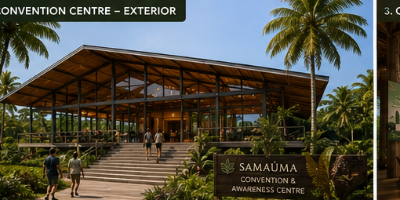
Convention & Knowledge Centre exterior concept
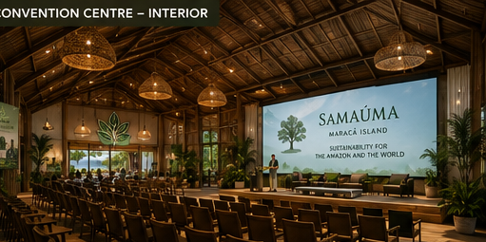
Convention & Knowledge Centre interior concept
The Convention & Knowledge Centre is intentionally compact and multifunctional. Its role is not to compete with major urban convention centres, but to provide a unique venue where tourism, science, conservation and policy meet.
High season | Low season
Conferences and workshops | Amazon and climate awareness events
Corporate retreats | Brazilian government programmes
Cultural presentations | Meetings involving economic blocs
Sustainable tourism forums | University and research events
Small international events | Conservation and biodiversity forums
Low-season strategy
“A small convention centre with a global purpose.” The facility keeps economic activity moving when leisure tourism is lower.

8. Community & Cultural Development
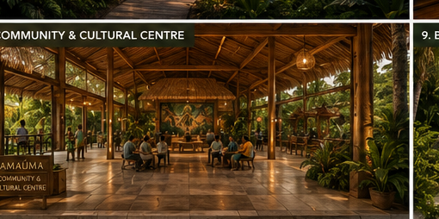
Community & Cultural Centre concept
The Community & Cultural Centre is designed as a genuine community space, not simply a tourist attraction. The final design should use a durable, high-quality floor and protected lateral areas so the building remains useful during heavy rain.
- Spaces for local crafts, exhibitions, music, dance, food and community meetings.
- Rain-protected circulation and gathering areas.
- Opportunities for local producers to sell directly to visitors.
- Community programming developed with local residents.
- Cultural tourism only with community permission and appropriate representation.

Community Fund — €250,000
- Micro-grants for local tourism and service businesses.
- Training and professional development.
- Support for cultural initiatives and local producers.
- Small infrastructure improvements selected with community participation.

9. Organic Farm & Brazilian Supply Chain
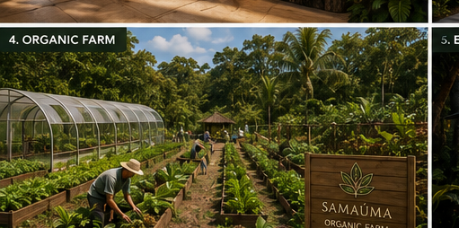
Organic farm concept
Samaúma will prioritise Brazilian food, furniture and other supplies, with regional producers receiving preference. The organic farm supports this strategy by supplying part of the resort's kitchen demand and creating an educational activity.
- Regional fruit, vegetables, herbs and selected other crops.
- Farm-to-table experiences for guests.
- Employment and supplier opportunities for residents.
- Reduced dependence on long-distance food logistics.
- Use of compost generated by the resort's organic waste programme where appropriate.

10. Samaúma Biodiversity Research Programme
€500,000 is allocated to a dedicated biodiversity research programme. The objective is to make the destination a living laboratory for sustainable tourism while generating useful knowledge for conservation.
- Fauna monitoring: birds, mammals, reptiles, amphibians and pollinators.
- Flora inventory, forest regeneration and ecosystem-health monitoring.
- Freshwater lake quality and aquatic biodiversity studies.
- Monitoring of tourism impacts and visitor carrying capacity.
- Partnerships with Brazilian universities and research institutions.
- Paid field-assistant and training opportunities for local residents.
- Publication and community-sharing of relevant research findings.
- Research access controlled so that sensitive habitats are not disturbed.
Research principle
Scientific research should give something back: findings should support conservation, education or community benefit.

11. Environmental Infrastructure
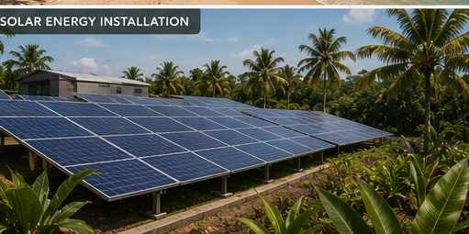
Solar energy concept
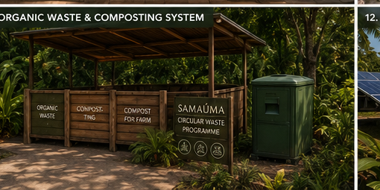
Organic waste and composting concept

Energy — €4M
A major solar-energy investment reduces dependence on fossil fuels and supports the resort's low-carbon positioning.

Water — €3M
Reliable water infrastructure is essential for both residents and visitors. The system should prioritise efficiency, reuse where safe and resilience.

Organic waste — €250,000
Rather than describing this as conventional recycling, the programme focuses on organic waste management through composting and, where technically appropriate, anaerobic digestion/biogas. The aim is to turn kitchen and green waste into a resource.
Circular principle
“At Samaúma, waste doesn't leave the island — it becomes a resource.”

12. Beaches & Protected Nature
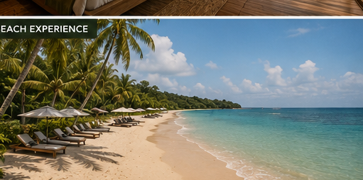
Low-impact beach experience concept
The beach investment is deliberately modest: €500,000 is reserved for protection and essential visitor infrastructure. The resort does not need heavy construction to make the beaches attractive.
- Low-impact access and boardwalks where appropriate.
- Waste and sanitation infrastructure.
- Clear visitor guidance and protected areas.
- Limits on activities in ecologically sensitive zones.
- No development inside protected wildlife habitats.

13. Mobility System
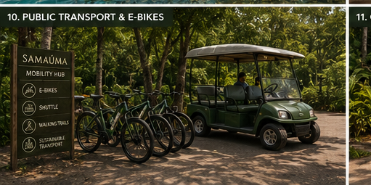
Shared e-bike and electric mobility concept
The €2M mobility allocation replaces the need for an extensive road-building programme with a lighter system based on electric shuttles, shared e-bikes and pedestrian routes.
- Electric shuttles for airport, cabins, villages and key facilities.
- Shared e-bikes for independent mobility.
- Pedestrian-first routes wherever practical.
- Only essential road improvements rather than island-wide road expansion.

14. Employment & Staffing
Samaúma expects approximately 250–300 employees during high season and 180–200 during low season. The difference reflects seasonal tourism demand while preserving a permanent operational core.
- At least 60% of employees must be local residents.
- Paid training programmes prepare residents for hospitality, guiding, maintenance, administration and event operations.
- Career progression should allow local staff to move into supervisory and management positions.
- Seasonal staffing should prioritise people who already live on the island.
- Research and conservation roles should include local field-assistant opportunities.

15. Five Rules to Protect Local Residents
- At least 60% of resort employees must be local residents.
- Tourism development cannot displace local families from residential housing.
- Protected wildlife areas and sacred/culturally sensitive areas remain restricted or closed to tourists.
- The island has an absolute annual visitor cap of 40,000 visitors.
- At least 70% of food, furniture and key supplies must come from Brazilian producers, with regional suppliers prioritised.
These rules make social protection part of the business model rather than a separate corporate-responsibility programme.

16. Final €30 Million Investment Plan
Investment | Amount | Purpose
Small international airport | €12.00M | Controlled international access and meet-and-greet.
Solar energy system | €4.00M | Renewable power and lower fossil-fuel dependence.
Water system | €3.00M | Reliable, resilient water supply and efficiency.
Transport + shared e-bikes | €2.00M | Electric shuttles, e-bikes and pedestrian mobility.
National park / conservation | €2.00M | Protected-area infrastructure and conservation management.
Eco-cabins — initial construction | €2.00M | Core low-impact accommodation.
Luxury cabin upgrade & expansion | €1.00M | Premium features and additional high-value units.
Convention & Knowledge Centre | €1.50M | Year-round events, awareness, research and policy dialogue.
Community & Cultural Centre | €1.00M | Community programming, cultural activities and local commerce.
Beach protection | €0.50M | Low-impact access, sanitation, waste and protection.
Biodiversity Research Programme | €0.50M | Fauna, flora, water and tourism-impact research.
Community Fund | €0.25M | Local business, training and cultural micro-grants.
Organic waste & composting | €0.25M | Composting / circular organic-waste system.
TOTAL | €30.00M | Complete development budget.

17. Why This Business Model Is Attractive
- Differentiation: Samaúma is not another beach resort; it combines eco-tourism, culture, research and knowledge events.
- Premium pricing: small-scale accommodation and curated packages support higher value per visitor.
- Risk control: a 40,000 visitor cap prevents uncontrolled volume growth.
- Seasonality management: the Convention & Knowledge Centre creates low-season demand.
- Local legitimacy: employment, sourcing and the Community Fund give residents a direct economic stake.
- Environmental credibility: biodiversity research, conservation and circular waste management are built into the operating model.
- Brand strength: Brazilian food, furniture, culture and landscape create a distinctive identity difficult to replicate.

18. Success Metrics
KPI | Target
Visitors | ~35,000/year initial target; 40,000 absolute cap
Local employment | ≥60% of employees
Brazilian sourcing | ≥70% of food, furniture and key supplies
Seasonality | Convention / knowledge events during low season
Waste | Organic waste diverted to composting/biogas where feasible
Research | Annual biodiversity monitoring and public-facing findings
Community | Annual allocation of Community Fund and local participation in decisions

19. Key Risks & Mitigations
Risk | Mitigation
Overtourism | Annual visitor cap; controlled airline capacity; no mass-market hotel model.
Community opposition | Local employment rule, housing protection, community fund and participatory cultural programming.
Environmental damage | Protected zones, research monitoring, low-impact infrastructure and conservation budget.
Water pressure | Dedicated water infrastructure, efficiency and reuse.
Seasonality | Convention & Knowledge Centre and low-season institutional events.
Supply logistics | Brazilian/regional sourcing and organic farm development.
Loss of cultural authenticity | Community-led interpretation; sacred areas remain restricted.

20. Final Proposition
Samaúma is designed around a simple idea: the most successful destination is not the one that attracts the most people, but the one that creates the most value without destroying what makes it special.
Final message
“The goal is not to bring the maximum number of people. It is to bring the right people.”

SAMAÚMA — Experience the Amazon. Protect its future.

Appendix — Visual Reference Index

Airport — Meet & Greet


Convention & Knowledge Centre — Exterior


Convention & Knowledge Centre — Interior


Organic Farm


Eco-Cabins — Exterior


Eco-Cabin — Interior


Docks


Community & Cultural Centre


Beach Experience


Public Transport & E-bikes


Organic Waste & Composting


Solar Energy


