**TASK-1**

**Exploratory Data Analysis (EDA) & Business Insights**

**Data Preparation:**

**Merging:**

1.) Joined Transaction, Customer and Product Data on Matching ID’s to create a single table, ensuring I can analyze by region , product category, etc.

**Data Cleaning:**

1.) Deduplicated Rows by CustomerID, ProductID, TransactionID

2.) Handled missing/invalid date fields by converting them to datetime format(or setting them to null if invalid).

**Business Insights:**

**Seasonal Revenue Peaks :** Revenue jumps significantly in January and again around mid‐year, which points to a strong seasonal buying trend. By timing marketing campaigns and stocking popular items before these high‐demand periods, we can make the most of customer interest.

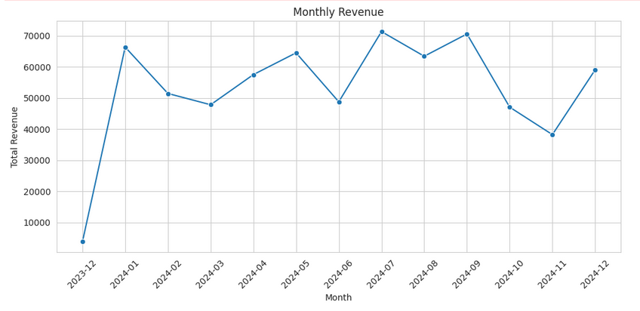

**Dominant Wearable Tech:** ActiveWear Smartwatch hits almost $40,000 in total sales, making it the top‐selling product by a noticeable margin. This success suggests more promotional efforts or expansions in the wearable tech category could boost overall revenue.

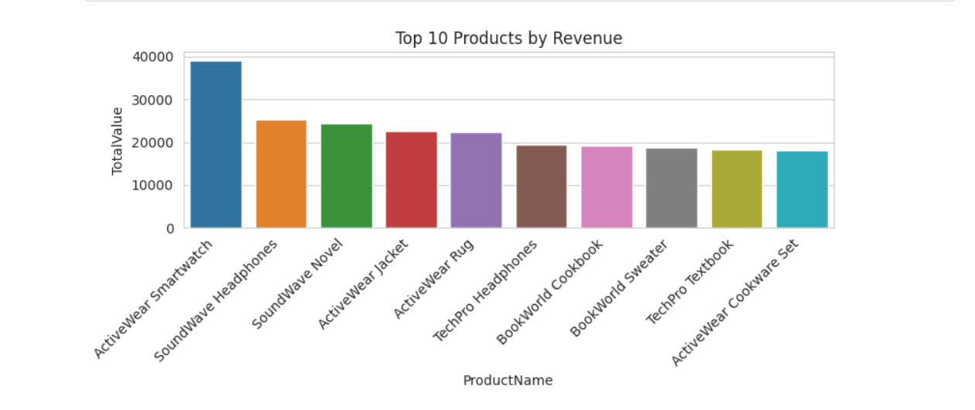

**South America’s Edge :** South America leads all regions in total revenue, showing a large, engaged audience. Improving marketing efforts and payment methods for this region may further increase sales.

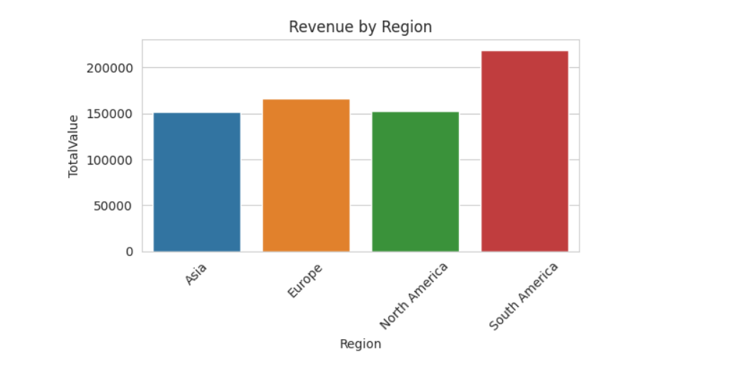

**Healthy Average Spend :** The average spend per customer stands at $3,467, reflecting solid buyer commitment. Keeping acquisition costs well below this figure can ensure sustained profitability.

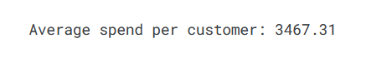

**High-Value Customers :** Five customers each exceed $7k in total spend, contributing disproportionately to revenue. Special perks or loyalty programs for these “power users” could Encourage them to stay, encourage referrals, and boost long‐term profitability.

