Austin Bennett
Rafeeq Al-Hashemi
CMPSC 262 - 2569
Forms APp CAse study

Table of Contents
Page 2 – Introduction
Page 3 – SQUARE Technical Report
Page 5 – Risk Management Framework
Page 6 – Threat Model
Page 8 – Conclusion

Introduction
A business is looking for a way for employees to fill out forms that handle sensitive data. This data has SSNs and banking information. This is something that employees care about and would like to have protected.

Some threats to this system would be: attackers posing as employees, employees handing the form in a careless way, and insecure sending of the data

SQUARE Technical Report

- Definitions
- Multi-factor authentication: Protects applications by requiring a second source of authentication via email, text, or voice call for individuals to log in
- Access Control: provides access levels between levels of employees to keep data that might not be intended for certain users secure
- Dedicated Server: hardware that connects devices in a building to Intranet and will keep data secure from outside sources
- Anti-virus Software: program that searches harddrives and networks for any known and potential threats or viruses
- Acquisition Organization Security Goals:
- Acquisition Organization provides services to building banking and finance applications
- To provide high quality software that will withstand current patterns of attacks as well as known attacks that might put customer data at risk
- To maintain the software and continuously improve as more attack patterns are developed in the future maintaining confidentiality, integrity, and availability
- Abuse Case
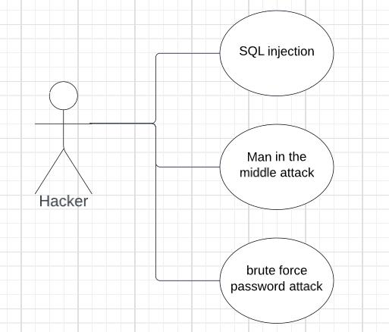
- Risk Assessment
- Highest risk to assets is insider threats – insider would need to bypass the controls in place to hook up external devices to the system
- Threat found for man in the middle attacks when information is uploaded to the global server from the internal server
Essential equipment:
- Computer used by branch managers to upload information to the global server – this computer has the capability to connect to every branch around the world in order to upload data as securely as possible
- Elicitation Technique
- The technique to use in the development of this system would be the JAD(joint application development) technique. In order to allow the users to point out features to be used in every day activities to create the most efficient system possible
- Elicit Security Requirements
- The system must distinguish between good and bad input
- The system must have levels of access in place to midigate a person from seeing sensitive perconal information that is not part of their immediate job
- The system must have a strong encryption in place when sending data over the internet as well as intranet
- If documents must be printed the system must log what document, the log in id, and computer/printer in which the document was printed
- The system must prevent unauthorized usage of internet and personal email from any and all employees without written consent
- System Security Level Requirements
- Software Level
- Software Level
- Software Level
- System Level
- Software Level
- Prioity Requirements
- The system must distinguish between good and bad input – High Priority

- The system must have levels of access in place to midigate a person from seeing sensitive perconal information that is not part of their immediate job – High Priority

- The system must have a strong encryption in place when sending data over the internet as well as intranet – Medium Priority

- If documents must be printed the system must log what document, the log in id, and computer/printer in which the document was printed – Low Priority

- The system must prevent unauthorized usage of internet and personal email from any and all employees without written consent – Low Priority

Risk Management Framework

- Understand the Business Context

This form provides a valuable passage of information for the company from users.

- Identify the Business and Technical Risks

The consequences of a hack on this form system would be: User’s person data getting leaked, company data being stolen, and possible communication disruption.

- Synthesize and Prioritize the Risks, Producing a Ranked Set

1. Company Data
2. Communication Disruption
3. User Data Leaked

- Define the Risk Mitigation Strategy

How I would fix these is by encrypting the data sent and received.

- Carry Out Required Fixes and Validate that They are correct

Threat Model
Roles (deviation from OWASP)
- Anonymous user – connected, but not yet authenticated
- Invalid user – attempted to authenticate and failed
- Staff – authenticated staff
- Site admin – authenticated site administrator with configuration privileges
- DB admin – authenticated database administrator with full db privileges
- Web server user – user/process id of web server
- Database read user – db user for accessing the database with read-only access
- Database write user – db user for accessing te database with read-write access
Threats
- Anonymous user evades the authentication system
- Anonymous user gathers information from the authentication system
- Anonymous user can forcefully browse to pages
- Staff has access to web site pages on the server
- Staff can modify privilege level
- Staff can forcefully browse to restricted pages
- Any user can tamper with critical data on the client
- Staff/Anonymous can inject SQL into the database
- Staff/Anonymous can inject JavaScript into an HTML page
- SSL version is vulnerable or allows vulnerable algorithms
- OWASP does this differently
- First they talk about STRIDE, but they don't follow through with a list of threats
- It is fine to use STRIDE and think about every place where Spoofing, Tampering, …. can be used
- You need a very complete list, but you can combine threats that are common
- Understand the threats
- There are tools to help: Threat Trees and Abuse Cases
Plan your mitigations
- OWASP uses the following categories
- Authentication
- All credentialed users require user name and password required for authentication
- All pages check authentication
- All credentials communicated only with secure channel
- No backdoor accounts or default accounts can be left available
- Authorization
- Use role-based authentication with unlimited levels, but including anonymous, user, staff, admin
- All accesses will use least privilege and fail securely
- Cookie Management
- Data/Input Validation
- Error Handling
- Logging/Auditing
- Cryptography
- Secure Code Environment
- Session Management

Conclusion
One of the most important aspects of Secure Software development that I learned this semester was how thoughtfully these systems have been designed. This summer I had an internship where we used the AGILE development cycle. This class helped me understand how it worked as during the summer to me it was mostly just weekly and daily meetings. The other part of this course that helped was seeing how many different considerations there are for secure software and then running through it myself.

