CS 220 | # ID | Austin Bennett

HW 03 - Floating-Point Numbers and Logic Design
Part 1: Questions (8)
Answer all Questions in BLUE color if applicable

1. Floating-Point Number Representation (4 pts)
1. Represent the following numbers in IEEE 32-bit floating-point format. Show ALL steps.
a. -2.5
b. 384

2. Floating-Point Number Arithmetic (4 pts)
1. Convert the IEEE 32-bit floating-point format to decimal and hexadecimal values.
Binary  # of bolded bits: 23 | Decimal | Hexadecimal
1 – 1000 0011 – 1100 … 0000
0 – 0111 1110 – 1010 … 0000

1
CS 220 | # ID | First & Last Name
Part 2: Digital Logic Questions (12)
- Construct a truth table for the following Boolean expressions:
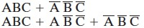

- Simplify the following expressions according to the commutative law, DeMorgan’s theorem, etc.
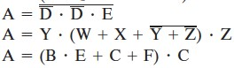

2

