Assignment #5
- Assume a pipeline with four stages
      - FI: Fetch instruction
      - DA: Decode instruction and calculate addresses
      - FO: Fetch operand
      - EX: Execute
Draw a diagram similar to Figure 16.10 (Shown as below) for a sequence of 7 instructions to show how many time units are now needed.
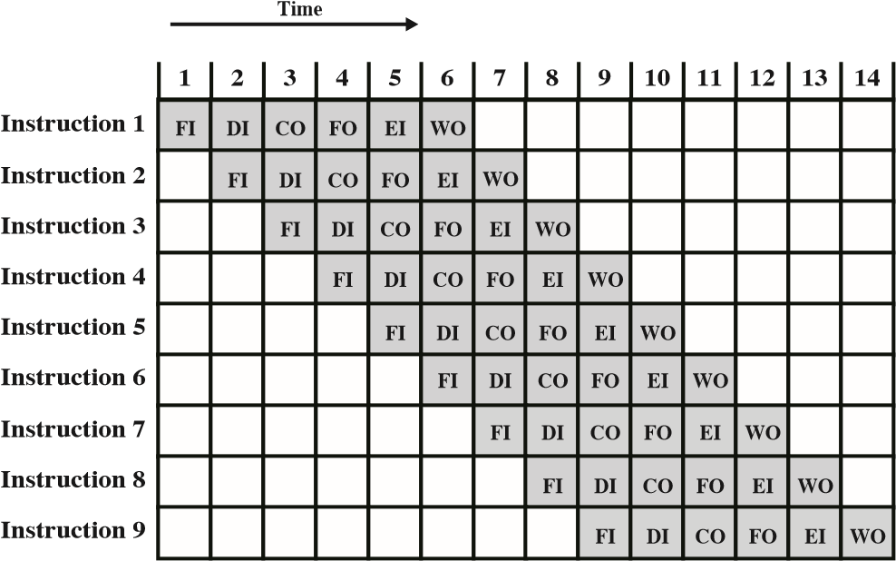
 | 1 | 2 | 3 | 4 | 5 | 6 | 7 | 8 | 9 | 10
Instruction 1 | FI | DA | FO | EX
Instruction 2 |  | FI | DA | FO | EX
Instruction 3 |  |  | FI | DA | FO | EX
Instruction 4 |  |  |  | FI | DA | FO | EX
Instruction 5 |  |  |  |  | FI | DA | FO | EX
Instruction 6 |  |  |  |  |  | FI | DA | FO | EX
Instruction 7 |  |  |  |  |  |  | FI | DA | FO | EX

- Consider the following assembly language program
  - Move R3, R7 / R3 ← (R7) /
  - Load R8, (R3) / R8 ← Memory (R3) /
  - Add R3, R3, 4 / R3 ← (R3) + 4 /
  - Load R9, (R3) / R9 ← Memory (R3) /
  - BLE R8, R9, L3 / Branch if (R9) > (R8) /
This program includes WAW, Raw, and WAR dependencies. Show these.
- I2 – R3 needs I1
- I3 – R3 needs I2
- Output needs I1 and I2
- I4 – R3 needs I3
- I5 – R9 need I4
- Parallelism, superscalar, super-pipelining:
- What is the essential characteristic of the superscalar approach to processor design?
It can run multiple instructions at once
- Compare and contrast: Super-scalar, Super-pipelining, and Parallelism.
Super-scalar and Parallelism are similar in that they run multiple computations at the same time. Super-pipelining is reducing the clock cycle time.
- Assume a pipeline with five stages (FI, DI, FO, EX, WO) each stage sues one time units. For a sequence of 6 instructions, how many time units are needed if we use the following approaches:
- Superscalar (two instructions are executed concurrently in each pipeline)
7
- Super-pipelined
7.5
- Parallelism
5
- Which one is better?
Parallelism
- Compare and Contrast CISC and RISC.
A RISC has more complex and more total instructions. RISC’s execution time is lower than CISC. RISC has multiple instruction sets. CISC does not have a problem with code expansion.

- Consider a 16-bit processor in which the following appears in main memory, starting at location 100.
        - The first part of the first word (content at 100) indicates that this instruction loads a value into an accumulator, the value of 300 in location 101 may be part of the address calculator. The mode field specifies an addressing mode and, if appropriate, indicates a source register.
        - Assume that when used, the source register R1, which has a value of 400.
        - There is also a base register that contains the value 200. Assume that location 259 contains the value 499, location 260 contains the value 500, and so on. Determine the effective address and the operand to be loaded for the following address modes:
          - Register Indirect Addressing
600 | 1200
          - Direct Address
300 | 600
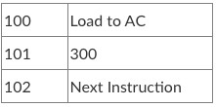
          - Displacement Addressing
600 | 1200
          - Indirect Addressing
600 | 2400
          - Immediate Addressing
100 | 300
          - Register Addressing
400 | 800
- Assume that the memory access time is 60 ns and the recharge time is 40 ns. What is the memory cycle time?
100 ns

