Tu vung
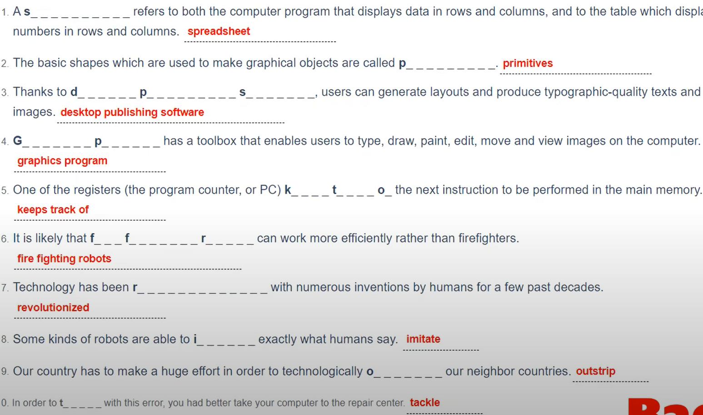

Sua loi
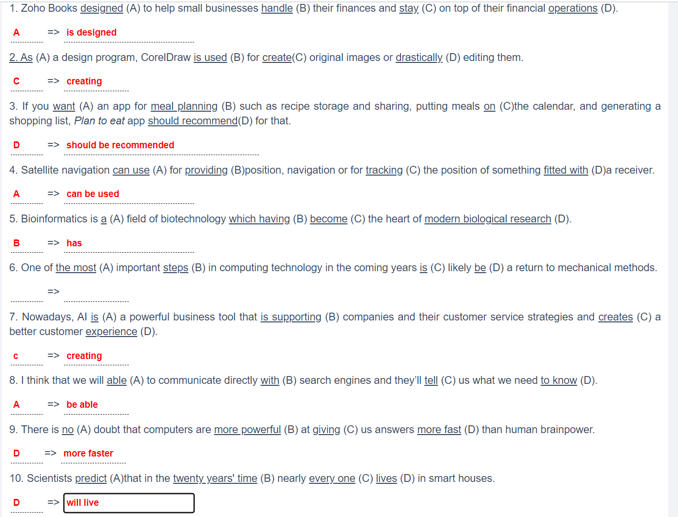

Nghe1
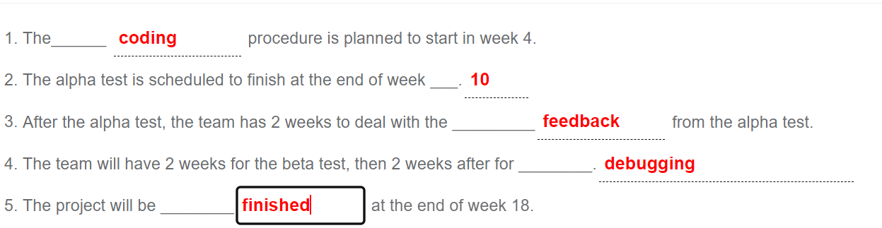

Nghe2 40%
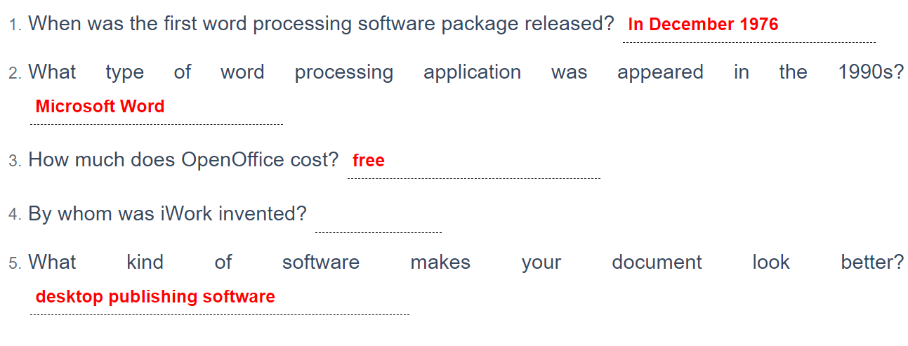

Doc1
Adobe Dreamweaver CC is a comprehensive website and mobile content visual development application. The software lets users create, and manage websites. Adobe Dreamweaver CC comes with a host of tools that enable developers to create dynamic websites using different languages. They can also expect their end-products to show beautifully on any browser and on any device.
With Adobe Dreamweaver CC, website designers can push their creations to the web faster. That is because the application is equipped with templates that can be customized according to businesses’ needs. On top of that, the application also actively assists coders in reading lines of code for them to be able to quickly make edits and updates.
The benefits offered by Adobe Dreamweaver CC
+ Multi-Device Products
With Adobe Dreamweaver CC, developers can create websites and web applications for any device. They only have to code it once on the platform and it will show beautifully across different screen sizes. This lets them display their creations appropriately without loss of functionality.
+ Dynamic Code Editor
Adobe Dreamweaver CC assists developers in quickly finishing their website and web application projects. The software comes with a code completion feature that automatically completes codes.
Moreover, the software also provides code hints to further advance learning. Visual aids also help in reducing errors and swiftly finishing sites.
+ Quick Publishing
Companies can push their websites and web applications to the web at a much faster pace with Adobe Dreamweaver CC. The application aids developers in creating and publishing with starter templates that they can customize to create HTML emails, website pages, blogs, e-commerce platforms, portfolios, and more.
Further, Adobe Dreamweaver CC is equipped with code highlighting tools that let developers process code and implement edits and updates expeditiously.
+ Regular Updates
Adobe Dreamweaver CC is not a static software. Users regularly receive updates that enhance their coding, publishing, and managing experience. The software also continues to roll-out updated and new features for expanded workspaces and better displays.
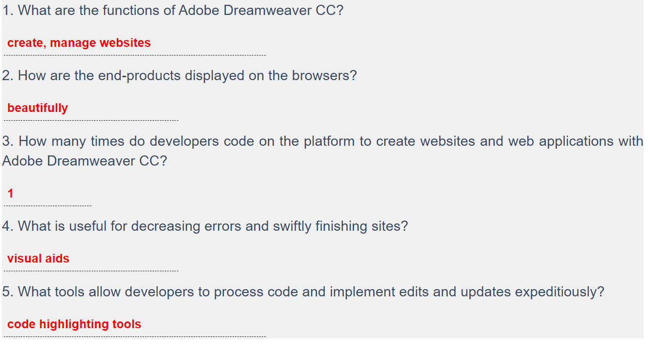

Doc2
If you believe some AI-watchers, we are racing towards the Singularity – a point at which artificial intelligence outstrips our own and machines go on to improve themselves at an exponential rate. If that happens – and it’s a big if – what will become of us? In the last few years, several high-profile voices, from Stephen Hawking to Elon Musk and Bill Gates have warned that we should be more concerned about possible dangerous outcomes of supersmart AI. And they’ve put their money where their mouth is: Musk is among several billionaire backers of OpenAI, an orgnisation dedicated to developing AI that will benefit humanity. But for many, such fears are overblown. As Andrew Ng at Stanford University, who is also chief scientist at Chinese internet giant Baidu, puts it: fearing a rise of killer robots is like worrying about overpopulation on Mars. That’s not to say our increasing reliance on AI does not carry real risks, however. In fact, those risks are already here. As smart systems become involved in ever more decisions in arenas ranging from healthcare to finance to criminal justice, there is a danger that important parts of our lives are being made without sufficient scrutiny. What’s more, AIs could have knock-on effects that we have not prepared for, such as changing our relationship with doctors to the way our neighbourhoods are policed. What exactly is AI? Very simply, it’s machines doing things that are considered to require intelligence when humans do them: understanding natural language, recognising faces in photos, driving a car, or guessing what other books we might like based on what we have previously enjoyed reading. It’s the difference between a mechanical arm on a factory production line programmed to repeat the same basic task over and over again, and an arm that learns through trial and error how to handle different tasks by itself.

1. Singularity is the point where AI
outstrips
our own and machines.

2. Many people including Stephen Hawking, Elon Musk and Bill Gates have warned us about possible
dangerous outcomes
of supersmart AI.

3. According to Andrew Ng, fearing a rise of
killer robots
is similar to worrying about overpopulation on Mars.

4. There is a danger that many important parts of our lives, like healthcare, finance and
criminal justice
will be made without sufficient scrutiny.

5. Simply put, AI is machines doing things that are considered to require
intelligence
when humans do them.

