Unit1

Nói về phát triển ấn tượng trong IT
What is the recent development in IT that impress you most?
What is it about?
What is its impact on society?
What are its advantages?
Why are you impressed by that development?
How about its future?
--
Today, there are many developments in the IT such as: block chain, cloud computing, machine learning,… the recent development in IT that impress me the most is AI. AI is a machine that can be intelligent as a human like: thinking, learning, communicate and understand language. We are using a lot of smart devices such as smart TVs, smartphones. It is impacting every industry, and changing our lives. AI creates many job for programmers, besides it also changes the global quality of life. In the future, AI will have applied to all devices. so we have to work hard to keep up with the development of technology. Thanks you for listening

Card 1
Lượt 1:
B: How intelligence will computers be in the future?
A: In the future, computers will have become intelligence than humans
B: when will it happen?
A:in 2020
B:how dose it impact people’s lives?
A:computer will be able to replace humans in risk-taking jobs; and have lots of people become unemployed
B:what about bears in the future?
A: Teddy bears will have engineered living genetically.
B: when will it happen?
A:in 2040
B: how dose it impact people’s society?
A:it’s possible that, the bears will not only a toy but also a helper taking care of children
*lượt 2:
A: What will electronic memory in the future?
B: Electronic memory will have enhanced
A: when will it happed?
B: in 2020
A: how dose it impact people’s lives?
B:it can be employed in memory loss treatment
A: what will artificial brain in the future?
B: it’s possible that we will have an artificial brain
A: when will it happen?
B: in 2045
A:how dose it impact people’s society?
B:it’s possible that it’ll be a breakthrough in medical treatment (saving people from serious accidents with severe brain damage)

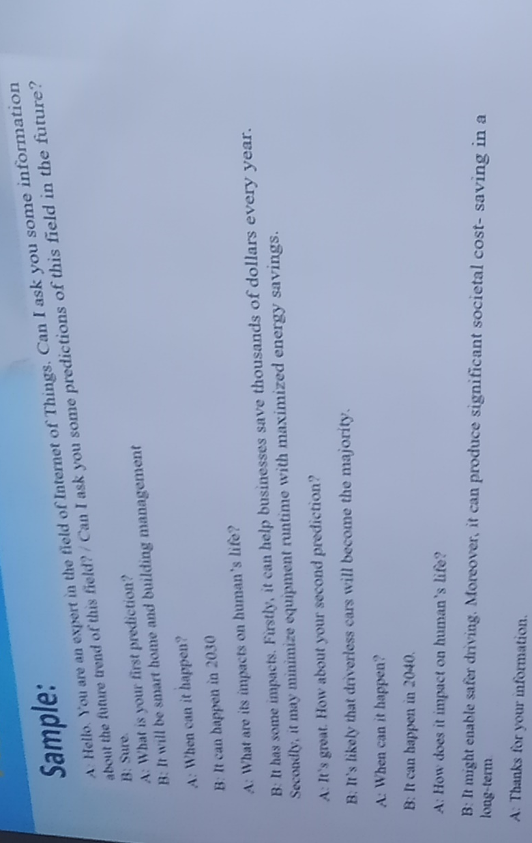

Unit2

Nói về phần mềm ứng dụng mà bạn thích
Task 6: Write a paragraph (120-140 words) about your favorite application software based on the suggested questions:
1. What is the name of your favorite application software?
2. By whom was it created?
3. What is it used for?
4. What benefits does it offer to the users?
5. Does it have any limitations? If any, what are they?
There are many software applications that I am using for learning and entertainment such as: Microsoft word, visual studio code, figma... . The application software that I like the most is Adobe Photoshop CC. Photoshop is a graphic editing software developed and published by Adobe Systems in 1988. Photoshop is the most popular software for editing bitmap images and is the standard for image editing. I like it because it has an easy to use interface on first use and has a large support community. it's convenient to design logos, creative art, blog images and more professional stuff. however it also has some limitations. It includes many different tools, so it will take a long time to learn how to use each tool correctly. And the computer will need a lot of RAM to use it.

Hội thoại

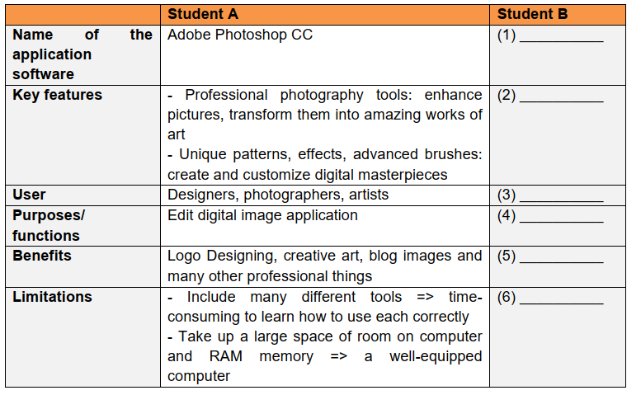
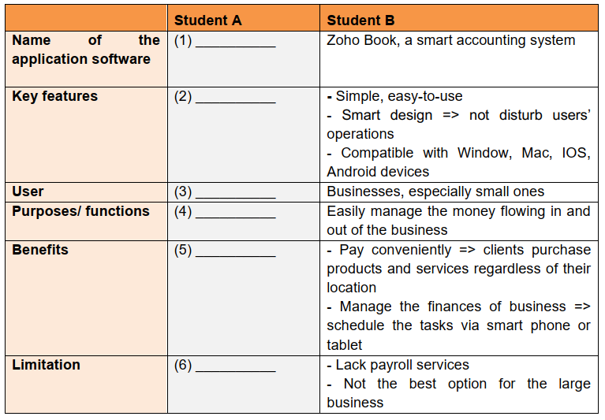
*B ask A
B: What is the name of your favorite application software?/ what is your favorite application software?
A: it is like Adobe phtoshop CC
B:What are its key features?/ what key features does it have?
A: it has many features, the first it is professional photography tools which used to enhace pictures, transform them into amazing works of art. The second: it has unique patents, effects, advanced brushes for creating and customizing digital masterpieces
B: by whom is it used?
A: it is used by designers, photographers, artists
B: what is it‘s function/ what is it used to?
A: is used to edit digital image application
B: What benefits does it have?
A: it is used for logo designing, creative art, blog images and many other professional things
B: Does it have any limitations
A: it includes many different tools. Therefore, it is time-consuming to learn how to use each correcty. Besides, it takes up a large space of room on computer and RAM memory. Your computer should be well-equipped
B: now your turn
A: what it the name of the application software?
B: it is zoho book, a smart accounting system
A: what are its key features?
B: it is simple and easy to use,. Besides it features smart design which doesn’t dusturb user’s operations. Moreover, it can be compatible with window, mac ios and android devices
A: by whom is it used?
B: it is used by business, especially small ones
A:what is it used for?
B:it is used to manage the money flowing in and out of the business.
A: what benefits dose it have?
B: it can pay conveniently, so clients purchase products and services regardless of their location. Moreover, it also manage the finance of business. So users can schedule the tasks via smart phone
A:dose it have any limitations?
B: it lacks of payroll services, moreover, it is not suittable for the large business.

Unit1

Unit1

Unit1

Unit1

Unit1

