Cài đặt vào bảo trì: installation and maintenance

# từ vựng

## Từ mới

BIOS(basic input, output system)

Boot drive: o dia khoi dong

CMOS setup(complementary metal-oxide semiconductor)

Configuration: cau hinh

Default seting:

Device drivers

Device manager

Disk cleanup

Expansion cards:

Installation

Maintenance

Microsoft drive optimize

Modem card

Partition, partitioning: phan vung

Rescue disk: dia cuu ho

Video card

## Tu noi

Align

Attach

Backup

Boot

Configure

Defragment: toi uu hoa

Insert

Maintaint

Optimize

Process

Reboot

secure

# ngữ pháp

## Động từ tuần tự

First, secode, then, next, after that, finnaly

Trong câu bị động thường có “by” hoặc “from”

## Mệnh lệnh

Là cấu trúc để đưa ra mệnh lệnh và không cần chủ ngữ.

*khẳng định:

V(nt) + O => keep your device dry

Be + adj =>be carefull of…

*phủ định

Don’t + v(nt) + O=> don’t insert…

Don’t + be + ad>don’t be afraid..

sf

## Câu đk đưa ra chỉ dẫn

If + s + v(hiện tại) + O, V(nguyên thể) + O

If the system doesn’t power up at all, check the power cord

*ví dụ: follow the instruction…

## Cấu trúc đưa ra lý do và mục đích

For + N =>for the new features.

So that + mệnh đề => so that you can use the new …

To/in order (not) to/so as (not) to + v(nt)=>to use || in order to use|| so as to use

*ví dụ:

Hầu hết dây mạng sử dụng to send

Hầu hết dây mạng sử dụng for sending

So that the computer is automatic..

# bài tập

## Từ vựng

1. Once you have entered C_ _ _ s_ _ _ _, you will see a set of text screens with a number of options.

CMOS setup

2. If you want to change d_ _ _ _ _ _ settings, you can open the "Preferences" window and modify the options to suit your needs.

default

3. Since e_ _ _ _ _ _ _ _ c_ _ _ _ require open slots, they cannot be installed in computers with no available slots like Apple iMac.

expansion cards

4. P_ _ _ _ _ _ _ _ _ _ _ a disk can make it easier to organize files, such as video and photo libraries, especially if you have a large hard drive.

Partitioning

5. Running D_ _ _ C_ _ _ _ _ _ to remove unnecessary files can help to speed up and improve the performance of the hard drive and computer.

Disk Cleanup

6. It’s recommended that you should b_ _ _ the computer to check the settings and verify that everything is working correctly.

boot

7. If you want a clean i_ _ _ _ _ _ _ _ _ _ _of Windows on a computer that already has Windows on it, you need to erase the existing Windows first.

installation

8. When you start to hear extra grinding sounds, or your computer doesn't open files as quickly as it did before, it's time to d_ _ _ _ _ _ _ _ _.

defragment

9. D_ _ _ _ _ d_ _ _ _ _ _ are small programs stored on the hard drive that tell the computer how to communicate with a specific device such as a printer, network card, or modem.

Device drivers

10. On startup, the B_ _ _ tests the system and prepares the computer for operation based on the installed hardware and the configuration settings from the manufacturer and user.

BIOS

## Ngữ pháp

1. Much of (A) the Internet uses (B) high-speed fibre optic cable to sending (C) data or information over (D) long distances.

C - send

2. WiFi is standard technology to (A) building wireless LANS and public hotspots while (B) Bluetooth networks let (C) mobile phones communicate (D) over short distances.

A - for

3. To follow (A) the instructions provided by your (B) ISP, probably in the form of (C) a .pdf file on a CD to install (D) the software for your router.

A - Follow

4. When (A) setting up antivirus software, make (B) sure that you choose the proper settings so as to (C) the computer is automatically scanned (D) for viruses on a regular basis.

C - that

5. Unless (A) the system appears (B) to be running but you don’t see anything (C) on the display, check the monitor to ensure (D) that it is plugged in and properly connected to video card.

A - If

6. To run (A) Windows updates, first, click (B) on ‘Start’, then ‘All programs’, and final (C) the ‘Windows Update’ icon at (D) the top of the list.

C - finally

7. If you install the drives before (A) the motherboard, not (B) connect the power cords until (C) the motherboard is (D) in place.

B - don’t

8. When installing (A) drives, being (B) sure to use short screws that (C) will not protrude too deeply into the drive and damage (D) it.

B - be

9. In order that (A) give the CPU a break and help (B) it run more efficiently, a video card can be used (C) to process the graphics portion of (D) the processing load.

A - to

10. Before you install (A) a software, the firstly (B) step is to check the configuration of (C) your computer, and the system requirements (D) of the software.

B - first

## Từ vựng test

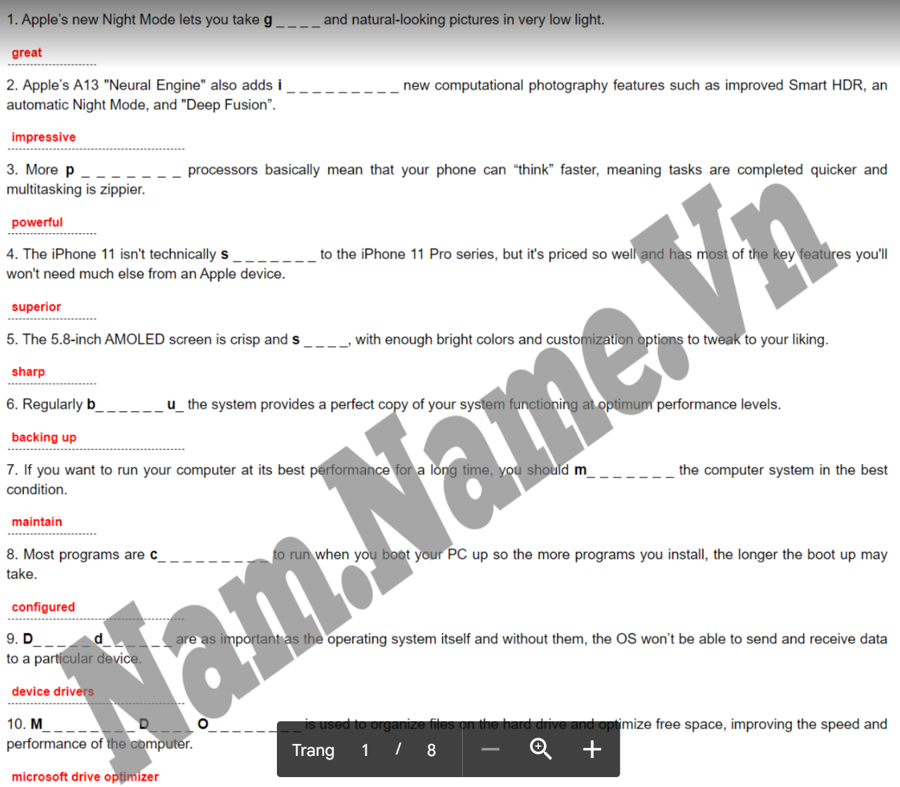

## Ngữ pháp test

