# unit 1

## Viết về các nguyên tắc đạo đức trong 1 công ty lập trình

Unit 1-1: các nguyên tắc đạo đức trong công ty lập trình

1. có những nguyên tắc và quy tắc đạo đức nào.

2. giải thích các nguyên tắc đó

3. ví dụ của các nguyên tắc đó

4. nó tác dụng đến công việc ntn?=>giống câu 6

5. bạn muấn làm việc trong môi trường ntn?( I want to work in an environment where everyone is responsible for their work and obey to the code of ethics =>because it helps me be a responsible and ethical employee.)

6. nguyên tắc nào là quan trọng nhất?

All the technology companies have a code of ethics. Here are some principles in a code of ethics that IT professionals should follow. First, respect intellectual property. This means you should apply for a patent, register for a trademark for your invention to protect your ownership. In addition, you are not allowed to plagiarism or duplicate others' source code. Second, respect privacy and security. You should remember not read your colleagues' emails and always keep your customers' information private. Finally, comply with the law. Every company has rules that employees must follow. If you break those rules then you will be fired. Code of Ethics is really important for all companies because it can help employees have honest behavior, and the environment you are working in becomes good..

## Viết cách đăng ký bản quyền trong IT

1. What are the files you need to have? Các files bạn cần có

2. Where do you need to go to? Bạn cần đến đâu

3. What steps do you do? Làm những bước nào

4. How much do you pay? Phải trả bn

5. Do you think it is important to register copyright in IT? Why (not)? Đk có quan trọng k

Today, I will talk about how to apply for a patent, register for a trademark for your invention to protect your ownership. You need prepare some files including: an application form with your signature, Identity copy and three original works,... Then, you bring all the documents to the copyright office of Vietnam and follow these steps. First, you fill out the application form and pay the fee. The copyright registration fee depends on the type of your work. After the payment is done, you will have to wait for 30 days. If there are no objections, the examiner will check your registration. If no similarities are found, your registration is accepted. Finally you received a notification from the Registrar's Office and now everything is done. Copyright registration is really important for all inventors because it can help inventor prevent dishonest behaviors and protect your intellectual property.

# unit 2

## Mô tả các bước để phát triển phần mềm mà bạn biết

describe steps to develop a software you know well

1. What software do you want to describe? Phần mềm nào

2. What is this software used for? PM này dùng để làm gì

3. How many steps are there? Có bao nhiêu bước

4. What are the steps? Các bước đó là gì

5. What notes do you need to consider? (if necessary) có lưu ý gì

Google chrome is a web browser developed by Google. It used to access web page on the Internet. There are 6 steps to develop Google Chrome including planning, analysis, design, development, testing, maintenance. In the first step - planning, the developer collects requirements information from the customer and builds an overview of the software. The second step is analysis to identify functions in the software. The third step is to design the layout with user behavior. The fourth is development that mean Programmers write code to create software. The next step is testing to detect software errors. Finally, maintenance means that the software will be maintained and upgraded when the user needs it. When developing software, developers should develop useful features so that users like their product.

## Hội thoại các bước phát triển phần mềm game di động (mobile game)

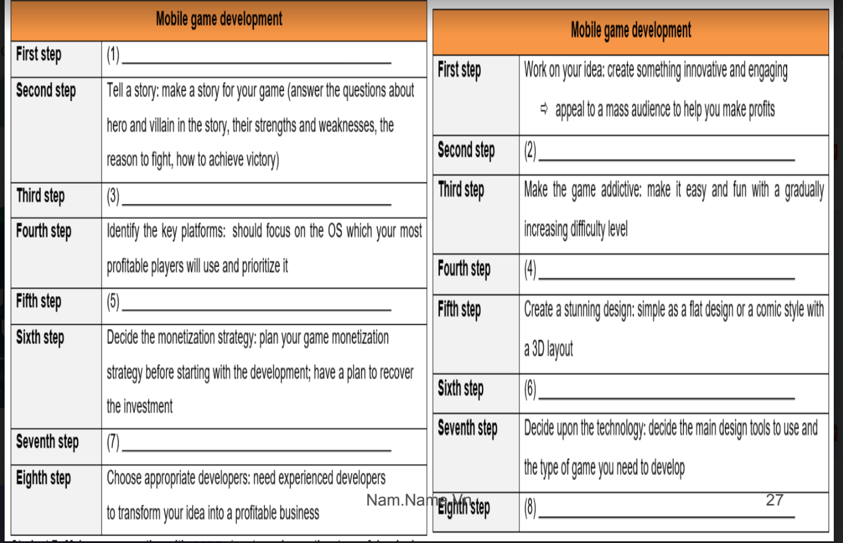

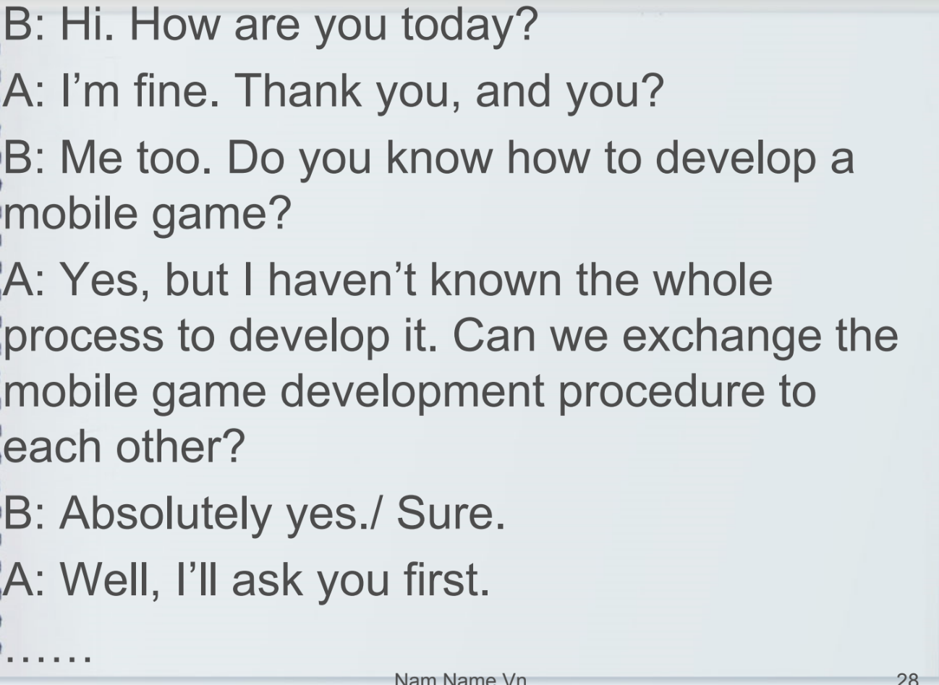

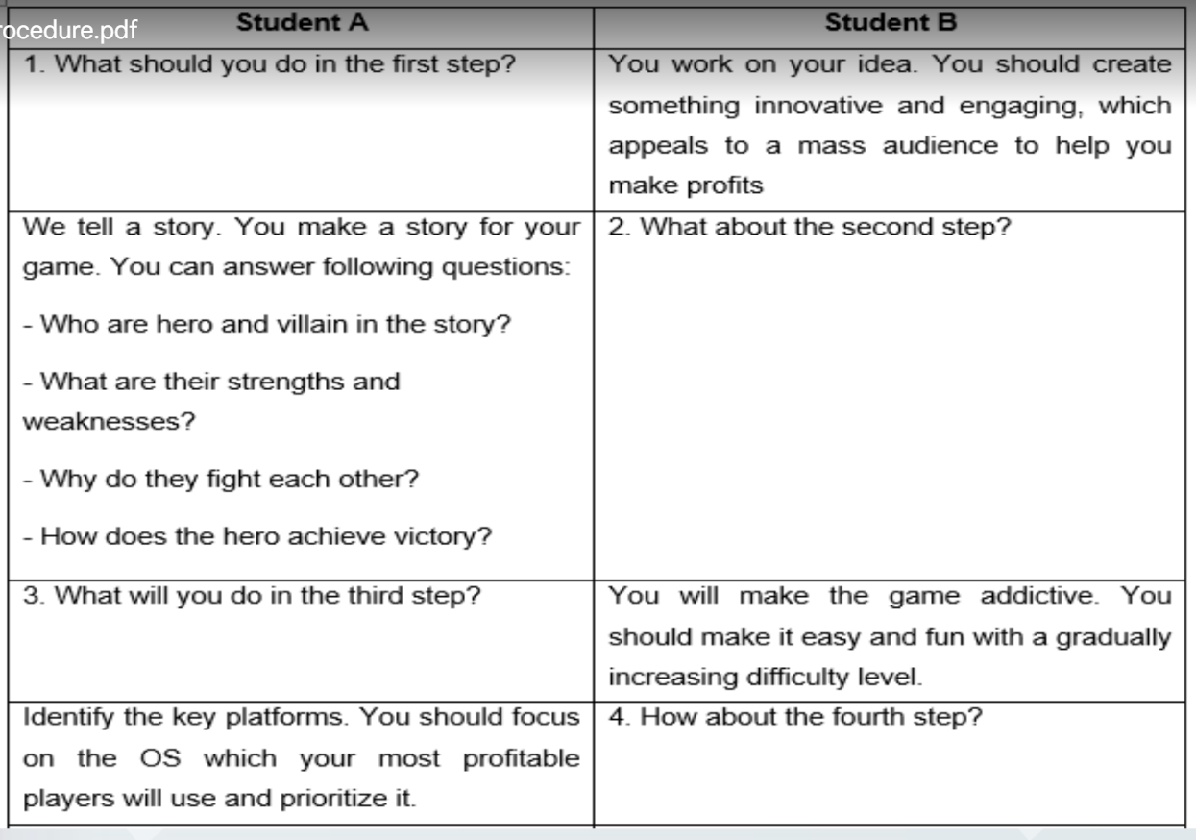

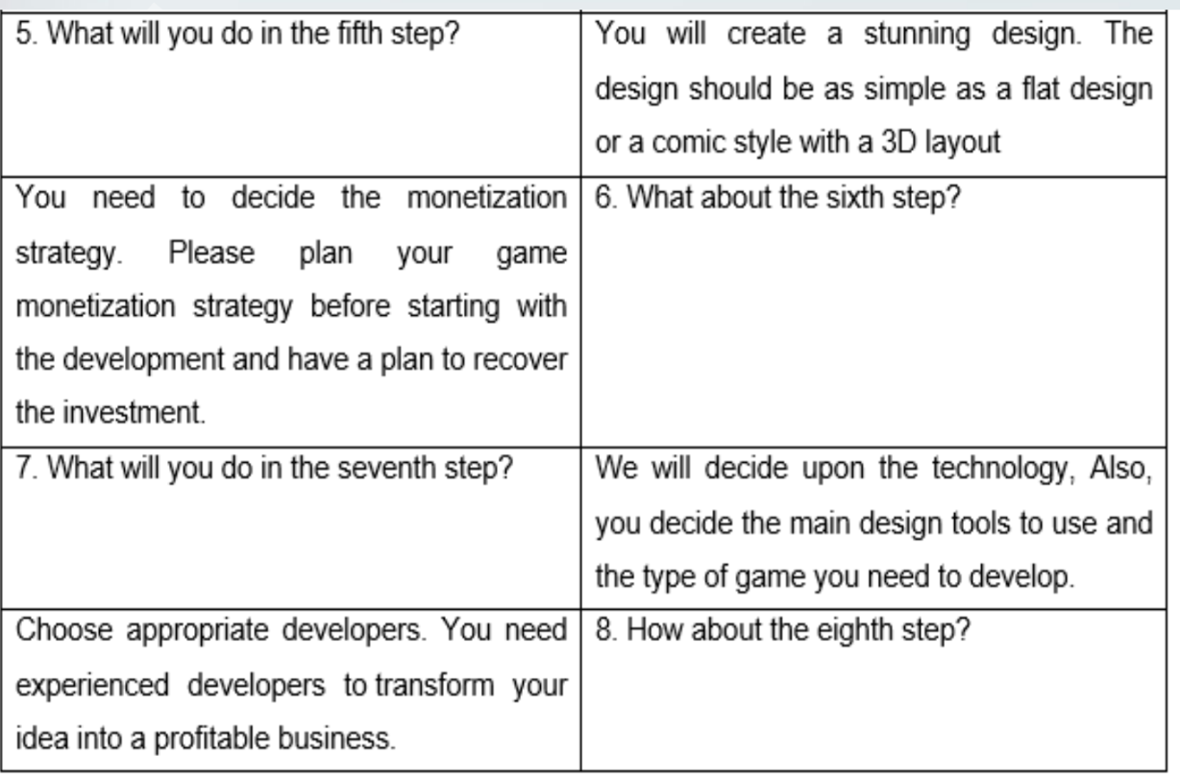

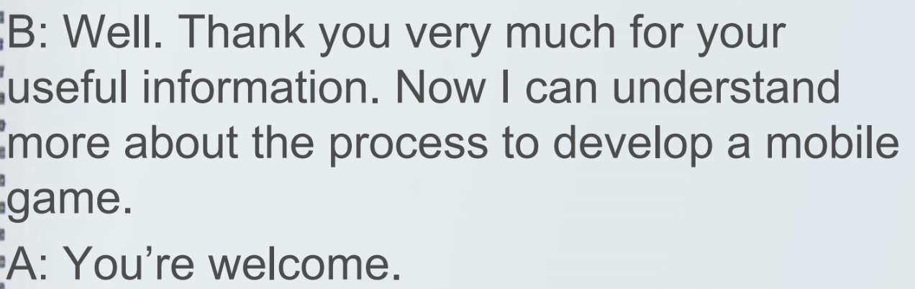

# unit 3

## Viết cách cài đặt phần cứng hoặc phần mềm trên máy tính

1. What computer software/ hardware do you want to install? Tên PM muấn cài

2. What is computer software/ hardware used for? PM đó dùng để làm ghì

3. How many steps are there? Có bao nhiêu bước để cài

4. What are done in each step? Nói rõ

5. What notes/ cautions do you need to consider? (if necessary) Lưu ý?

Google chrome is a web browser developed by Google. It used to access web page on the Internet. There are 4 steps to install Google Chrome. In the first step, open your computer's default web browser, go to ‘google.com/chrome’ to access the Google Chrome website. Once there, click on the blue box that says "Download Chrome." When the executable file has been downloaded, double click on this file to make the installation run. Nowyou just.need click on ‘Next’ and follow the onscreen instructions to complete the installations Finally, reboot ;your PC if prompted. Before you start to install Chrome, you must check if Chrome supports your operating system and your computer meets the minimum system requirement of the software. In addition, an Internet connection is compulsorily required during Google chrome installation, so always keep your computer stay connected to the Internet.

## Miêu tả quy trình bảo trì máy tính (viết + nói)

describe a computer maintenance procedure (at least two components).

1. What computer components are maintained?

2. How often is each component maintained?

3. What activities are done in each component’s maintenance?

4. What is the most important step in maintenance procedure?

5. Why is the maintenance necessary?

Computer maintenance is very important for keeping your computer running smoothly. The components that should be maintained including power supply, fan, heat sink, motherboard, hard drive, mouse, keyboard, monitor... For internal components, every 6 to 12 months, you should use a compressed air to blow the dust out of the case or a dry cloth to clean vents, power supply, hard drive, motherboard, heat sink and fan. For external components, every month, you should use a wet cloth to clean your monitor screen and remove dust from your keyboard and mouse. Remember to always keep the monitor, keyboard and mouse clean and away from liquids. For software, you must always have your firewall run. Additionally, it’s recommended to run antivirus and spyware scan, update the operating system. The average life of a computer is 5 to 6 years; however, it can last 7 to 8 years when properly maintained. So it's really important

# unit 4

## Bạn là tester, review new IT product

As a member of testing team, write a review (120-140 words) on a new IT product

1. What is the name of the product?

2. What do you think of its features (design, color, size, shape, durability, image quality, ….)?

3. What is your opinion on its performance?

4. What are its pros and cons?

5. What is your recommendation to improve this product?

Now, I would like to review one of our upcoming, phones: named S21 Plus. The S21 Plus features a new flat-sided design, which makes it lookymore. industrial and brings a solid feel. However, compared to the previous versions, it is a bit less comfortable to hold. Besides the tradional colors such as black, white and gold, the S21 is also available in four more.colors: Graphite, Gold, Silver and Pacific Blue providing users with various color choices. When it comes to.performance, the S21 is powered by A14 Bionic chip, the fastest chip inside a smartphone for both GPU and CPU performance and can supposedly complete 11trillion operations per second, Additionally, it has 8GB of Ram with the starting storage of 128GB and supports 5G connectivity allowing usersto browse, upload and download faster. In terms of battery life, the phone supports for 65W fast-charging and its battery goes from 0 to 100 percents in just 35 minutes, which is a seriously impressive achievement. Basing on the above features, it can be said that the S21 is really beautiful, has the longest battery life and top-notch performance; however, it still exists one downside that is it doesn’tfeature a high.refresh rate, which makes it a bit less responsive than other phones at the same price. Therefore, it’s recommended that the developers should upgrade its refresh rate to 90Hz or 120Hz to make it more\perfectiand attract more users.

## Hội thoại giữa leader và tester trao đổi về new IT product(bài topic)

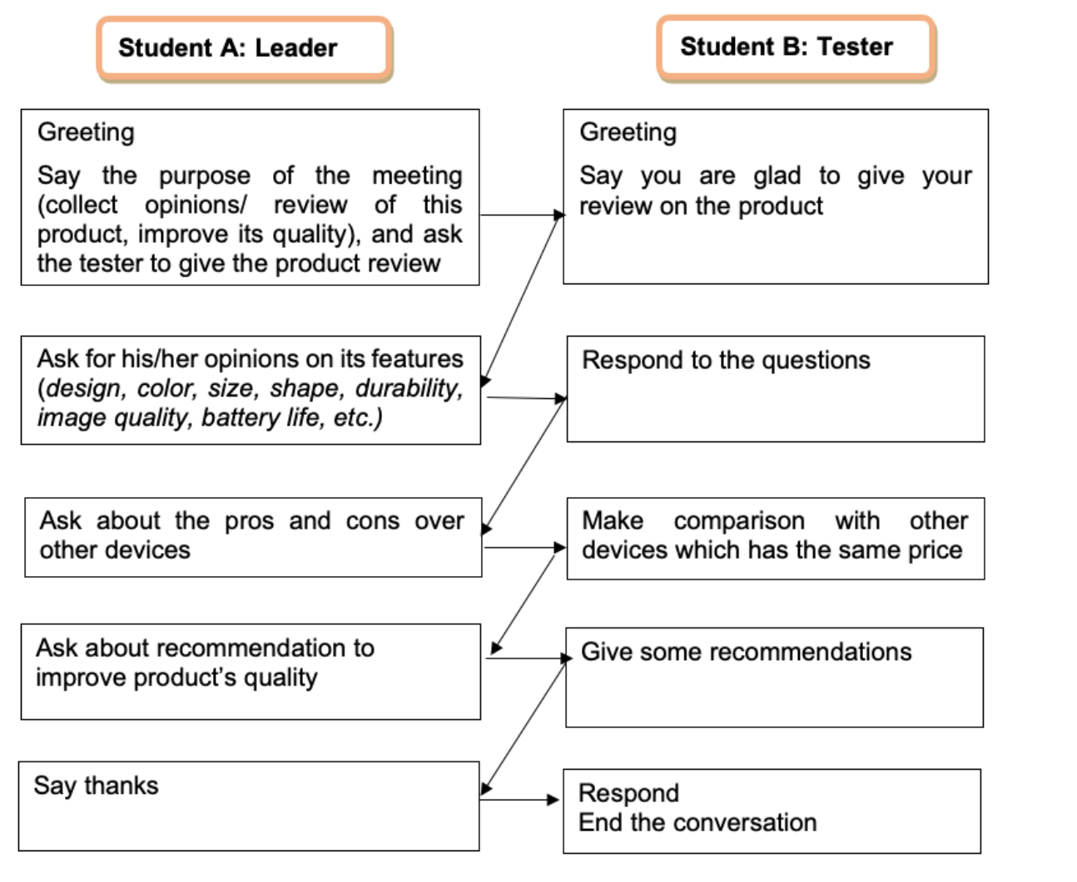

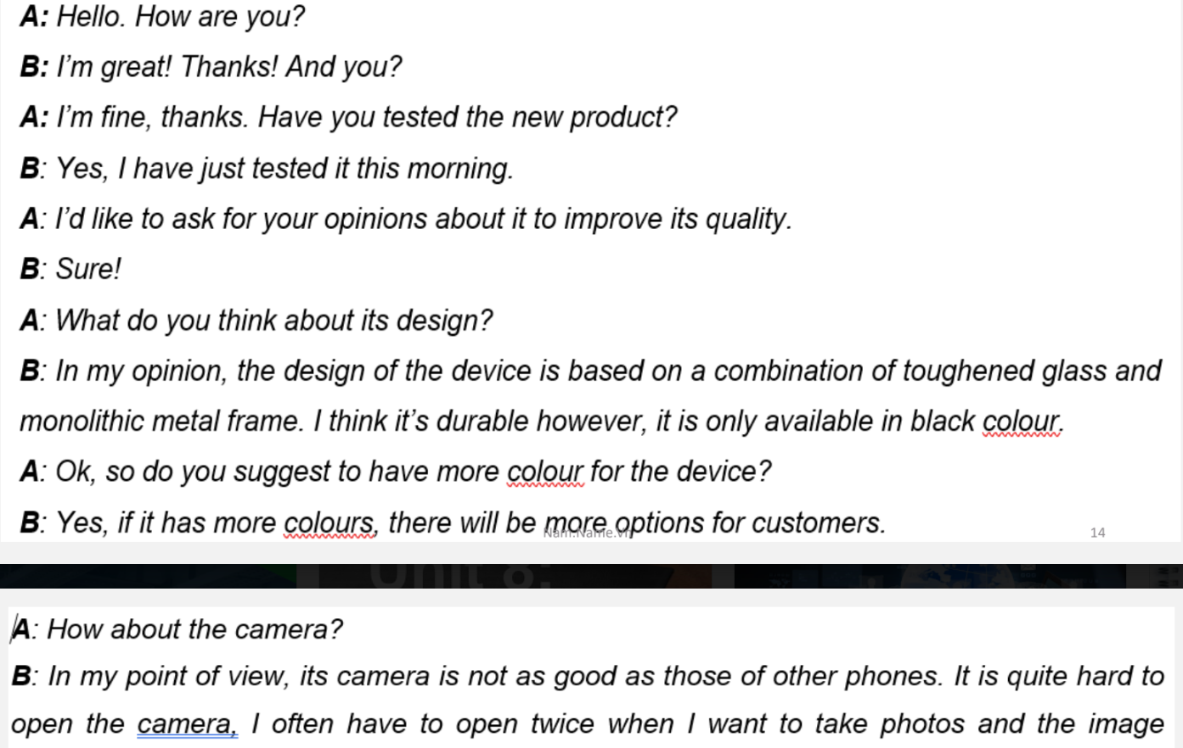

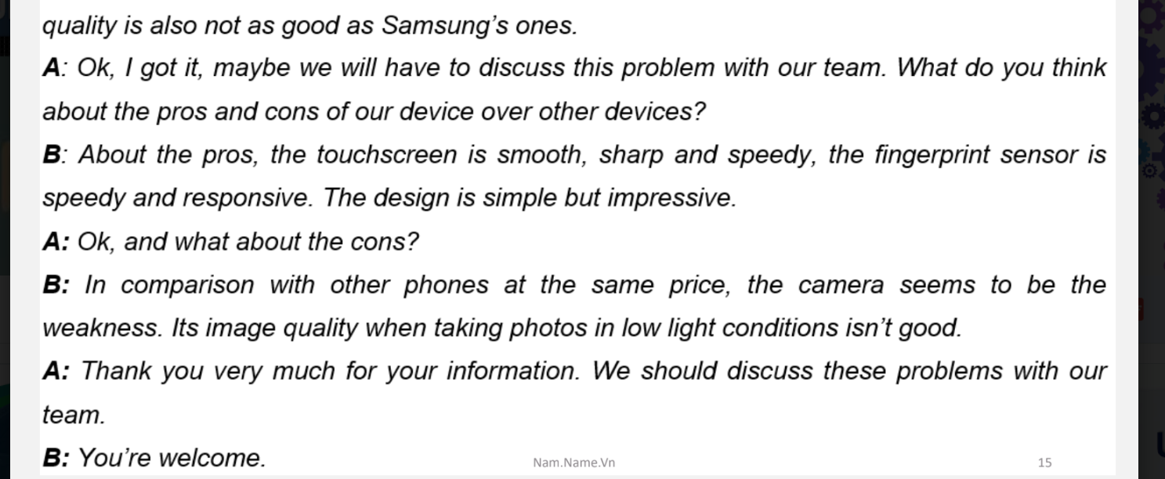

# unit 5

## Write a passage about the procedures for handling a customer’s complaint based on the suggestions.(nói)

(Viết một đoạn văn về các thủ tục giải quyết khiếu nại của khách hàng dựa trên các gợi ý.)

Greeting: lời chào

Active listening: lắng nghe tích cực

Gaining agreement: đạt được thỏa thuận

Apologizing, empathizing and assuring: xin lỗi, cảm thông, đảm bảo

Problem solving: giải quyết vấn đề

Confirmation: xác nhận

All support technician must follow this procedure for handling a customer's complaint. The first step is greeting the customer and identifying yourself. A good greeting should be concise and contain the information such as your name, position, company name. More importantly, be authentic, professional and friendly. The second step is active listening. In this step, you need to listen to the customer's complaint and collect necessary information, for example, customer's name, phone number and specifics of the problem. The third step is gaining agreement. You need to summarize the customer's issue and confirm that you have the correct information. The fourth step is apologizing, empathizing and assuring. Offer an apology if the problem is caused by the company or one of our products. In any case, an expression of empathy is always welcomed. Finally, assure the customer that we will do anything necessary to help them. The next step is problem solving. Ask the customer if he/she prefers to wait while you are working on the issue or want you to contact him/her later. If the customer decides to wait, handle the customer's problem quickly. If the customer wants you to call back later, end the conversation with a friendly tone and work on the issue. The final step is confirmation. In this step, you need to ensure that the issue has been resolved to customer's satisfaction.

# unit 6

## Viết về đạo đức code, trách nhiệm, kỹ năng, chứng chỉ bạn cần cho nghề tương lai của bạn(noí)

Write a short paragraph (120-140 words) about codes of ethics, responsibilities, skills, qualifications/ degrees needed for your future job.

What is your major and your future job option?

What are your job responsibilities?

What degree/ qualifications do you need to have to get a good job?

What skills do you need to have for your future job?

What codes of ethics should you follow in your future job?

I’m the four-year at HaUI, my major is Intelligen technology. This major provides me a wide variety of job choices such as programmer, webmaster, computer security specialist ... After graduation, would like to become a web designer who,is responsible for designing and programming the structure of websites using HTML, CSS, JavaScript... Additionally, I am also in charge of testing websites and monitoring online traffic and conversions.Besides the bachelor’s degree in Information Technology, O need to obtain some other international certificates such as IELTS, CCNA or CCNP which will help to beautify my CV and make it outstanding from other applicants. Furthermore, it’s also necessary for me to equip myself with important skills such as teamworking, problem-solving, communication skill, especially coding skill. To become a ,professional web designer and make contribution to maximizing the company’s value, Imyself must follow a code of ethics. First, I must obey the laws and policies set by the company. Second, it's important to,respect intellectual property by saying no to plagiarism or duplicating. Moreover, I mustn't spread malicious program code such as viruses or worms. Information Technology is a broad and hard field; therefore, from now on I'll have to try my best and make continuous effort to accumulate useful knowledge and work-related skills to become an excellent web designer in the future.

# Unit 7

## Hãy tưởng tượng, bạn tham gia 1 buổi phỏng vấn. Hãy kể lại nó dựa vào câu hỏi gợi ý.(nói)

Task 9: Imagine you have taken part in a job interview recently. Write a paragraph (120-140 words) to retell it based on suggested questions.

1. What position and company did you apply for?

2. What questions were you asked?

3. What good/ bad things did you do?

4. What was the result of the interview?

5. What will you do to have a better job interview for the next time?

I have just graduated with a bachelor in Information Technology at HaUl. After graduation, I applied for the position of a web designer in MISA company, one of the largest software companies in Vietnam. I prepared all the necessary document such as CV, cover letter, bachelor's degree, English certificates, ... and attended a job interview with the manager and head of Human Resources. During the interview, I was asked some questions related to personal information, work experience, educational background, skills, ... Practising interview answers at home and equipping myself with major knowledge and job and company information, I could answer all the questions quite confidently and show the recruiters what my strengths were. However, I was quite nervous at the beginning of the interview; that's perhaps also the reason why I failed at that interview. Although I did not get an offer from the interview, it would be a great experience for me, which will help me perfect my self and be an excellent candidate for the next times.

## Viết thư xin việc

1. Introduction

- State the reasons for writing(Lý do)

- Talk about your academic background(Học vấn)

- Point out your experience, skills and achievements(Kinh nghiệm)

2. Competence and Interest

- Stress what you can do as an employee(Bạn có thể làm gì cho cty)

- Show your understanding about the company’s needs(hiểu gì về cty)

- Demonstrate why you want the job(lý do vào cty)

- Request a personal interview(yêu cầu phỏng vấn cá nhân)

3. Ending

- Repeat your contact information(lặp lại thông tin liên lạc)

- Thank the employer for taking time to consider your application(cảm ơn nhà tuyển dụng)

I have just graduated with a bachelor in Information Technology at HaUl. After graduation, I applied for the position of a web designer in MISA company, one of the largest software companies in Vietnam. I prepared all the necessary document such as CV, cover letter, bachelor's degree, English certificates, ... and attended a job interview with the manager and head of Human Resources. During the interview, I was asked some questions related to personal information, work experience, educational background, skills, ... Practising interview answers at home and equipping myself with major knowledge and job and company information, I could answer all the questions quite confidently and show the recruiters what my strengths were. However, I was quite nervous at the beginning of the interview; that's perhaps also the reason why I failed at that interview. Although I did not get an offer from the interview, it would be a great experience for me, which will help me perfect my self and be an excellent candidate for the next times.