The 8th International Conference on Engineering Mechanics and Automation (ICEMA 2025)
Hanoi, November 14÷15, 2025

Fabrication and Investigation of an IoT-Based Smart Crop Care System Using LoRa and Solar Energy

Nguyen To Vu Khoi
Faculty of Electronics and Telecommunications
VNU – University of Engineering and Technology
Hanoi, Vietnam 22027500@vnu.edu.vn

Duc Nguyen Thanh
Faculty of Electronics and Telecommunications
VNU – University of Engineering and Technology
Hanoi, Vietnam 22027544@vnu.edu.vn
Thi Ngoc Anh Hoang
Faculty of Electronics and Telecommunications
VNU – University of Engineering and Technology
Hanoi, Vietnam 21020888@vnu.edu.vn

Chi Tran Nhu
Faculty of Electronics and Telecommunications
VNU – University of Engineering and Technology
Hanoi, Vietnam trannhuchi@vnu.edu.vn

Duc Lam Le Faculty of Electronics and Telecommunications
VNU – University of Engineering and Technology
Hanoi, Vietnam
21020922@vnu.edu.vn

Tung Bui Thanh
Faculty of Electronics and Telecommunications
VNU – University of Engineering and Technology
Hanoi, Vietnam
tungbt@vnu.edu.vn

Abstract—This paper proposes an automated greenhouse monitoring and care system that integrates IoT, LoRa communication, and solar energy. The system overcomes challenges of long-range data transmission, limited network infrastructure, and energy constraints in agricultural environments. It includes sensor nodes measuring pH, electrical conductivity (EC), soil moisture, temperature, and light, alongside control nodes managing irrigation and nutrient pumps. A central gateway facilitates reliable two-way communication via LoRa, supported by an acknowledgment (ACK)-timeout-retry mechanism. Energy efficiency is achieved through solar power combined with advanced power management techniques such as deep-sleep mode and power gating. Signal processing with Kalman and median filters, together with interpolation models, ensures accurate nutrient mixing control. Field tests demonstrate over 97% data reception at 700 meters and continuous operation for 37 days without recharging. The system achieves nutrient dosing errors under 7% for pH and 25% for EC, confirming its suitability for precision agriculture. This work offers a scalable, sustainable solution for smart farming in resource-limited settings.
Keywords— IoT agriculture, LoRa, Solar energy, Energy optimization, Automatic control, Interpolation

- INTRODUCTION
In the context of agricultural modernization and climate change, optimizing resource use and improving production efficiency are crucial. One promising solution is the use of Internet of Things (IoT) technology to monitor and automate environmental conditions, particularly in greenhouses for fruit trees and organic vegetables. Parameters like pH, electrical conductivity (EC), soil moisture, temperature, and light intensity are vital for optimal plant growth. However, current systems still depend on farmers' experience, resulting in labor-intensive processes and inconsistent yields and quality. LoRa communication technology provides an effective solution with its long-range, low-power capabilities and wide coverage, making it ideal for agricultural applications. When integrated with an IoT platform, it allows for real-time monitoring, flexible control, and scalability. The system uses advanced control models, such as linear and quadratic interpolation, to manage pH and EC levels in nutrient systems, along with automated control of water and nutrient pumps to maintain ideal growing conditions.
This study develops a monitoring and control system using

LoRa technology and the ERa IoT platform to improve greenhouse environmental management. The aim is to optimize energy use, reduce operational costs, and enable real-time monitoring and remote control via an intuitive interface. Additionally, the system incorporates solar energy, providing a sustainable power source to address power instability in rural areas while reducing maintenance costs. By improving energy management and resource use, this research advances the application of IoT in agriculture, especially in rural areas with limited access to electricity, promoting sustainable farming practices.

- principle of the system
The system is designed for efficient, automatic operation through the integration of advanced technologies. A key component is LoRa (Long Range), an LPWAN technology that enables long-distance communication while minimizing power usage. Using Chirp Spread Spectrum (CSS) modulation, LoRa enhances interference resistance, improves receiver sensitivity, and optimizes spectrum efficiency, ensuring reliable communication over several kilometers, even in obstructed environments like net houses. The system utilizes the LoRa SX1278 Ra-02 module operating in the 433 MHz license-free band, with settings optimized for a balance between range, data rate, and reliability. Its master-slave architecture, shown in Fig. 1, includes sensor nodes, control nodes, and a central gateway, which manages half-duplex LoRa communication and connects to the cloud-based ERa IoT platform via MQTT. To ensure stable performance in noisy outdoor conditions, an ACK-timeout-retry mechanism is used, maintaining data integrity and consistent command execution. Communication packets include headers, MAC addresses, packet types, payloads, and CRC-16 checksums for error detection and efficient data exchange, supporting functions like data reporting, control commands, and status updates.
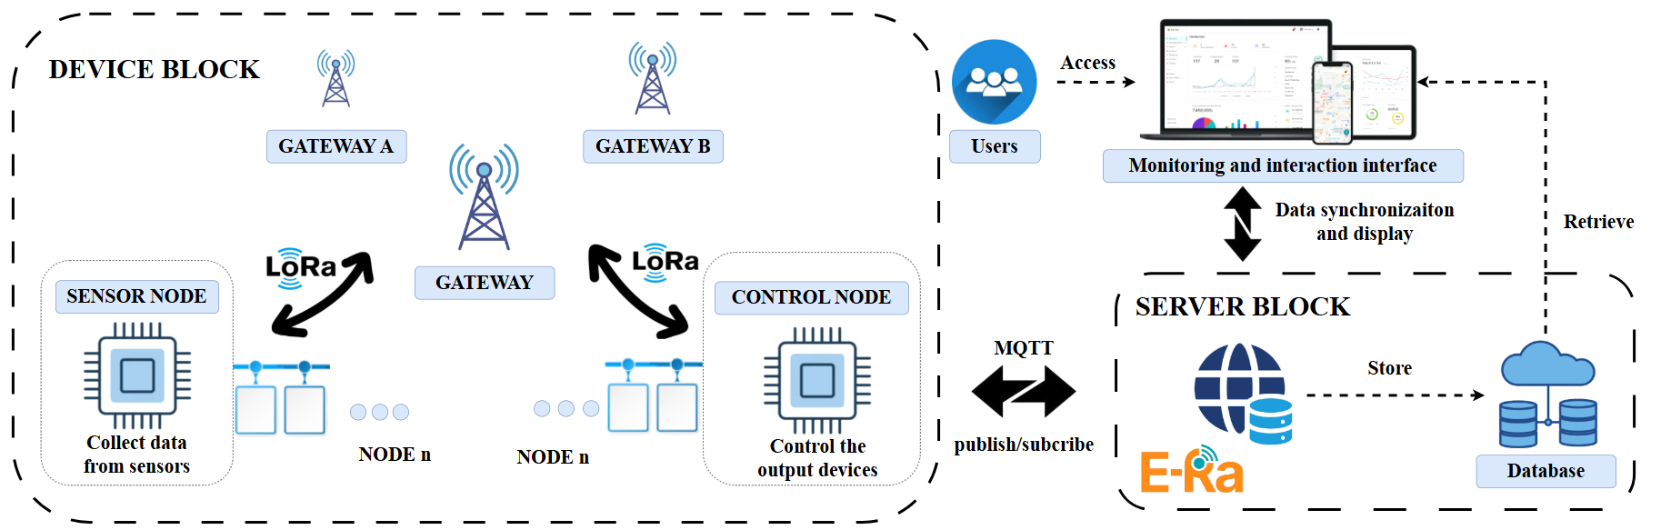
Fig. 1. The block diagram of the overall system.
The system optimizes energy by using two power sources: a converter for the Gateway and solar panels for the sensor and control nodes. The sensor nodes are powered by Li-ion 18650 batteries, charged through the CN3791 circuit via solar energy. To conserve power, the system enters deep sleep mode and powers down peripherals when idle. Sensor node consumption varies from 20–140 mA but drops to under 100 µA in deep sleep. The control node, which includes a mechanical relay, uses 70–90 mA, but the relay only operates briefly, minimizing energy usage. The Gateway consumes 100–120 mA, and energy use can be reduced by turning off the TFT backlight. In the solar-powered system, adjusting the wake-up and sleep cycles of the sensor nodes is crucial for balancing energy efficiency and data updates. During the day, the system uses a short 10-minute sleep cycle to update data frequently, while at night or when the battery is low, the sleep cycle extends to 30–60 minutes, depending on the remaining battery voltage. The ESP32’s internal Real-Time Clock (RTC) manages periodic wake-ups based on battery levels and time of day. The night sleep duration, automatically adjusted by a predefined table, ensures energy conservation and stable operation overnight.
TABLE I. Night Sleep Duration Based on Remaining Battery PERCENTAGE.
Battery Voltage (V) | Remaining Battery Percentage (%) | Sleep Duration (minutes)
≥ 4.0 | ≥ 83 | 10
3.8 - 4.0 | 66 - 83 | 20
3.6 - 3.8 | 50 - 66 | 30
3.3 - 3.6 | 25 - 50 | 45
≤ 3.3 | ≤ 25 | 60
The system optimizes data transmission frequency and energy efficiency by employing an acknowledgment (ACK) waiting mechanism, retrying up to 10 times with a 5-second interval between attempts if no acknowledgment is received. This ensures reliable transmission and prevents LoRa signal conflicts. The node typically requires about 60 seconds to send a packet and generally receives a response after 1-3 retries. Various environmental sensors (EC, pH, soil moisture, temperature, humidity, light, voltage/current) are used for comprehensive monitoring. Advanced filtering techniques, like Kalman and median filters, are applied to maintain data accuracy and stability. To address the nonlinear relationship between nutrient concentration/acidity and pump activation time, interpolation algorithms are employed. Linear interpolation is used for EC control due to its near-linear correlation with pump duration, defined as:
$$y=y_{0}+\frac{\left(x-x_{0}\right)×\left(y_{1}-y_{0}\right)}{\left(x_{1}-x_{0}\right)}$$ | (1)
where x is the EC value and y is the pump duration.
For pH control, quadratic interpolation with the Lagrange polynomial is used to model the nonlinear response:
$$P_{2}\left(x\right)=y_{0}×L_{0}\left(x\right)+y_{1}×L_{1}\left(x\right)+y_{2}×L_{2}\left(x\right)$$ | (2)
where the basis polynomials $L_{i}\left(x\right)$ are given by:
$$L_{0}\left(x\right)=\frac{\left(x-x_{1}\right)×\left(x-x_{2}\right)}{\left(x_{0}-x_{1}\right)×\left(x_{0}-x_{2}\right)}$$ | (3)
$$L_{1}\left(x\right)=\frac{\left(x-x_{0}\right)×\left(x-x_{2}\right)}{\left(x_{1}-x_{0}\right)×\left(x_{1}-x_{2}\right)}$$ | (4)
$$L_{2}\left(x\right)=\frac{\left(x-x_{0}\right)×\left(x-x_{1}\right)}{\left(x_{2}-x_{0}\right)×\left(x_{2}-x_{1}\right)}$$ | (5)

- Experiments
- System Design and Hardware Setup
The hardware system is designed for efficient outdoor agricultural operations and includes sensor nodes, control nodes, and a central gateway. The sensor node, based on ESP32 and LoRa SX1278, collects data on EC, pH, moisture, temperature, humidity, and light, displaying it on an OLED screen and storing it on a microSD card. It is powered by a lithium-ion battery with solar charging via an MPPT controller, and optimized for energy efficiency with low-quiescent current regulators and MOSFET-based power gating. The control node, also using ESP32 and LoRa SX1278, provides manual control through five SRD-05VDC-SL-C relays, buttons, and LEDs for agricultural process management. It is powered by either a DC adapter or solar system, with voltage regulation via MP2451 and 7805. The control node is housed in a weatherproof 3D-printed enclosure for outdoor durability. The central gateway, built on ESP32 and LoRa SX1278, features a 2.8-inch TFT touchscreen for user interaction and a DS3231 RTC for synchronization. It integrates an INA226 power sensor to monitor consumption and supports cloud connectivity via Wi-Fi with optional 4G backup (SIM A7682S) for uninterrupted communication. Powered by an 8–12V DC adapter, the gateway is also housed in a weatherproof case. The pump subsystem includes three mini-pumps delivering nutrient solutions, with EC and pH monitored at the output, all protected within a waterproof housing. Together, these components create a robust system for continuous agricultural monitoring and control (Fig. 2).
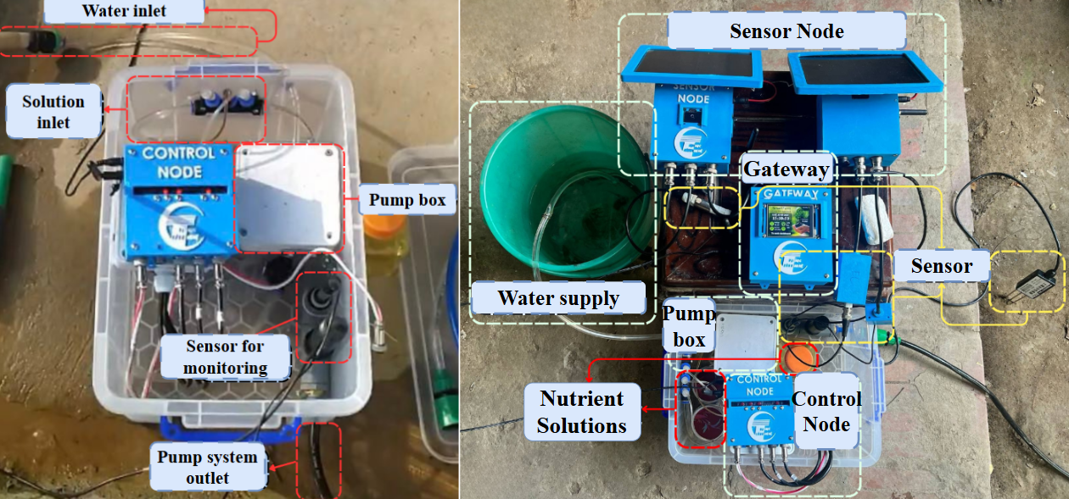
Fig. 2. The actual design of the mixing pump system.
- Procedures for Experimental Evaluation
In this study, two LoRa communication configurations for agricultural applications were tested. The first configuration used SF = 7, 14 dBm transmit power, and 125 kHz bandwidth, with tests conducted from 10 to 200 meters in environments with fixed obstacles. The second configuration used SF = 12, 17 dBm transmit power, and 125 kHz bandwidth, with tests extended to 700 meters in areas with dense foliage and dynamic obstructions. Performance indicators (PRR, RSSI, SNR) and the acknowledgment (ACK)-timeout-retry mechanism were assessed for link reliability. The system was deployed for nearly two weeks in a garden area, consisting of two sensor nodes and one control node. Node 1 measures temperature, humidity, and light, while Node 2 measures EC, pH, and soil moisture. The control node, housed in a sealed plastic box, controls the water and nutrient pumps and receives commands from the Gateway via LoRa. The Gateway, mounted on a concrete pole, is powered by a 12V adapter and features a touch screen. The goal was to assess system stability, LoRa performance, enclosure durability, solar power efficiency, and automatic irrigation control. In addition to evaluating LoRa communication, experiments were conducted to improve sensor data quality. Various filters (Moving Average, EMA, Kalman, Median, and IIR) were tested to reduce noise and stabilize the signal, using data from five sensors: voltage (INA226), current (INA226), temperature (DHT11), humidity (DHT11), and light intensity (TSL2561). Experiments were carried out in stable and fluctuating environments, collecting 400 continuous samples per trial. Filters were evaluated based on Mean Absolute Error (MAE), Standard Deviation (STD), and Peak-to-Peak (P2P) amplitude. Additionally, the nutrient solution mixing pump system (Fig. 3) was calibrated to ensure accurate preparation and pH control. In the experiments, solution A/B was diluted at a 1:5 ratio, and concentrated HNO₃ at a 1:100 ratio. The water pump had an average flow rate of 2 L/min, while the nutrient pump flowed at 5 mL/min. The results showed a linear increase in electrical conductivity (EC) from around 1000 to 3600 μS/cm, while pH decreased nonlinearly from 7.5 to approximately 6.2.
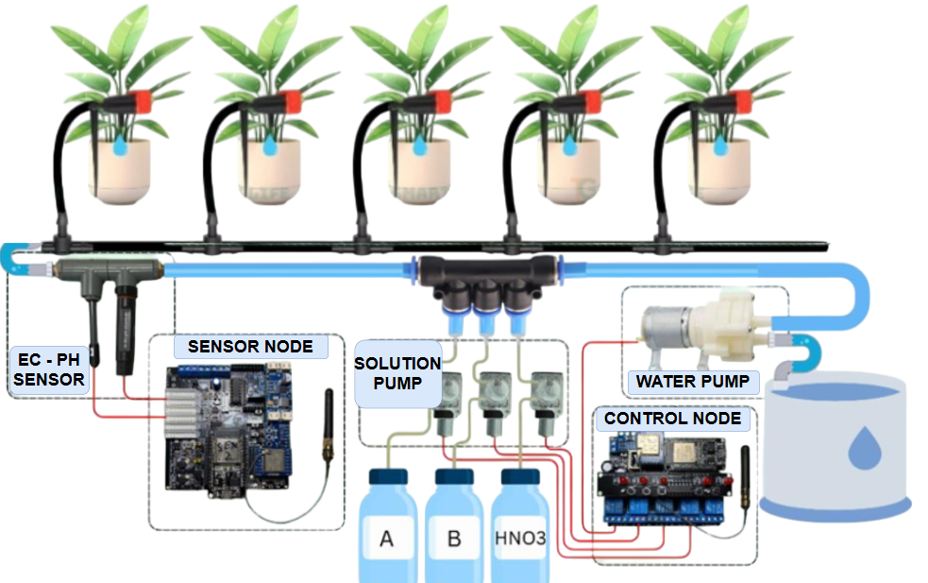
Fig. 3. The overall design of the mixing pump system.
Based on the collected data, interpolation models were derived, with EC represented by a linear function:
$$C_{\left(t\right)}=637.09×t+383.57$$ | (6)
and pH described by a quadratic function capturing its nonlinear behavior:
$$pH_{\left(t\right)}=0.0321×t^{2}-0.3460×t+7.7548$$ | (7)
The function simulates a slow decreasing trend, with an error under 0.2 units, sufficient for calculating HNO₃ pumping time. Both models were tested with a more concentrated solution, yielding better results. This model enables faster control, removing the need for lookup tables and simplifying updates with new data. Finally, the ERa IoT platform was tested on web and mobile interfaces, featuring real-time data visualization, historical charting, and automated scenario configuration. Remote control, including pump control, was evaluated. Key metrics like response time, ease of use, and reliability were crucial in assessing user experience. The Gateway's TFT touchscreen was tested for accuracy and responsiveness in on-site monitoring and control.
- Results and discussions
In this study, the LoRa communication system was evaluated through controlled tests under varying environmental conditions. Configuration 1 (SF7, Tx14) demonstrated excellent performance, with a 100% packet reception rate at distances up to 80 meters. The RSSI values ranged from -65 dBm to -91 dBm, and the SNR varied between 10 dB and 1.5 dB. However, as distance increased, the packet reception rate declined: at 150 meters, it dropped to 73%, and at 200 meters, it further decreased to 40%. This configuration is ideal for smaller agricultural setups, such as greenhouses or localized gardens, where both energy efficiency and communication speed are essential. In contrast, Configuration 2 (SF12, Tx17) provided a longer communication range, maintaining over 85% packet reception up to 500 meters, even in urban environments with obstacles. The RSSI values ranged from -75 dBm to -101 dBm, and the SNR fluctuated between 9.5 dB and -9.5 dB. However, at 700 meters, the reception rate dropped drastically to just 3%, primarily due to signal obstructions. This configuration is better suited for large-scale agricultural operations requiring extended communication range. The results, shown in Fig. 4, illustrate the varying RSSI and SNR parameters for both configurations with distance.
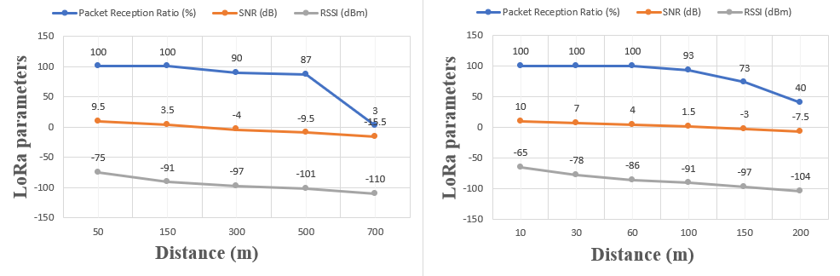
Fig. 4. The chart of RSSI and SNR parameters for two LoRa configurations based on distance.
The system was operated outdoors for nearly two weeks to assess its performance under real-world weather conditions, including sun, rain, fog, and high humidity. The sensor nodes remained stable, operating without resets or power loss. The sleep mode adjusted based on battery levels and time of day, ensuring continuous operation. Data showed battery fluctuations with weather changes. As shown in Figure 5, battery levels reached nearly 100% on sunny days, indicating efficient solar charging. Node 1 consumed an average of 295.92 mWh/day, while Node 2 consumed 533.77 mWh/day, with estimated operation times of 37.5 days and 20.8 days, respectively.
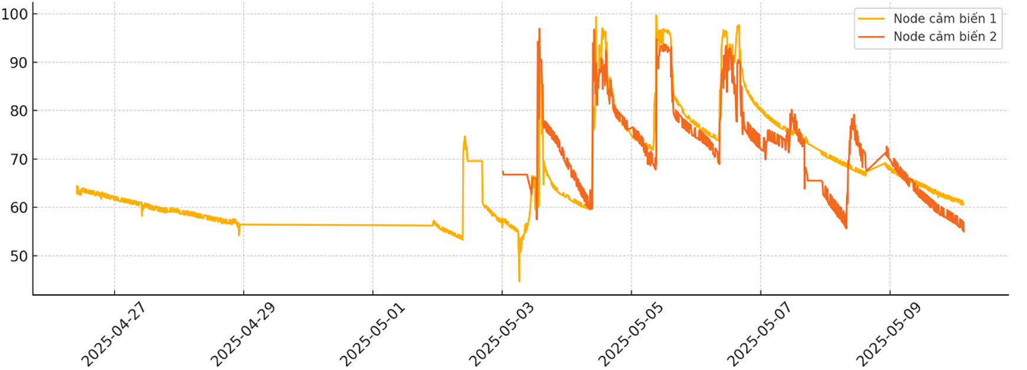
Fig. 5. Power consumption of the two sensor circuit versions.
The 3D-printed enclosures showed no warping or water ingress, and the system’s pump and control nodes worked correctly. The wireless connection between nodes and Gateway remained stable, as seen in Figure 6.
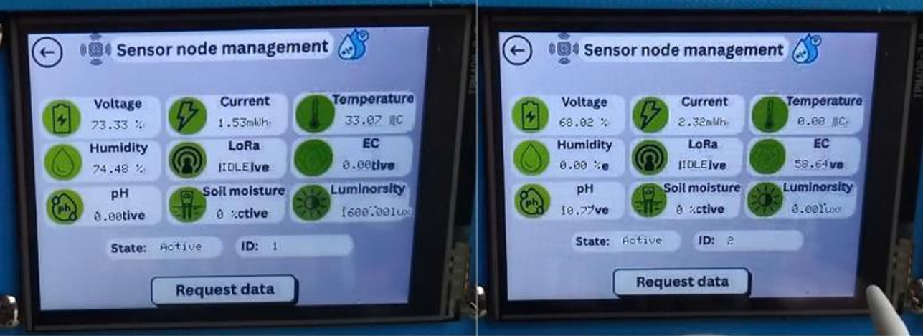
(a) | (b)
Fig. 6. Sensor data at the Gateway. a) Sensor Node 1; b) Sensor Node 2.
Through the survey, Kalman filters outperformed others, especially for current and luminosity signals, by smoothing fluctuations and maintaining key trends. They handled noisy data with precision, making them ideal for dynamic variables. On the other hand, Median filters were more effective for temperature and humidity data, particularly with sensors like the DHT11, which are prone to spikes. The Median filter removed anomalies, improving data consistency, especially with low-cost sensors. Voltage signals, being stable, required minimal filtering as the raw data was reliable. By applying the right filter to each signal type, the system optimized performance and ensured clean data for control algorithms.
Linear interpolation for EC showed a near-linear relationship between pumping time and EC values, with the system consistently following the desired trend. The average error ranged from 19.90% to 27.85% against a target of 2000 µS/cm, due to hardware limitations like pump precision and incomplete diffusion in short pipe segments. Despite this, the system successfully tracked the intended trend, demonstrating the effectiveness of linear interpolation for EC control. For pH, quadratic interpolation accurately modeled the non-linear decrease as acid was added. The average pH error ranged from 5.2% to 6.6%, close to the target of 6.5, which is acceptable for most vegetable crops. pH fluctuations resulted from non-linear sensor response and mixing dynamics in the pipes. Overall, the system demonstrated consistent performance, confirming quadratic interpolation’s effectiveness for pH control. These trends for both EC and pH, after mixing over pump time, are shown in Table II.
TABLE II. The measurement results of EC/pH of the solution after mixing over the pump time.
Time (min) | EC (μS/cm) | EC Error (%) | pH | pH Error (%)
30 | 1443 | 27.85 | 6.93 | 6.62
60 | 1472 | 26.4 | 6.89 | 6
120 | 1535 | 23.25 | 6.87 | 5.69
152.4 | 1505 | 24.75 | 6.9 | 6.15
162 | 1578 | 21.1 | 6.84 | 5.23
180 | 1602 | 19.9 | 6.86 | 5.54
The ERa IoT platform offers an intuitive interface, ensuring seamless integration with system hardware and enhancing user experience. Real-time sensor data—including current, voltage, temperature, humidity, light, soil moisture, EC, and pH—remains stable and accurate, enabling effective monitoring of key parameters and providing timely insights into system performance and environmental conditions. The pump control system is highly responsive, with no noticeable lag, ensuring immediate execution of commands such as irrigation and nutrient delivery. Additionally, the platform features advanced tools like historical charting, statistical reports (exportable to Excel), and automated alerts (e.g., low battery notifications), offering users valuable insights. These tools not only aid in monitoring but also facilitate data-driven decisions to optimize crop care and resource management.
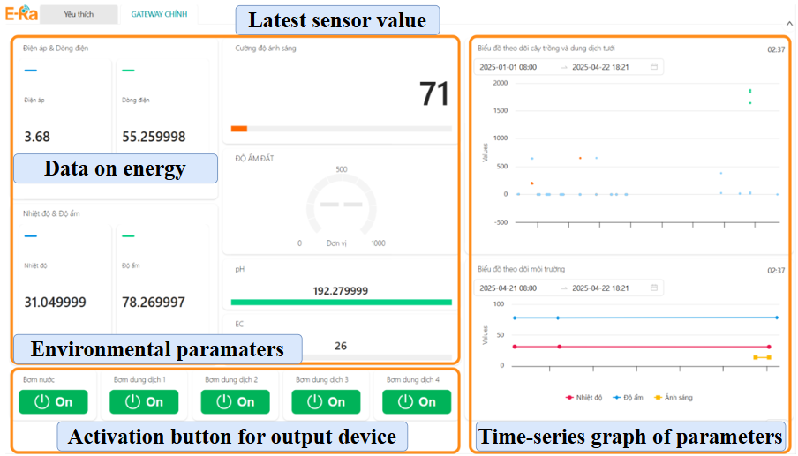
Fig. 7. The main interface of the ERa IoT platform.
As shown in Figure 7, the ERa IoT platform's main interface is simple, user-friendly, and provides a seamless experience. The Gateway’s integrated TFT touchscreen enhances this further, offering an effective on-site interface for quick monitoring and manual control. Its responsiveness allows direct adjustments, eliminating the need for external devices and improving operational efficiency. A key strength of the platform is its scalability, making it easy to add and manage multiple sensor nodes across various locations. This flexibility allows the system to adapt to different agricultural operations, supporting the expansion to larger farm areas or additional parameters as needed. With its intuitive features, the ERa IoT platform provides a versatile and efficient solution for modern agricultural management.
The system was deployed in a small garden for two weeks (Fig. 8), proving its stability and durability under typical outdoor conditions, such as intense sunlight, light rain, and high humidity. The 3D-printed waterproof enclosures protected internal components from water damage, ensuring reliable electrical connections in harsh conditions. During the deployment, all nodes maintained stable LoRa communication, followed programmed cycles, and reliably collected, transmitted data, and executed remote controls. The automated irrigation system, including the pump mixing unit, adjusted irrigation and nutrient delivery based on real-time sensor data. Relay state feedback ensured continuous monitoring for effective system management. The modular design allowed for easy scaling and seamless node integration, supporting expansion for larger agricultural areas.
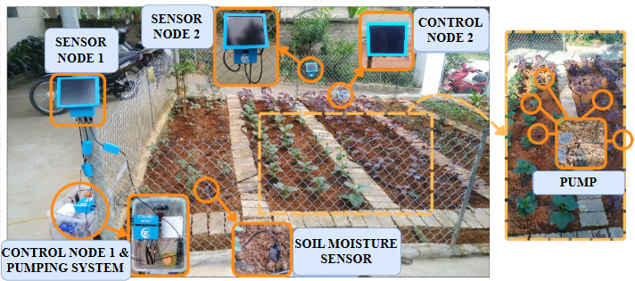
Fig. 8. The actual layout of nodes and the system.
- Conclusions
The study designed and implemented an automated plant care system using LoRa technology combined with solar energy. The LoRa-based plant care system consists of sensor and control nodes connected to a central gateway via two-way LoRa communication. The system supports environmental measurement, irrigation pump control, and automatic feedback. Outdoor experiments showed that the system operates stably, maintaining connection and accurate data transmission, with a packet reception rate of over 97%, ensuring high reliability. The EC/pH interpolation model, built from sensor data, allows automatic solution mixing pump control, improving accuracy in irrigation and nutrient delivery to crops. The user interface on the ERa IoT platform enables remote monitoring, device control, and time-based data storage, facilitating easy multi-point deployment.
For the energy management system, designed to operate independently for long-term use in areas without grid infrastructure, solar panels are used to regenerate energy, ensuring continuous operation without intervention. The sensor nodes can operate for up to 37 days without recharging, thanks to an efficient energy management mechanism. Throughout the real-world testing process, the system maintained wireless connectivity and accurately controlled the pump system and relays via LoRa. Outdoor test results showed that the system regularly recorded and transmitted sensor data while keeping solar energy levels sufficient to compensate for daily and nightly consumption.
References
- “LoRa- (Long Range) Network and Protocol Architecture & Frame Structure,” https://www.techplayon.com/lora-long-range-network-architecture-protocol architecture-and-frame-formats/.
- J. Qin et al., “Industrial Internet of Learning (IIoL): IIoT based pervasive knowledge network for LPWAN—concept, framework and case studies,” CCF Transactions on Pervasive Computing and Interaction, vol. 3, no. 1, pp. 25–39, Mar. 2021, doi: 10.1007/s42486-020-00050-2.
- YK Huang, “What is the Technology Behind LoRa Frequency,” https://www.mokosmart.com/lora-frequency/.
- Abhimanyu Pandit, “Serial Communication https://circuitdigest.com/tutorial/serial-communication-protocols. Protoco
- S. Lee, H. Yoon, K. J. Baik, and B. J. Jang, “Emulator for generating heterogeneous interference signals in the Korean RFID/USN frequency band,” Journal of Electromagnetic Engineering and Science, vol. 18, no. 4, pp. 254–260, Oct. 2018, doi: 10.26866/jees.2018.18.4.254.
- M. B. Giri and R. S. Pippal, “Use of linear interpolation for automated drip irrigation system in agriculture using wireless sensor network,” in 2017 International Conference on Energy, Communication, Data Analytics and Soft Computing, ICECDS 2017, Institute of Electrical and Electronics Engineers Inc., Jun. 2018, pp. 1599–1603. doi: 10.1109/ICECDS.2017.8389716.
- G. Singh, N. Kalra, N. Yadav, A. Sharma, and M. Saini, “SMART AGRICULTURE: A REVIEW,” Dec. 25, 2022, Science and Innovation Center Publishing House. doi: 10.12731/2658-6649-2022-14-6-423-454.
- B. Ahmed, H. Shabbir, S. R. Naqvi, and L. Peng, “Smart Agriculture: Current State, Opportunities and Challenges,” IEEE Access, 2024, doi: 10.1109/ACCESS.2024.3471647.
- K. Abouelmehdi, K. Elhattab, A. El Moutaouakkil, and E. Jadida, “Smart Agriculture Monitoring System using Clean Energy,” 2022.
- V. K. Quy et al., “IoT-Enabled Smart Agriculture: Architecture, Applications, and Challenges,” Apr. 01, 2022, MDPI. doi: 10.3390/app12073396.
- P. Musa, H. Sugeru, and E. P. Wibowo, “Wireless Sensor Networks for Precision Agriculture: A Review of NPK Sensor Implementations,” Jan. 01, 2024, Multidisciplinary Digital Publishing Institute (MDPI). doi: 10.3390/s24010051.
- S. Shiravale and S. M. Bhagat, “Wireless Sensor Networks in Agriculture Sector- Implementation and Security Measures,” Int J Comput Appl, vol. 92, no. 13, pp. 25–29, Apr. 2014, doi: 10.5120/16069-5217.
- N. Meratnia, B. J. van der Zwaag, H. W. van Dijk, D. J. A. Bijwaard, and P. J. M. Havinga, “Sensor networks in the low lands,” Sensors, vol. 10, no. 9, pp. 8504–8525, Sep. 2010, doi: 10.3390/s100908504.
- S. J. Suji Prasad et al., “An efficient LoRa-based smart agriculture management and monitoring system using wireless sensor networks,” International Journal of Ambient Energy, vol. 43, no. 1, pp. 5447–5450, 2022, doi: 10.1080/01430750.2021.1953591.
- S. Sadowski and P. Spachos, “Solar-Powered Smart Agricultural Monitoring System Using Internet of Things Devices,” in 2018 IEEE
- 9th Annual Information Technology, Electronics and Mobile Communication Conference, IEMCON 2018, Institute of Electrical and Electronics Engineers Inc., Jul. 2018, pp. 18–23. doi: 10.1109/IEMCON.2018.8614981.
- T. Maddileti and L. Cherukuri, “REVIEW ON TYPES OF SOLAR POWER SYSTEMS,” 2019
- Mohd. R. S. Shaikh, “A Review Paper on Electricity Generation from Solar Energy,” Int J Res Appl Sci Eng Technol, vol. V, no. IX, pp. 1884–1889, Sep. 2017, doi: 10.22214/ijraset.2017.9272.
- D. Kumar and A. Verma, “ENERGY-EFFICIENT IOT DEVICE MANAGEMENT USING ESP-32 FOR SMART AGRICULTURE: A REVIEW,” www.irjmets.com @International Research Journal of Modernization in Engineering, vol. 877
- S. Sadowski and P. Spachos, “Wireless technologies for smart agricultural monitoring using internet of things devices with energy harvesting capabilities,” Comput Electron Agric, vol. 172, May 2020, doi: 10.1016/j.compag.2020.105338.
- T. A. Khoa, M. M. Man, T. Y. Nguyen, V. D. Nguyen, and N. H. Nam, “Smart agriculture using IoT multi-sensors: A novel watering management system,” Journal of Sensor and Actuator Networks, vol. 8, no. 3, 2019, doi: 10.3390/jsan8030045.
- W. Y. Chung et al., “Solar powered monitoring system development for smart farming and Internet of Thing applic

