MATH 3042

Homework 4

Yevhen myroniuk 4r a01005177

2018

**Homework 4 – Continuous Probability Distributions  
Due: Friday, November 16, at beginning of lecture, as a hard copy  
Demonstrate your code during lab, week of November 19**

In this assignment, you are going to write a series of functions that model three different small computer repair businesses. Each company has four employees who all work at different rates, and when a computer arrives at the shop for repair, it is assigned to a staff member at random. We are interested in the total amount of time it takes each company to fix a given number of computers.

Note: in Lab 6, we saw how to generate random numbers that follow uniform and normal distributions. One of the questions in this assignment requires you to generate random numbers that follow an exponential distribution, which is similar but which we haven’t seen. See the HW4 supplement for help.

**Deliverables: put all of your functions in a single .R file and submit this file to the Homework 4 assignment folder in the lab section of Learning Hub. During lecture, submit a hard copy of all of your answers. If a question required you to write code or produce a graph, include those as part of your answer to the question.**

**You will be demonstrating one or more of your functions in lab during the week of November 19.**

1. Constant Computers has four employees: Brenda, Carl, David, and Erika. Brenda fixes five computers per day (ie, it takes Brenda 0.2 days to fix a computer); Carl fixes two computers per day; David fixes one computer per day; and Erika fixes four computers per day. When a computer arrives at the shop, there is a 5/12 chance it is assigned to Brenda, a 2/12 chance it is assigned to Carl, a 1/12 chance it is assigned to David, and a 4/12 chance it is assigned to Erika.
   1. Write a function called **RepairConstantComputers(m)** that models sending **m** computers to Constant Computers for repair. The function should return the total time to repair 100 computers. (Note: the four employees work simultaneously, so the total time is the maximum of the four workers’ individual total times.) Submit five outputs for m=100.

> RepairConstantComputers(100)

[1] 10.75

> RepairConstantComputers(100)

[1] 12

> RepairConstantComputers(100)

[1] 12

> RepairConstantComputers(100)

[1] 11

> RepairConstantComputers(100)

[1] 9.2

* 1. Write a function called **SimulateConstantRepairs(n,m)** that runs **RepairConstantComputers(m)** **n** times and returns the following:
     + - a histogram of the repair times. The title of your histogram should read “Total repair times for **m** computers at Constant Computers”, where **m** is the actual value of **m** you used, and is generated automatically by your function.
       - the mean total repair time
       - the standard deviation of the total repair times

Give histograms for n=10000 and m=1, 10, 100. Under each histogram, display the mean and standard deviation from your outputs.

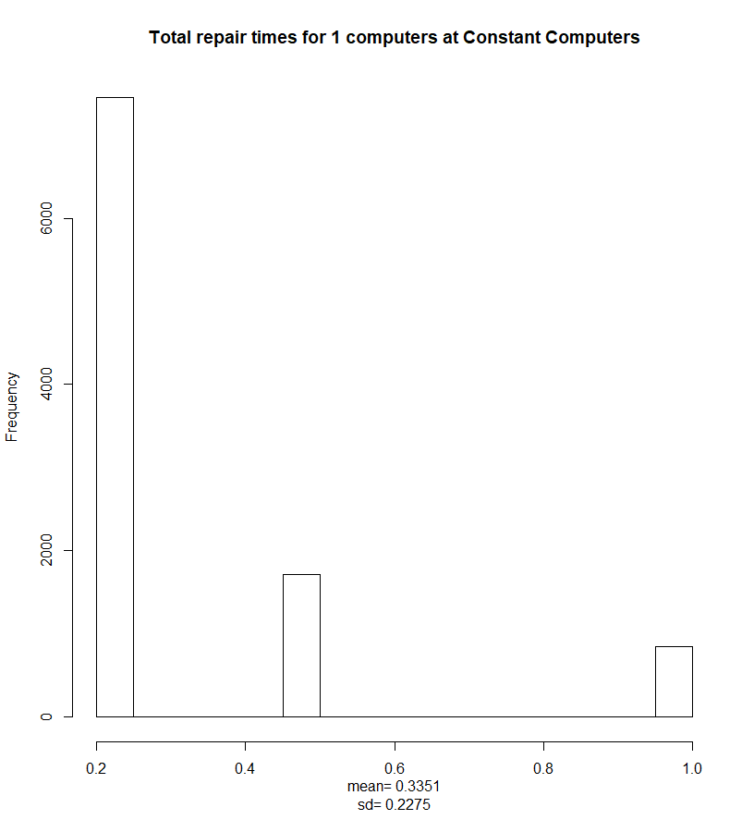 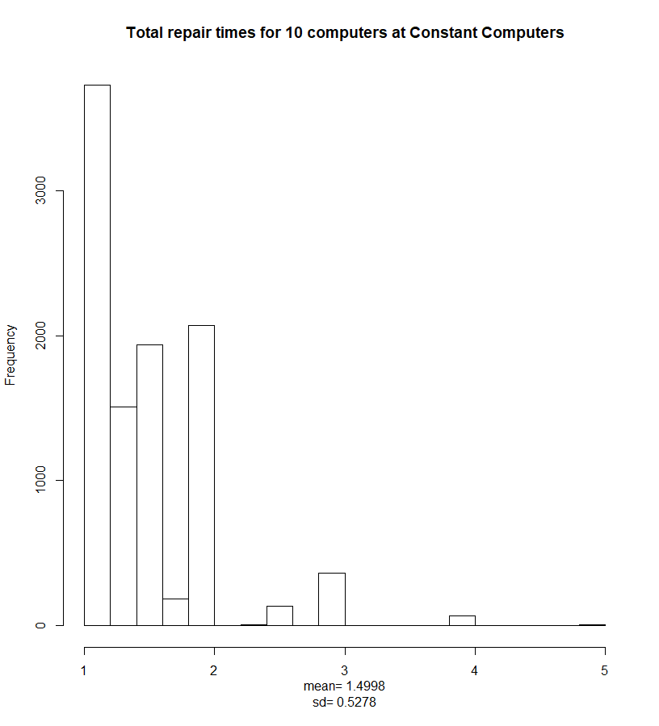

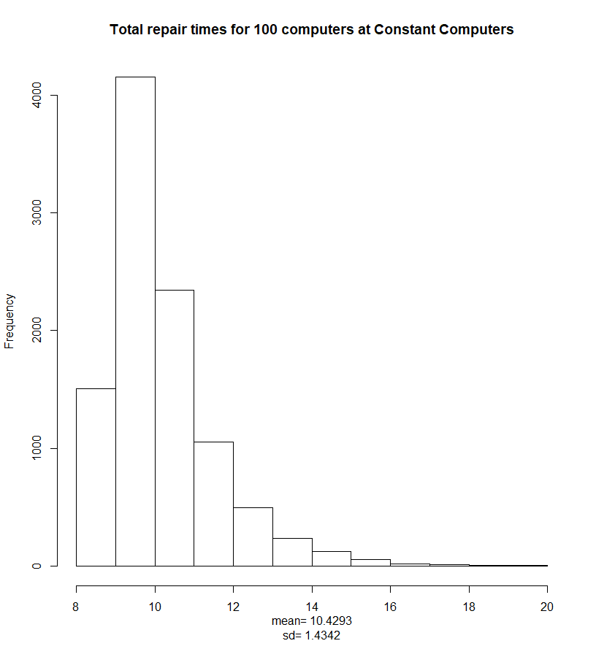

> SimulateConstantRepairs(10000, 1)

[1] 0.3351 0.2275

> SimulateConstantRepairs(10000, 10)

[1] 1.4998 0.5278

> SimulateConstantRepairs(10000, 100)

[1] 10.429 1.434

1. Exponential Computers has four employees: Kambiz, Goran, Harpreet, and Jim. Kambiz fixes a *mean* of five computers per day (ie, it takes Kambiz an average of 0.2 days to fix a computer); Goran fixes a mean of two computers per day; Harpreet fixes a mean of one computer per day; and Jim fixes a mean of four computers per day. When a computer arrives at the shop, there is a 5/12 chance it is assigned to Kambiz, a 2/12 chance it is assigned to Goran, a 1/12 chance it is assigned to Harpreet, and a 4/12 chance it is assigned to Jim. In each case, the amount of time it takes for a worker to repair a single computer follows an exponential probability distribution with mean rates given above.
   1. Write a function called **RepairExponentialComputers(m)** that models sending **m** computers to Exponential Computers for repair. The function should return the total time to repair 100 computers. (As before, the four employees work simultaneously.) Submit five outputs for m=100.

> RepairExponentialComputers(100)

[1] 9.970298

> RepairExponentialComputers(100)

[1] 10.10843

> RepairExponentialComputers(100)

[1] 9.705095

> RepairExponentialComputers(100)

[1] 12.66488

> RepairExponentialComputers(100)

[1] 13.84309

* 1. Write a function called **SimulateExponentialRepairs(n,m)** that runs **RepairExponentialComputers(m)** **n** times and returns the following:
     + - a histogram of the repair times. The title of your histogram should read “Total repair times for **m** computers at Exponential Computers”, where **m** is the actual value of **m** you used, and is generated automatically by your function.
       - the mean total repair time
       - the standard deviation of the total repair times

Give histograms for n=10000 and m=1, 10, 100. Under each histogram, display the mean and standard deviation from your outputs.

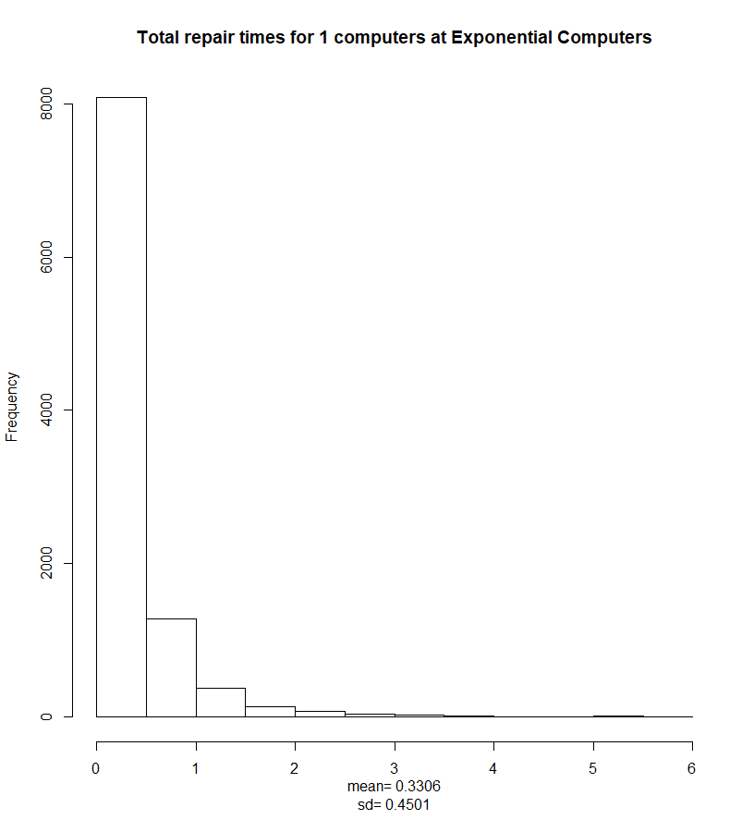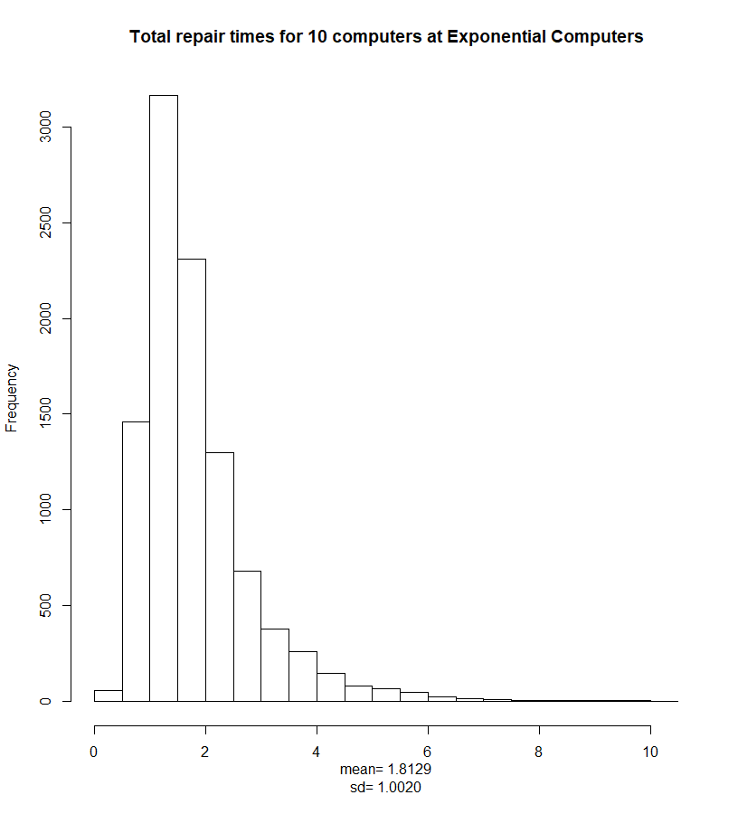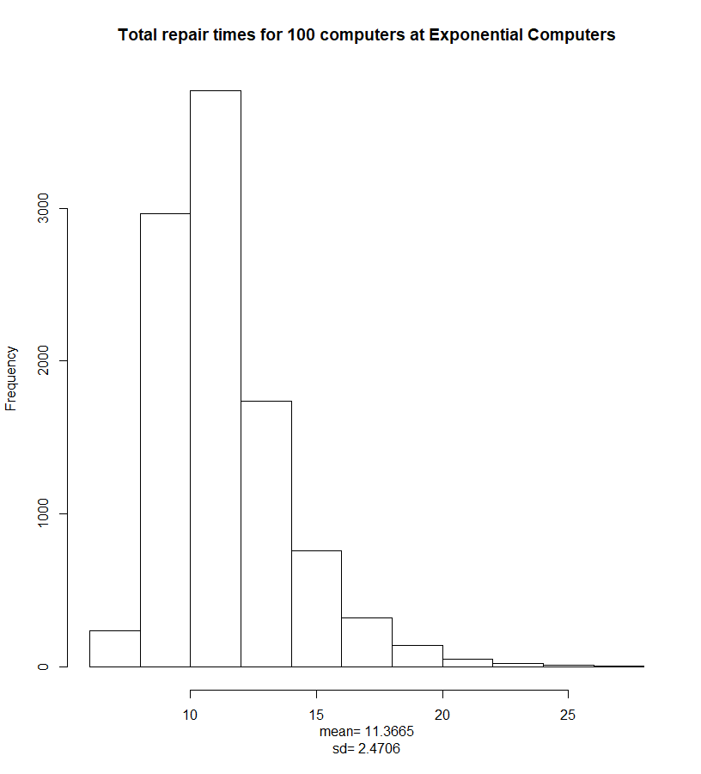

> SimulateExponentialRepairs(10000, 1)

[1] 0.3306 0.4501

> SimulateExponentialRepairs(10000, 10)

[1] 1.813 1.002

> SimulateExponentialRepairs(10000, 100)

[1] 11.366 2.471

1. Normal Computers has four employees: Laura, Maryam, Paul, and Sandi. Laura fixes a *mean* of five computers per day (ie, it takes Laura an average of 0.2 days to fix a computer); Maryam fixes a mean of two computers per day; Paul fixes a mean of one computer per day; and Sandi fixes a mean of four computers per day. When a computer arrives at the shop, there is a 5/12 chance it is assigned to Laura, a 2/12 chance it is assigned to Maryam, a 1/12 chance it is assigned to Paul, and a 4/12 chance it is assigned to Sandi. In each case, the amount of time it takes forr a worker to repair a single computer follows a normal probability distribution with mean repair times as above, and standard deviations for each distribution equal to one third of its mean.
   1. Write a function called **RepairNormalComputers(m)** that models sending **m** computers to Normal Computers for repair. The function should return the total time to repair 100 computers. (As before, the four employees work simultaneously.) Submit five outputs for m=100. *Note: due to the nature of the normal distribution, it is possible for your function to return a negative repair time for a single computer. Obviously, this is not realistic. To prevent your program from giving nonsensical values, adjust your code so that if a computer appears to take a negative amount of time to repair, your function assigns a repair time of zero to that computer instead.*

> RepairNormalComputers(100)

[1] 10.57

> RepairNormalComputers(100)

[1] 9.109

> RepairNormalComputers(100)

[1] 11.13

> RepairNormalComputers(100)

[1] 10.59

> RepairNormalComputers(100)

[1] 9.426

* 1. Write a function called **SimulateNormalRepairs(n,m)** that runs **RepairNormalComputers(m)** **n** times and returns the following:
     + - a histogram of the repair times. The title of your histogram should read “Total repair times for **m** computers at Normal Computers”, where **m** is the actual value of **m** you used, and is generated automatically by your function.
       - the mean total repair time
       - the standard deviation of the total repair times

Give histograms for n=10000 and m=1, 10, 100. Under each histogram, display the mean and standard deviation from your outputs.

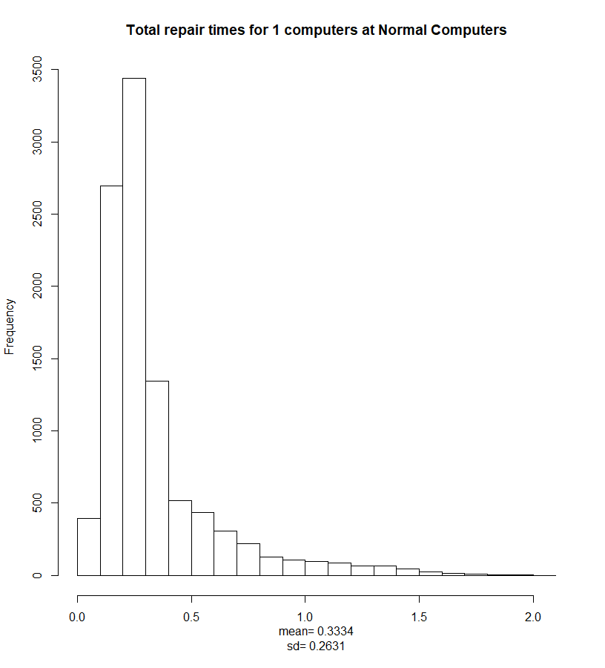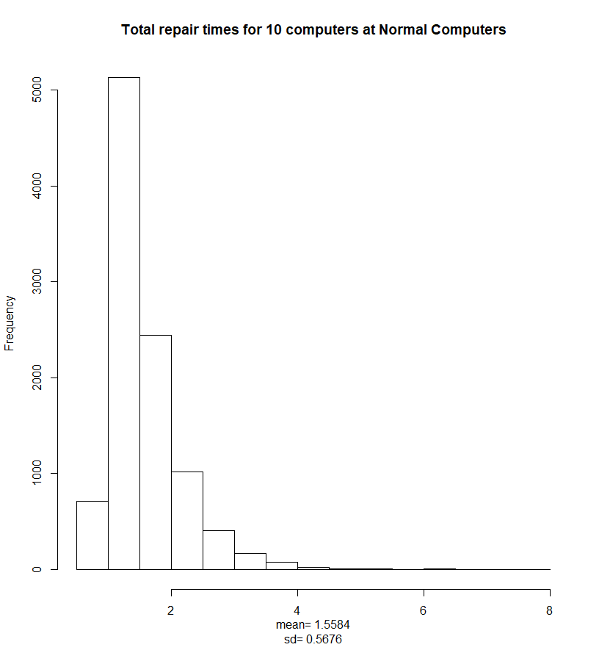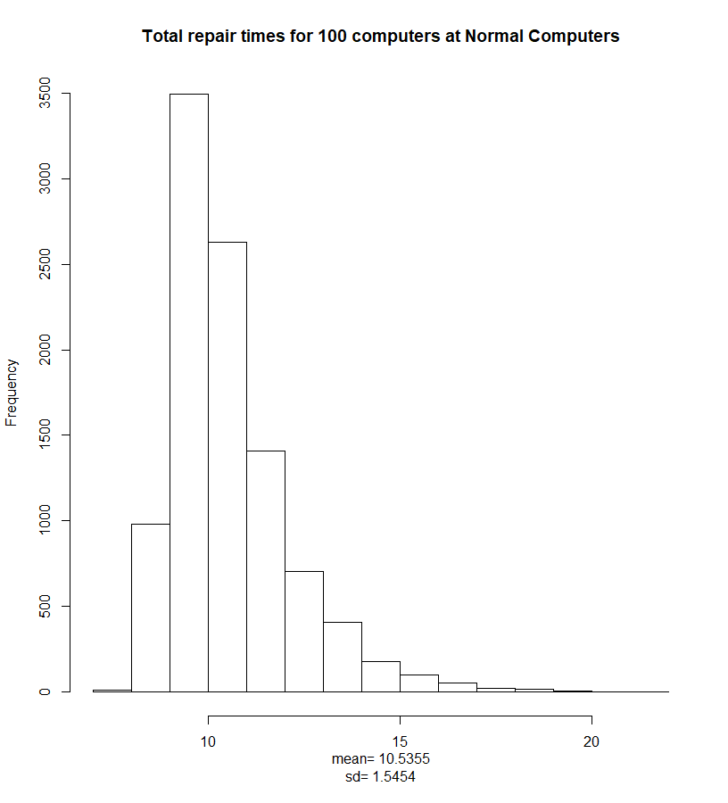

> SimulateNormalRepairs(10000, 1)

[1] 0.3334 0.2631

> SimulateNormalRepairs(10000, 10)

[1] 1.5584 0.5676

> SimulateNormalRepairs(10000, 100)

[1] 10.535 1.545

1. Suppose you run a large company that regularly needs to send computers in for repairs. Which of the three companies would you choose? Does your answer depend on how many computers you are sending in? There is more than one right answer, but in order to receive full marks, you must justify yours, making explicit reference to all of the outputs of your functions, including the graphs.

I would choose Normal Computers. My answer slightly depends on the amount of computers I have to send.

|  |  |  |  |
| --- | --- | --- | --- |
|  | Constant | Exponential | Normal |
| 1 | [1] 0.3351 0.2275 | [1] 0.3306 0.4501 | [1] 0.3334 0.2631 |
| 10 | [1] 1.4998 0.5278 | [1] 1.813 1.002 | [1] 1.5584 0.5676 |
| 100 | [1] 10.429 1.434 | [1] 11.366 2.471 | [1] 10.535 1.545 |

As we can see, the mean time for 1 computer doesn’t matter too much – all companies would average about the same time. However, for the larger ammount the results differ a little. I would prefer Normal computers for the larger ammounts of computer reparis, as they have second lowest mean (after constant repairs) but also more evenly distributed repair values judging by the graph – it has less outliers than Exponential repairs.

*This assignment is dedicated to my computer, which through my own stupidity I broke last week, and which will be repaired or replaced “between 10 and 30 days from now”.*