Nicholas McKubre

159.352 Assignment 1

Distributed Social Network Server – Usage Report

# Before Use:

You must update the “friends.xml” file in the resources folder to reflect the user’s friends. For each friend, input the friend’s name and the IP address of their server. Use this format:

<friends>  
 <friend>  
 <name>Benjamin Bunny</name>  
 <ip_address>192.168.86.71</ip_address>  
 </friend>  
 <friend>  
 <name>Audrey</name>  
 <ip_address>192.168.86.63</ip_address>  
 </friend>  
</friends>

In order to access a friend’s server, that friend must also add you as a friend in their own “friends.xml” file. So, please ensure that your friends have also added you.

Also, find a jpg image that you would like to use for your profile picture! Replace the “profilePicture.jpg” file in the resources folder with the one you would like to use for your own profile picture.

# To Start Your Server:

Run Distributed_Social_Network_Main.py using Python. By default the server operates on port 8080.

# Using Your Server:

Using your favorite web browser, navigate to <http://localhost:8080/>, this will bring up the site index which is nothing but these navigation links:



To update your status, or view your past statuses, click on “Status Update”. To view your friends statuses and profile pictures, click on “Friends List”.

On the status update page, you can easily add a new status by entering it into the text box and pressing “Post”. You can also look at all your old statuses and see how many likes each got. If you wait on this page, it will even update the number of likes your most recent status is getting without having to refresh the page.

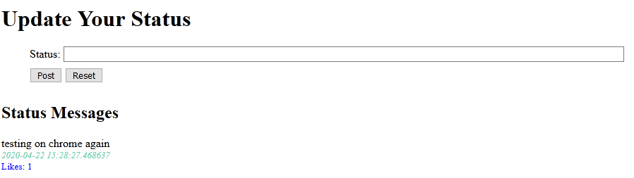

On the friends page, you can see your friends’ profile pictures and most recent statuses. You can also choose to like a status (note you can only like a friend’s status once). If a friend is offline and there is no cache of their picture and status yet, you will see a blank profile informing you of that. You can see an example of a status and a blank in the image below.

