Image process with OpenCV

:

Library setup.
– make sure to setup visual studio 2019, MFC x64 & 86 (from visual studio installer) and C++
– Download and setup opencv.
Link download: ======> Click here
Download, run the setup file. Then the disk would look like this:
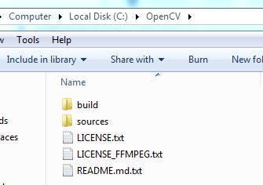

Make a project.
Learning opencv would help you make a console’s project with basic c++
Let’s build a software’s interface
1. With MFC, C++ and OpenCV to build a Image process’s software prototype .
Open visual studio => new project, => MFC
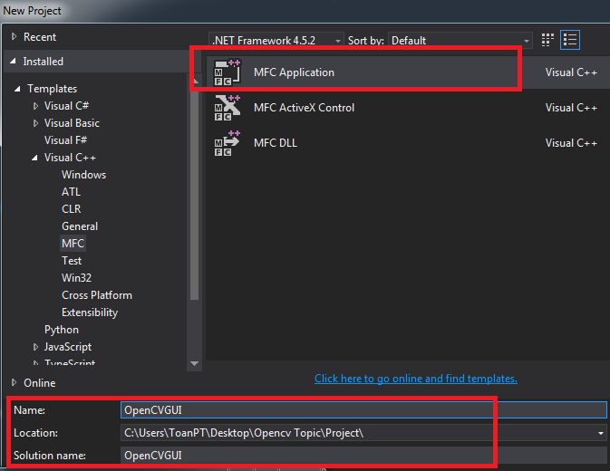
Naming the project, solution and change the path
Ok button
At Application Type, choose MDI’s architecture, style MFC standard => next
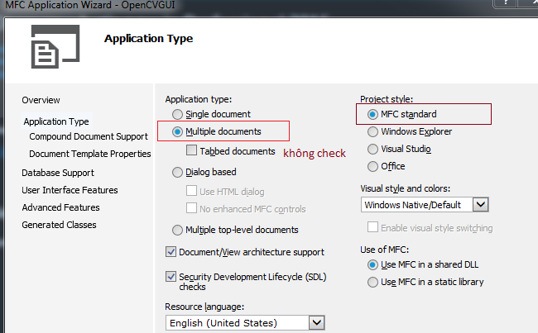

next to tab User , choose this option (for 256 colors toolbar)
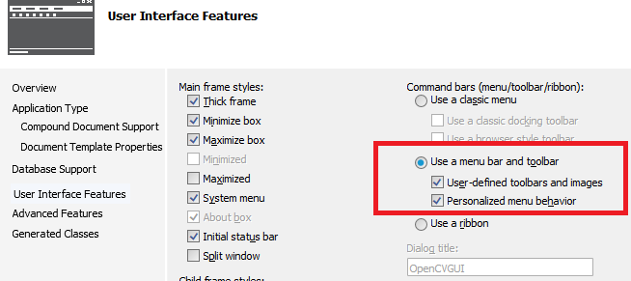
next to tab General Classes.
Change the class, don’t recommend if you chose to continues this course ( there will be some misunderstand in the future)
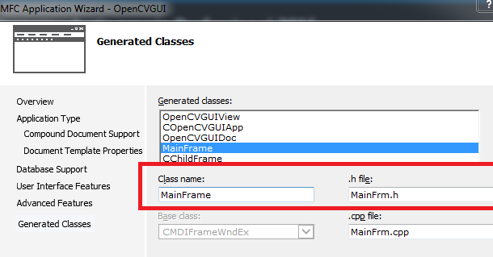

choose finished, a project will be made
Let’s try to build, if success the it’s ok. Run to confirm it
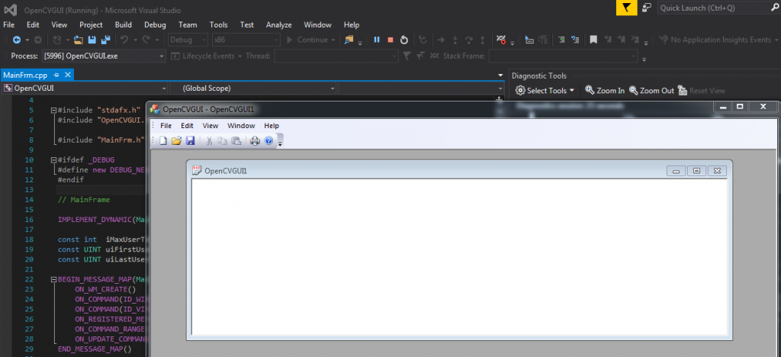
If you have not learn MFC yet, it will somewhat difficult to understood,when there will be several code’s file in a project
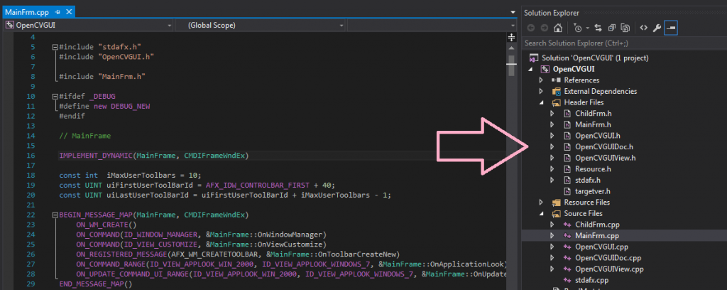

Link the library with OpenCV
Setup folder “include” for opencv
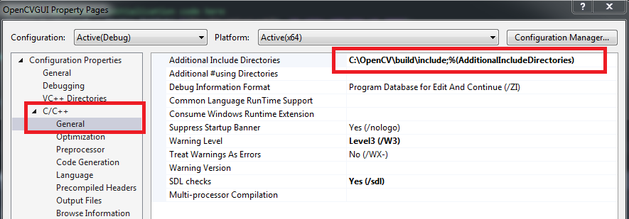

Setup folder library “lib” for the project
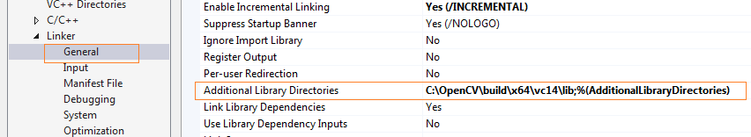

Then add openCV’s file
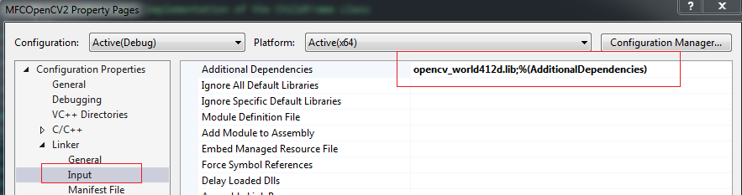

Go in OpenCV file in your disk: C:\OpenCV\build\x64\vc14
Go in “bin” folder, seek 2 file dll :
opencv_videoio_ffmpeg412_64.dll
opencv_world412d.dll
copy this 2 files and paster in folder with file exe (usually in x64→debug) in the project’s file
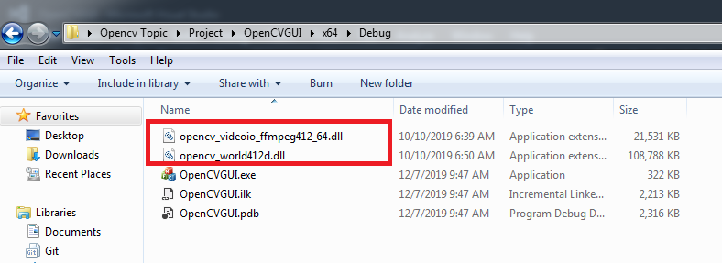

Note:
in foler : C:\OpenCV\build\x64\vc14 có hai file
opencv_world412d.dll for mode build debug
opencv_world412.dll (no d char) for mode release

remember, this is x64, not x86, don’t be wrong.

