**EMPLOYEE WEEKLY REPORT**

|  |  |  |  |
| --- | --- | --- | --- |
| Engineer Name | Nguyen Phuc Toan |  |  |
| Department | Intern | Report date | June 15th, 2025 |

1. **Activities completed this week**

|  |  |  |
| --- | --- | --- |
| **Description of activities, task, duty, or responsibility** | **Result (done/delayed)** | **Note** |
| Change group subject from smart garden to weather station | Done | Both use the same design |
| Set up simulation for usb and sensor debuger | Done | Branch Usb_sensor |
| Set up simulation for ethernet and web server | Done | Branch Ethernet_SDcard |
| Change MCU to Atmega32U4 for build in USB on all branch | Done |  |
| Find document for all branch | Delayed |  |
| Design PCB broad | Delayed |  |
| Find out more about POE chip | Delayed |  |
| Capacitive sensor research | Delayed | May be skip/removed |

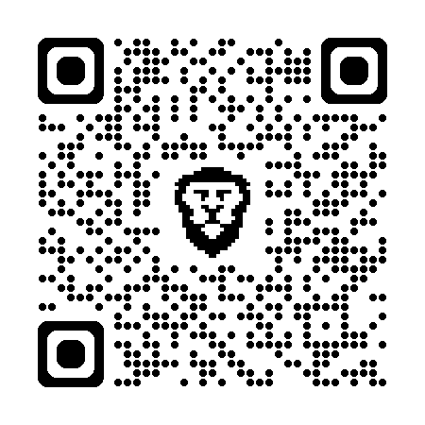

**Note Description:**

1. Group working link: <https://github.com/Toan8561/TTTN_Project-1> .
2. Document and PCB design still on for discussion.
3. POE chip research is now as chip selection for PCB design phase.
4. With build usb from Atmega32U4 ethernet chip with be change for better compatibily.
5. Capacitive is replace with ADCs chip.
6. **Activities to be started next week**

|  |  |  |  |  |  |  |  |  |  |  |  |
| --- | --- | --- | --- | --- | --- | --- | --- | --- | --- | --- | --- |
| **Description of activities, task, duty, or responsibility** | **2** | | **3** | | **4** | | **5** | | **6** | | **7** |
| * Finished the broad functions. |  |  | X | X |  |  |  |  |  |  |  |
| * Programming USB funtion and sensor. |  |  |  |  |  |  | X | X |  |  |  |
|  |  |  |  |  |  |  |  |  |  |  |  |

1. **Thing that went particularly well this week**

**-**

1. **Thing that was the most challenging this week**

**-**

1. **Self-Evaluation: (Circle one)**

**󠆽 A+ 󠆽󠆽A 󠆽󠆽A- 󠆽󠆽B+ 󠆽󠆽B 󠆽󠆽B- 󠆽󠆽C+ 󠆽󠆽C 󠆽󠆽C- 󠆽󠆽D 󠆽󠆽F**

|  |  |
| --- | --- |
| **Reporter** | |
| *(Signature)*  Toan250609  Name: Nguyen Phuc Toan  Title: Intern  Dept: |  |