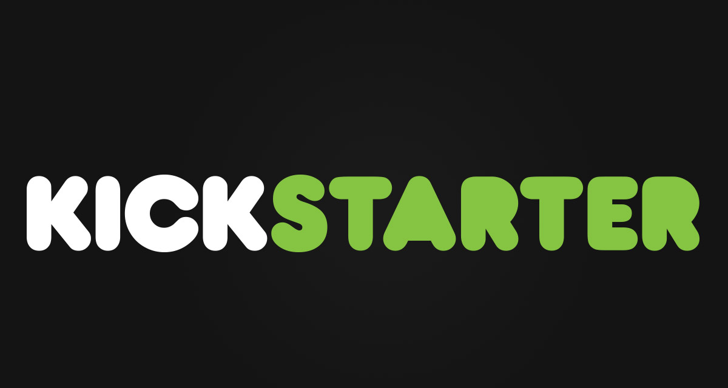

CSIS-3860-001

Data Visualization Project

Instructor: Bambang SARIF; WILLIAM Tan

Student: Toan Diec | 300320364 | March, 2021

I find myself, a very innovative and creative person with many ideas. Because of it, KICKSTARTER is what I want to explore by using the Tableau. Kickstarter is a funding platform directed toward helping creative projects get off the ground. It's entirely driven by crowdfunding, so donations from the general public fuel these dynamic new ideas. Kickstarter is driven by creators and backers. Creators present creative project ideas, and backers fund those projects. Creators set up a page to display their project's details and prototypes using text, video, and photos. Project creators set a funding goal and a deadline. The creators also create reward levels for backers who pledge specific amounts. The more a backer pledges, the bigger the reward. Once enough backers have funded the project, the creator can develop and produce their vision. Depending on the project's complexity, backers may have to wait months to see the finished product.

In this project I want to use Tableau, one of the most widely used data visualization tools, to find information that generates useful insights. To proceed with the project, I use a 2016 dataset about KICKSTARTER projects that I found on Kaggle. The dataset included 13 columns that contain information of KICKSTARTER’s project range from the project’s name to the amount of money pledged by each project.

The dataset can be found through this link: <https://www.kaggle.com/kemical/kickstarter-projects>

To begin with the project, I first did some cleaning with the raw dataset. I converted the country column, which contains a country abbreviation, into a column with the full country name by using the Excel technique that I had learned in the class. Next, I remove every row that has contains incorrect data. For example, the deadline column and the launched column are supposed to contain date and time data, but some of the data in currency data are recorded in the deadline and the launched columns. Besides, the goal column is also cleaned to have only data in the form of the amount of money.

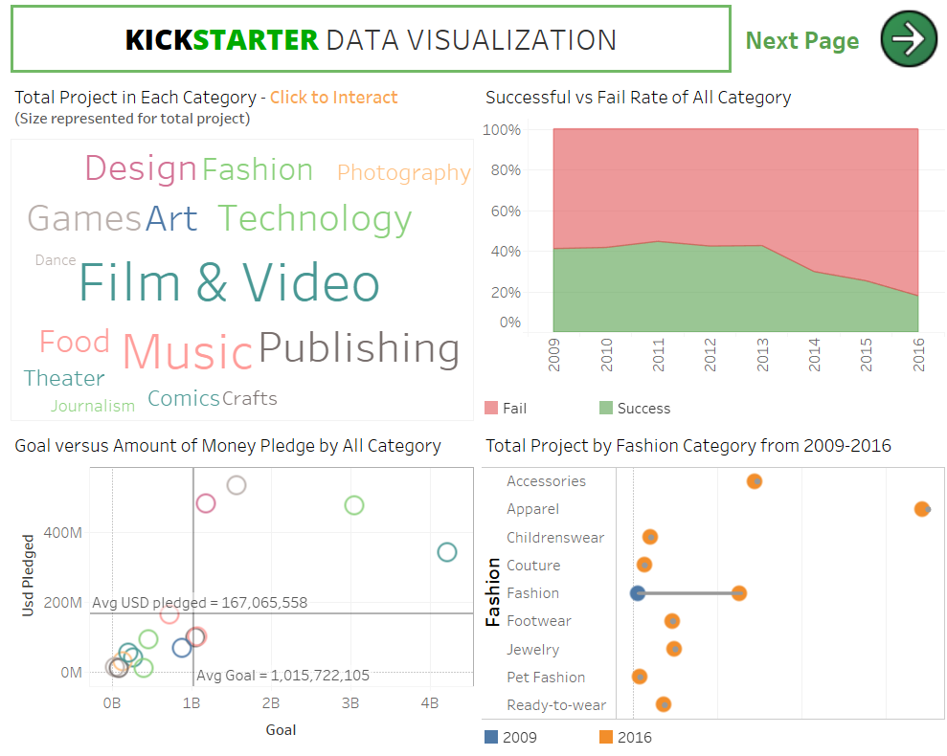After the cleaning process, I take time to look at the data to have a general point of view about the dataset. From that, I could raise some basic questions like which country has the most project, how many projects launched were succeeded on the platform, or which category is the most popular among all of them. Spending weeks with ideas and questions, I finally can generate some charts and dashboards to answer my questions.

The first dashboard contains four charts that can dig deeper into the categories of project, that was created on KICKSTARTER platform. The first chart is a Word chart, which shows the user what kind of project categories were created and how many projects were created in every kind of the main category. From that, we can compare one to the other easily. To the right of the word chart, the area chart helps the user comparing the successful rate versus the fail rate of all categories or specific categories when choosing the category from the word chart. To the left corner of the dashboard, a scatter plot of all main categories shows us the comparison of the amount of money pledged versus its goals. The idea of this scatter plot is to find which category has the most amount of money being pledged versus its goal, and also tells the user the average number of all categories. The last chart in the first dashboard is the dumbbell chart that digs deeper into the sub-category of each main category. This chart shows the growth of the total project created on the platform between 2009 and 2016, but with the deeper layer.

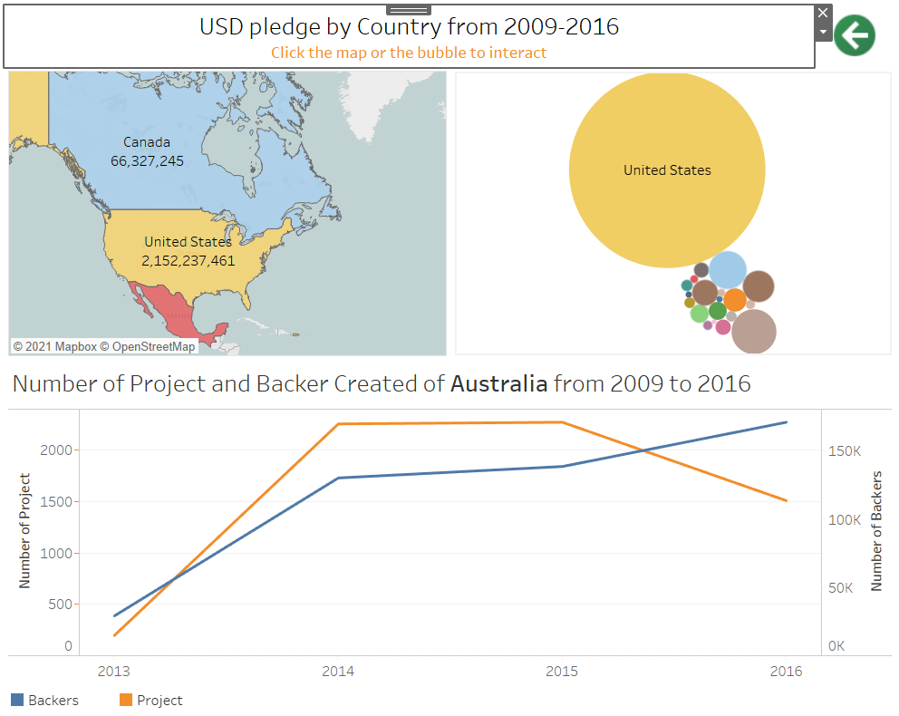The second dashboard contains three charts, which are developed to compare and answer questions related to the country. At the first glance, there are a map and a bubble chart for the user to interact and to have a general idea of where projects were developed and how much money was generated from different countries.

However, to have a better comparison, users can interact and use the bubble chart beside the map. The line chart is the last piece of the dashboard, which highlights the trend of project and backer for a different country in the period from 2009 to 2016.

From the first dashboards, we can have some insights about the project categories such as total project, the success rate of each category, the goal versus total money pledged, and finally the development of sub-categories from year to year. This kind of information will help the developers to have a general picture of the platform and maybe lean toward categories with higher potential. Besides, it also helps the backers to identify the trend of the overall project on Kickstarter. The second dashboard clearly shows the significant activities of developers in America in comparison with other countries. Moreover, the dashboard also gives a deeper view of the project-created trend from year to year in each country.