DriveMate – Software Requirements Specification
Use Case Description

2. Functional Requirements
2.1. Use Case Description

UC01: Login
Name | Login
Description | This use case describes user authentication with account credentials to access DriveMate features.
Actor | All users (Student, Instructor, Center Manager, Admin)
Trigger | When the user submits [email] and [password] on the Login screen.
Pre-condition | The user is not logged in and the login form is available.
Post-condition | A valid JWT is issued for successful authentication and the user is redirected to the home page.

Activities Flow
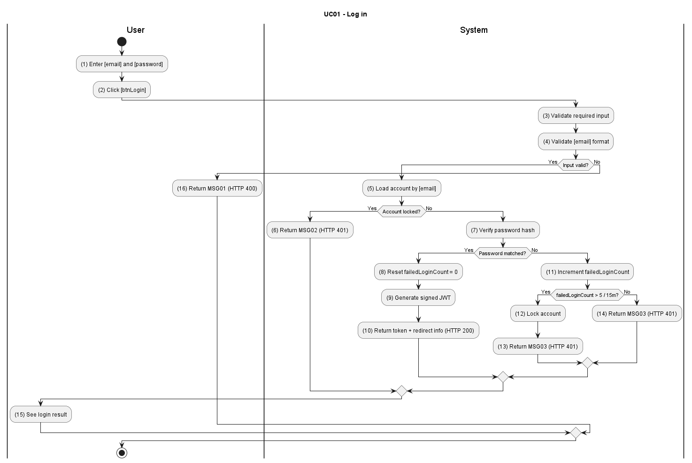
Figure UC01-A: Activity Diagram – Login

Sequence Diagram
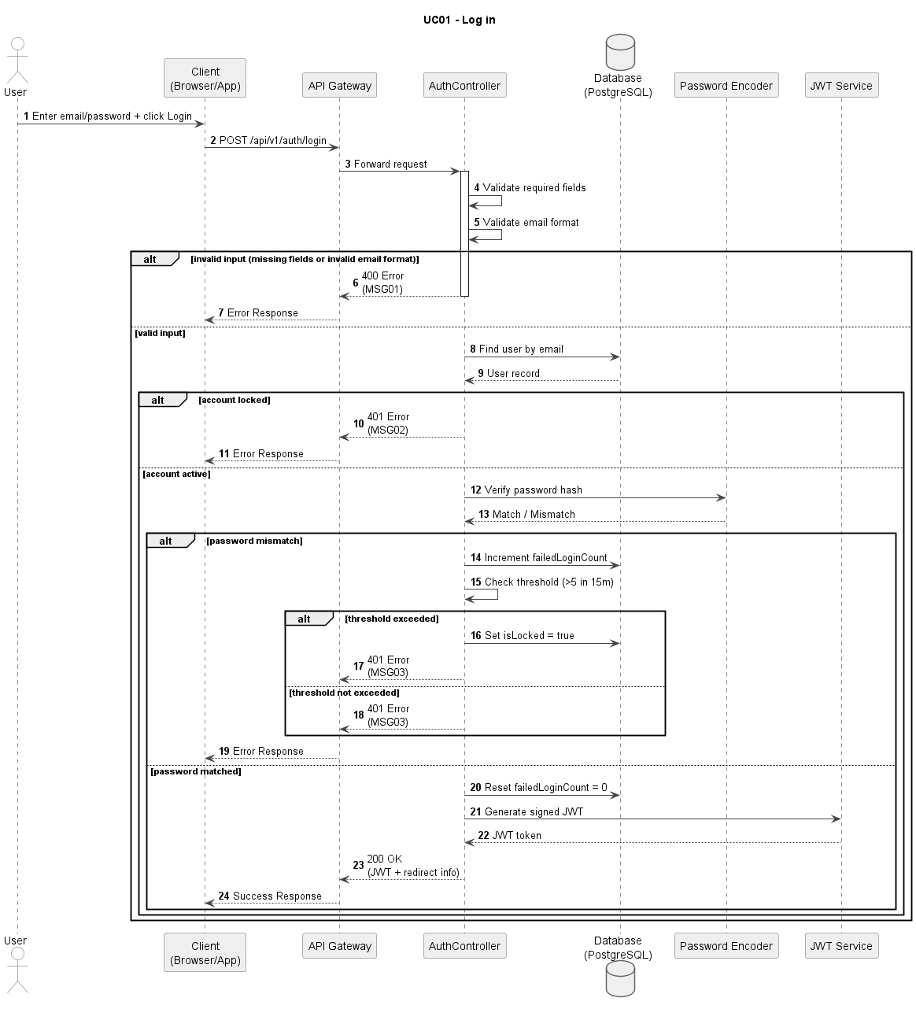
Figure UC01-S: Sequence Diagram – Login

Business Rules
Activity | BR Code | Description
(1) | BR01 | Input Validation:  Condition: A login request is submitted.  Action: Validate [email] and [password] are not empty and [email] format is valid.  Result: If invalid, display MSG01; HTTP 400.
(2) | BR02 | Account Lock Check:  Condition: Input is valid.  Action: Load account by [email] and check [isLocked].  Result: If account is locked, display MSG02; HTTP 401.
(3) | BR03 | Credential Verification:  Condition: Account is active.  Action: Verify hash([password]) against stored credential and update failed-attempt counters.  Result: If invalid credentials, display MSG03; HTTP 401.
(4) | BR04 | Brute-Force Protection:  Condition: Credential verification fails.  Action: Evaluate lock threshold within policy window and set [isLocked=true] when threshold is exceeded.  Result: Account lock policy is enforced consistently.
(5) | BR05 | Success Response:  Condition: Credential verification succeeds.  Action: Generate JWT with role claims, reset failed login counter, and return auth payload.  Result: User is authenticated and redirected to home; HTTP 200.

UC02: Forgot Password
Name | Forgot Password
Description | This use case describes the process of a user requesting a password reset via email or another authentication method when they forget their password.
Actor | All users (Student, Instructor, Center Manager, Admin)
Trigger | When the user submits a forgot-password request from the Login screen.
Pre-condition | The user is not logged in and provides a registered email address.
Post-condition | A valid reset token is consumed and the account password is updated securely.

Activities Flow
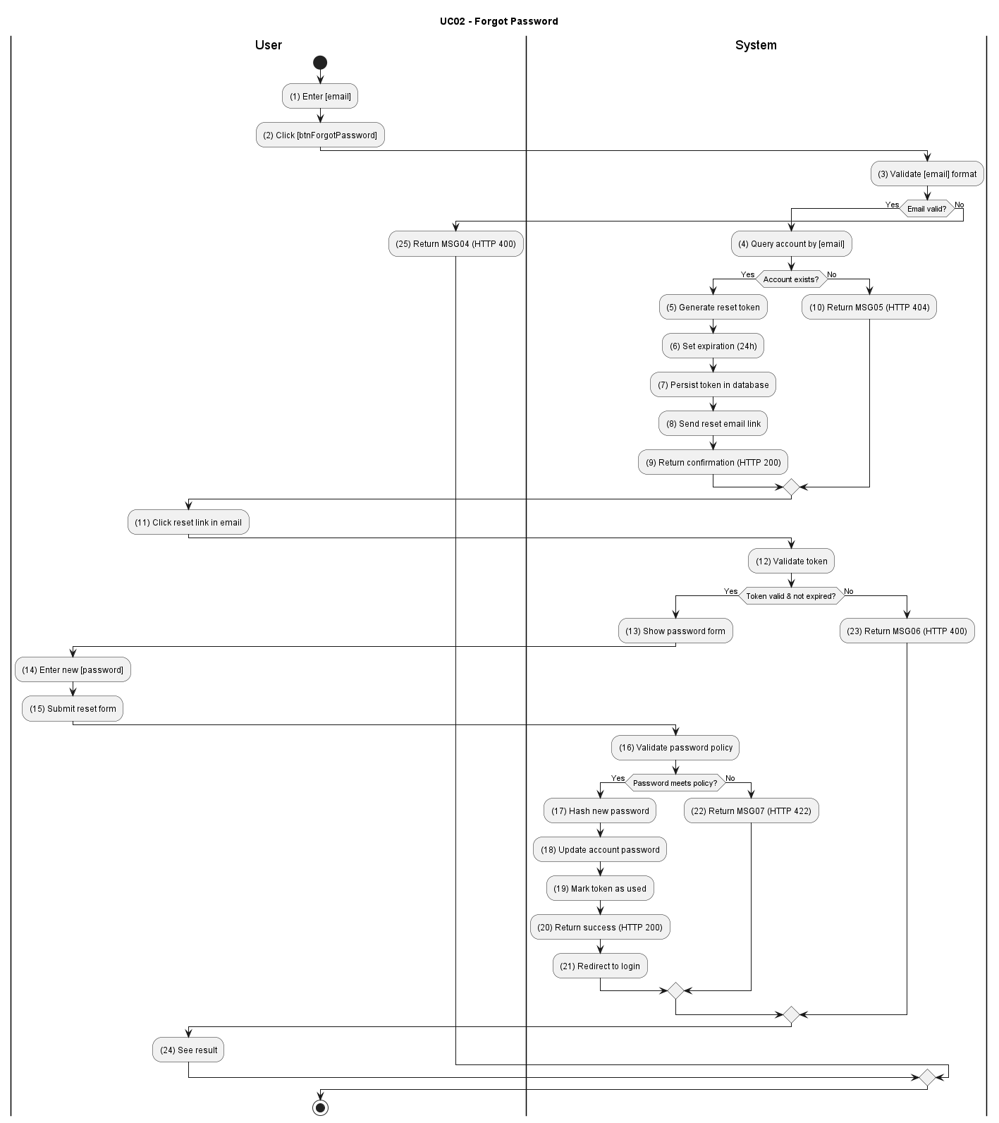
Figure UC02-A: Activity Diagram – Forgot Password

Sequence Diagram
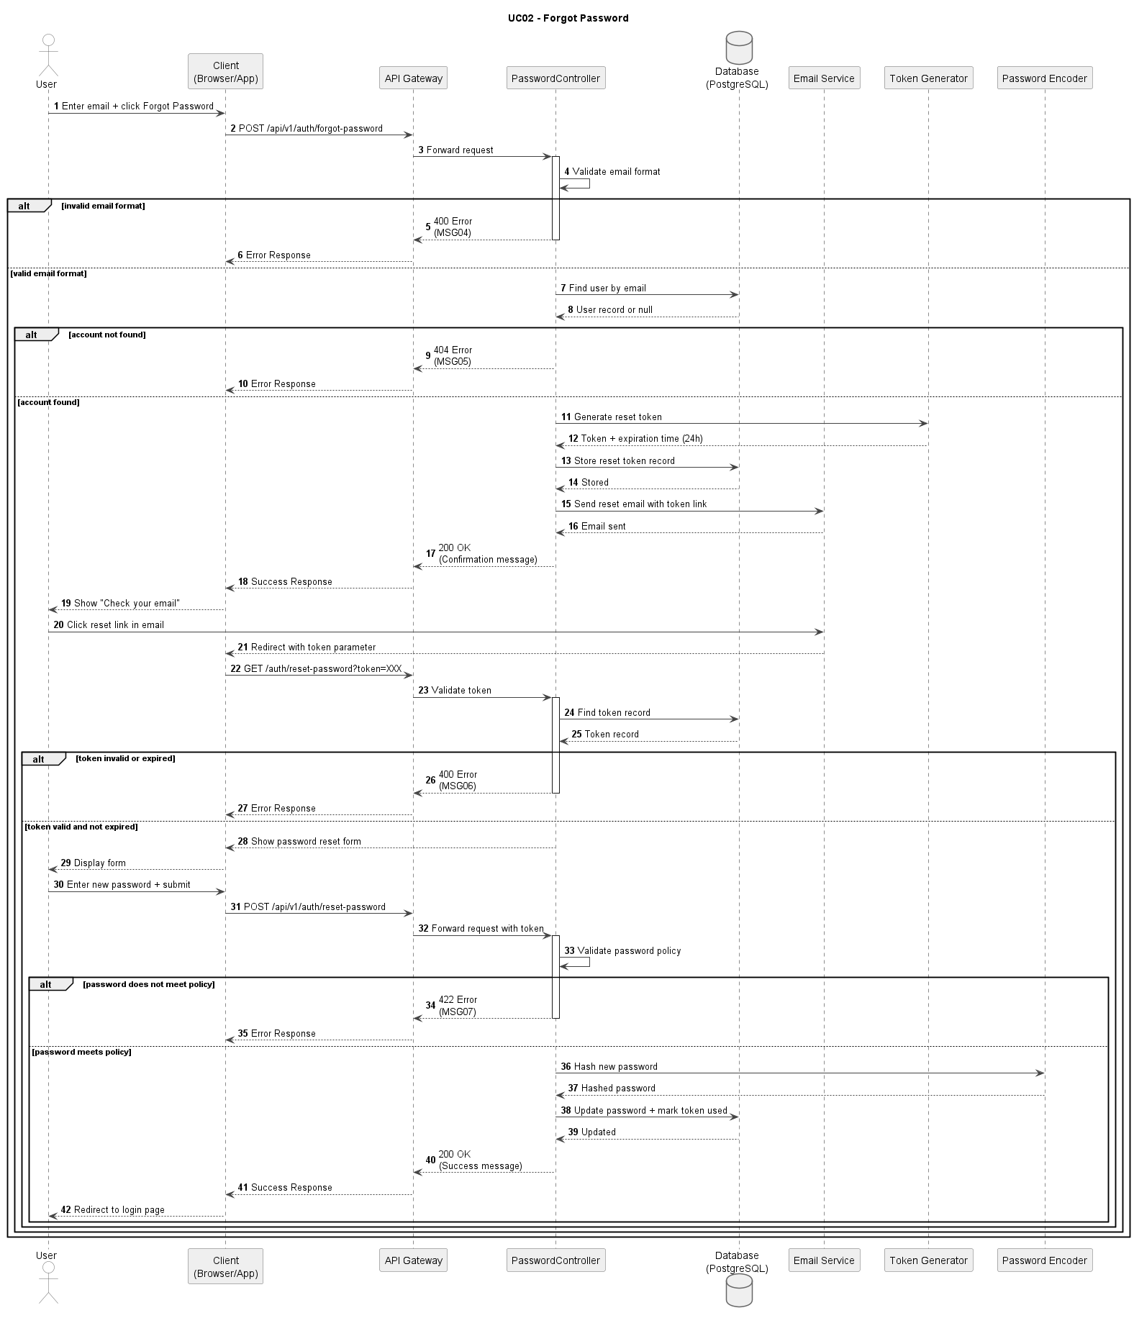

Figure UC02-S: Sequence Diagram – Forgot Password

Business Rules
Activity | BR Code | Description
(1) | BR01 | Email Validation:  Condition: Forgot-password request is submitted.  Action: Validate [email] format and required fields.  Result: If invalid, display MSG04; HTTP 400.
(2) | BR02 | Account Lookup:  Condition: Input is valid.  Action: Query account by [email].  Result: If account does not exist, display MSG05; HTTP 404.
(3) | BR03 | Token Generation:  Condition: Account exists.  Action: Generate secure reset token with single-use and expiration policy. Result: Reset token is persisted successfully.
(4) | BR04 | Token Validation and Password Policy:  Condition: Reset link is used.  Action: Validate token state ([exists], [unused], [notExpired]) and validate [newPassword] policy.  Result: If invalid token or password policy fails, display MSG06 or MSG07; HTTP 400 or 422.
(5) | BR05 | Success Response:  Condition: Token and password are valid.  Action: Hash and update password, mark token as used, and complete reset flow.  Result: Password reset completes successfully; redirect to login; HTTP 200.

UC03: Create Student Account
Name | Create Student Account
Description | This use case describes the process of admins or center managers creating a new student account in the system.
Actor | Admin, Center Manager
Trigger | When the actor submits the create-account form on User Management.
Pre-condition | The actor is authenticated with account-management permission.
Post-condition | A new active account is created and visible in the user list.

Activities Flow
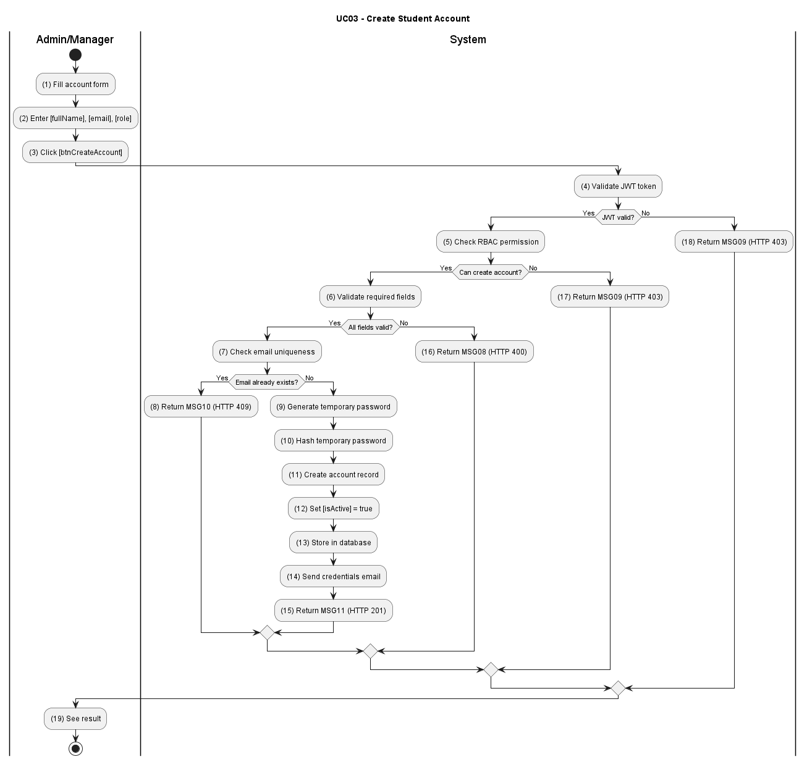

Figure UC03-A: Activity Diagram – Create Student Account

Sequence Diagram
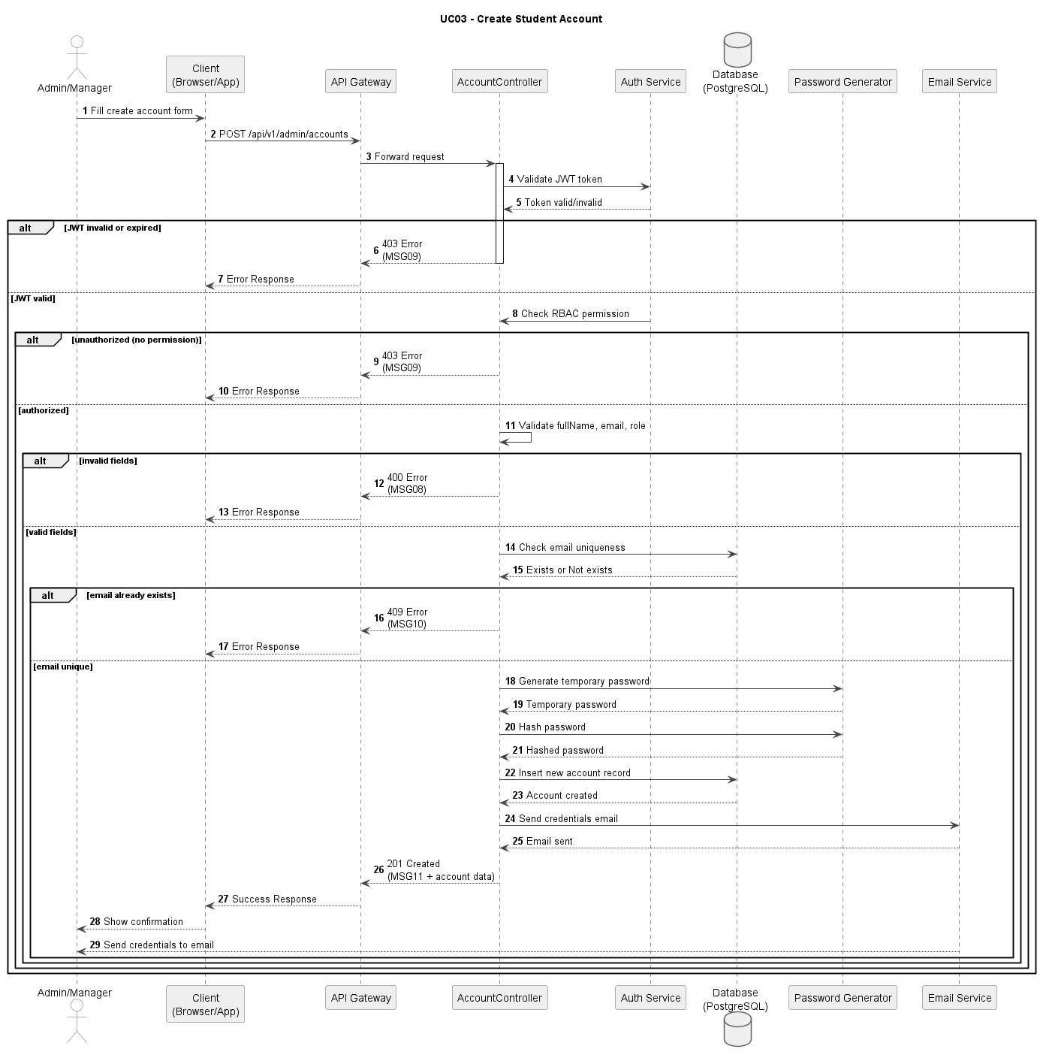

Figure UC03-S: Sequence Diagram – Create Student Account

Business Rules
Activity | BR Code | Description
(1) | BR01 | Input Validation:  Condition: Create-account request is submitted.  Action: Validate [fullName], [email], [role], and [temporaryPassword]. Result: If invalid, display MSG08; HTTP 400.
(2) | BR02 | RBAC Validation:  Condition: Input is valid.  Action: Validate actor permission to create target role account.  Result: If unauthorized, display MSG09; HTTP 403.
(3) | BR03 | Uniqueness Check:  Condition: Actor is authorized.  Action: Check duplicate [email] in user repository.  Result: If duplicated, display MSG10; HTTP 409.
(4) | BR04 | Account Creation Transaction:  Condition: All checks pass.  Action: Hash temporary password and persist new account with role mapping.  Result: Account is created with active status.
(5) | BR05 | Success Response:  Condition: Account is created.  Action: Send credential notification email and return creation payload. Result: Display MSG11; HTTP 201.

UC04: Update Student Account
Name | Update Student Account
Description | This use case describes the process of admins or center managers updating an existing student account in the system.
Actor | Admin, Center Manager
Trigger | When the actor submits the update-account form on User Management.
Pre-condition | The actor is authenticated and the student account exists.
Post-condition | The student account is updated and visible in the user list.

Activities Flow
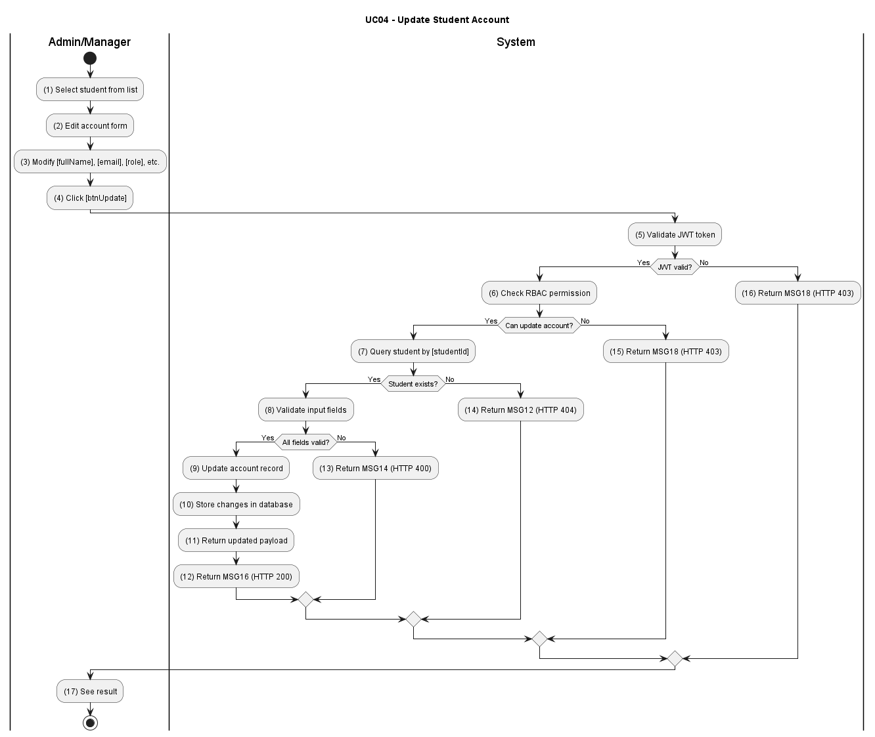

Figure UC04-A: Activity Diagram – Update Student Account

Sequence Diagram

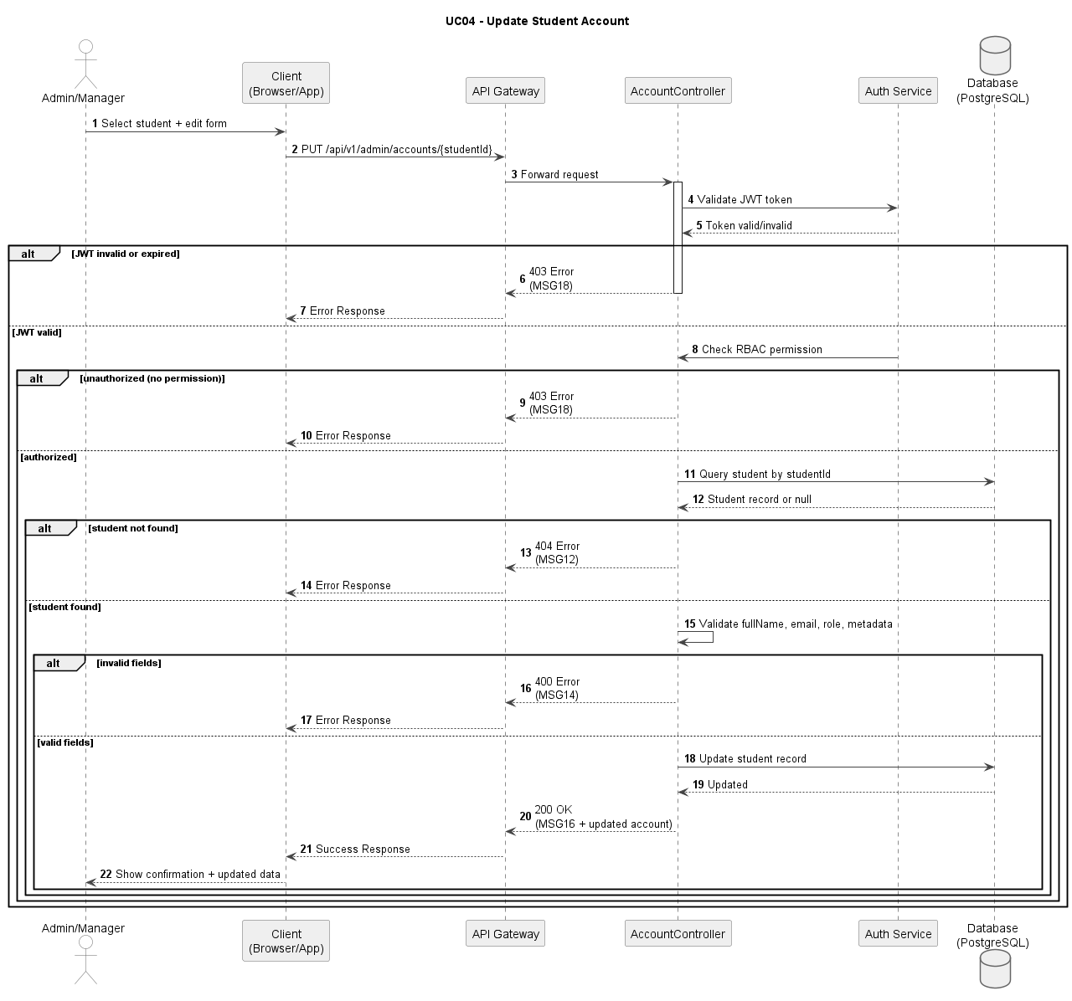

Figure UC04-S: Sequence Diagram – Update Student Account

Business Rules
Activity | BR Code | Description
(1) | BR01 | JWT and RBAC Validation:  Condition: Update request is submitted.  Action: Validate JWT and permission to update student accounts.  Result: If unauthorized, display MSG18; HTTP 403.
(2) | BR02 | Student Existence Check:  Condition: [studentId] is provided.  Action: Query student by [studentId].  Result: If not found, display MSG12; HTTP 404.
(3) | BR03 | Input Validation:  Condition: Student exists.  Action: Validate [fullName], [email], [role] and other metadata.  Result: If invalid, display MSG14; HTTP 400.
(4) | BR04 | Update Transaction:  Condition: All validations pass.  Action: Persist updated student account details.  Result: Account updated successfully.
(5) | BR05 | Success Response:  Condition: Transaction committed.  Action: Return updated account payload.  Result: Display MSG16; HTTP 200.

UC05: Lock Student Account
Name | Lock Student Account
Description | This use case describes the process of admins or center managers locking an inactive or invalid student account in the system.
Actor | Admin, Center Manager
Trigger | When the actor selects a student and clicks [btnLockAccount].
Pre-condition | The actor is authenticated and the target student account exists and is not already locked.
Post-condition | The student account status is set to locked and the user cannot log in.

Activities Flow

Figure UC05-A: Activity Diagram – Lock Student Account

Sequence Diagram

Figure UC05-S: Sequence Diagram – Lock Student Account

Business Rules
Activity | BR Code | Description
(1) | BR01 | JWT and RBAC Validation:  Condition: Lock request is submitted.  Action: Validate JWT and permission to lock accounts.  Result: If unauthorized, display MSG20; HTTP 403.
(2) | BR02 | Student Existence Check:  Condition: [studentId] provided.  Action: Query student account.  Result: If not found, display MSG12; HTTP 404.
(3) | BR03 | Status Validation:  Condition: Student exists.  Action: Check current account status.  Result: If already locked or invalid state, display MSG24; HTTP 400.
(4) | BR04 | Lock Transaction:  Condition: Account is active.  Action: Set [isLocked=true] and record lock reason/metadata.  Result: Account locked successfully.
(5) | BR05 | Success Response:  Condition: Transaction committed.  Action: Return lock confirmation.  Result: Display MSG128; HTTP 200.

UC06: Assign License Categories To Students
Name | Assign License Categories To Students
Description | This use case describes assigning or updating a student's license category for the appropriate training program.
Actor | Admin, Center Manager
Trigger | When the actor submits a new license category for a selected student.
Pre-condition | The actor is authenticated with assignment permission and the student account exists.
Post-condition | The student's license category is updated and audit information is recorded.

Activities Flow
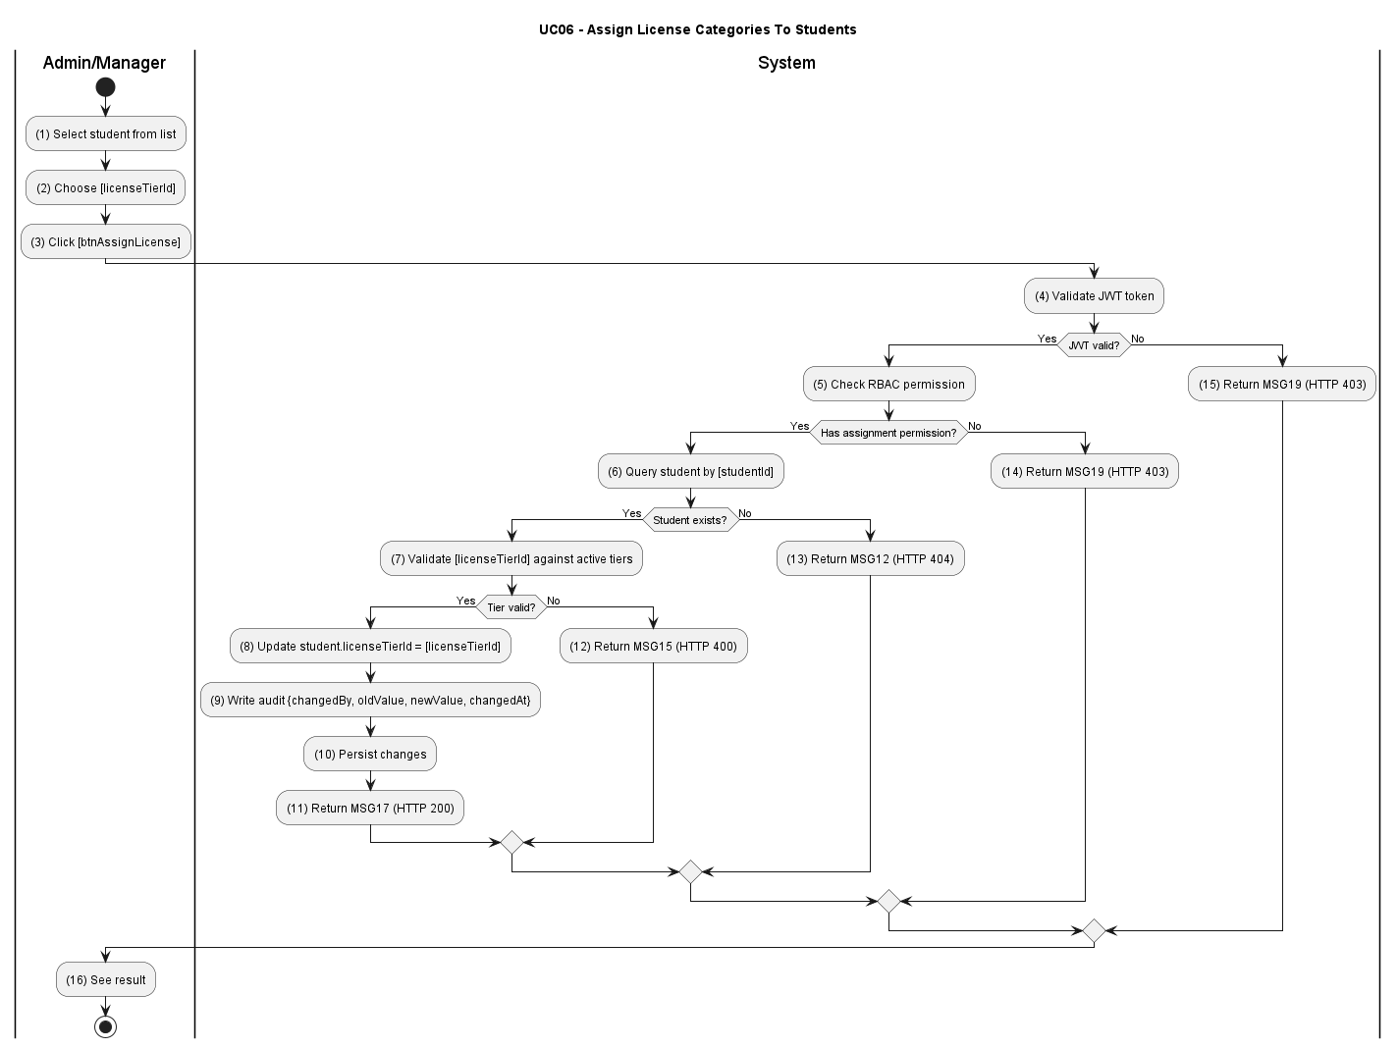

Figure UC06-A: Activity Diagram – Assign License Categories To Students

Sequence Diagram
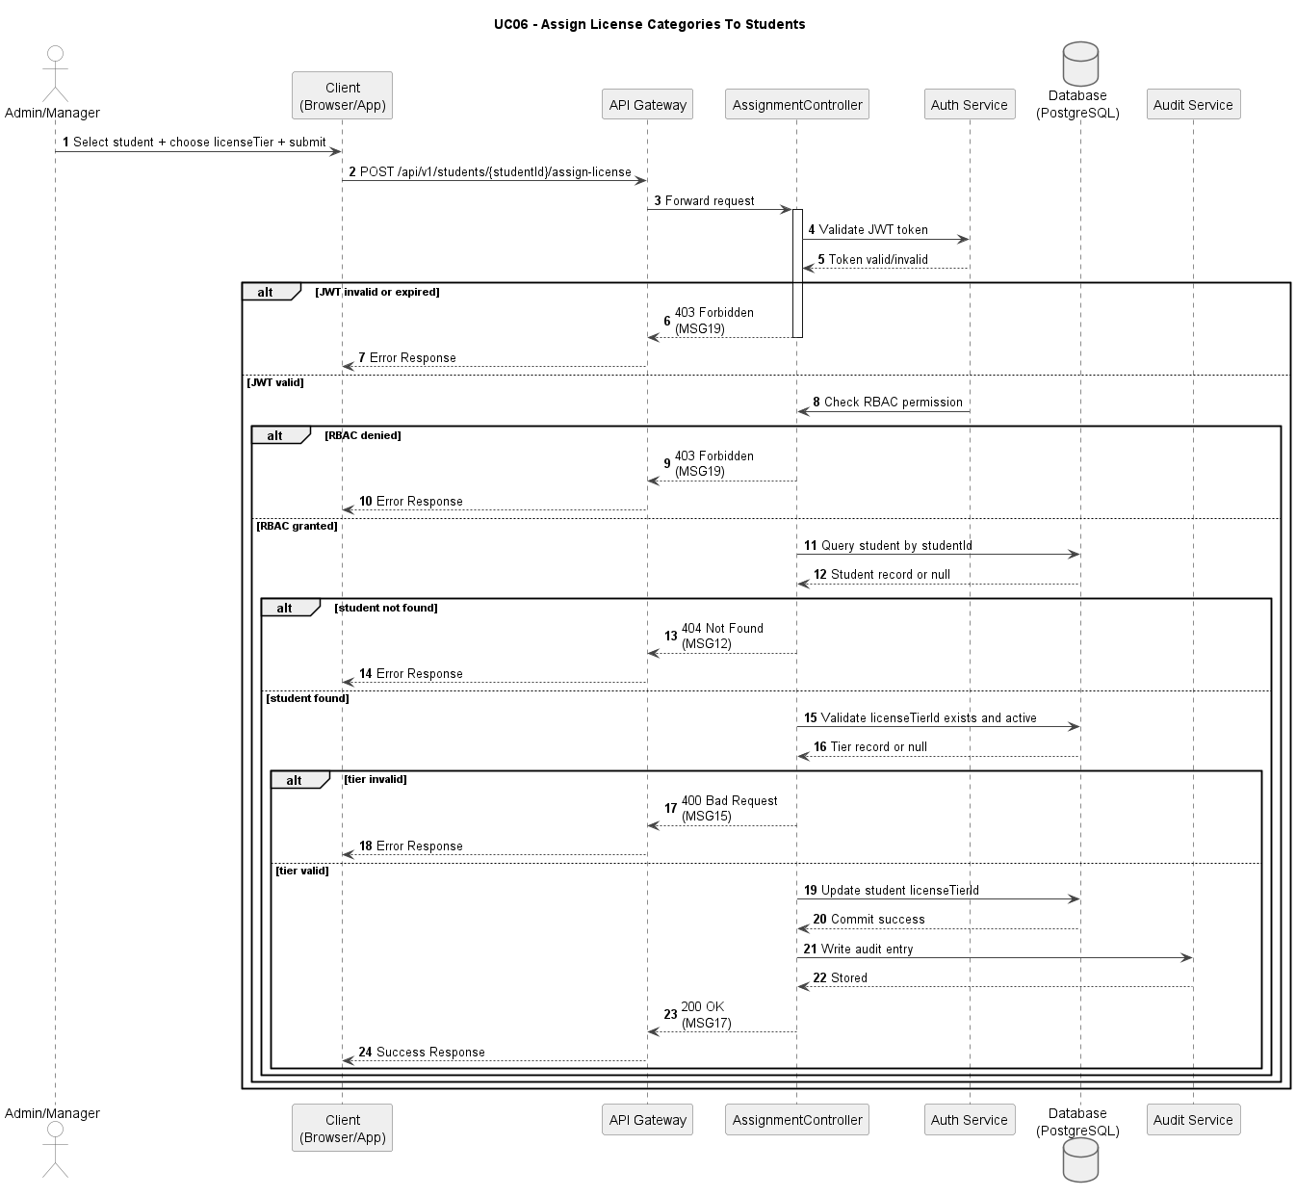

Figure UC06-S: Sequence Diagram – Assign License Categories To Students

Business Rules
Activity | BR Code | Description
(1) | BR01 | JWT and RBAC Validation:  Condition: Assignment update request is submitted.  Action: Validate JWT and permission to update student assignment data. Result: If unauthorized, display MSG19; HTTP 403.
(2) | BR02 | Student Existence Check:  Condition: [studentId] is provided.  Action: The system queries student by [studentId].  Result: If not found, display MSG12; HTTP 404.
(3) | BR03 | License Tier Validation:  Condition: Student exists.  Action: The system validates [licenseTierId] against active license tiers. Result: If invalid, display MSG15; HTTP 400.
(4) | BR04 | Assignment Update and Audit:  Condition: Permission, student, and tier are valid.  Action: Update [student.licenseTierId] and write [changedBy], [oldValue], [newValue], [changedAt].  Result: Assignment update is persisted with audit trail.
(5) | BR05 | Success Response:  Condition: Update transaction commits successfully.  Action: Return updated student profile payload.  Result: Display MSG17; HTTP 200.

UC07: View Detailed Course List
Name | View Detailed Course List
Description | This use case describes the process of a user viewing the detailed list of available courses in the system.
Actor | All users (Student, Instructor, Center Manager, Admin)
Trigger | When the user navigates to the Course List page.
Pre-condition | The user is logged in.
Post-condition | The user receives paginated results and can navigate to a selected course detail.

Activities Flow
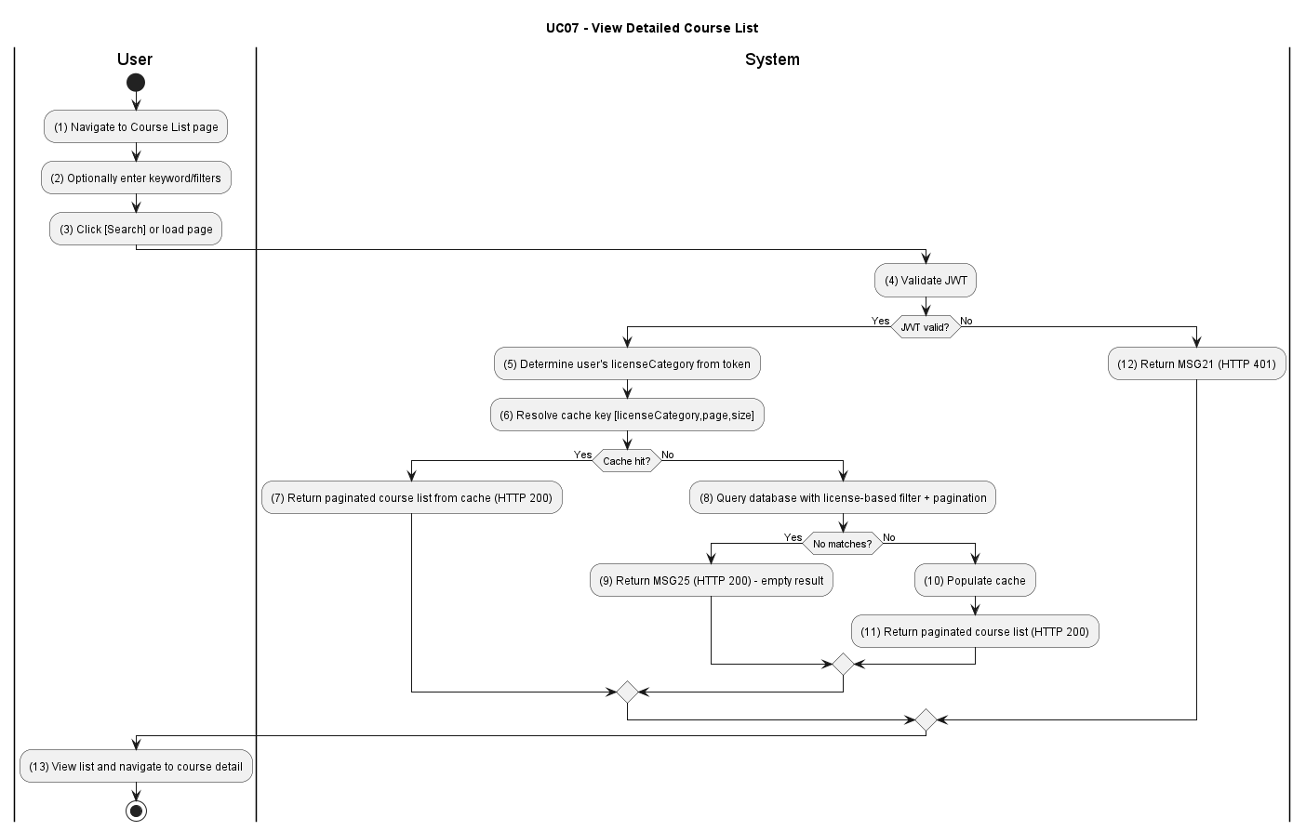

Figure UC07-A: Activity Diagram – View Detailed Course List

Sequence Diagram
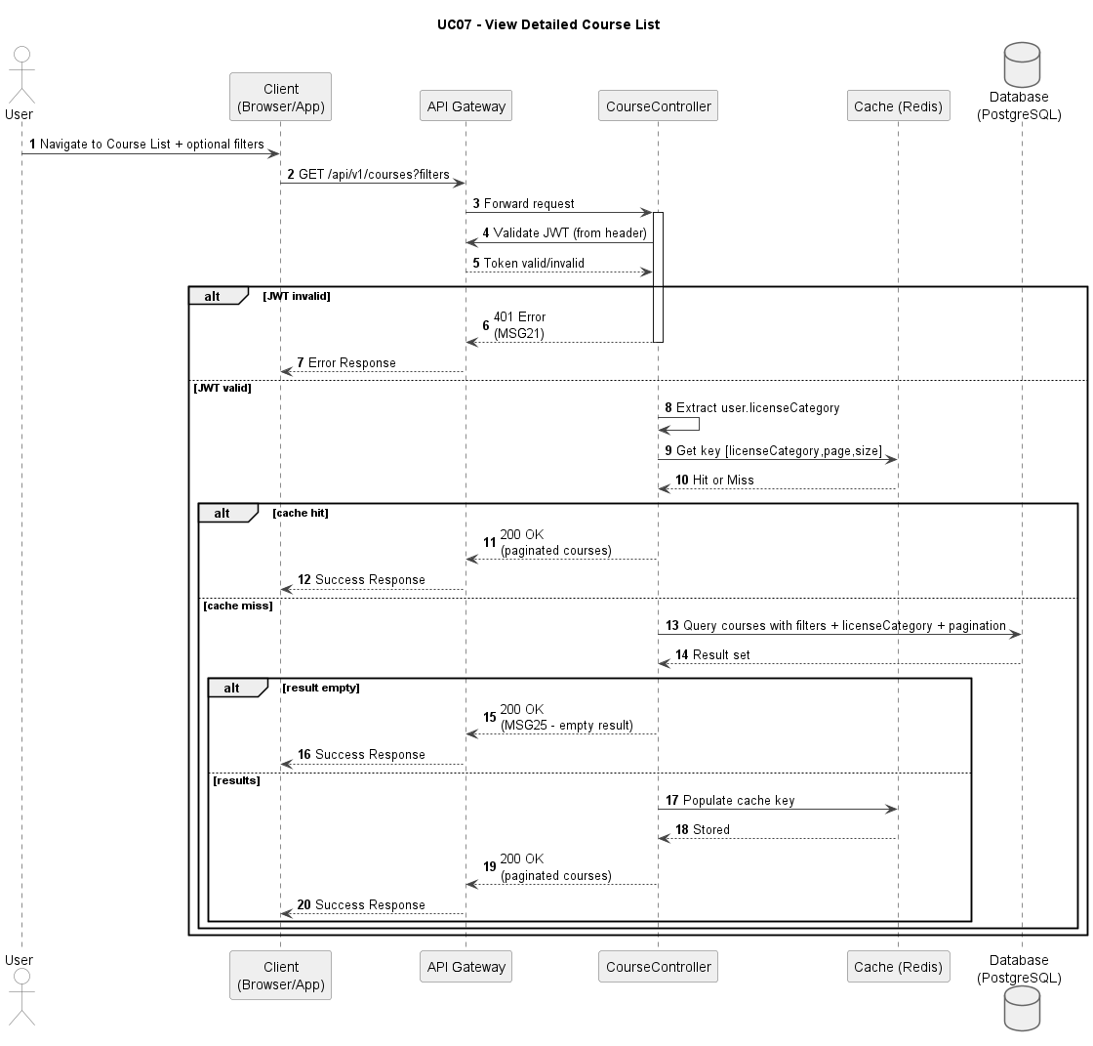

Figure UC07-S: Sequence Diagram – View Detailed Course List

Business Rules
Activity | BR Code | Description
(1) | BR01 | JWT Authentication Check:  Condition: Course list request is submitted.  Action: Validate JWT from Authorization header.  Result: If invalid, display MSG21; HTTP 401.
(2) | BR02 | License-Based Filtering:  Condition: Token is valid.  Action: Filter courses by [user.licenseCategory].  Result: Only eligible courses are included in the query scope.
(3) | BR03 | Cache-Aside Query:  Condition: Default list query is requested.  Action: Resolve cache key [licenseCategory,page,size], then fallback to database on cache miss.  Result: Paginated course list is returned; HTTP 200.
(4) | BR04 | Search and Pagination Handling:  Condition: User applies keyword/filter or page navigation.  Action: Execute filtered query and maintain pagination state rules.  Result: If no matches, display MSG25; otherwise render result page; HTTP 200.
(5) | BR05 | Course Detail Response:  Condition: User opens a course item.  Action: Query detail by [courseId] and return detail payload.  Result: If not found, display MSG23; otherwise return detail view; HTTP 200 or 404.

UC08: Create Course
Name | Create Course
Description | This use case describes the process of admins or center managers creating a new course in the system.
Actor | Admin, Center Manager
Trigger | When the actor clicks [btnCreateCourse] and submits the Course Create form.
Pre-condition | The actor is logged in with Admin or Center Manager role.
Post-condition | A new course is created and visible in the course list. A creation audit record is stored.

Activities Flow
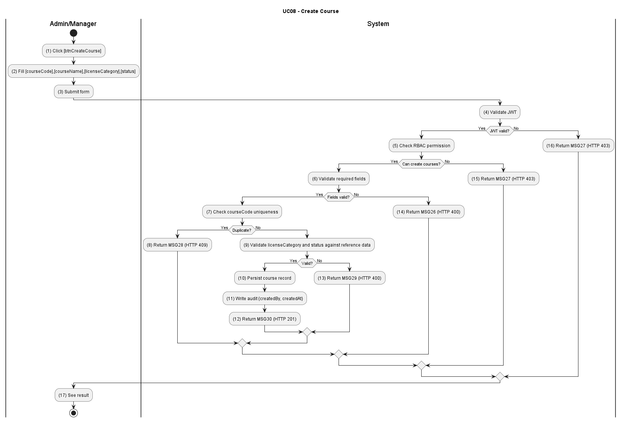

Figure UC08-A: Activity Diagram – Create Course

Sequence Diagram
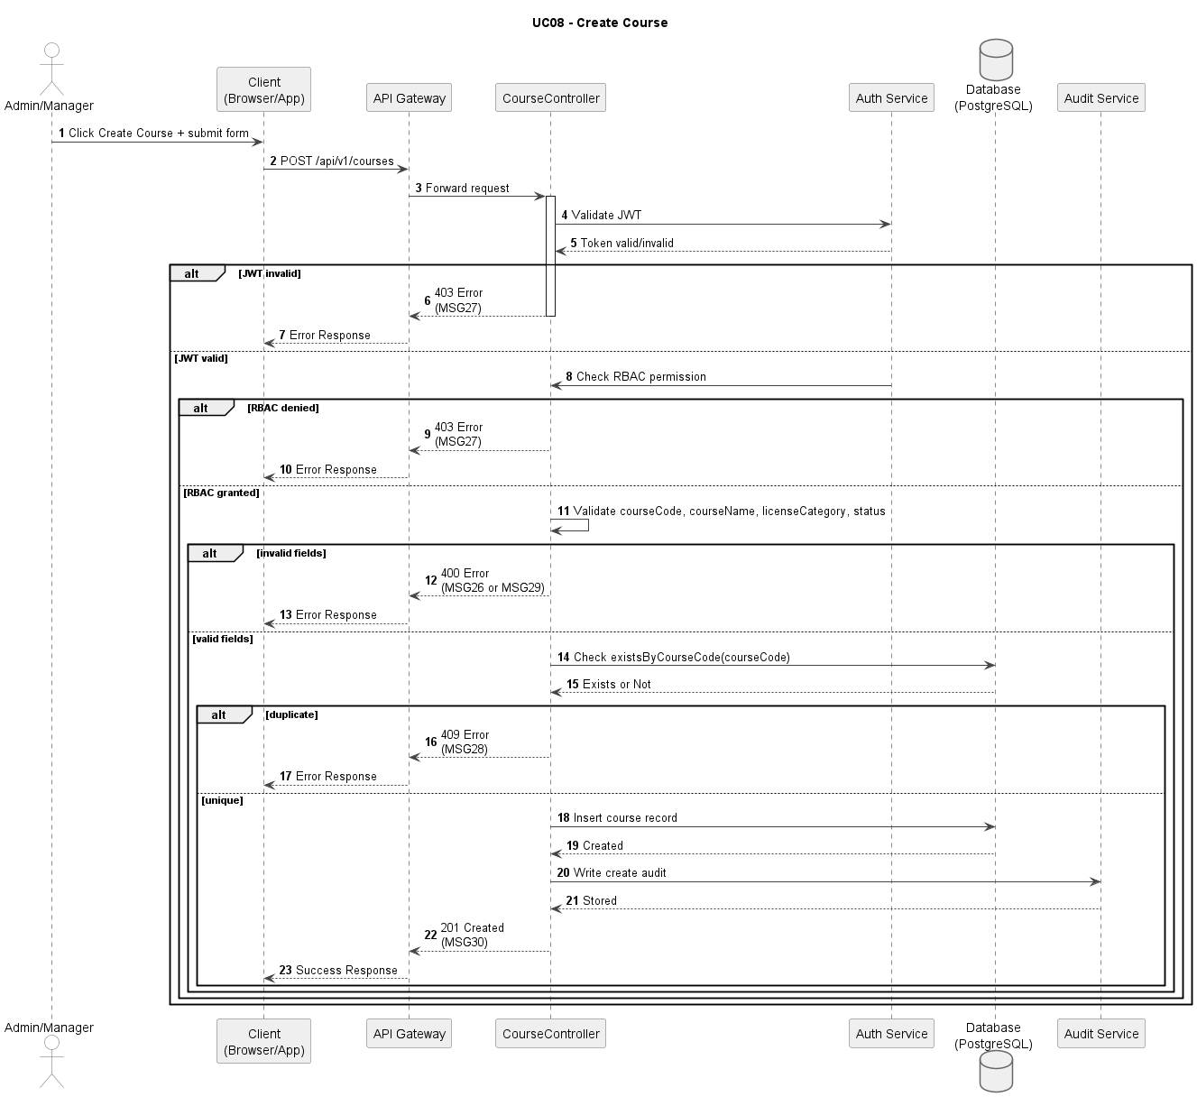

Figure UC08-S: Sequence Diagram – Create Course

Business Rules
Activity | BR Code | Description
(1) | BR01 | Required Field Validation:  Condition: Create-course request is submitted.  Action: Validate [courseCode], [courseName], [licenseCategory], and [status].  Result: If any required field is invalid or missing, display MSG26; HTTP 400.
(2) | BR02 | RBAC Permission Check:  Condition: Input is valid.  Action: Verify actor permission to create courses.  Result: If unauthorized, display MSG27; HTTP 403.
(3) | BR03 | Course Code Uniqueness:  Condition: Actor is authorized.  Action: Check existsByCourseCode([courseCode]).  Result: If duplicated, display MSG28; HTTP 409.
(4) | BR04 | Data Integrity Validation:  Condition: Request passes uniqueness check.  Action: Validate [licenseCategory] and [status] against reference data. Result: If invalid, display MSG29; HTTP 400.
(5) | BR05 | Course Creation Transaction:  Condition: All checks pass.  Action: Persist course record in one transaction with creator metadata and timestamps.  Result: Course saved with [isDeleted] = false.
(6) | BR06 | Success Response:  Condition: Transaction committed.  Action: Write audit log [action=CREATE_COURSE] and return created payload.  Result: Display MSG30; HTTP 201.

UC09: Update Course
Name | Update Course
Description | This use case describes the process of admins or center managers updating an existing course in the system.
Actor | Admin, Center Manager
Trigger | When the actor selects a course and clicks [btnUpdateCourse].
Pre-condition | The actor is logged in with Admin or Center Manager role. The course exists and is not deleted.
Post-condition | Course data is updated and reflected in list/detail pages. Update action is logged in audit trail.

Activities Flow
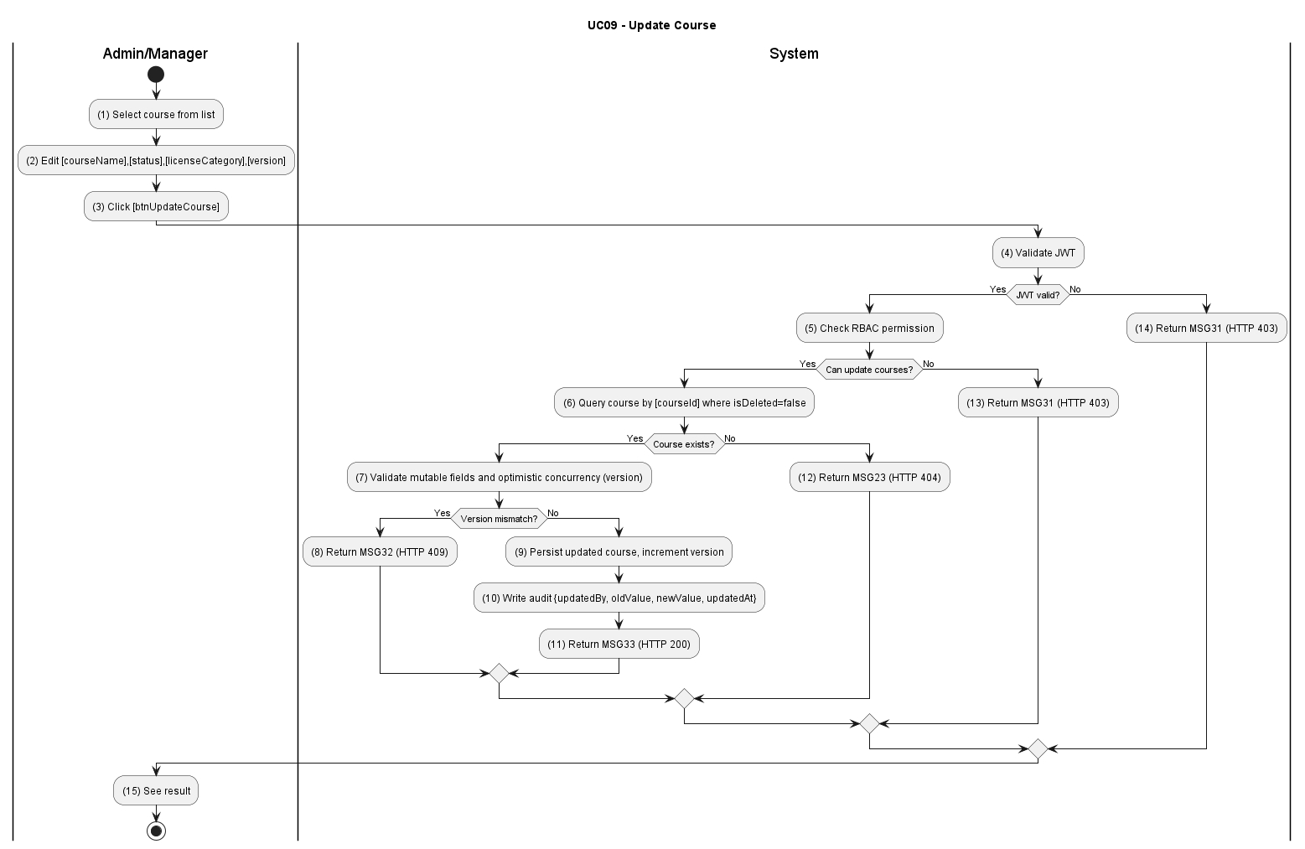

Figure UC09-A: Activity Diagram – Update Course

Sequence Diagram
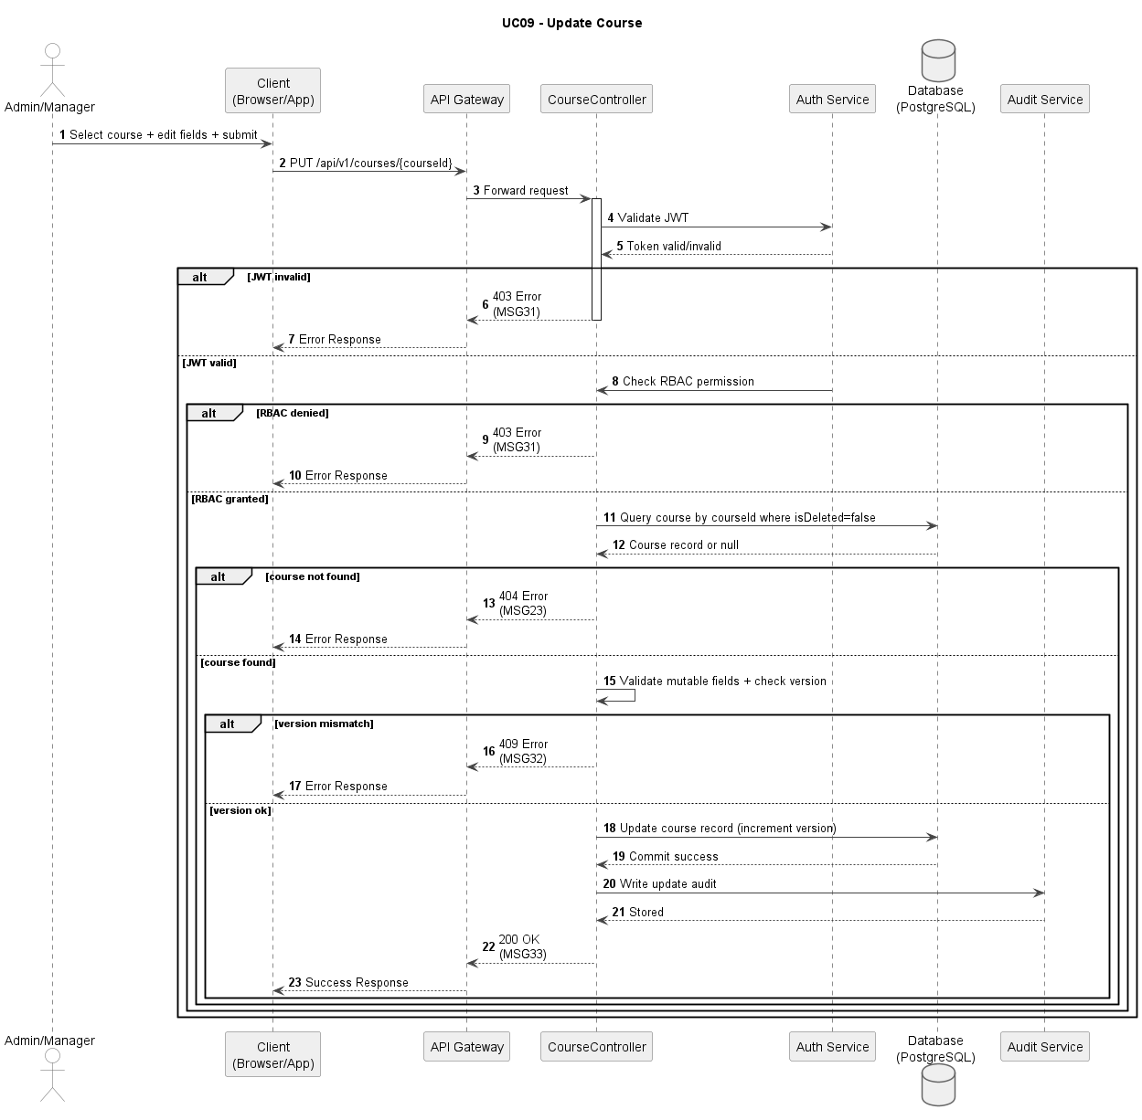

Figure UC09-S: Sequence Diagram – Update Course

Business Rules
Activity | BR Code | Description
(1) | BR01 | JWT and RBAC Validation:  Condition: Update request submitted.  Action: Validate token and role permission for course update.  Result: If unauthorized, display MSG31; HTTP 403.
(2) | BR02 | Course Existence Check:  Condition: [courseId] provided.  Action: Query course by [courseId] and [isDeleted=false].  Result: If missing, display MSG23; HTTP 404.
(3) | BR03 | Update Payload Validation:  Condition: Course exists.  Action: Validate mutable fields [courseName], [status], [roadmap], [licenseCategory].  Result: If invalid, display MSG29; HTTP 400.
(4) | BR04 | Optimistic Concurrency Check:  Condition: Client sends [version] value.  Action: Compare with current record version before update.  Result: If mismatch, display MSG32; HTTP 409.
(5) | BR05 | Persist Update and Audit:  Condition: All validations pass.  Action: Update course record, increment [version], and store audit log [action=UPDATE_COURSE].  Result: Updated course persisted.
(6) | BR06 | Success Response:  Condition: Update committed successfully.  Action: Return updated payload to client.  Result: Display MSG33; HTTP 200.

UC10: Delete Course
Name | Delete Course
Description | This use case describes the process of admins or center managers deleting an existing course from the system.
Actor | Admin, Center Manager
Trigger | When the actor clicks [btnDeleteCourse] and confirms the deletion dialog.
Pre-condition | The actor is logged in with Admin or Center Manager role. The target course exists and is not deleted.
Post-condition | The course is marked as deleted ([isDeleted=true]), excluded from active course lists, and deletion is logged for audit.

Activities Flow
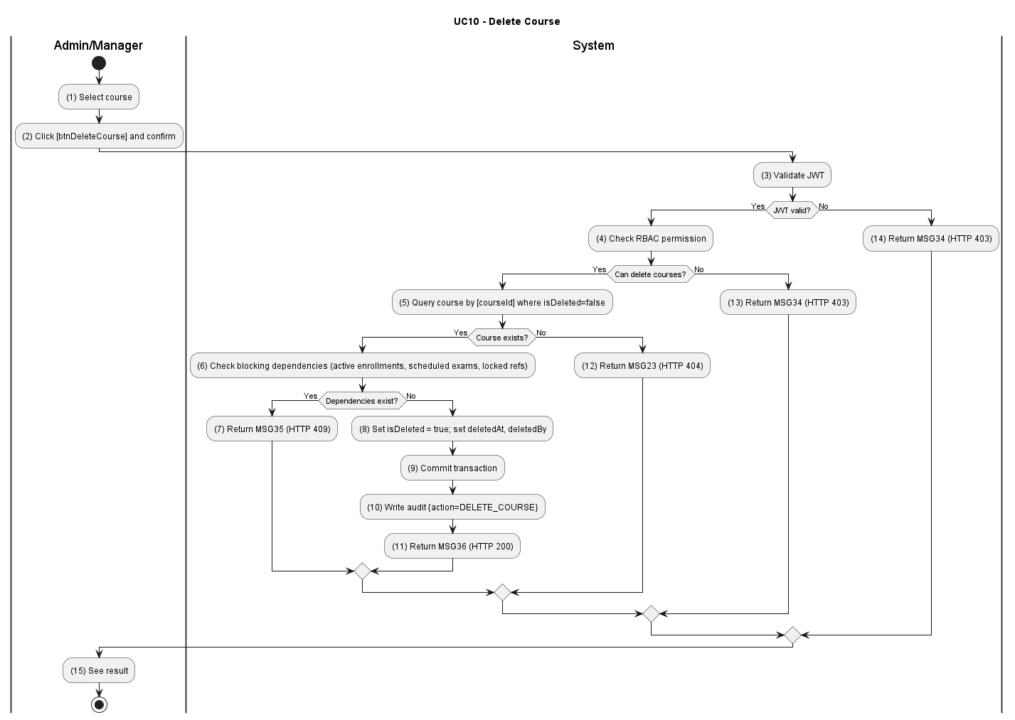

Figure UC10-A: Activity Diagram – Delete Course

Sequence Diagram
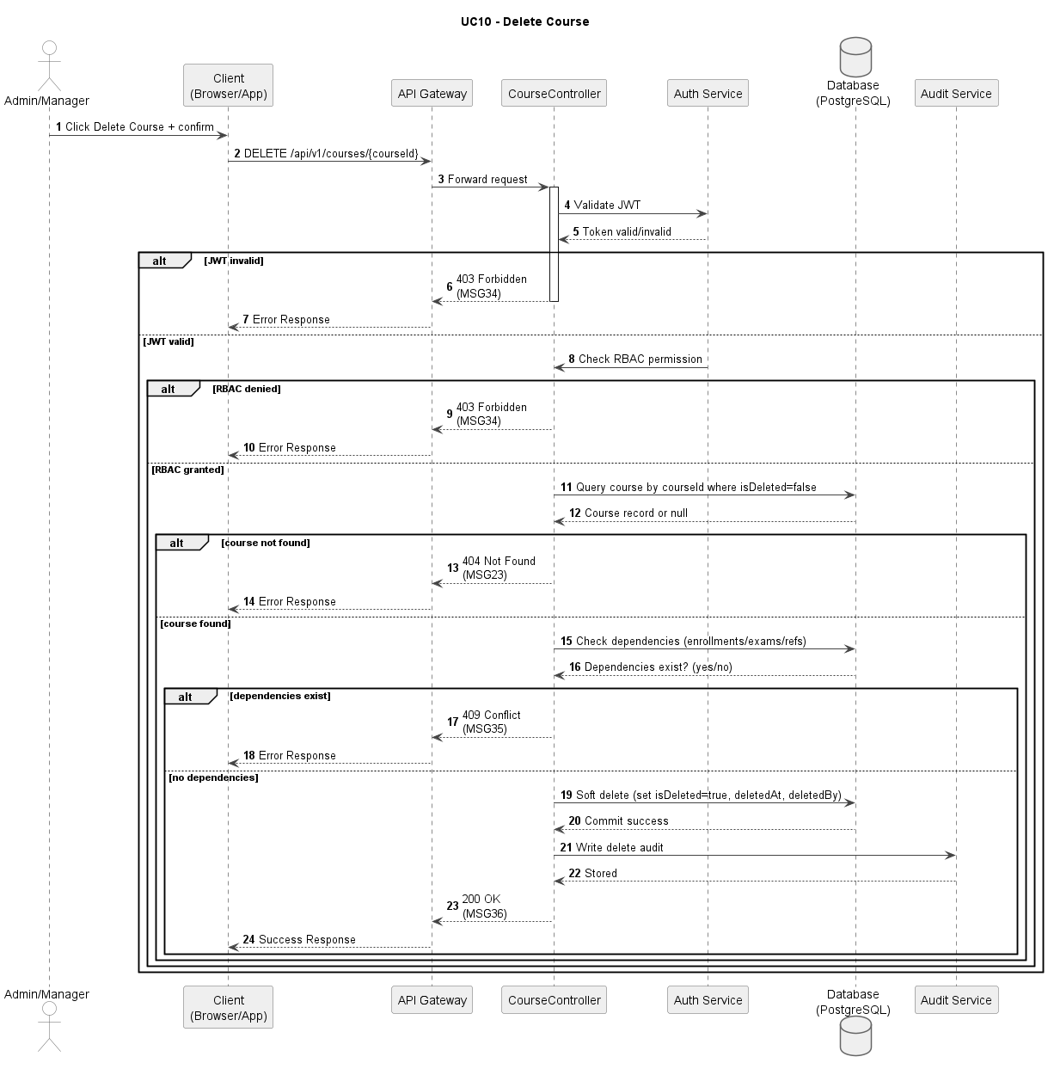
Figure UC10-S: Sequence Diagram – Delete Course

Business Rules
Activity | BR Code | Description
(1) | BR01 | JWT and RBAC Validation:  Condition: Delete request submitted.  Action: Validate token and role permission for course deletion.  Result: If unauthorized, display MSG34; HTTP 403.
(2) | BR02 | Course Existence Check:  Condition: [courseId] provided.  Action: Query course by [courseId] where [isDeleted=false].  Result: If not found, display MSG23; HTTP 404.
(3) | BR03 | Dependency Check:  Condition: Course exists.  Action: Validate there are no blocking dependencies (active enrollments, scheduled exams, locked references).  Result: If dependencies exist, display MSG35; HTTP 409.
(4) | BR04 | Soft Delete Transaction:  Condition: No blocking dependencies.  Action: Set [isDeleted=true], [deletedAt], [deletedBy] in one transaction. Result: Course removed from active list queries.
(5) | BR05 | Success Response:  Condition: Soft delete committed.  Action: Write audit log [action=DELETE_COURSE] and return success response.  Result: Display MSG36; HTTP 200.

UC11: Take Theory Exam
Name | Take Theory Exam
Description | This use case describes the process of a student taking a theoretical exam on the system.
Actor | Student
Trigger | When the student clicks [btnStartExam].
Pre-condition | The student is logged in and eligible for exam attempt creation.
Post-condition | A new exam attempt is created with randomized questions, timer settings, and initial session state.

Activities Flow
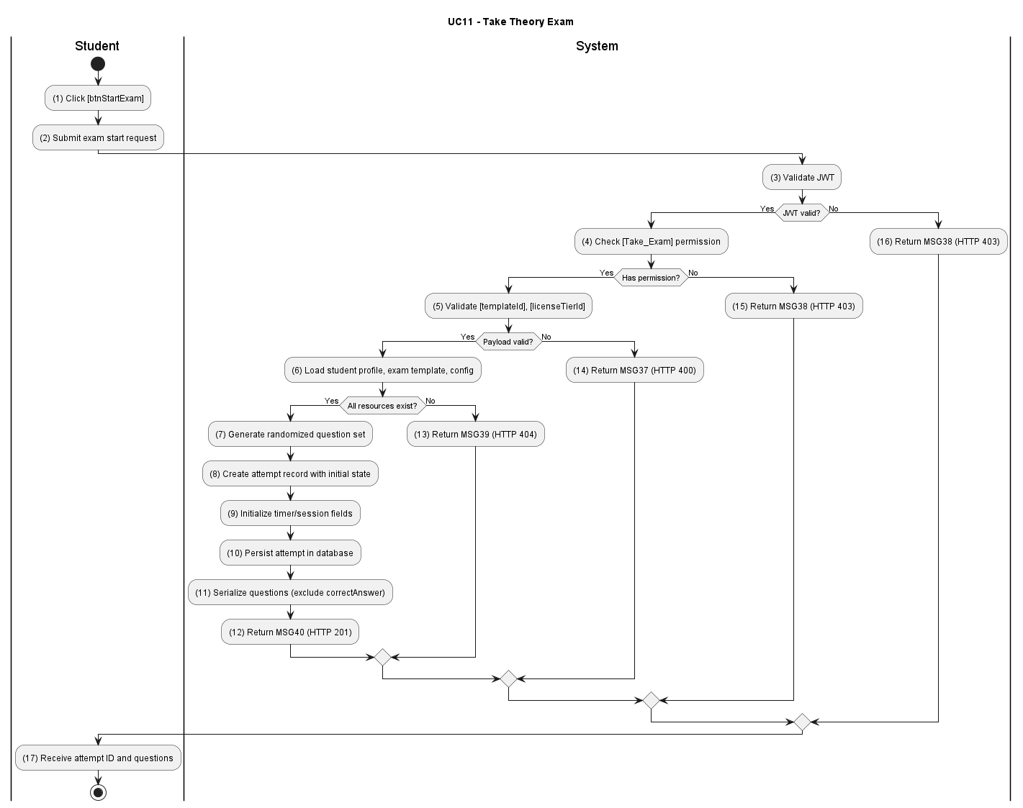

Figure UC11-A: Activity Diagram – Take Theory Exam

Sequence Diagram
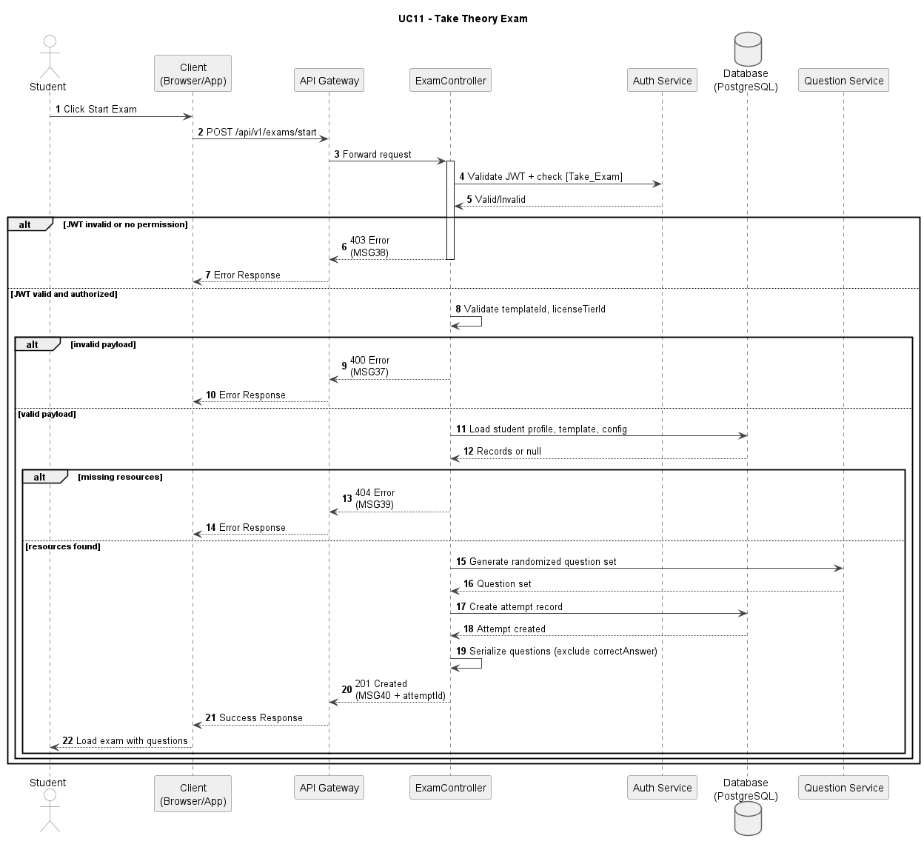
Figure UC11-S: Sequence Diagram – Take Theory Exam

Business Rules
Activity | BR Code | Description
(1) | BR01 | JWT and RBAC Validation:  Condition: Student requests a new attempt.  Action: Validate JWT and [Take_Exam] permission.  Result: If invalid, return MSG38; HTTP 403.
(2) | BR02 | Attempt Payload Validation:  Condition: Request reaches service layer.  Action: Validate [templateId], [licenseTierId], and policy constraints.  Result: If invalid/conflict, return MSG37; HTTP 400.
(3) | BR03 | Resource Existence Check:  Condition: Payload is valid.  Action: Load student profile, exam template, and contextual configuration. Result: If missing, return MSG39; HTTP 404.
(4) | BR04 | Attempt Creation Transaction:  Condition: Context is available.  Action: Generate randomized question set, create attempt record, and initialize timer/session fields.  Result: Attempt persisted successfully.
(5) | BR05 | Answer Confidentiality:  Condition: Question set is prepared for response payload.  Action: Serialise each question using a restricted DTO that includes only [questionId], [questionText], [options[]] (option text only), [questionOrder], and [isFatal] flag. The [correctAnswer] field, answer key index, and any scoring metadata must be explicitly excluded. Verify the response schema in the contract test suite.  Result: The [correctAnswer] field is never present in the GET /exam/questions response body. Verified by API contract test on every build pipeline run; HTTP 200.
(5) | BR06 | Success Response:  Condition: Transaction committed.  Action: Return attempt identifier and session bootstrap payload.  Result: Return MSG40; HTTP 201.

UC12: Manage Exam Session
Name | Manage Exam Session
Description | This use case describes how the system supports in-exam features such as bookmarking questions, auto-saving answers, and displaying a countdown timer.
Actor | Student
Trigger | When the student performs session actions during an active attempt.
Pre-condition | The student has an active exam attempt.
Post-condition | Session state is updated and persisted for continuity and crash recovery.

Activities Flow
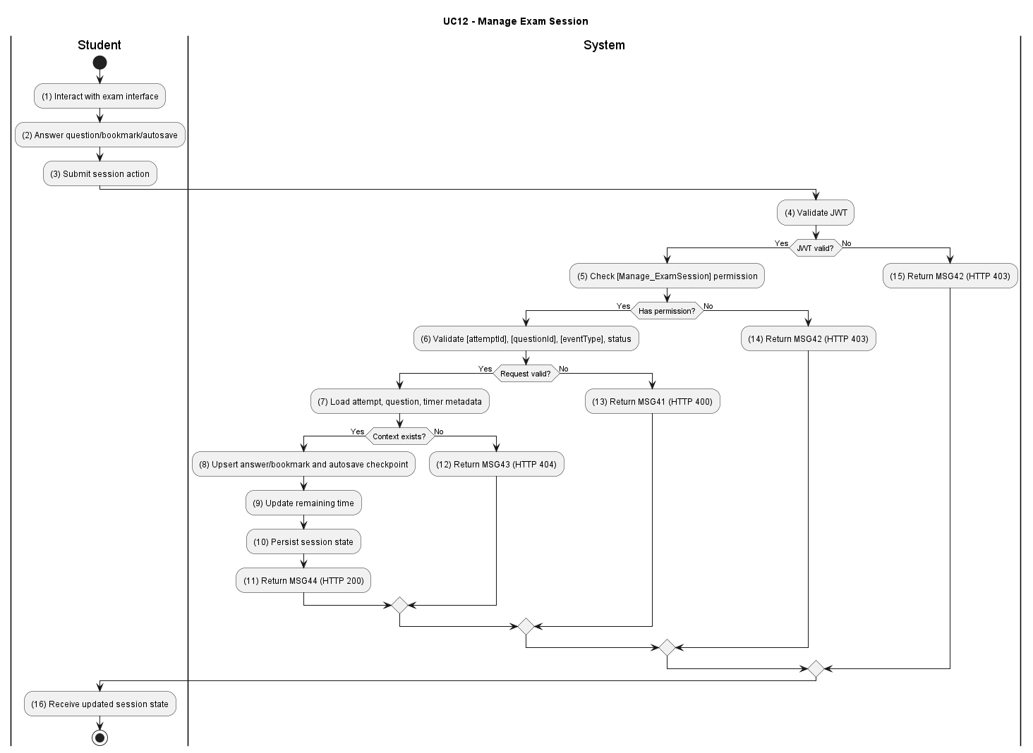

Figure UC12-A: Activity Diagram – Manage Exam Session

Sequence Diagram
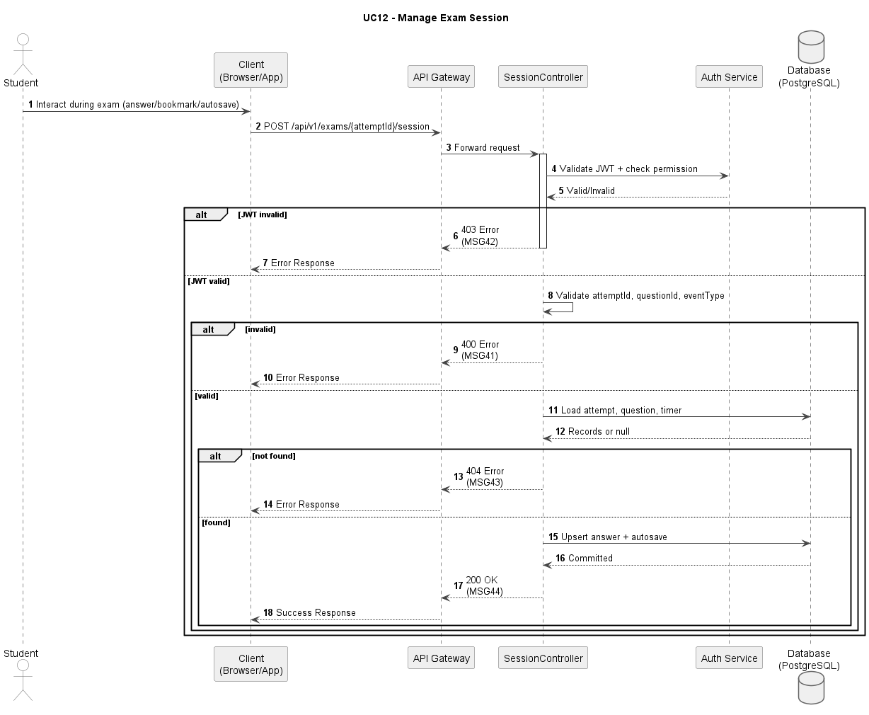
Figure UC12-S: Sequence Diagram – Manage Exam Session

Business Rules
Activity | BR Code | Description
(1) | BR01 | JWT and RBAC Validation:  Condition: Session event is submitted.  Action: Validate JWT and [Manage_ExamSession] permission.  Result: If invalid, return MSG42; HTTP 403.
(2) | BR02 | Session Event Validation:  Condition: Request is authorized.  Action: Validate [attemptId], [questionId], [eventType], and attempt status. Result: If invalid/conflict, return MSG41; HTTP 400.
(3) | BR03 | Attempt Context Check:  Condition: Payload is valid.  Action: Load attempt, question context, and timer metadata.  Result: If not found, return MSG43; HTTP 404.
(4) | BR04 | Session Persistence:  Condition: Context exists.  Action: Upsert answer/bookmark and persist autosave checkpoint with remaining time.  Result: Session state updated safely.
(5) | BR05 | Success Response:  Condition: Session update persisted.  Action: Return latest session state.  Result: Return MSG44; HTTP 200.

UC13: Submit Exam
Name | Submit Exam
Description | This use case describes the process of a student completing and submitting the exam to the system.
Actor | Student
Trigger | When the student clicks [btnSubmitExam].
Pre-condition | The student has an active attempt and submission is still allowed.
Post-condition | Attempt is finalized, answers are locked, and grading is queued.

Activities Flow
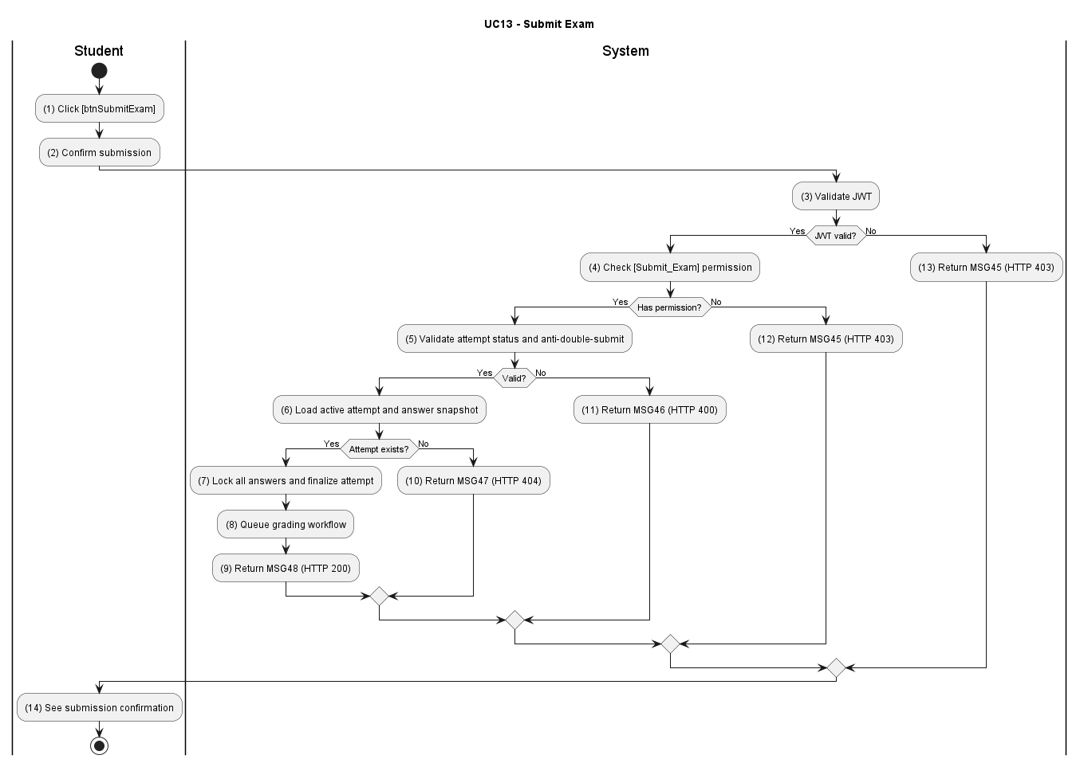

Figure UC13-A: Activity Diagram – Submit Exam

Sequence Diagram
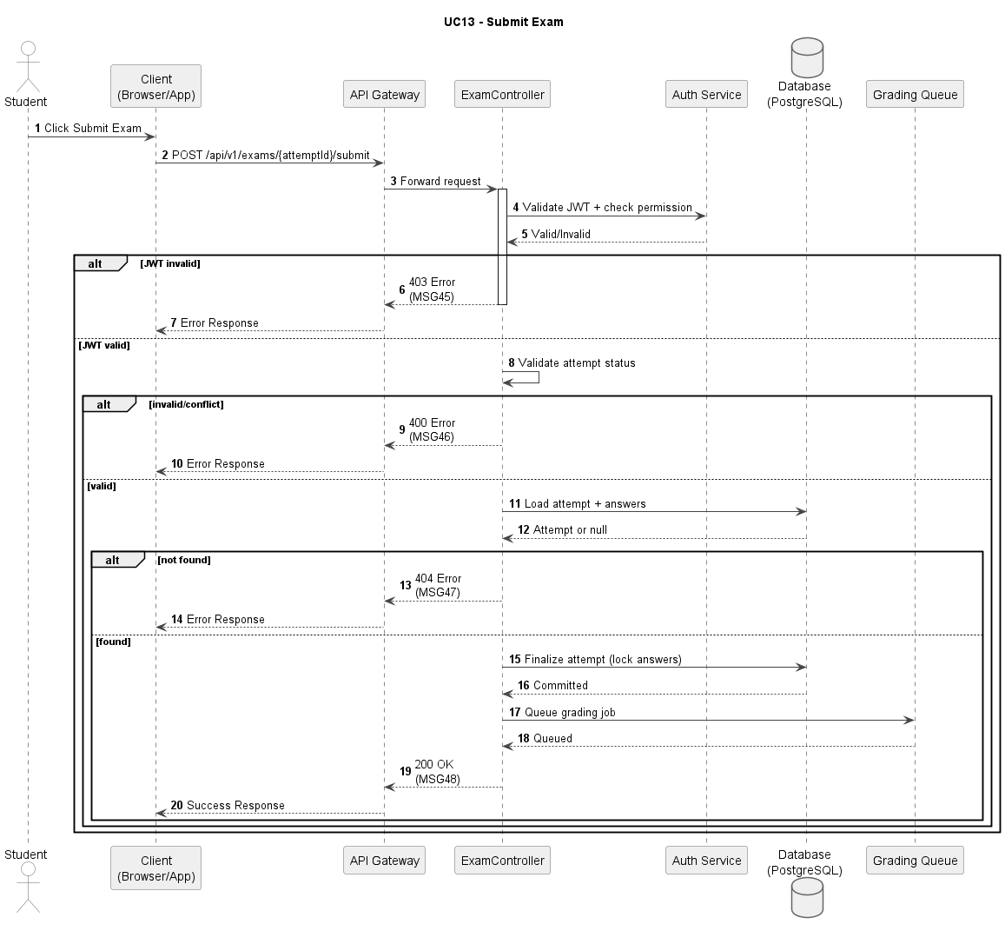
Figure UC13-S: Sequence Diagram – Submit Exam

Business Rules
Activity | BR Code | Description
(1) | BR01 | JWT and RBAC Validation:  Condition: Submit request is received.  Action: Validate JWT and [Submit_Exam] permission.  Result: If invalid, return MSG45; HTTP 403.
(2) | BR02 | Submission State Validation:  Condition: Request is authorized.  Action: Validate attempt status and anti-double-submit policy.  Result: If invalid/conflict, return MSG46; HTTP 400.
(3) | BR03 | Attempt Existence Check:  Condition: State is valid.  Action: Load active attempt and answer snapshot.  Result: If missing, return MSG47; HTTP 404.
(4) | BR04 | Finalization Transaction:  Condition: Attempt exists.  Action: Lock all answers, finalize attempt status, and queue grading workflow.  Result: Attempt submitted successfully.
(5) | BR05 | Success Response:  Condition: Finalization committed.  Action: Return submission confirmation.  Result: Return MSG48; HTTP 200.

UC14: Grade Exam
Name | Grade Exam
Description | This use case describes the system automatically grading the exam based on the answer key and fatal question rules.
Actor | System
Trigger | When submission finalization triggers grading.
Pre-condition | Attempt is submitted and eligible for grading.
Post-condition | Grading result is persisted with score, pass/fail, and fatal-question evaluation.

Activities Flow
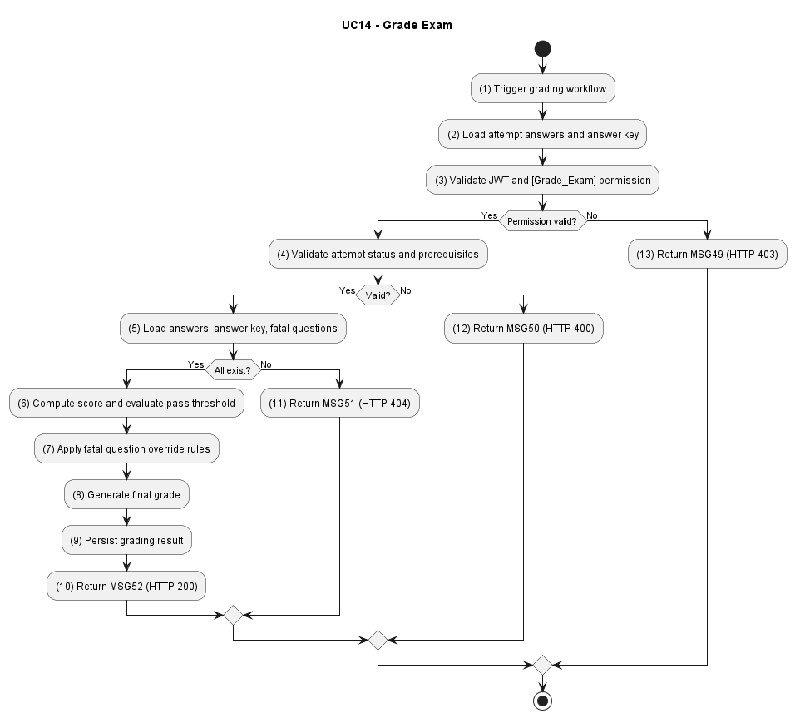

Figure UC14-A: Activity Diagram – Grade Exam

Sequence Diagram
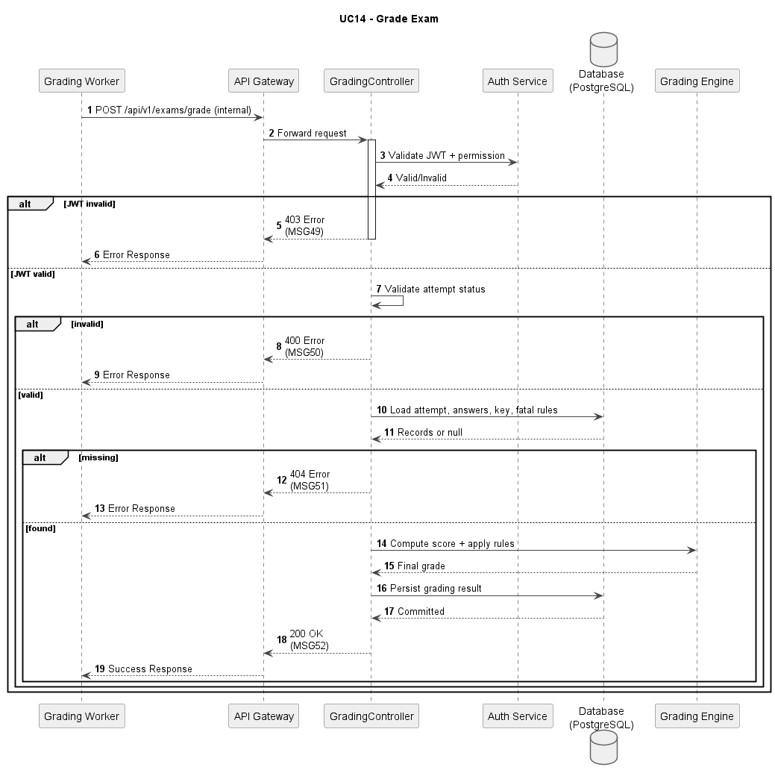
Figure UC14-S: Sequence Diagram – Grade Exam

Business Rules
Activity | BR Code | Description
(1) | BR01 | JWT and RBAC Validation:  Condition: Grading endpoint/worker executes.  Action: Validate JWT and [Grade_Exam] permission.  Result: If invalid, return MSG49; HTTP 403.
(2) | BR02 | Grading Input Validation:  Condition: Authorization passes.  Action: Validate attempt status and grading prerequisites.  Result: If invalid/conflict, return MSG50; HTTP 400.
(3) | BR03 | Resource Existence Check:  Condition: Input is valid.  Action: Load attempt answers, answer key, and fatal-question definitions. Result: If missing, return MSG51; HTTP 404.
(4) | BR04 | Grading Logic Execution:  Condition: Resources loaded.  Action: Compute score, evaluate pass threshold, and apply fatal-question override rules.  Result: Final grade generated.
(5) | BR05 | Success Response:  Condition: Grade persisted.  Action: Return grading completion payload.  Result: Return MSG52; HTTP 200.

UC15: View Exam Results
Name | View Exam Results
Description | This use case describes the process of a student viewing their results after completing an exam.
Actor | Student
Trigger | When the student opens exam result detail.
Pre-condition | Exam attempt has been graded.
Post-condition | Student sees score, pass/fail status, and answer-level feedback.

Activities Flow
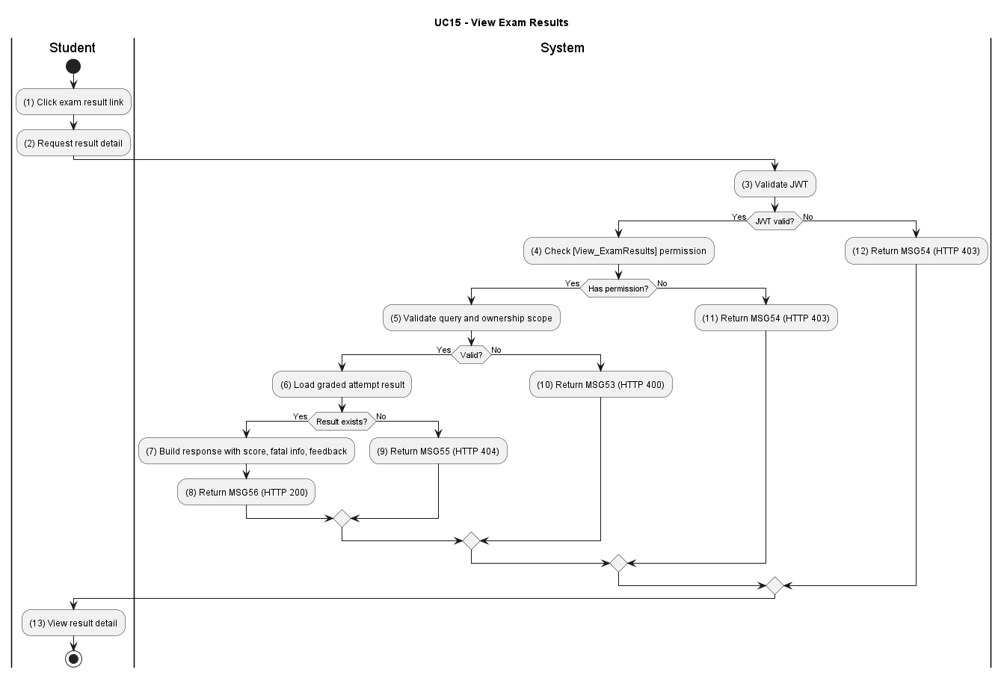

Figure UC15-A: Activity Diagram – View Exam Results

Sequence Diagram
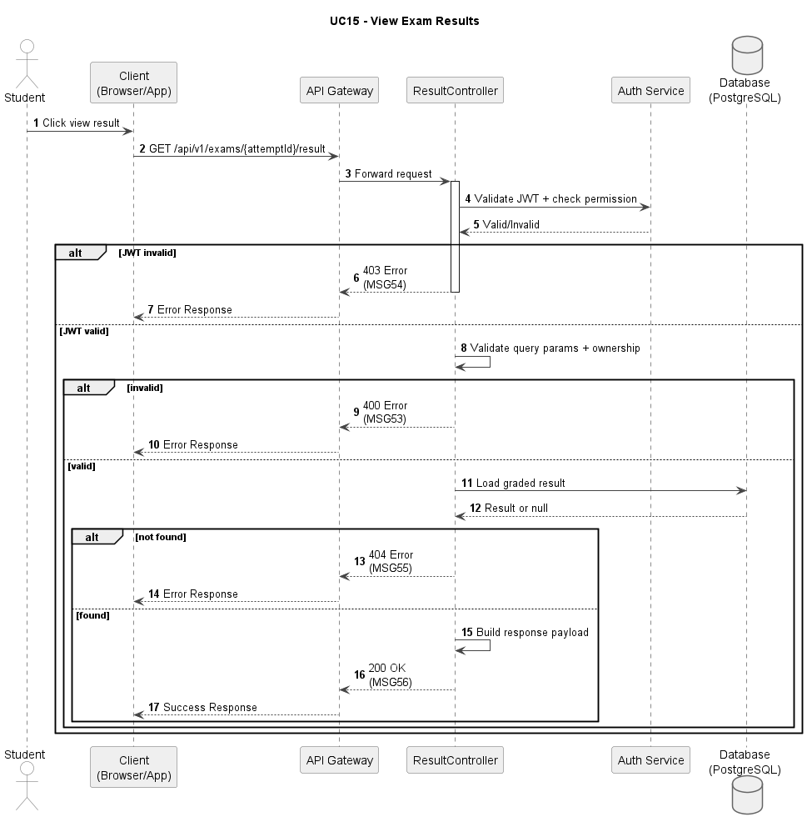
Figure UC15-S: Sequence Diagram – View Exam Results

Business Rules
Activity | BR Code | Description
(1) | BR01 | JWT and RBAC Validation:  Condition: Result request is received.  Action: Validate JWT and [View_ExamResults] permission.  Result: If invalid, return MSG54; HTTP 403.
(2) | BR02 | Query Validation:  Condition: Authorization passes.  Action: Validate ownership scope and query params.  Result: If invalid/conflict, return MSG53; HTTP 400/.
(3) | BR03 | Result Existence Check:  Condition: Query is valid.  Action: Load graded attempt result.  Result: If not found, return MSG55; HTTP 404.
(4) | BR04 | Result Projection:  Condition: Result exists.  Action: Build response with score, fatal-question info, and per-question feedback.  Result: Result payload prepared.
(5) | BR05 | Success Response:  Condition: Projection ready.  Action: Return result detail to client.  Result: Return MSG56; HTTP 200.

UC16: Review Exams
Name | Review Exams
Description | This use case describes the process of a student reviewing the exams they have previously taken.
Actor | Student
Trigger | When the student opens the exam review module.
Pre-condition | Student has at least one historical exam attempt.
Post-condition | Student receives a list of attempts and can drill down into selected review detail.

Activities Flow
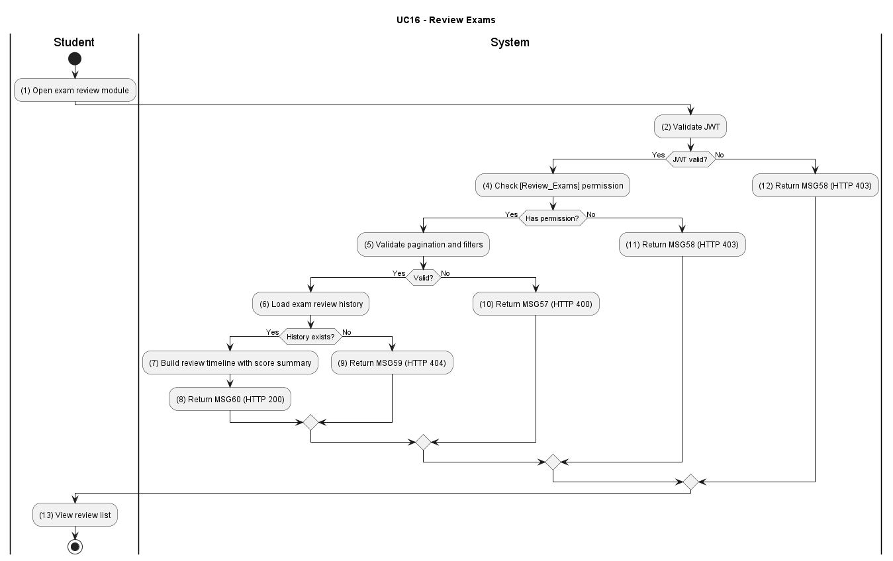

Figure UC16-A: Activity Diagram – Review Exams

Sequence Diagram
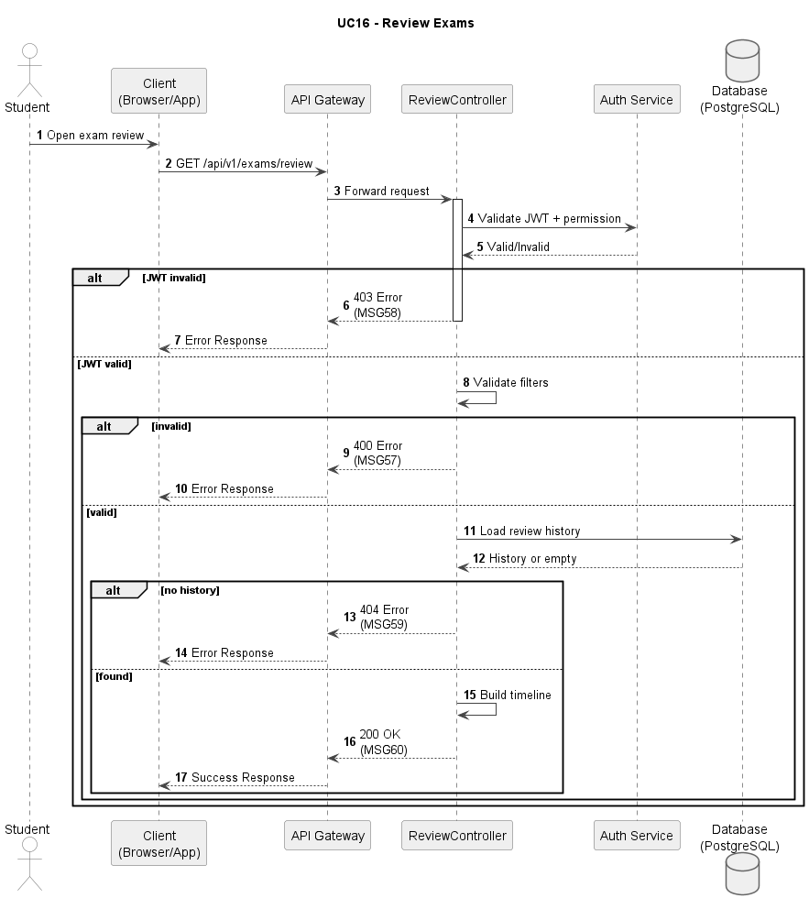
Figure UC16-S: Sequence Diagram – Review Exams

Business Rules
Activity | BR Code | Description
(1) | BR01 | JWT and RBAC Validation:  Condition: Review list request is submitted.  Action: Validate JWT and [Review_Exams] permission.  Result: If invalid, display MSG58; HTTP 403.
(2) | BR02 | Filter Validation:  Condition: Authorization passes.  Action: Validate pagination, sorting, and filter options.  Result: If invalid/conflict, display MSG57; HTTP 400.
(3) | BR03 | Review Data Check:  Condition: Query is valid.  Action: Load exam review history and metadata.  Result: If not found, display MSG59; HTTP 404.
(4) | BR04 | Review Projection:  Condition: History exists.  Action: Build review timeline with attempt status and score summary. Result: Review list ready.
(5) | BR05 | Success Response:  Condition: Projection prepared.  Action: Return review listing payload.  Result: Display MSG60; HTTP 200.

UC17: Search Question Bank
Name | Search Question Bank
Description | This use case describes the process of admins or center managers searching and filtering questions in the system.
Actor | Admin, Center Manager
Trigger | When actor enters keyword/filter on Question Bank page.
Pre-condition | Actor is logged in with question-bank access rights.
Post-condition | Filtered question list is returned with pagination.

Activities Flow
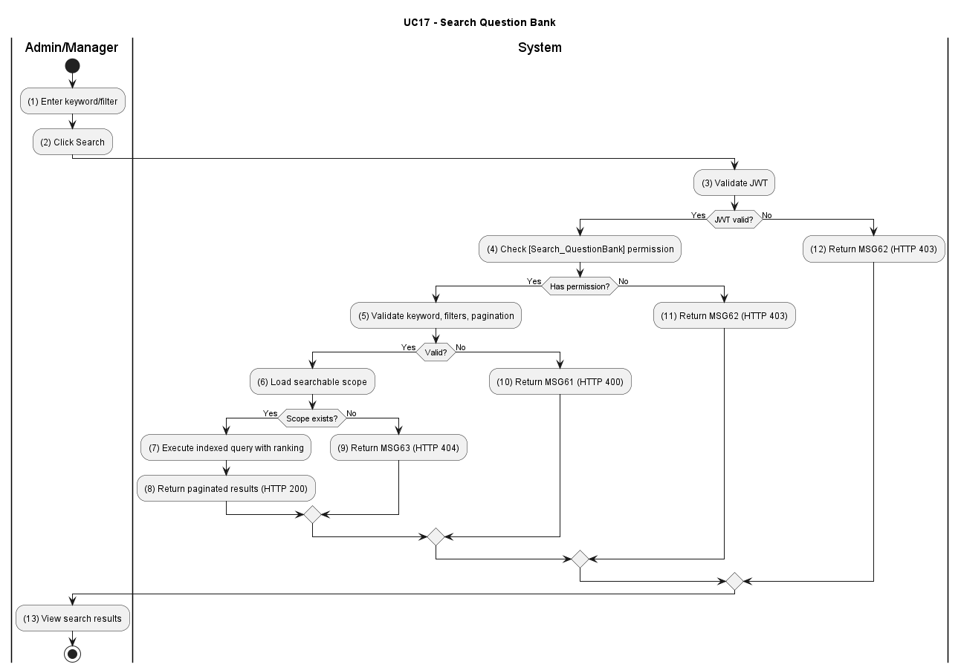

Figure UC17-A: Activity Diagram – Search Question Bank

Sequence Diagram
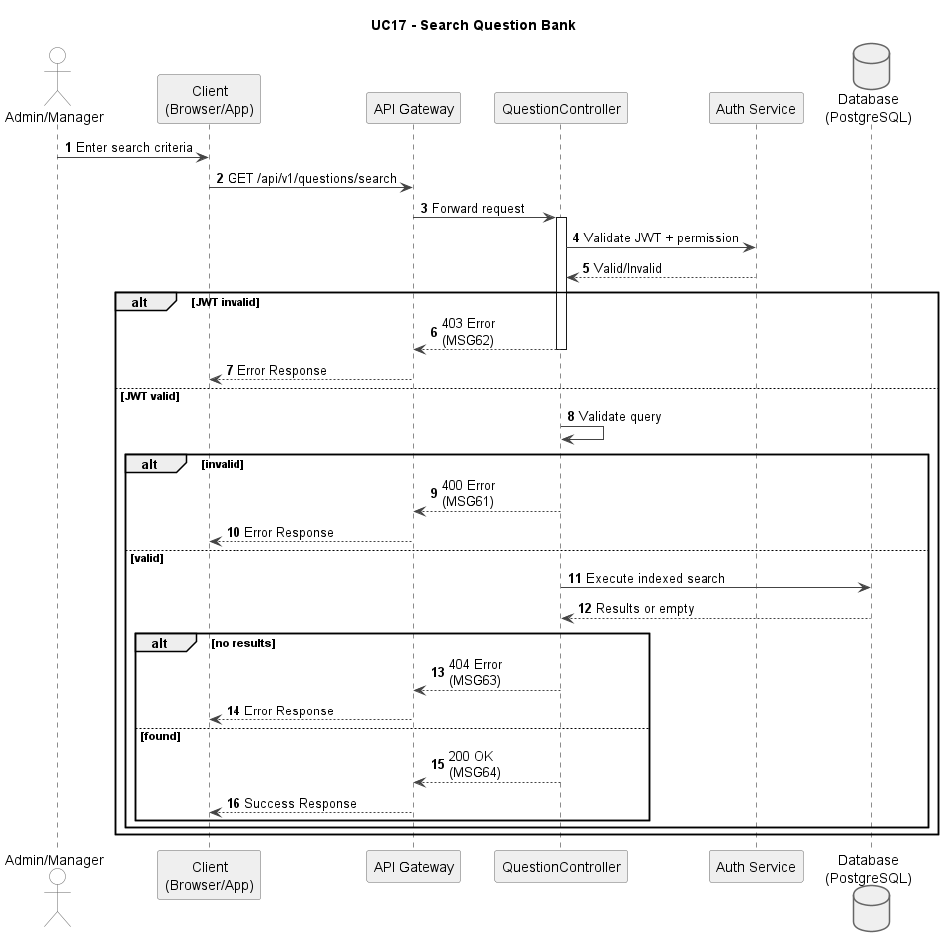
Figure UC17-S: Sequence Diagram – Search Question Bank

Business Rules
Activity | BR Code | Description
(1) | BR01 | JWT and RBAC Validation:  Condition: Search request is submitted.  Action: Validate JWT and [Search_QuestionBank] permission.  Result: If invalid, display MSG62; HTTP 403.
(2) | BR02 | Query Validation:  Condition: Authorization passes.  Action: Validate [keyword], [licenseTierId], [status], [page], [size].  Result: If invalid/conflict, display MSG61; HTTP 400.
(3) | BR03 | Search Scope Check:  Condition: Query is valid.  Action: Load searchable scope from question repository.  Result: If scope/resource missing, display MSG63; HTTP 404.
(4) | BR04 | Indexed Search Execution:  Condition: Scope exists.  Action: Execute indexed query with ranking and pagination.  Result: Filtered list generated.
(5) | BR05 | Success Response:  Condition: Search result generated.  Action: Return paginated data to client.  Result: Display MSG64; HTTP 200.

UC18: Create Question
Name | Create Question
Description | This use case describes the process of admins or center managers creating a new question in the question bank.
Actor | Admin, Center Manager
Trigger | When actor submits [btnCreateQuestion] form.
Pre-condition | Actor is logged in with question creation permission.
Post-condition | New question is persisted and appears in the question list.

Activities Flow
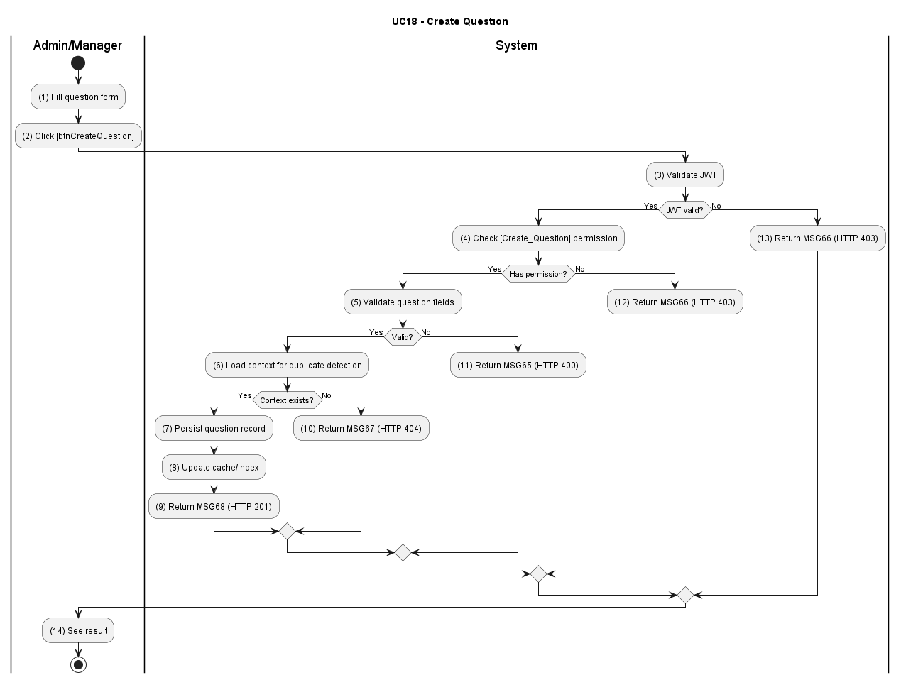

Figure UC18-A: Activity Diagram – Create Question

Sequence Diagram
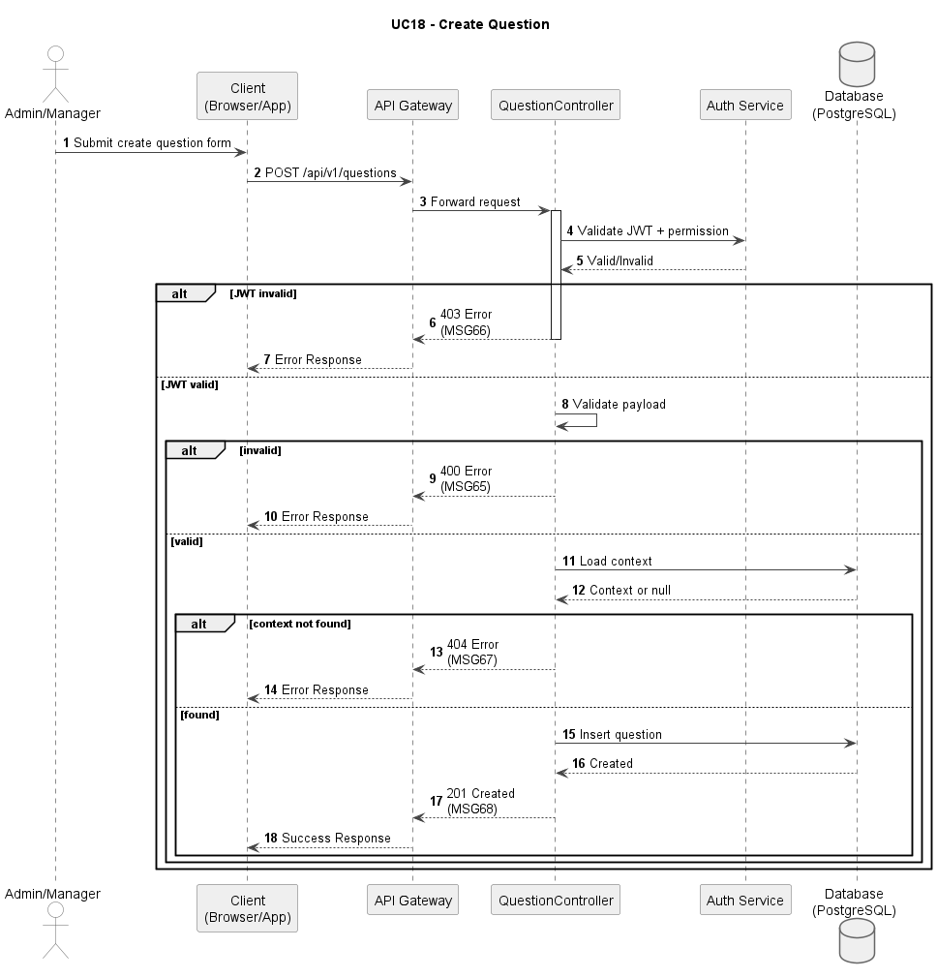
Figure UC18-S: Sequence Diagram – Create Question

Business Rules
Activity | BR Code | Description
(1) | BR01 | JWT and RBAC Validation:  Condition: Create request is submitted.  Action: Validate JWT and [Create_Question] permission.  Result: If invalid, display MSG66; HTTP 403.
(2) | BR02 | Payload Validation:  Condition: Authorization passes.  Action: Validate question text, options, correct answer, and metadata. Result: If invalid/conflict, display MSG65; HTTP 400.
(3) | BR03 | Duplication Context Check:  Condition: Payload valid.  Action: Load question signature context for duplicate detection.  Result: If resource context not found, display MSG67; HTTP 404.
(4) | BR04 | Create Transaction:  Condition: Context exists and constraints pass.  Action: Persist new question and update related cache/index.  Result: Question created successfully.
(5) | BR05 | Success Response:  Condition: Transaction committed.  Action: Return created question payload.  Result: Display MSG68; HTTP 201.

UC19: Update Question
Name | Update Question
Description | This use case describes the process of admins or center managers updating an existing question in the question bank.
Actor | Admin, Center Manager
Trigger | When actor submits [btnUpdateQuestion] form.
Pre-condition | Actor is logged in and target question exists.
Post-condition | Question content is updated with audit/version history.

Activities Flow
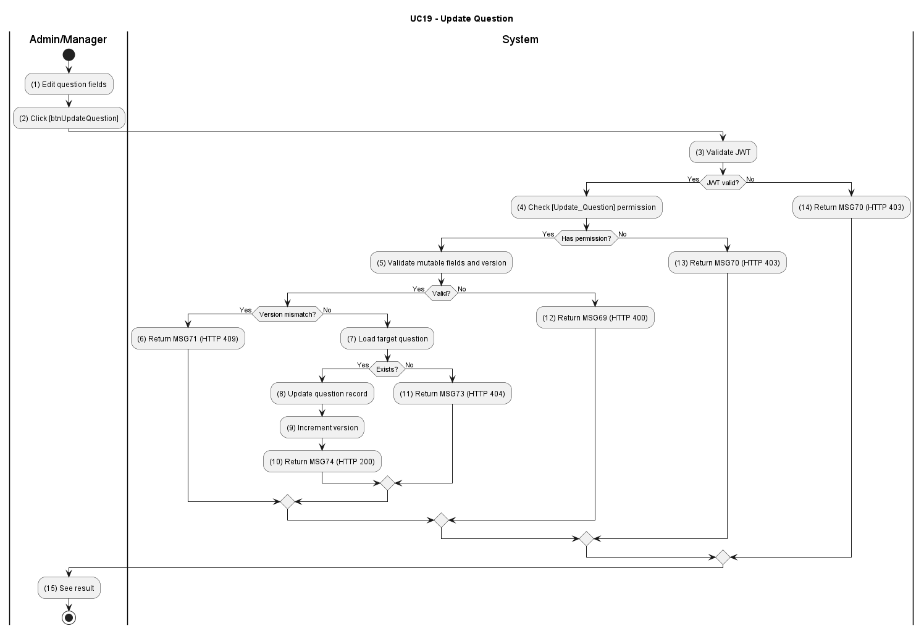

Figure UC19-A: Activity Diagram – Update Question

Sequence Diagram
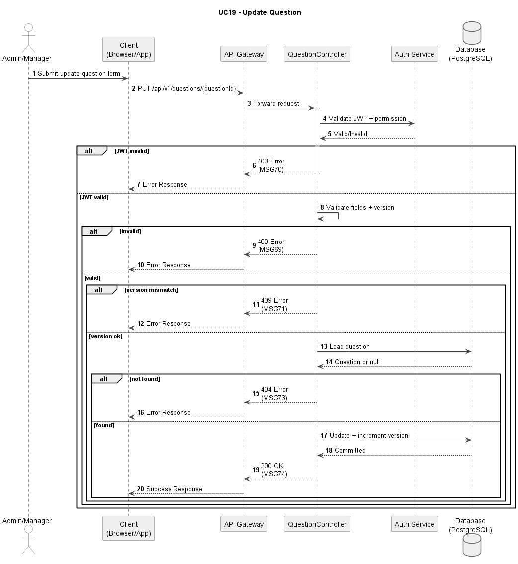
Figure UC19-S: Sequence Diagram – Update Question

Business Rules
Activity | BR Code | Description
(1) | BR01 | JWT and RBAC Validation:  Condition: Update request is submitted.  Action: Validate JWT and [Update_Question] permission.  Result: If invalid, display MSG70; HTTP 403.
(2) | BR02 | Payload and Version Validation:  Condition: Update request is authorised.  Action:  (a) Validate all mutable fields [questionText], [options[]], [correctAnswer], [isFatal], [topicId], [licenseTierId] for correct format and required values.  (b) Validate optimistic concurrency: compare the client-supplied [version] field against the current [version] stored in the database for this question record.  Result: If any field is invalid → display MSG69; HTTP 400. If [version] field is missing → display MSG70; HTTP 400. If version does not match (concurrent modification detected) → display MSG71; HTTP 409 Conflict. The client must reload the latest version before retrying.
(3) | BR03 | Question Existence Check:  Condition: Payload valid.  Action: Load target question and dependency context.  Result: If missing, display MSG71; HTTP 404.
(4) | BR04 | Update Transaction:  Condition: Resource exists.  Action: Update question, keep version snapshot, and refresh index/cache. Result: Question updated successfully.
(5) | BR05 | Success Response:  Condition: Update committed.  Action: Return updated question payload.  Result: Display MSG74; HTTP 200.

UC20: Delete Question
Name | Delete Question
Description | This use case describes the process of admins or center managers deleting a question from the question bank.
Actor | Admin, Center Manager
Trigger | When actor confirms [btnDeleteQuestion].
Pre-condition | Actor is logged in and question delete policy is satisfied.
Post-condition | Question is soft-deleted and no longer shown in active lists.

Activities Flow
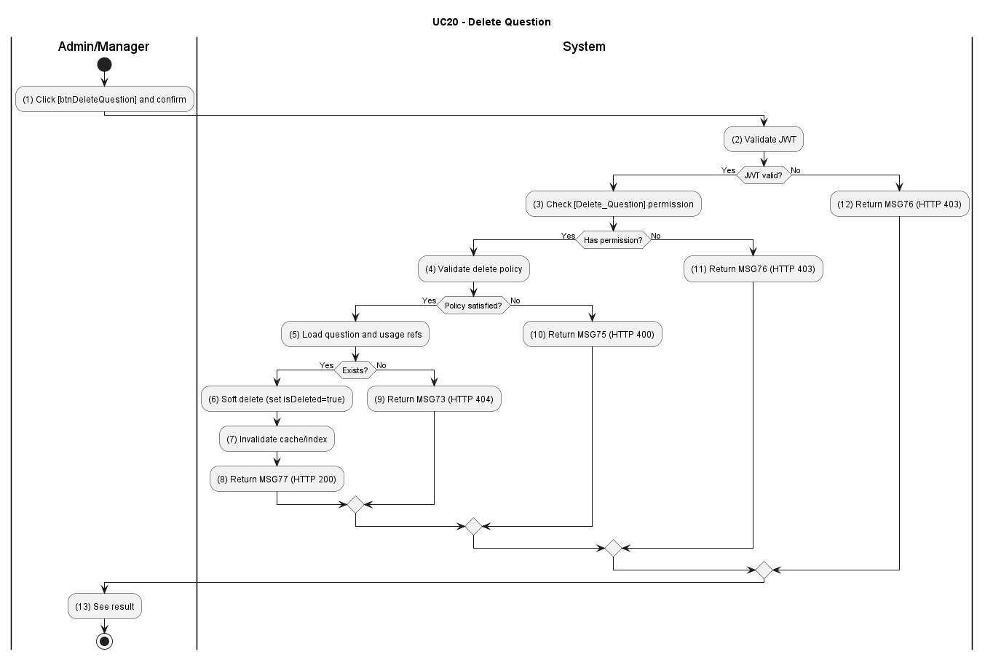

Figure UC20-A: Activity Diagram – Delete Question

Sequence Diagram
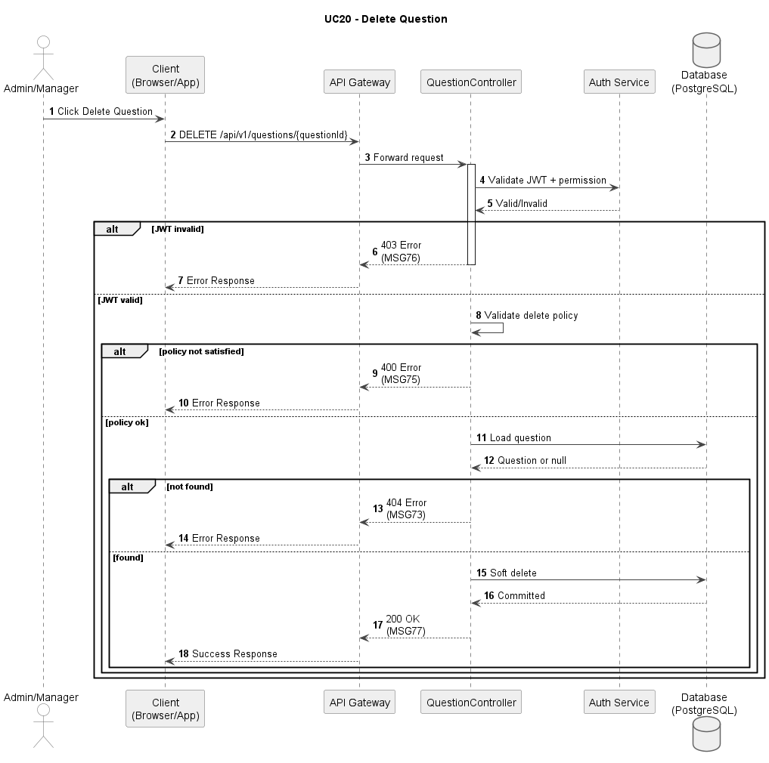
Figure UC20-S: Sequence Diagram – Delete Question

Business Rules
Activity | BR Code | Description
(1) | BR01 | JWT and RBAC Validation:  Condition: Delete request is received.  Action: Validate JWT and [Delete_Question] permission.  Result: If invalid, display MSG75; HTTP 403.
(2) | BR02 | Delete Rule Validation:  Condition: Authorization passes.  Action: Validate safe-delete policy and conflict constraints.  Result: If invalid, display MSG75; HTTP 400.
(3) | BR03 | Existence Check:  Condition: Request valid.  Action: Load target question and usage references.  Result: If not found, display MSG73; HTTP 404.
(4) | BR04 | Soft Delete Transaction:  Condition: Resource exists and constraints pass.  Action: Mark [isDeleted=true], invalidate cache/index, and preserve history. Result: Question removed from active query set.
(5) | BR05 | Success Response:  Condition: Deletion committed.  Action: Return deletion result payload.  Result: Display MSG77; HTTP 200.

UC21: Create Exam Template
Name | Create Exam Template
Description | This use case describes the process of an admin creating a new exam template with structure, number of questions, question types, and related rules.
Actor | Admin
Trigger | When actor submits [btnCreateExamTemplate].
Pre-condition | Actor is logged in with exam-config management permission.
Post-condition | New template is created and available for exam paper generation.

Activities Flow
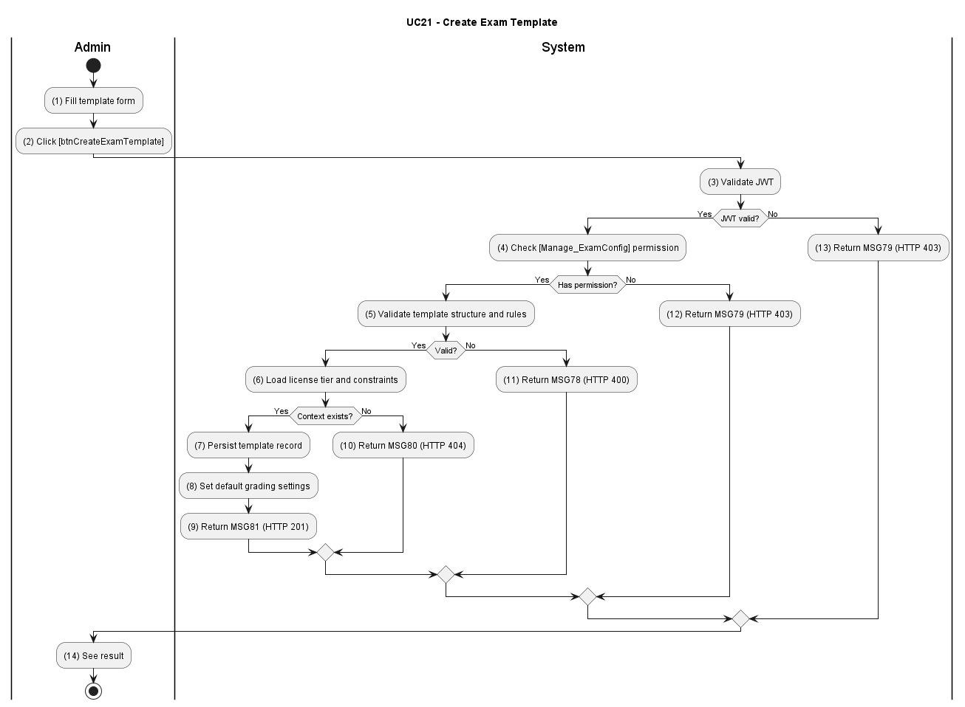

Figure UC21-A: Activity Diagram – Create Exam Template

Sequence Diagram
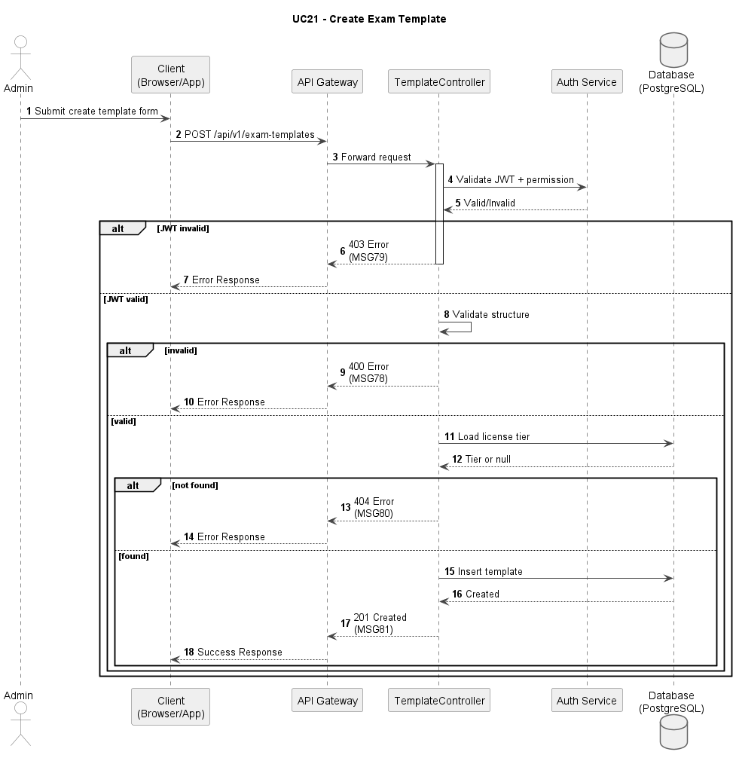
Figure UC21-S: Sequence Diagram – Create Exam Template

Business Rules
Activity | BR Code | Description
(1) | BR01 | JWT and RBAC Validation:  Condition: Create-template request submitted.  Action: Validate JWT and [Manage_ExamConfig] permission.  Result: If invalid, display MSG78; HTTP 403.
(2) | BR02 | Template Validation:  Condition: Authorization passes.  Action: Validate structure, section quotas, pass rules, and metadata.  Result: If invalid/conflict, display MSG78; HTTP 400.
(3) | BR03 | Context Existence Check:  Condition: Payload valid.  Action: Load license tier and related constraints.  Result: If missing, display MSG80; HTTP 404.
(4) | BR04 | Create Transaction:  Condition: Context exists.  Action: Persist template and default grading settings in one transaction. Result: Template created successfully.
(5) | BR05 | Success Response:  Condition: Transaction committed.  Action: Return created template payload.  Result: Display MSG81; HTTP 201.

UC22: Update Exam Template
Name | Update Exam Template
Description | This use case describes the process of an admin updating an existing exam template configuration.
Actor | Admin
Trigger | When actor submits [btnUpdateExamTemplate].
Pre-condition | Actor is logged in and template exists.
Post-condition | Template is updated and becomes active for subsequent generation flows.

Activities Flow
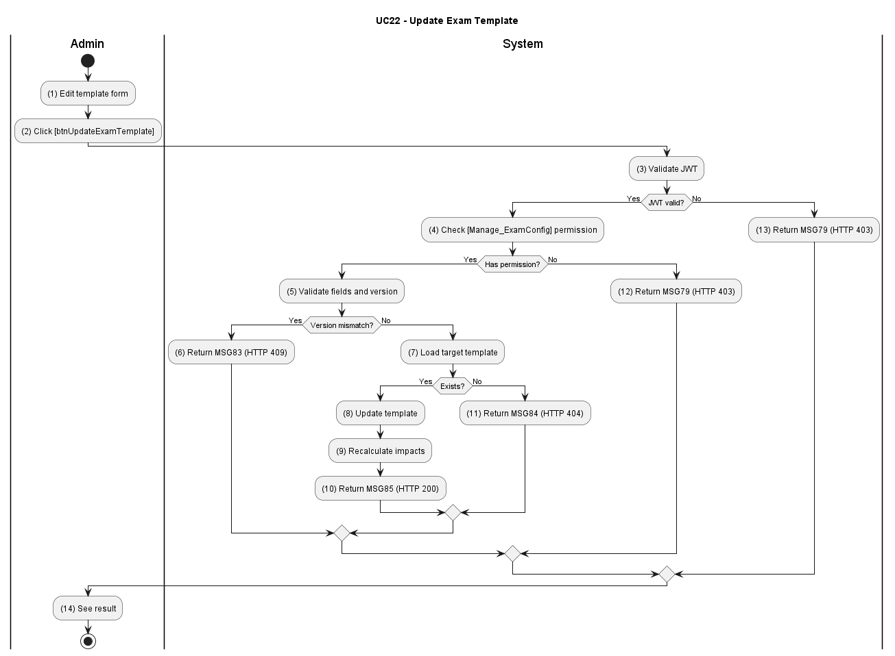

Figure U22-A: Activity Diagram – Update Exam Template

Sequence Diagram
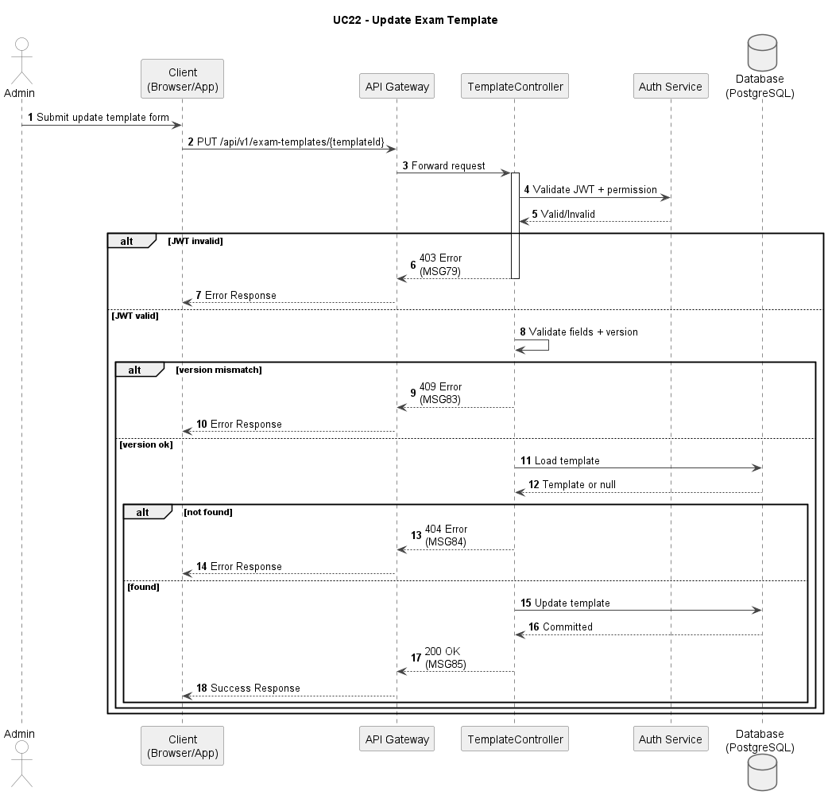
Figure UC22-S: Sequence Diagram – Update Exam Template

Business Rules
Activity | BR Code | Description
(1) | BR01 | JWT and RBAC Validation:  Condition: Update-template request submitted.  Action: Validate JWT and [Manage_ExamConfig] permission.  Result: If invalid, display MSG79; HTTP 403.
(2) | BR02 | Update Validation:  Condition: Update request is authorised.  Action: (a) Validate mutable fields [templateName], [questionCount], [timeLimit], [passingScore], [fatalQuestionIds[]], [sectionQuotas[]], [licenseTierId] for correct format and required values. (b) Validate optimistic concurrency: compare client-supplied [version] against the current [version] in the database for this template record.  Result: If any field is invalid → display MSG82; HTTP 400. If version mismatch is detected → display MSG83; HTTP 409 Conflict.
(3) | BR03 | Template Existence Check:  Condition: Payload valid.  Action: Load target template and lock state.  Result: If not found, display MSG84; HTTP 404.
(4) | BR04 | Update Transaction:  Condition: Template exists.  Action: Persist changes and recalculate constraint impacts.  Result: Template updated successfully.
(5) | BR05 | Success Response:  Condition: Transaction committed.  Action: Return updated payload.  Result: Display MSG85; HTTP 200.

UC23: Delete Exam Template
Name | Delete Exam Template
Description | This use case describes the process of an admin deleting an unused exam template from the system.
Actor | Admin
Trigger | When actor confirms [btnDeleteExamTemplate].
Pre-condition | Actor is logged in, template exists, and template is not blocked by in-use constraints.
Post-condition | Template is soft-deleted and removed from active configuration views.

Activities Flow
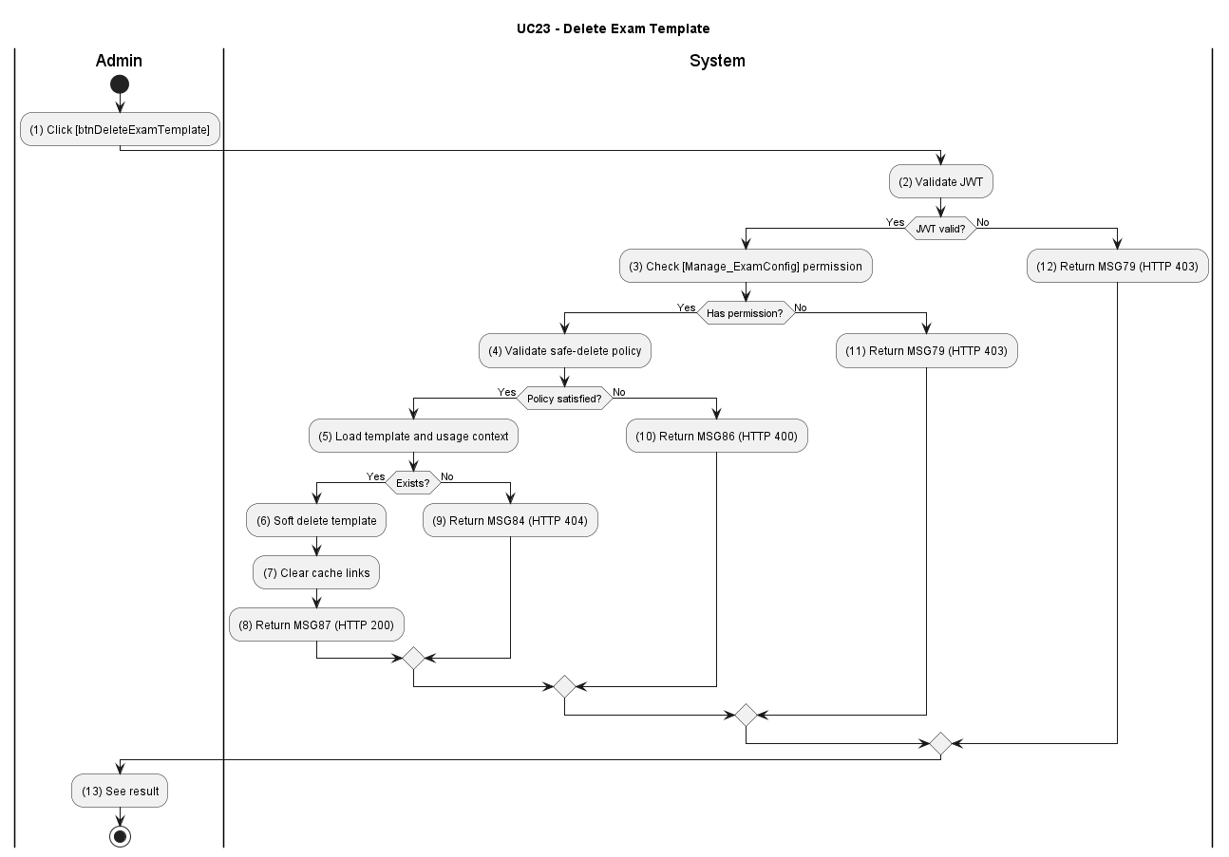

Figure UC23-A: Activity Diagram – Delete Exam Template

Sequence Diagram
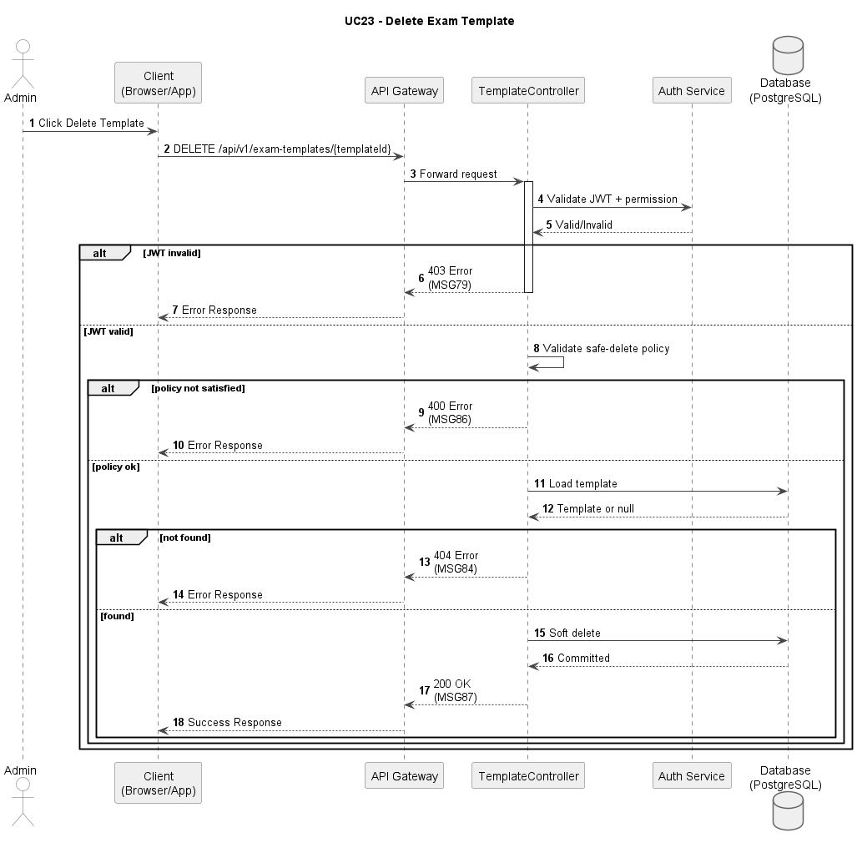
Figure UC23-S: Sequence Diagram – Delete Exam Template

Business Rules
Activity | BR Code | Description
(1) | BR01 | JWT and RBAC Validation:  Condition: Delete-template request submitted.  Action: Validate JWT and [Manage_ExamConfig] permission.  Result: If invalid, display MSG79; HTTP 403.
(2) | BR02 | Safe-Delete Validation:  Condition: Authorization passes.  Action: Validate in-use dependency rules and delete constraints.  Result: If invalid, display MSG86; HTTP 400.
(3) | BR03 | Template Existence Check:  Condition: Request valid.  Action: Load target template and usage context.  Result: If not found, display MSG84; HTTP 404.
(4) | BR04 | Delete Transaction:  Condition: Constraints pass.  Action: Soft-delete template and clear cache links.  Result: Template removed from active set.
(5) | BR05 | Success Response:  Condition: Deletion committed.  Action: Return operation result payload.  Result: Display MSG87; HTTP 200.

UC24: Auto-generate Exam Papers
Name | Auto-generate Exam Papers
Description | This use case describes the system automatically generating an exam based on the established configuration.
Actor | System, Admin
Trigger | When generation job is triggered manually or by schedule.
Pre-condition | Valid template and sufficient question pool are available.
Post-condition | Exam papers are generated and persisted for upcoming attempts.

Activities Flow
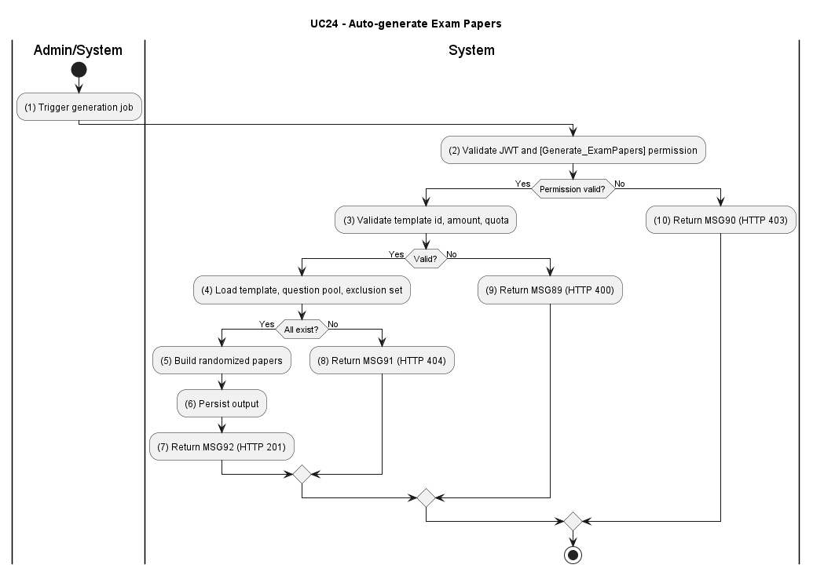

Figure UC24-A: Activity Diagram – Auto-generate Exam Papers

Sequence Diagram
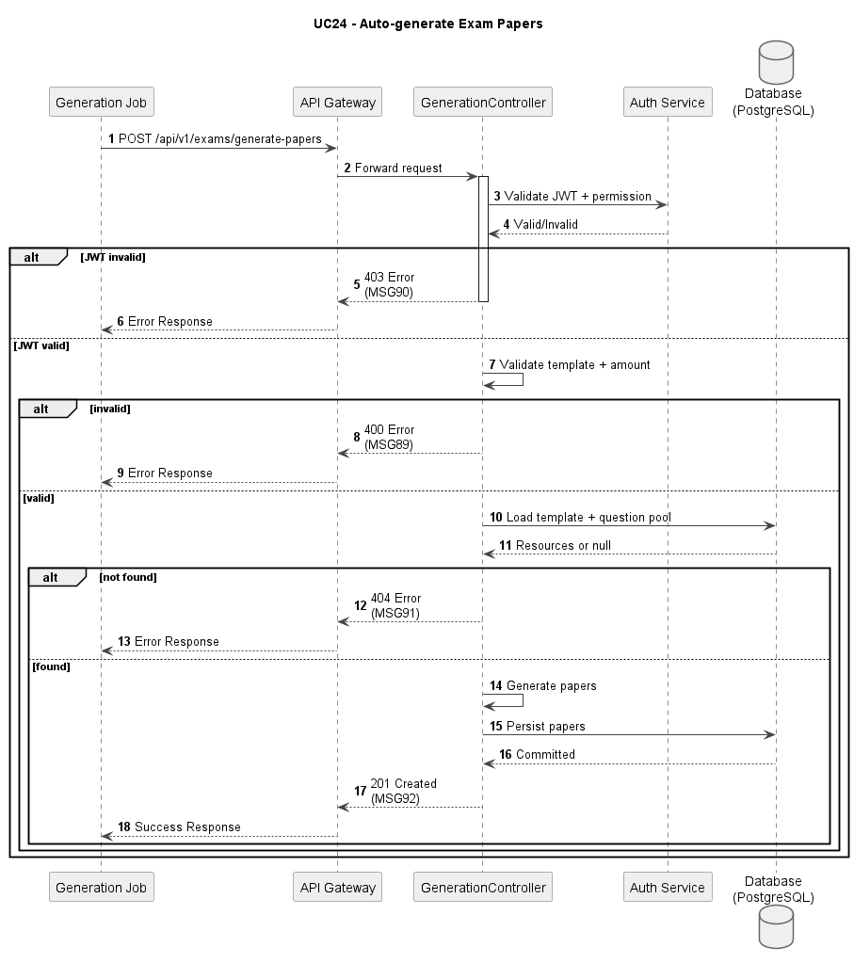

Figure UC24-S: Sequence Diagram – Auto-generate Exam Papers
Business Rules
Activity | BR Code | Description
(1) | BR01 | JWT and RBAC Validation:  Condition: Generation request is received.  Action: Validate JWT and [Generate_ExamPapers] permission.  Result: If invalid, display MSG90; HTTP 403.
(2) | BR02 | Generation Validation:  Condition: Authorization passes.  Action: Validate template id, amount, quota balance, and exclusion options. Result: If invalid, display MSG89; HTTP 400.
(3) | BR03 | Resource Existence Check:  Condition: Input valid.  Action: Load template, question pool, and exclusion set.  Result: If not found, display MSG91; HTTP 404.
(4) | BR04 | Generation Transaction:  Condition: Resources loaded.  Action: Build randomized papers satisfying all constraints and persist output.  Result: Papers generated successfully.
(5) | BR05 | Success Response:  Condition: Persistence committed.  Action: Return generation summary payload.  Result: Display MSG92; HTTP 201.

UC25: View Student List
Name | View Student List
Description | This use case describes the process of an instructor or admin viewing the list of students in the system.
Actor | Instructor, Admin
Trigger | When actor opens student roster module.
Pre-condition | Actor is logged in and has roster-view scope.
Post-condition | Student list is displayed with summary indicators and navigation to detail.

Activities Flow
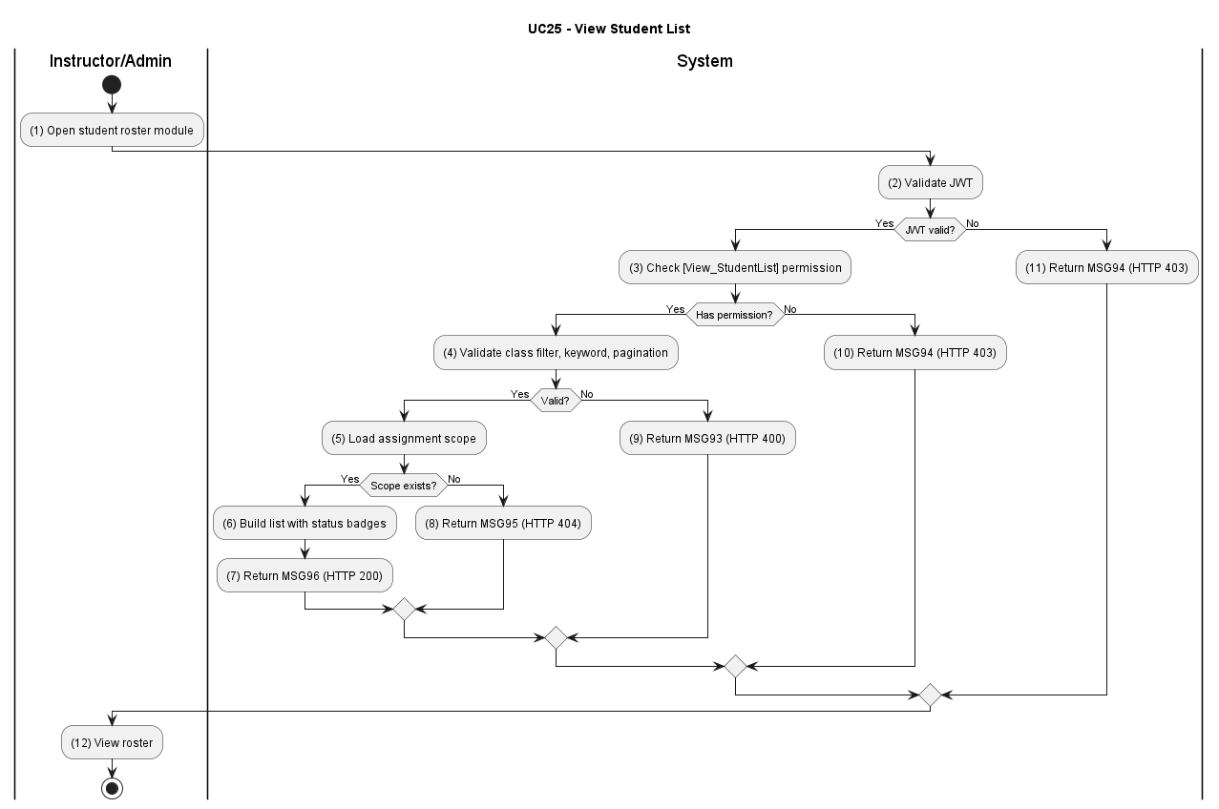

Figure UC25-A: Activity Diagram –View Student List

Sequence Diagram
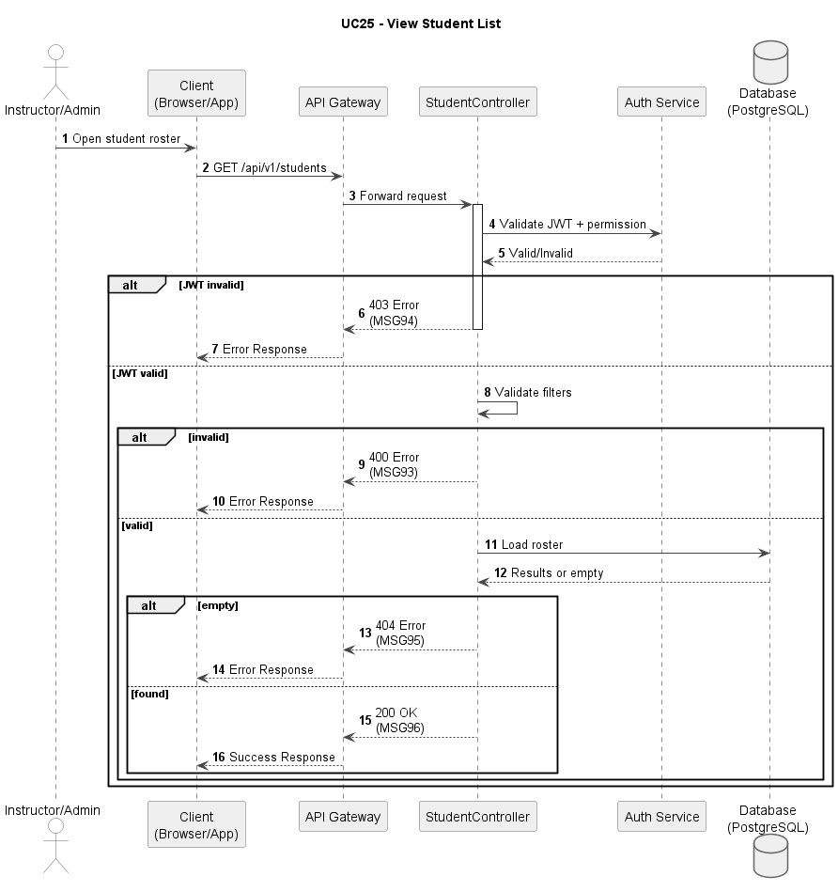

Figure UC25-S: Sequence Diagram – View Student List
Business Rules
Activity | BR Code | Description
(1) | BR01 | JWT and RBAC Validation:  Condition: Student list request submitted.  Action: Validate JWT and [View_StudentList] permission.  Result: If invalid, display MSG94; HTTP 403.
(2) | BR02 | Query Validation:  Condition: Authorization passes.  Action: Validate class filter, keyword, and pagination fields.  Result: If invalid, display MSG93; HTTP 400.
(3) | BR03 | Scope Existence Check:  Condition: Query valid.  Action: Load assignment scope and roster resource.  Result: If missing, display MSG95; HTTP 404.
(4) | BR04 | Roster Projection:  Condition: Scope exists.  Action: Build list with status badges and ordering.  Result: List payload prepared.
(5) | BR05 | Success Response:  Condition: Projection ready.  Action: Return roster response.  Result: Display MSG96; HTTP 200.

UC26: Track Learning Progress
Name | Track Learning Progress
Description | This use case describes the process of an instructor or admin tracking the learning progress and exam results of students.
Actor | Instructor, Admin
Trigger | When actor opens progress dashboard for one or more students.
Pre-condition | Actor is logged in with learning-progress access rights.
Post-condition | Progress indicators are displayed to support instructional interventions.

Activities Flow
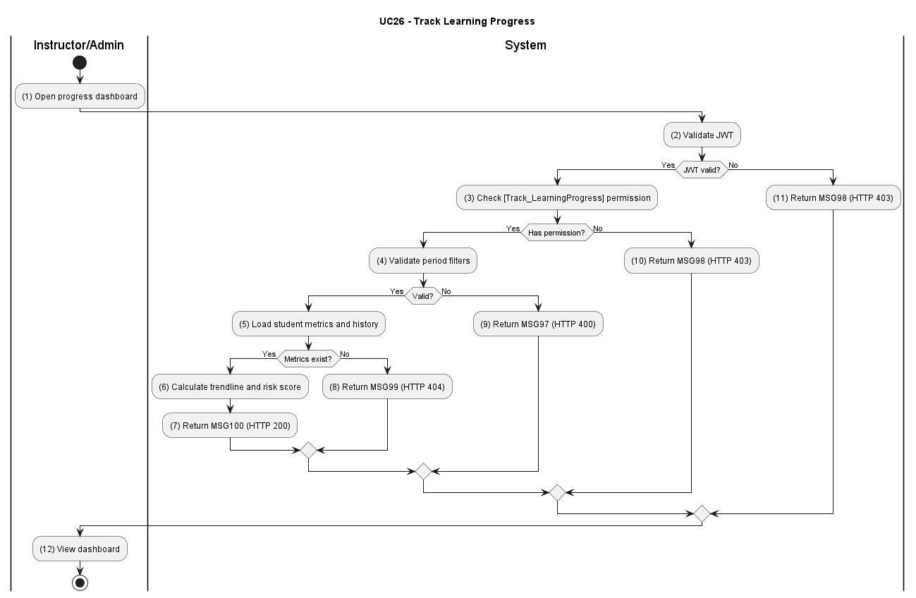

Figure UC26-A: Activity Diagram – Track Learning Progress

Sequence Diagram
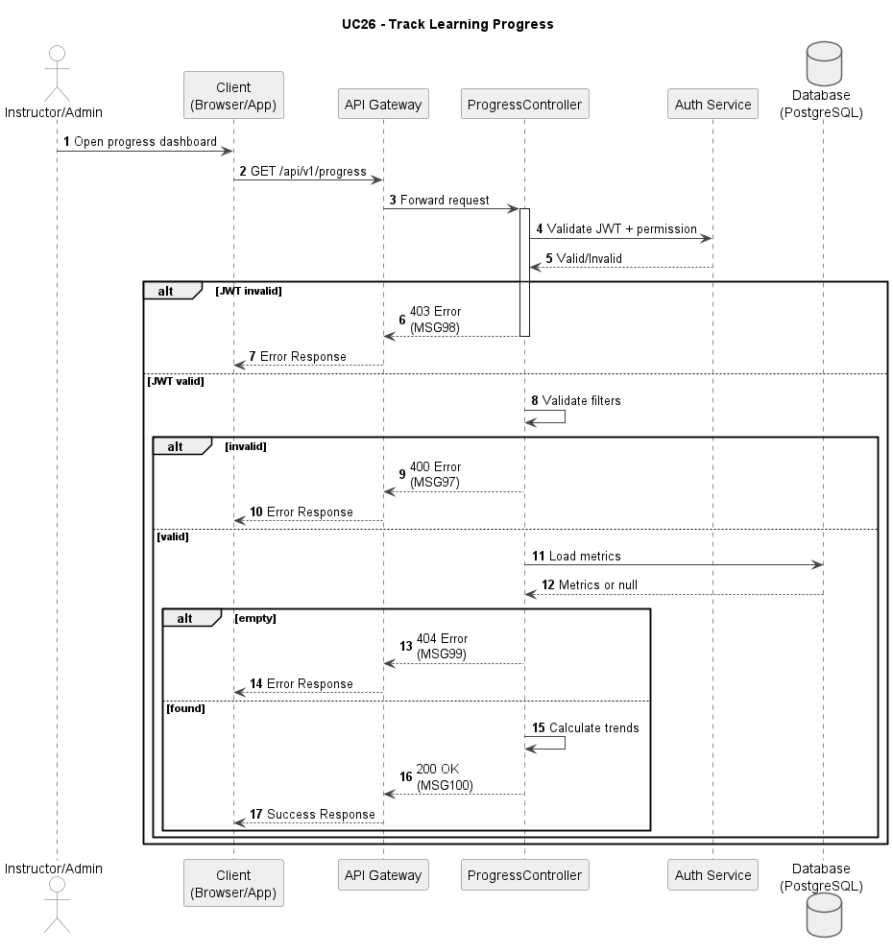

Figure UC26-S: Sequence Diagram – Track Learning Progress
Business Rules
Activity | BR Code | Description
(1) | BR01 | JWT and RBAC Validation: Condition: Progress request submitted. Action: Validate JWT and [Track_LearningProgress] permission. Result: If invalid, display MSG98; HTTP 403.
(2) | BR02 | Scope Validation: Condition: Authorization passes. Action: Validate period filters and target scope. Result: If invalid/conflict, display MSG97; HTTP 400.
(3) | BR03 | Metric Source Check: Condition: Input valid. Action: Load student metrics and recent attempt history. Result: If missing, display MSG99; HTTP 404.
(4) | BR04 | Trend Computation: Condition: Metrics available. Action: Calculate trendline, completion ratio, and risk score. Result: Progress dashboard dataset prepared.
(5) | BR05 | Success Response: Condition: Computation completed. Action: Return dashboard payload. Result: Display MSG100; HTTP 200.

UC27: View Exam History
Name | View Exam History
Description | This use case describes the process of an instructor or admin reviewing a student's exam history, including information such as exam time, exam type, score, and pass/fail result.
Actor | Instructor, Admin
Trigger | When actor opens exam history page for a student.
Pre-condition | Actor is logged in and student reference is valid.
Post-condition | Exam timeline is displayed and can be used for deeper review.

Activities Flow
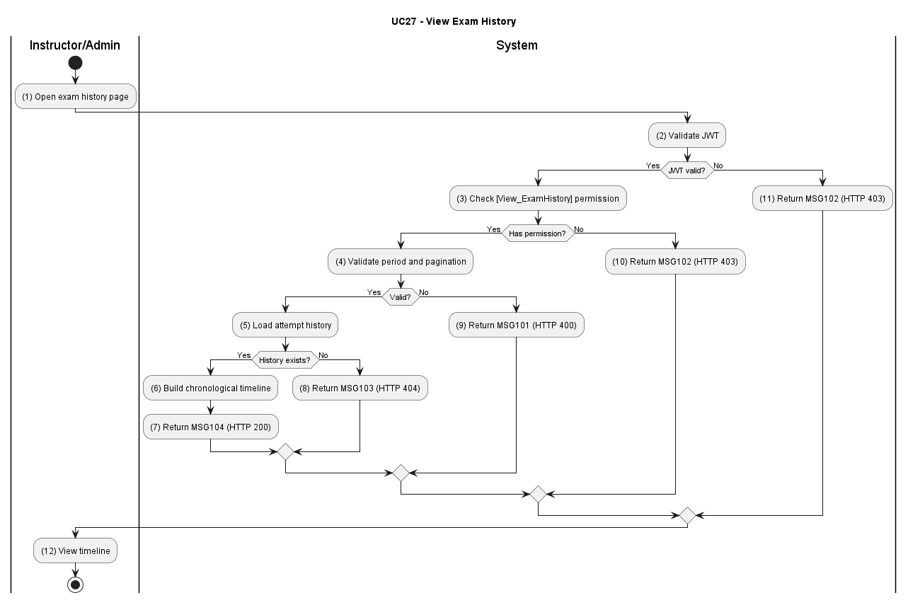

Figure UC27-A: Activity Diagram –View Exam History

Sequence Diagram
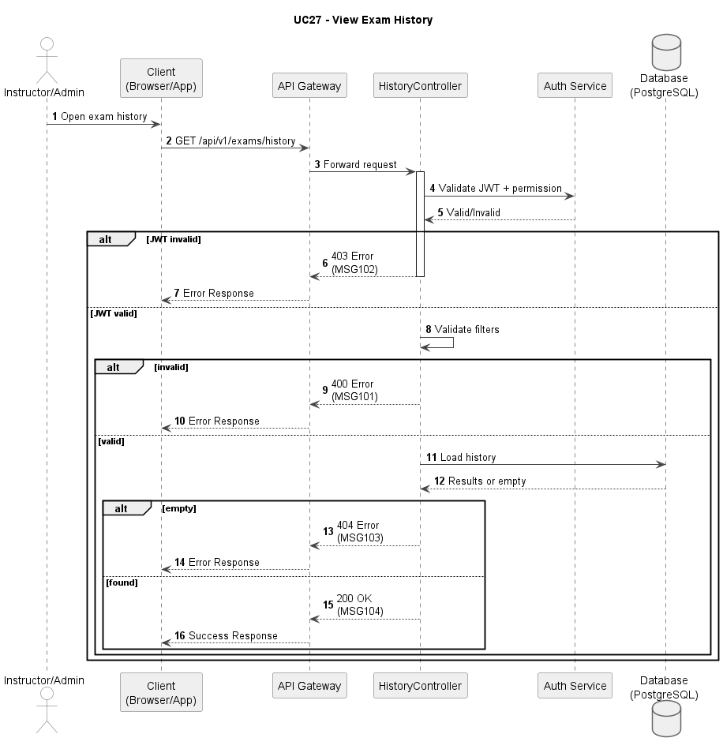

Figure UC27-S: Sequence Diagram – View Exam History
Business Rules
Activity | BR Code | Description
(1) | BR01 | JWT and RBAC Validation:  Condition: Exam-history request submitted.  Action: Validate JWT and [View_ExamHistory] permission.  Result: If invalid, display MSG102; HTTP 403.
(2) | BR02 | Query Validation:  Condition: Authorization passes.  Action: Validate period, exam-type, and pagination filters.  Result: If invalid, display MSG101; HTTP 400.
(3) | BR03 | History Existence Check:  Condition: Query valid.  Action: Load attempt history source for student.  Result: If not found, display MSG103; HTTP 404.
(4) | BR04 | Timeline Projection:  Condition: Source exists.  Action: Build chronological exam history with score/pass-fail fields.  Result: Timeline payload prepared.
(5) | BR05 | Success Response:  Condition: Projection complete.  Action: Return timeline to client.  Result: Display MSG104; HTTP 200.

UC28: Reset Learning Progress
Name | Reset Learning Progress
Description | This use case describes the process of a student resetting their learning progress when necessary.
Actor | Student
Trigger | When the student confirms [btnResetProgress].
Pre-condition | Student is logged in and reset policy conditions are met.
Post-condition | Progress markers are reset and learning flow restarts from baseline.

Activities Flow
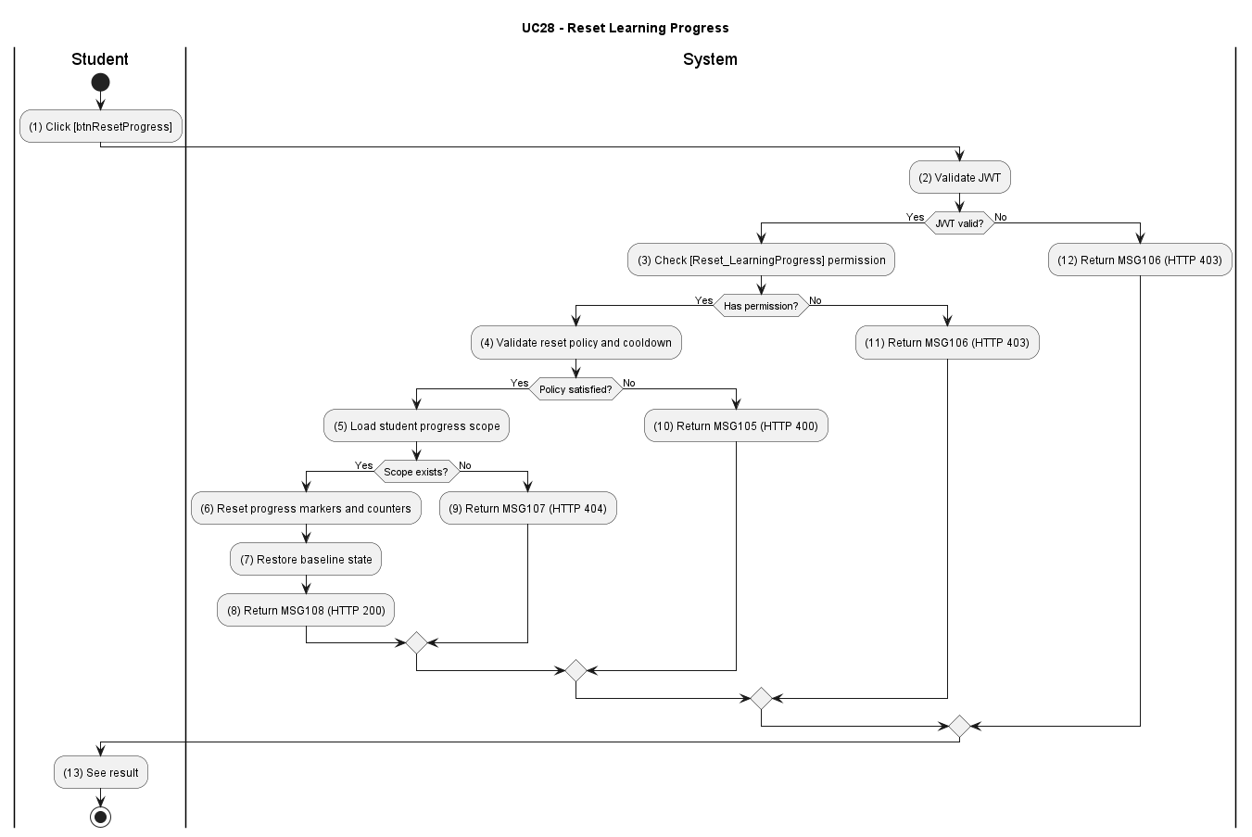

Figure UC28-A: Activity Diagram – Reset Learning Progress

Sequence Diagram
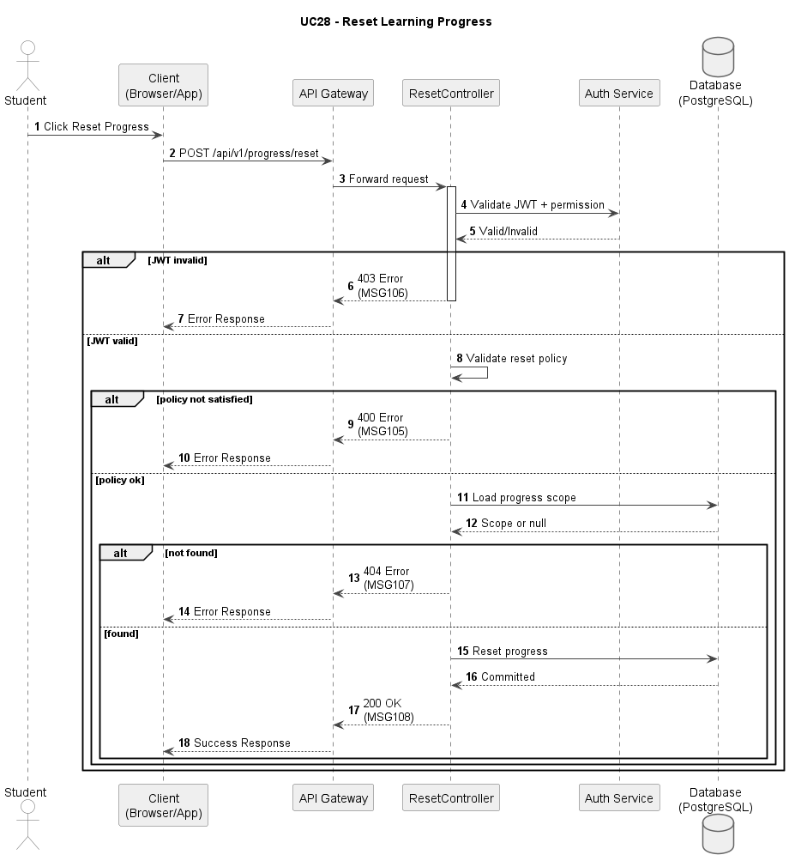

Figure UC28-S: Sequence Diagram – Reset Learning Progress
Business Rules
Activity | BR Code | Description
(1) | BR01 | JWT and RBAC Validation:  Condition: Reset request submitted.  Action: Validate JWT and [Reset_LearningProgress] permission.  Result: If invalid, display MSG106; HTTP 403.
(2) | BR02 | Reset Policy Validation:  Condition: Authorization passes.  Action: Validate cooldown, frequency, and allowed scope.  Result: If invalid/conflict, display MSG105; HTTP 400.
(3) | BR03 | Resource Existence Check:  Condition: Policy valid.  Action: Load student progress scope to reset.  Result: If not found, display MSG107; HTTP 404.
(4) | BR04 | Reset Transaction:  Condition: Resource exists.  Action: Reset progress markers, review queues, and dependent counters by policy.  Result: Baseline state restored.
(5) | BR05 | Success Response:  Condition: Reset committed.  Action: Return reset confirmation payload.  Result: Display MSG108; HTTP 200.

UC29: Send Academic Warnings
Name | Send Academic Warnings
Description | This use case describes the process of an instructor or admin sending warnings to students when the system detects slow learning progress, low exam scores, or incomplete learning requirements.
Actor | Instructor, Admin
Trigger | When actor submits warning form for selected students.
Pre-condition | Actor is logged in with warning-dispatch permission.
Post-condition | Warning records are created and notifications are dispatched.

Activities Flow
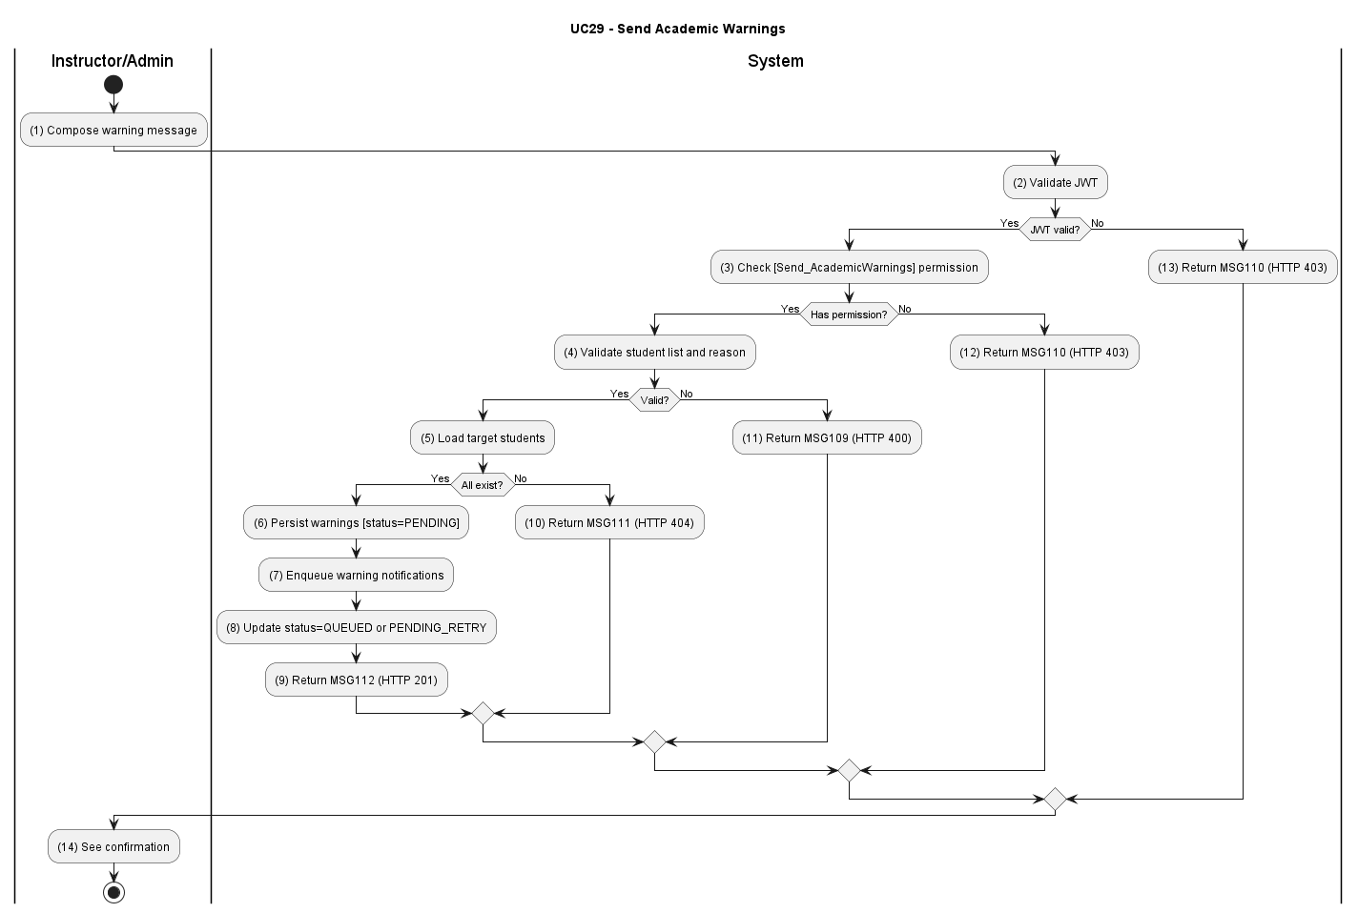

Figure UC29-A: Activity Diagram –Send Academic Warnings

Sequence Diagram
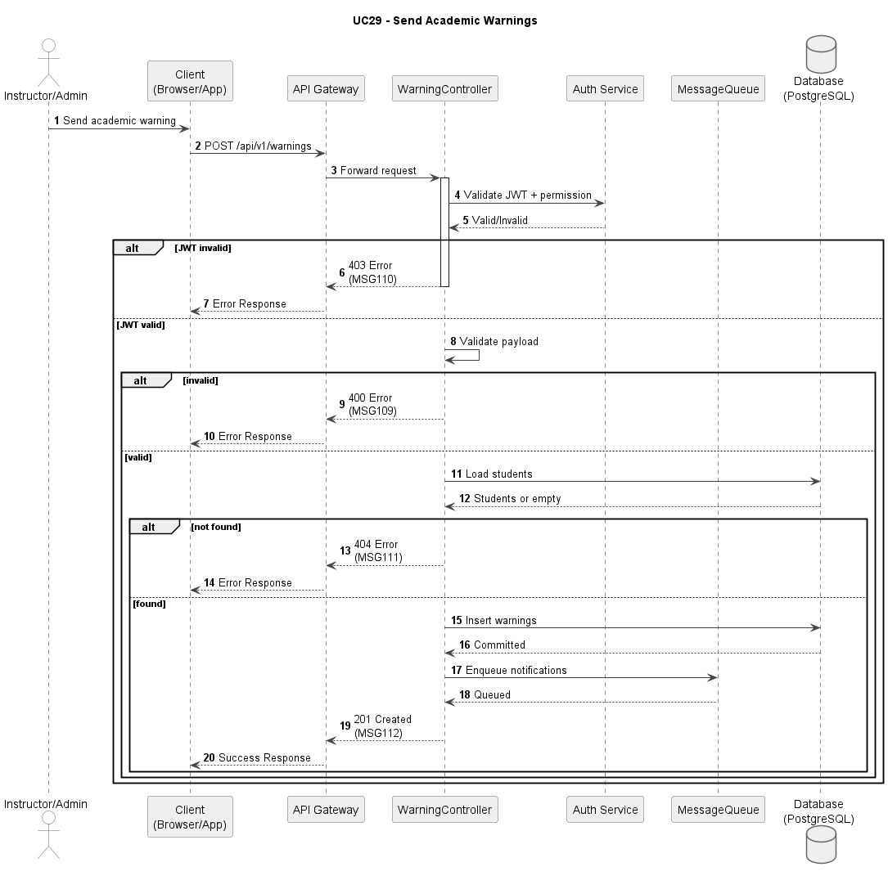

Figure UC29-S: Sequence Diagram – Send Academic Warnings
Business Rules
Activity | BR Code | Description
(1) | BR01 | JWT and RBAC Validation:  Condition: Warning request submitted.  Action: Validate JWT and [Send_AcademicWarnings] permission.  Result: If invalid, display MSG110; HTTP 403.
(2) | BR02 | Warning Payload Validation:  Condition: Authorization passes.  Action: Validate recipients, reason codes, and delivery channel settings. Result: If invalid/conflict, display MSG109; HTTP 400.
(3) | BR03 | Target Existence Check:  Condition: Payload valid.  Action: Load target students and warning context.  Result: If not found, display MSG111; HTTP 404.
(4) | BR04 | Dispatch Transaction:  Condition: Warning targets exist and payload is valid.  Action: (a) Persist all warning records to the database with status = [PENDING] in a single transaction. (b) Attempt to enqueue notification jobs to the message queue (RabbitMQ / Kafka) for async Push Notification / Email delivery. (c) If enqueue succeeds: update warning record status to [QUEUED]. (d) If enqueue fails (queue unavailable, network error): retain warning records with status = [PENDING_RETRY]; a background retry scheduler re-attempts enqueue within the configured retry window (default: 3 attempts, 5-minute intervals). The instructor UI is never blocked by queue availability.  Result: Warning records are always persisted regardless of queue state. Notification delivery is eventually consistent.
(5) | BR05 | Success Response:  Condition: Dispatch persisted.  Action: Return delivery summary payload.  Result: Display MSG112; HTTP 200.

UC30: View Maneuver Checkpoint Details
Name | View Maneuver Checkpoint Details
Description | Allows a Student to navigate driving maneuvers via a hybrid Map/List view and drill down into step-by-step instructions and penalty criteria for a selected checkpoint.
Actor | Student
Trigger | Student clicks the "Sa Hình Chi Tiết" button on the Training dashboard.
Pre-condition | Student is authenticated. The system has identified the specific license class.
Post-condition | Detailed maneuver screen is rendered with color-coded steps and error classifications.

Activities Flow
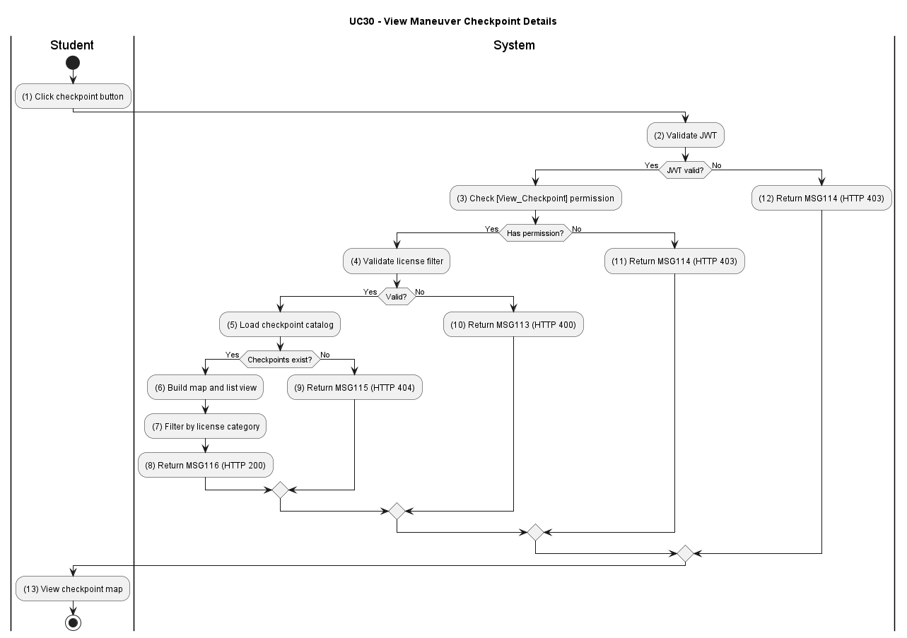

Figure UC30-A: Activity Diagram – View Maneuver Checkpoint Details
Sequence Diagram
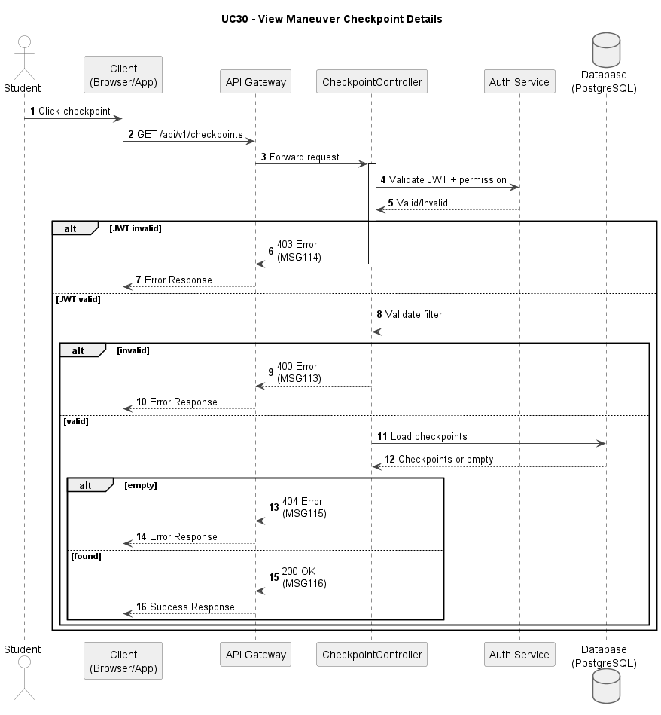

Figure UC30-S: Sequence Diagram – View Maneuver Checkpoint Details

Business Rules

Activity | BR Code | Description
(1) | BR01 | JWT and RBAC Validation:  Condition: Checkpoint view request submitted.  Action: Validate JWT and query for active checkpoints.  Result: If unauthorized, display MSG134; HTTP 401.
(2) | BR02 | License Class Context:  Condition: Request is authorized.  Action: Filter checkpoints by user's identified license category.  Result: If no checkpoints exist for that class, display MSG135; HTTP 404.
(3) | BR03 | Checkpoint List and Map Rendering:  Condition: Filtered checkpoint data available.  Action: Build dual presentation (map pins + scrollable list) from checkpoint coordinates and names.  Result: Hybrid UI rendered with navigation capability.
(4) | BR04 | Checkpoint Selection Query:  Condition: Student selects checkpoint (pin or list item).  Action: Load detailed instructions and penalty rules for selected checkpointId.  Result: Checkpoint detail payload prepared.
(5) | BR05 | Categorized Penalty Display:  Condition: Detail payload ready.  Action: Categorize and render penalties (Green=Correct, Yellow=Deduction, Red=Fatal) with visual distinction.  Result: Display MSG136; HTTP 200.

UC31: View General Maneuver Errors
Name | View General Maneuver Errors
Description | Provides a comprehensive list of universal driving errors applying to the entire exam, categorized by penalty severity.
Actor | Student
Trigger | Student clicks "Các Lỗi Sa Hình Chung" on the Training dashboard.
Pre-condition | System is operational. The student is on the main Training screen.
Post-condition | System is operational. The student is on the main Training screen.

Activities flow
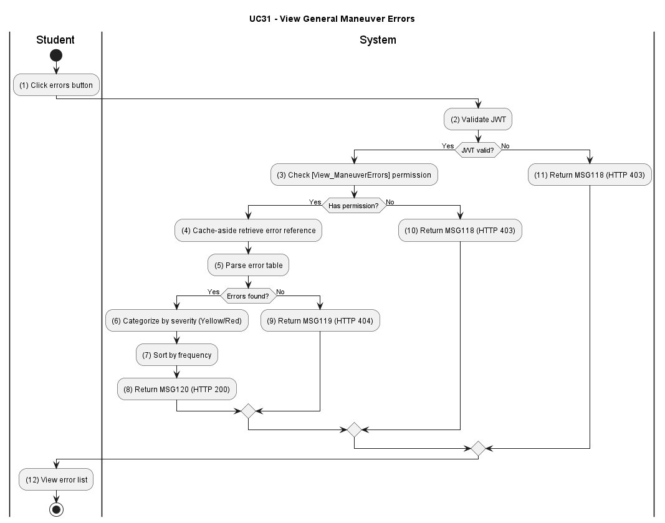

Figure UC31-A: Activity Diagram – View General Maneuver Errors
Sequence Diagram
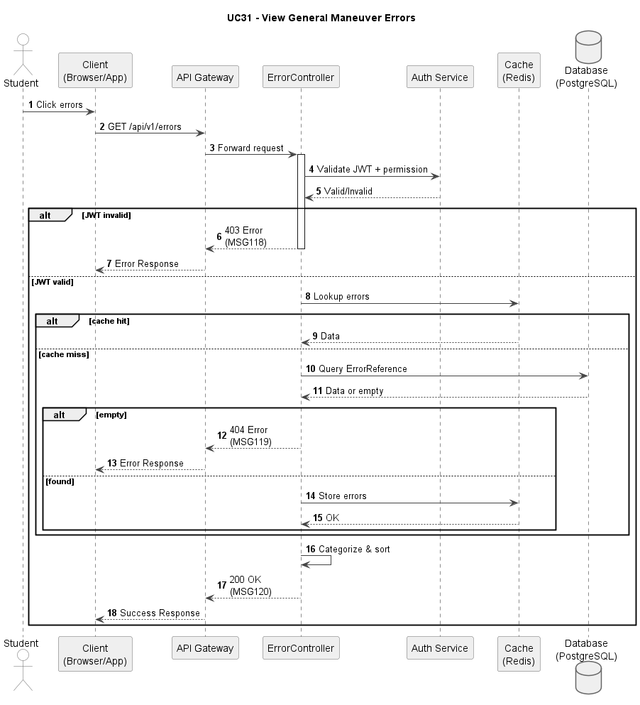

Figure UC31-S: Sequence Diagram – View General Maneuver Errors

Business Rules

Activity | BR Code | Description
(1) | BR01 | JWT and RBAC Validation:  Condition: General maneuver error list request submitted.  Action: Validate JWT and [View_ManeuverErrors] permission.  Result: If unauthorized, display MSG137; HTTP 401.
(2) | BR02 | Error Reference Query:  Condition: Authorization passes.  Action: Query ErrorReference table for active universal driving errors (isGeneral=true, status=ACTIVE).  Result: If no errors found, display MSG138; HTTP 404.
(3) | BR03 | Cache-Aside Retrieval:  Condition: Query executed.  Action: Check Redis cache for error list; if cache miss, fetch from database and populate cache.  Result: Error dataset retrieved with performance optimization.
(4) | BR04 | Error Categorization and Sorting:  Condition: Error dataset available.  Action: Separate into Yellow (Deduction: pointsDeducted > 0, isFatal=false) and Red (Fatal: isFatal=true) categories; sort alphabetically within each.  Result: Categorized error list prepared.
(5) | BR05 | Success Response:  Condition: Categorization complete.  Action: Return error list with visual styling metadata (colors and icons).  Result: Display MSG139; HTTP 200.

UC32: Review Frequently Missed Questions
Name | Review Frequently Missed Questions
Description | This use case describes the process of a student taking review tests generated by the system based on questions or question types they frequently answered incorrectly in previous exams.
Actor | Student
Trigger | When student requests missed-question review session.
Pre-condition | Student is logged in and has exam history with wrong-answer records.
Post-condition | Personalized review set is generated and returned for study.

Activities Flow
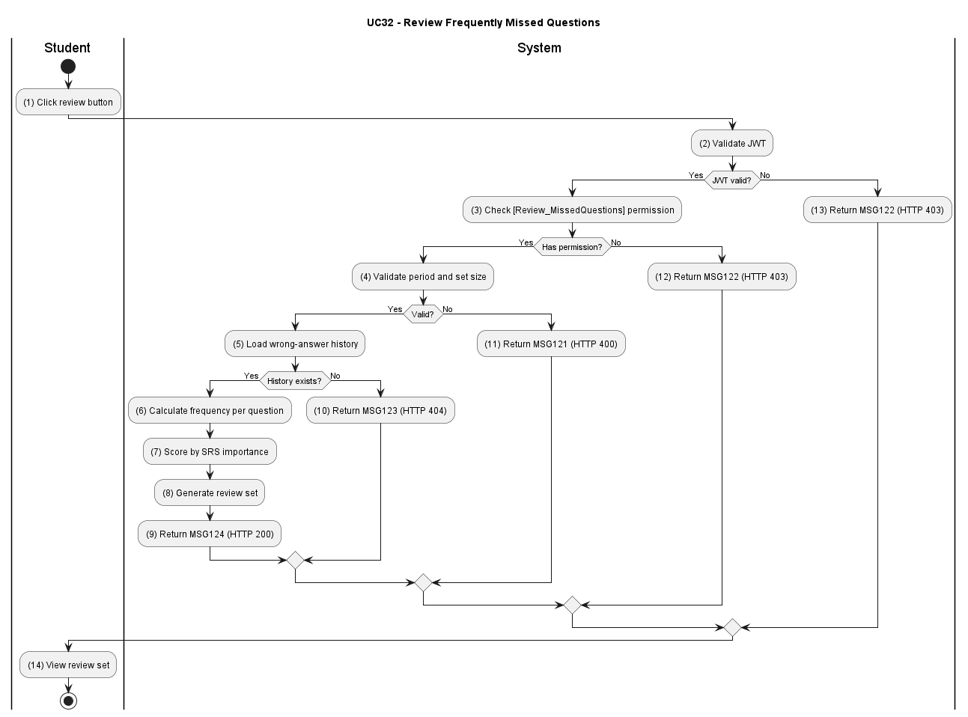

Figure UC32-A: Activity Diagram –Review Frequently Missed Questions

Sequence Diagram
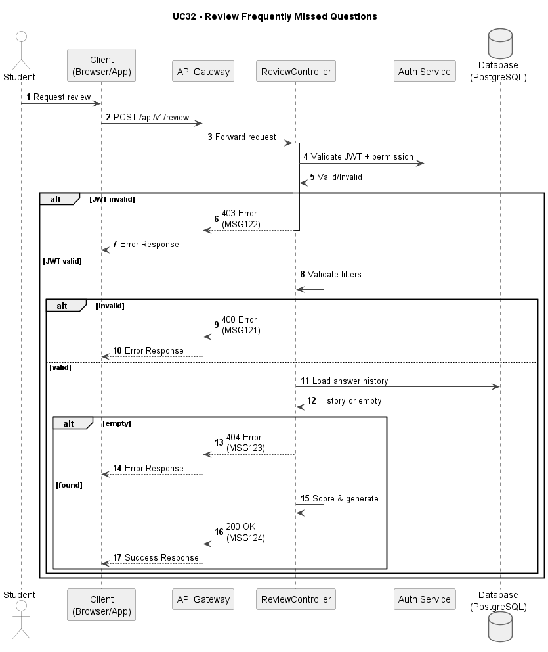

Figure UC32-S: Sequence Diagram – Review Frequently Missed Questions
Business Rules
Activity | BR Code | Description
(1) | BR01 | JWT and RBAC Validation:  Condition: Review-set request submitted.  Action: Validate JWT and [Review_MissedQuestions] permission.  Result: If invalid, display MSG122; HTTP 403.
(2) | BR02 | Request Validation:  Condition: Authorization passes.  Action: Validate review period, size, and mode options.  Result: If invalid/conflict, display MSG121; HTTP 400.
(3) | BR03 | Data Existence Check:  Condition: Input valid.  Action: Load wrong-answer history and SRS prioritization source.  Result: If not found, display MSG123; HTTP 404.
(4) | BR04 | Review-Set Generation:  Condition: Data available.  Action: Build prioritized question set based on frequency and SRS score. Result: Review set prepared.
(5) | BR05 | Success Response:  Condition: Set generation complete.  Action: Return personalized review payload.  Result: Display MSG124; HTTP 200.

UC33: Logout
Name | Logout
Description | This use case describes the process of a user terminating their authenticated session, invalidating the server-side JWT, and clearing all client-side session state.
Actor | All users (Student, Instructor, Center Manager, Admin)
Trigger | When the user clicks the [btnLogout] button or when a session-management event triggers a forced logout.
Pre-condition | The user is authenticated and holds a valid JWT.
Post-condition | The JWT is blacklisted server-side. The client-side token is cleared. Any subsequent API call using the invalidated token returns 401 Unauthorized.

Activities Flow
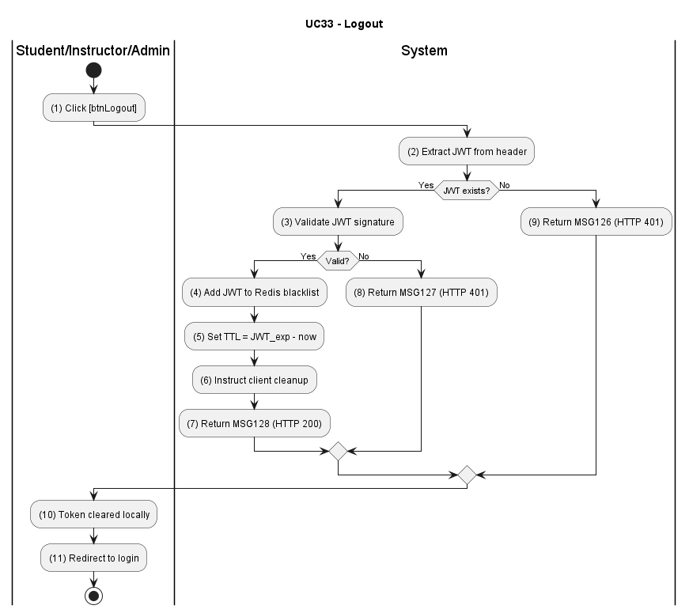

Figure UC33-A: Activity Diagram – Logout

Sequence Diagram
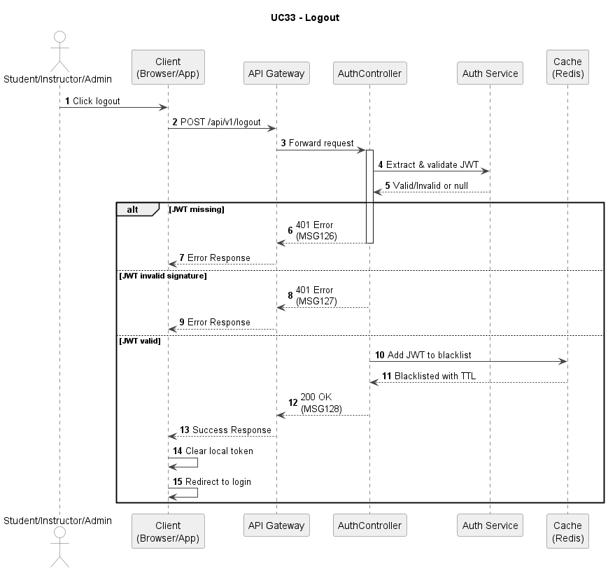

Figure UC33-S: Sequence Diagram – Logout
Business Rules
Activity | BR Code | Description
(1) | BR01 | JWT Validation: Condition: Logout request is submitted. Action: Extract and validate JWT from the Authorization header or cookie. Result: If JWT is missing or malformed, display MSG129; HTTP 401.
(2) | BR02 | Token Blacklisting: Condition: JWT is valid. Action: Add the current JWT to the Redis token blacklist with TTL equal to the token's remaining lifespan (TTL = exp − now). Operation must be atomic. Result: Token is immediately invalid for all subsequent requests across all service instances.
(3) | BR03 | Client-Side Cleanup Instruction: Condition: Token has been blacklisted. Action: Return a response instructing the client to delete the token from LocalStorage / Cookie / in-memory store. Result: Client-side session state is cleared; no stale token remains on the device.
(4) | BR04 | Post-Logout Verification: Condition: Client attempts any API call with the invalidated token. Action: API Gateway checks token against Redis blacklist on every request (O(1) lookup). Result: Old token is rejected; HTTP 401 Unauthorized is returned for every call using the blacklisted token.
(5) | BR05 | Success Response: Condition: Token has been blacklisted and client cleanup instruction has been issued. Action: Return logout confirmation payload. Result: Display MSG130; HTTP 200.
UC34: View my learning progress
Name | Logout
Description | This use case describes the process of a student viewing their own learning progress, including theory completion percentage, practice exam pass rate over time, and weak topic analysis. Data is served from a pre-aggregated cache to ensure fast response.
Actor | Student
Trigger | When the student navigates to the Learning Progress screen on the mobile app.
Pre-condition | The student is authenticated and has at least one recorded learning activity (exam attempt or topic studied).
Post-condition | The student receives their personalised progress dashboard data including completion statistics, pass-rate trend, and weak topic indicators.

Activities Flow
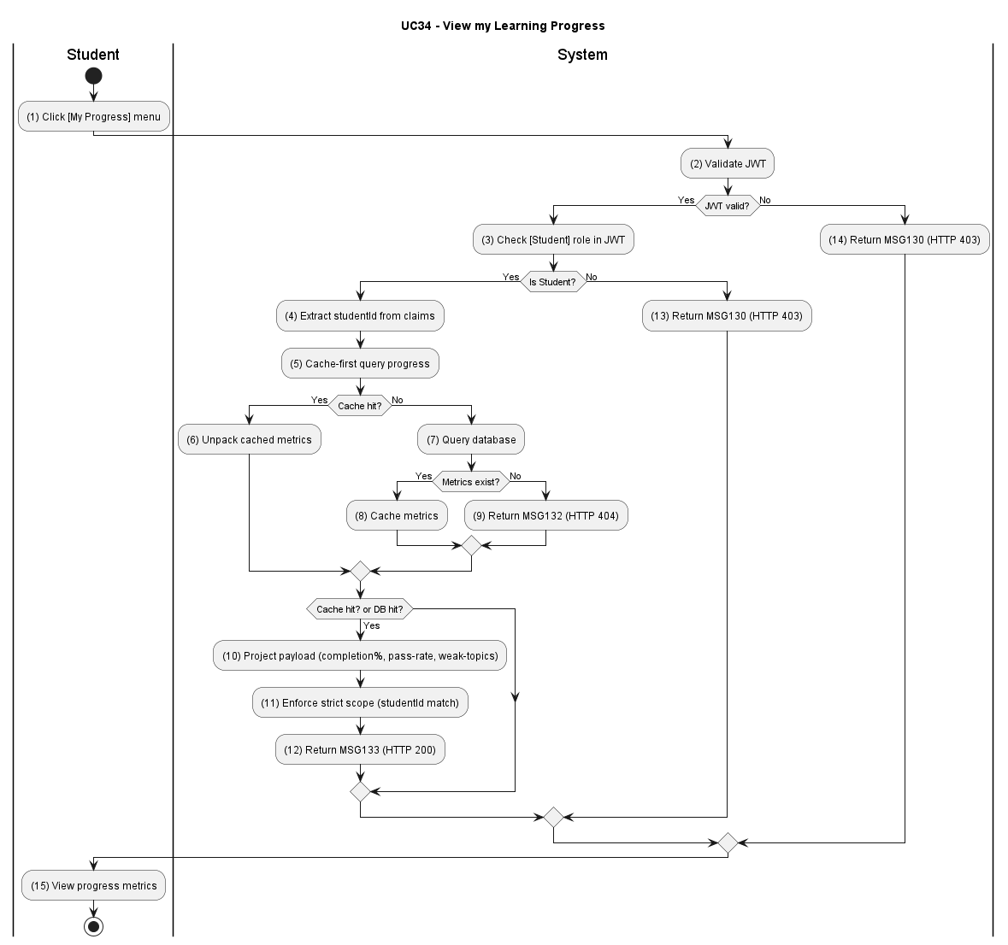

Figure UC34-A: Activity Diagram – View my learning progress
Sequence Diagram
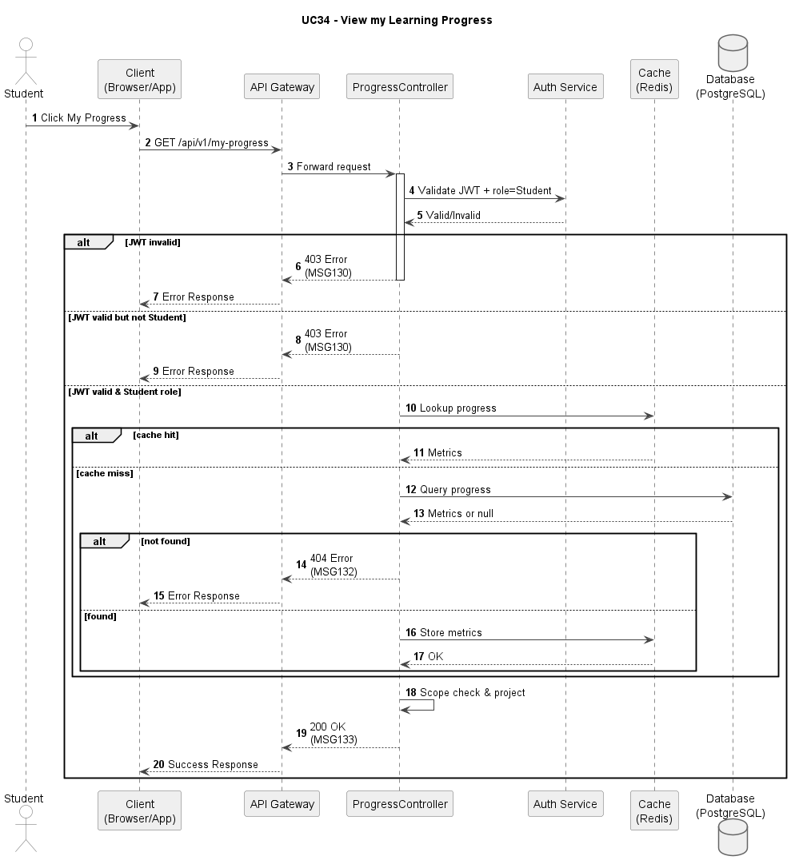

Figure UC34-S: Sequence Diagram – View my learning progress

Business Rules
Activity | BR Code | Description
(1) | BR01 | JWT and RBAC Validation: Condition: Progress view request is submitted. Action: Validate JWT and [View_MyProgress] permission. Confirm actor role is Student. Result: If unauthorized or role mismatch, display MSG131; HTTP 403.
(2) | BR02 | Strict Scope Enforcement: Condition: Authorization passes. Action: Extract [studentId] exclusively from the authenticated JWT claims — never from the request URL or body. Reject any request where the requested scope does not match the authenticated identity. Result: If scope mismatch is detected, display MSG132; HTTP 403. Cross-student data access is impossible by design.
(3) | BR03 | Cache-First Data Resolution: Condition: Scope is validated. Action: Attempt to resolve progress data from Redis cache using key [progress:{studentId}:{licenseTierId}]. On cache miss, fall back to the periodically updated Aggregation table. Do not run real-time aggregation queries on the raw log table. Result: If no data exists (new account with no activity), return an empty progress payload; HTTP 200.
(4) | BR04 | Progress Payload Projection: Condition: Data source is resolved. Action: Build response payload containing: (a) overall completion percentage [completionPct], (b) number of questions studied [studiedCount], (c) total exam attempts [attemptCount], (d) pass rate [passRate], (e) pass-rate trend for last 30 days, (f) top 5 weak topics ranked by incorrect-answer frequency. Result: Payload assembled; response time < 200 ms. (Ref: ASR-PERF-04)
(5) | BR05 | Success Response: Condition: Payload is ready. Action: Return progress dashboard payload to client. Result: Display MSG133; HTTP 200.

MSG Code | UC | Message | HTTP Status
MSG01 | UC01 | Please enter email and password. | 400
MSG02 | UC01 | Your account is locked. Please contact support. | 401
MSG03 | UC01 | Invalid email or password. | 401
MSG04 | UC02 | Please enter a valid email address. | 400
MSG05 | UC02 | No account found for this email. | 404
MSG06 | UC02 | Reset link is invalid or expired. | 400
MSG07 | UC02 | Password does not meet complexity requirements. | 422
MSG08 | UC03 | Please complete all required fields. | 400
MSG09 | UC03 | You do not have permission to create this account. | 403
MSG10 | UC03 | Email already exists. | 409
MSG11 | UC03 | Student account created successfully. | 201
MSG12 | UC04 | Student account not found. | 404
MSG14 | UC04 | Invalid student account data. | 400
MSG15 | UC06 | Invalid license category. | 400
MSG16 | UC04 | Student account updated successfully. | 200
MSG17 | UC06 | License category assigned successfully. | 200
MSG18 | UC04 | You do not have permission to update student accounts. | 403
MSG19 | UC06 | You do not have permission to assign license categories. | 403
MSG20 | UC05 | You do not have permission to lock student accounts. | 403
MSG21 | UC07 | Your session has expired. Please log in again. | 401
MSG23 | UC07 | Course not found. | 404
MSG24 | UC05 | Invalid student account status for locking. | 400
MSG25 | UC07 | No courses match your criteria. | 200
MSG128 | UC05 | Student account locked successfully. | 200
MSG26 | UC08 | Please complete all required course fields. | 400
MSG27 | UC08 | You do not have permission to create courses. | 403
MSG28 | UC08 | Course code already exists. | 409
MSG29 | UC08 | Invalid course data. | 400
MSG30 | UC08 | Course created successfully. | 201
MSG31 | UC09 | You do not have permission to update courses. | 403
MSG32 | UC09 | Course was modified by another user. Please reload and try again. | 409
MSG33 | UC09 | Course updated successfully. | 200
MSG34 | UC10 | You do not have permission to delete courses. | 403
MSG35 | UC10 | Course cannot be deleted because it is currently in use. | 409
MSG36 | UC10 | Course deleted successfully. | 200
MSG37 | UC11 | Invalid exam start request. | 400
MSG38 | UC11 | You are not authorized to start an exam. | 403
MSG39 | UC11 | Exam resource not found. | 404
MSG40 | UC11 | Exam attempt created successfully. | 201
MSG41 | UC12 | Invalid exam session request. | 400
MSG42 | UC12 | You are not authorized to manage exam session. | 403
MSG43 | UC12 | Exam session resource not found. | 404
MSG44 | UC12 | Exam session updated successfully. | 200
MSG45 | UC13 | You are not authorized to submit exam. | 403
MSG46 | UC13 | Invalid exam submission request. | 400
MSG47 | UC13 | Exam attempt not found. | 404
MSG48 | UC13 | Exam submitted successfully. | 200
MSG49 | UC14 | You are not authorized to grade exam. | 403
MSG50 | UC14 | Invalid grading request. | 400
MSG51 | UC14 | Grading resource not found. | 404
MSG52 | UC14 | Exam graded successfully. | 200
MSG53 | UC15 | Invalid exam result query. | 400
MSG54 | UC15 | You are not authorized to view exam results. | 403
MSG55 | UC15 | Exam result not found. | 404
MSG56 | UC15 | Exam result loaded successfully. | 200
MSG57 | UC16 | Invalid exam review query. | 400
MSG58 | UC16 | You are not authorized to review exams. | 403
MSG59 | UC16 | Exam review resource not found. | 404
MSG60 | UC16 | Exam review data loaded successfully. | 200
MSG61 | UC17 | Invalid question search request. | 400
MSG62 | UC17 | You are not authorized to search question bank. | 403
MSG63 | UC17 | Question resource not found. | 404
MSG64 | UC17 | Question search completed successfully. | 200
MSG65 | UC18 | Invalid create-question request. | 400
MSG66 | UC18 | You are not authorized to create question. | 403
MSG67 | UC18 | Question context not found. | 404
MSG68 | UC18 | Question created successfully. | 201
MSG69 | UC19 | Invalid update-question request. | 400
MSG70 | UC19 | Version field is missing. | 400
MSG71 | UC19 | This question was modified by another user. Please reload and try again. | 409
MSG72 | UC19 | You are not authorized to update question. | 403
MSG73 | UC19 | Question not found. | 404
MSG74 | UC19 | Question updated successfully. | 200
MSG75 | UC20 | Invalid delete-question request. | 400
MSG76 | UC20 | You are not authorized to delete question. | 403
MSG77 | UC20 | Question deleted successfully. | 200
MSG78 | UC21 | Invalid create-template request. | 400
MSG79 | UC21 | You are not authorized to manage exam templates. | 403
MSG80 | UC21 | Exam template context not found. | 404
MSG81 | UC21 | Exam template created successfully. | 201
MSG82 | UC22 | Invalid update-template request. | 400
MSG83 | UC22 | This exam template was modified by another user. Please reload and try again. | 409
MSG84 | UC22 | Exam template not found. | 404
MSG85 | UC22 | Exam template updated successfully. | 200
MSG86 | UC23 | Invalid delete-template request. | 400
MSG87 | UC23 | Exam template deleted successfully. | 200
MSG88 | UC24 | Invalid exam-paper generation request. | 400
MSG89 | UC24 | You are not authorized to generate exam papers. | 403
MSG90 | UC24 | Generation resource not found. | 404
MSG91 | UC24 | Exam papers generated successfully. | 201
MSG92 | UC25 | Invalid student-list query. | 400
MSG93 | UC25 | You are not authorized to view student list. | 403
MSG94 | UC25 | Student list resource not found. | 404
MSG95 | UC25 | Student list loaded successfully. | 200
MSG96 | UC26 | Invalid learning-progress query. | 400
MSG97 | UC26 | You are not authorized to track learning progress. | 403
MSG98 | UC26 | Learning-progress resource not found. | 404
MSG99 | UC26 | Learning-progress data loaded successfully. | 200
MSG100 | UC27 | Invalid exam-history query. | 400
MSG101 | UC27 | You are not authorized to view exam history. | 403
MSG102 | UC27 | Exam-history resource not found. | 404
MSG103 | UC27 | Exam history loaded successfully. | 200
MSG104 | UC28 | Invalid reset-learning-progress request. | 400
MSG105 | UC28 | You are not authorized to reset learning progress. | 403
MSG106 | UC28 | Progress resource not found. | 404
MSG107 | UC28 | Learning progress reset successfully. | 200
MSG108 | UC29 | Invalid academic-warning request. | 400
MSG109 | UC29 | You are not authorized to send academic warnings. | 403
MSG110 | UC29 | Warning target not found. | 404
MSG111 | UC29 | Academic warnings sent successfully. | 200
MSG112 | UC30 | Invalid track-simulation request. | 400
MSG113 | UC30 | You are not authorized to run track simulation. | 403
MSG114 | UC30 | Simulation resource not found. | 404
MSG115 | UC30 | Track simulation completed successfully. | 200
MSG116 | UC32 | Invalid driving-scenario request. | 400
MSG117 | UC32 | You are not authorized to run driving scenarios. | 403
MSG118 | UC32 | Driving-scenario resource not found. | 404
MSG119 | UC32 | Driving scenario completed successfully. | 200
MSG120 | UC33 | Invalid missed-question review request. | 400
MSG121 | UC33 | You are not authorized to review missed questions. | 403
MSG122 | UC33 | Missed-question resource not found. | 404
MSG123 | UC33 | Missed-question review set generated successfully. | 201
MSG129 | UC33 | Authentication token is missing or invalid. | 401
MSG130 | UC33 | You have been logged out successfully. | 200
MSG131 | UC34 | You are not authorized to view this progress data. | 403
MSG132 | UC34 | Access denied: you may only view your own progress. | 403
MSG133 | UC34 | Learning progress loaded successfully. | 200
MSG134 | UC30 | You are not authorized to view checkpoint details. | 401
MSG135 | UC30 | No checkpoints exist for this license category. | 404
MSG136 | UC30 | Checkpoint details loaded successfully. | 200
MSG137 | UC31 | You are not authorized to view maneuver errors. | 401
MSG138 | UC31 | No maneuver errors found. | 404
MSG139 | UC31 | Maneuver errors loaded successfully. | 200

