Business Rules Platform
Design Overview & Points For Your Review
July 2026 · Draft for customer review
This document summarizes the platform design, records the decisions confirmed together, and lists the points where we would like your input. New in this version: the two delivery modes, a concrete legacy-code-to-rule-to-code example, and the full technology stack. Deeper technical detail lives in the repository (prd.md, architecture.md).

1. What This Platform Does
Today, the rules that decide whether and how a customer can enroll in a financial or insurance product live inside application source code. Understanding them requires a developer; changing them requires a development project.
This platform moves those rules out of code and into a governed Rule Repository, so that:
- adding a product or changing enrollment logic means editing data, not code;
- business users can read, review, version, and approve every rule;
- every change is auditable — who changed what, when, and why;
- the same platform can be rolled out to many systems and sites — it is a product, not a one-off.

2. How It Works — End To End
Phase 1 · Initial Load (one time per system). We connect to the system's source repository and database, automatically locate the enrollment logic, and convert it into draft rules. Nothing is applied automatically: your experts review and approve every rule, and each rule keeps a link back to the exact place in the legacy source it came from.
Phase 2 · Operation (ongoing). Business users add or edit rules in a governed workspace. Once approved, the change goes live through one of the two delivery modes below — with no re-extraction and no manual coding.
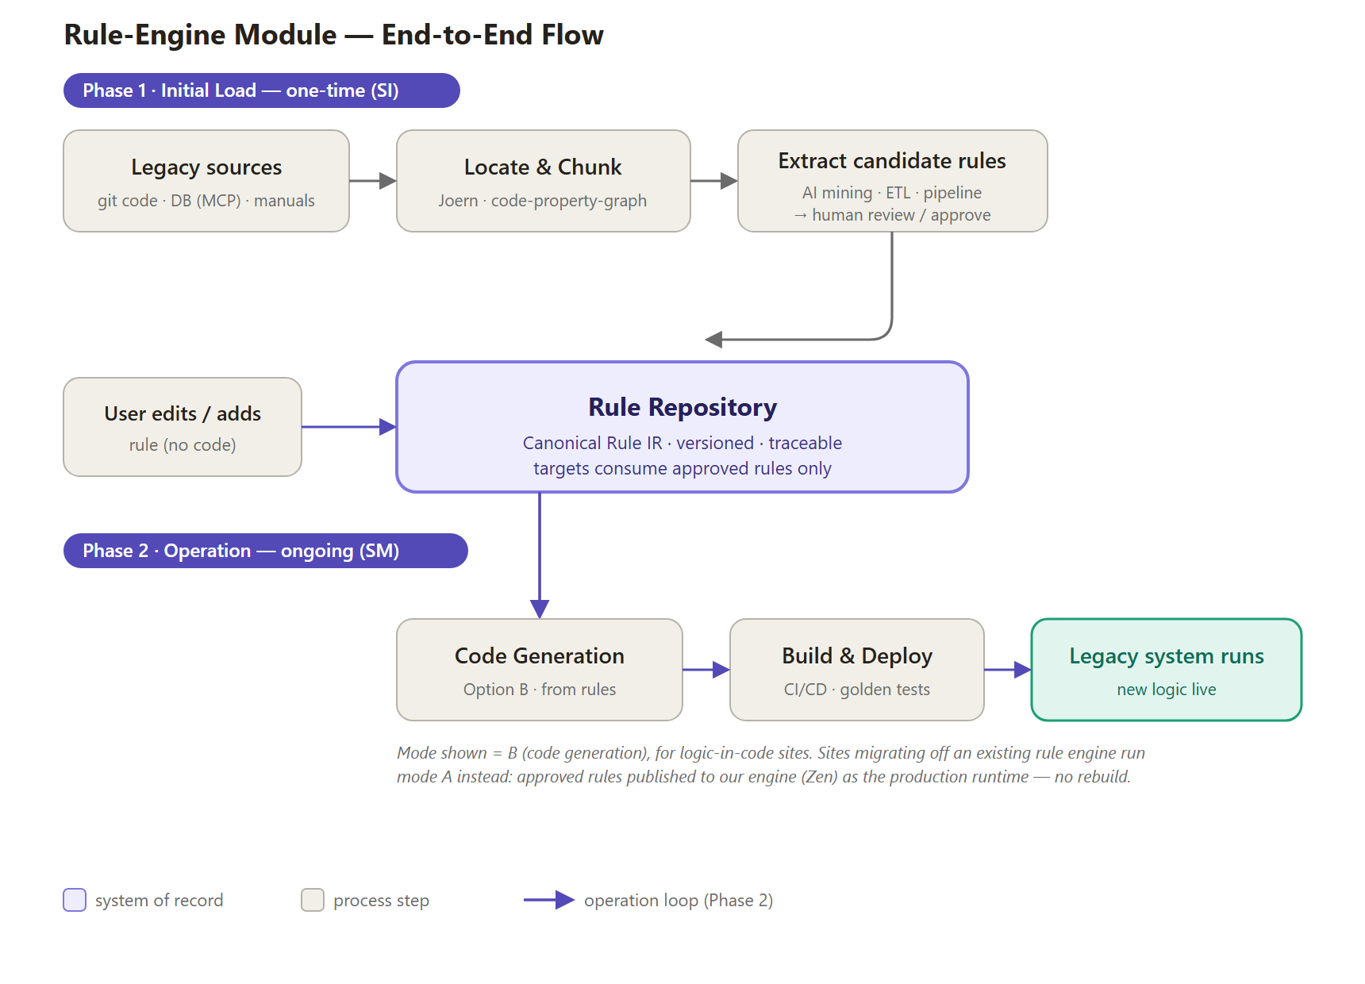
Figure 1 — End-to-end flow: one-time initial load (top), ongoing operation (bottom).

3. One Repository, Two Ways To Go Live
Different systems start from different places, so the final step is chosen per system — everything before it (extraction, review, approval, audit) is identical.
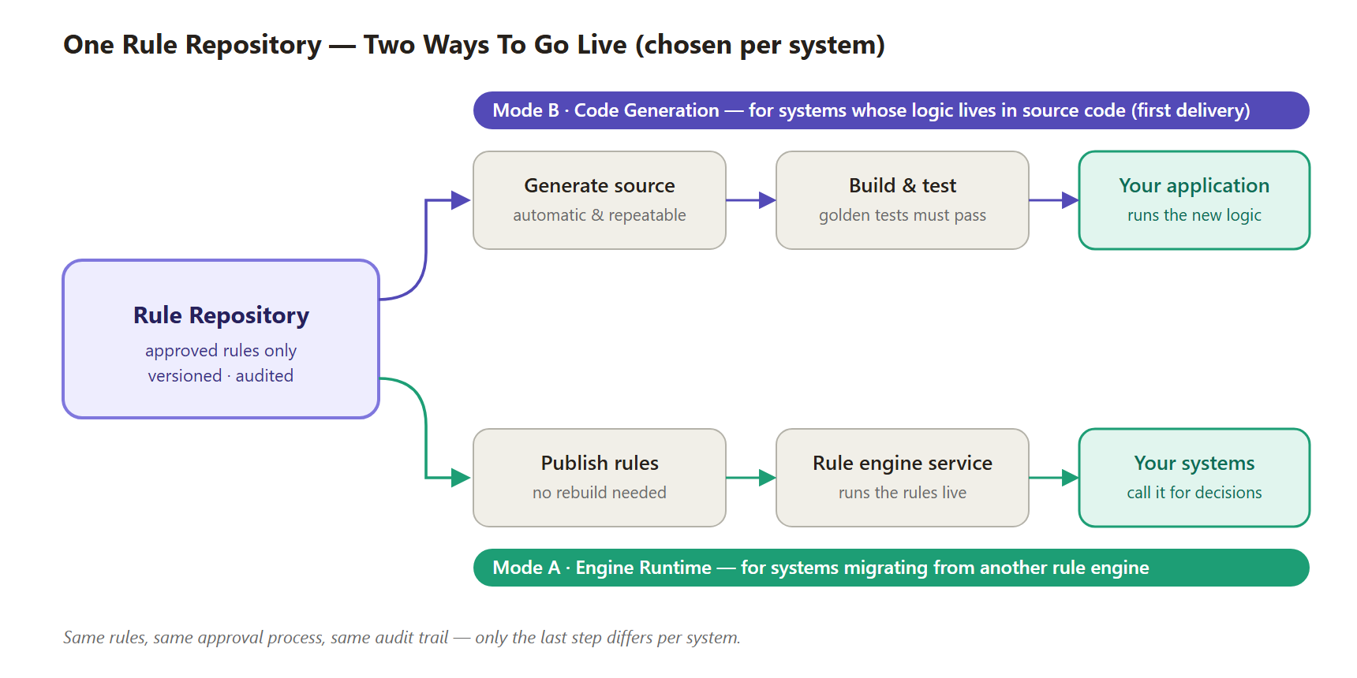
Figure 2 — The delivery mode is a per-system choice, not a platform fork.
 | Mode B — Code Generation | Mode A — Engine Runtime
Best for | Systems whose logic lives in source code (most legacy systems) | Systems already running another rule engine (e.g., DMN/Camunda)
What “go live” means | The platform regenerates the source code, tests it, and deploys it through your normal release process | The approved rule is published to our rule engine — effective immediately, no rebuild
Runtime footprint | None — your application keeps running its own code | A small decision service runs alongside your systems
Delivery order | First (Phase 1 pilot) | Second (with the engine-migration work)

4. A Concrete Example — From Legacy Code To Rule To New Code
The whole platform in one example. Today, an enrollment condition is buried in Java (only a developer can find and change it):
① What exists today — legacy source code (what we mine)
// EnrollmentValidator.java — legacy system, lines 120–132
if (customer.getAge() < 18) {
result.setEligible(false);
result.setReasonCode("UNDER_AGE");
return result;
}
if ("CANCER_BASIC".equals(product.getCode()) && customer.getAge() > 65) {
result.setEligible(false);
result.setReasonCode("OVER_AGE_LIMIT");
return result;
}
During the initial load, static analysis (Joern) locates this logic inside the large codebase, and AI converts it into a draft rule — reviewed and approved by your experts before it counts. The rule is stored as neutral, engine-independent data with a trace back to its origin:
② What the repository stores — the rule as data (business users see this as a decision table)
{
"decisionId": "enrollment_eligibility",
"hitPolicy": "FIRST",
"rules": [
{ "ruleId": "R001",
"when": [ { "field": "customer.age", "op": "<", "value": 18 } ],
"then": [ { "field": "eligible", "value": false },
{ "field": "reasonCode", "value": "UNDER_AGE" } ],
"source": "EnrollmentValidator.java:120-132",
"confidence": 0.82, "status": "APPROVED" },
{ "ruleId": "R002", "...": "OVER_AGE_LIMIT rule, same shape" }
]
}
Later, in operation: a business user changes the age limit from 18 to 19 in the decision-table screen; an approver signs it off. The platform then regenerates the code — automatically, from a fixed template, the same way every time — runs the golden tests, and hands your release pipeline a reviewable change:
③ What gets deployed — regenerated source code (Mode B)
// GENERATED — Business Rules Platform · decision enrollment_eligibility · v8
// Do not edit by hand; changes are made in the Rule Repository.
@Generated("rules-platform")
public final class EnrollmentEligibilityRules {
public Decision evaluate(EnrollmentInput in) {
if (in.customerAge() < 19) { // R001 (edited: 18 → 19)
return Decision.reject("UNDER_AGE");
}
if ("CANCER_BASIC".equals(in.productCode()) && in.customerAge() > 65) {
return Decision.reject("OVER_AGE_LIMIT"); // R002
}
return Decision.accept();
}
}
For a Mode A system, step ③ is different: the approved rule is simply published to the rule engine and takes effect immediately — no rebuild. Steps ① and ② are identical in both modes.

5. Technology Stack
Every runtime component is open-source — the platform itself carries no third-party license fees. AI is used only in the extraction step (drafting candidate rules for human review). The extraction model is deliberately not fixed: bulk extraction is high-volume, repetitive work where cost-efficient models excel, so we benchmark candidate models on your real sample code in Phase 0 and select by measured accuracy per cost — and for closed environments, open-weights models can run fully on-premise.
Area | Technology | Role | License
Legacy code analysis | Joern (code property graph) | Locates the enrollment logic inside large codebases and cuts out exactly the relevant parts | Apache-2.0
AI-assisted extraction | Tiered LLMs, selected by benchmark (e.g., DeepSeek / Kimi / GLM / Qwen for bulk work; frontier models for hard cases) — fully swappable per site policy | Reads the located code and drafts candidate rules — always human-reviewed, never writes production code. Open-weights options can run fully on-premise for closed environments | API / open-weights
Rule repository | PostgreSQL 16 | Stores rules as data with full version history and audit trail | PostgreSQL (open)
Platform services | Python · FastAPI | Extraction pipelines, repository API, governance workflow | MIT
Governance web UI | Vue 3 (decision-table editor, diff & approval screens) | Where business users browse, edit, compare, and approve rules | MIT
Java code generation | JavaPoet + google-java-format | Turns approved rules into deterministic, formatted Java source (Mode B) | Apache-2.0
One-time code integration | OpenRewrite | Surgically replaces the mined legacy region with a call to the generated module (initial load only) | Apache-2.0
Rule engine | GoRules Zen | Runs rules live for Mode A systems; also powers instant rule preview for reviewers | MIT
DB connectivity | Reusable MCP connector library (PostgreSQL first) | Plug-and-play database access per site — connection info in, no per-site development | Open (ours)
Build & delivery | Your existing git + CI/CD (Gradle build) | Generated code ships through your normal, already-audited release process | —
Java and PostgreSQL are the first adapters, not the boundary: each language, database, and legacy rule engine is a plug-in, so extending to C#, Oracle, or Drools later is an add-on, not a rewrite.

6. Decisions Confirmed With You
Topic | Confirmed direction | Confirmed
Purpose of initial loading | One-time migration step (SI). In operation (SM), users maintain rules in the platform — the initial conversion is never repeated. | Jun 30
Legacy sources & priority | DB configuration tables first; business manuals as a supplement; extracting rules from source code is pursued as this platform's key differentiator. Stored procedures and screen validations are deferred. | Jun 30
Delivery approach | Code generation leads (Mode B). Systems migrating from another rule engine will run on our engine instead (Mode A). | Jun 30 / Jul 3
Technology base | Java and PostgreSQL first — designed from day one to extend to other languages and databases. | Jul 2
Multi-site product | Built as a reusable, plug-and-play solution: per-site setup is configuration (including a ready-made database connector), not custom development. | Jul 2
Rule engine | GoRules Zen — open-source (MIT), no license fees, embeddable. Working choice; formal confirmation open. | Jul 2–3
Migration from other engines | DMN (the international decision-model standard) is supported as an import path for rules held in other engines. | Jul 2

7. Safety & Governance Built In
- Nothing is applied automatically. Every extracted rule is a draft that a person must review and approve, with a link to the exact legacy source it came from (file and line).
- Maker-checker approval. Rule changes require independent approval; every version and decision is kept in a full audit trail.
- Golden tests. A fixed set of known cases (input → expected outcome) must pass before any change reaches production — for both delivery modes.
- Predictable code generation. Generated code comes from fixed templates — the same rules always produce the same code, delivered as a reviewable change. AI assists only in reading legacy code; it never writes production code.
- Runs in your environment. Fully self-hostable on-premise, suitable for regulated finance/insurance environments.

8. Questions For Your Review
These are the open points where your input directly shapes the design. None of them block the start of Phase 1 except the pilot selection (Q1).
# | Question | Why it matters
1 | Which product and which enrollment flow should the pilot start with? | Defines the smallest end-to-end proof; everything in Phase 1 is built and demonstrated against it.
2 | How should rules be grouped for browsing and approval — per product, or per business process (e.g., one enrollment flow)? | Shapes the rule catalog and the approval screens your team will use every day.
3 | When a rule uses reference data (e.g., rate tables), should updates take effect immediately, or only when explicitly published? | Determines how quickly a rate-table change reaches production, and how such changes are audited.
4 | Who may approve a rule change, how many approvals are needed, and what evidence (e.g., test results) must be attached? | We build the maker-checker workflow around your compliance requirements, not a generic default.
5 | For generated code changes, is business-level review sufficient, or should IT also review the code change before deployment? | Sets the final gate of the release process for Mode B systems.
6 | Do any target systems already run a rule engine today (e.g., Camunda / DMN-based)? | Those systems take the faster Mode A migration path; knowing them early lets us schedule it.
7 | Can you share a small sample of your coding conventions? | Generated code should look like your code and pass your internal code review without friction.

9. What We Need To Start Phase 1
- A sample of Java source code containing enrollment logic (anonymized/masked is fine).
- The related PostgreSQL schema and sample configuration/rate tables (masked is fine).
- Your pilot selection (Question 1 above).
- A short working session on the approval policy (Question 4 above).
With the samples in hand, Phase 1 delivers a working proof: edit one approved rule, and the platform regenerates the code, passes the golden tests, and changes the enrollment outcome — with no hand-written code.

