Item 2 — Rule-Engine-Based Source Generation Module
Initial Proposal

Understanding of the goal
Today the enrollment logic for financial / insurance products lives inside source code, which makes it hard to change and hard to understand. The goal is to manage this logic as data (rules-as-data) so that adding a product or changing enrollment logic requires editing data, not code — and, longer-term, to have edited rules reflected back into the source and deployed.
Note to confirm up front: “reflected into the source and deployed” can mean two different things (see §3), and the choice shapes the whole design. We recommend clarifying this before detailed design.

1. Which legacy items to use as the basis for initial data loading
Enrollment logic is scattered across the legacy system. The candidate sources are ranked below by ease of extraction and risk.
Priority | Legacy item | Nature | Ease | Note
1 (start here) | Config / code tables in DB (product master, rate tables, eligibility code tables) | Already tabular | Easiest | Direct ETL → rule data, near-lossless
2 | Business manuals / documents | Structured text | Easy | Our current system already extracts these — reuse it
3 | Validation logic in source code (if-else, switch) | Code | Hard | Needs rule mining + mandatory human review
4 | Stored procedures / SQL business logic | DB code | Hard | Same as #3
5 | Screen / UI validation rules (required fields, value ranges) | UI code | Medium | Supplementary
Selection criterion: prefer items that are (i) frequently changed, (ii) already semi-structured, and (iii) business-owned. Start with #1 (config tables) + #2 (manuals) — low risk, high value — then tackle code (#3, #4) under a strict review process.

2. Initial design — five-layer pipeline
The module is organized as a five-layer pipeline. The diagram below shows the overall flow; each layer is then described in detail.
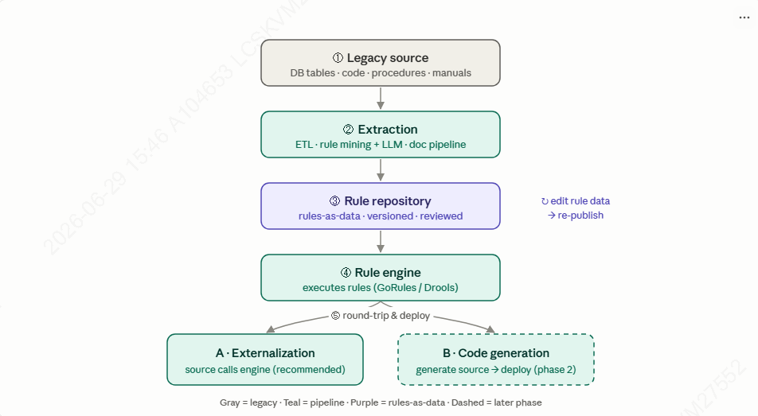

Step ① — Legacy source (input inventory)
Catalog where enrollment logic actually lives, per §1 (DB config tables, source code, stored procedures, manuals, UI validation). The deliverable of this step is a concrete inventory plus a chosen pilot subset (one product / one enrollment flow) so that extraction starts narrow and verifiable.

Step ② — Extraction (the core engineering step)
This layer converts heterogeneous legacy logic into normalized candidate rules. It runs as several parallel sub-pipelines, all feeding one common candidate-rule format. Crucially, nothing here is auto-applied to the live system — every extracted item is a suggestion routed to human review in Step ③.
2a. Tabular config → ETL (deterministic, highest trust).
- Connect read-only to the legacy DB and read config / code tables (product master, rate tables, eligibility codes).
- Map each table to a decision structure: identify condition columns (e.g., age band, product code, channel) and outcome / action columns (e.g., eligible Y/N, rate, required documents).
- Each row becomes one rule row. Near-lossless and needs no AI; the real work is column-to-semantics mapping and code / unit normalization.
2b. Source-code logic → rule mining (static analysis + LLM assist).
- Static analysis locates decision points (if/else, switch, guard / validation clauses) and extracts the control flow and conditions.
- An LLM converts each branch into a human-readable rule plus a structured condition / action pair.
- De-duplicate overlapping rules and attach the exact source location (file, function, line) for traceability.
- Output is candidate rules only — never auto-applied; they must be human-reviewed. This is where accuracy risk concentrates, so review is mandatory.
2c. Stored procedures / SQL → same pattern as 2b, applied to DB-side logic (procedures, triggers, complex CASE expressions).
2d. Business manuals / documents → reuse the existing pipeline. The project already turns manuals into structured knowledge; we map those extracted process / condition statements into the same candidate-rule format.
Common output contract. Regardless of source, every extracted item is normalized to the same shape:
- { conditions, action(s), product / domain, source_reference, confidence, status = pending }
This uniformity is what lets Step ③ review and Step ④ load every rule consistently, no matter which legacy source it came from.

Step ③ — Rule repository (rules-as-data)
The canonical system of record for rules, stored as data (decision tables / JSON), not code.
- Data model: rule id, conditions, actions, product, version, effective / expiry dates, source trace, confidence, status (pending / approved / retired).
- Governance: maker-checker approval workflow, versioning and diff, full audit log — essential for finance / insurance compliance.
- Quality: a regression / golden test set so rule changes can be validated before publishing.
The engine consumes only approved rules; pending and rejected suggestions never reach production.

Step ④ — Rule engine
Takes the approved rules, renders them into the engine’s native format (e.g., GoRules JDM JSON or a Drools decision table), loads them, and evaluates enrollment requests. Evaluation is stateless; reference / lookup data is attached as needed. Engine choice follows the separate vendor survey (GoRules for the PoC, DecisionRules if API-first, Drools for a proven Java / open-source base).

Step ⑤ — Round-trip & deploy
A business user edits a rule in the repository and re-publishes. How that change reaches the running system is the A / B decision in §3:
- Option A (externalization): the engine picks up the new rule version — no application redeploy.
- Option B (code generation): source is regenerated from the rule data, then built and deployed via CI/CD.

3. Two options for “reflect into source & deploy” (decision needed)
 | A — Externalization (recommended first) | B — Code generation (literal interpretation)
How | Current source calls the rule engine at runtime (API / embedded) | Generate source code from rule data → compile → deploy via CI/CD
“Deploy” means | Publish a new rule version (no app rebuild) | Rebuild & redeploy the code module
Pros | Fast, low-risk, industry standard (40–60% faster time-to-market) | Logic runs inside legacy, no engine runtime dependency
Cons | Requires the engine running alongside | Complex; safe / correct code generation is hard; higher risk
Use when | Most cases | Logic must run inside legacy, or for performance / compliance reasons
Recommendation: Phase 1 = A (externalization) to prove value quickly; Phase 2 = add B (code generation) only where truly required. Present both for the customer to choose.

4. Suggested PoC scope
- One financial / insurance product, one enrollment flow.
- Initial source: config tables + manuals (#1, #2).
- Engine: GoRules (JSON) — easy to generate and load automatically.
- Round-trip: externalization first.
- Success criterion: editing one rule in data changes the enrollment outcome correctly, with no code change.

5. Risks & notes
- Rule mining from code is error-prone → always human-reviewed (finance / insurance compliance).
- Option B (code generation & deploy) is substantially more complex → keep it a separate phase; don’t over-commit early.
- Need an audit trail + versioning, and Korean text must be preserved.

6. Questions to clarify
- What is the legacy stack? (COBOL / Java / .NET? which DB?) — drives the mining and code-gen approach.
- Does “reflected & deployed” mean regenerating source code (B), or simply having the source call the engine (A)? — most important.
- Which product / flow should be the pilot?
- Any compliance / audit constraints?

7. Request — sample materials
To make the design concrete and validate feasibility, could you share any sample legacy materials — for example sample source code containing enrollment logic, the relevant DB schema / table definitions, or sample config / rate-table data (anonymized or masked is fine)? Even a small, representative slice would let us assess the extraction approach and refine this design with real data points rather than assumptions.

