CIS 340 Project

Name1: Kyle Lim

Name2: Aidan Cavanaugh

Name3: Colin Mueller

1. **Identify entity types with brief description**

Attributes:

1. Patient : A patient of the hospital.
2. Staff : Hired employees of the organization.
3. Next-Of-Kin : Designated Contact of Patient’s family member.
4. DOB : Date-Of-Birth
5. Wards : Areas of the hospital designated for patients / staff.
6. WardNo : Identifier of Ward
7. Telephone extns - Telephone extension to contact ward or person.
8. NIN - National Insurance Number.
9. Address - The address of Patient / Staff.
10. Salary - The money earned by staff.
11. SalaryScale - The multiplicity of earned money.
12. Hours - The amount of hours staff has worked.
13. SalaryType - Whether it is bi-weekly or monthly payments.
14. CertDate - Date of Qualification passed
15. CertType - Type of Qualification
16. IntistutionName - Name of the institution that staff were in.
17. PastWork - Past experience in work.
18. PastWorkPosition - Position held in past work experience.
19. StartDate - Date of hire.
20. FinishDate - Last Date of Job.
21. PatientNum - Unique Patient Identifier.
22. MaritalStatus - Status of Marriage.
23. DateRegis - Date registered in hospital.
24. NextOfKin - Contact info of relative/friend.
25. KinName - Name of next of kin.
26. AppNum - Appointment Identifier
27. AppDateTime - Appointment date and time
28. ExamRoom - Room location
29. IsRecommended- Whether room is recommended.
30. OutPatientNum - Outpatient Identifier
31. ListDate -
32. WardPlaceDate - Date of Patient being assigned to ward
33. ExpLeaveDate - Expected ward leave.
34. LeaveDate - Date of patients leaving.
35. PatMedID - The identifier of which medication goes to who.
36. DrugName - The name of the drug.
37. DrugNum - Drug identifier (specifier).
38. UnitsPerDay - The dosage
39. MethodofAdmin- Method of administering drug.
40. ClinNum - Clinic Number of local doctor
41. ClinAddress - Address of local doctor.
42. ClinPhone - Phone number of local doctor
43. Quantity - How much in-stock of drugs
44. ReorderLvl - Reorder level.
45. Cost - Cost per unit of drug
46. SuppName - Supplier name
47. SuppNum - Identifier of supplier/supplies
48. SuppPhone - Phone number of supplier
49. SuppFax - Fax number of supplier.
50. **Identify relationship types with brief descriptions. You must include the multiplicity and attributes if any.**

The **Patient Number** and **Staff ID** and **Ward ID** are the *one to many* relationship types. They are basically the primary keys that link to almost everything else on the code.

The **Next Of Kin** has a one to one relationship with **Patient**.

**Patients** and **Local Doctors** have a many to one relationship.

1. **Describe each entity type in detail**

* Wards - Ward Number / Ward Name / Contact Info

Each ward has a unique name and ID to differ which ward contains which patients/staff.

They also include a unique extension to contact each other.

* Patients - DOB / Name / ID / Contact Info / Sex / Marital-Status / NOK / DateRegis

[ Ward ID as key? ]

Each patient has personal information registered on the day they were checked into the hospital, their ID is (kept to reference which ward they are kept?)

* NextOfKin - Name /Relationship/Address/Contact-Info

A contact for the patient with personal information ( needs patient primary key )

* Staff - Staff ID / Name / Address / Contact-Info / Gender / NIN / Position / Salary / SalaryScale / Hours-Worked / Contract-type / Salary-type

A rundown of staff’s unique ID and personal information. They also include a National Insurance Number, what hours you work, salary and contract types (bi-weekly / weekly / monthly).(Key to Ward)

* Supplier - Supplier Name / Supplier Number / Supplier Address / Supplier Phone Number / Supplier Fax

A contact for medical suppliers including Name, ID Number, Address, Phone Number, and Fax Information. The Primary Key being ID Number.

* Supplies - Item Number / Item Name / Item Description / Quantity In Stock / Reorder Level / Cost Per Unit

A catalog of supplies detailing Item Number, Description, Quantity in Stock, Reorder Lever, and Cost per Unit. The Primary Key being the Item Number.

1. Draw the E-R diagram

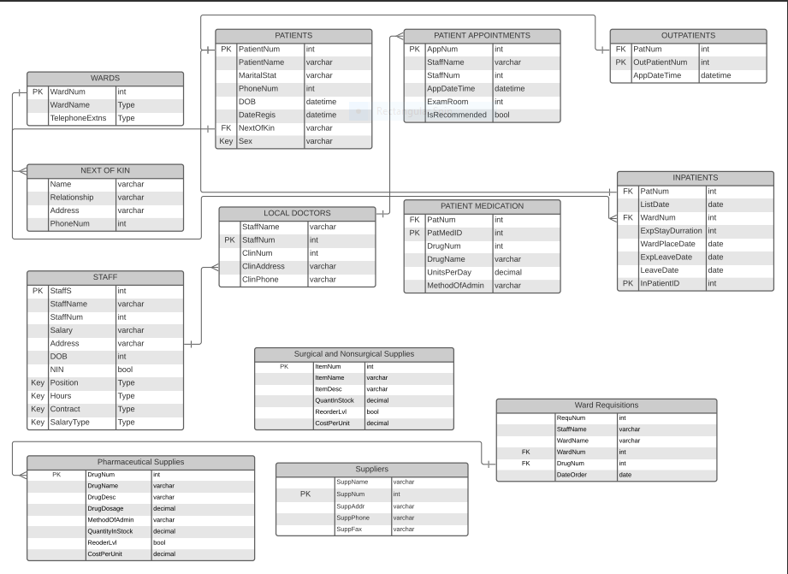

You must specify the multiplicity on the E-R diagram.

Create your tables on workbench environment using all the constraints above.

Create table WARDS (

WardNum int,

WardName varchar (25) NOT NULL DEFAULT '',

TelephoneExtns varchar (25) NOT NULL DEFAULT ''

);

Create table STAFF (

StaffNum int,

StaffName varchar (25) NOT NULL DEFAULT '',

Address varchar (25) NOT NULL DEFAULT '',

PhoneNum int,

DOB date,

Sex varchar (25) NOT NULL DEFAULT '',

NIN int,

Position varchar (25) NOT NULL DEFAULT '',

Salary int,

SalaryScale int,

Hours int,

Contract varchar (25) NOT NULL DEFAULT '',

SalaryType varchar (25) NOT NULL DEFAULT ''

);

Create table QUALIFICATIONS (

CertDate date,

CertType varchar (25),

InstitutionName varchar (25),

PastWork varchar (25),

PastWorkPosition varchar (25),

StartDate date,

Primary Key(StaffNum),

FinishDate date

);

Create table PATIENT (

PatientNum int,

PatientName varchar (25) NOT NULL DEFAULT '',

Address varchar (25) NOT NULL DEFAULT '',

PhoneNo int,

DOB date,

Sex varchar (25) NOT NULL DEFAULT '',

MartialStatus varchar (25) NOT NULL DEFAULT '',

DateRegis date,

NextOfKin int

);

Create table NEXTOFKIN (

KinName int,

Relationship varchar (25) NOT NULL DEFAULT '',

Address int,

PhoneNo int,

Primary Key (NextofKin)

);

Create table P_APPOINTMENT

(

AppNum int,

StaffName varchar (25) NOT NULL DEFAULT '',

StaffNum int NOT NULL DEFAULT '',

AppDateTime datetime,

ExamRoom int,

IsRecommended bool,

Primary Key(AppNum)

);

Create table OUTPATIENTS

(

PatientNum int,

OutPatientNum int,

AppDateTime datetime,

Primary Key(OutPatientNum),

Foreign Key(PatientNum) References PATIENTS(PatientNum)

);

Create table INPATIENTS

(

PatientNum int,

ListDate date,

WardNum int,

ExpStayDuration int,

WardPlaceDate date,

ExpLeaveDate date,

LeaveDate date,

Primary Key(InPatientID),

Foreign Key(PatientNum) References PATIENTS(PatientNum),

Foreign Key(WardNum) References WARDS(WardNum)

);

Create table P_MEDICATION

(

PatientNum int,

PatMedID int,

DrugNum int,

DrugName varchar (25) NOT NULL DEFAULT '',

UnitsPerDay decimal,

MethodOfAdmin varchar (25) NOT NULL DEFAULT '',

Primary Key(PatMedID),

Foreign Key(PatientNum) References PATIENTS(PatientNum)

);

Create table L_DOCTORS

(

StaffNum int,

StaffName varchar (25) NOT NULL DEFAULT '',

ClinNum int,

ClinAddress varchar (25) NOT NULL DEFAULT '',

ClinPhone varchar (25) NOT NULL DEFAULT '',

Primary Key(StaffNum)

);

Create table PHARM_SUP

(

DrugNum int,

DrugName varchar (25),

Description varchar (50),

Dosage int,

AdminMethod varchar (10),

Quantity int,

Reorder int,

Cost int

);

Create table WARD_REQ

(

Foreign Key (StaffName) REFERENCES STAFF(StaffName),

Foreign Key (WardNum) REFERENCES WARDS(WardNum),

Foreign Key (WardName) References WARDS(WardNum),

Foreign Key (DrugNum) References PHARM_SUP(DrugNum)

);

Create table SURGICAL_SUPPLIES

(

ItemNum int,

ItemName varchar(25) NOT NULL DEFAULT "",

ItemDesc varchar(50) NOT NULL DEFAULT "",

QuantInStock decimal,

ReorderLvl bool,

CostPerUnit decimal,

Primary Key(ItemNum)

);

Create table SUPPLIERS

(

SuppName varchar(25) NOT NULL DEFAULT "",

SuppNum int,

SuppAddr varchar(50) NOT NULL DEFAULT "",

SuppPhone varchar(12) NOT NULL DEFAULT "",

SuppFax varchar(50) NOT NULL DEFAULT "",

Primary Key(SuppNum)

);