**Project Name:** Agile Writer

**Project Description:** A “smart” processor with prompt generation, autocompletion, and more. Our application features a server-based user login and registration and file directory service as well as client side rich-text-editing and dynamic AI text generation. Users can create, rename, reorganize, and delete documents at their leisure. Our rich-text editor features dozens of styling options and up to 1GB of potential storage per document. Additionally, when stalled for thoughts or when at a loss for words, our word processor is linked to an open-sourced AI that will provide a suggestion to keep your thoughts moving. Our project also features a prompt generation page to get ideas started along with the ability to save and load previously created prompts.

**Project Tracker:**

<https://csci-3308-fall21-018-1.atlassian.net/jira/software/projects/A01/boards/1>

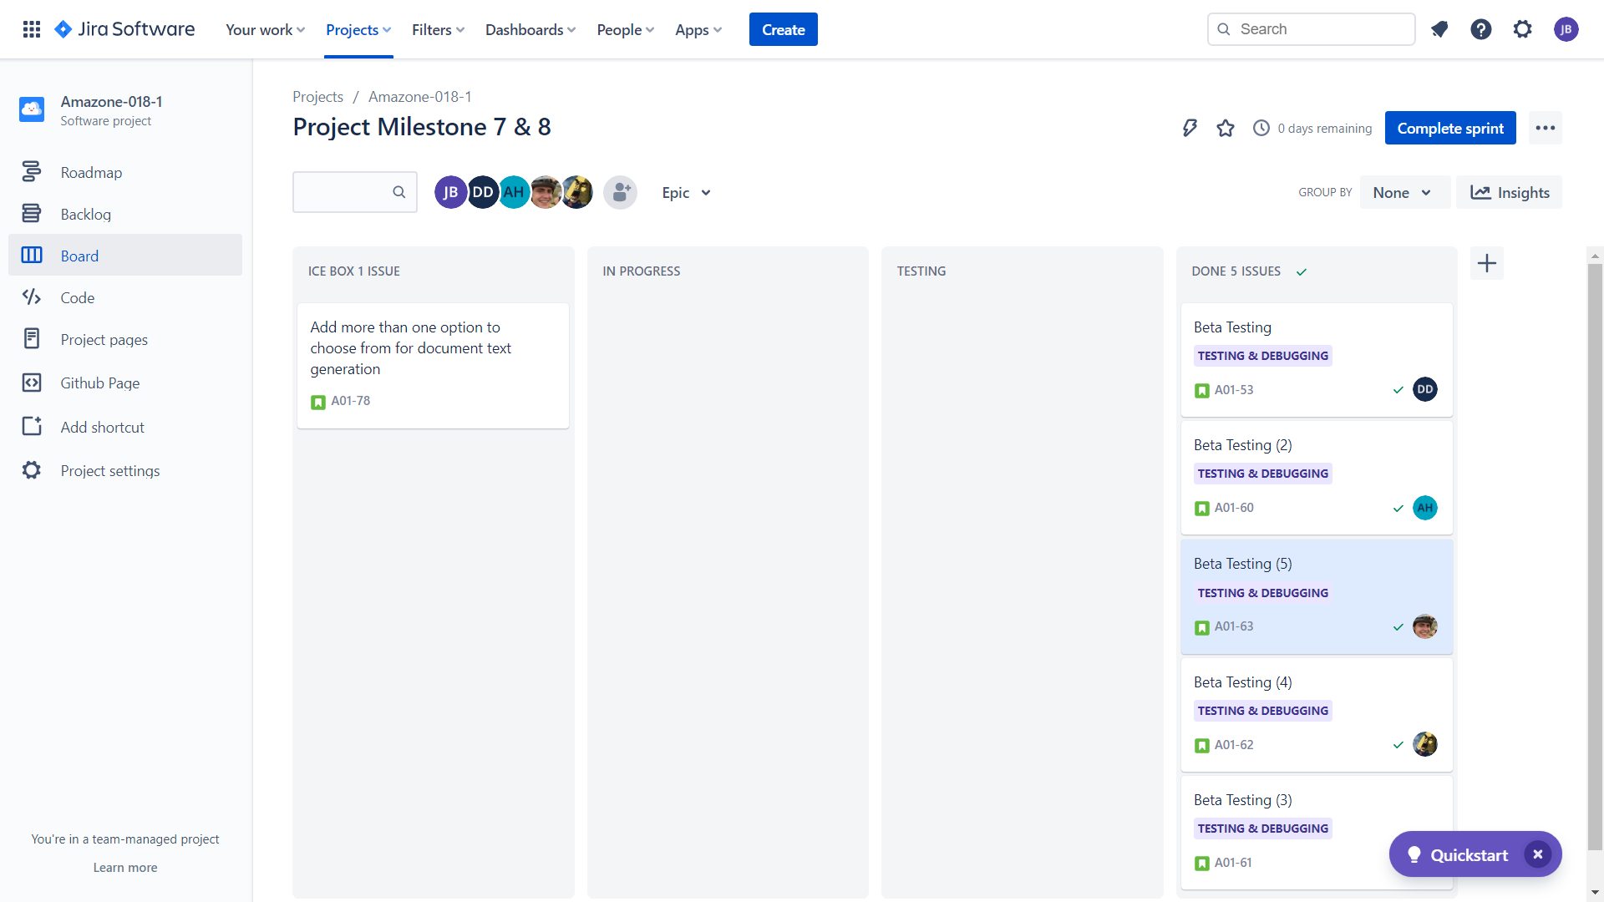

**Video Demo:** The demo video can be found in the repository

**VCS:** <https://github.com/CU-CSCI-3308-Fall-2021/CSCI-3308-Fall21-018-01.git>

**Contributions:** For contribution history, follow link or see screenshots below.<https://github.com/CU-CSCI-3308-Fall-2021/CSCI-3308-Fall21-018-01/commits/main>

| **Name** | **Brief Description of contributions** |
| --- | --- |
| Davis Davalos- DeLosh | * AI auto-completion library * Quill keyboard shortcuts for completion selection * Styling for completions following document cursor * Incorporating AI into document writer page * Incorporating AI into prompt generation page * Initial implementation of node.js server |
| James Vogenthaler | * Quill implementation and stylization options. * File directory implementation and design. * File and folder manipulation (create, move, load, rename, delete). * Implementation of ejs, docker, nodemon, heroku, and mocha/chai. * Cleaned up large swaths of code and the overall file structure. |
| James Boynton | * Original website design using Figma * Initial database design using postgres * Linked database using node-postgres * User login and registration using bcrypt * User session data using passport * Implemented document saving and overwriting |
| Aleksey Huhua | * Prompt generation page design * Added functionality to save previously created prompts * Was working on functionality to load previously created prompts |
| Nolan Ales | * Homepage design * Quill keyboard shortcuts * Word count and date created additions to quill and database * Organized efforts around milestones * Was working on implementing sentence/page count |

**Deployment:** <https://csci3308-018.herokuapp.com/Login>

**Contribution History**