|  |  |
| --- | --- |
| Button | Function |
| A |  |
| X | Intake (rev) |
| Y | Intake (fwd) |
| B |  |
| 1 - CLICK |  |
| 1 - AXIS |  |
| 2 - UP |  |
| 2 - RIGHT | Color |
| 2 - DOWN | Intake Piston (toggle) |
| 2 - LEFT |  |
| 3 - CLICK |  |
| 3 - AXIS | Hang |
| 4 | Shooter (rev) |
| 5 |  |
| 6 | Conveyor (rev) |
| 7 |  |
| 8 | Air Brake (Hang) |
| 9 | Conveyor (fwd) |
| 10 | Shooter (fwd) |

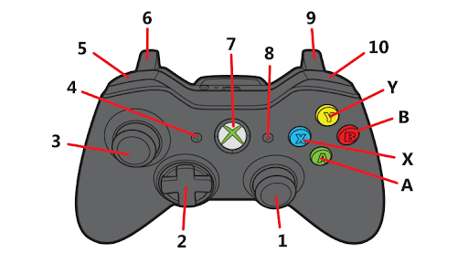

*DEFAULT setting

|  |  |
| --- | --- |
| Button | Function |
| HAT |  |
| 1 |  |
| 2 |  |
| 3 | Low Gear |
| 4 | High Gear |
| 5 |  |
| 6 |  |
| 7 |  |
| 8 |  |
| 9 |  |
| 10 |  |
| 11 | LimeLight Automation |
| 12 |  |

