Report Template (Underactuated Robotics)
  - MATLAB Project: Cart With Serial Double Pendulum
  - Your Name
  - Prepared: 4 May 2026

Item | Project Detail
System | A horizontally actuated cart carrying a two-link serial pendulum. The generalized coordinates are s, theta1, and theta2.
Input | Single horizontal cart force u; the pendulum joints are unactuated, so the plant has 3 degrees of freedom and 1 input.
MATLAB files | underactuated_model.m, simulation.m, control1.m, control2.m, controller1_sim.m, controller2_sim.m, animate_cartpole.m.
Main objective | Model the nonlinear dynamics, verify the model numerically, and compare a local LQR stabilizer with a nonlinear swing-up controller that hands off to LQR near upright.

1 Introduction
This report describes the MATLAB project for an underactuated cart with a serial double pendulum. The cart is actuated by a horizontal force, while both pendulum joints move passively. The resulting system is strongly nonlinear, has fewer independent inputs than generalized coordinates, and is a useful benchmark for modeling, verification, and nonlinear control design.
The project implements an Euler-Lagrange model, verifies the model through energy conservation and linearization checks, and demonstrates two control strategies. The first controller is a local continuous-time LQR stabilizer around the upright equilibrium. The second controller is an energy-shaping swing-up method that pumps mechanical energy until the state enters the upright neighborhood, where it hands off to the LQR controller.

2 System Model
The considered plant is a cart of mass M moving horizontally on a rail. A first massless rod of length l1 carries point mass m1, and a second massless rod of length l2 carries point mass m2 from the tip of the first rod. The angle convention in the MATLAB model measures theta1 and theta2 from the upward vertical, so theta = 0 denotes upright and theta = pi denotes hanging.
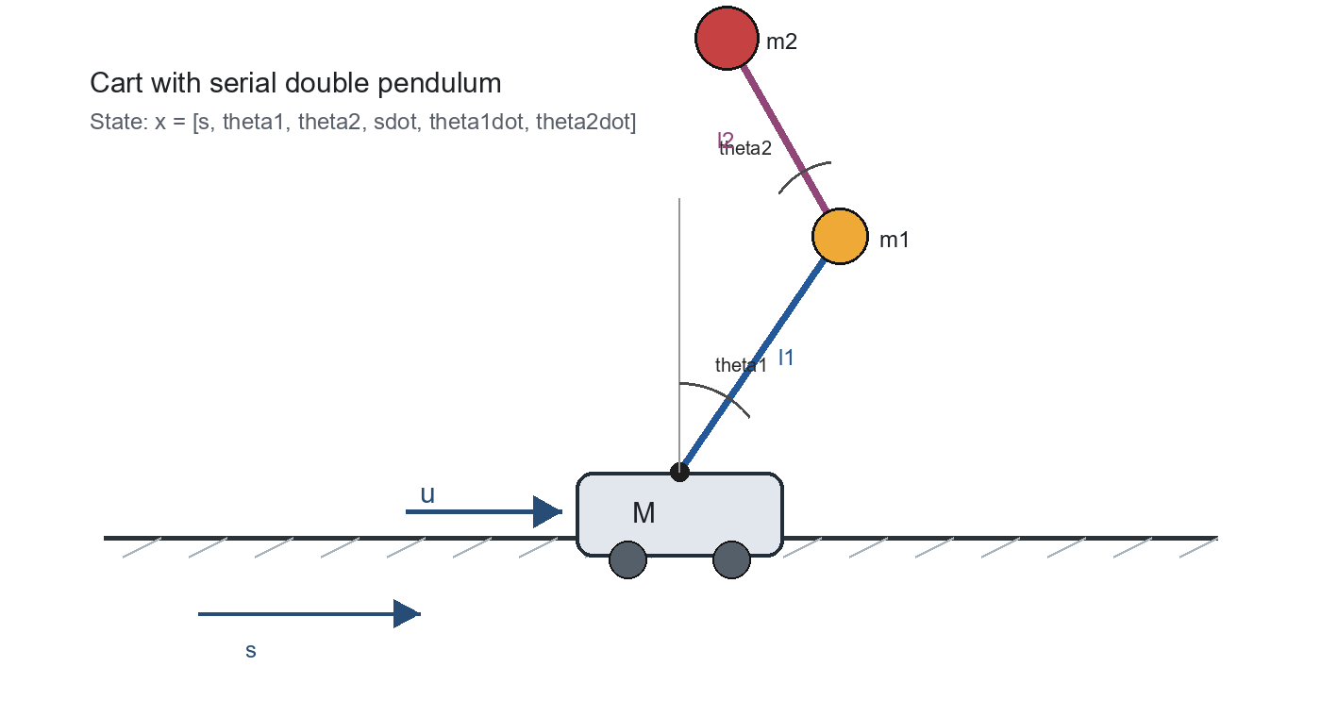
Figure 1. Cart with serial double pendulum and the variables used by the MATLAB model.
Symbol | Meaning | Value used in controller simulations
s | Cart position | State component x(1)
theta1, theta2 | Pendulum angles measured from upward vertical | State components x(2), x(3)
M | Cart mass | 1.0 kg
m1, m2 | Point masses at the rod ends | 0.20 kg, 0.15 kg
l1, l2 | Rod lengths | 0.50 m, 0.40 m
g | Gravitational acceleration | 9.81 m/s^2
b_cart, b_pend1, b_pend2 | Viscous friction terms | 0.05 N s/m, 0.001 N m s/rad, 0.001 N m s/rad for controller runs

2.1 Euler-Lagrange Modeling
The model in underactuated_model.m is written in manipulator form:
M(q) qddot + C(q, qdot) qdot + G(q) = B u
The generalized coordinates are q = [s, theta1, theta2]^T. The state vector used by ode45 is x = [s, theta1, theta2, sdot, theta1dot, theta2dot]^T. The input matrix B = [1, 0, 0]^T applies force only to the cart coordinate, which is why the system is underactuated.
The MATLAB implementation derives the bob positions from the cart coordinate and rod angles, computes kinetic and potential energy, and then uses the resulting mass matrix, Coriolis/centrifugal terms, gravity vector, and optional viscous friction to solve for qddot at each integration step. The details of the matrices are included in Appendix A.

2.2 Analysis of Model
The simulation.m script performs three model checks before using the animation as a visual sanity check. First, it verifies energy conservation by setting the input and friction to zero; the total mechanical energy should stay constant along the trajectory. Second, it evaluates the right-hand side at the upright-upright and hanging-hanging equilibria with zero velocity and zero input. Third, it compares numerical finite-difference linearizations with closed-form linearizations from the manipulator equations.
Analysis Step | Purpose | MATLAB Implementation
Energy conservation | Checks that the Euler-Lagrange dynamics preserve total energy in the friction-free, unforced case. | simulation.m computes E = T + V and reports the maximum drift.
Equilibrium check | Confirms that upright-upright and hanging-hanging configurations remain at rest when velocities and input are zero. | underactuated_model.m is evaluated at x = [0, 0, 0, 0, 0, 0]^T and x = [0, pi, pi, 0, 0, 0]^T.
Linearization | Checks local behavior and controllability around both equilibria. | simulation.m forms numerical and analytic A, B matrices, reports eigenvalues, and checks rank(ctrb(A,B)) = 6.

3 Controller Design
The project implements two control methods. The local method stabilizes the upright equilibrium when the state starts close enough to that operating point. The nonlinear method is designed for larger excursions: it changes the total mechanical energy of the pendulum chain, then switches to the local controller when the upright neighborhood is reached. This two-stage structure is common in underactuated systems because a purely local linear controller cannot recover the system from the hanging configuration by itself [1].

3.1 Controller Design Method 1
The first method, implemented in control1.m, is a continuous-time LQR controller. The nonlinear model is numerically linearized around x* = 0 and u* = 0 using central finite differences. MATLAB then solves the continuous-time algebraic Riccati equation through lqr(A, B, Q, R) and applies the feedback law u = -Kx.
Design Choice | Value or Behavior
Equilibrium | Upright-upright: x* = [0, 0, 0, 0, 0, 0]^T, u* = 0.
Cost matrices | Q = diag([10, 100, 100, 1, 10, 10]), R = 1. The angle and angular-rate states are weighted heavily to favor upright balance.
Gain handling | The LQR gain K is cached in persistent variables and recomputed only when the parameter struct changes.
Expected domain | Local stabilization near upright; the code comments explicitly note that global swing-up should use control2.m.

Because this controller is based on a linearization, its stability claim is local: when the nonlinear state remains close enough to the upright equilibrium, the LQR feedback makes the linearized closed-loop dynamics stable and is expected to stabilize the nonlinear system in a neighborhood of that equilibrium.

3.2 Controller Design Method 2
The second method, implemented in control2.m, is an energy-shaping swing-up controller with an internal hand-off to control1.m. Far from upright, it computes the total mechanical energy E and compares it with the desired upright energy E_des. The controller then applies a saturated cart force intended to add or remove energy from the pendulum chain.
u = k (E - E_des) sign(theta1dot cos(theta1) + theta2dot cos(theta2))
The implemented gain is k = 5 with a soft saturation of +/-100 N. The hand-off condition wraps both angles to [-pi, pi] and switches to LQR when both wrapped angles are within 0.2 rad of upright and both angular velocities are below 1.0 rad/s. This creates a practical hybrid controller: energy shaping handles large-amplitude motion, and LQR handles the final local stabilization.

4 Simulation Results
The project contains three main simulation scripts. simulation.m verifies the model and generates free-response plots. controller1_sim.m tests local balance from a small angular perturbation. controller2_sim.m starts near the hanging equilibrium, runs the swing-up controller, tracks total energy, and plots the control signal together with the full state trajectory.
Script | Initial Condition | What It Demonstrates | Main Plots or Outputs
simulation.m | [0, pi - 0.30, pi + 0.20, 0, 0, 0]^T for free response; also exact equilibrium states. | Model validation: energy conservation, equilibria, linearization agreement, controllability. | State trajectories, energy drift, eigenvalues, controllability ranks, and animation.
controller1_sim.m | [0, 0.15, -0.15, 0, 0, 0]^T. | LQR can balance the double pendulum when started inside a small upright neighborhood. | Cart position, angles, velocities, control force u, final angle errors, and peak |u|.
controller2_sim.m | [0, pi - 0.1, pi + 0.1, 0, 0, 0]^T. | Energy shaping can move the system from near hanging toward upright before handing off to LQR. | Cart position, angles, velocities, u, total energy E, E_des, final wrapped angle errors, and peak |u|.

The expected result for controller1_sim.m is rapid decay of theta1 and theta2 toward zero from the small perturbation, with a control signal that remains bounded. The expected result for controller2_sim.m is a visible energy-pumping phase in which E approaches E_des, followed by an LQR capture phase near upright. The animation routine interpolates the ode45 trajectory to 60 frames per second so the cart and pendulum motion can be inspected in real time.
The report template asks for graphs of state x or output y, control signal u, and energy/work. The MATLAB project already produces those graphs in the controller and verification scripts. For a final submission, the generated MATLAB figures should be exported and inserted in this section, with captions identifying the initial condition, controller, and parameter set.

5 Conclusions
The MATLAB project gives a coherent workflow for an underactuated robotics problem: derive the nonlinear dynamics, validate the model numerically, analyze equilibria and controllability, then design controllers matched to different operating regions. The LQR controller is appropriate for local balancing, while the energy-shaping controller extends the operating range by swinging the pendulum chain toward the upright energy level before switching to LQR.
The main limitation is that the swing-up method is heuristic and uses a simple switching condition. A stronger final project report could add formal hybrid-stability arguments, actuator-limit analysis, and exported simulation plots comparing settling time, peak force, energy error, and robustness to friction or parameter changes.

References
[1] R. Xu and U. Ozguner, "Sliding mode control of a class of underactuated systems," Automatica, vol. 44, no. 1, pp. 233-241, 2008.

A Something
The appendix records the implementation details that support the main text. The MATLAB model uses the following manipulator matrices, with s1 = sin(theta1), c1 = cos(theta1), s2 = sin(theta2), c2 = cos(theta2), s12 = sin(theta1 - theta2), and c12 = cos(theta1 - theta2).
Term | Expression or Role
Mass matrix M(q) | [M+m1+m2, (m1+m2)l1c1, m2l2c2; (m1+m2)l1c1, (m1+m2)l1^2, m2l1l2c12; m2l2c2, m2l1l2c12, m2l2^2].
Coriolis/centrifugal matrix C(q,qdot) | Contains velocity-coupling terms proportional to s1 theta1dot, s2 theta2dot, and s12 thetaidot.
Gravity vector G(q) | [0; -(m1+m2) g l1 sin(theta1); -m2 g l2 sin(theta2)].
Input vector B | [1; 0; 0], meaning the cart is actuated and both pendulum coordinates are passive.
Friction | Optional diagonal viscous friction [b_cart, b_pend1, b_pend2] .* qdot, enabled when fields exist in params.

File | Role in the Project
underactuated_model.m | Defines the nonlinear state derivative and manipulator matrices.
simulation.m | Runs energy, equilibrium, linearization, controllability, and animation checks.
control1.m | Builds and applies the cached local LQR stabilizer.
control2.m | Implements energy shaping and switches to LQR near upright.
controller1_sim.m | Closed-loop LQR balance simulation from a small upright perturbation.
controller2_sim.m | Swing-up plus LQR simulation from near hanging.
animate_cartpole.m | Real-time visualization of cart and two pendulum links.

