Cricket Analytics

Document 3 — UI Guide with Screenshots

Complete Walkthrough of the Ultimate Dashboard

Screenshots — All Tabs
All screenshots taken live from the running app at http://localhost:8501 (or the port Streamlit prints)

Screenshot 1 — App Overview (first load)
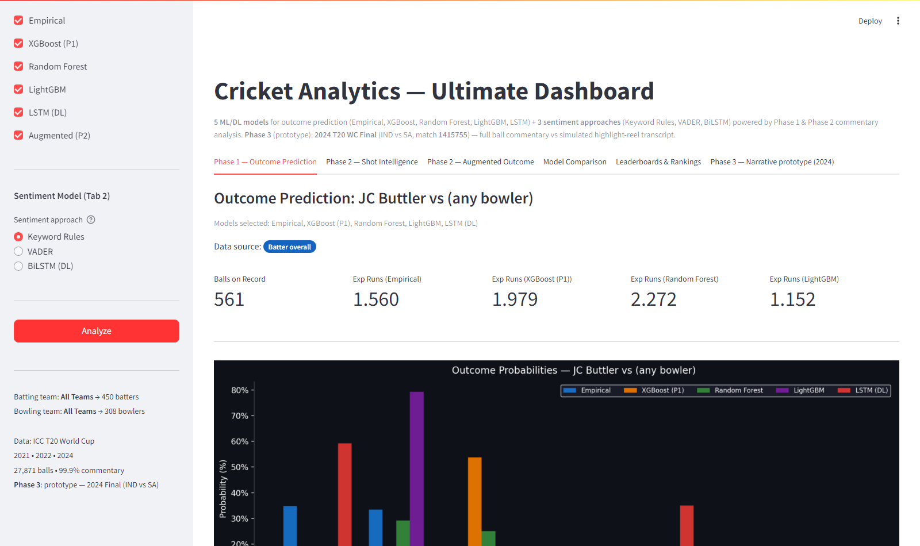
Screenshot 1 — App Overview (first load)

Screenshot 2 — Sidebar: Model Selectors and Sentiment Toggle
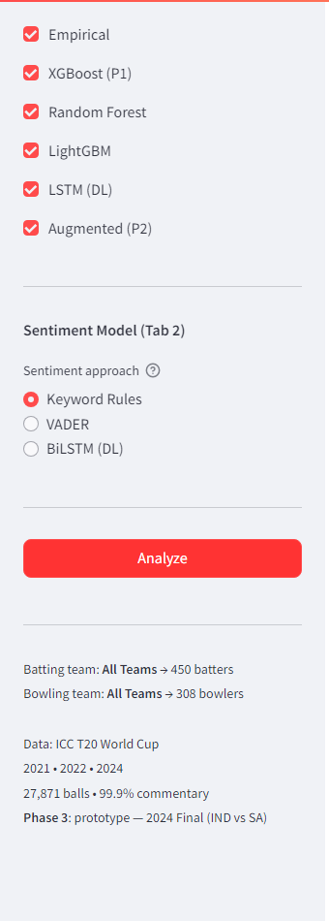
Screenshot 2 — Sidebar: Model Selectors and Sentiment Toggle

Screenshot 3 — Tab 1: Phase 1 Outcome Prediction
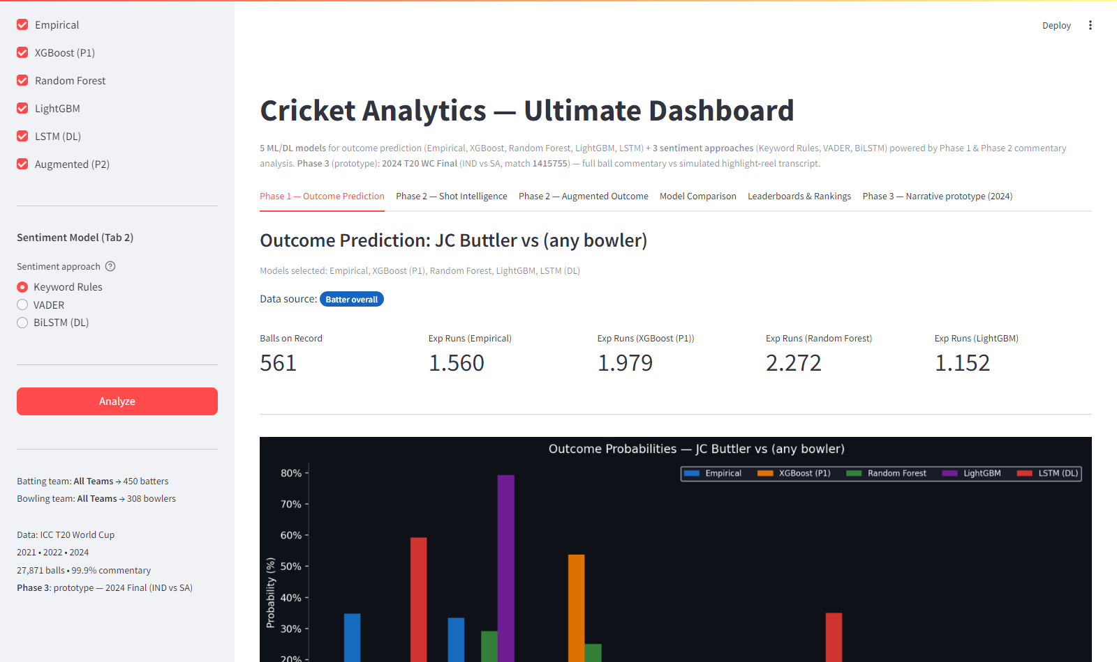
Screenshot 3 — Tab 1: Phase 1 Outcome Prediction

Screenshot 4 — Tab 2: Shot Intelligence (Keyword Rules)
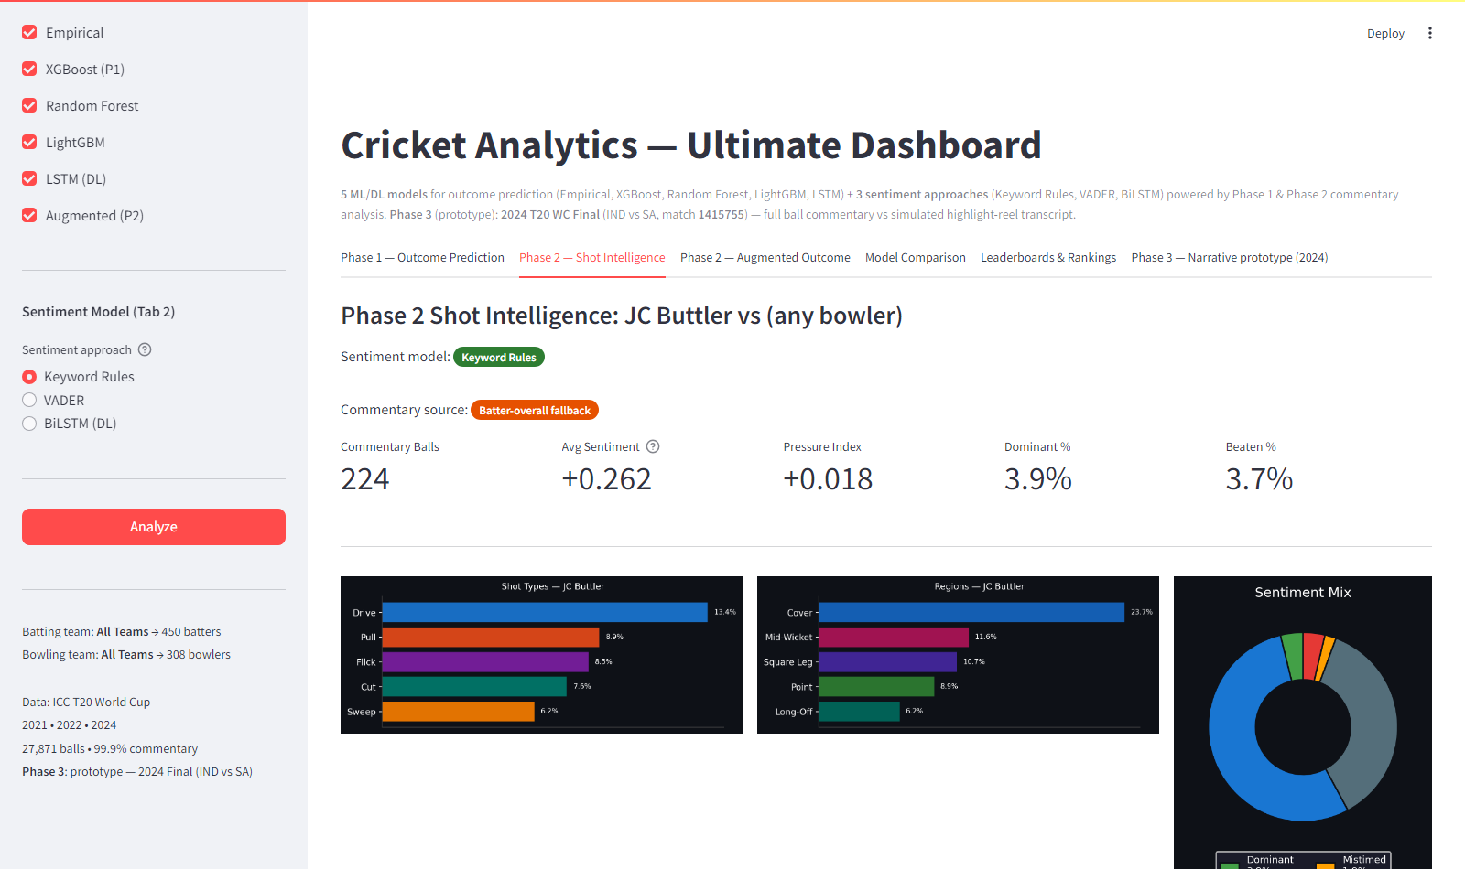
Screenshot 4 — Tab 2: Shot Intelligence (Keyword Rules)

Screenshot 5 — Tab 3: Phase 2 Augmented Outcome
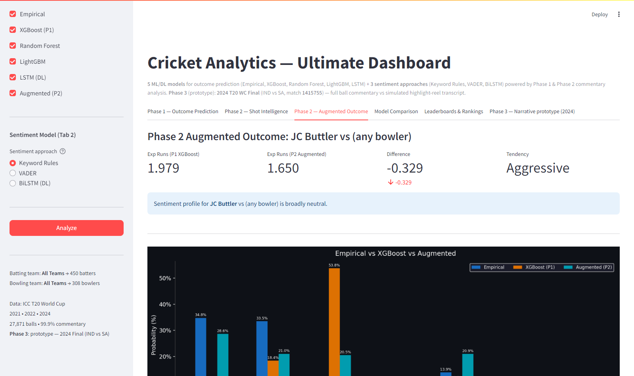
Screenshot 5 — Tab 3: Phase 2 Augmented Outcome

Screenshot 6 — Tab 4: Model Comparison
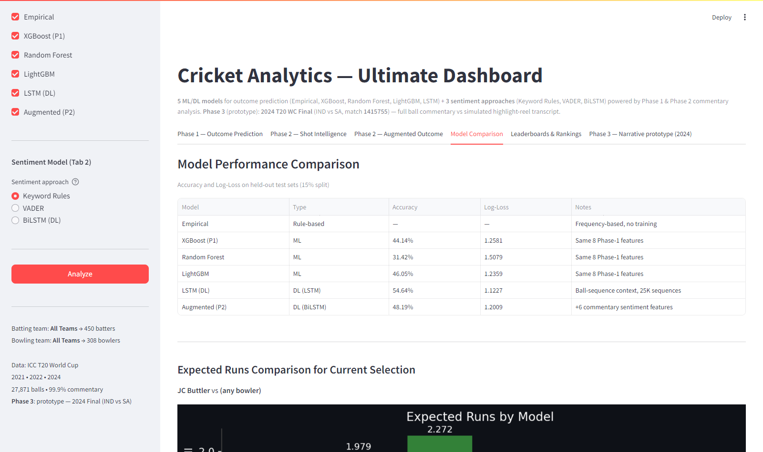
Screenshot 6 — Tab 4: Model Comparison

Screenshot 7 — Tab 5: Leaderboards & Rankings
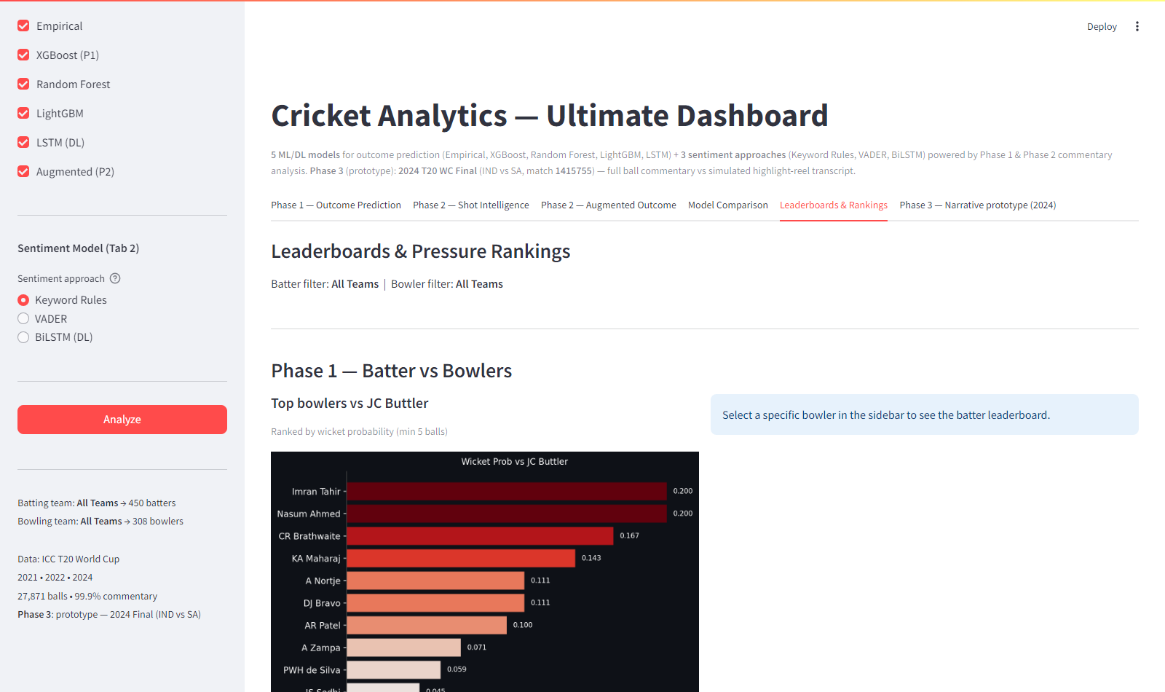
Screenshot 7 — Tab 5: Leaderboards & Rankings

Screenshot 8 — Tab 6: Phase 3 Narrative (2024 final)
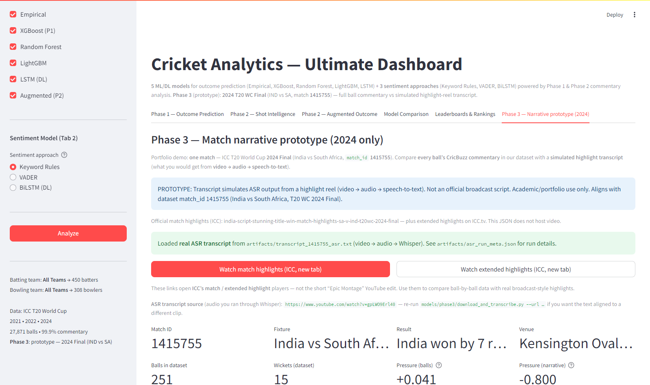
Screenshot 8 — Tab 6: Phase 3 Narrative (2024 final)

Detailed UI Explanation

Document 3 — UI Guide with Screenshots

Cricket Analytics Ultimate Dashboard — Complete Walkthrough
App URL: run streamlit run app.py from models/ultimate_model/ (default port often 8501; use whatever URL Streamlit prints).
This document walks through every part of the Ultimate Dashboard — every tab, every widget, every number explained with annotated screenshots.
────────────────────────────────────────────────────────────

Table of Contents
- App Overview — First Load
- The Sidebar — Controls and Selection
- Tab 1 — Phase 1: Outcome Prediction
- Tab 2 — Phase 2: Shot Intelligence
- Tab 3 — Phase 2: Augmented Outcome
- Tab 4 — Model Comparison
- Tab 5 — Leaderboards & Rankings
- Tab 6 — Phase 3: Narrative Prototype (2024)
- Team Filtering Feature
- Sentiment Model Toggle
────────────────────────────────────────────────────────────

1. App Overview

What you see on first load

Screenshot 1 — App Overview (first load)

When the app opens you see:
Element | Location | What it means
"Cricket Analytics — Ultimate Dashboard" | Top centre | App title
Subtitle line | Below title | Confirms: 5 outcome models + 3 sentiment approaches + Phase 3 narrative prototype (2024 final)
6 tabs | Below subtitle | Phase 1, Phase 2 Shot, Phase 2 Augmented, Model Comparison, Leaderboards, Phase 3 Narrative
Wide main layout | Main column | CSS widens the right-hand content (up to ~1800px) for charts
"Outcome Prediction: JC Buttler vs (any bowler)" | Main area | Default selection — JC Buttler, no specific bowler
"Models selected: Empirical, XGBoost (P1), Random Forest, LightGBM, LSTM (DL)" | Below heading | Confirms which models are active
Data source: Batter overall (orange badge) | Below models | Shows data quality — no specific bowler selected
4 metric cards | Row of numbers | Key prediction metrics per model
Bar chart (dark background) | Lower main area | 5-bar grouped chart per outcome (one bar per model)
Sidebar | Left panel | All player selection and model controls

The default batter is JC Buttler with no specific bowler — so predictions are based on Buttler's overall career stats against all bowlers.
───────────────────────────────────────────────────────────

2. The Sidebar

Full sidebar with model controls

Screenshot 2 — Sidebar: Model Selectors and Sentiment Toggle

The sidebar header shows Cricket Analytics and Phase 1 + Phase 2 + Phase 3 — Ultimate Dashboard.
The sidebar has three main control sections:

Section A — Batter Selection
Batting Team: [All Teams ▾] ← dropdown: filter batter list by country
Select Batter: [JC Buttler ▾] ← dropdown: choose the batter
How to use:
- Select "Batting Team" to filter the batter list to players from one country only
- Example: Select "England" → only England batters appear in "Select Batter"
- 22 teams available (all ICC T20 WC 2021-2024 teams)
- Then select the specific batter from the filtered list

Section B — Bowler Selection
Bowling Team: [All Teams ▾] ← dropdown: filter bowler list by country
Select Bowler (optional): [(Any / Overall) ▾] ← dropdown
How to use:
- Select "(Any / Overall)" → predictions based on batter's overall stats vs all bowlers
- Select a specific bowler → predictions specific to THAT batter vs THAT bowler matchup
- "Bowling Team" filter narrows the bowler dropdown to players from one country
Batting Team and Bowling Team filters are independent — you can select India's batter vs Australia's bowler with no conflict.

Section C — Model Controls
Outcome Models:
[✓] Empirical ← frequency-based statistical model
[✓] XGBoost (P1) ← Phase 1 gradient boosting
[✓] Random Forest ← ensemble tree model
[✓] LightGBM ← fast gradient boosting
[✓] LSTM (DL) ← deep learning sequence model
[✓] Augmented (P2) ← Phase 2 XGBoost with sentiment
Sentiment Model (Tab 2):
(●) Keyword Rules ← rule-based cricket keyword parsing
( ) VADER ← general NLP sentiment
( ) BiLSTM (DL) ← trained deep learning sentiment
Model checkboxes: Uncheck any model to remove it from Tab 1's bar chart and table. Useful for a cleaner comparison (e.g., uncheck RF and Empirical to just compare ML models).
Sentiment radio: Changes which sentiment approach is used in Tab 2 (Shot Intelligence) to compute the Dominant%, Beaten%, Pressure Index, and the sentiment donut chart.

Analyze Button
[ Analyze ] ← big red button
Click this after changing any selection to run predictions with the new inputs. Results also update automatically when you change batter/bowler/models.

Status Footer
Batting team: All Teams → 450 batters
Bowling team: All Teams → 308 bowlers
Data: ICC T20 World Cup
2021 • 2022 • 2024
27,871 balls • 99.9% commentary
Phase 3: prototype — 2024 Final (IND vs SA)
Tells you how many players are currently available given the team filter, confirms the data scope, and reminds you that Phase 3 uses one fixed 2024 final (match_id 1415755).
────────────────────────────────────────────────────────────

3. Tab 1 — Phase 1: Outcome Prediction

Screenshot 3 — Tab 1: Phase 1 Outcome Prediction

This is the primary analysis tab. It shows all selected models' predictions side by side for the chosen batter vs bowler matchup.

Header Section
Outcome Prediction: JC Buttler vs (any bowler)
Models selected: Empirical, XGBoost (P1), Random Forest, LightGBM, LSTM (DL)
Data source: [Batter overall] ← orange badge
Data source badges:
Badge colour | Text | Meaning
Green | Direct matchup | ≥10 balls of head-to-head data — most accurate
Orange | Blended | 1–9 balls, blended 30% matchup + 70% overall
Red | Fallback — batter overall | No matchup data — uses career stats only
Blue | Batter overall | Overall stats (when no bowler selected)
Purple | ML model | XGBoost/RF/LGBM fallback label

Metric Cards Row
Balls on Record: 561
Exp Runs (Empirical): 1.560
Exp Runs (XGBoost P1): 1.979
Exp Runs (Random Forest): 2.272
Exp Runs (LightGBM): 1.152
- Balls on Record: How many balls of data are in the empirical matchup (or batter's overall career balls)
- Exp Runs per model: Expected runs per ball = sum(outcome × probability) for outcomes 0,1,2,3,4,6 (Wicket = 0 runs contribution)
Why do models give different expected runs?
Each model has different internal weights for boundary probability. RF with balanced class weights predicts boundaries more often → higher ER. LSTM with sequence context may suppress boundaries in certain contexts → lower ER.

The Bar Chart
The central chart shows a grouped bar chart — one group per outcome (0 runs, 1 run, 2 runs, 3 runs, 4 runs, 6 runs, Wicket), and within each group, one bar per model.
Bar colours:
- Blue bar: Empirical
- Orange bar: XGBoost (P1)
- Green bar: Random Forest
- Purple bar: LightGBM
- Red bar: LSTM (DL)
How to read it:
- The tallest bar in the "0 runs" group → which model thinks dot balls are most likely
- If the green (RF) bar in "4 runs" is tall → Random Forest predicts boundaries more often than other models
- If the red (LSTM) bar in "W" is short → LSTM gives low wicket probability in this situation

Probability Table
Below the chart is a detailed table:
Outcome | Empirical % | XGBoost (P1) % | Random Forest % | LightGBM % | LSTM (DL) %
0 runs | 30.7% | 28.6% | 16.4% | 28.9% | 43.8%
1 run | 31.5% | 20.5% | 21.9% | 22.5% | 33.7%
2 runs | 4.6% | 13.8% | 14.8% | 5.6% | 3.9%
...

The table has blue gradient shading — darker blue = higher probability. Useful for quickly spotting which outcomes each model is most confident about.
────────────────────────────────────────────────────────────

4. Tab 2 — Phase 2: Shot Intelligence

Screenshot 4 — Tab 2: Shot Intelligence (Keyword Rules)

This tab shows the commentary-derived intelligence for the selected batter vs bowler, using whichever sentiment model is selected in the sidebar.

Header and Badges
Phase 2 Shot Intelligence: JC Buttler vs (any bowler)
Sentiment model: [Keyword Rules] ← green badge (changes per sidebar selection)
Commentary source: [Batter-overall fallback] ← orange badge
Commentary source badges:
- Green "Direct pair data" → uses data from the specific batter-bowler matchup's commentary
- Orange "Batter-overall fallback" → not enough pair commentary, uses batter's overall commentary vs all bowlers

Metric Cards (5 cards)
Commentary Balls: 224
Avg Sentiment: +0.262
Pressure Index: +0.018
Dominant %: 3.9%
Beaten %: 3.7%
What each means:
Metric | Range | Interpretation
Commentary Balls | Integer | Number of deliveries with parsed commentary
Avg Sentiment | -1.0 to +1.0 | Average score across all balls. Positive = more dominant, negative = more pressure
Pressure Index | Any float | beaten% + mistimed% - dominant%. Higher = more pressure on batter
Dominant % | 0–100% | Percentage of balls where batter was described as dominant (FOUR, SIX, smashed, etc.)
Beaten % | 0–100% | Percentage of balls where batter was beaten or missed completely

For JC Buttler overall:
- Avg Sentiment +0.262 → slightly positive (in control on average)
- Pressure Index +0.018 → very slight pressure (nearly balanced)
- Low Dominant% and Beaten% suggest a controlled, conservative batting style

Three Chart Panels
Left panel — Shot Types bar chart:
Drive ──────────────────── 53.6%
Pull ──────────── 9.0%
Flick ────────── 8.1%
Cut ─────── 7.6%
Sweep ─── 3.7%
Shows what percentage of commentary-tagged balls involved each shot type. Longer bar = more frequently used shot.
Middle panel — Regions bar chart:
Cover ────────────────────── 25.7%
Mid-Wicket ──────────── 11.0%
Square Leg ──────── 10.1%
Point ──── 4.5%
Long-Off ─── 4.7%
Shows where the batter tends to hit the ball. Useful for fielding placement analysis.
Right panel — Sentiment Donut chart:
The donut shows the proportion of balls tagged with each sentiment label:
- Green segment: DOMINANT
- Blue segment: CONTROLLED
- Dark grey: DEFENSIVE
- Yellow: MISTIMED
- Red: BEATEN
A large blue/green segment = batter in control.
A large red/yellow segment = batter under pressure.

Full Sentiment Breakdown Table
Below the charts, a detailed table appears:
Signal | Value | Meaning
Dominant | 3.9% | Boundaries and big shots — batter in control
Controlled | 54.0% | Timed singles/doubles — batter comfortable
Defensive | 36.5% | Blocked/played out — safe but passive
Mistimed | 1.9% | Top/leading edges — not timing well
Beaten | 3.7% | Beaten / missed completely
Boundary Hit | 13.8% | Actual boundary rate in commentary balls
Dot Ball | 30.4% | Actual dot ball rate
Pressure Index | +0.018 | beaten% + mistimed% - dominant%

────────────────────────────────────────────────────────────

Switching Sentiment Model (VADER or BiLSTM)
Change the radio button in the sidebar under "Sentiment Model (Tab 2)":
With VADER selected: The Avg Sentiment, Pressure Index, and donut chart recalculate using VADER's lexicon-based scoring. VADER tends to be more positive on cricket text than keyword rules because boundary commentary often has celebratory language VADER recognises.
With BiLSTM selected: The full commentary text is run through the trained BiLSTM model in real time. This may take 2–5 seconds for large batter/bowler combinations. The BiLSTM's learned patterns often produce more nuanced sentiment distributions than keyword rules.
A comparison table appears (VADER/BiLSTM only): When a non-keyword model is selected, a table appears comparing Keyword Rules % vs the selected model % for each sentiment class.
────────────────────────────────────────────────────────────

5. Tab 3 — Phase 2: Augmented Outcome

Screenshot 5 — Tab 3: Phase 2 Augmented Outcome

This tab shows the Augmented XGBoost model's predictions — the model that adds 6 commentary sentiment features to the 8 Phase 1 features.

Metric Cards (4 cards)
Exp Runs (P1 XGBoost): 1.979
Exp Runs (P2 Augmented): 1.650
Difference: -0.329 ↓ (shown in red)
Tendency: Aggressive
- P1 XGBoost expected runs: Prediction from Phase 1 model (8 features)
- P2 Augmented expected runs: Prediction from Phase 2 model (14 features, including sentiment)
- Difference: How much the sentiment features changed the prediction. Negative = Phase 2 thinks fewer runs than Phase 1. Positive = Phase 2 is more optimistic.
- Tendency: Batter tendency (Aggressive SR≥140 / Balanced SR≥100 / Defensive SR<100)

Sentiment Context Box
"Sentiment profile for JC Buttler vs (any bowler) is broadly neutral."
This box shows one of three messages:
- "Batter is in dominant form" → sentiment score >0.3 and dominant% >5%
- "Batter is under pressure" → pressure index >0.05 and beaten% >5%
- "Broadly neutral" → neither extreme

Three-Way Bar Chart
Shows Empirical vs XGBoost (P1) vs Augmented (P2) side by side:
0 runs: Empirical 36.8% XGBoost 28.6% Augmented 22.5%
1 run: Empirical 26.6% XGBoost 20.5% Augmented 13.5%
4 runs: Empirical 13.9% XGBoost 20.3% Augmented 21.9%
...
Reading the chart: Where Augmented % diverges from XGBoost %, the sentiment features are having an effect. For JC Buttler overall, the Augmented model predicts fewer dots and 1-runs (less conservative) but similar boundary rate — reflecting that commentary describes him as an aggressive player even when not hitting boundaries.

Full Probability Comparison Table
Outcome | Empirical % | P1 XGBoost % | P2 Augmented % | P2 vs P1 diff
0 runs | 36.8% | 28.6% | 22.5% | -6.1% (red)
1 run | 26.6% | 20.5% | 13.5% | -7.0% (red)
4 runs | 13.9% | 20.3% | 21.9% | +1.6% (green)

Diff column: green = Augmented predicts higher probability, red = lower probability.

Phase 2 Model Improvement Expander
Click to expand and see:
| Model | Accuracy | Log-Loss |
| Baseline | 43.77% | 1.2581 |
| Augmented | 48.19% | 1.2009 |
| Improvement| +4.43% | -0.057 |
Plus an explanation of the 6 sentiment features and feature importance rankings.
────────────────────────────────────────────────────────────

6. Tab 4 — Model Comparison

Screenshot 6 — Tab 4: Model Comparison

This tab is the technical scorecard — all models compared on accuracy, loss, and expected runs for the current selection.

Model Performance Table
Model | Type | Accuracy | Log-Loss | Notes
Empirical | Rule-based | — | — | Frequency-based, no training
XGBoost (P1) | ML | 44.14% | 1.2581 | Same 8 Phase-1 features
Random Forest | ML | 31.42% | 1.5079 | Same 8 Phase-1 features
LightGBM | ML | 46.05% | 1.2359 | Same 8 Phase-1 features
LSTM (DL) | DL (LSTM) | 54.64% | 1.1227 | Ball-sequence context, 25K sequences
Augmented (P2) | DL (BiLSTM) | 48.19% | 1.2009 | +6 commentary sentiment features

What the columns mean:
- Type: Rule-based = no training; ML = traditional machine learning; DL = deep learning neural network
- Accuracy: Percentage of test set balls where the model predicted the correct outcome class. Higher is better.
- Log-Loss: Measures how well-calibrated the probability estimates are. Lower is better. A model with low log-loss gives confident probabilities for outcomes that actually happen.
- Notes: Key architectural detail

Expected Runs Comparison Bar Chart
A bar chart below the table shows the Expected Runs per ball for the current selection (JC Buttler vs any bowler) from each model:
Empirical: 1.560
XGBoost (P1): 1.979
Random Forest: 2.272 ← highest (balanced class weights)
LightGBM: 1.152 ← lowest
LSTM: 1.401
Augmented P2: 1.650
The chart makes it visually clear which models are bullish vs bearish for this batter, useful for identifying systematic biases per model.

Sentiment Approach Comparison Table
Model | Type | Accuracy | Vocab | Speed | Key Advantage
Keyword Rules | Rule-based | Ground truth | ~80 patterns | Instant | Cricket-specific, interpretable
VADER | Rule-based NLP | 18.8% vs keywords | General English | Instant | No training, standard NLP
BiLSTM (DL) | Deep Learning | 96.8% vs keywords | 5,000 commentary words | ~1s per batch | Generalises beyond keyword list

Important note: The "Accuracy" for sentiment models is measured against keyword rules (which are used as ground truth), not against an external gold standard.
────────────────────────────────────────────────────────────

7. Tab 5 — Leaderboards & Rankings

Screenshot 7 — Tab 5: Leaderboards & Rankings

This tab shows two types of rankings:

Phase 1 — Batter vs Bowlers (top section)
Left column: "Top bowlers vs [selected batter]"
A horizontal bar chart ranked by wicket probability — which bowlers have historically taken the current batter's wicket most often:
Top bowlers vs JC Buttler (wicket probability):
Imran Tahir ──────────────────── 0.200
Nasum Ahmed ──────────────────── 0.200
CR Brathwaite ────────────── 0.167
KA Maharaj ─────────── 0.143
A Nortje ──────── 0.111
DJ Bravo ──────── 0.111
...
Caption: "Ranked by wicket probability (min 5 balls)"
Right column: "Top batters vs [selected bowler]"
Only appears when a specific bowler is selected. Shows which batters score most freely against that bowler, ranked by expected runs per ball.

Phase 2 — Pressure Rankings (bottom section)
Left column: "Most pressured batters"
Batters ranked by average pressure index across all their matchups (minimum 20 commentary balls):
Pressure Index (Batters):
[batter names ranked by avg_pressure_index]
Positive values → under more pressure from bowlers
Negative values → tend to dominate bowlers
Right column: "Bowlers creating most pressure"
Bowlers ranked by how much pressure they create across all their matchups:
Pressure Index (Bowlers):
[bowler names ranked by avg_pressure_index they impose]
Higher = better at pressuring batters

Using the Team Filters with Leaderboards
The team filters in the sidebar (Batting Team / Bowling Team) also affect the leaderboards:
- Batting Team filter narrows "Top batters vs [bowler]" to players from that team
- Bowling Team filter narrows "Top bowlers vs [batter]" to players from that team
- Pressure Rankings: batting team filter applies to batter rankings, bowling team filter to bowler rankings
────────────────────────────────────────────────────────────

8. Tab 6 — Phase 3: Narrative prototype (2024)

Screenshot 8 — Tab 6: Phase 3 Narrative (2024 final)

Phase 3 is a portfolio prototype: one match only — ICC Men’s T20 World Cup 2024 Final, India vs South Africa (match_id 1415755). It does not use the sidebar batter/bowler selection.

What it compares
Source | What it is
Ball commentary (blue bars / left donut) | Every CricBuzz commentary ball in the dataset for that match — same keyword sentiment rules as Phase 2
Highlight narrative (red bars / right donut) | Text from video → audio → Whisper (ASR) on a YouTube match highlights clip, or the JSON fallback if no ASR file is present

When models/phase3/artifacts/transcript_1415755_asr.txt exists, a green banner confirms real ASR is loaded; asr_run_meta.json records the exact source_url used.

ICC watch buttons (new tab)
Two link buttons open official ICC pages (not embedded video):
- Match highlights — ICC.tv match highlights player for IND vs SA Final
- Extended highlights — longer ICC package for the same final
Use these for broadcast-style viewing; ASR uses a downloadable YouTube highlights reel for the pipeline.

Charts and metrics
- Grouped bar chart — sentiment mix (% Dominant, Controlled, Defensive, Mistimed, Beaten) for balls vs narrative sentences
- Two donuts — same comparison visually
- Pressure Index — beaten + mistimed − dominant for both sides
- Expander — full ASR transcript (or placeholder text)

Pipeline scripts (offline)
- models/phase3/download_and_transcribe.py — yt-dlp → ffmpeg → OpenAI Whisper → updates transcript + asr_run_meta.json
- Media files live under models/phase3/media/ (gitignored); small text artifacts stay in artifacts/
────────────────────────────────────────────────────────────

9. Team Filtering Feature
The team filters are the most powerful selection tool in the sidebar.
Example — Finding India vs Australia matchup analysis:
- Under "Batter" section → set "Batting Team" to India
- The "Select Batter" dropdown now shows only Indian players (e.g., V Kohli, RG Sharma, KL Rahul)
- Under "Bowler" section → set "Bowling Team" to Australia
- The "Select Bowler" dropdown now shows only Australian players (e.g., A Nortje, MA Starc, A Zampa)
- Select batter and bowler from the filtered lists
- Click Analyze
All 22 teams available:
Australia, Bangladesh, Canada, England, Hong Kong, India, Ireland, Namibia, Nepal, Netherlands, New Zealand, Oman, Pakistan, Papua New Guinea, Scotland, South Africa, Sri Lanka, Uganda, United Arab Emirates, United States of America, West Indies, Zimbabwe
Sidebar status shows count:
Batting team: India → 25 batters
Bowling team: Australia → 13 bowlers
Fallback: If a team has no players in the dataset (unlikely but possible for very minor teams), the filter falls back to showing all players.
────────────────────────────────────────────────────────────

10. Sentiment Model Toggle
The radio button under "Sentiment Model (Tab 2)" in the sidebar controls which method is used to compute sentiment in Tab 2 only (Shot Intelligence).

Option 1: Keyword Rules (default)
- Uses pre-computed values from sentiment_stats.csv
- Instant — no additional computation at runtime
- Most accurate for cricket commentary
- The values shown in Tab 2 match exactly what was computed by pressure_builder.py

Option 2: VADER
- Runs VADER's polarity_scores() on every commentary string for the selected batter/bowler pair in real time
- Takes 1–3 seconds depending on the number of balls
- Uses cricket-enhanced lexicon (with custom scores for "six", "four", "beaten", etc.)
- Results are noticeably different from Keyword Rules — VADER tends to see more "neutral" or misclassified balls

Option 3: BiLSTM (DL)
- Runs the trained BiLSTM model on every commentary string for the selected pair in real time
- Takes 2–8 seconds depending on number of balls
- Most computationally expensive but also most accurate
- Produces a comparison table showing Keyword Rules % vs BiLSTM % per sentiment class
When to use each:
- Keyword Rules → everyday use, fastest, cricket-specific
- VADER → research comparison, see how general NLP compares
- BiLSTM → deeper analysis where you want the learned model's opinion, or for research/presentation purposes
────────────────────────────────────────────────────────────

Quick Reference — All UI Elements
UI Element | Location | What it controls
Batting Team dropdown | Sidebar | Filters batter list
Select Batter dropdown | Sidebar | Choose batter
Bowling Team dropdown | Sidebar | Filters bowler list
Select Bowler dropdown | Sidebar | Choose bowler (optional)
Empirical checkbox | Sidebar | Show/hide Empirical in Tab 1
XGBoost (P1) checkbox | Sidebar | Show/hide XGBoost in Tab 1
Random Forest checkbox | Sidebar | Show/hide RF in Tab 1
LightGBM checkbox | Sidebar | Show/hide LightGBM in Tab 1
LSTM (DL) checkbox | Sidebar | Show/hide LSTM in Tab 1
Augmented (P2) checkbox | Sidebar | Show/hide Aug. in Tab 1
Sentiment approach radio | Sidebar | Which sentiment method Tab 2 uses
Analyze button | Sidebar | Refresh all predictions
Status footer | Sidebar bottom | Shows player counts + data info
Tab 1 bar chart | Main area | 5-model probability comparison
Tab 1 metric cards | Main area | Expected runs per model
Tab 1 table | Main area | Detailed probability per outcome
Tab 2 metric cards | Main area | Commentary balls, sentiment, pressure
Tab 2 shot chart | Main area | Shot type frequency bars
Tab 2 region chart | Main area | Region frequency bars
Tab 2 donut | Main area | Sentiment proportion pie
Tab 2 breakdown table | Main area | Full sentiment label breakdown
Tab 3 cards | Main area | P1 vs P2 expected runs + diff
Tab 3 context box | Main area | Sentiment narrative
Tab 3 3-way chart | Main area | Empirical vs XGB vs Augmented
Tab 3 expander | Main area | Model accuracy history
Tab 4 accuracy table | Main area | All models accuracy + log-loss
Tab 4 ER bar chart | Main area | Expected runs by model
Tab 4 sentiment table | Main area | VADER vs BiLSTM vs Keywords
Tab 5 wicket chart | Main area | Top bowlers vs selected batter
Tab 5 runs chart | Main area | Top batters vs selected bowler
Tab 5 pressure charts | Main area | Pressure index rankings
Tab 6 Phase 3 | Main area | ICC links, ASR vs ball sentiment, donuts
Phase 3 transcript | Tab 6 expander | Full ASR / placeholder text

