Hanwen Zhaang
Project 2
11/20/2019

Story: As a user, I want to add a new product or update a current product in the system.（Manager）

- First we will login to the system (as a manager).  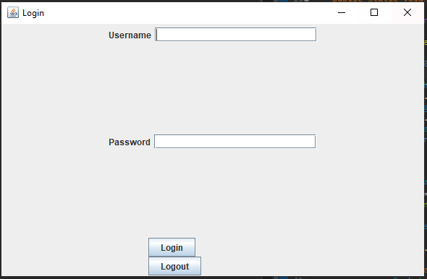 | - After we login, we are presented with the manager view.  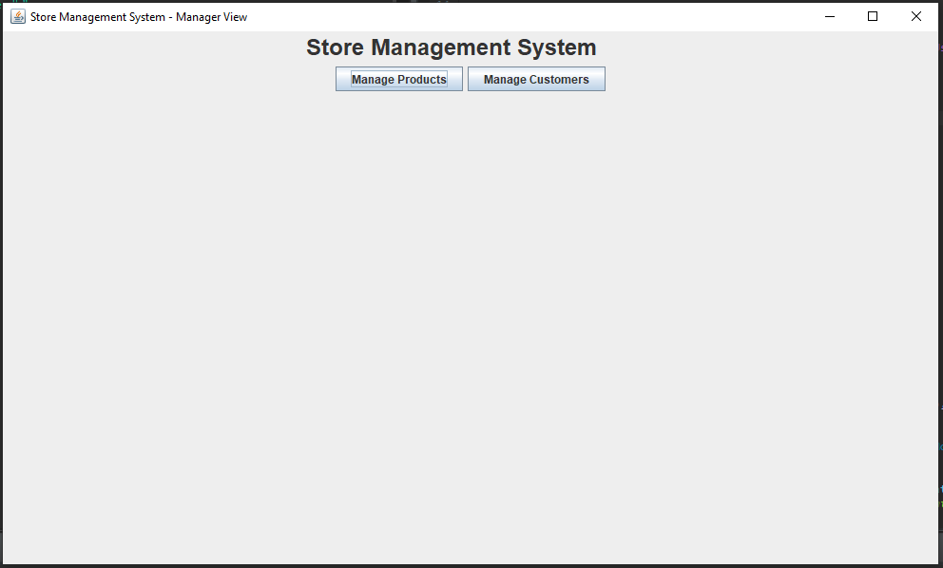
- We then click the “Manage Products” button to add a new product into the system.  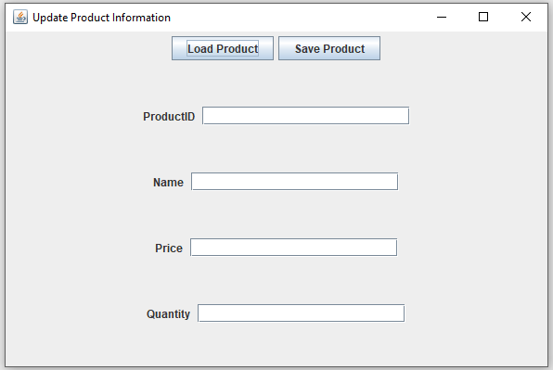 | - Finally we will fill in the information for the new product, and save it into the system. We will receive a message stating our addition was successful.  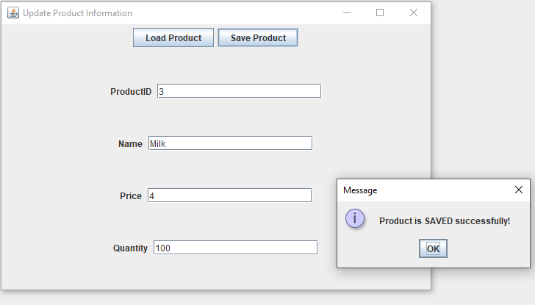

- Login as manager and enter the Manager UI  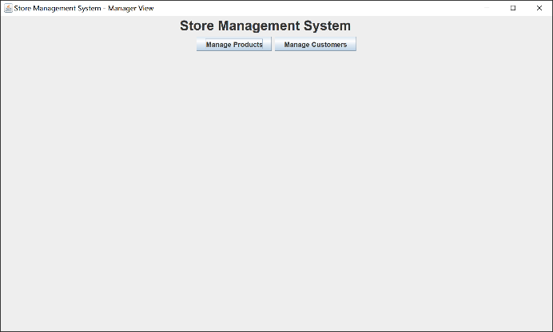 | - Press “Manage Product” to enter the manage product UI  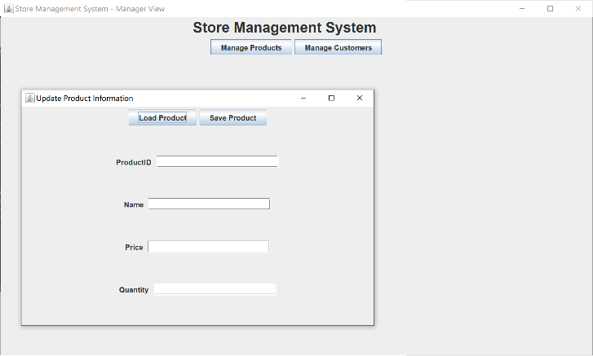
- Enter the Product ID you want to edit  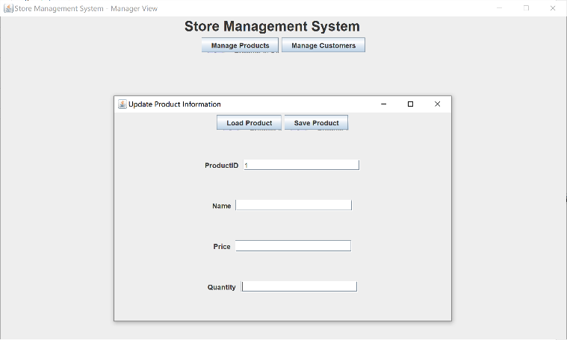 | - Fill all new information and click “Save product” to save.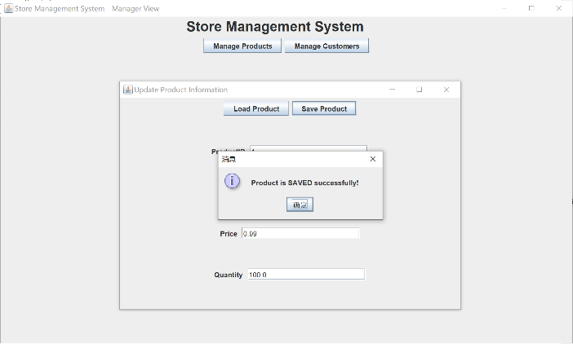

As a user, I want to add a new customer or update a current customer in the system.（Manager）

- Login as manager and enter the Manager UI | - Press “Manage Customer” to enter the manage customer UI  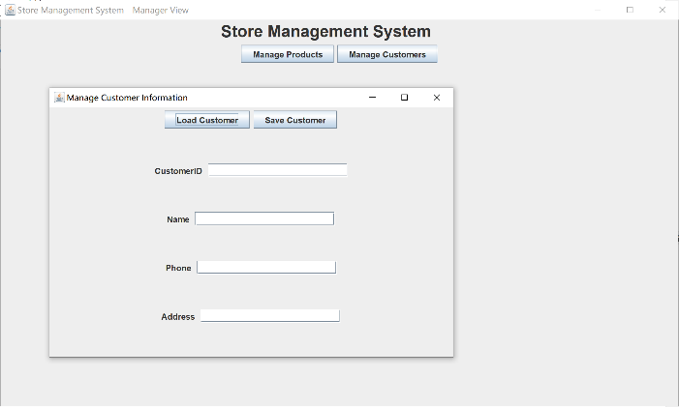
- Fill all required information and click “Save Customer” to save.
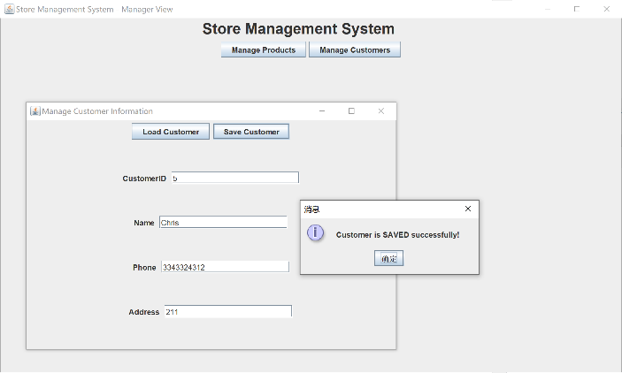

- Login as manager and enter the Manager UI | - Press “Manage Customer” to enter the manage product UI
- Enter the customer ID you want to edit  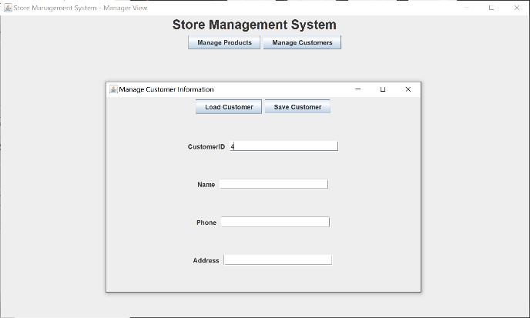 | - Fill all new information and click “Save customer” to save.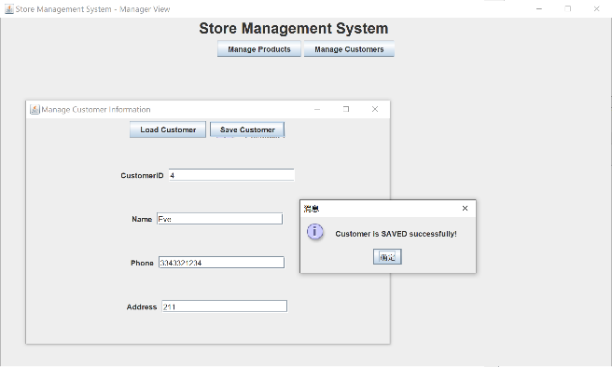

As a user, I want to add a new purchase or update a current purchase in the system.（User）

- Login as customer and enter the Manager UI  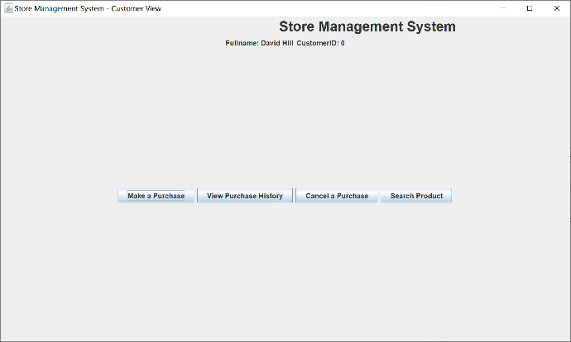 | - Press “Make a Purchase” to enter the urchase UI  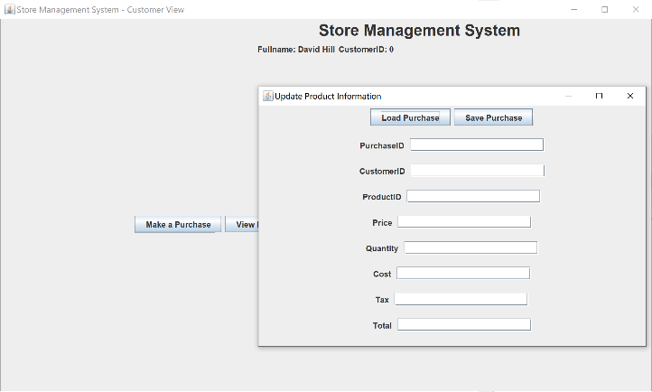
- Fill all required information and click “Save Purchase” to save.
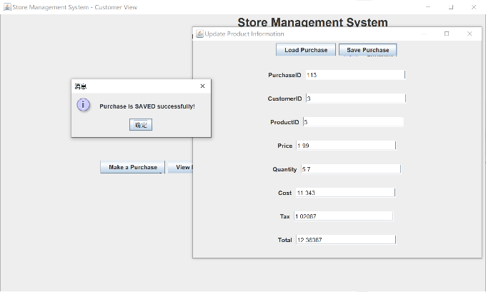

- First we will login to the system (as a customer). | - After we login, we are presented with the customer view.  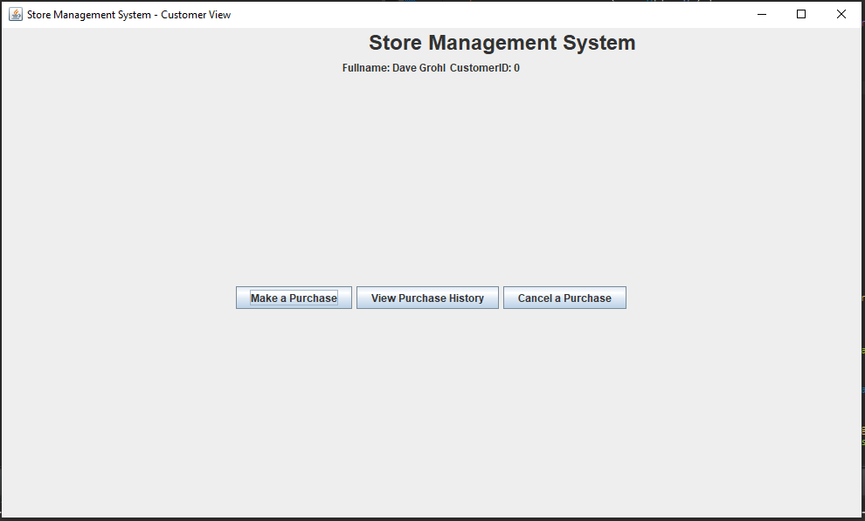
- We then click the “Cancel a Purchase” button to cancel a purchase from the system.  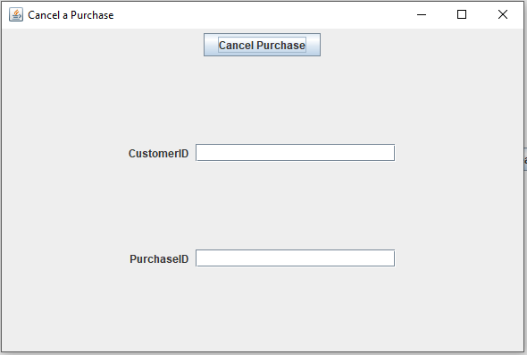 | - Finally we will fill in the information to cancel our purchase. We will receive a message confirming we have cancelled our desired purchase.  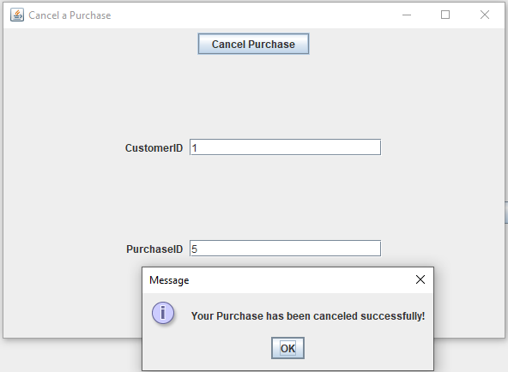

SQL design code:

CREATE TABLE “Customers” (
“CustomerID” INTEGER NOT NULL UNIQUE,
“Name” TEXT NOT NULL,
“Phone” TEXT NOT NULL,
“Address” TEXT NOT NULL
);

CREATE TABLE “Products” (
“ProductID” INTEGER NOT NULL UNIQUE,
“Name” TEXT NOT NULL,
“Price” REAL NOT NULL,
“Quantity” INTEGER NOT NULL
);

CREATE TABLE “Purchases” (
“PurchaseID” INTEGER NOT NULL UNIQUE,
“ProductID” INTEGER NOT NULL,
“CustomerID” INTEGER NOT NULL,
“Price” NUMERIC NOT NULL,
“Quantity” NUMERIC NOT NULL,
“Cost” NUMERIC NOT NULL,
“Tax” NUMERIC NOT NULL,
“Total” INTEGER NOT NULL,
“Date” TEXT NOT NULL
);

CREATE TABLE “Users” (
“Username” TEXT NOT NULL UNIQUE,
“Password” TEXT NOT NULL,
“Fullname” TEXT NOT NULL,
“UserType” INTEGER NOT NULL
);

