Assets – Introduction
This section documents the visual design assets and wireframes for the POS Inventory System.
As the UX Lead, I am responsible for defining and documenting the core user flows, screens, and edge cases to ensure clarity, consistency, and smooth handoff to development.
The documentation is structured by user flow, with each flow broken down into:
- Primary screens representing the normal path
- Edge cases and error states that impact usability and system feedback
My current focus covers:
-Sales Checkout flow
- Login Sub-Flow and related edge cases
- Register selection Sub-Flow and edge cases
- Cashier (checkout)Sub-Flow and edge cases
Each set of screens is designed to reflect the approved requirements, user flows, and UX goals defined in the baseline document, and will be iterated as the product evolves.
Flow 1 - Sales Checkout
Login Sub-Flow – Structure
Purpose
Allow authorized users to access the system securely and quickly.
Prototype link : https://www.figma.com/proto/Sr79pnawyH6JZkpinFPhIS/POS-System_UI_Wireframes?node-id=48-159&t=WhlMmWUaD1e664Xm-1&scaling=contain&content-scaling=fixed&page-id=8%3A4

Primary Screens
- Login Screen
- Username and password (Login CTA)
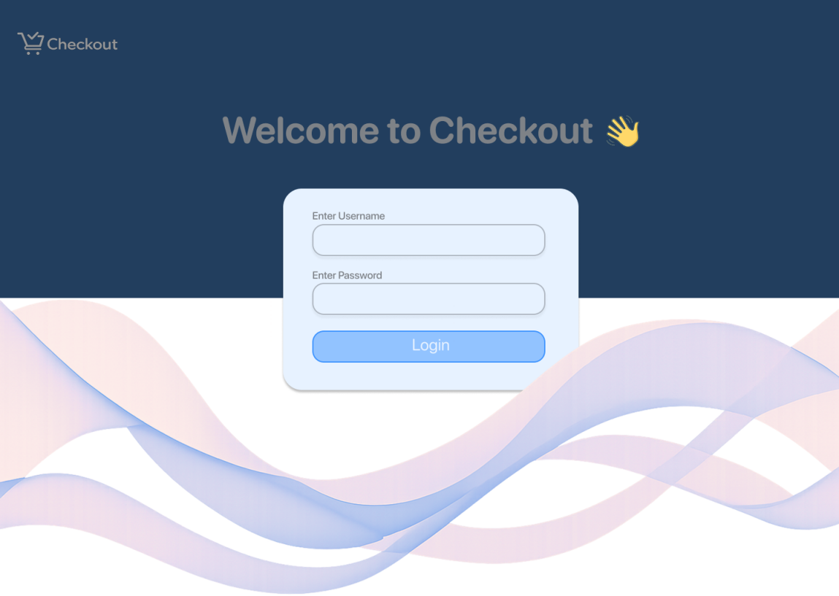

b. Loading state
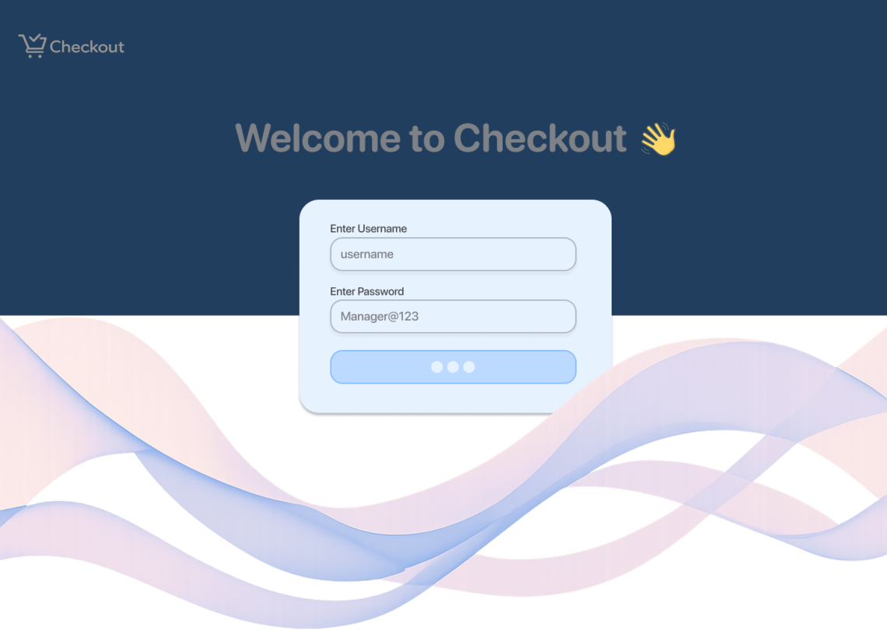

Happy Path
- User enters credentials
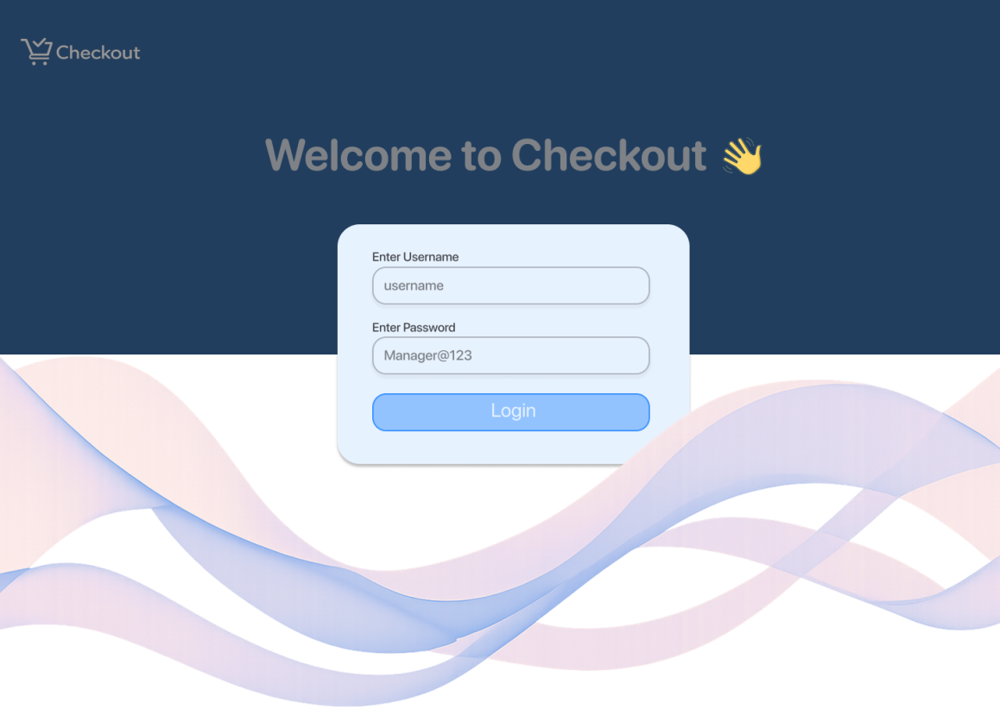

- System validates credentials
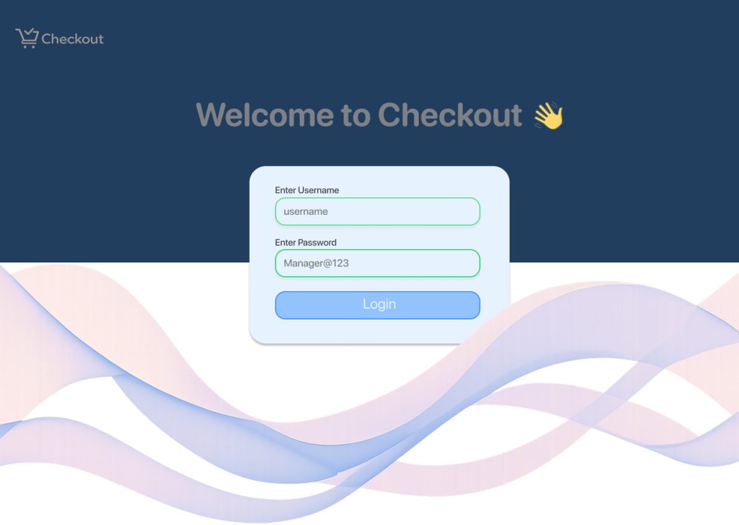

- Successful login → redirect to Register Selection
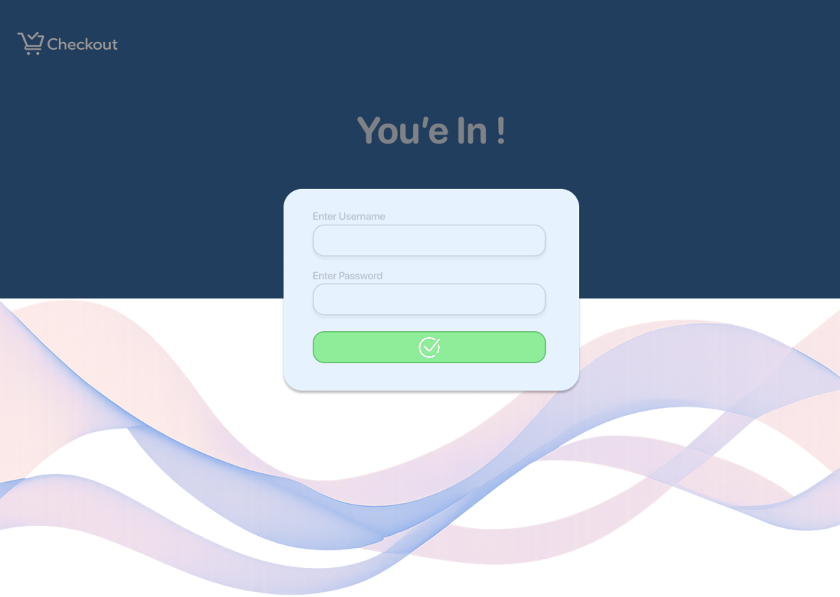
Edge Cases to Design
- Invalid username or password

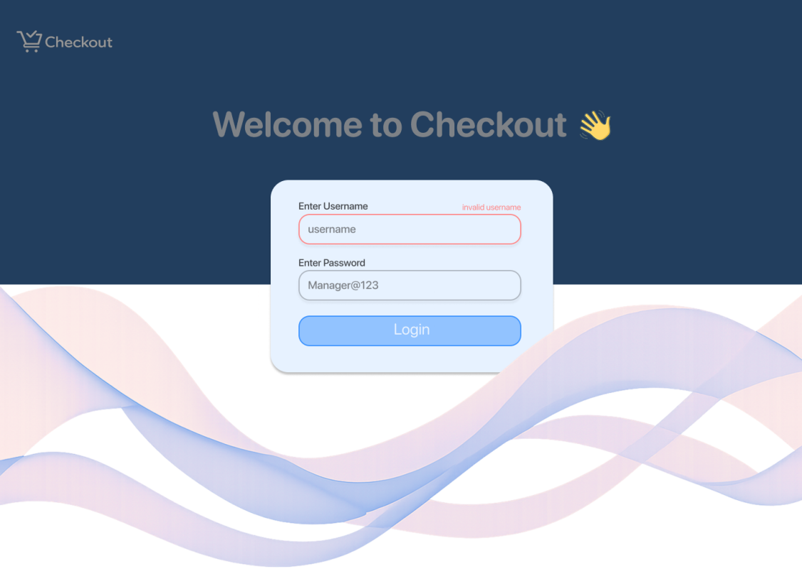

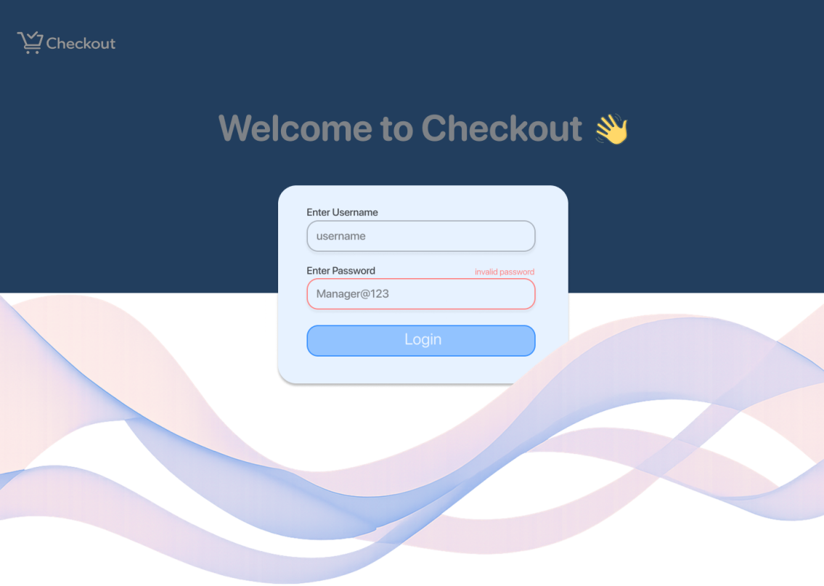

- Empty input fields
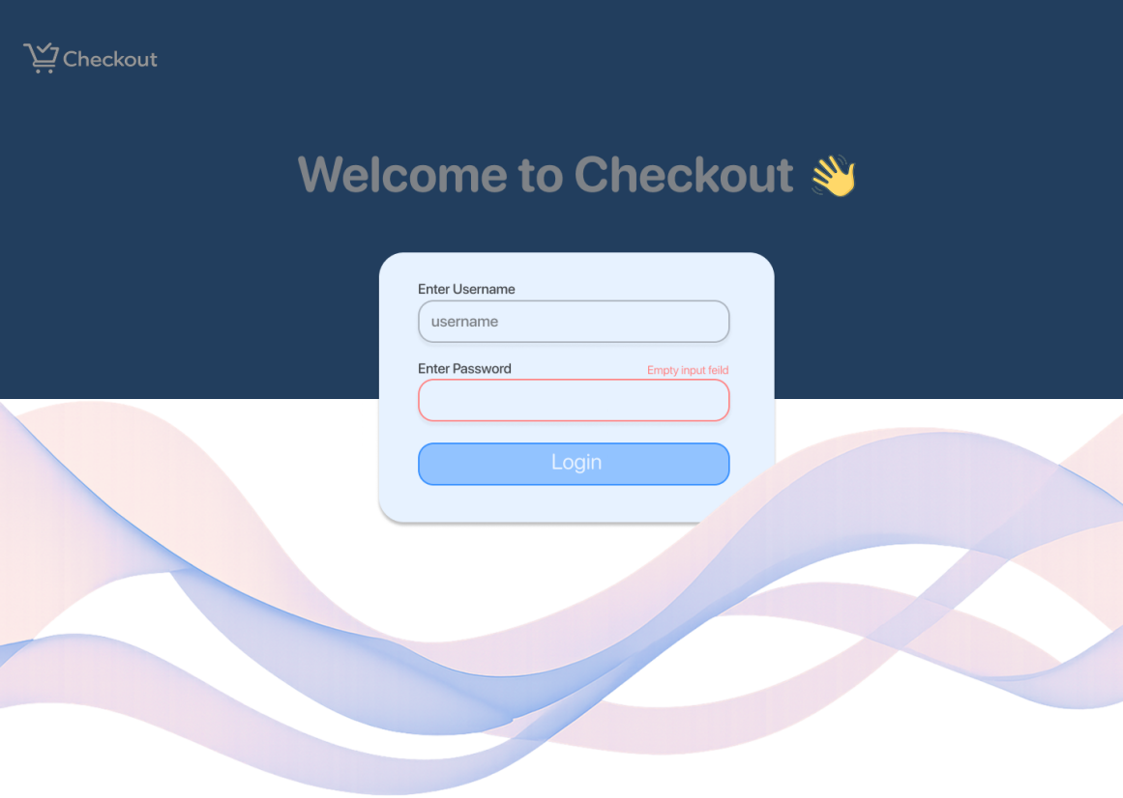

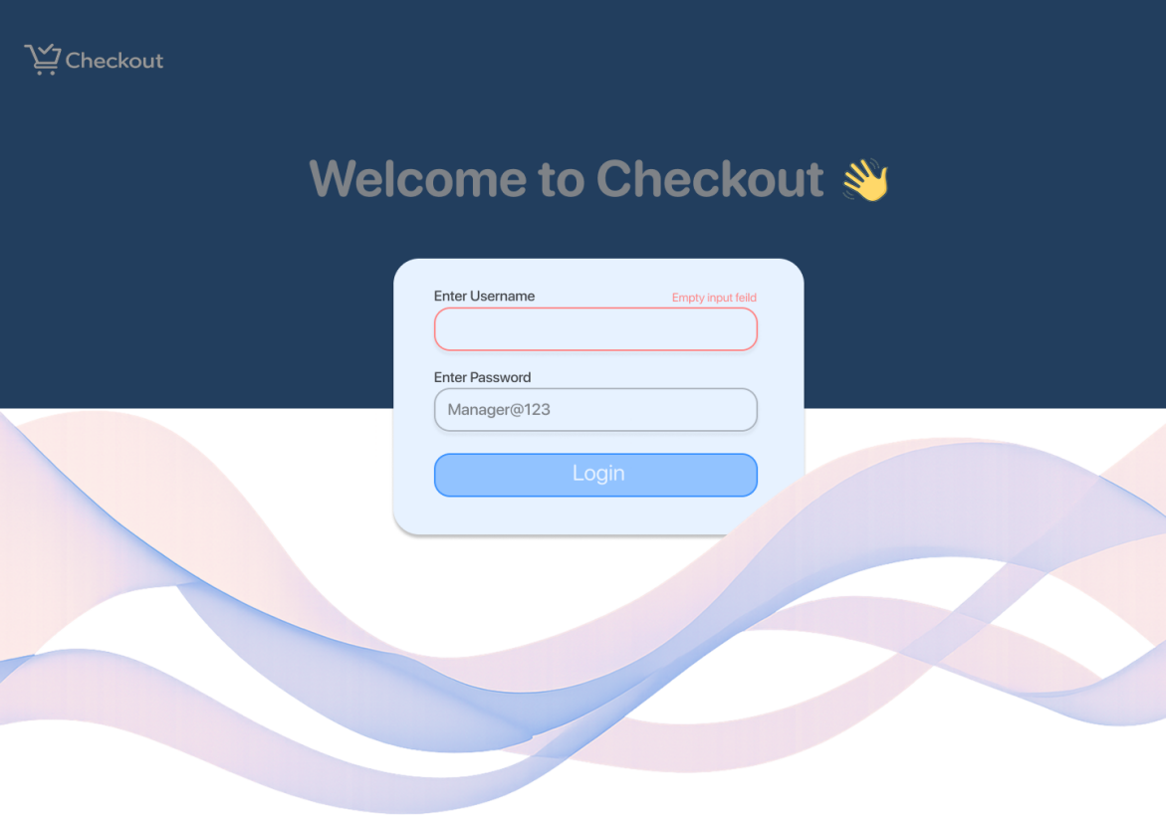

- Account locked or inactive
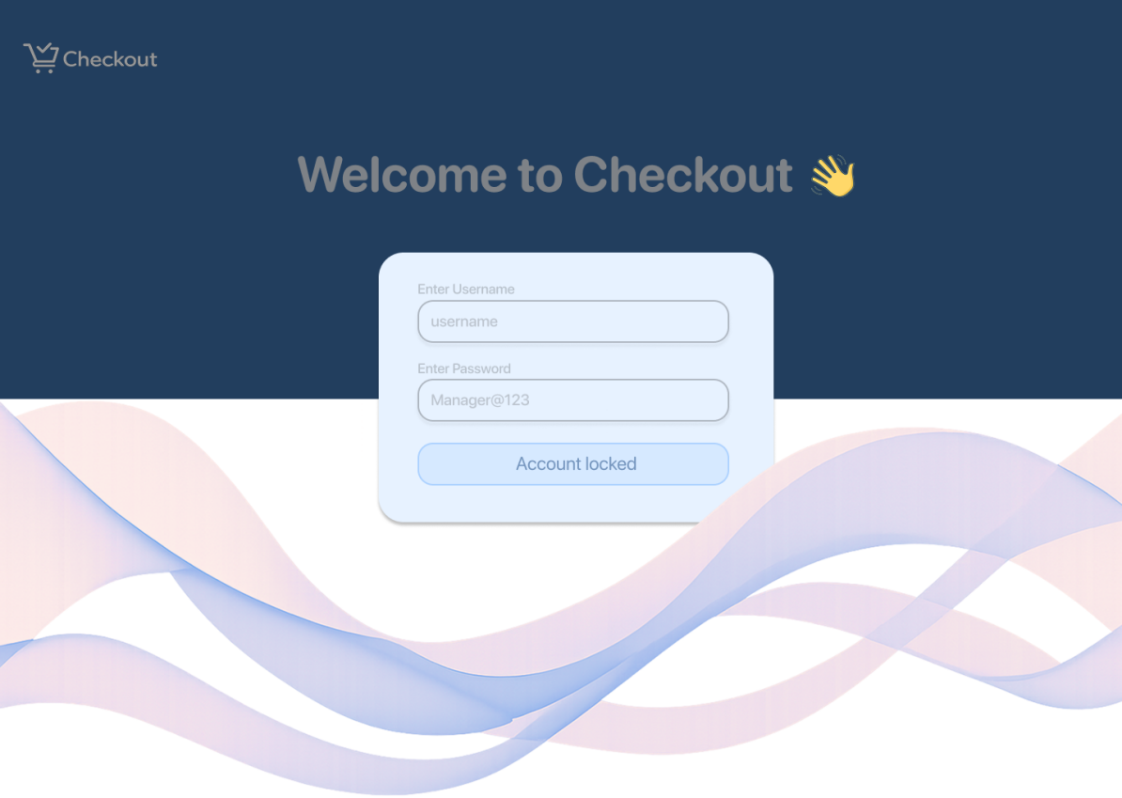

- Network or server error
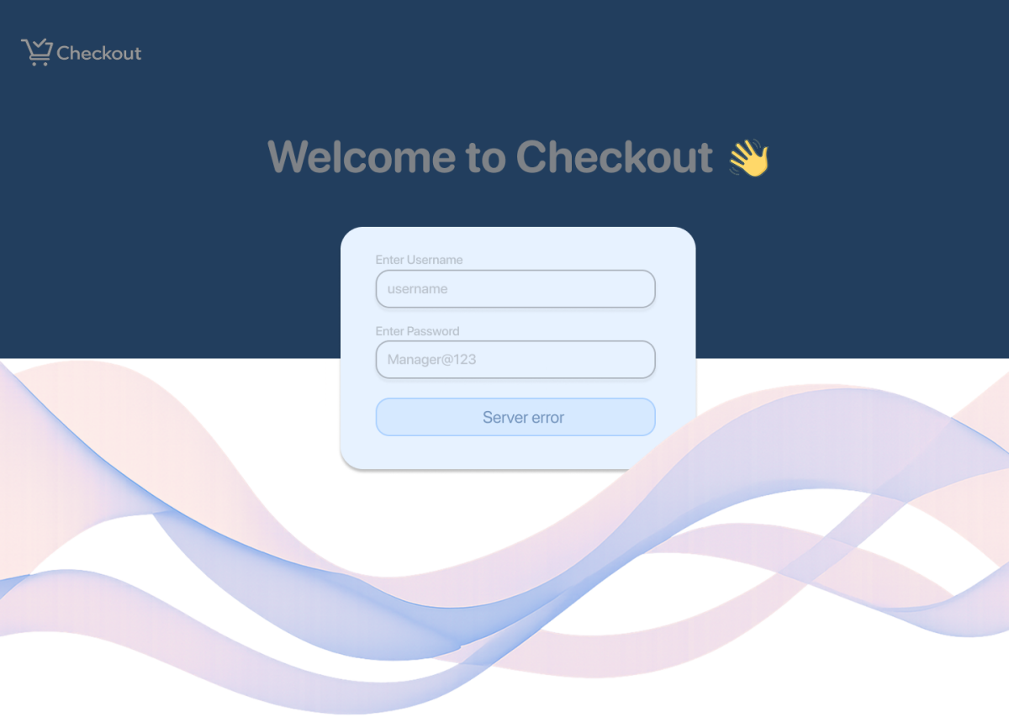
UX Notes
- Disable login button during processing
- Visual feedback for success or failure

Register Selection – Sub-Flow Structure
Purpose
Assign the cashier to an active register before starting sales, ensuring accurate session and transaction tracking.
Primary Screen
- Register Selection Screen (Available / In Use)
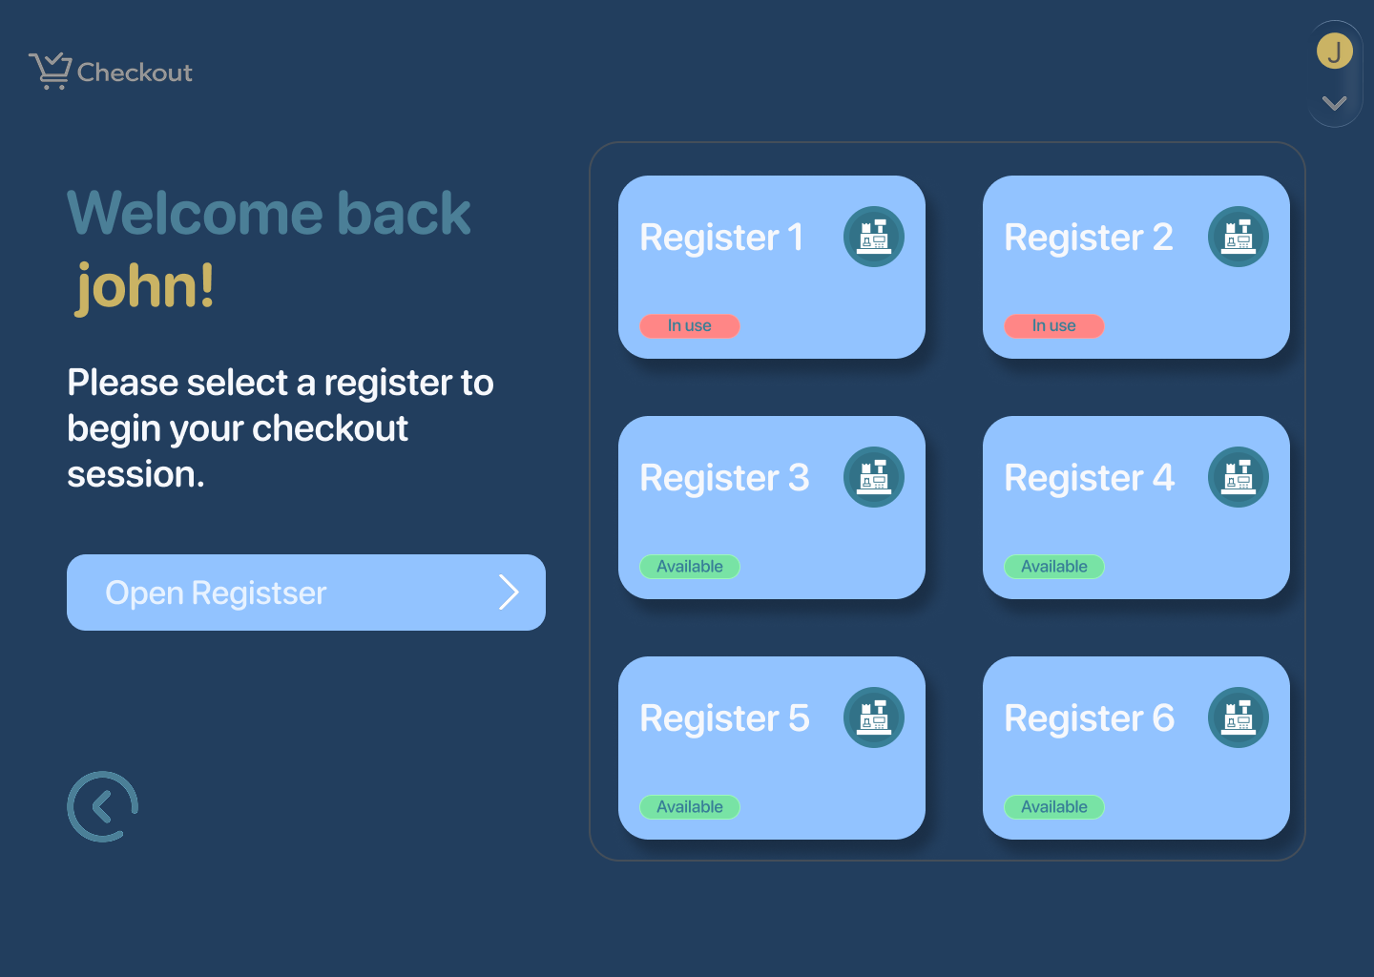

  - List of available registers (Confirm / Continue CTA)
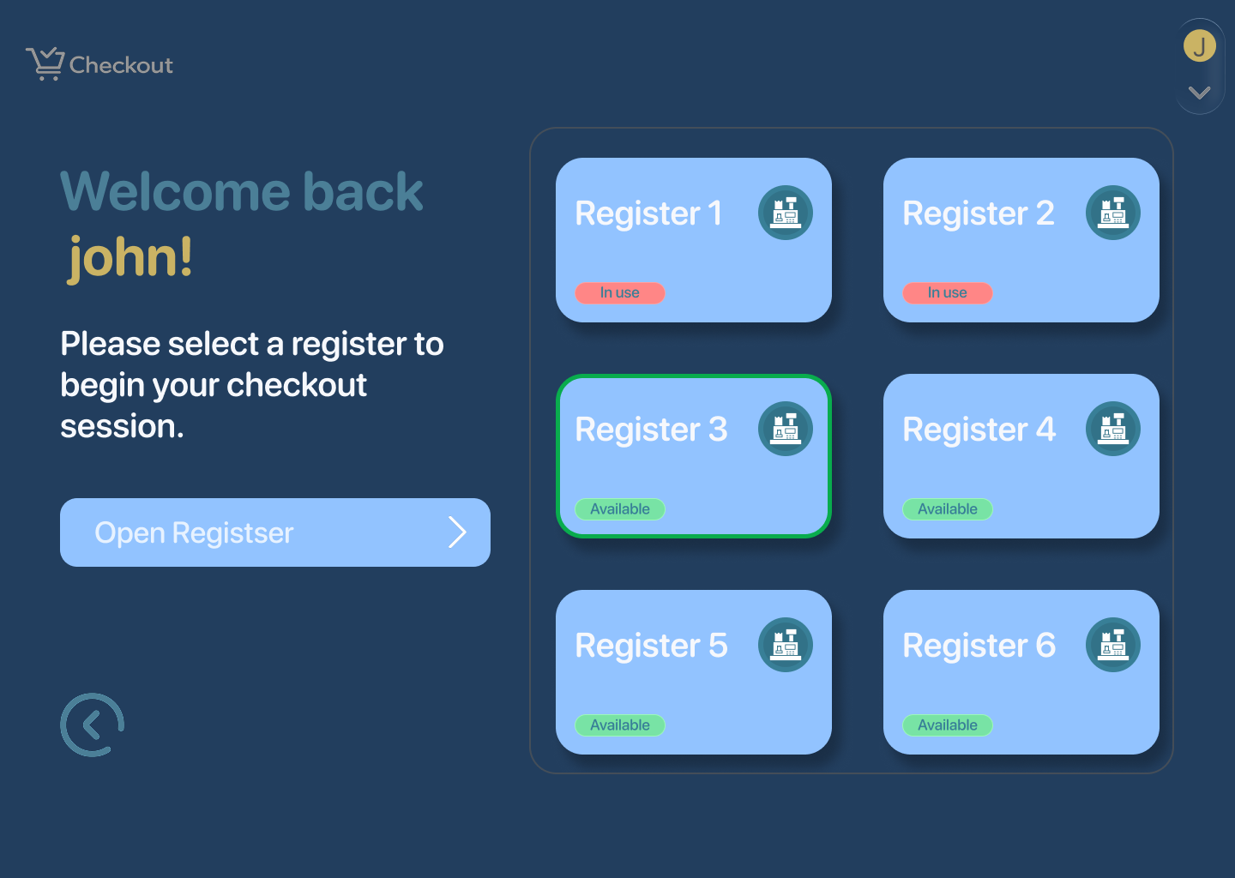

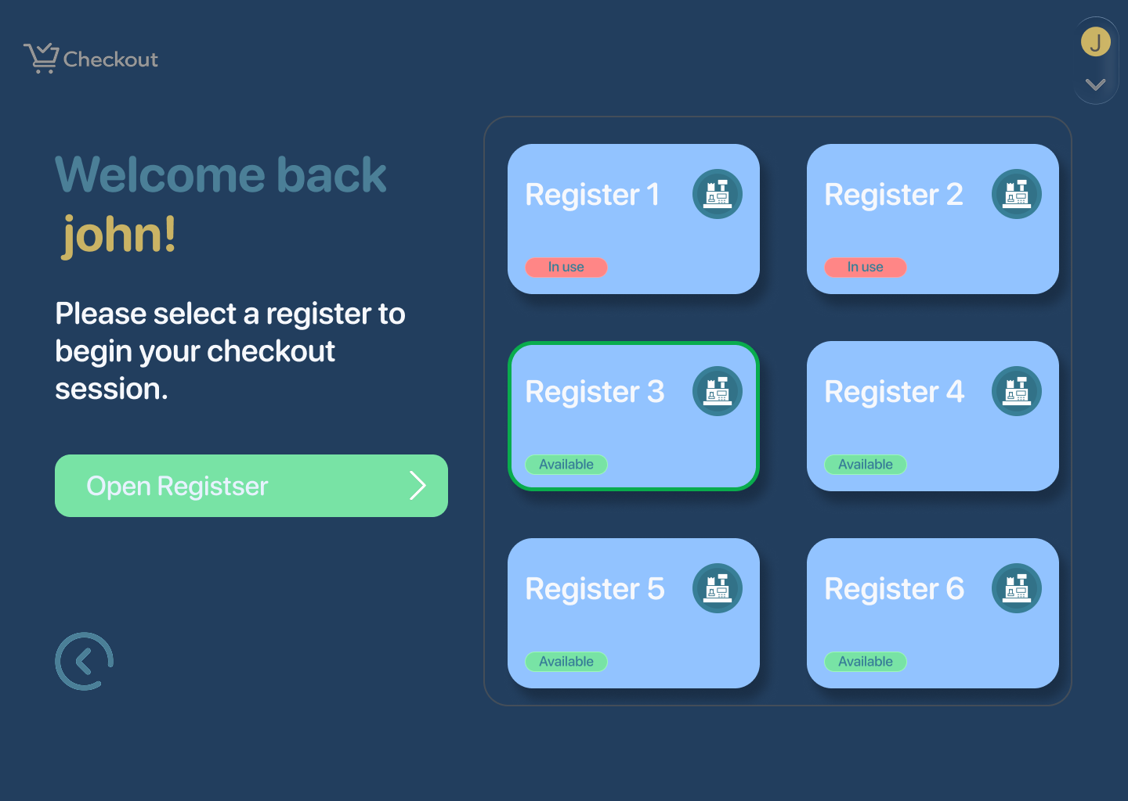
Edge Cases to Design
- Register already in use
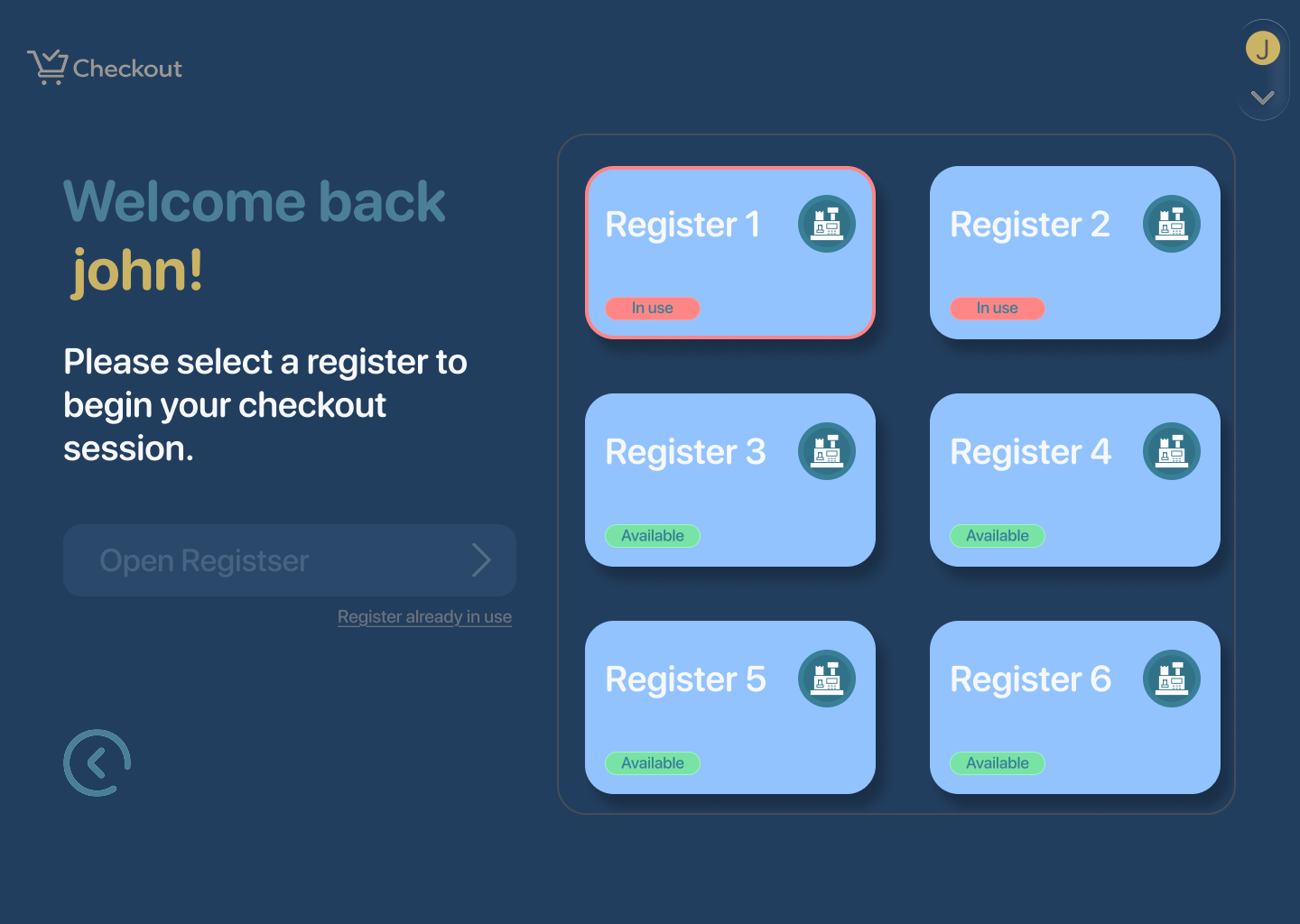
UX Notes
- Show only valid, selectable registers
- Clear error and retry options
- Immediate feedback on successful selection

POS Checkout Screen- Sub-flow Structure

Key Screen
POS Checkout (Main Sales Screen)
This single screen handles scanning, product search, cart review, discounts, payment, and sale completion:
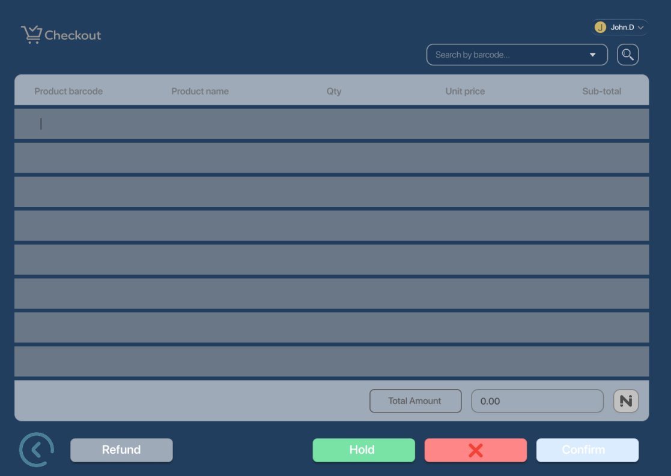

Happy Path
- Product Scanned
  - Scanned products appear
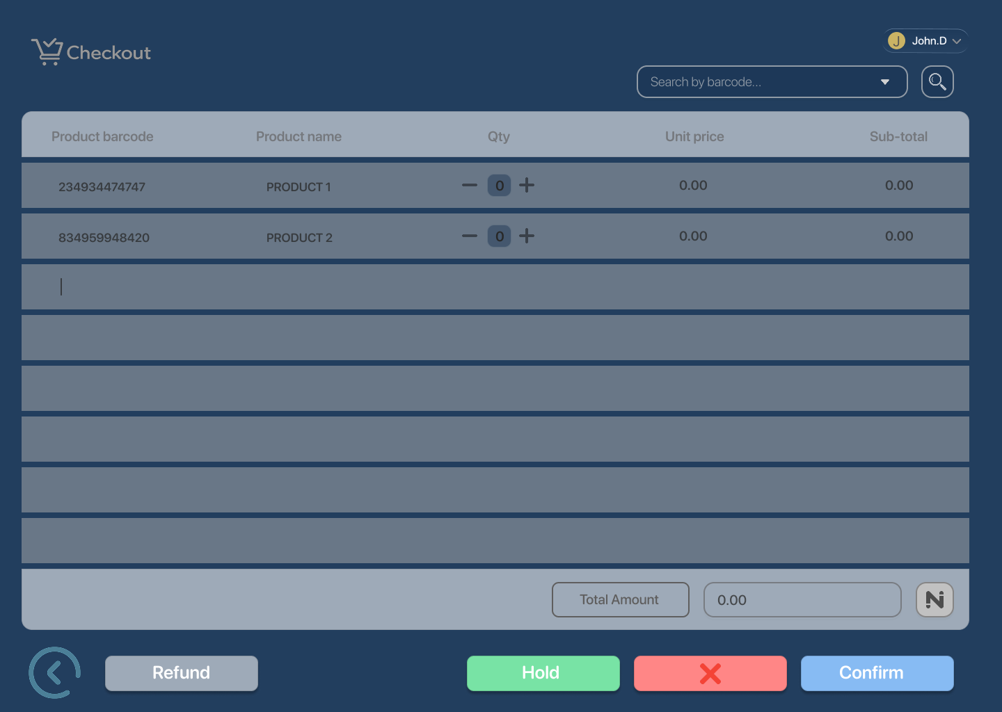

- Total Calculated
  - Total amount auto-calculated for added products
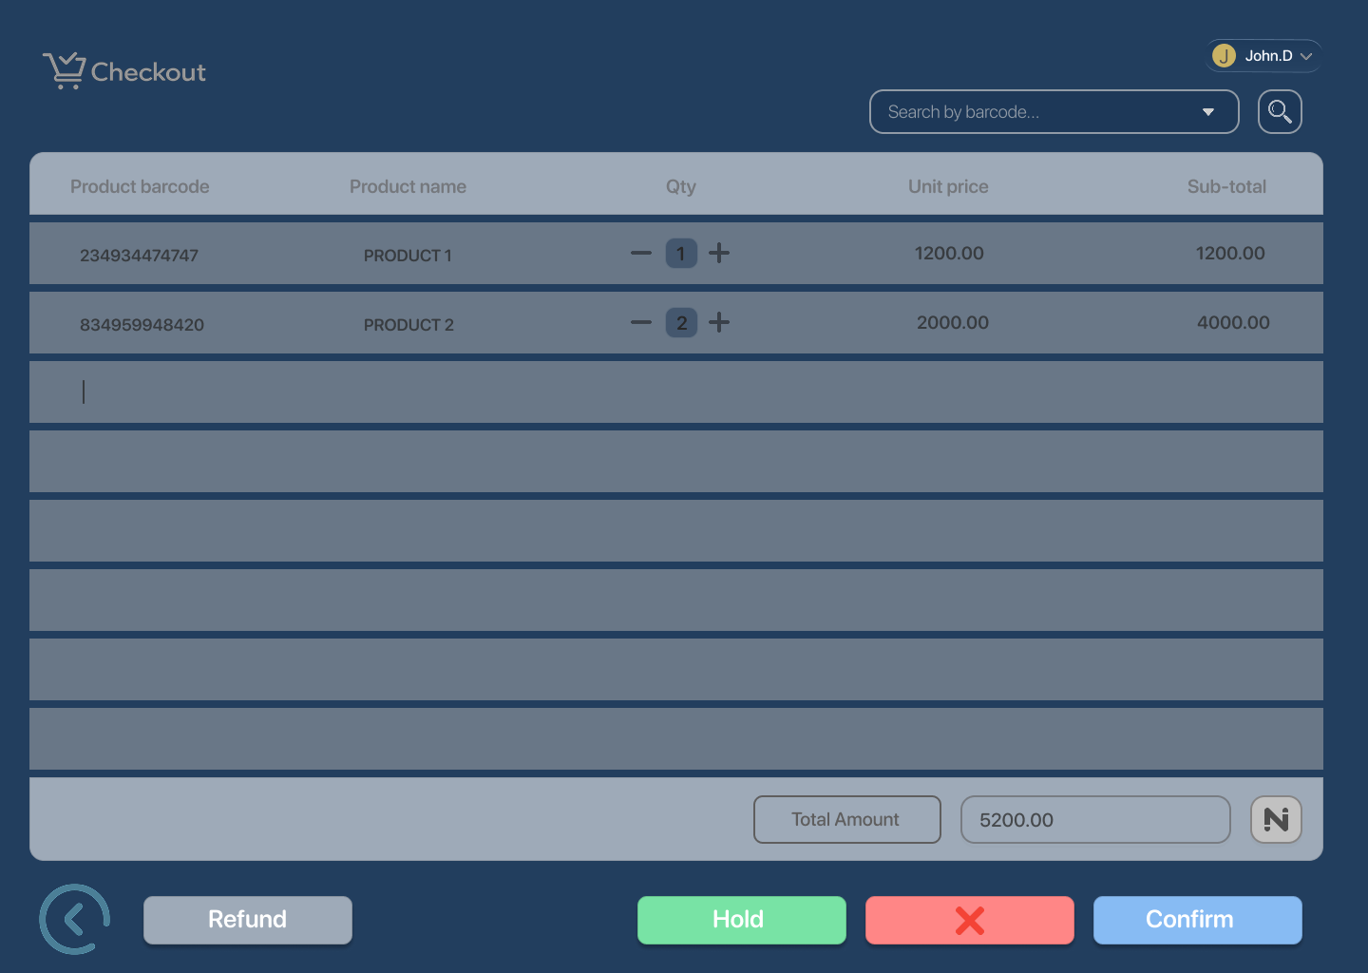

- Product Search (Optional)
  - Search options shown
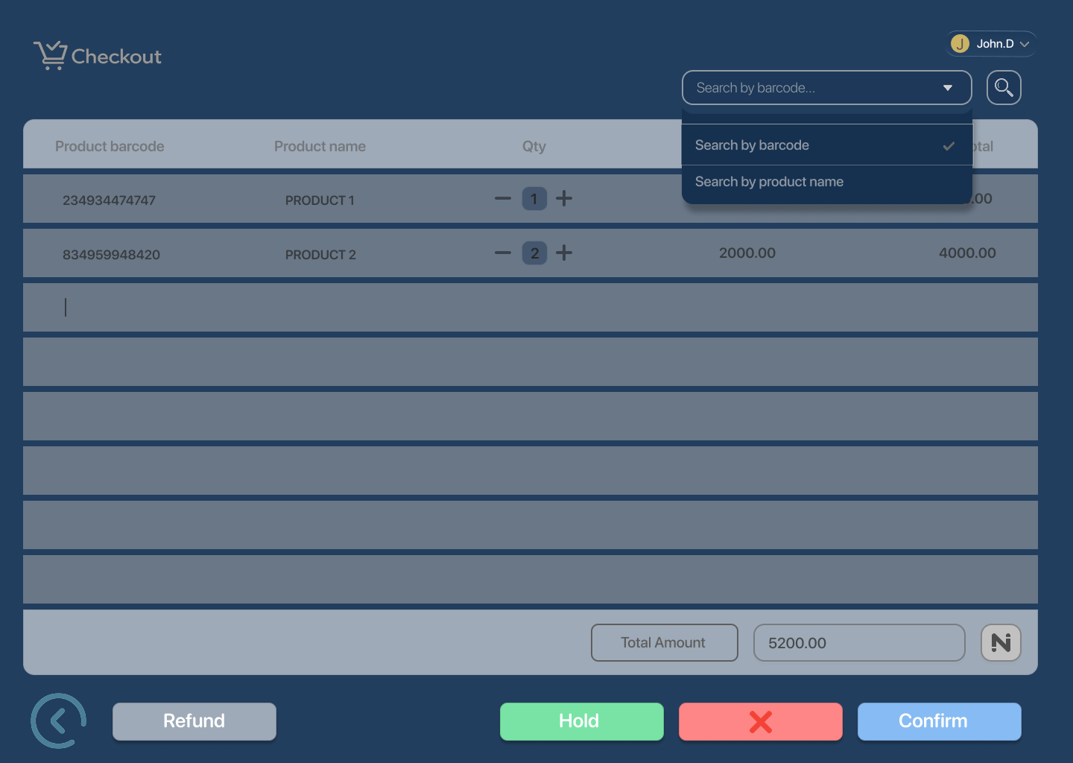

  - Product selected from search
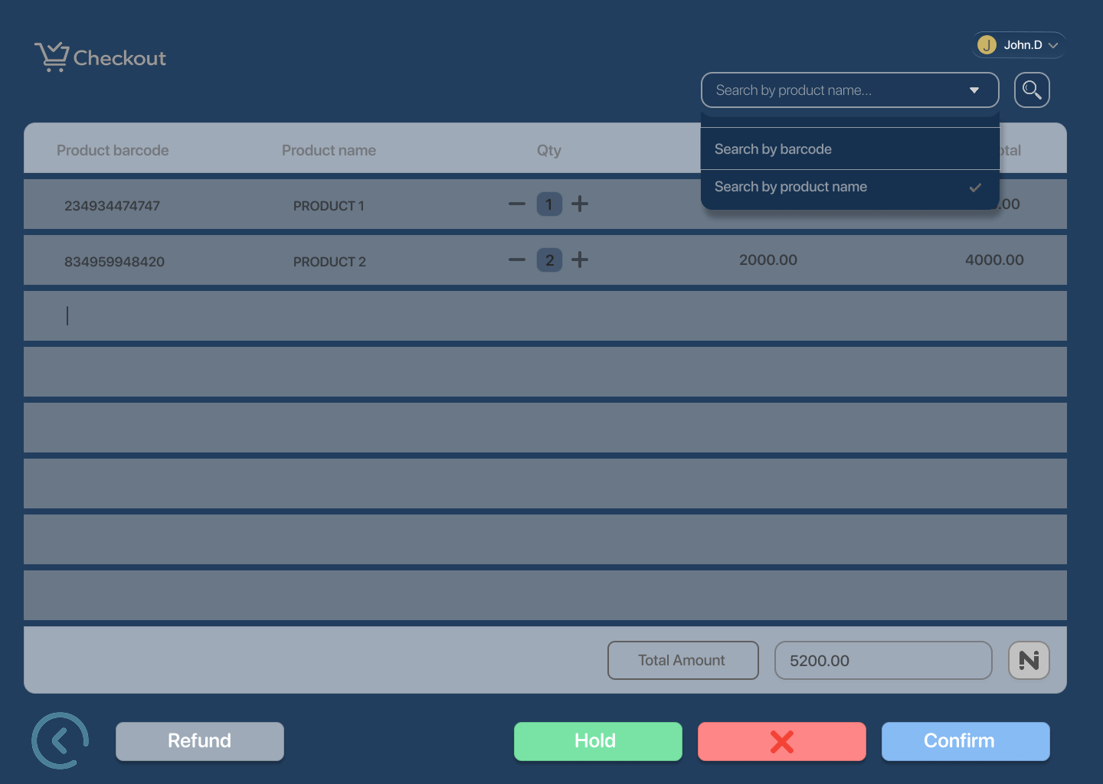

  - Product found
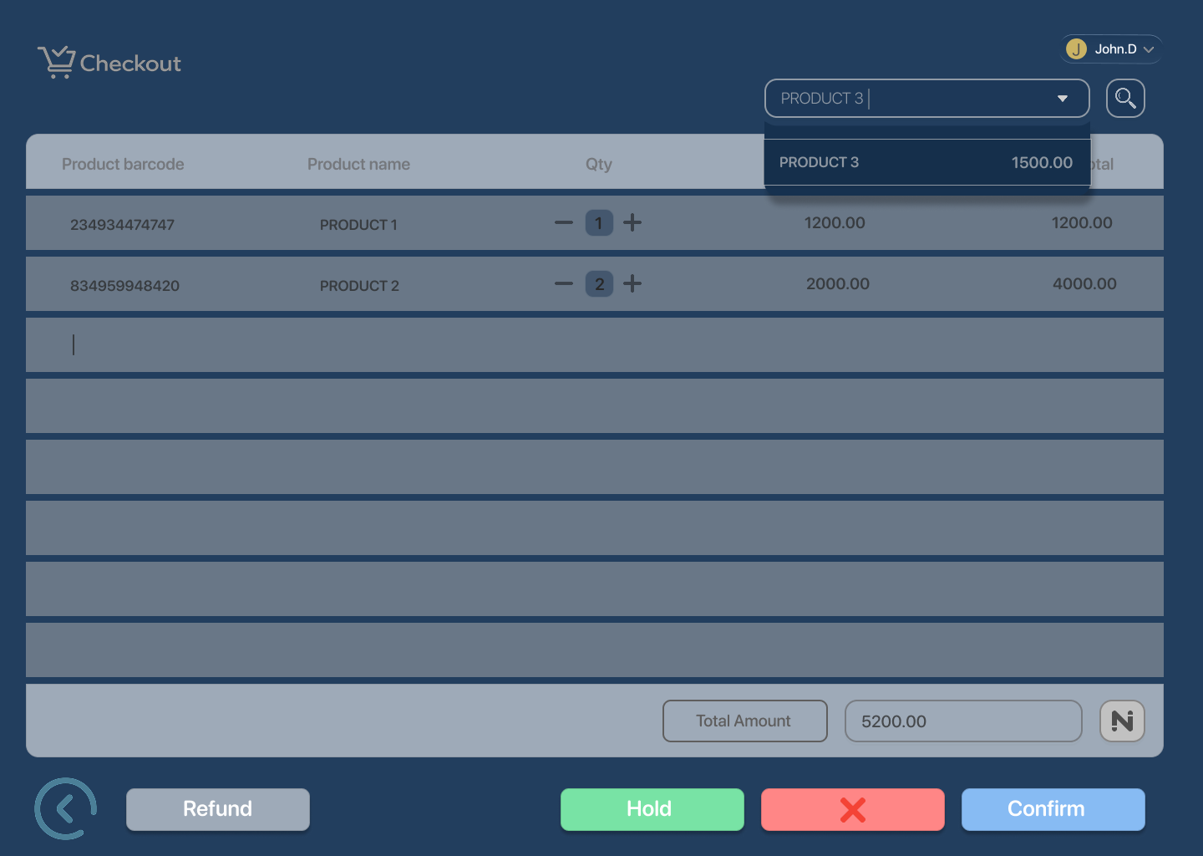

  - Product added to cart
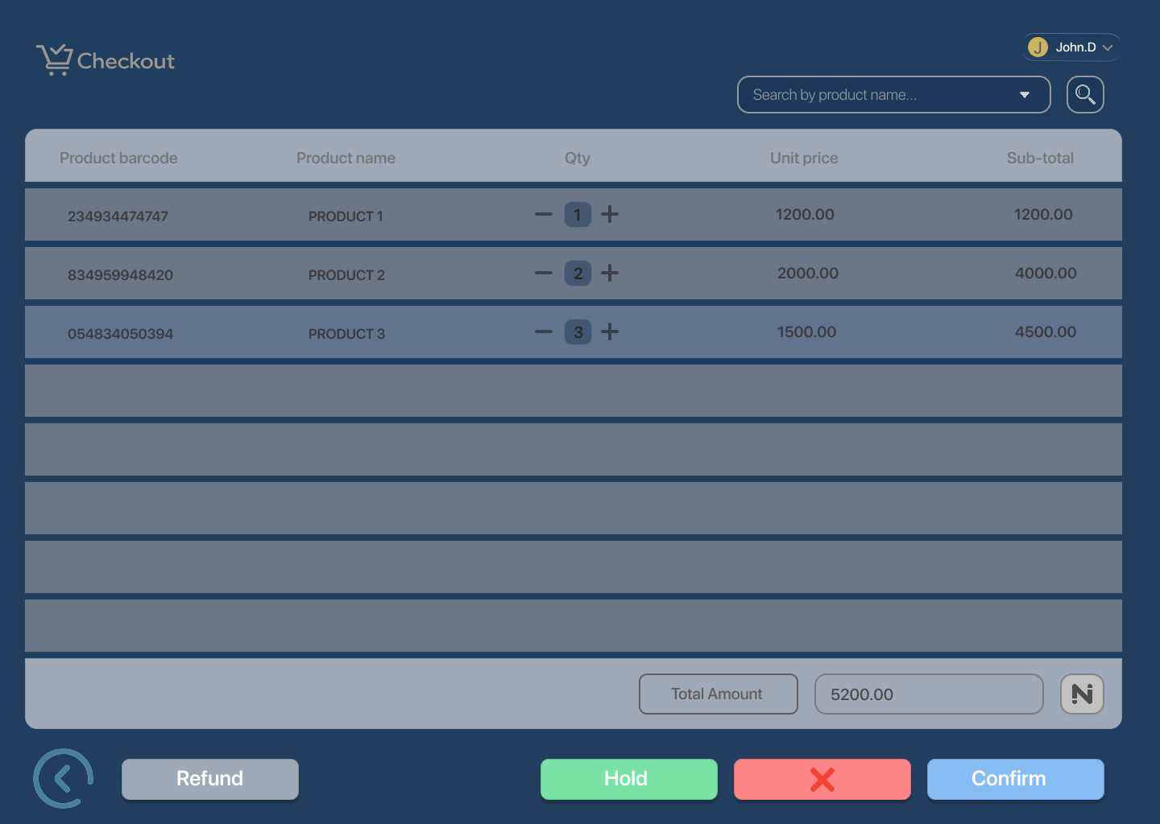

- Discount Applied (Optional)
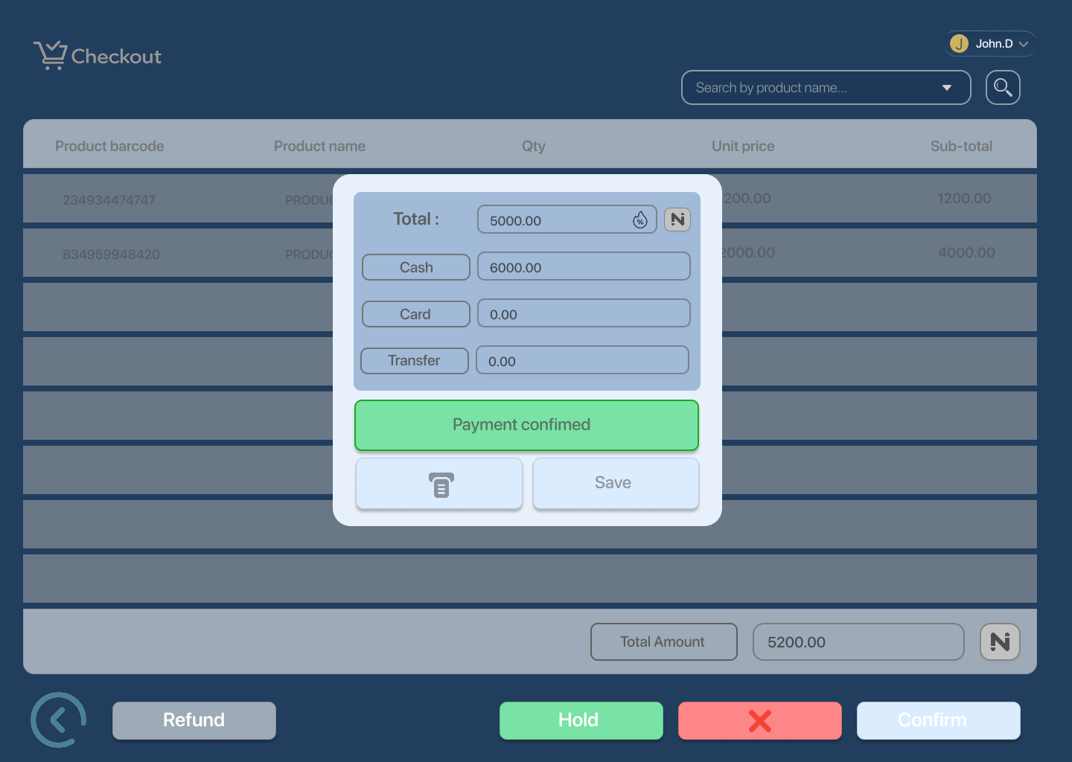

- Payment Method Input
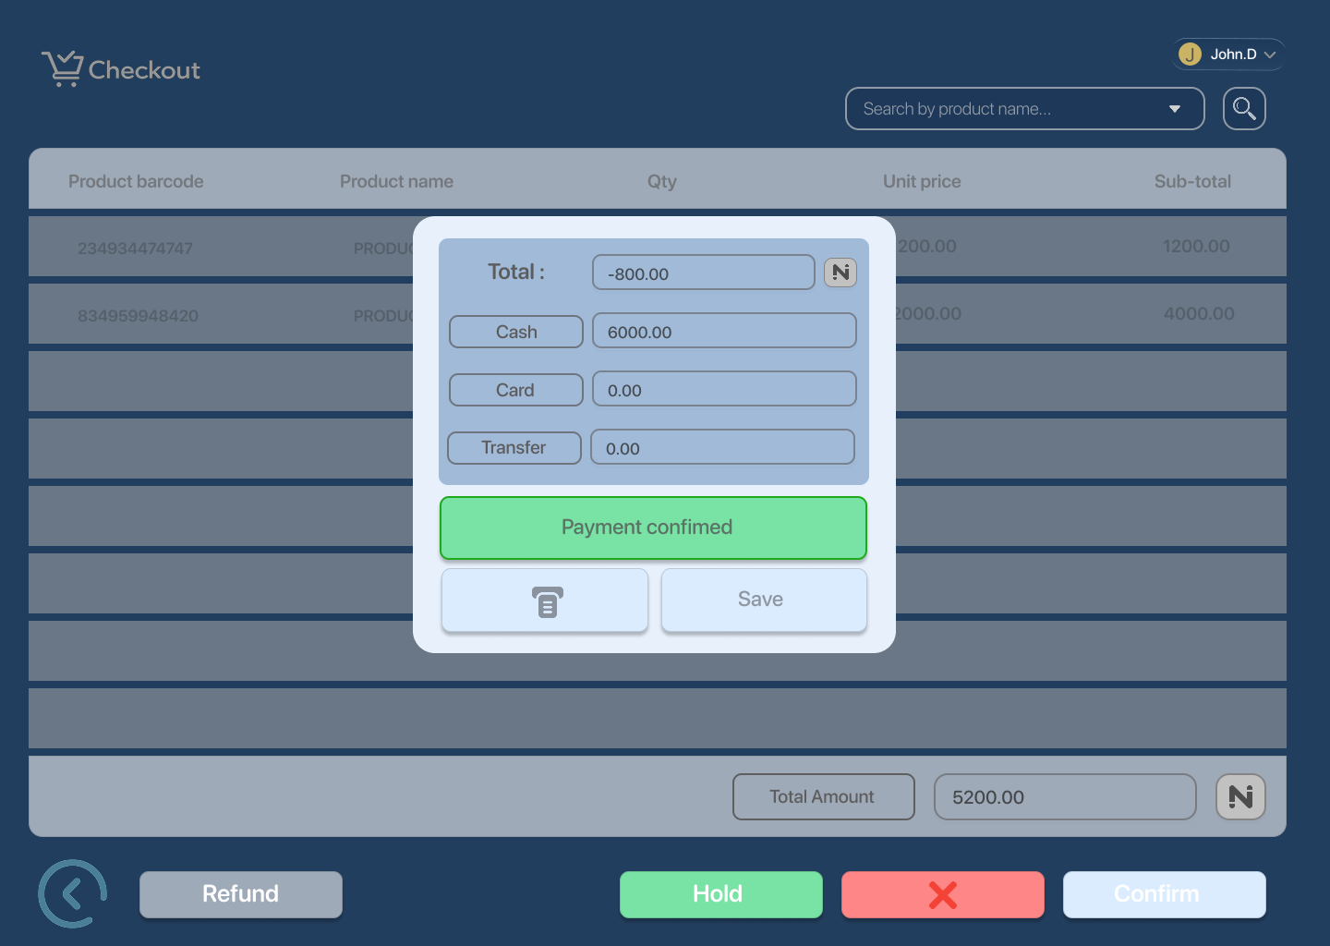

- Payment Processing
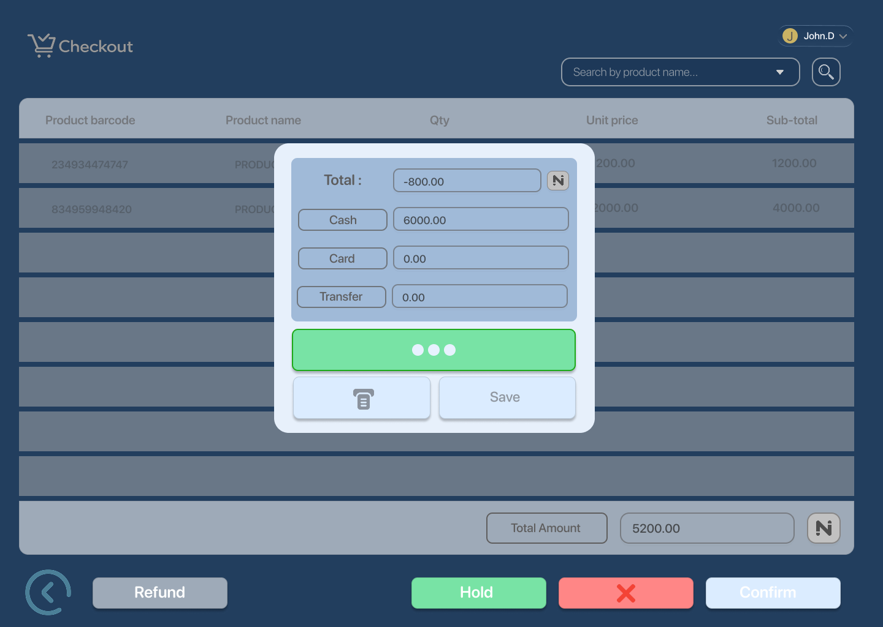

- Payment Success
  - Receipt printed
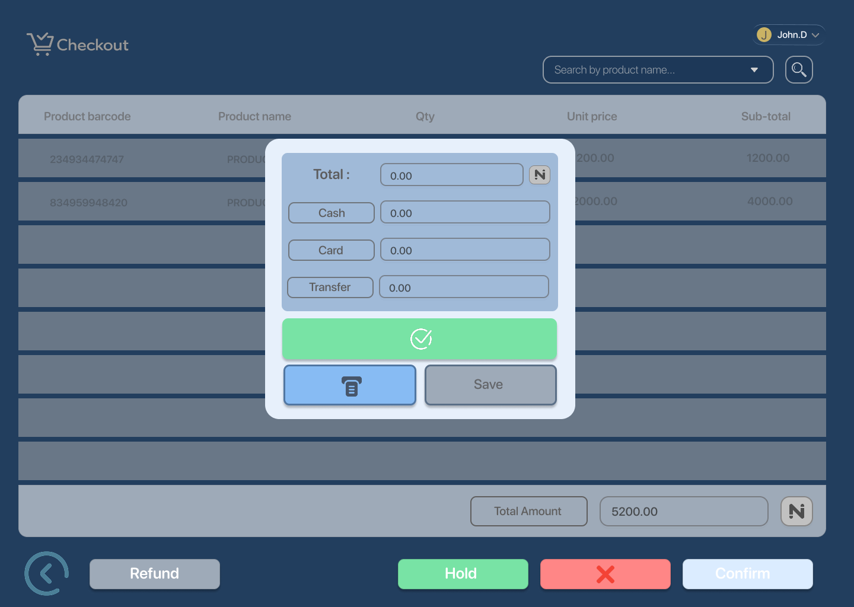

- Sale Completed
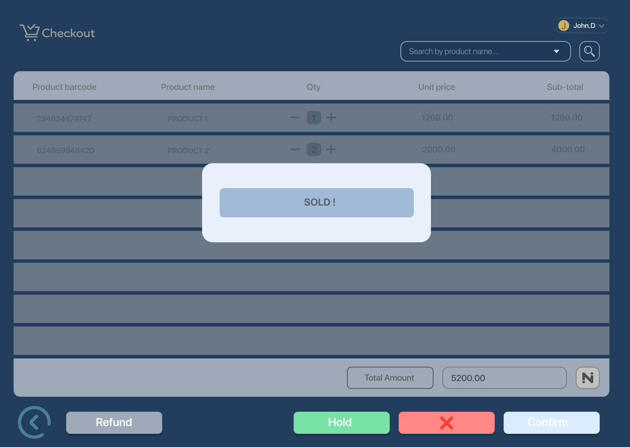

- Checkout Cleared
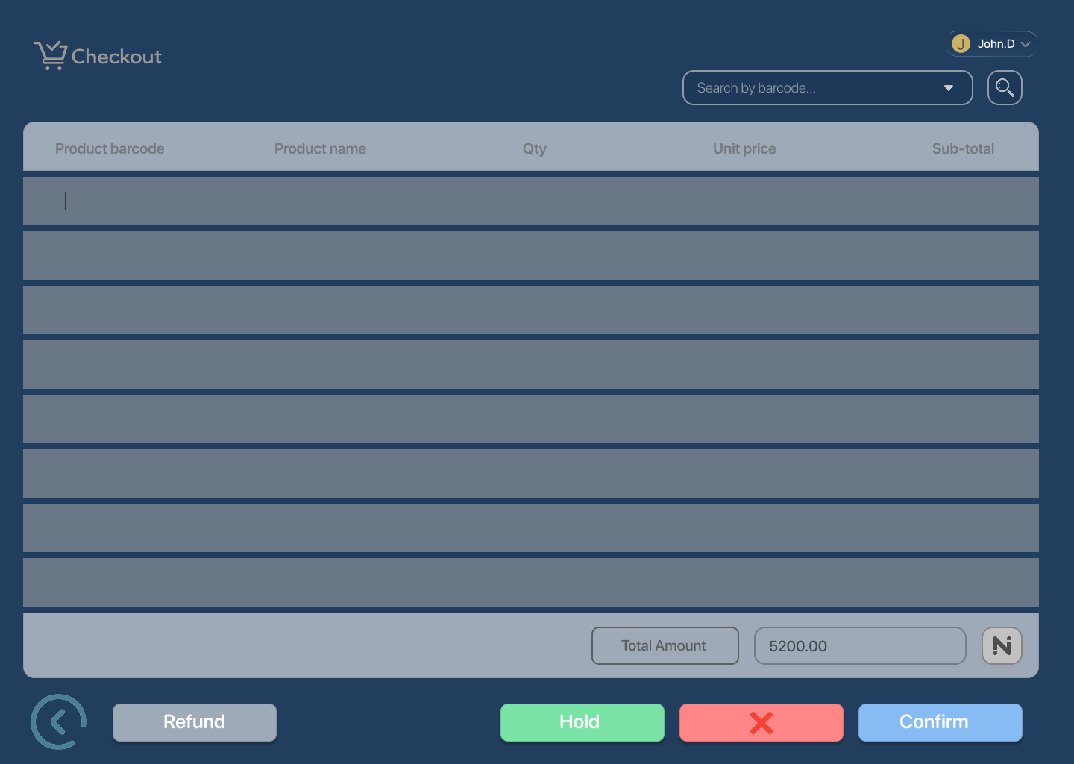

Edge Cases / States
- Invalid Barcode
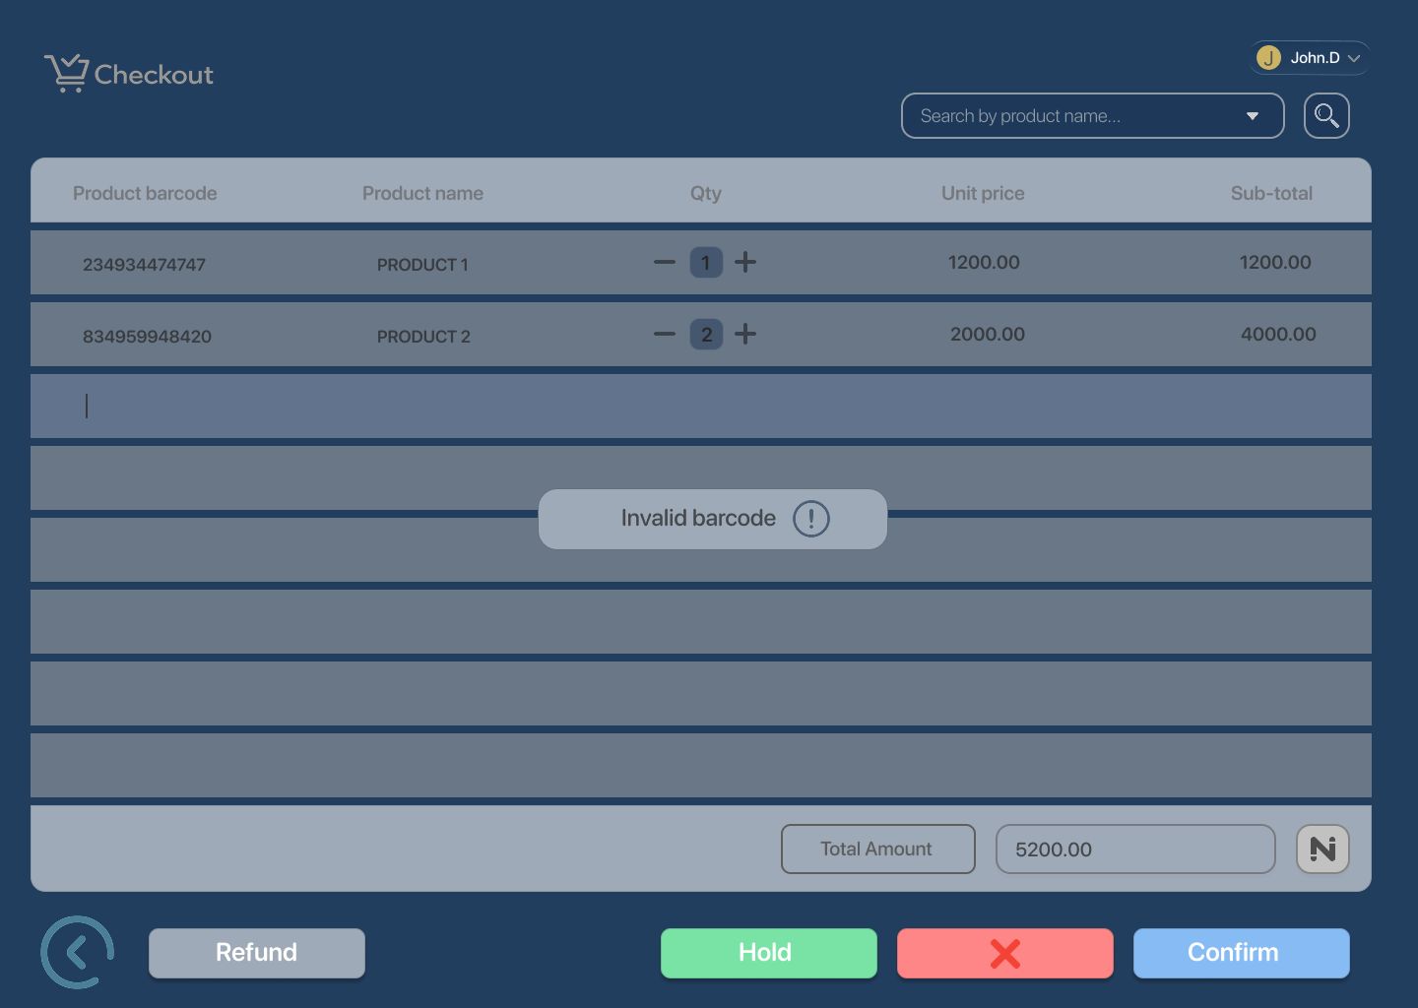

- Out of Stock
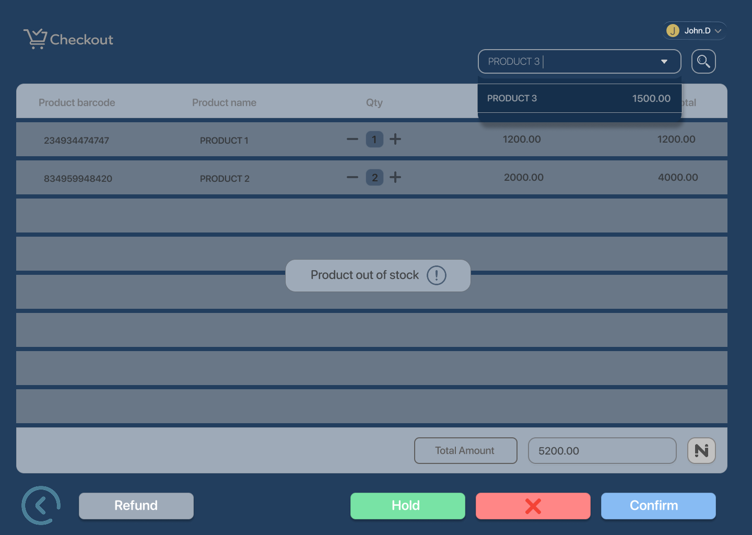

- Low Stock Warning
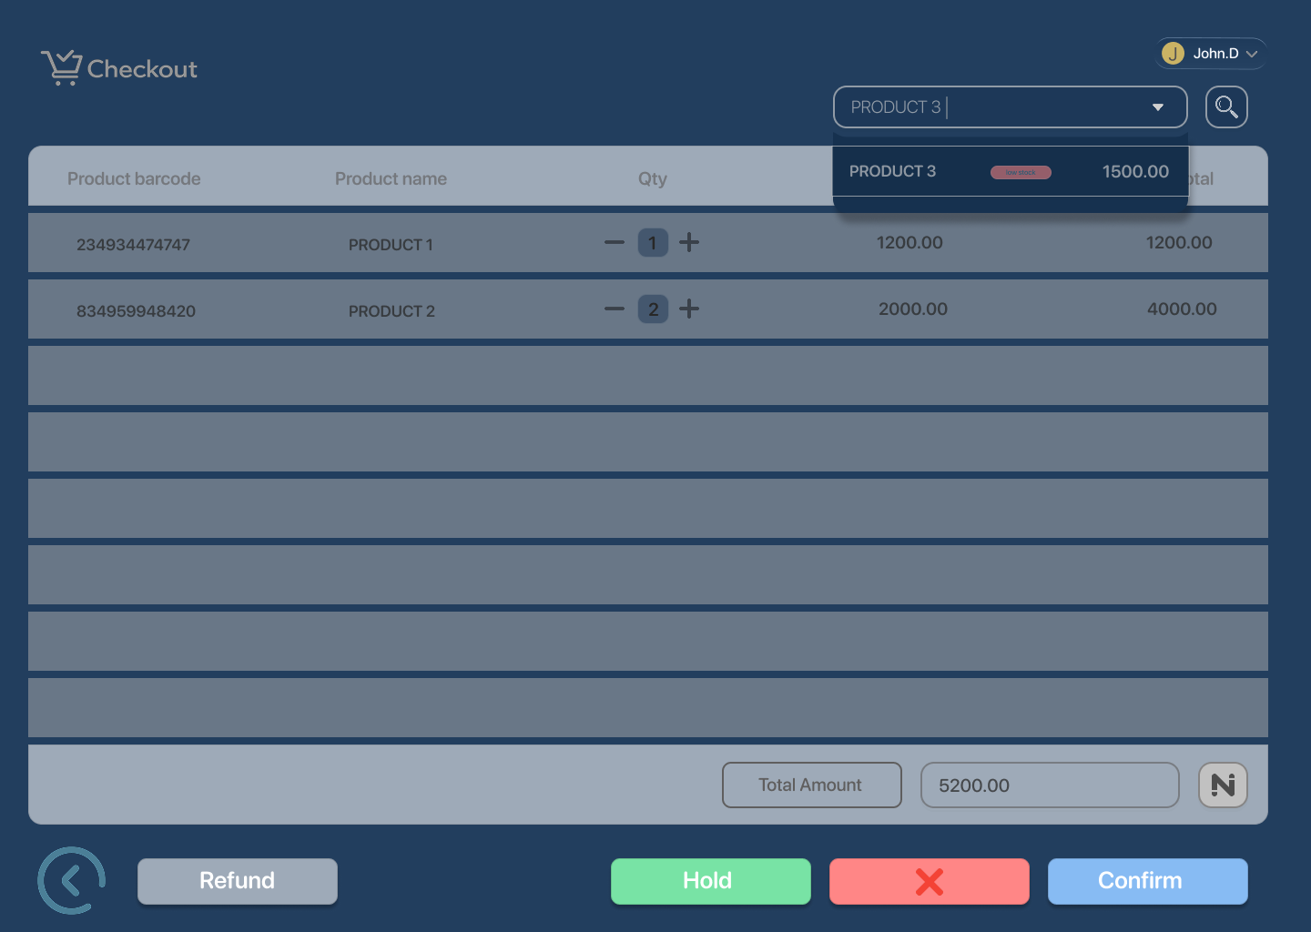

- Payment Failed
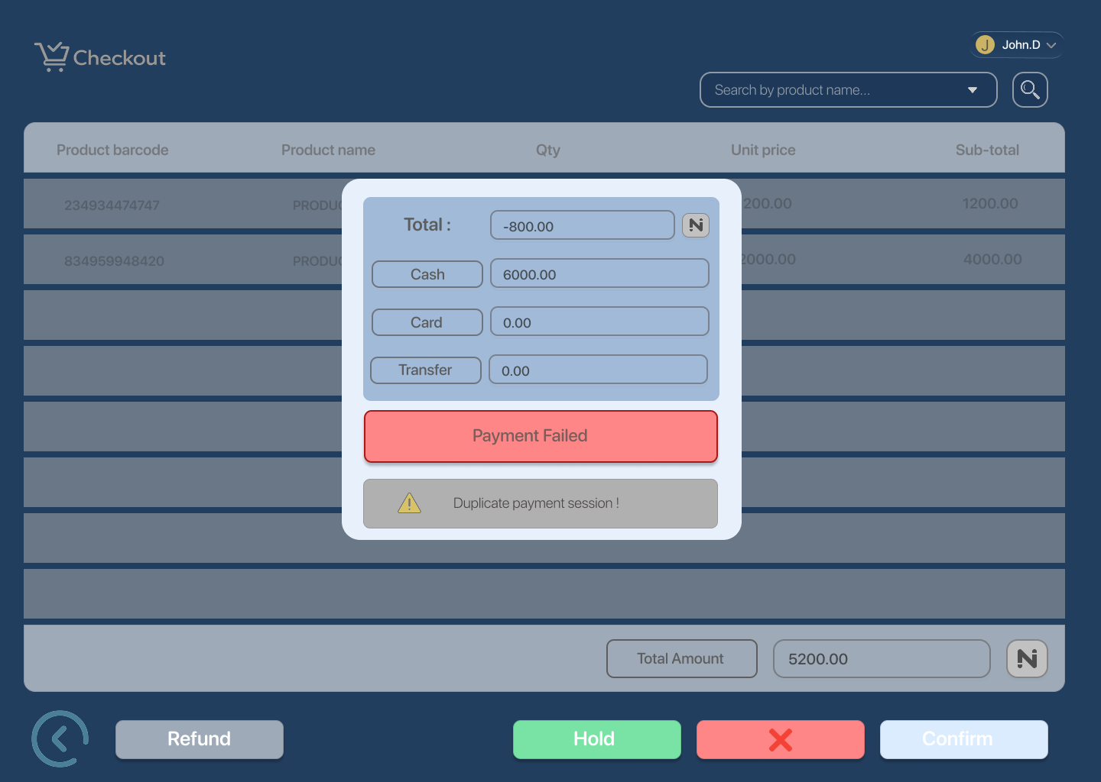

- Payment Cancelled
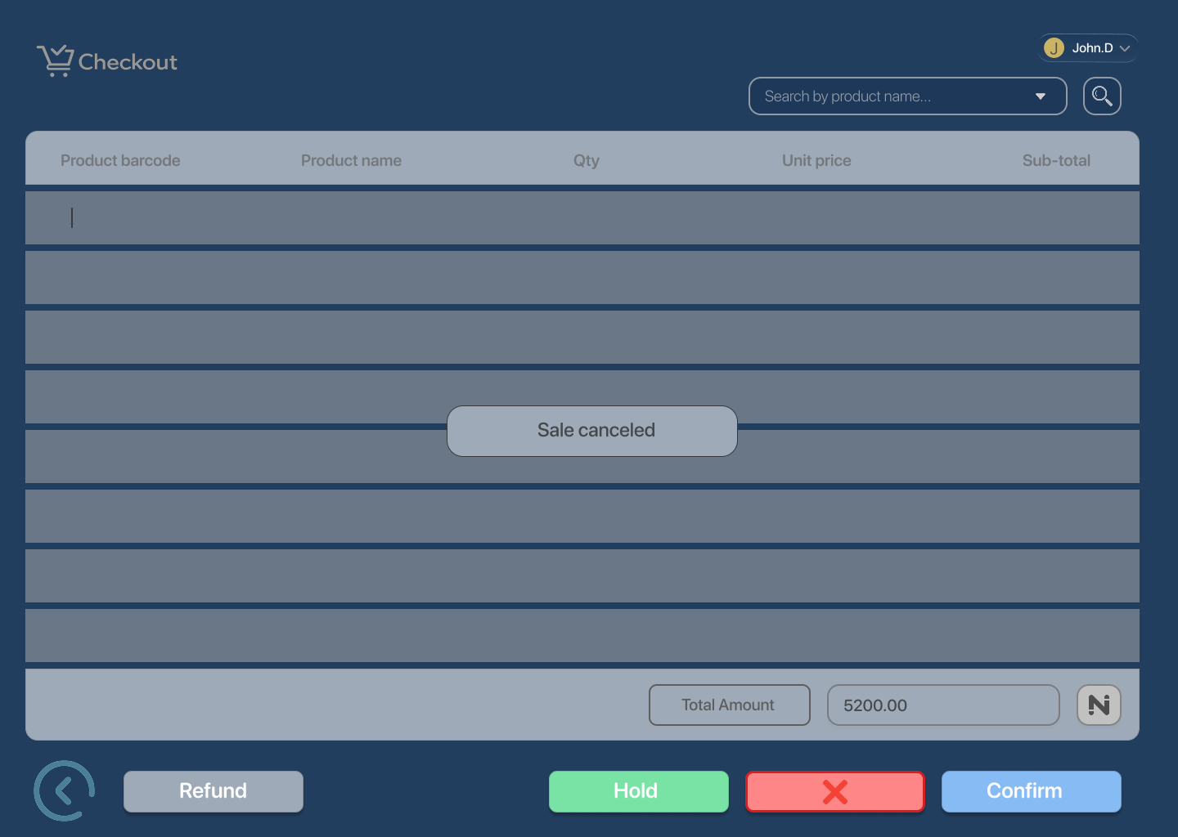

UX Notes

Checkout operates on a single continuous screen
- Real-time updates for scanned products and totals
- Search acts as a fallback to barcode scanning
- Payment has clear processing, success, failure, and cancel states
- System resets automatically after sale completion

Item Return Flow — Structure

Happy Path
Item return 1
Return initiated
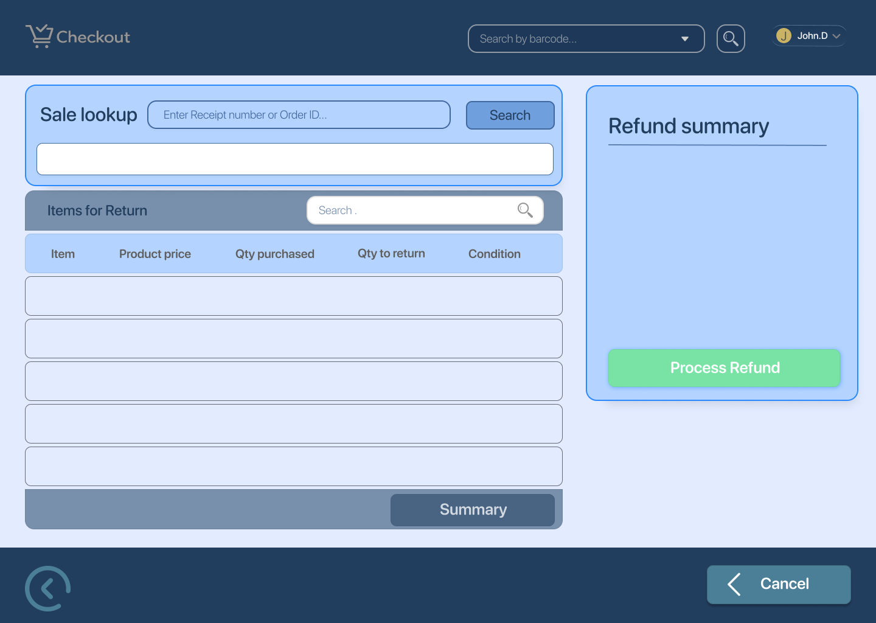

Item return 2 – Order found and items added
System finds order and loads purchased items
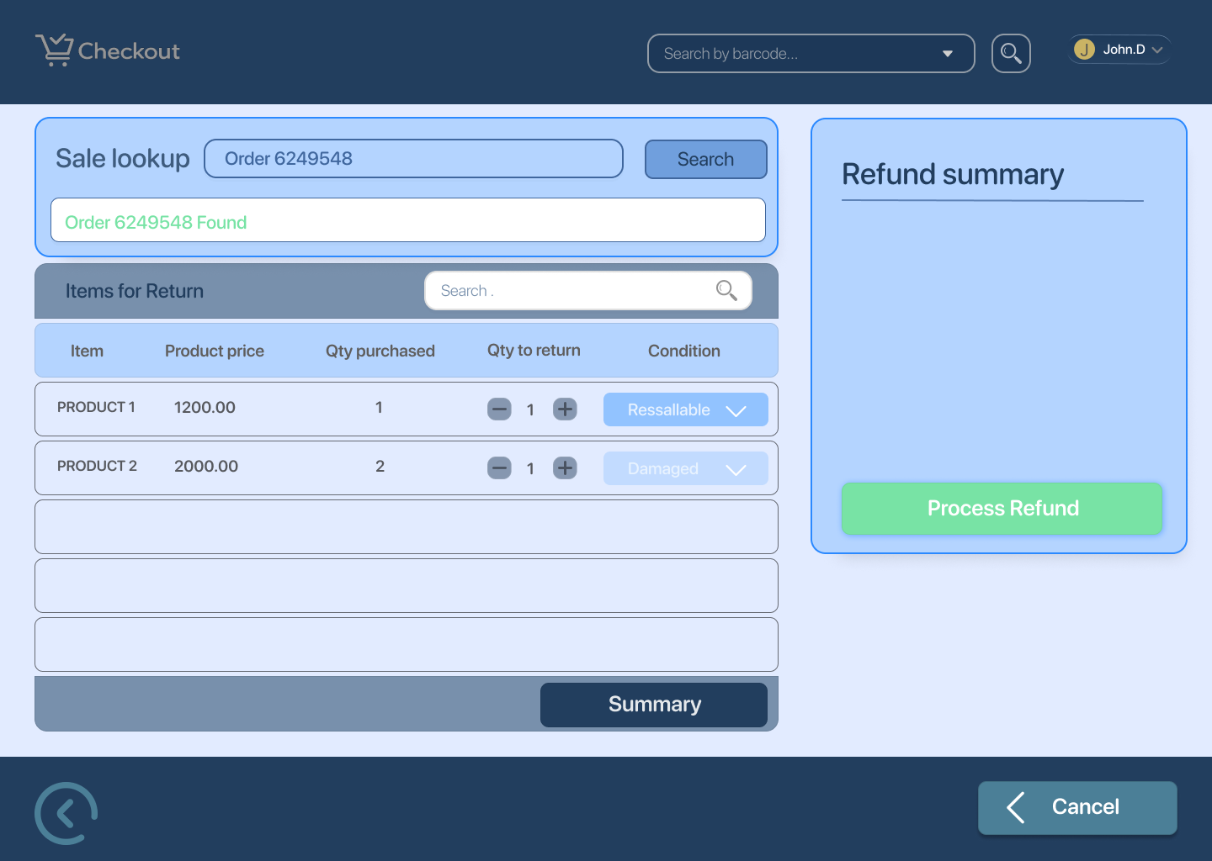

Item return 3 – Order found
Order details confirmed for return flow
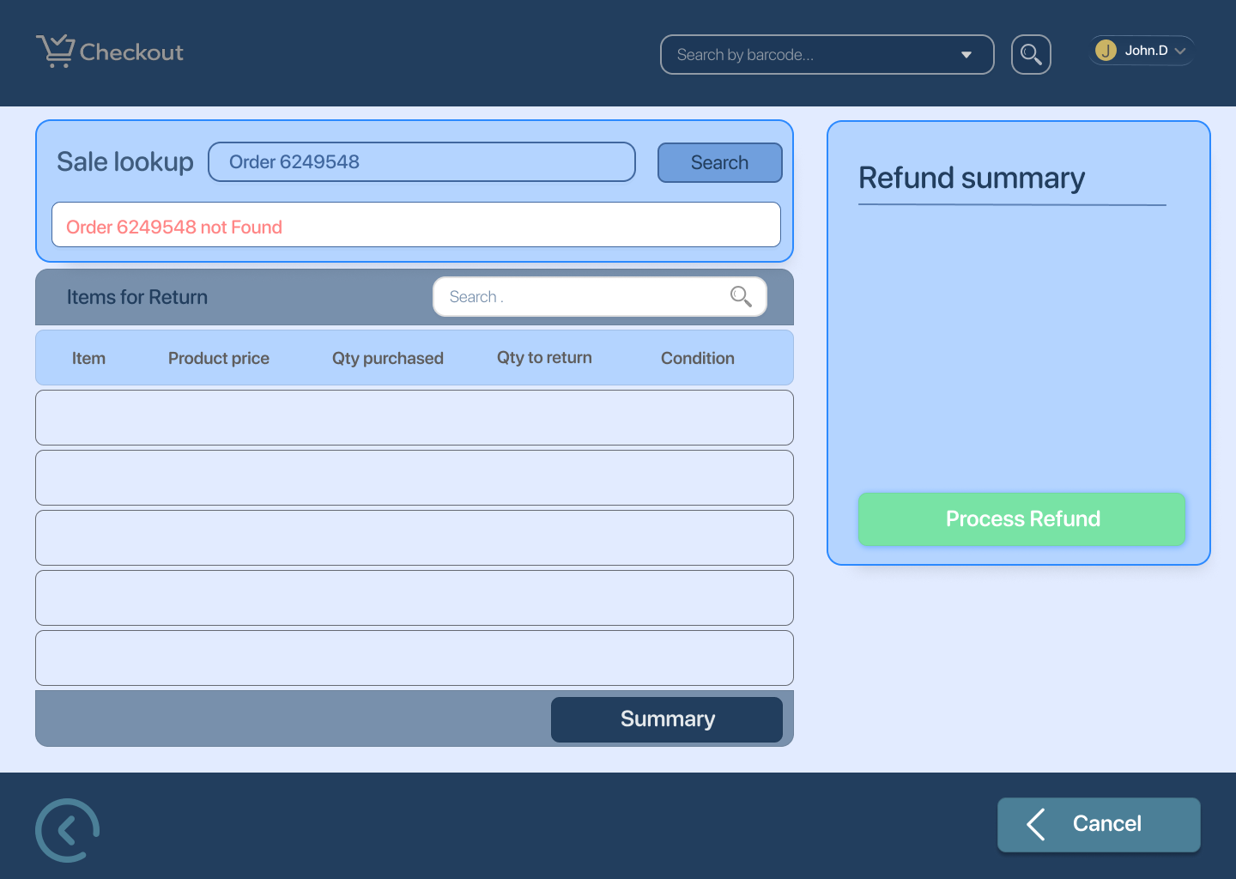

Item return 4 – Refund summary
Selected items and refund amount displayed
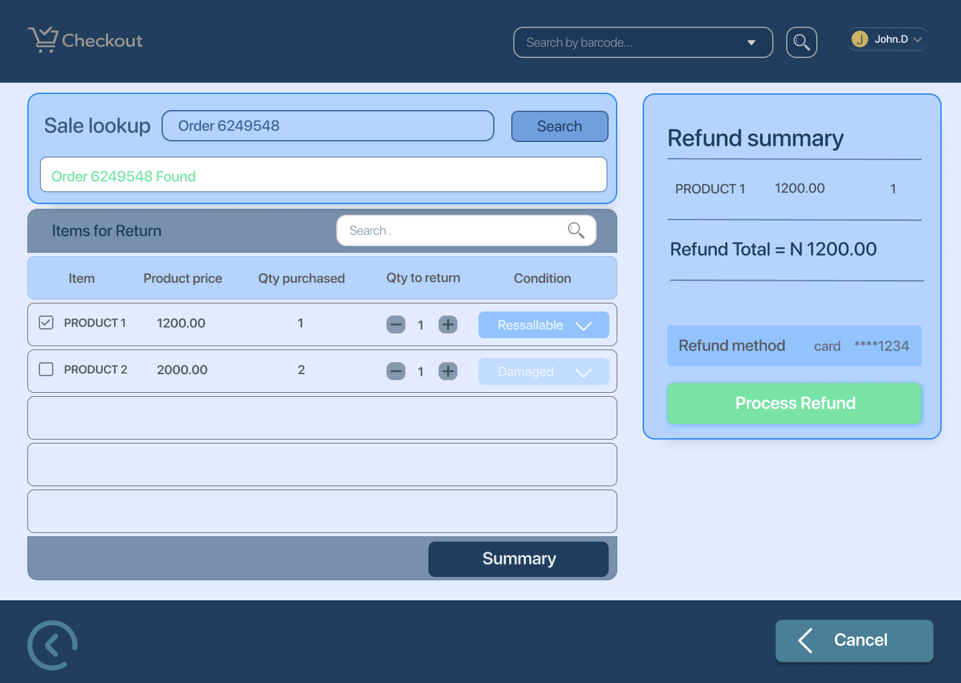

Item return 6 – Confirm refund pop-up
Cashier confirms refund action
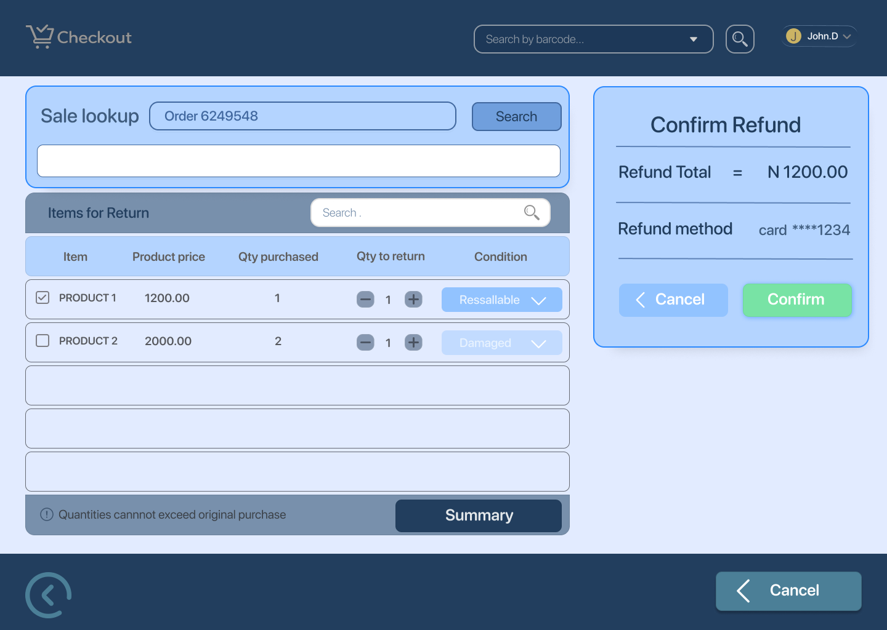

Item return 7 – Refund processing
System processes refund
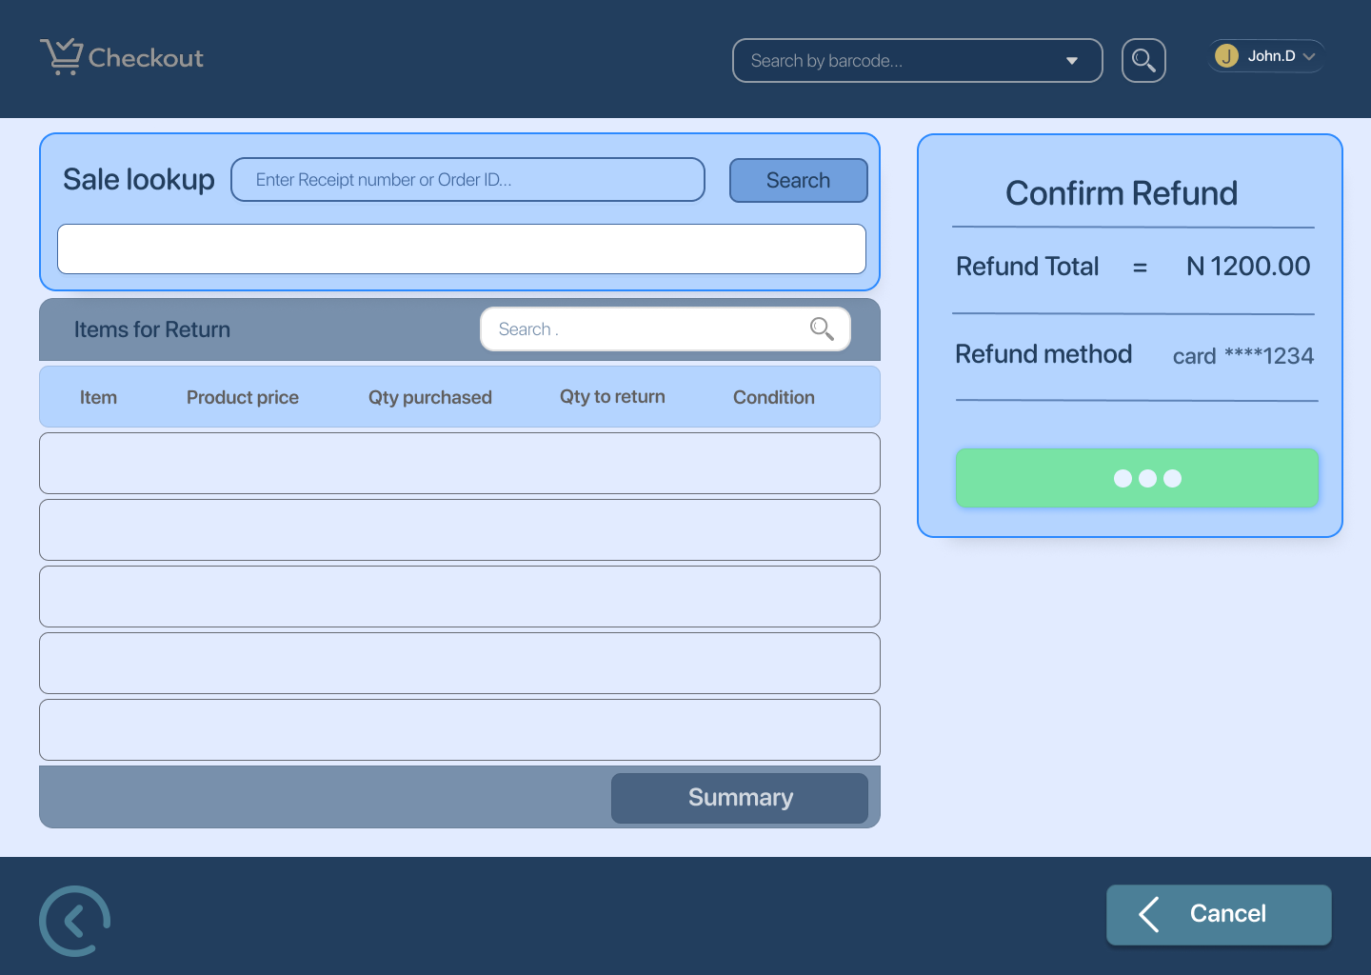

Item return 8 – Refund confirmed
Refund successfully completed
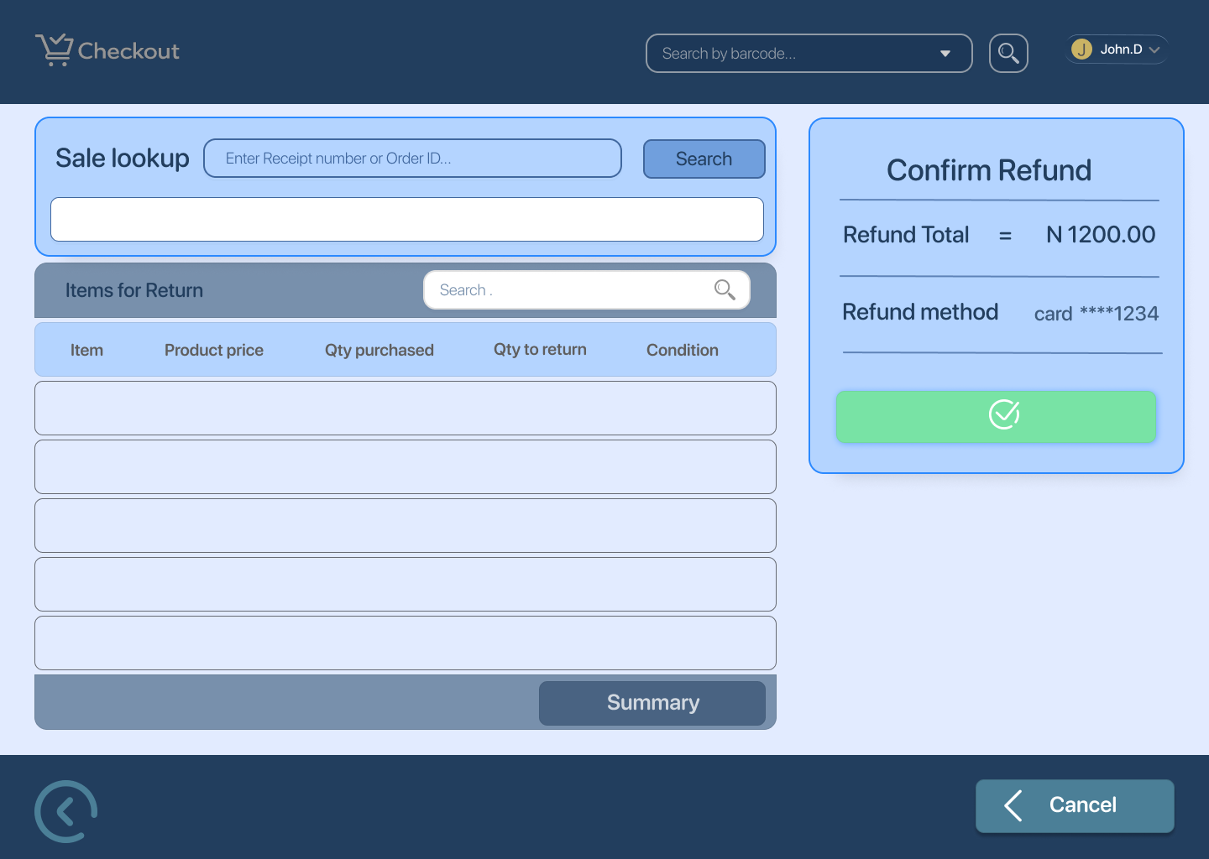

Edge Cases / Exception States
Item return 5 – Quantities cannot exceed original purchase
Validation error when return quantity is higher than purchased quantity
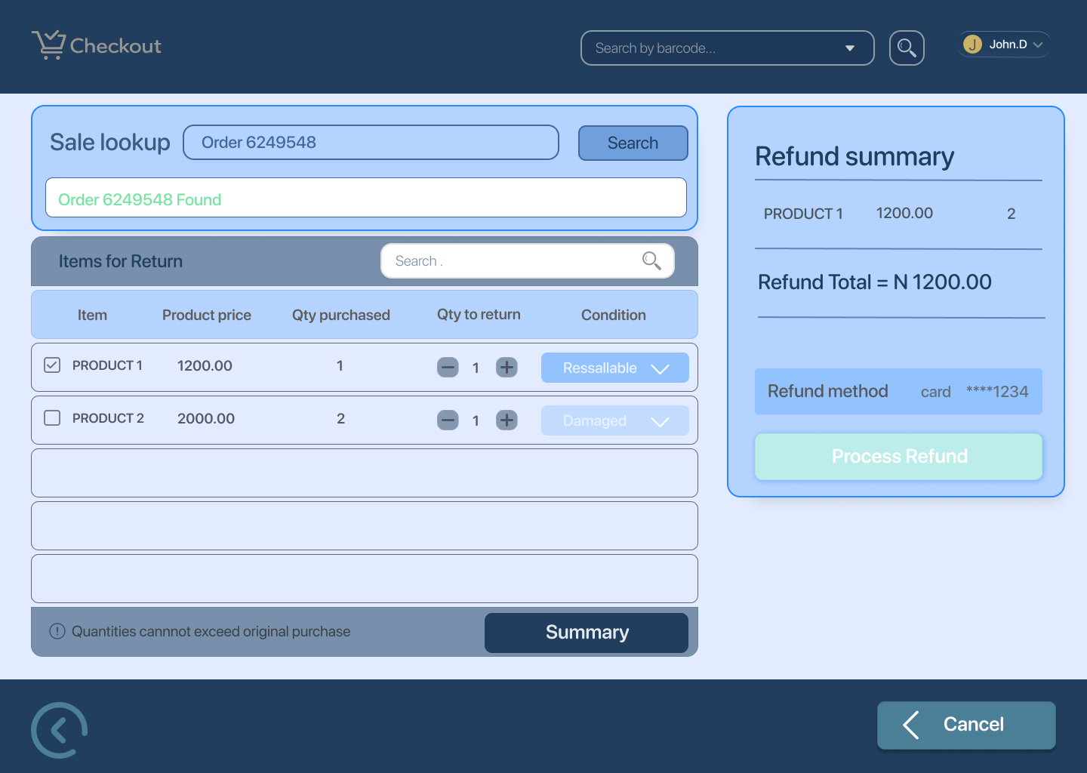

Item return 9 – Refund not allowed error / item beyond return window
Return blocked due to policy violation
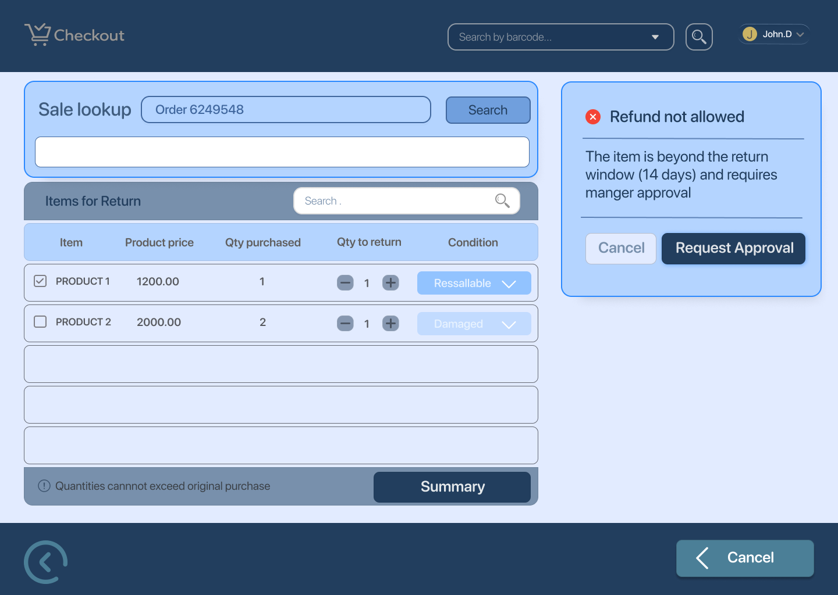

Item return 10 – Request sent for review
Return requires approval and is escalated for review

UX Notes
- Clear status messaging at each step (found, processing, confirmed)
- Validation errors shown inline and explained simply
- Confirmation pop-up prevents accidental refunds
- Processing state blocks duplicate actions
- Error and review states provide clear next steps to cashier

Inventory Updates — Manager Experience

1. Receive Stock (Primary Screen)
Screens
Inventory Updates (Manager) 1 — Receive Stock
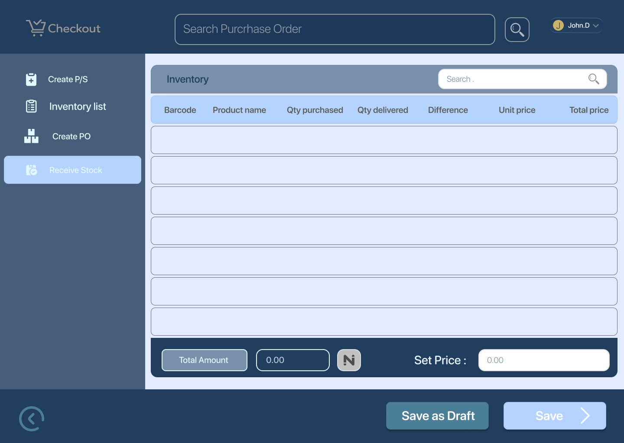

Inventory Updates (Manager) 2 — Search Purchase Order
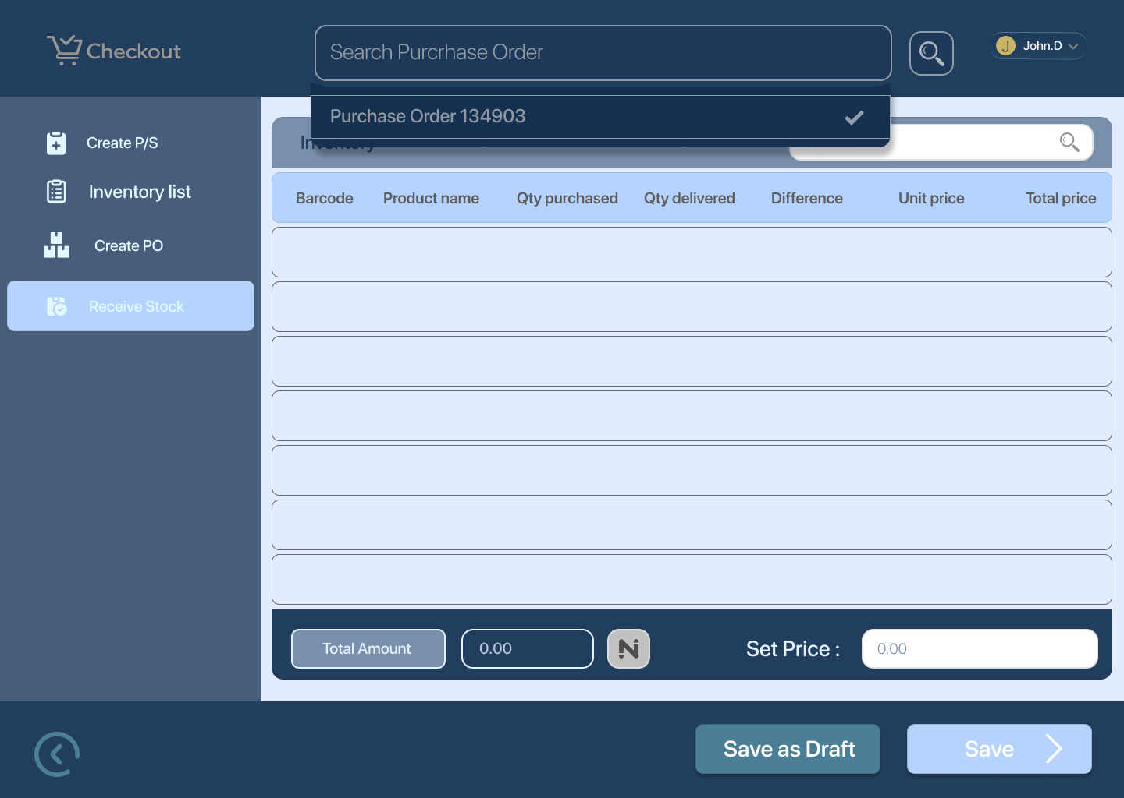

Inventory Updates (Manager) 3 — Receive Stock (PO Loaded)
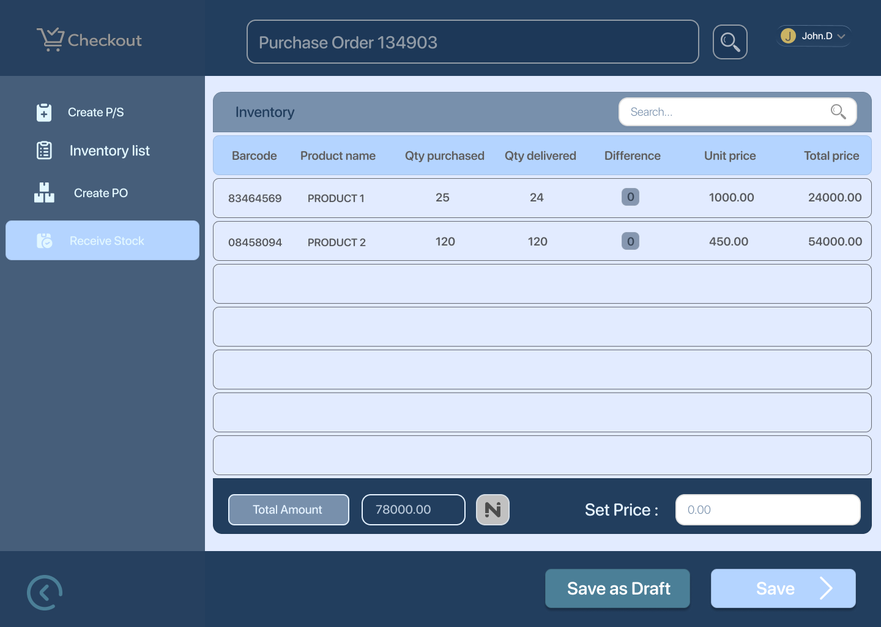

Inventory Updates (Manager) 4 — Receive Stock (Set Product Price)
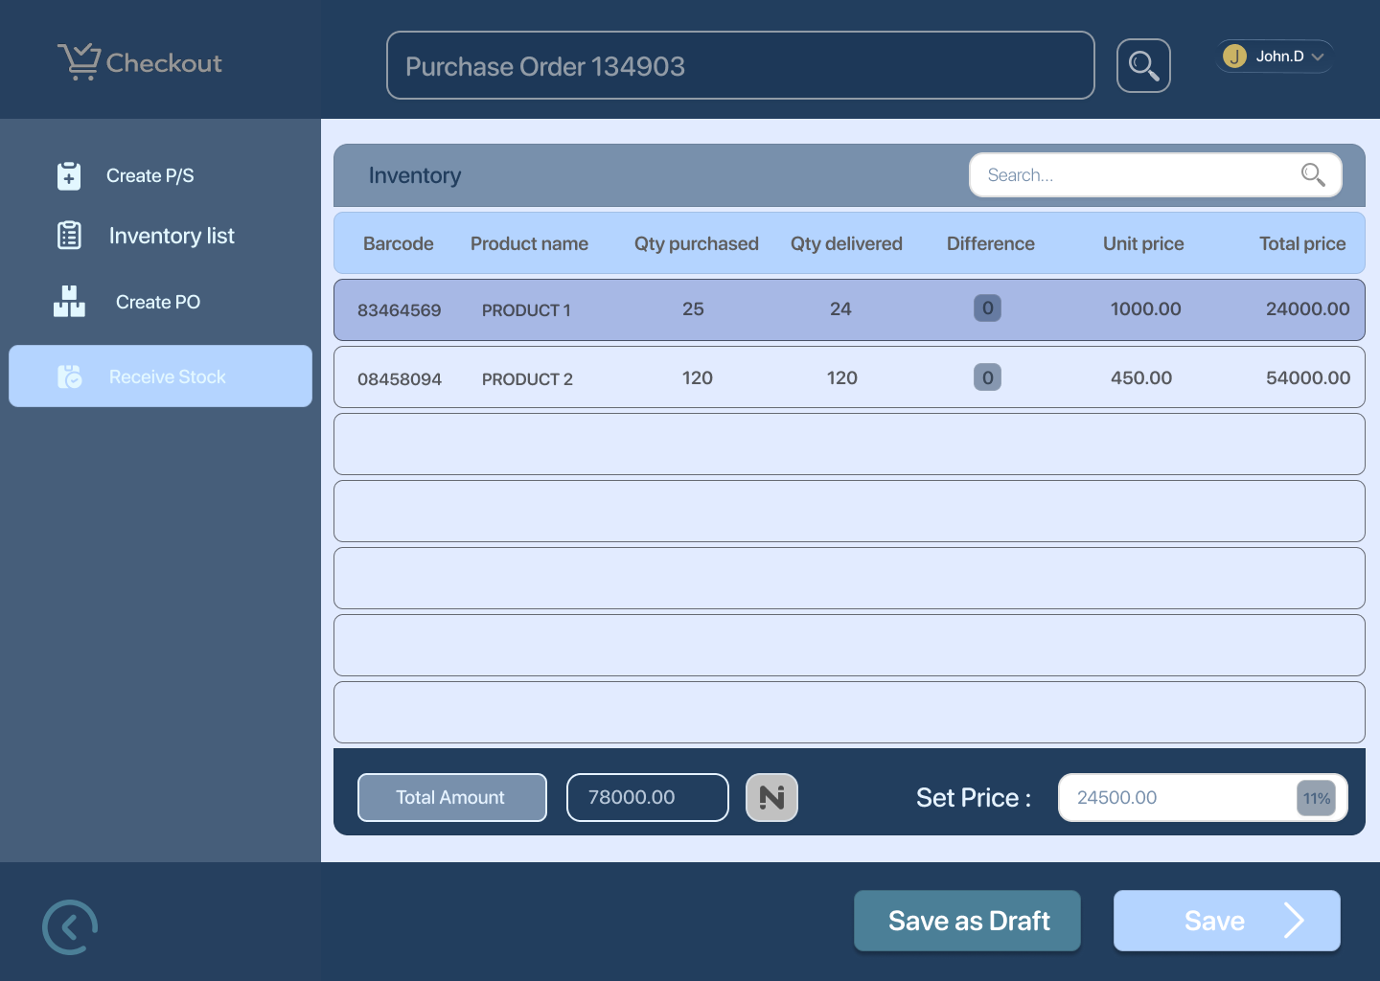

Inventory Updates (Manager) 8 — Error: Review Quantities Before Saving
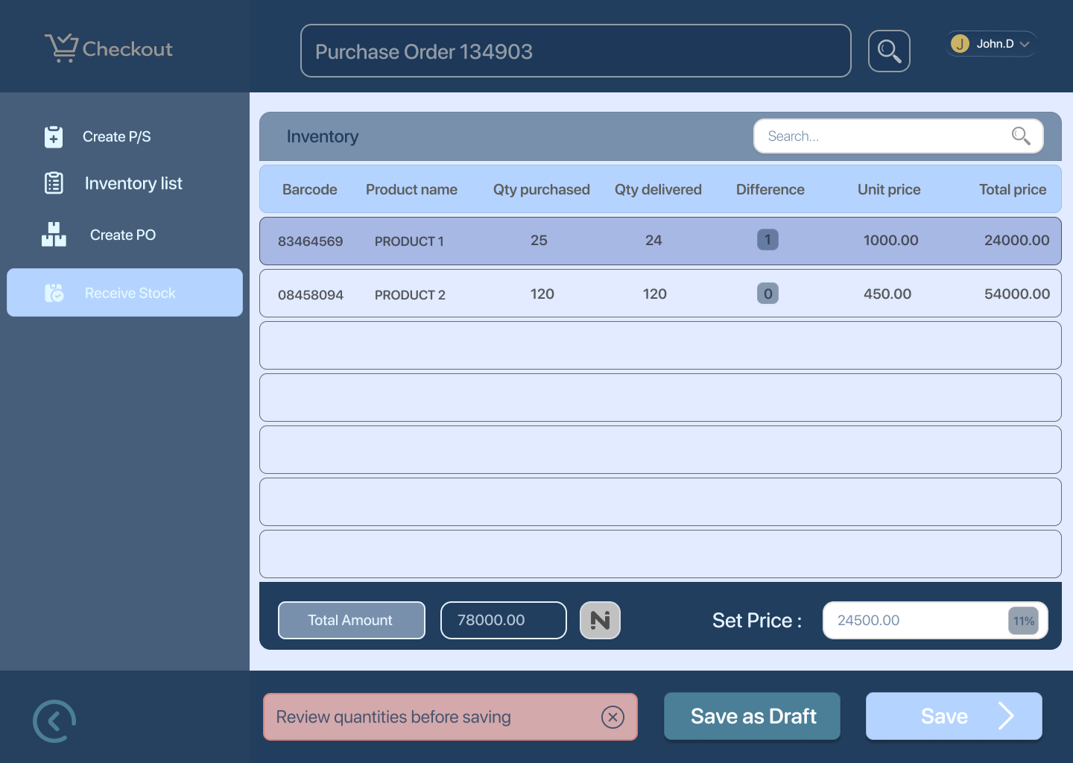

Inventory Updates (Manager) 5 — Inventory Successfully Updated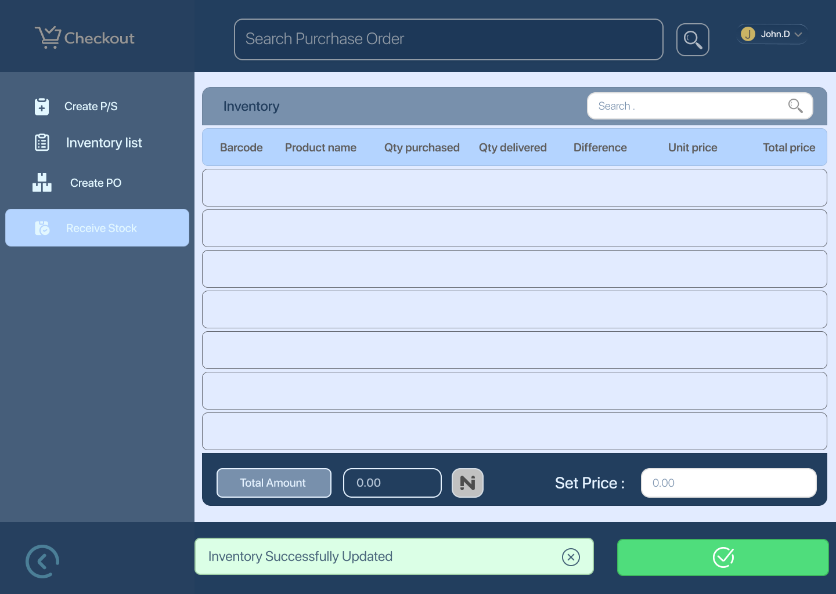

Happy Path
- Manager opens Receive Stock
- Searches and selects an existing Purchase Order
- System loads expected items and quantities
- Manager enters received quantities and sets product cost price
- Confirms stock update
- Inventory updates successfully

Edge Cases
- Quantity mismatch between expected and received
- Missing or invalid quantity values
- Attempt to save without reviewing quantities
- Invalid or closed purchase order

UX Notes
- Clearly show Expected vs Received quantities
- Highlight mismatches visually
- Inline validation before save
- Success confirmation must be explicit and reassuring

2. Create Purchase Order (Primary Screen)
Screens

Inventory Updates (Manager) 6 — Create Purchase Order
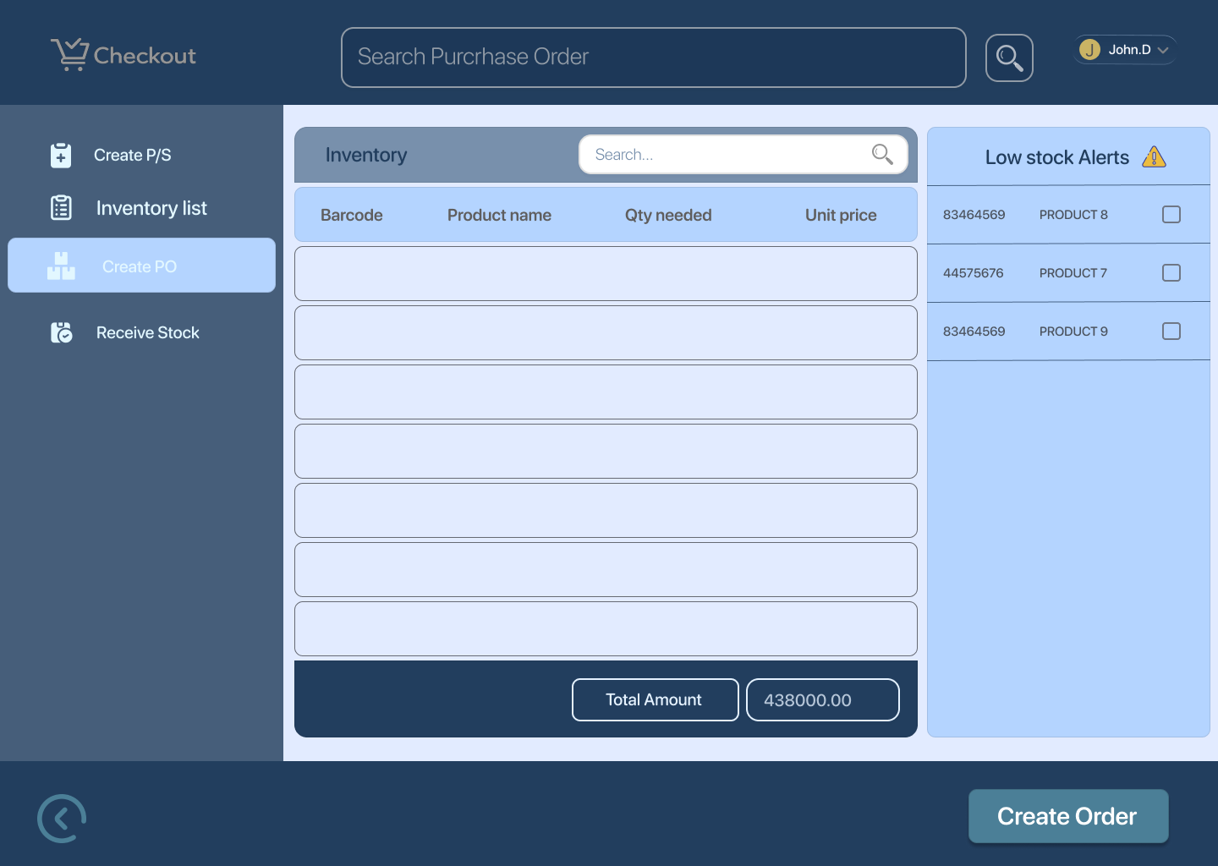

Inventory Updates (Manager) 7 — Create PO (Low Stock Alerts + Supplier Details)
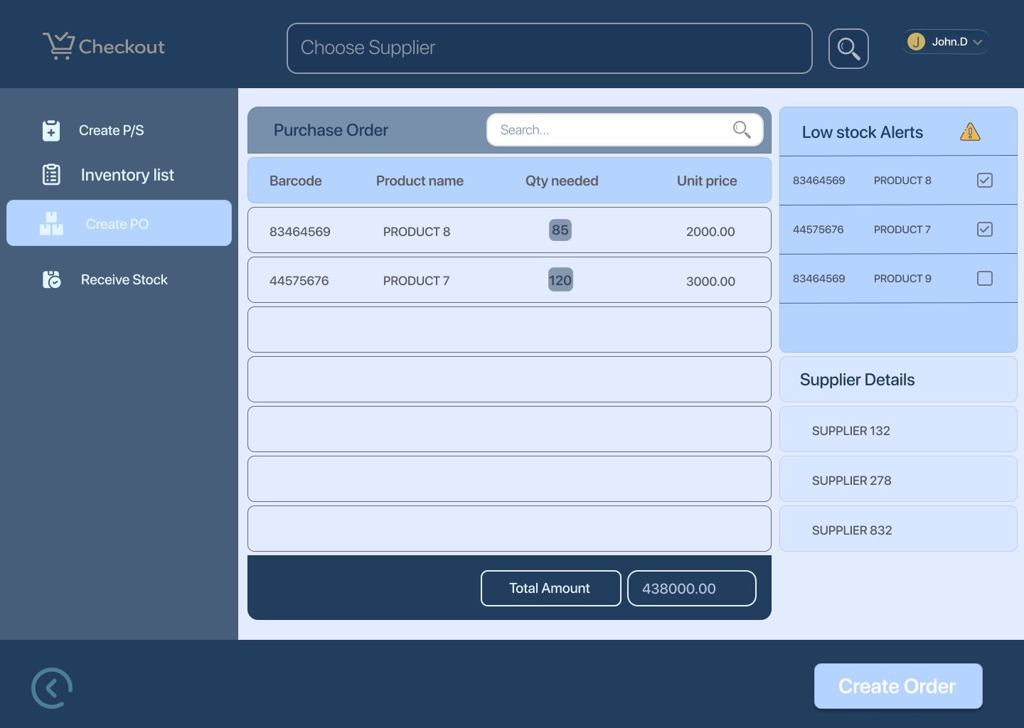

Inventory Updates (Manager) 9 — Order Created and Forwarded
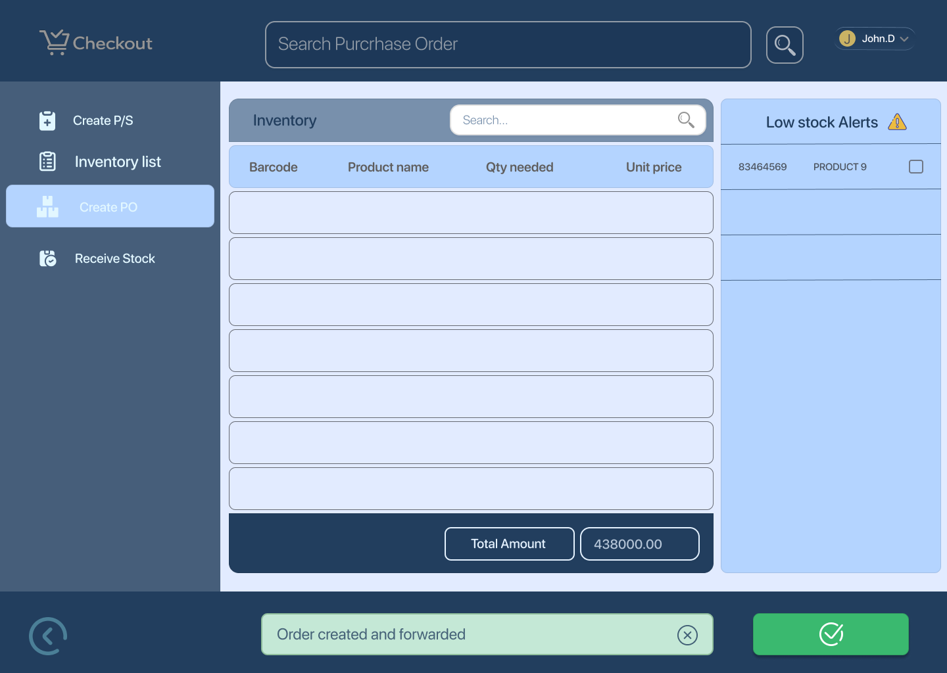
Happy Path
- Manager creates a new purchase order
- Selects supplier and products
- Enters quantities
- Submits order
- System confirms order creation and forwarding

Edge Case
- Missing supplier or product
- Quantity left empty or invalid
- Supplier unavailable
- Network or submission failure

UX Notes
- Auto-suggest products based on low stock
- Validate inputs in real time
- Show clear confirmation after submission

3. Inventory List & Purchase History (Primary Screen) Screens
- Inventory Updates (Manager) 10 — Inventory List
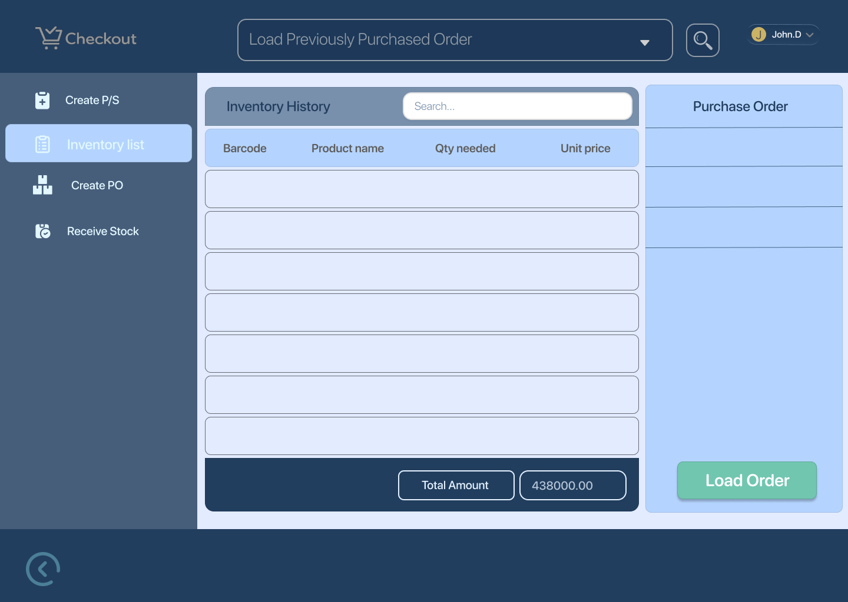

- Inventory Updates (Manager) 11 — Set to Load Previous Purchase Orders
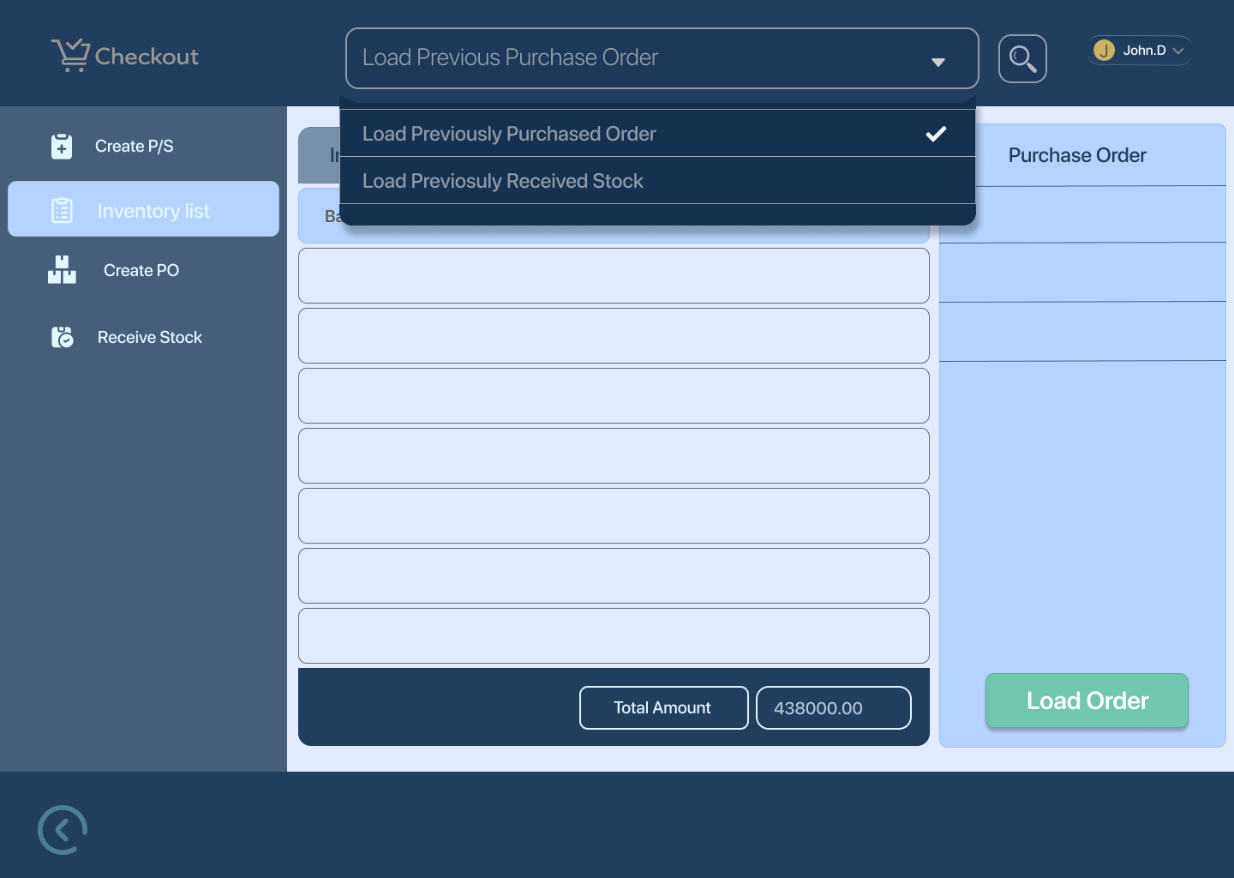

- Inventory Updates (Manager) 12 — Load Previous Purchase Orders
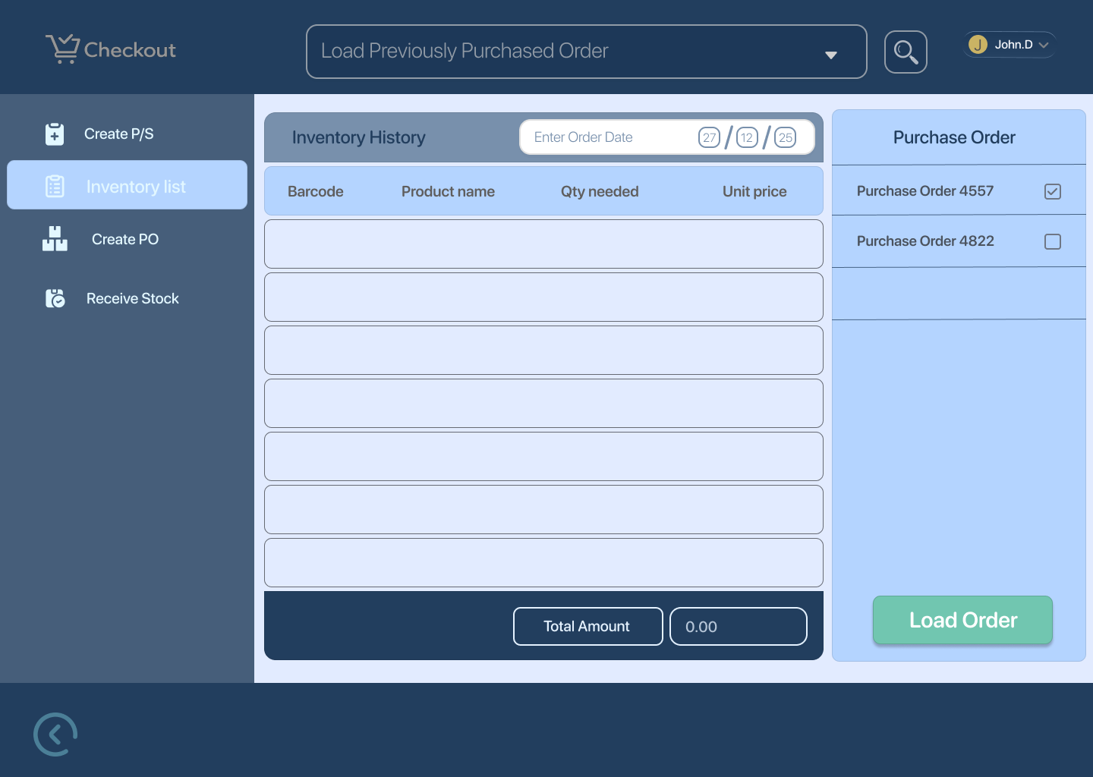

- Inventory Updates (Manager) 13 — Purchase Orders Loaded
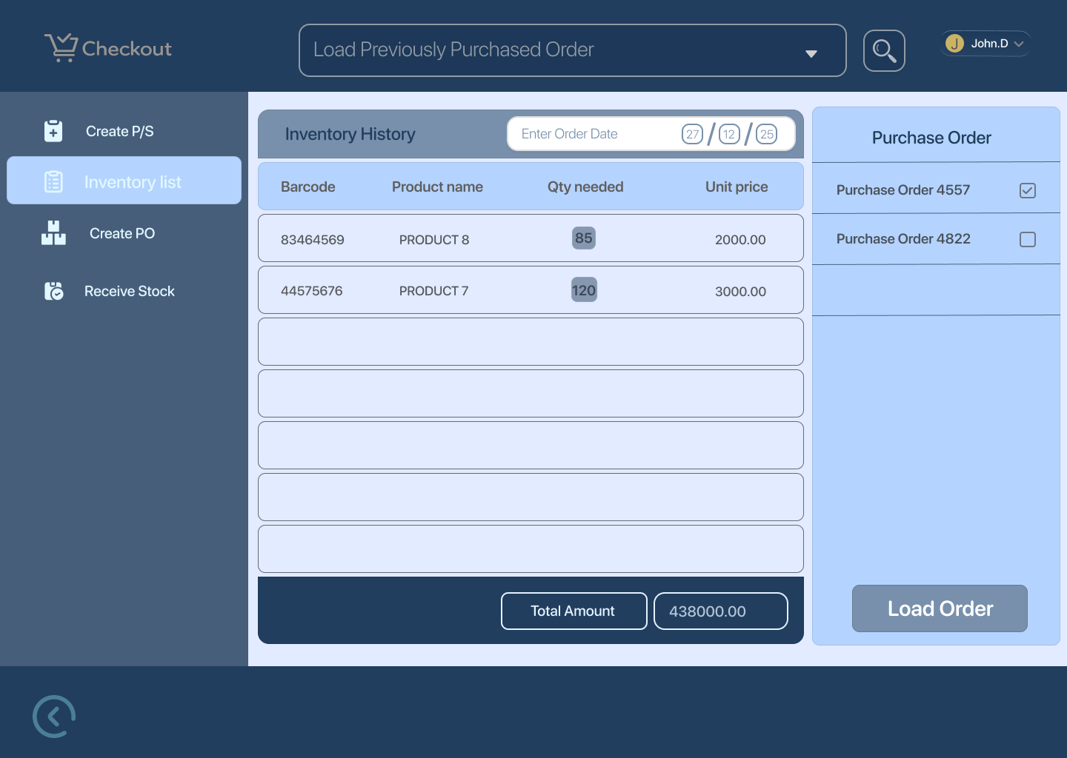

- Inventory Updates (Manager) 14 — Set to Previously Received Stock
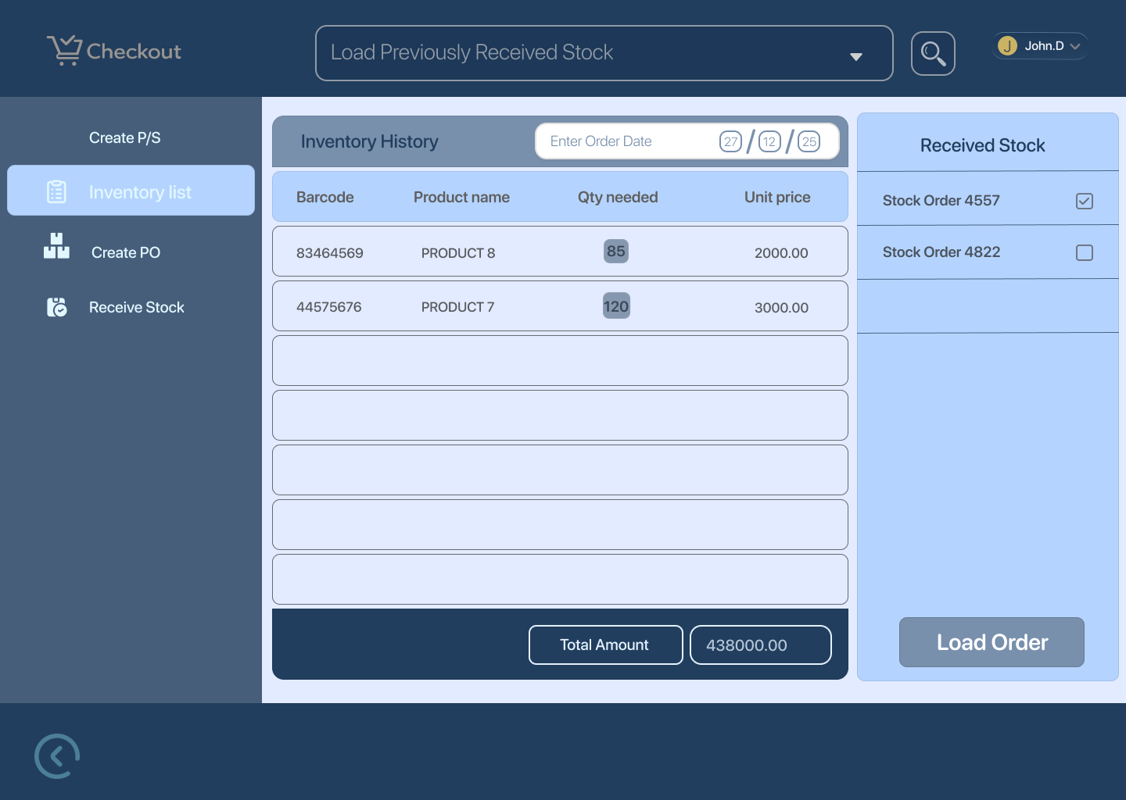

Happy Path
- Manager views inventory list
- Switches between current stock, previous purchase orders, and received stock
- Data loads successfully

Edge Cases
- No previous purchase orders available
- Data load failure
- Large dataset loading delays
UX Notes
- Clear filters/toggles between views
- Loading indicators for data fetch
- Empty states with guidance text

4. Create New Product / Supplier (Primary Screen)
Screens
- Inventory Updates (Manager) 15 — Create New Product/Supplier
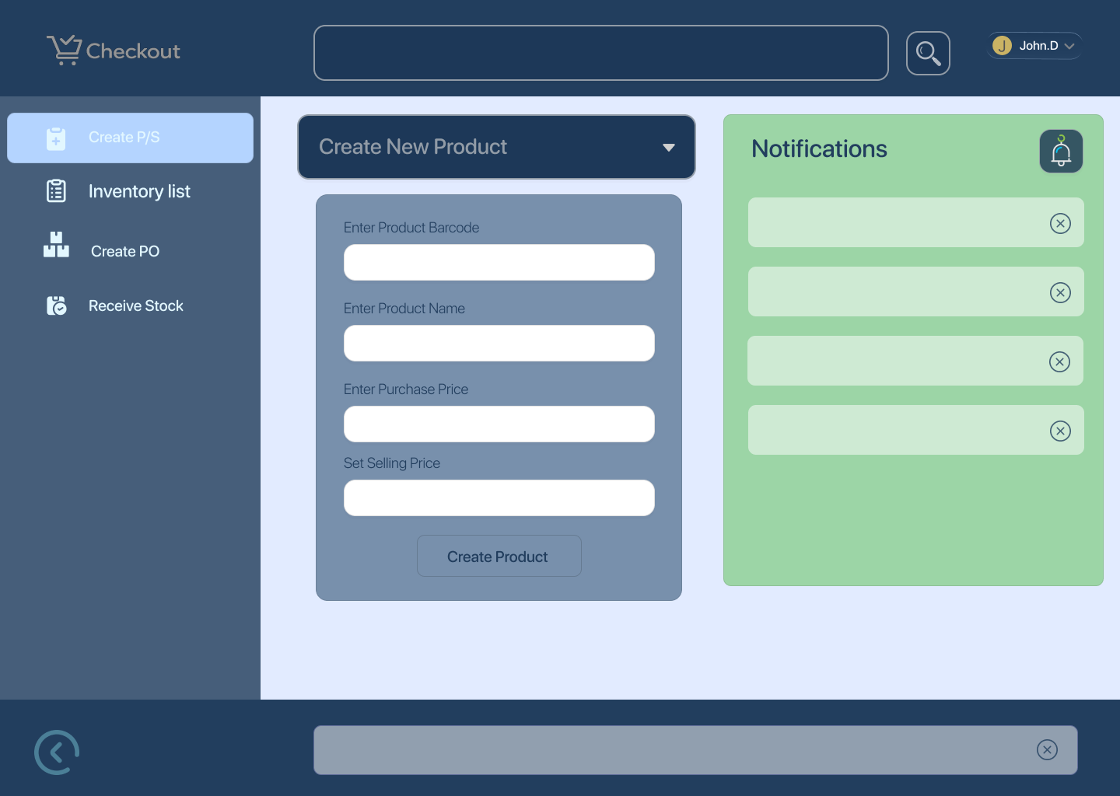

- Inventory Updates (Manager) 16 — Set to Create New Product + Notification
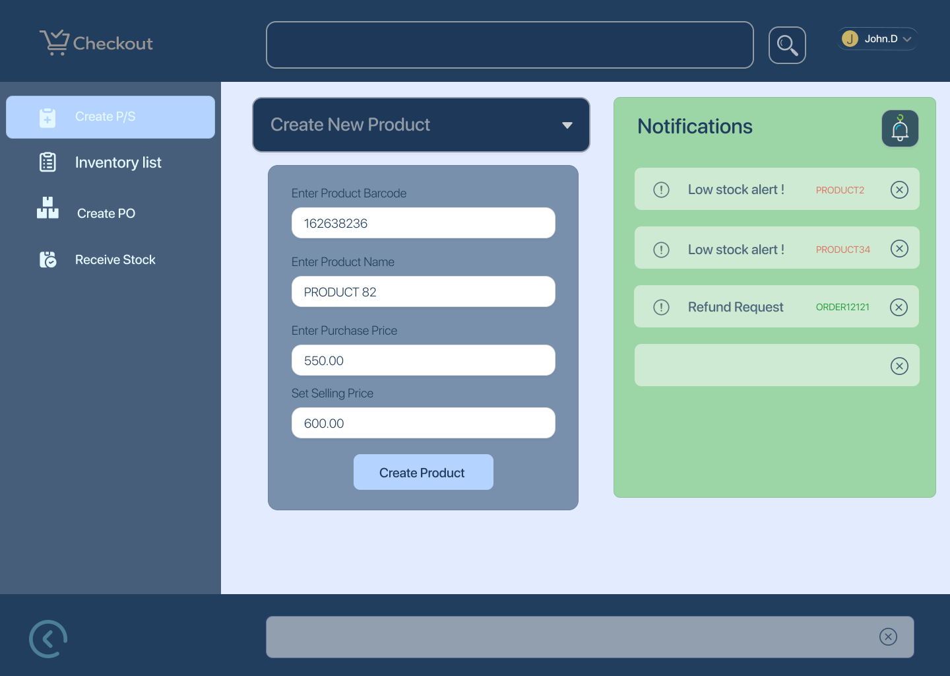

- Inventory Updates (Manager) 17 — New Product Created Successfully
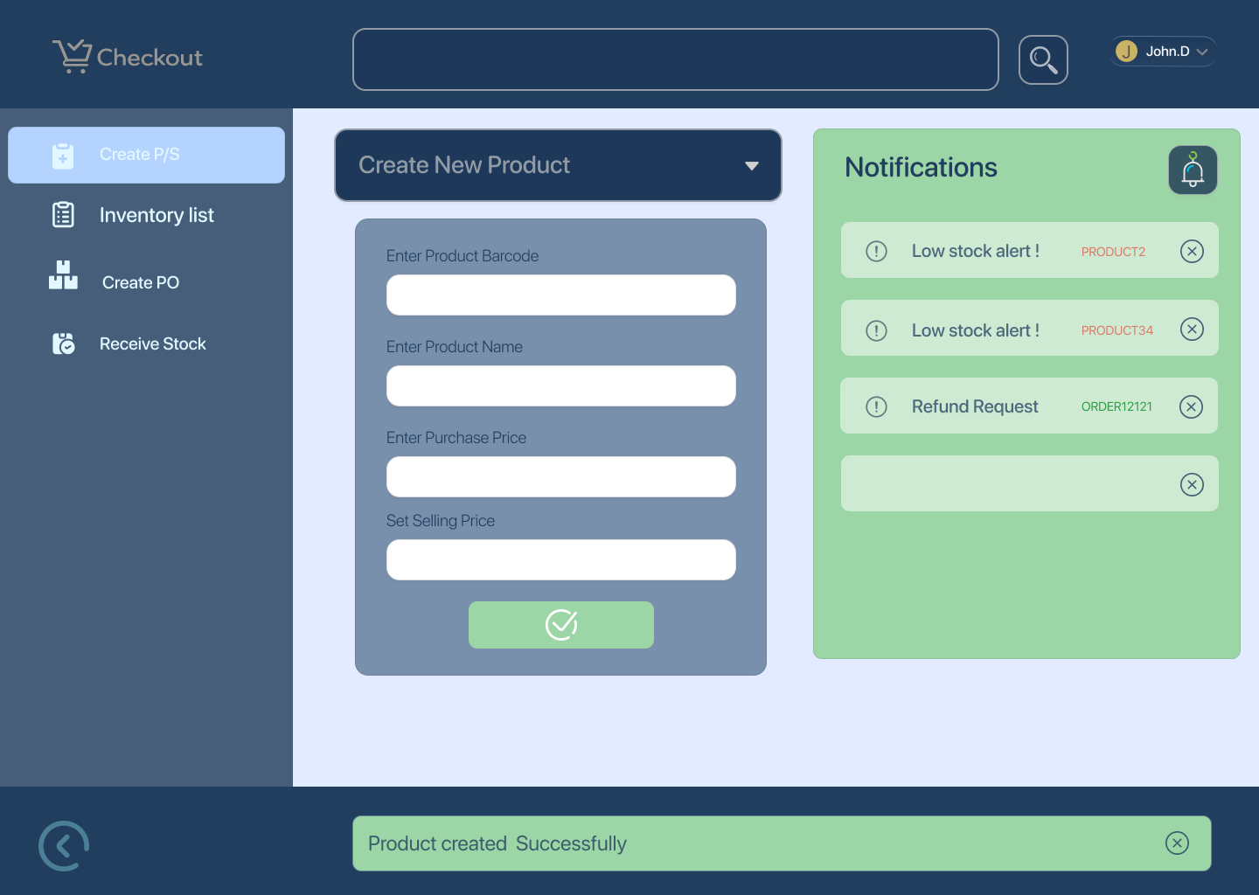

- Inventory Updates (Manager) 18 — Product Creation Failed
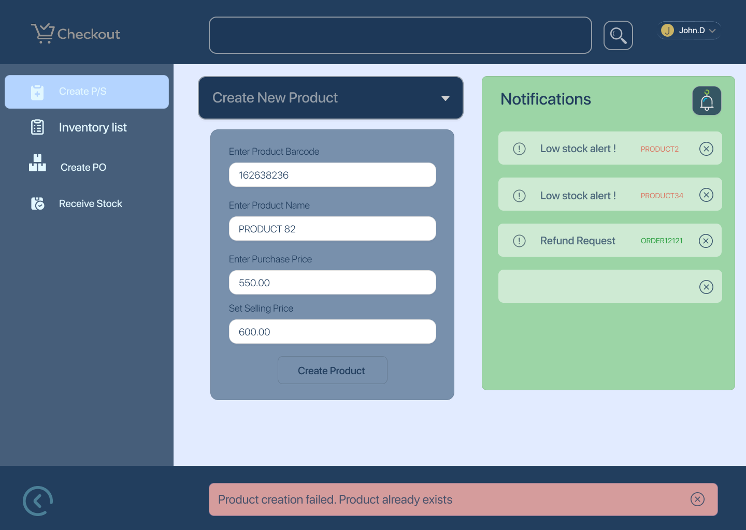

- Inventory Updates (Manager) 19 — Create New Supplier
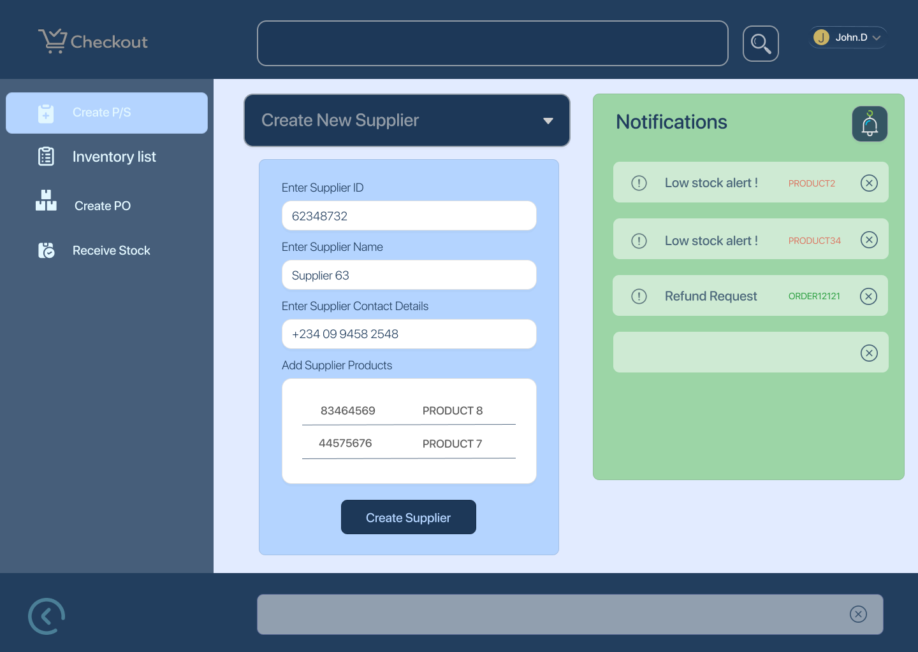

- Inventory Updates (Manager) 20 — Supplier Created Successfully

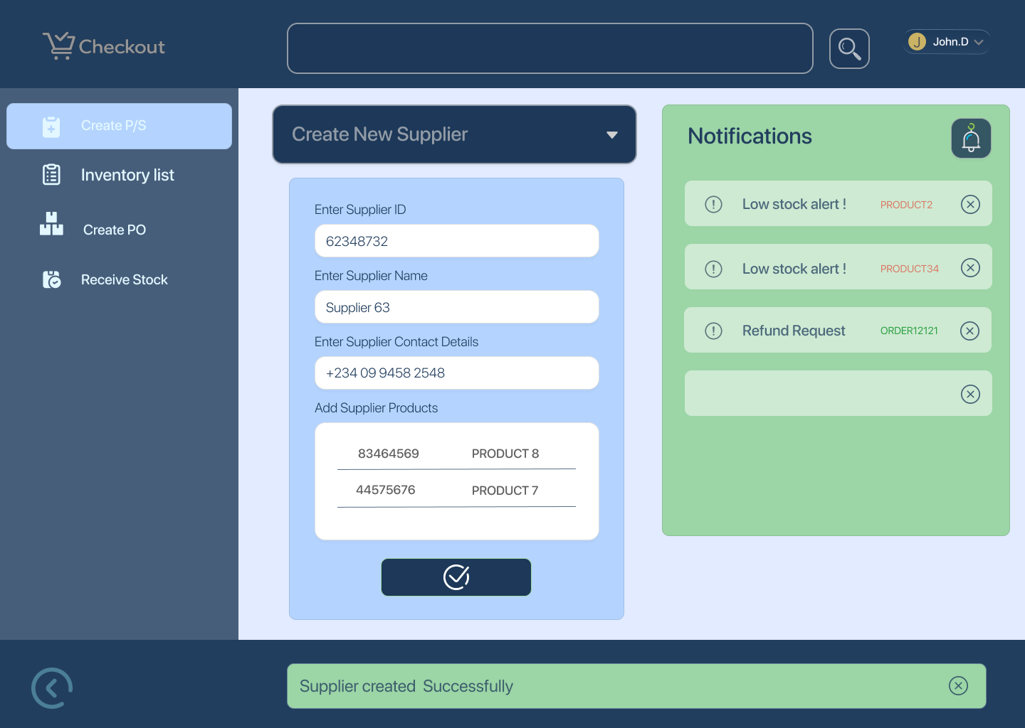

- Inventory Updates (Manager) 21 — Supplier Creation Failed

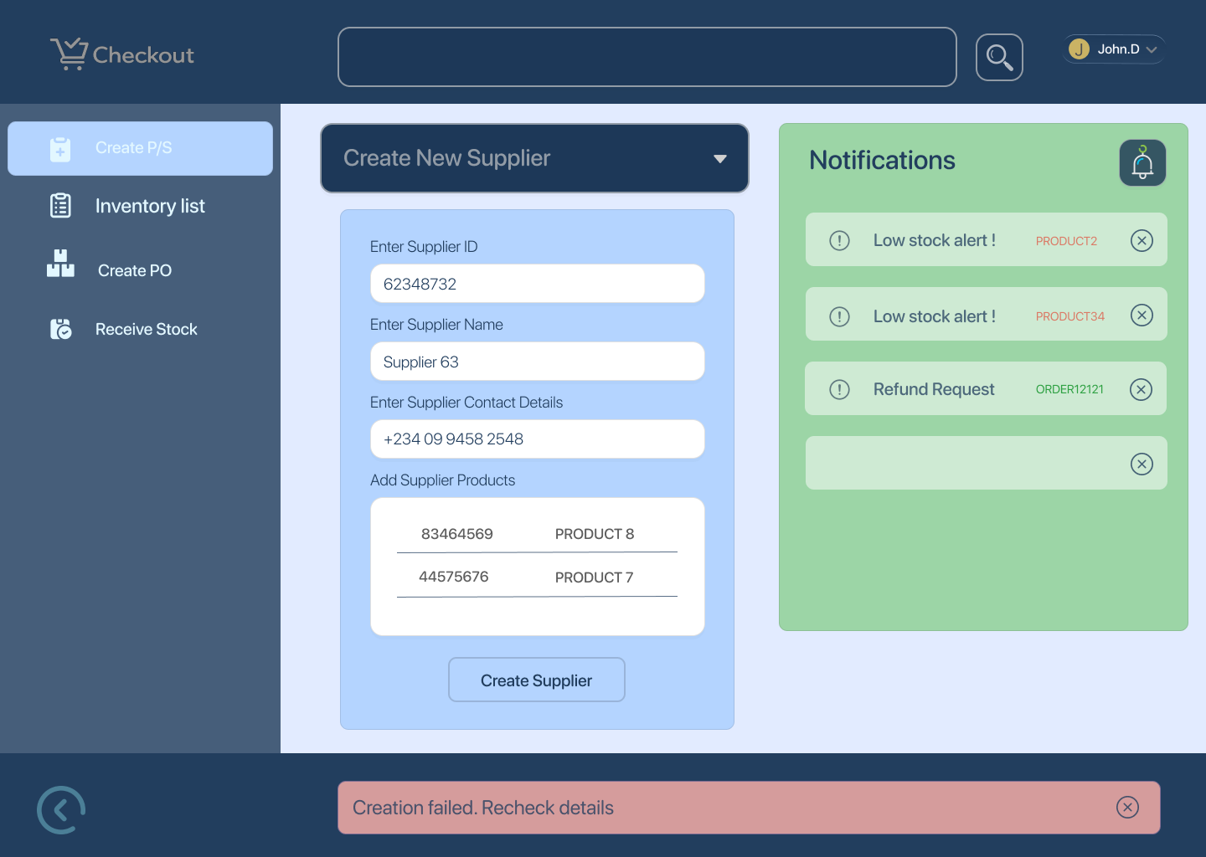

Happy Path
- Manager opens create new product/supplier
- Enters required detail
- Submits form
- System confirms successful creation
Edge Cases
- Duplicate product barcode
- Missing required fields
- Invalid supplier information
- Creation failure due to system error

UX Notes
- Clear field requirements and examples
- Inline validation and error messaging
- Success and failure states must be unambiguous

