POS Inventory System

UX Design Baseline Document
Version: 1.0
Prepared by: Lead UX Designer
Purpose: MVP UX foundation for POS Inventory System

1. Introduction
This document establishes the baseline UX design direction for the POS Inventory System MVP.
It captures user requirements, user stories, logical user flows, key screens, and layout rules to guide design, development, and future iterations.
The goal of this baseline is to ensure:
- Shared understanding across product, design, and development teams
- A user-centred foundation before wireframing and UI implementation
- Clear scope definition for MVP delivery
This document will be updated iteratively as wireframes, usability feedback, and implementation insights evolve.

2. Requirements & User Stories

2.1 Primary Users
- Cashier
- Store Manager

2.2 Secondary Users
- Inventory / Admin Staff

3. User Pain Points
- Manual stock tracking
- Slow checkout processes
- Inaccurate inventory levels
- Poor sales visibility

4. User Stories
- As a cashier, I want to scan barcodes and complete sales quickly so customers are not delayed.
- As a manager, I want to view real-time stock levels to prevent out-of-stock situations.
- As a manager, I want to apply discounts and pricing rules correctly during sales.
- As a store admin, I want to record purchase orders and supplier deliveries to update inventory.
- As a manager, I want to generate sales and inventory reports for decision-making.
- As a cashier, I want to process returns and refunds correctly.

5. Key Requirements

5.1 Must-Have Features
- Product & SKU management with barcode scanning
- Sales processing with receipt generation
- Stock level tracking and stock movement logs
- Returns and refunds handling
- Pricing rules and discounts
- Sales and inventory reports
- Role-based access control (Cashier vs Manager)

5.2 Constraints
- MVP scope only
- Support multiple stores and registers
- Offline tolerance (if possible)

6. User Flows (Logic Only)

Flow 1 — Sales Checkout (Cashier Experience)
UX Goal:
Enable the cashier to complete a sale quickly, accurately, and with minimal cognitive load, while providing clear feedback at every step.
Primary User:
Cashier

Flow Steps with UX Implications
Login / Session Start
- Screen: Login screen
- Inputs: Username + password OR badge scan
- UX Notes:
  - Clear error message for invalid login
  - Loading indicator during authentication
  - Auto-redirect on success
Register Selection
- Screen: Register selection
- UX Notes:
  - Show available registers only
  - Auto-select if only one register
  - Error state if register is unavailable
Product Scanning
- Screen: POS checkout screen
- Interaction:
  - Barcode scan auto-adds item to list
  - Manual search fallback (search field)
- UX Feedback:
  - Visual confirmation when item is added
  - Inline error for unknown barcode
  - Clear out-of-stock warning
Cart Review & Total Calculation
- Screen: POS checkout screen
- UX Elements:
  - Item list with quantity controls (+ / –)
  - Subtotal, discounts, tax, and total clearly separated
- UX Notes:
  - Totals update instantly
  - Applied discounts highlighted for transparency
Payment Confirmation
- Screen: Payment modal or payment screen
- Inputs:
  - Payment method selection
  - Amount received (for cash)
- UX Feedback:
  - Inline validation errors
  - Clear success/failure states
  - Disable double submission
Receipt Confirmation
- Screen: Receipt confirmation
- UX Options:
  - Print receipt
  - Send digital receipt
  - Skip
- UX Notes:
  - Clear success message
  - “Start New Sale” CTA
Automatic Stock Update (Background)
- UX Behavior:
  - No user action required
  - Optional toast notification for low-stock warnings

Flow 2 — Inventory Update (Manager Experience)
UX Goal:
Allow managers to add stock confidently and traceably while minimizing receiving errors.
Primary User:
Store Manager / Inventory Admin

Flow Steps with UX Implications
Create Purchase Order
- Screen: Create PO screen
- Inputs:
  - Supplier selection
  - Product selection
  - Quantity
- UX Notes:
  - Auto-suggestions for products
  - Validation for empty or invalid fields
  - Save-as-draft option
Receive Stock
- Screen: Receive inventory screen
- Interaction:
  - Match delivered quantities against expected quantities
- UX Feedback:
  - Visual highlights for mismatches
  - Allow partial receiving
  - Notes field for discrepancies
Confirm Stock Movement
- Screen: Confirmation modal
- UX Notes:
  - Summary of changes before confirmation
  - Clear confirmation CTA
  - Warning for large quantity changes
Inventory Updated
- Screen: Inventory list/dashboard
- UX Behavior:
  - Updated quantities visible immediately
  - Optional success notification
  - Low-stock alerts cleared if applicable
UX Edge States to Design
- Partial delivery
- Quantity mismatch
- Duplicate receiving attempt
- Invalid supplier or product
Key Screens to Wireframe
- Purchase order creation
- Stock receiving
- Inventory list/dashboard

Flow 3 — Returns & Refunds (Cashier Experience)
UX Goal:
Enable fast, policy-compliant returns while maintaining clarity and trust for both cashier and customer.
Primary User:
Cashier

Flow Steps with UX Implications
Sale Lookup
- Screen: Return lookup screen
- Inputs: Receipt number / Order ID / Date
- UX Notes:
  - Helpful empty-state instructions
  - Clear error if sale not found
Select Items for Return
- Screen: Return details screen
- Interaction:
  - Select item(s)
  - Adjust quantity
  - Select condition (resellable / damaged)
- UX Notes:
  - Prevent returning more than purchased
  - Show original prices clearly
Return Validation
- UX Behavior:
  - Display policy messages (e.g. return window exceeded)
  - Manager approval prompt if required
  - Clear rejection reasons
Refund Processing
- Screen: Refund confirmation
- UX Options:
  - Refund method shown clearly
  - Confirm refund CTA
- UX Feedback:
  - Success / failure messaging
  - Loading indicator during processing
Completion
- Screen: Refund receipt / confirmation
- UX Notes:
  - Refund summary
  - Print or send refund receipt

7. Key Screens Overview

A. Authentication & Session
- Login screen (username/password or badge scan)
- Error feedback and loading state
- Register selection screen with auto-select logic

B. POS / Sales Flow (Cashier)
- POS checkout screen
- Product search and selection
- Payment method selection
- Payment processing state
- Receipt confirmation

C. Inventory Management (Manager / Admin)
- Inventory list / stock overview
- Purchase order creation
- Stock receiving
- Stock update confirmation

D. Returns & Refunds (Cashier)
- Return lookup screen
- Return details screen
- Refund confirmation
- Refund receipt / completion screen

E. Reporting (Manager)
- Sales report dashboard
- Inventory report screen

8. Grid System & Layout Rules
- Target Platform: Desktop
- Resolution: 1440 × 900
- Grid: 12-column layout
- Margins: 80px
- Gutters: 30px
- Primary Colour Palettes:
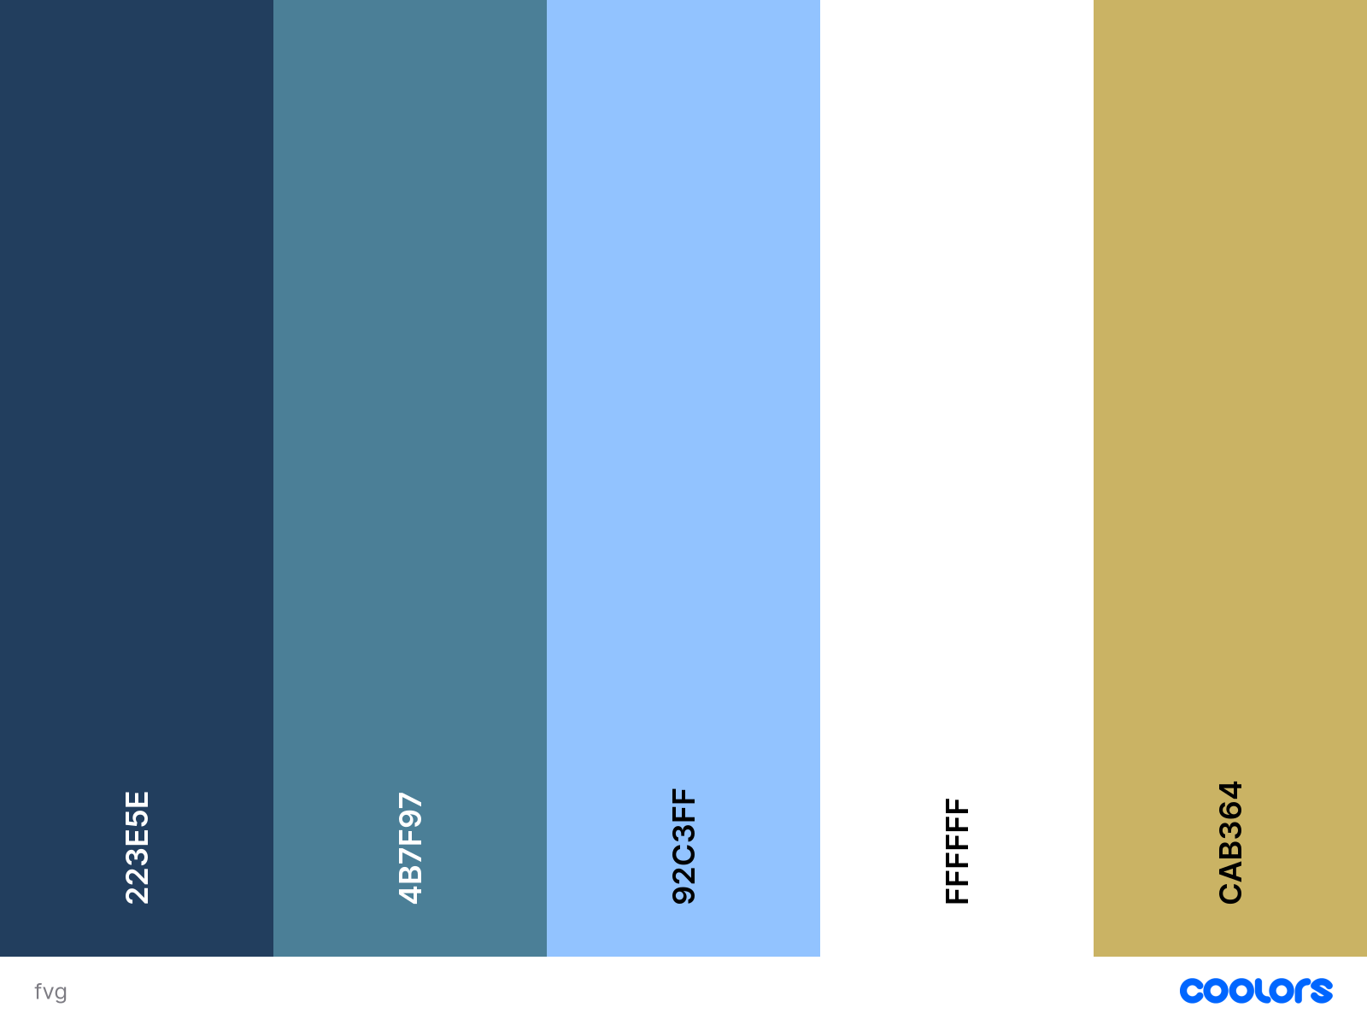

9. Wireframes & Visual Assets
- Wireframes and screenshots will be stored under:
assets/wireframes/

